DAILY CHECKLIST – CMDL Aerosol System
Month: ________Year:200__ Station: Trinidad Head, California
Date | CNC butanol level: fill y/n | CN drier flow*  ~8.5 lpm | CNC vacuum 14 ” Hg | CNC status lights  →green | PSAP filter change | PSAP flow  ~1.2 lpm | Q_stack* ~850 lpm | Water reservoir level: fill y/n | MFC box, hum. rack ~29 lpm | MFC box, filt. rack ~29 lpm | Filter vacuum  ” Hg | Comments  (e.g., rain, smoke, instrument issues, vehicle traffic, etc.etc.)
1
2
3
4
5
6
7
8
9
10
11
12
13
14
15
16
17
18
19
20
21
22
23
24
25
26
27
28
29
30
31
Problems: Contact Pat Sheridan (303) 497-6672 or Betsy Andrews (303) 497-5171 Logging Status: ABCFHLMNOUVW
*Check values on computer screen in ‘aerosol window’ <alt><a>
Month:________________ Year: 200___

WEEKLY TASKS
PSAP ref. filter
Date
Time (UTC)
Neph span check
Date
Time (UTC)
Impactor cleaning
(Hum. Rack)
Date
Carousel filters
(Filter Rack)
Date
Leak check  Date | ambCN=  amb_dP=  filtCN=  filt_dP= | ambCN=  amb_dP=  filtCN=  filt_dP= | ambCN=  amb_dP=  filtCN=  filt_dP= | ambCN=  amb_dP=  filtCN=  filt_dP= | ambCN=  amb_dP=  filtCN=  filt_dP=
Mail carousel filters to PMEL
Pumpbox
Vac guage~0.25”H₂O
Rotameters ~30 lpm

MONTHLY TASKS
Mail PSAP filters, checklists to NOAA
Flush CN Butanol
Check supply levels | Butanol  DI water  PSAP filters  Impactor films  Plastic bags  Other:___________________

Typical Parameter Values
Window | <Alt> key | Parameter | Typical | Lower limit | Upper limit | Action
Aerosol Sampling Status | A | RH_sample | 40 | 0 | 45 | Check inlet heater
 | A | T_sample | 25 | 10 | 40
 | A | T_rack | 30 | 20 | 35 | Check air conditioner
 | A | T_pumpbox | 32 | 25 | 40
 | A | Q_analyzer | 30 | 28 | 32 | Check pump, adjust flow
Aerosol dP sensors | A | dP_Neph_imp | 2 – 10 | 2 | 13 | Check for leaks around impactors
 | A | dP_CNC_vac | 700 | 650 | 750 | Check CN pump
 | A | dP_pitot | 70 | 60 | 80 | Check carbon vane pump
CN counter | A | Drier flow | 8 | 7.5 | 8.5 | Adjust valve
Best UPS | B | Inverter | OFF
 |  | Charger | ON
 |  | AC Volts IN | 113 | 110 | 120 | Fix generators
 |  | AC Volts OUT | 121 | 118 | 125
 |  | AC Amps OUT
 |  | Output Load VA |  |  |  | Check that all systems are drawing power, and than nothing unauthorized is connected to UPS
 |  | Battery DC V | 13.9 | 13 | 14 | Possible UPS malfunction
 |  | Frequency | 60 | 50 | 70 | Fix generators
PSAP | L | Flow | 3.0 | 2.5 | 3.5 | Adjust flow
 | L | Transmittance | 0.9 | 0.7 | 1.0 | Change filter
 | L | I_sample | 250000 | 90000 | 300000 | Check light source
 | L | I_reference | 570000 | 250000 | 300000 | Check light source
 | L | Filter change | FALSE | FALSE | FALSE | You forgot to press <Esc>ILF after last filter change.

Window | <Alt> | Parameter | Typical | Lower | Upper | Action
Neph_N & Neph_O | N & O | Bkg_tot_Blue | 2.0E-5 | 1E-7 | 5*typ.
 |  | Bkg_tot_Green | 1.8E-5 | 1E-7 | 5*typ.
 |  | Bkg_tot_Red | 1.6E-5 | 1E-7 | 5*typ.
 |  | Bkg_back_Blu | 6.0E-6 | 1E-7 | 5*typ.
 |  | Bkg_back_Grn | 5.0E-6 | 1E-7 | 5*typ.
 |  | Bkg_bak_Red | 4.0E-6 | 1E-7 | 5*typ.
 |  | MODE | NBXX | BBXX | ZBXX | Any other value is an error
 |  | P_hPa | 1000 | 950 | 1020
 |  | SecToGo | 30000 |  |  | Must decrease by one every second
 |  | Sample_T | 300 | 290 | 320 | Check room temperature
 |  | Inlet_T | 297 | 290 | 320 | Check room temperature
 |  | Next_Z | Xx:57:00 |  |  | Possible error in CP.INI entry for [Neph] ZeroAt= entry.
 |  | GreenRef | 4.0E+5 | 3.0E+5 | 5.0E+5 | Lamp may be failing.
 |  | Lamp_V | 13 | 10 | 14 | Lamp may be failing
 |  | Lamp_I | 5.7 | 5 | 7.5 | Lamp_V times Lamp_I should be 75.0
Humidograph | H | refNeph | 30% | 0% | 40%
 |  | wetNeph | Varies | 0% | 95%
 |  | RH_S1  (RH after preheater) | 30% | 0% | 40% | Check humidograph system
 |  | T_S1  (T after preheater) | 297 | 290 | 320 | Check humidograph system
 |  | RH_S2  (RH after humidifier) | varies | 0% | 97% | Check humidograph system
 |  | T_S2  (T after humidifier) | 297 | 290 | 320 | Check humidograph system
uMAC & vMAC | U & V | Room Temp | 38 | 30 | 40 | Check room temperature
 |  | Power supply | 5.0 | 4.9 | 5.1 | Power supply bad?
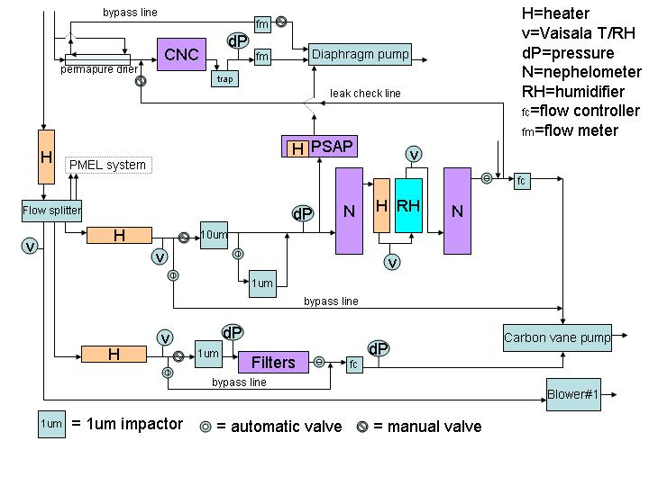
System Schematic

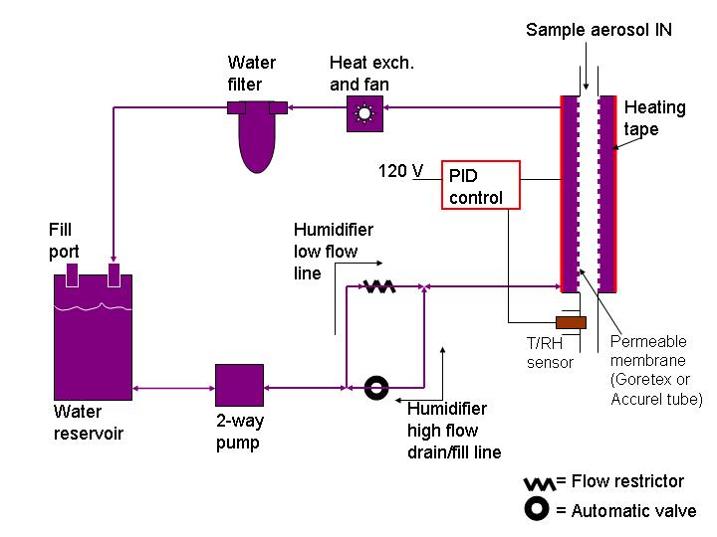
Humidifier system

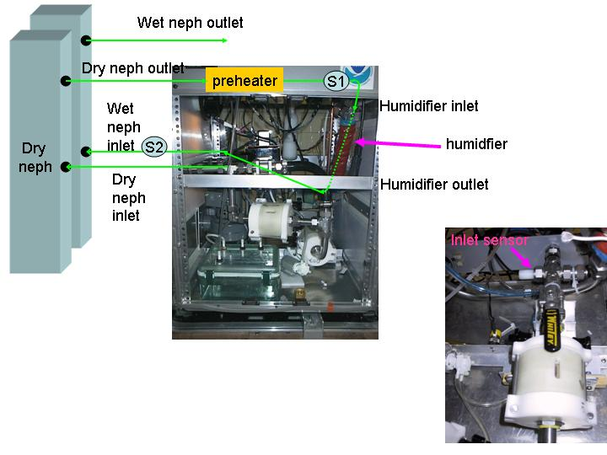
RH sensor locations

