Operating Manual
NOAA/CMDL Aerosol Sampling System
Last Updated – November 5, 2004
Table of Contents
1. General description 2
1.0. Maintenance Checklist 4
1.0.1. Daily Tasks 4
1.0.2. Weekly Tasks 4
1.0.3. Monthly Tasks 4
1.1. CMDL Contact information 4
2. Maintenance 5
2.1. Check System Parameters and Logging Status - (Daily Task) 5
2.2. Check water level in reservoir (Daily Task) 5
2.3. CN counter butanol level (Daily Task) 6
2.4. Changing the PSAP Filter (Daily Task) 6
2.5. Changing Impactor Films - (Weekly Task) 7
2.5.1. Removal of Impactors 8
2.5.2. Cleaning of Impactors 8
2.5.3. Re-assembly 9
2.6. Change Carousel Filters (Weekly Task) 10
2.6.1. Preparation 10
2.6.2. Change the impactor films 10
2.6.3. Changing the filters 11
2.7. System Leak Test - (Weekly Task) 11
2.8. Nephelometer Span Check - (Weekly Task) 13
2.8.1. Plumbing 13
2.8.2. Operation 13
2.9. Changing Nephelometer Lamp 14
2.10. System Clock 14
2.11. Instant Messenger 14
3. Computer Operation 14
3.0. General 14
3.1. Startup 15
3.2. Shutdown 16
3.3. Archiving and Backing-up Data 16
3.3.1. Saving to hard disc 16
3.4. Other desktop icons 17
3.5. LiveCPD Documentation 17
3.6. Graphical Client Program (cpx) 17
3.7. Aerosol Data Logger Program 17
3.7.1. General Operation 17
3.7.2. Display 18
3.7.3. Root Menu <Control><M> or <esc> 19
3.7.4. Aerosol Status Window and Monitor Menu <Alt><A><M> 20
3.7.5. Nephelometer Status Window and Menu <Alt><N><M> or <Alt><O><M> 21
3.7.6. PSAP Menu <alt> <L><M> 21
3.7.7. Filters Menu <Alt> <F><M> 22
3.7.8. Humidograph Menu <Alt> <H><M> 22
4. Safety 23
4.1. Heater Control 23
4.2. Electrical Safety 23
5. Specifications 23
5.1. Power Draw at 115 V DC 23
6. Additional Computer info 24
6.0. Data flow 24
6.1. Aerosol Server Program (cpd) 24
6.2. User account 24
6.3. Location of this document 24
7. Station specific appendix 25

General description
The CMDL Aerosol Sampling System is deployed at a number of stations around the world (see Table 1). It is an automated system for measuring aerosol light scattering as a function of wavelength, aerosol light absorption, and condensation nuclei. At several stations the light scattering as a function of relative humidity is also measured. 1 and 10 um impactors are used to measure these properties for aerosol less than 1 and 10 um, respectively. The main components are a three wavelength nephelometer (TSI model 3563), a light absorption photometer (Radiance Research PSAP) and a Condensation Nucleus Counter (TSI mode 3760). At some stations filter measurements are also made in conjunction with PMEL of the ionic composition of the aerosol. sea salt, non-sea salt (nss) sulfate, methanesulfonate, NH₄⁺, nss K⁺, Mg⁺², and Ca⁺ for sub-micron and super-micron size ranges. Table 1 indicates which components are deployed at each station.

Table 1 Long term station list, locations and system components | 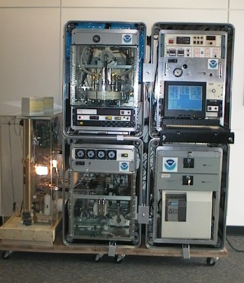
  Station ID | Station Location | Neph | PSAP | CNC | Chem filters | Humid-ograph | other
  BRW | Barrow, AK | X | X | X | X
  MLO | Mauna Loa, HI | X | X | X
  SMO | American Samoa |  |  | X
  SPO | South Pole | X |  | X
  THD | Trinidad Head, CA | X | X | X | X | X
  BND | Bondville, IL | X | X | X | X
  SGP | Lamont, OK | X | X | X | X | X | pcasp
  IAP | Lamont, OK (airplane) | X | X |  |  | X | Amb T,RH

A system with all the options generates the following information:
- Total and backwards scattering coefficients time series at 450, 550 and 700 nm wavelengths in two size ranges
- Total and backwards scattering coefficients time series at 450, 550 and 700 nm wavelengths in two size ranges as a function of relative humidity
- Absorption coefficient time series at 565 nm in two size ranges
- Condensation nuclei concentration time series
- Mass concentration of sea salt, non-sea salt (nss) sulfate, methanesulfonate, NH₄⁺, nss K⁺, Mg⁺², and Ca⁺ for sub-micron and super-micron size ranges

From the measurements the following parameters can be calculated:

- Single scattering albedo at about 550 nm in two size ranges
- Angstrom coefficient
- Hemispheric backwards scattering fraction in two size ranges
- f(rh)

Maintenance Checklist
The system is mostly automated but there are some tasks that need to be performed on a daily, weekly or monthly basis. The tasks for a complete system are listed below and are described in more detail in Section 2 – Maintenance. More specific maintenance tasks for individual stations are described in each station’s appendix. Each station also has a binder of instrument manuals for each of the instruments and other system components to aid in more complicated trouble-shooting and maintenance (in consultation with station scientists).

Daily Tasks
1. Fill out daily checklist
2. Check logging status: letters at bottom of screen should be appropriate for that station (see appendix)
3. Add distilled water to humidifier rack reservoir (if less than half full)
4. Check butanol level in CN counter and add butanol if needed
5. Change PSAP filter if transmittance< 0.9

Weekly Tasks
1. Perform daily tasks
2. Change PSAP reference filter
3. Service nephelometer impactors
4. Perform leak test (if weather permits)
5. Perform nephelometer span check
6. Change filter carousel and carousel impactor film (can be done during span check)
7. Perform leak test (if weather permits)
8. Begin filter sampling
9. Mail carousel filter samples to NOAA/PMEL

Monthly Tasks
1. Mail PSAP filters and daily check lists to NOAA/CMDL
2. Check supply levels of PSAP filters, impactor films, plastic bags, butanol, ethanol.
3. Check air filter on front of PC, clean if necessary

CMDL Contact information
Betsy Andrews  Email: betsy.andrews@noaa.gov  Office Phone: 303-497-5171  Home Phone : 303-442-5142 | Allison Payton  Email: allison.payton@noaa.gov  Office Phone: 303-497-6189  Home Phone: 303-543-1338
Anne Jefferson  Email: anne.jefferson@noaa.gov  Office Phone: 303-497-6493  Home Phone: 303-579-9013 | Pat Sheridan  Email: patrick.sheridan@noaa.gov  Office Phone: 303-497-6672  Home Phone: 303-494-1461
John Ogren
Email: john.a.ogren@noaa.gov
Office Phone:303-497-6210
Home Phone: 303-499-4079

Maintenance
This section describes the general maintenance/station tasks for a station with all the options. Not all tasks are applicable to each station, so each task includes a list of stations where it must be performed.

Check System Parameters and Logging Status - (Daily Task)
Stations applicable: BRW, MLO, SMO, SPO, THD, BND, SGP, IAP
Time required: 5 minutes
Tools/supplies: Daily check list
Overview: There are a few system parameters that are not recorded and hence need to be checked manually. A daily checklist is used to record the values and is mailed back to CMDL at the end of each month with the used PSAP filters.

1. Fill out daily checklist (and weekly/monthly on back of sheet if applicable)
2. Check that letters on bottom of computer screen match the letters listed in section 1.0.1

Check water level in reservoir (Daily Task)
Stations applicable: THD, SGP, IAP
Time required: 5 minutes
Tools/supplies: distilled water
Overview: The humidifier condenses water vapor onto particles after they exit the reference nephelometer, but before they enter the humidified nephelometer. The condensed water vapor exits the system and must be replenished.

The water reservoir needs to be refilled whenever the level in the reservoir gets below ~1/2.
If reservoir has lost lots of water in a short period of time this may indicate a leak! Inspect for water around the system or for an RH value in the second nephelometer above 90%. If there is a leak a) turn off humidifier heater and preheater b) unplug the water pump c) enter a log message in the computer <Control><M><enter>reservoir leak!! <enter>

Lift the attached fill funnel above the top of the reservoir bottle. Slowly pour distilled water into the funnel. Do not fill reservoir above the bottom of the red tape line.
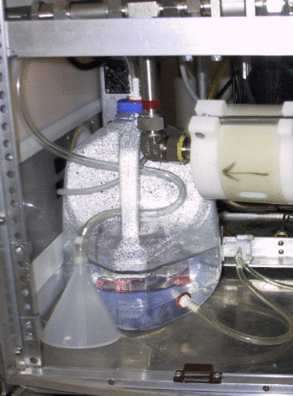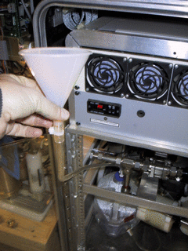

CN counter butanol level (Daily Task)
Stations applicable: BRW, MLO, SMO, SPO, THD, BND, SGP
Time required: 5 minutes
Tools/supplies: butanol fill bottle
Overview: The CN counter condenses butanol vapor onto particles in the sample line to grow them to a size so that they can be seen and counted by the instrument optics. The condensed butanol goes out the exhaust stream to the butanol trap and fresh butanol must be added to the counter to replenish the supply.

Check the butanol level – it should be about ½ way up the view port. Do not overfill.
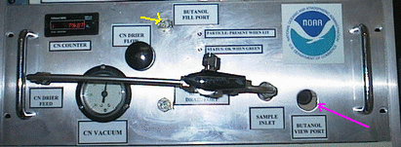

If butanol needs to be added connect the butanol fill bottle to the butanol fill port. Loosen the cap on the butanol bottle and fill the CN counter until the butanol level shown in the view port is acceptable.

Changing the PSAP Filter (Daily Task)
Stations applicable: BRW, MLO, THD, BND, SGP, IAP
Time required: 5 minutes
Tools/supplies: PSAP Filter Kit
Overview: The PSAP filter transmittance degrades as particles collect on it. To ensure valid measurements the filters need to be changed.

Is the PSAP filter transmittance above 0.9? (Look at Tr value, in picture is 0.799)
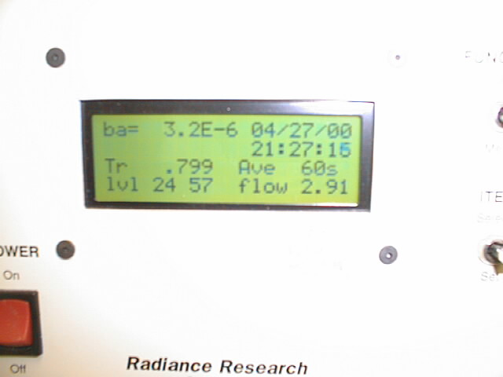
If not, the filter needs to be changed.

1. In the Aerosol Data Logger window, press <Alt><L><M><3> to signal start of a filter change.
2. Turn the flow down to zero using the knob on the right side of the PSAP.
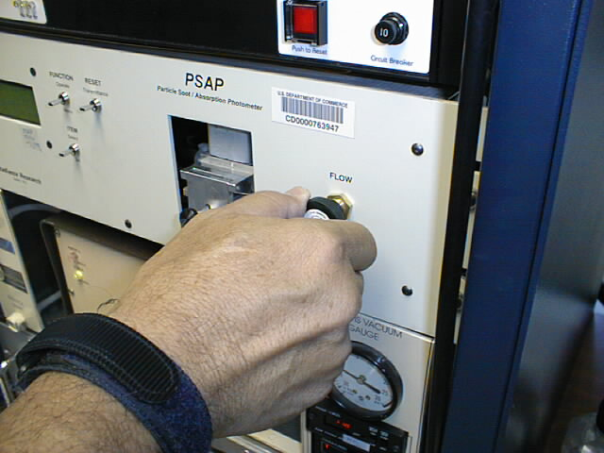
3. Unscrew the black knob on the sampling head, raise the lockdown panel, and remove the filter holder.
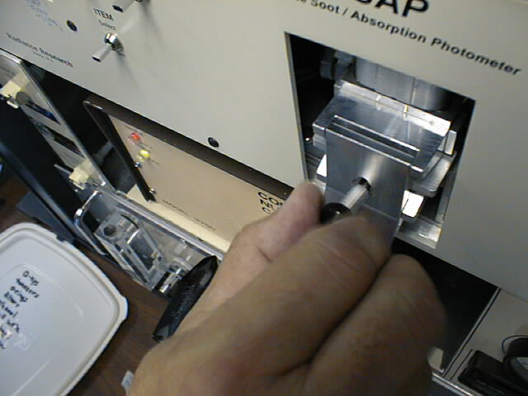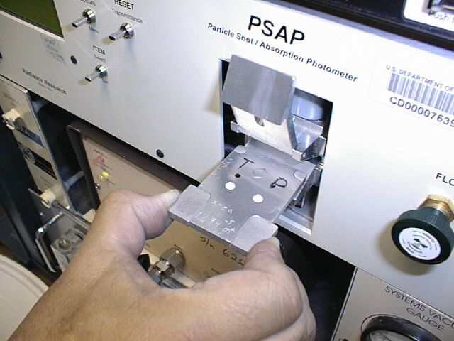
Sample
ref
Samplee
ref
4. Remove the filters. It is only necessary to replace the reference filter once per week. Place the sample filter (the left-hand one) in a small zip bag and label the bag with the station name and the date the filter was pulled out of the PSAP. The label should have the format: YYMMDD-THD (so December 13, 2000 would be labeled: 001213-THD). Write your initials on the bag.

5. Place new filters in the filter holder. The white side of the filter should be facing up.
Re-insert the filter holder into the sampling head; secure the lockdown panel with the black knob. Make sure the lower lip of the lockdown panel goes under the bottom edge of the sampling head.

6. Set PSAP flow to the following (in lpm): BRW=2; MLO=3; THD=1; BND=0.5; SGP=0.75; IAP= 2.5.
7. On the PSAP, press the “RESET Transmittance” switch up and verify that Tr=1.000 on the display of the PSAP.

8. Press <Alt> <L><M><3> to signal end of the filter change. Verify Transmittance = 1.000 before answering the “Y” when asked, “Have you pressed the RESET Transmittance switch?”
Note: the data acquisition software will do this step automatically, about 2 minutes after the transmittance returns to 1.0, in case you forget this step.

Changing Impactor Films - (Weekly Task)
Stations applicable: BRW, MLO, THD, BND, SGP
Time required: 20 minutes
Tools/supplies: a 1 1/8” wrench, and the impactor kit
Overview: It is necessary to change impactor films to ensure the impactor size cut is accurate. Changing impactor films involves disconnecting the impactor units and disassembling them so that the impaction film can be replaced. Change films more frequently than weekly if large particle deposits are observed.

Removal of Impactors
- <Control><M><enter> Enter message "Starting impactor servicing".<enter>
- At THD, turn off humidifier heater and preheater on Watlow control box (picture below).
Pink shows location of humidifier heater and preheater switches on CN/PSAP/Control rack.
<Control><M><enter> Enter message "Heaters off".<enter>

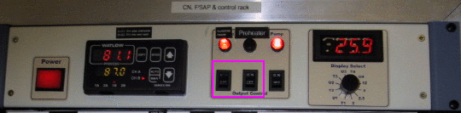

- <Alt><A ><M><3> to select “bypass analyzers”. This closes a solenoid valve and notifies the computer that impactors are off-line. Close the Whitey ball valve behind the 10 um impactor by rotating 90 degrees to left.
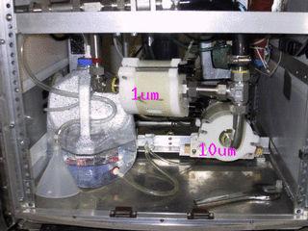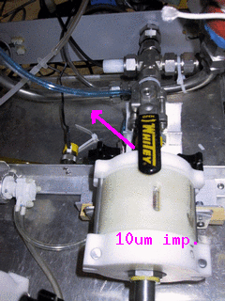
- Using 1 1/8” wrench, loosen the fitting marked with red tape and disconnect the 4 fittings that are marked with yellow nail polish. Carefully remove impactors. Be careful of the water tubing and heater cables so as not to disturb them.
- Place impactors on a flat clean surface. Use a large clean Kimwipe or printer paper.

Cleaning of Impactors
HINT: If you lay aside the cleaned pieces in order of removal, it will be easier to reassemble afterwards.
- Unscrew black knobs on 10-um impactor, and fold down the side arms.
- Remove top piece, clean inside (including inlet) with alcohol, tissue, and cotton swabs.
- Remove impactor jet plate, clean both sides with alcohol, tissue, and cotton swabs.
- Remove spacer ring, wipe clean.
- Remove old impaction film, discard
- Remove impaction plate, clean both sides with alcohol, tissue, and cotton swabs.
- Remove bottom spacer ring that impaction plate sits in, wipe clean.
- Clean inside of outlet fitting.
- Replace bottom spacer ring.
- Replace impaction plate.
- Spray an impaction film with a thin coat of silicone lubricant spray. Place film, with the sprayed side facing up, onto the impaction plate.
- Replace spacer ring.
- Apply a generous coating of silicone vacuum grease to the impaction cup on the top surface of the impactor jet plate (only on 10-um impactor).
- Replace impactor jet plate.
- Replace top cover
- Tighten assembly back together with black knobs

Re-assembly
- Reinstall impactors in system being careful not to strip threads on fittings. Tighten all fittings by hand and then again with 1 1/8” wrench. Don’t forget to tighten the fitting with the red tape that was loosened.
- Open Whitey valve by rotating handle 90 degrees to right (so it is parallel with flow).
- <Alt> <A><M><3> again when the impactors have been re-installed, to “unbypass analyzers” and to resume data logging. The ball valve message is asking if you have opened the Whitey valve. Enter ‘Y’ once the valve is open.
- At THD, turn preheater and humidifier heater switches on Watlow box back on.
- <Alt> <N><M>5> to start a nephelometer zero cycle
- Enter a log message: <Control><M><Enter> "System back on-line after impactor servicing and zeroing.” <enter>
- Do a leak check (weather permitting) to make sure all fittings have been tightened

Sketch of impactor
Side view Top view

Inlet

Impaction cup
Jet plate

Top spacer ring

Impactor film

Impaction plate

Bottom spacer ring

Outlet

Change Carousel Filters (Weekly Task)
Stations applicable: BRW, THD, BND, SGP
Time required: 30 minutes
Tools/supplies: Kimwipes, new canister of filters, old canister of filters, glovebox, 1 1/8” wrench, silicon spray.
Overview: Aerosol filters need to be removed from the carousel weekly and sent in to be analyzed.

Preparation
1. Prepare glovebox by putting down new Kimwipes and a new pair of outer gloves. Every other week or when you notice holes in the vet gloves replace them (you will need to tape these gloves on).
2. Turn on glove box pump.
3. Prepare a clean flat surface for changing the impactor films.
4. Type ‘<Alt><F>,<M>,<6>’ to select filter change and notify the computer that the filters are off line.
5a. Close manual Whitey ball valve, which is above filter carousel, behind impactor by moving it 90 degrees clockwise so that it is perpendicular to the flow.
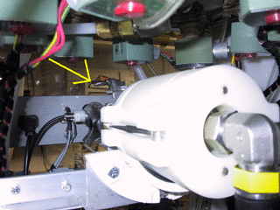
5b. Select option #2 to inform cpd that the ball valve is closed.
6. Release 8 white tubes with the quick connect/disconnect fittings, and disconnect the fitting at the elbow on the black tubing connecting the impactor to the carousel.
7. Place the carousel and a canister of filters (write start date on outside) in the glovebox, close the glove box and turn on the pump.
8. Back at the rack, disconnect fitting near valve so the impactor can be removed.

Change the impactor films
1. Wear gloves
2. Unscrew the black knobs and remove outer white sleeve. Make a note of the order of each section so that they can be put back in the correct order.
3. top section: clean out grease using methanol and Kimwipe; apply new grease
4. Section 2 (>10 μm particles): throw out film; clean section; spray a film from the plastic bag with silicon lubricant and place in holder with spacer ring on top
5. Section 3 (1-10 μmm particles): take out film with tweezers and place in old ‘S’ Petri dish. Clean section; Place new ‘B’ film on the stage, let sit for a minute and then return to ‘B’ Petri dish. This is the new ‘background’ film. Put new ‘S’ film on stage, place spacer ring on top and put impactor back together.
6. Place impactor back in rack.

Changing the filters
1. Take lid off carousel; black knobs first, then white knobs, turning knobs in counter-clockwise direction. (If you have difficulty doing this, try doing this outside of the glove box but put a note in the filter box when you do.)
2. Take out the red discs from the old container. Remove filters from carousel and stack in the old container in reverse numerical order (8 to 1), putting a red disc in between each filter. Put on the container cap and screw down.
3. Clean the carousel with alcohol. Place the new filter samples in the carousel, matching up the filter number with the carousel number.
4. Put top back on carousel, turn white knobs then black knobs
5. Put carousel back in the rack, attach the quick connects (orange-to-orange and black-to-black). Attach black hose to impactor.
6. Open Whitey valve by rotating handle 90 degrees clockwise so it is parallel to the flow.
7. Do a leak check (weather permitting) to make sure all fittings have been tightened
8. Type ‘<Alt><F>,<M>,<6>’ to end filter change and begin filter sampling, select option #2 to inform computer that the ball valve is open..
9. Record stop date on old sample container, put in box along with Petri dishes to mail to PMEL:
Theresa Miller phone: 206-526-6220
NOAA/PMEL email: Theresa.Miller@noaa.gov
7600 Sand Point Way NE
Seattle, WA 98115

System Leak Test - (Weekly Task)
Stations applicable: THD, BND
Time required: Approximately 10 minutes
Tools/supplies: Large white HEPA filter with 2” cup fitting
Overview: It is important to test the aerosol system for leaks to ensure that measurements are made on outside/conditioned air and not on inside air. Two diagnostics are used to test the aerosol system for leaks: the pressure drop and the CN counts. Note this is easier/quicker with 2 people – one person to place and remove the filter at the saddle port and one person to enter the observed values for pressure drop and CN counts.

DO NOT attempt this procedure during stormy weather; SAFETY FIRST!! ☺

Enter a log message <Control><M><enter> ”Starting leak check” <enter>.

At THD, turn off the humidifier heater and preheater.

Bring up the aerosol monitors window <Alt><A>.

Turn 3-way at CN inlet to ‘Neph’ position (i.e., it’s perpendicular to flow into the CN counter inlet).
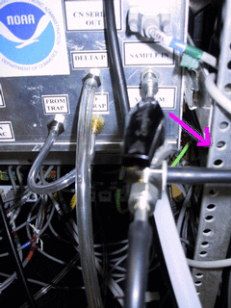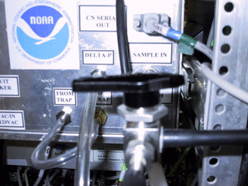

Enter a log message <Control><M><enter> “Ambient CN count= value; dp_Neph_imp= value” <enter>. (The CN counts value is in the lower left corner of the screen (below the aerosol monitor window) and the dp_neph_imp value is in the center of the screen (center bottom of the aerosol monitor window).)

Climb up to the saddle port at the base of the 8” PVC, undo the pins and remove the saddle port. Place the filter with the metal cup securely on top of the exposed 2” metal inlet stack.
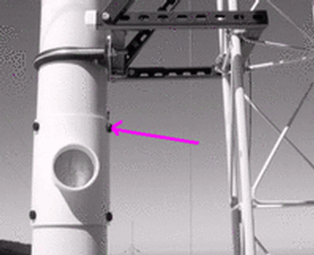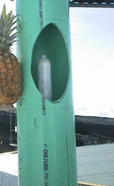

Enter a log message <Control><M><enter> “Filtered CN count= value; dp_Neph_imp= value” <enter>.
Acceptable ranges for these two variables when the filter is on the stack are:
dp_neph_imp > 20 CN_counts < 50
If the observed values are outside these ranges, there may be a leak in the system. A likely location to check is the connections on the impactors. If tightening those fittings doesn’t help, call the CMDL contact person.

Remove the filter and replace saddle on 8" PVC.

Return the CN counter value to Inlet position (i.e., parallel to CN inlet sample).

At THD, turn on the humidifier heater and preheater.

Nephelometer Span Check - (Weekly Task)
Stations applicable: BRW, MLO, SPO, THD, BND, SGP
Time required: Approximately 40 minutes
Tools/supplies: None
Overview: The nephelometer span check confirms that the nephelometer calibration is correct. The procedure is mostly automated, although the valve on the CO₂ tank needs to be manually opened and closed. At THD and SGP this procedure needs to be done when there is water in the humidifier, so it should be started between 15 and 30 minutes after the hour (based on the PC clock time)

Plumbing
The plumbing for a span check is as follows: CO₂ tank → Regulator→ Flow control Valve → Rotameter→ Copper tubing→ Plastic tubing→ Blue balston filter → neph. CO₂ inlet (wet neph inlet at THD)
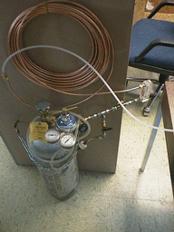

Operation
At THD, turn off the humidifier heater and preheater. (see above)
Open CO₂ tank valve

Press <Alt> <O><M><3> to begin span checks (at THD this will start span checks and CO2 flow through both nephelometers).
The computer will prompt you for CO2 tank pressure and flow rate and will notify you when the span check is over and display the calibration results. You will need to toggle between nephelometer windows to check both nephelometer’s span check results. Typing these sequences: <Alt> <N> and <Alt><O> a couple times each will take you to each nephelometer’s window and the corresponding span check results.
Conduct a second span check if the average deviation is more than 4% for either nephelometer.

Close CO₂ tank valve when finished.

At THD, when done with the span check, turn on the humidifier heater and preheater.

Changing Nephelometer Lamp
The CMDL scientist will let you know if this needs to be done. The nephelometer lamp usually last about six months. Typically, scientists watching the station data (lamp voltage and current) at CMDL can tell about a week ahead of time when the lamp is going to go. We like to change the lamp before it goes due to the possibility that when the lamp goes it could cause further damage to the nephelometer. Detailed instructions for changing the nephelometer lamp are given in the TSI nephelometer manual on page 8-13.

System Clock
The clock is synched automatically using the GPS unit.

Table 2 Difference between station local standard time (daylight savings) and UTC
STN | BRW | MLO | SPO | SMO | THD | BND | SGP/IAP
hrs diff | 9 | 10 | 0 | 11 | 8 (7) | 6 (5) | 6 (5)

Instant Messenger
A text based instant messenger system is available within CPD. This is useful for troubleshooting with one person at the field computer and one person in Boulder. To use the instant messenger, both the person in the field and the person back in Boulder need to be logged into the field computer and running cpdclient.

Then both people follow these directions:
Bring up the main aerosol system menu <M> or <enter>. Choose the option ‘Instant Messaging’ either by using the arrow keys or selecting <4> and hitting <enter> . Then choose <M> to get a box for typing in messages. Hit <enter> to send the typed message. When you are done with all the instant messaging, hit <W> to close the window.

Computer Operation

General
The computer runs the RedHat 9 distribution of the Linux operating system, with the kernel upgraded to version 2.4.22. The data acquisition and instrument control is done with a family of programs, collectively referred to as 'cpd', which uses a client-server architecture to separate the continuous operating tasks (acquiring data, writing to disk, controlling instruments) from the user interface tasks. The server is called 'cpd'. There are currently two clients, 'cpdclient' for text-mode display (i.e., the screen with windows displaying values for different measurement parameters), and 'cpx' for graphical (stripchart) display. The text-mode client allows the user to issue commands to 'cpd'.

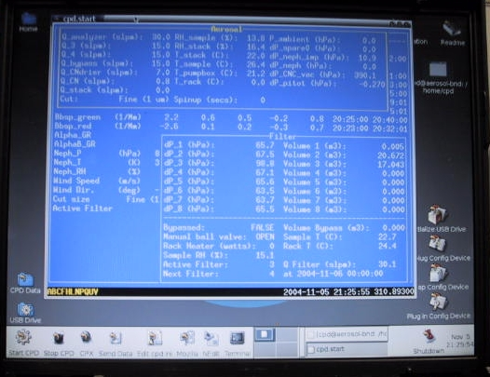 | 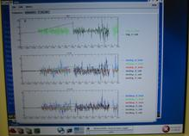
cpdclient (text mode) display  also called aerosol data logger window | graphical (stripchart) display

The system clock is set to UTC (6 hours different than Boulder time during daylight savings). The clock is synchronized with a network time server using the 'ntp' protocol. Some stations (THD, MLO, SMO, IAP) have a GPS receiver directly connected to the computer, in which case the GPS serves as the time standard. The system clock is displayed in the lower right corner of the Aerosol Data Logger window.

Instruments are connected to the computer via RS-232C ports.

Startup
This assumes you have a USB stick which is already initialized and a LiveCPD CD. The CD contains everything you need to run CPD on the computer, while the initialized USB stick contains station specific configuration information (e.g., the cpd.ini file) and, depending on configuration, the USB stick may also be the location where data is stored. (Currently, at all of our long term stations, data is stored on the hard drive of the computer rather than the USB stick.)

Insert USB stick in USB port (either on back of computer or in edgeport module)
Turn on PC.
After a few minutes, the NOAA/CMDL aerosol data logger window will appear.
There are eight icons in the toolbar at the bottom left of the screen. The shutdown icon is the ninth icon at the very far right of the screen. Position the mouse over each one to see its function.
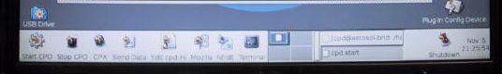

These functions, from left to right, are:
- Start data logger – the CPD program
- Stop data logger
- Stripchart data – the CPX program
- Send data to CMDL
- Edit the cpd.ini file (using Nedit)
- Web browser
- Nedit – which brings up a simple text editor window
- Icon to bring up a terminal window
- Shutdown everything!

To choose an action, click ONCE on the icon.

During normal operation you should never need to select 1 because the data logger starts up automatically when the computer is turned on. Number 4 also happens automatically, with a frequency between 1 and 4 times per day (you get an automatic email each time data is sent to CMDL and processed).

If for some reason you did need to start cpd and the data logger, here’s the scoop:
To start the data acquisition program, click on the “Start cpd” icon. This will start 'cpd' in a background window, and several seconds later starts 'cpdclient' in the terminal window.
To start the graphical client 'cpx', click on the “Stripchart data” icon. This takes a little while to get started so don’t keep clicking if it doesn’t start right away!! To stop data acquisition and shut everything off, click on the “Shutdown” icon. The “Shutdown” icon will ask whether you want to shut everything down, reboot or cancel the request to shutdown.

These programs can also be started from a command line in a terminal window by typing one of the following commands:
cpdclient - starts the text mode client
cpd.start - starts both the server and text mode client
cpd.kill - kills the server
cpx - starts the graphical client (X-windows only)

Shutdown
Terminate the data acquisition software by clicking on the “Shutdown” icon.
Click on the “Main Menu” icon, then click on the “Log out” icon.
On the login screen, click on “System” and then “Halt”.
Wait for the computer to display “Power down.”.
Turn off power.

Archiving and Backing-up Data
Note: This is typically done automatically, these steps are needed only if manual archiving is required. The data archives are standard “ZIP” format. The data files are plain ASCII, tab-delimited, with headers. “A*.TXT files contain 1-minute averages. “M*.TXT” files contain snapshots (every 22.5 minutes) of system status info.

Saving to hard disc
If up-to-the-minute data are desired, press <Control> <M><2><2> in Root Menu to close current files and start new files.

Other desktop icons
In the lower left hand corner of the desktop above the toolbar there are two icons.
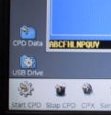
Clicking once on the CPD data icon opens a window with the file directory in which the current data is being logged. (Equivalent to /aer/stn/log).

If you need to transfer data or something from the field computer to a windows compatible USB stick, insert the USB stick into the USB port on the back of the computer or in the Edgeport device, and click once on the USB drive icon. This will bring up a window with the directory structure of the USB stick. (Note: you may need to refresh the directory window if a different USB stick had previously been inserted.) When you are done with transferring data (or whatever) remove the USB stick – the system will automatically dismount within 30 seconds or so. The USB icon has a little dot on it while the USB stick is mounted and the dot goes away when it automatically dismounts.

LiveCPD Documentation
There are icons on the upper right hand corner of the desktop documenting how this all works.
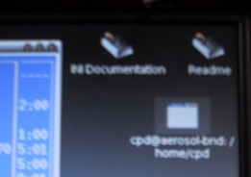
The INI Documentation icon opens a text document describing how to set up a cpd.ini file. The README icon describes the LiveCPD application in gory detail – how to configure the USB stick, more detailed descriptions of all the icons, etc. The documentation also explains the use of the icons in the lower right of the desktop.

Graphical Client Program (cpx)
The graphical client is a work in progress. Please send suggestions for improvement to John.A.Ogren@noaa.gov. Documentation for cpx can be viewed by clicking on the “Help” item on the cpx menu bar. This graphical interface allows you to see what’s happening with the data over time, so you could use it to watch CN counts get much lower when you put the leak test filter on the stack.

Aerosol Data Logger Program

General Operation
Press <Ctrl-M> to access menus, <Esc> to abort from any menu or entry box without any changes, <Enter> to accept the current entry or highlighted item. Any instrument window can be displayed by the shortcut key <Alt-X>, where “X” is the code letter for the desired instrument. Windows are closed by pressing the <W> key. Pressing the <Tab> key cycles the view among all the active windows. Windows can be repositioned on the screen using the arrow keys.
Menu entries can be selected with the arrow keys or pressing the numerical digit for the desired selection.

The program will request an access code if you select a menu item that will result in a change to the data being logged to disk, in order to prevent inadvertent changes. The access code is ‘cmdl’ (lowercase is necessary).

Keystrokes | Action
<control> <M> | Shows root menu
<esc> | Shows root menu and hides root menu
<alt> <X> | Selects root menu entry ‘X’ when root menu is not focused (X can be A,B,C,F,G,H,L,M,N,O,S,U,V,W)
<control><D> | Disc operations menu
<control><M><enter> | Online log entry (message window)
<F12> | Online log entry (message window)
<control><E> | Toggles error window
<control><C> | Quit cpdclient
<M> | Shows menu for active window
<control> <W> or <W> | Closes active window
<tab> | Cycles through open windows
Arrow keys (in menu) | Move thru menu list
Number/letter (in menu) | Quick select on menu list
Keystrokes | Action
<enter> (in menu/dialog box) | Chooses or toggles selected item
<enter> (dialog box) | Begins enter input mode, text will be bolded; pressing <enter> again will end input mode
<control><W> (in menu) | Cancels selection
<esc> or <control><W> | Exits menu/dialog box without applying changes
<enter> (with bottom entry selected in dialog box) | Closes dialog box and applies all changes
<enter><enter> | Brings up message window

Display
The “base” display consists of a “root” window for displaying current values for ambient measurements and a status line at the bottom left of the screen.
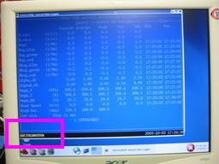 ←status line location (in pink box) in root window
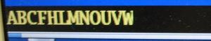 ←status line

The bottom status line gives the code letters of the active instruments and the system date and time. If the code letter for an instrument is absent, then that instrument is not present or not responding.

The code letters are assigned in cpd.ini, and vary from station to station. Status windows for specific instruments can be displayed by pressing <Alt> plus the code letter for that instrument. Not all windows are operative at every station. Commonly-used code letters are:

Normal operation for a complete aerosol system is indicated by the code letters ABCFHLMNOUVW which are interpreted as follows:
A – aerosol data system active and logging enabled
B – Best UPS active and logging enabled
C – CN contamination control algorithm active (not logged)
F – Filters active and logging enabled
H – Humidograph active and logging enabled
L – PSAP active and logging enabled
M – system monitor file logging (always present)
N – nephelometer (reference/dry) active and logging enabled
O – nephelometer (humidified/wet) active and logging enabled
U - μMAC1050 A/D I/O subsystem active
V - μMAC1050 A/D I/O subsystem active
W - Watlow PID controller active

Root Menu <Control><M> or <esc>
Pressing <Esc> or <Control><M> brings up the root menu, with the following choices (shortcut keys are in the left column). Use the arrow keys to highlight the desired action and then press <Enter>:

 | Online log entry | allows the user to make an entry in the system log file. Think of this as an on-line logbook, and use it liberally. Each entry can be at most 80 characters long, and each entry is recorded with a time stamp. Please make an entry for any deviations from normal operation, such as exceptions that you note on the daily checksheets. These logbook entries will be sent to the CMDL aerosol group by email shortly after the data are sent to Boulder.
1 | Client Options | controls some features of the client program.
2 | Disk operations | allows the user to flush any buffered data to disk, and to change to a new set of data files
3 | Save Window Setup | Saves layout of windows if you have a set up you like
4 | Instant Messaging | Starts Instant Messenger
A | Activate the aerosol status window | 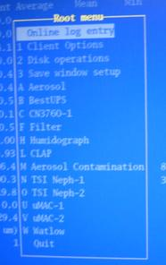
B | Activate the Best UPS status window
C | Activate the CNC status window (shows current concentration)
F | Activate the filter status window
G | Activate the GPS status window
H | Activate the humidograph status window
L | Activate the PSAP status window
M | Activate the Aerosol contamination window
N | Activate the nephelometer status window (Typically this is the ‘dry’ or ‘reference’ neph.)
O | Activate the second neph status window (Typically this is a ‘wet’ or ‘humidified’ neph.)
U | Activate the umac status window (This is the main umac.)
V | Activate the 2nd umac status window (This is the umac that typically controls the filter carousel.)
W | Activate the Watlow status window (The Watlow controls things like temperature and relative humidities.)
 | Quit | exit the client program

Aerosol Status Window and Monitor Menu <Alt><A><M>
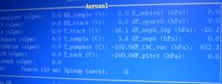 The aerosol status window shows the values of monitoring parameters like temperatures, humidities, pressures flows and sampling size cut (1 or 10 um). | 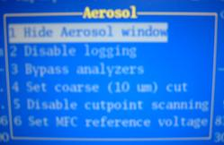 The aerosol menu allows you to disable logging, bypass the instruments, set the cut size, disable cut-size switching and change the reference voltage of the mass flow controllers.

Window hide/Window unhide <1> changes visibility of status window

Logging end/ Logging start <2> context-sensitive function to enable/disables logging of aerosol parameters

Analyzers bypass/Analyzers unbypass <3> context-sensitive function to bypass/unbypass the continuous analyzers

Cut coarse/Cut fine <4> context-sensitive function to toggle between sub 10 μm and sub 1 μm cut size

Scanning cut points <5> turns off switching between impactor size cuts

Analyzer flow <6> goes to menu for controlling flow thru instruments (e.g., mass flow controller). 1 volt corresponds to 10 lpm; the typical setting is 3 V to get 30 lpm. (This option is only used on aircraft systems.)

Nephelometer Status Window and Menu <Alt><N><M> or <Alt><O><M>
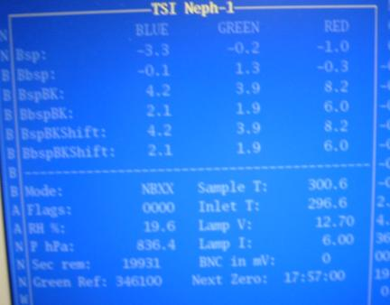 | This window shows the current state of the nephelometer, including measured light scattering and back scattering at 3 wavelengths, neph monitoring parameters like temperature and voltage and neph state.
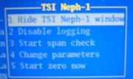the neph menu allows the user to do a span check and change neph parameters. | 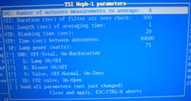 | The neph change parameters menu lets the user talk directly to the neph and affect its operating conditions.

Window hide/Window unhide <1> changes visibility of status window

Logging end/ Logging start <2> context-sensitive function to enable/disables logging of nepholometer parameters

Span Check /Abort Span Check <3> context-sensitive menu to start/abort a CO₂ span check.

Change parameters (formerly ‘Send command’ <4> Activates a menu for sending selected commands to the nephelometer. Not normally used except for troubleshooting.

Start Neph zero <5> starts neph zero

PSAP Menu <alt> <L><M>
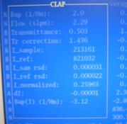The CLAP window shows the light absorption flows, transmittance through the filter and various other monitoring parameters. | 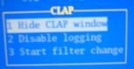the CLAP menu is used to disable logging of absorption data and to note when a filter change takes place.
Window hide/Window unhide <1> changes visibility of status window

Logging end/ Logging start <2> context-sensitive function to enable/disables logging of PSAP parameters

Start filter change/ End filter change <3> Context-sensitive menu to start/end a filter
Use this function to prevent data logging during a PSAP filter change, and to generate automatic log file entries when PSAP filters are changed.

Filters Menu <Alt> <F><M>
Window hide/Window unhide <1> changes visibility of status window

Logging end/ Logging start <2> context-sensitive function to enable/disables logging of filter parameters

Filters bypass/Filters unbypass <3> context sensitive function to allow manual bypassing of filter samples

Heater power <4> Set in watts

Q Filter Flow <5> goes to menu for controlling flow thru instruments (e.g., mass flow controller). 1 volt corresponds to 10 lpm; the typical setting is 3 V to get 30 lpm. (Only used on aircraft systems.)

Filter change <6> context-sensitive function to notify system that the filters will be changed. Changes to “Filter start” when changing..

Humidograph Menu <Alt> <H><M>
Disable/enable scanning <1> start or stop the humidifier from humidifying

Window hide/Window unhide <2> changes visibility of status window

Change Setpoint <3> displays submenu for changing setpoints manually

Set Channel A <A> Sets RH set point of reference nephelometer

Set Channel B <B> Sets RH set point of humidified nephelometer

Set Channel C <C> Sets pump direction and speed. (range between -20 and 100)
0 = not pumping
15 = pumping water at 15% power into humidifier
-20 = pumping water backwards out of humidifier at 20% power

Set Channel D <D> Sets whether the high-range flow valve is open (H) or closed (L).

Safety

Heater Control
If the pump fails, any of the heaters (stack, humidifier rack inlet, preheater, humidifier, filter rack inlet) could overheat because the PID sensors don’t have flow past them. There is a high-temperature cut out switch on the heaters, which limits the temperature on the outer tube to about 80 degrees Celsius.

Electrical Safety
We have insulated the electrical connections inside the rack, so that it is safe to perform standard tasks inside the rack (e.g., changing impactor films) with the power on. However for non-standard tasks (e.g., replacing the humidifier), you should always remove power from the rack and the instruments you are working on..

Specifications

Power Draw at 115 V DC
Equipment | Draw (A) | Surge (A)
Carbon vane pump | 8.6 | 20
Diaphragm pump | 2.4 | 12
Bypass blower | 1.3 | 3
Cooling fan | 2.7 | 3.5
Aerosol System | 9.0

Additional Computer info

Data flow
The 'cpd' server logs data in the /aer/stn/log directory, where "stn" is the identifier of the station. Every six hours (or 24 hours), the current data are archived in a zip file, for subsequent transmission to CMDL in Boulder. The program that does the archiving is /aer/prg/cpd/cpd.archive, which is scheduled to run by the cron daemon. The configuration file for cron is /aer/prg/crontab/crontab.stn. The archived data are stored locally in the /aer/stn/log/sent directory. In Boulder, the data are initially put in the /ftp/incoming/aer/stn directory on the ftp.cmdl.noaa.gov server.

Aerosol Server Program (cpd)
Operation of cpd is controlled by a plain-text configuration file /aer/prg/cpd/etc/cpd.ini. Configuration information for different stations are contained in separate files; for example, the SPO configuration file is /aer/prg/cpd/etc/cpd.ini.spo. Normally, cpd.ini is a symbolic link file that points to the station-specific configuration file. Detailed information on the entries in cpd.ini can be found in /aer/prg/cpd/usr/doc/cpdini.txt.

The server program is designed to run as a daemon, which means that the user does not directly interact with the program. It is started with the 'cpd -d' command, and terminated with the 'cpd.kill' command. To verify that the server program is operating, type 'cpd.ps' from a command prompt. This will display the processes associated with the cpd program.

User account
The computer is configured to automatically log into the 'cpd' user account, which is used for running the cpd program at field stations.

Location of this document
This document is stored in /aer/doc/ops_man/oper_man_gen_cpd.doc.

Station specific appendix

