INSTRUCTIONS FOR THE 32A SERIES MICROPROCESSOR BASED TEMPERATURE/PROCESS CONTROLLERS

This document contains information on the Love PID controllers used in the NOAA Aerosol Systems. Instructions are provided for resetting the controllers to factory default values (in the event of a controller failure), and the proper settings for the Primary, Secondary, and Secure Menus are provided for both the heater and flow PID controllers. The heaters are controlled by PIDs #1, #2, and #3. These PIDs, with a minor configuration change, can also be used to control humidifiers. The flow is controlled by PID #4.

Settings for PID Controllers should be as shown in the sections below, unless otherwise noted. You may see some other parameters listed in your PID menus, but if they are not specifically listed below, they are not applicable and can be ignored.

PID Manufacturer
Dwyer Instruments
Love Controls Division
P.O. Box 338
Michigan City, IN 46361-0338
(800) 828-4588
(219) 879-8000
Fax: (219) 872-9057
www.love-controls.com

Heater PID Model number: 32A123-992

Flow PID Model number: 32A050-992

Resetting the controller: This should be done if any strange messages (e.g., FAIL tESt) appear on the controller display)

- 1. Turn off power to controller
- 2. Turn on power to controller
- 3. While controller is performing SELF tESt, press and hold the INDEX and
- ENTER keys.
- 4. The controller will display the ROM ID code. Press INDEX.
- 5. The controller will display FACt dFLt. If you wish to just restore factory settings, Press ENTER and DOWN ARROW at the same time. The
- controller will be reset to the original factory settings.
- 6. Press INDEX to display ACPt. Select YES or no.
- YES Changes are accepted and control re-boots.
- no Changes are discarded and control re-boots.

PRIMARY MENU (HEATER PID CONTROLLERS #1, #2, AND #3)

Press INDEX to advance to the next menu item. Press UP ARROW or DOWN ARROW to change the value in the display. Press ENTER to retain the value.

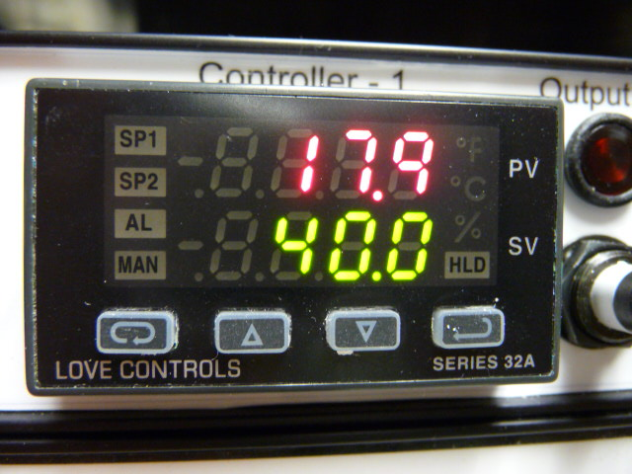
The top value (red numbers) is the measured value. The bottom value (green numbers) is the set point.
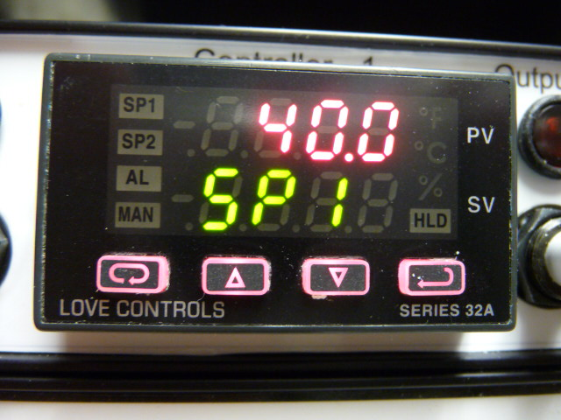
This is where you adjust the set point. Press UP or DOWN arrows to adjust. Press Enter to retain value.
Here the top red number is the desired setpoint.
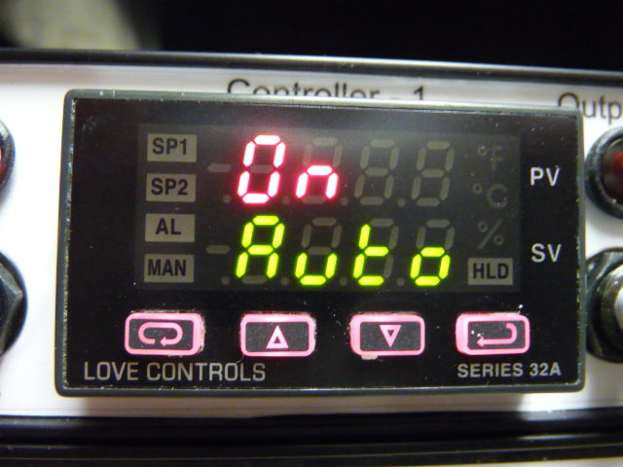
Set Auto to “On”.

SECONDARY MENU (HEATER PID CONTROLLERS #1, #2, AND #3)

To get to the Secondary Menu, press the UP ARROW and ENTER buttons at the same time. Press INDEX to advance to the next menu item. Press UP ARROW or DOWN ARROW to change the value in the display. Press ENTER to retain the value. Settings for PID Controllers should be as follows, unless otherwise noted. You may see some other parameters listed in your PID menus, but if they are not specifically listed below, they are not applicable and can be ignored.

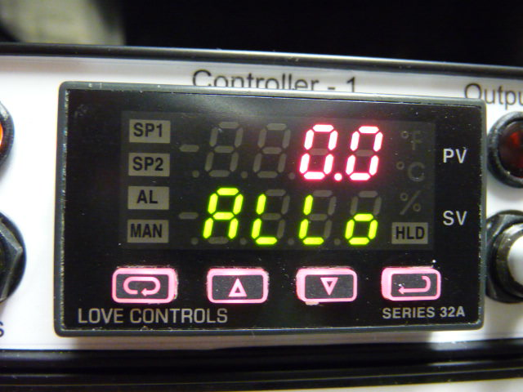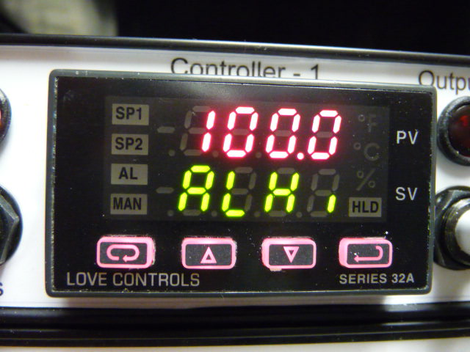

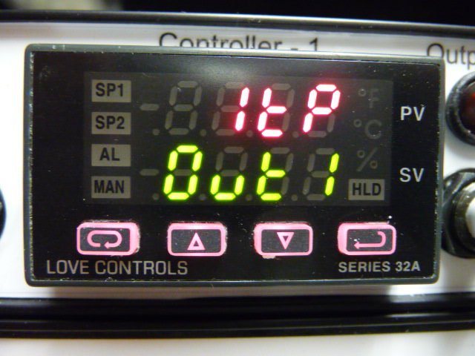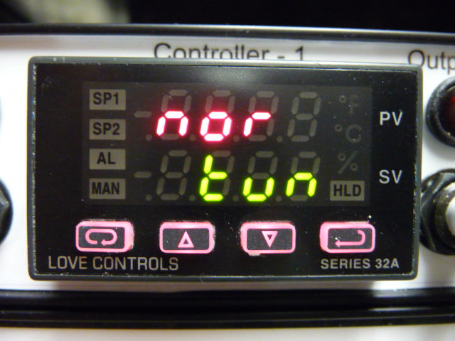
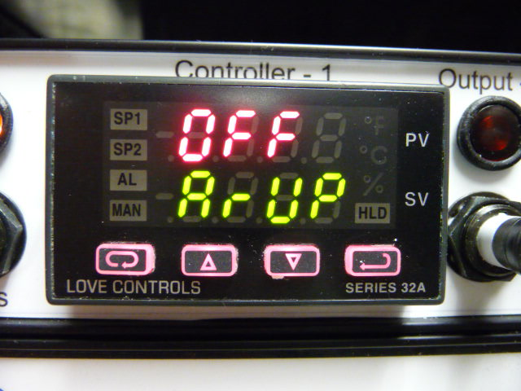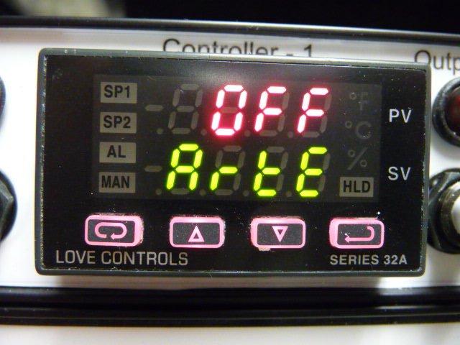
SECONDARY MENU (HEATER PID CONTROLLERS #1, #2, AND #3, continued)

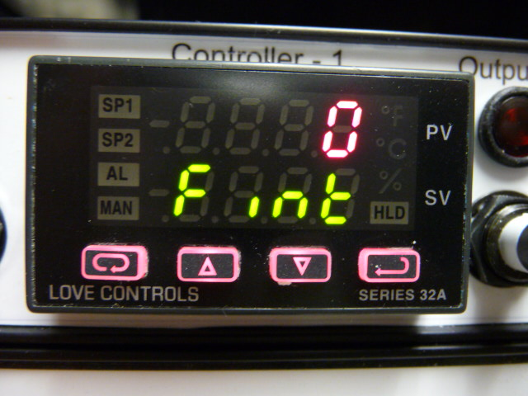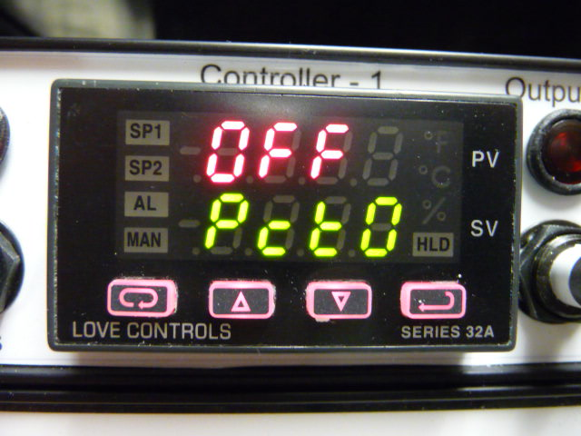
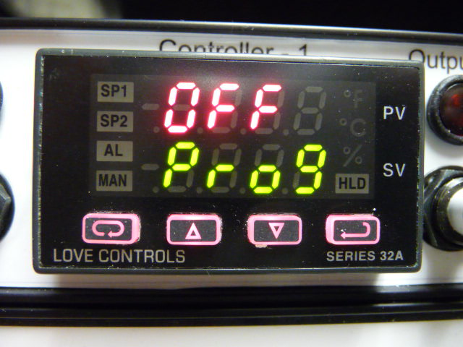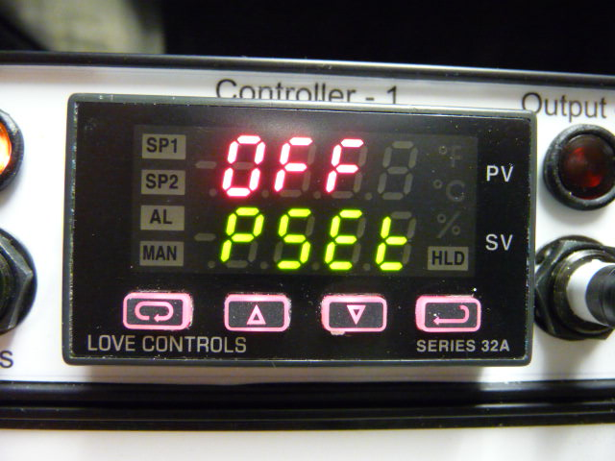
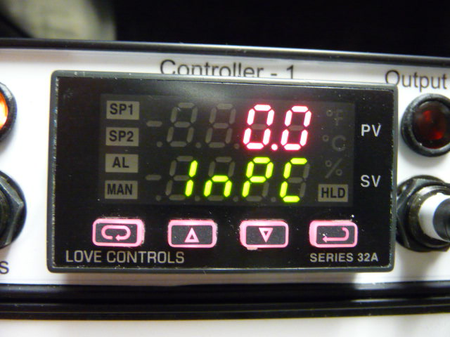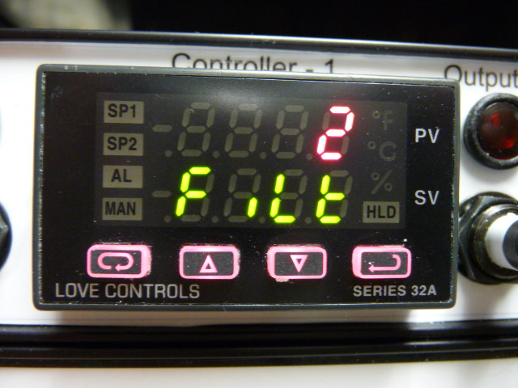
SECONDARY MENU (HEATER PID CONTROLLERS #1, #2, AND #3, continued)

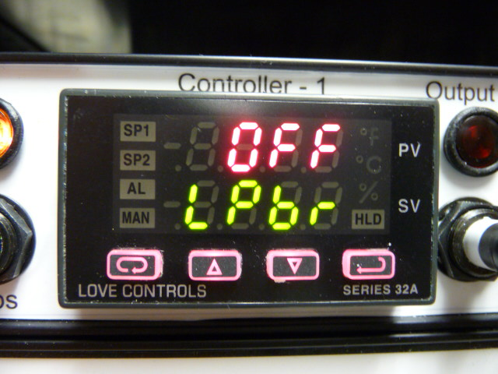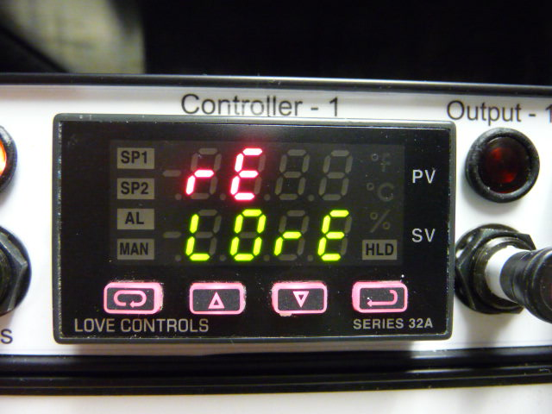
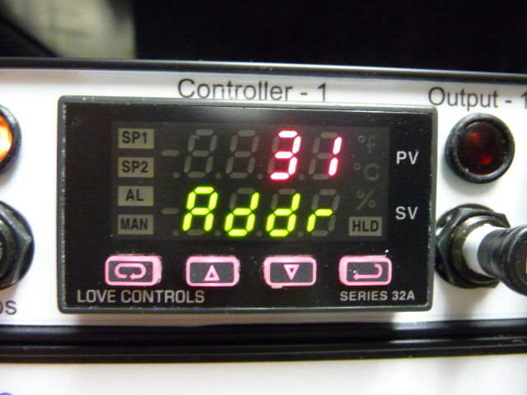
This Address value should read “31”, “32”, or “33”, depending on the position of the controller in the PID box.
SECURE MENU (HEATER PID CONTROLLERS #1, #2, AND #3)

To get to the Secure Menu, press and hold the UP ARROW and ENTER buttons for 5 seconds. Press INDEX to advance to the next menu item. Press UP ARROW or DOWN ARROW to change the value in the display. Press ENTER to retain the value.

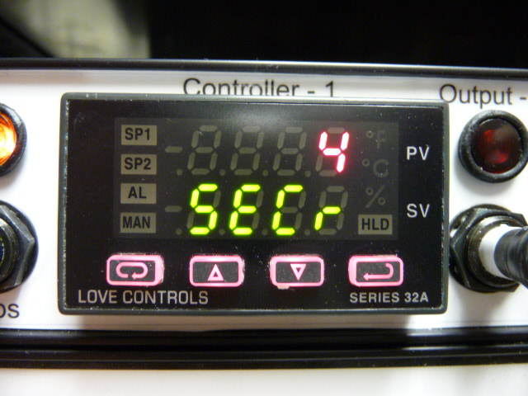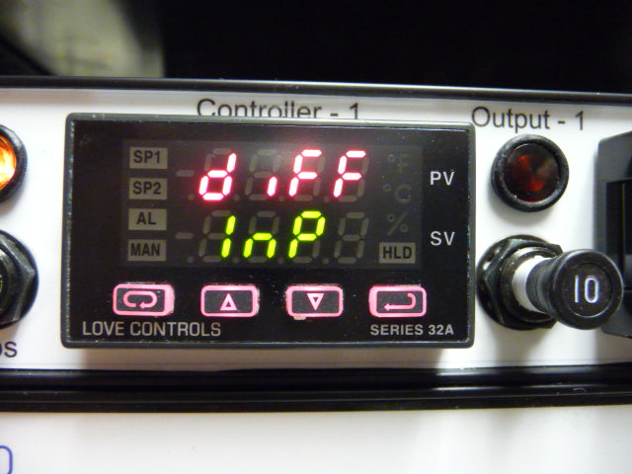
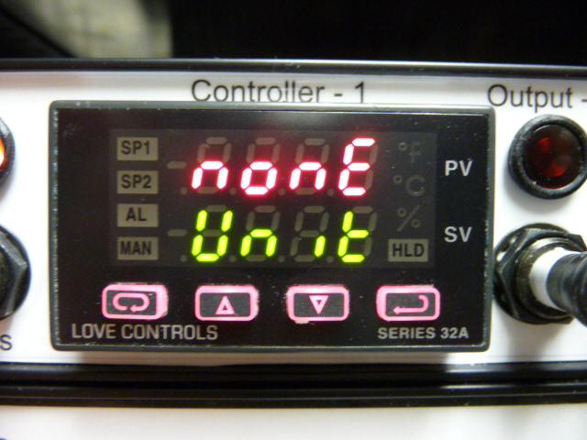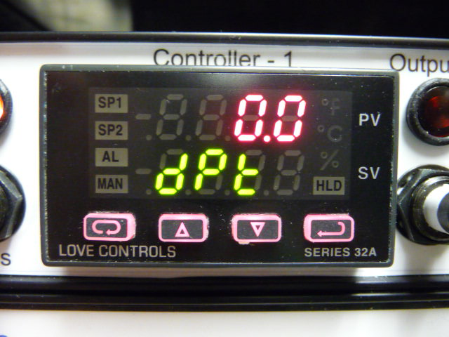
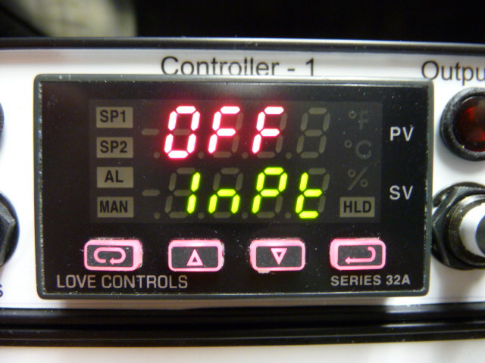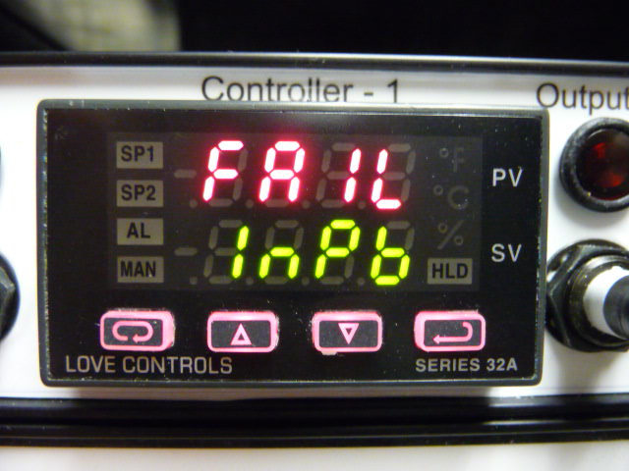
SECURE MENU (HEATER PID CONTROLLERS #1, #2, AND #3, continued)

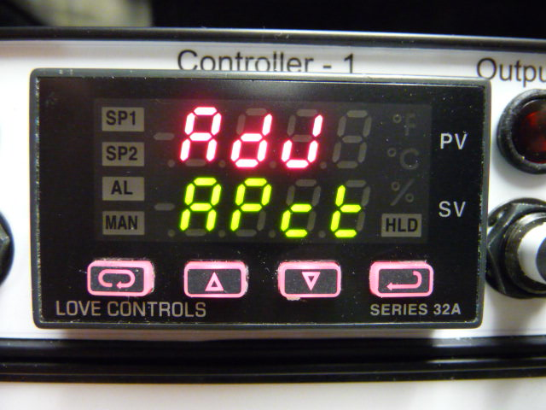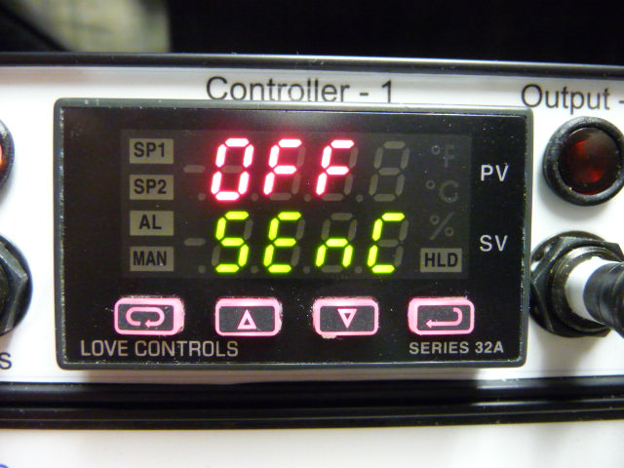
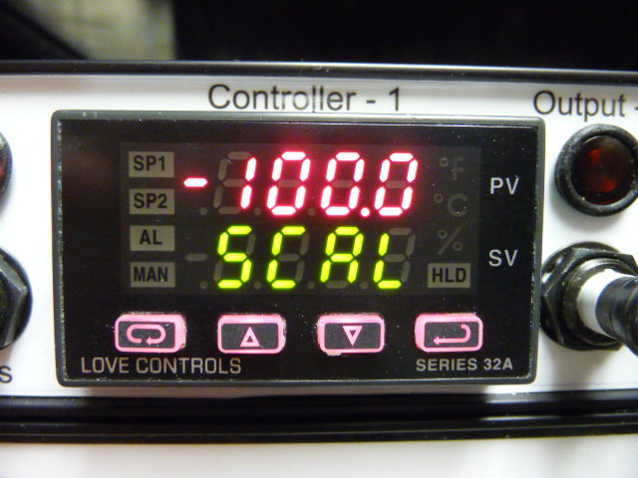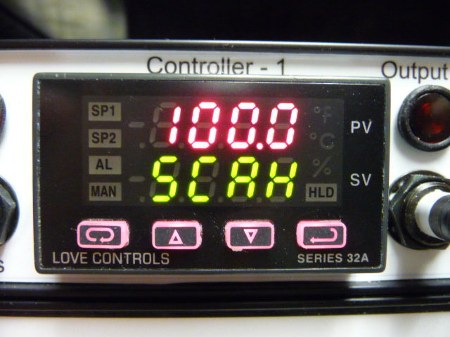
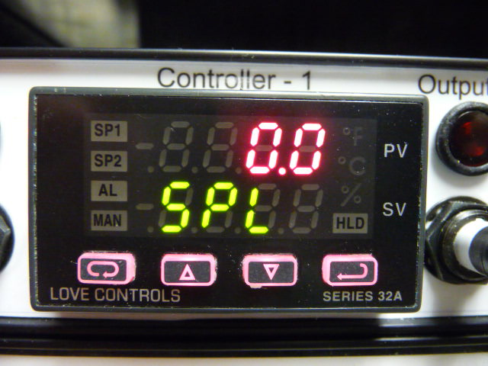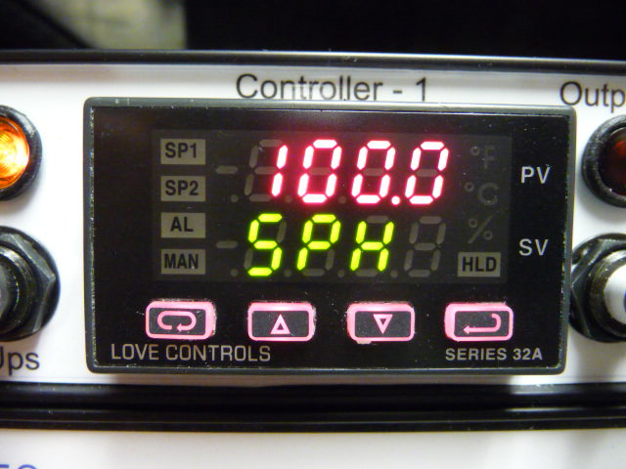
SECURE MENU (HEATER PID CONTROLLERS #1, #2, AND #3, continued)

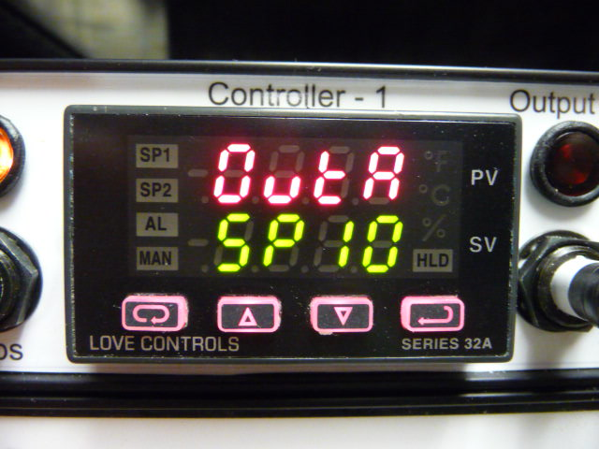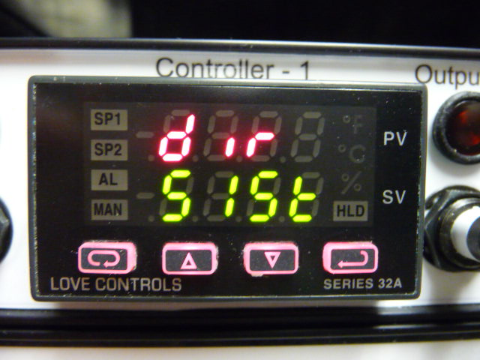
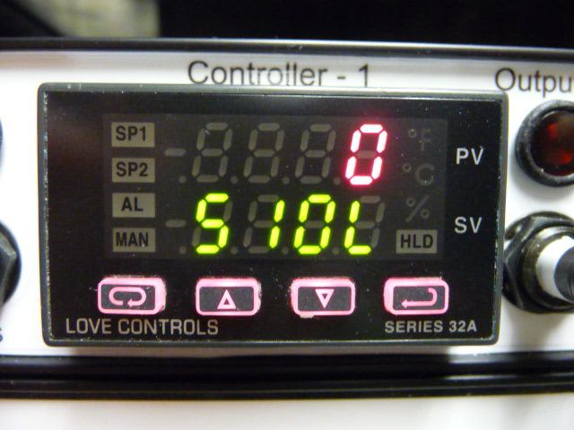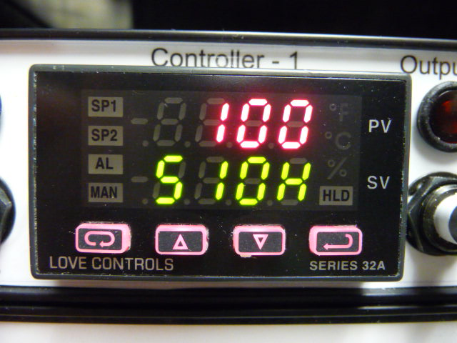
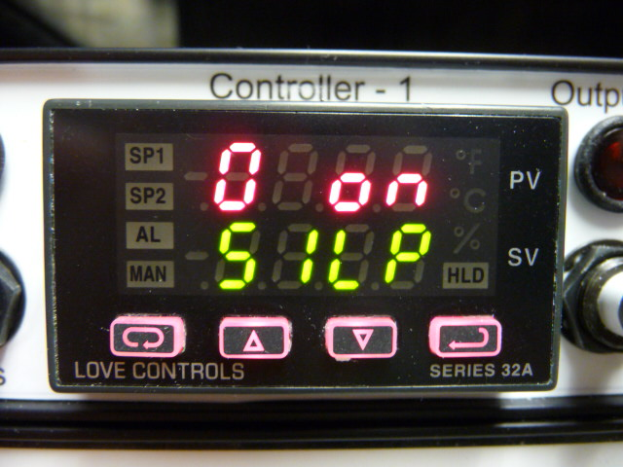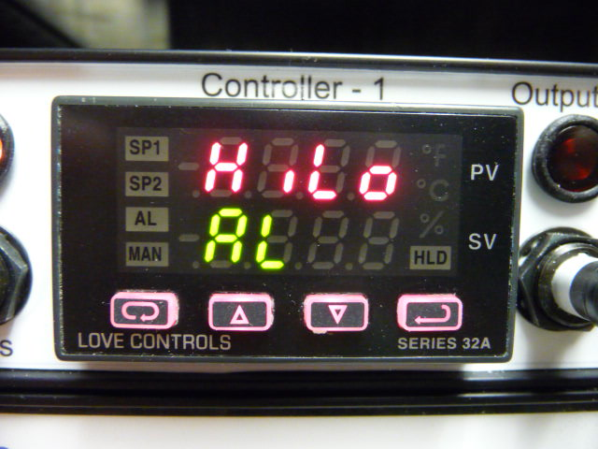
SECURE MENU (HEATER PID CONTROLLERS #1, #2, AND #3, continued)

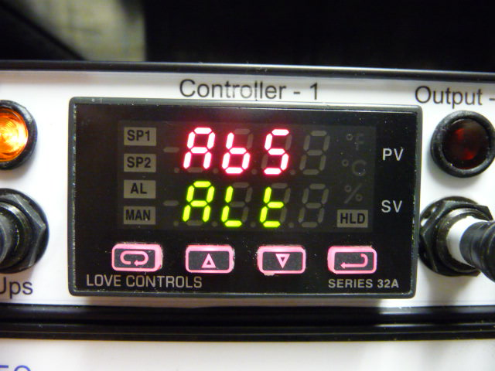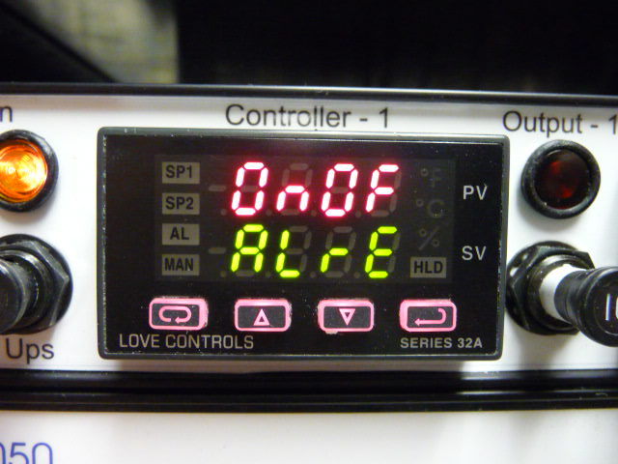
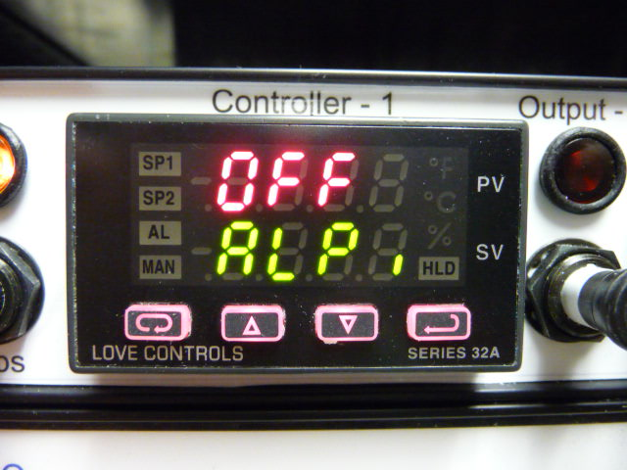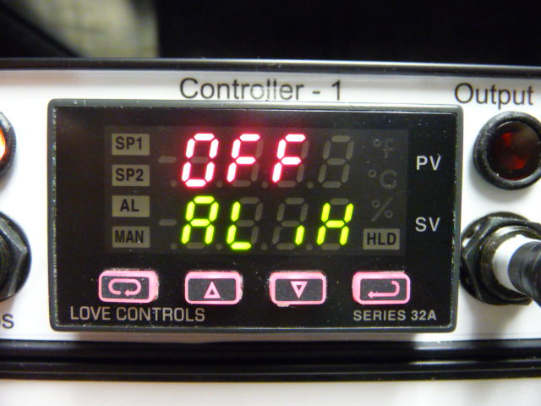
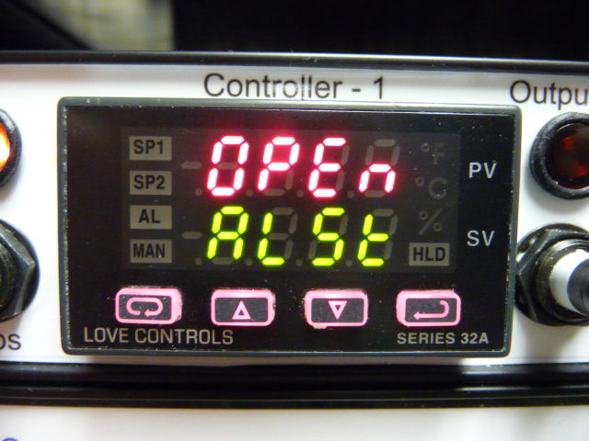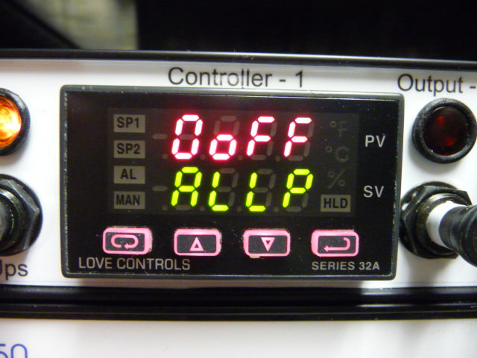
SECURE MENU (HEATER PID CONTROLLERS #1, #2, AND #3, continued)

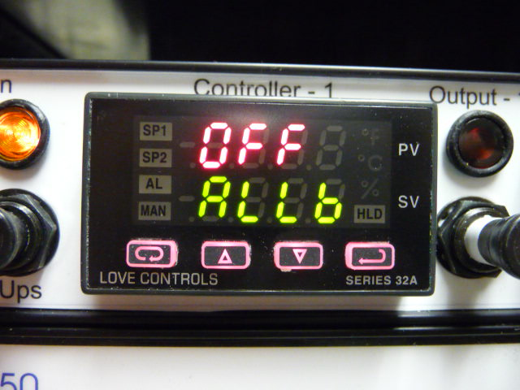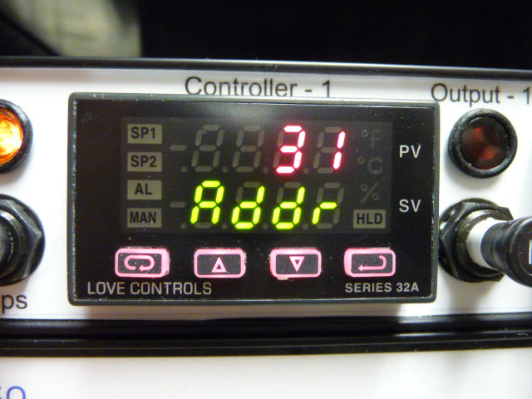
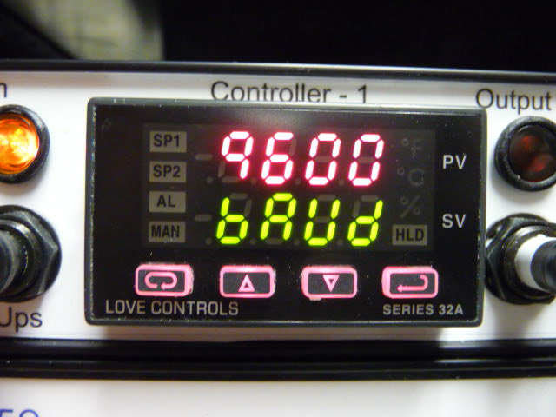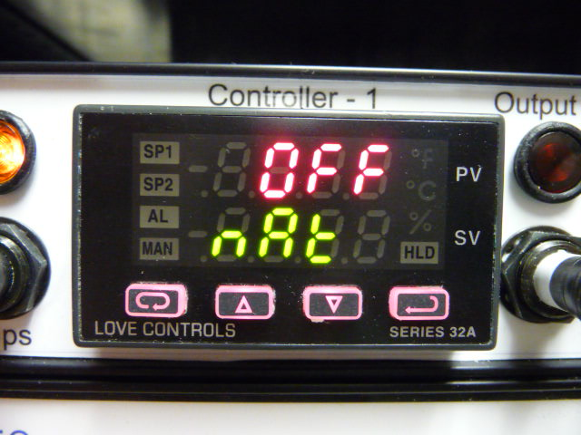
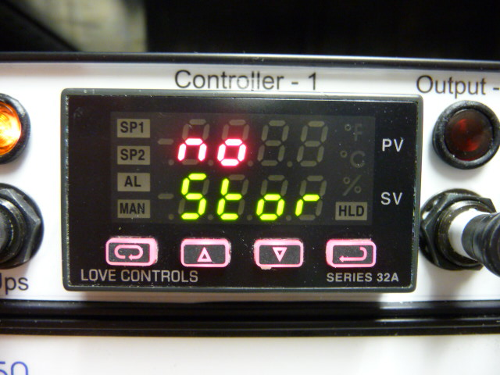
This Address value should read “31”, “32”, or “33”, depending on the position of the controller in the PID box.
PRIMARY MENU (FLOW PID CONTROLLER #4)

Press INDEX to advance to the next menu item. Press UP ARROW or DOWN ARROW to change the value in the display. Press ENTER to retain the value.

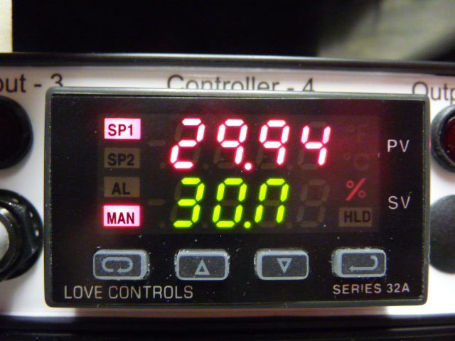
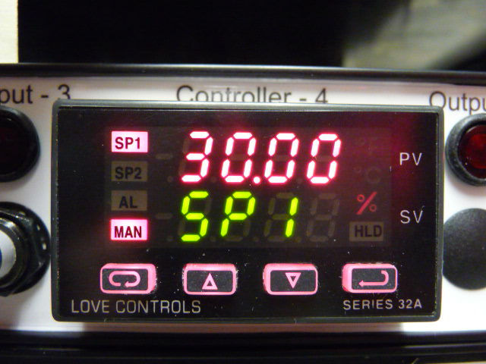
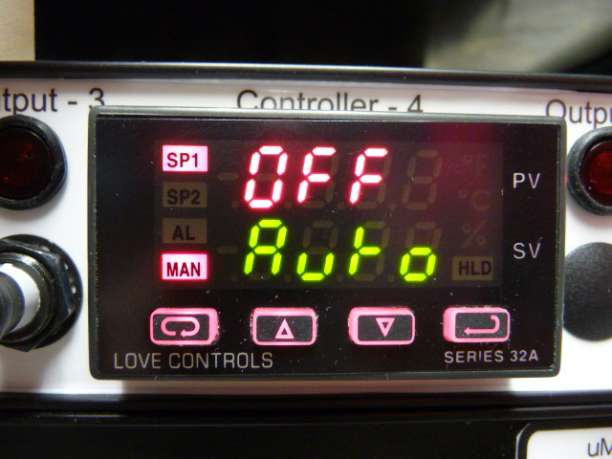
Auto should be set to “OFF”.
SECONDARY MENU (FLOW PID CONTROLLER #4)

To get to the Secondary Menu, press the UP ARROW and ENTER buttons at the same time. Press INDEX to advance to the next menu item. Press UP ARROW or DOWN ARROW to change the value in the display. Press ENTER to retain the value. Settings for PID Controllers should be as follows, unless otherwise noted. You may see some other parameters listed in your PID menus, but if they are not specifically listed below, they are not applicable and can be ignored.

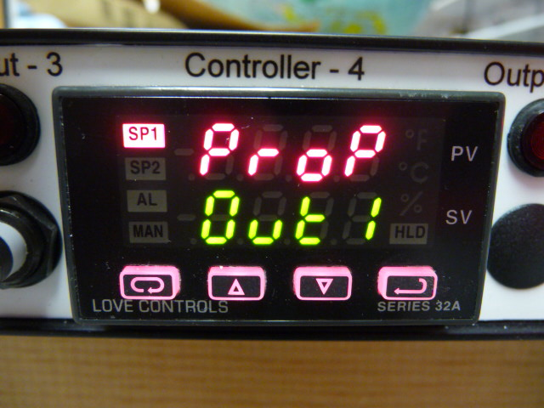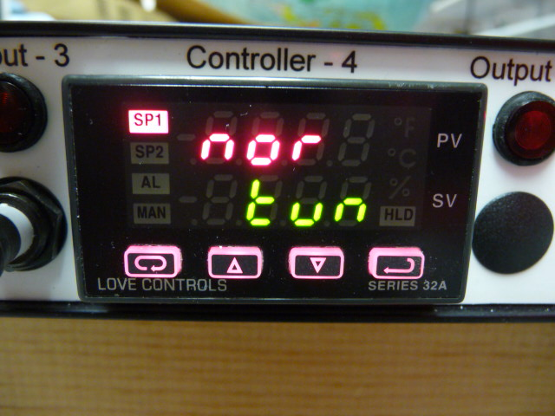
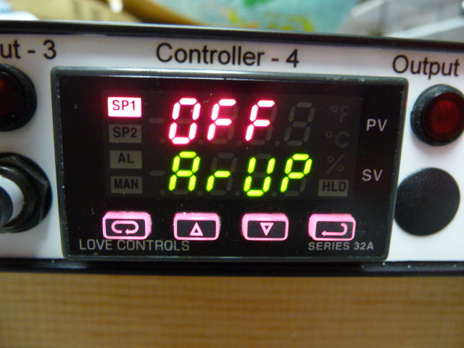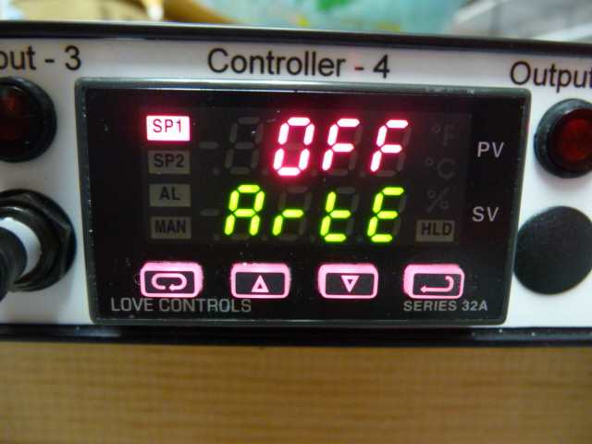
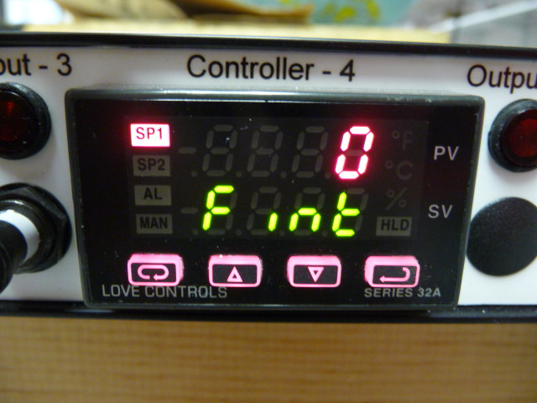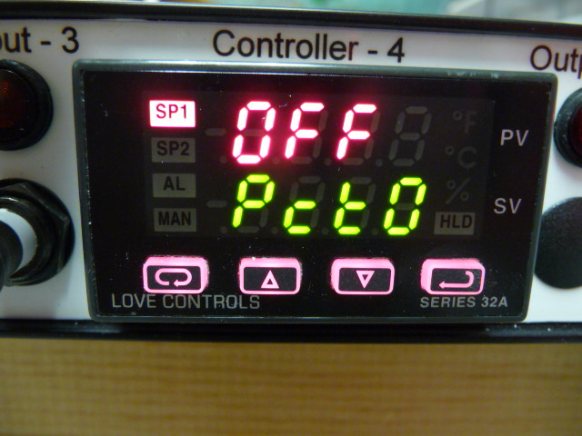
SECONDARY MENU (FLOW PID CONTROLLER #4, continued)

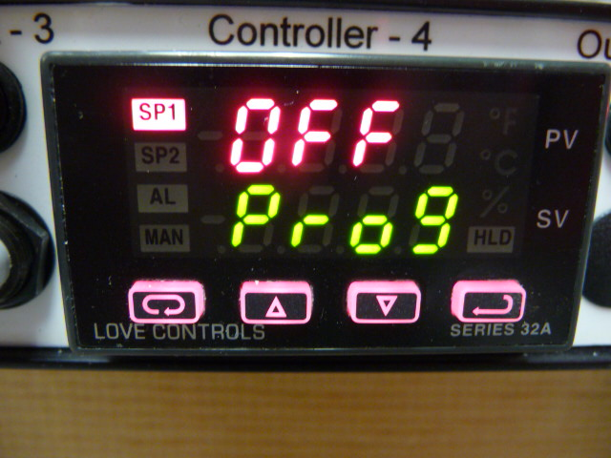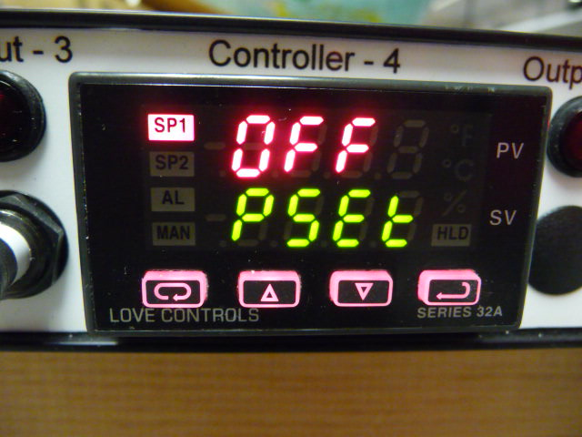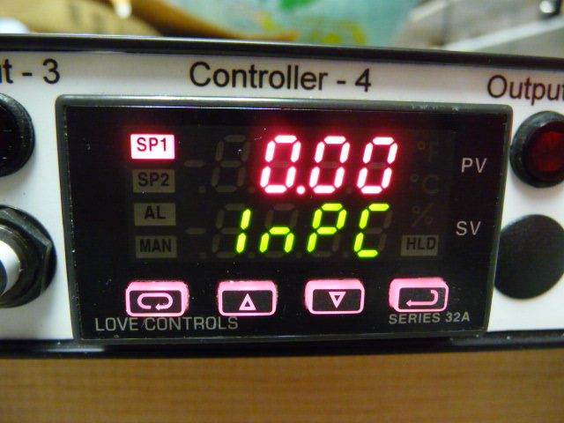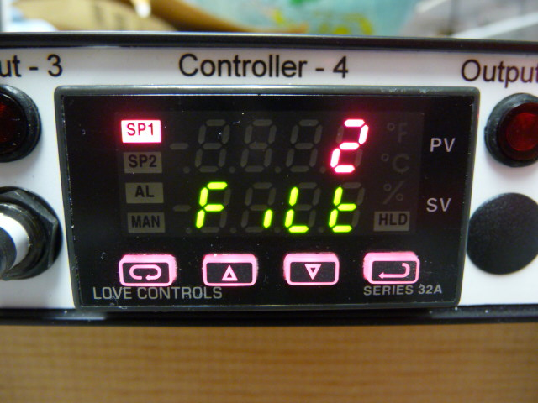
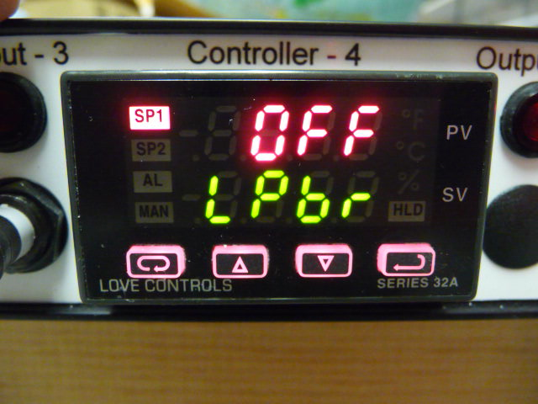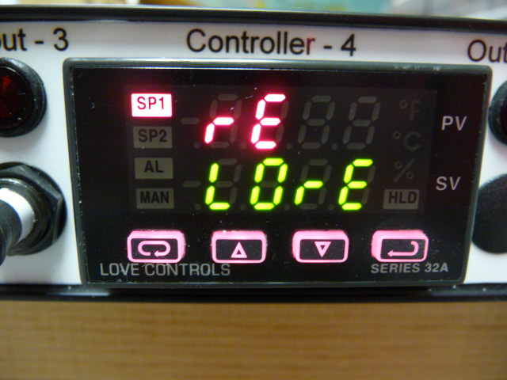
SECONDARY MENU (FLOW PID CONTROLLER #4, continued)

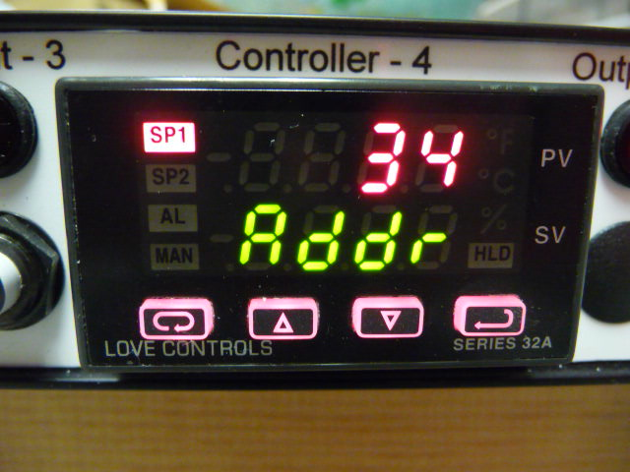
SECURE MENU (FLOW PID CONTROLLER #4)

To get to the Secure Menu, press and hold the UP ARROW and ENTER buttons for 5 seconds. Press INDEX to advance to the next menu item. Press UP ARROW or DOWN ARROW to change the value in the display. Press ENTER to retain the value.

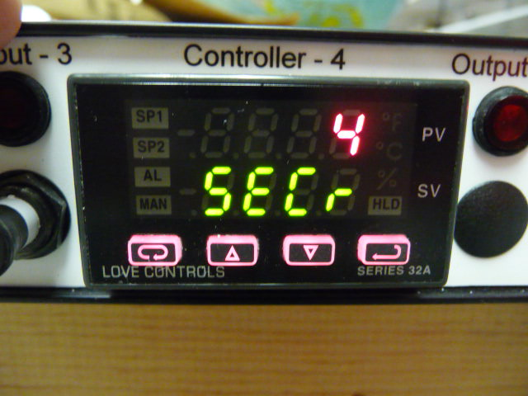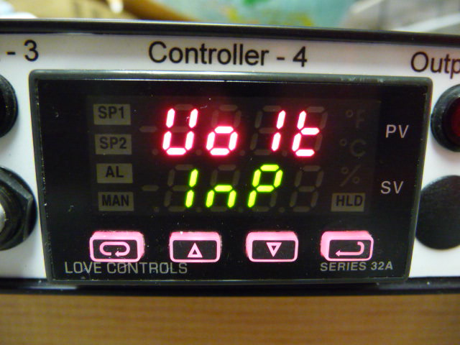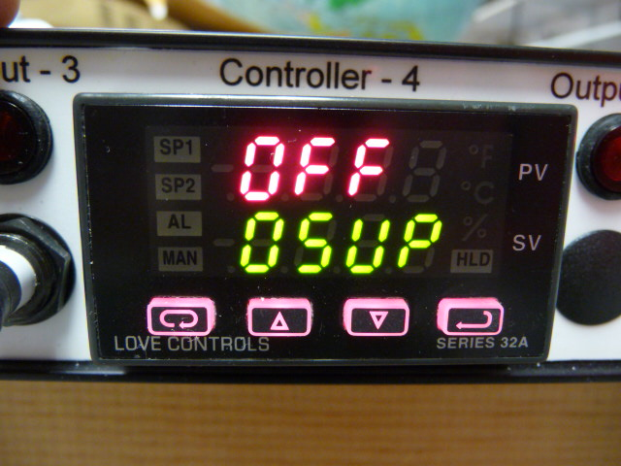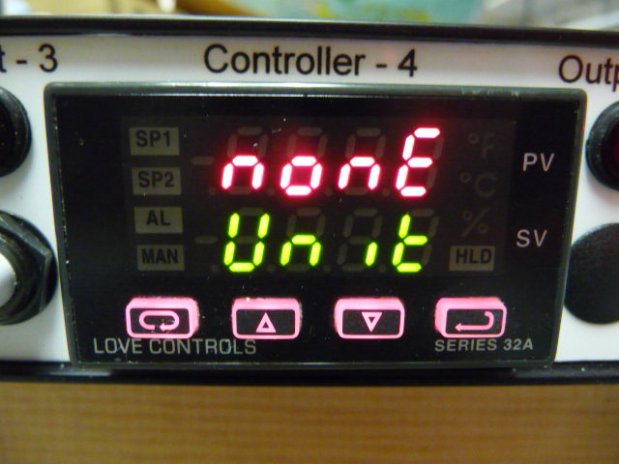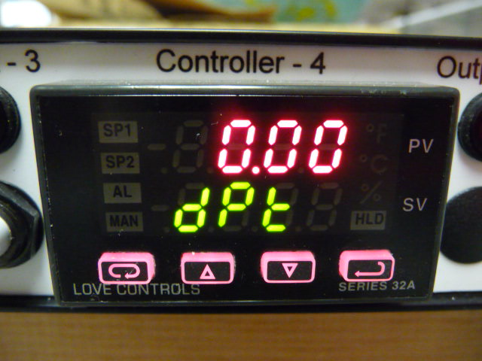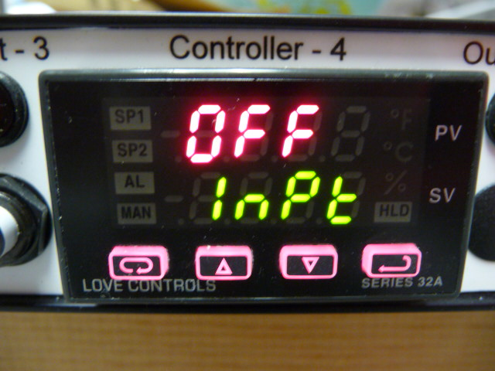
SECURE MENU (FLOW PID CONTROLLER #4, continued)

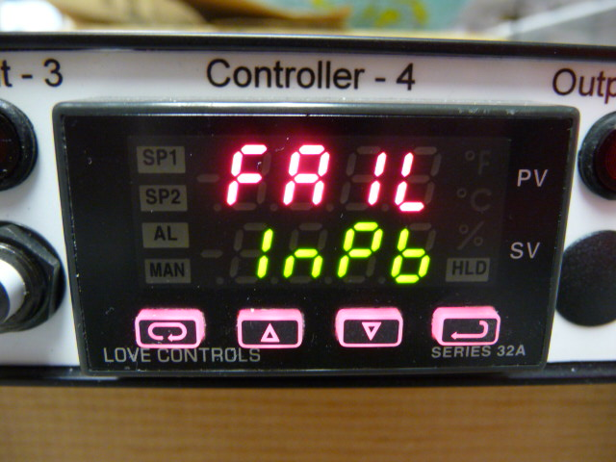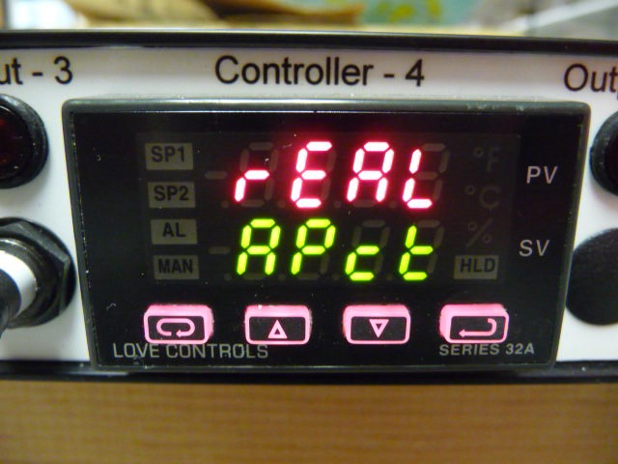
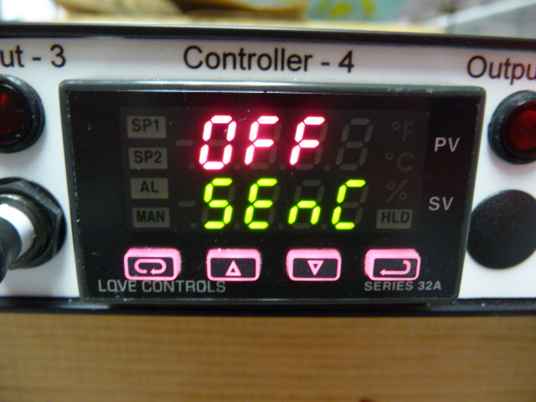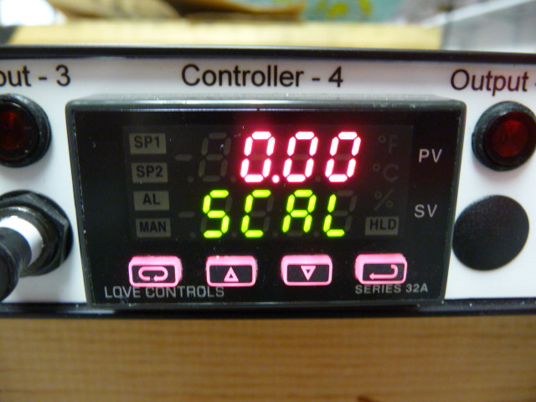
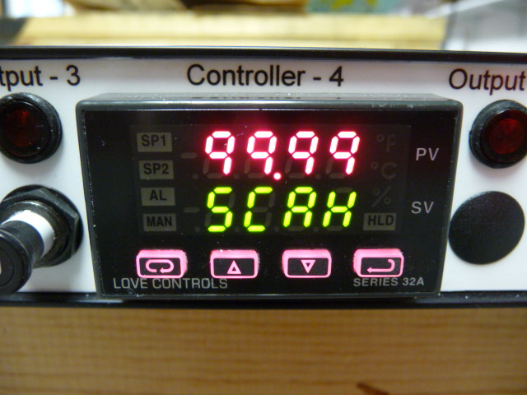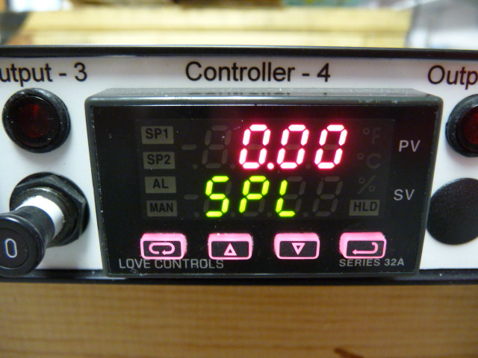
SECURE MENU (FLOW PID CONTROLLER #4, continued)

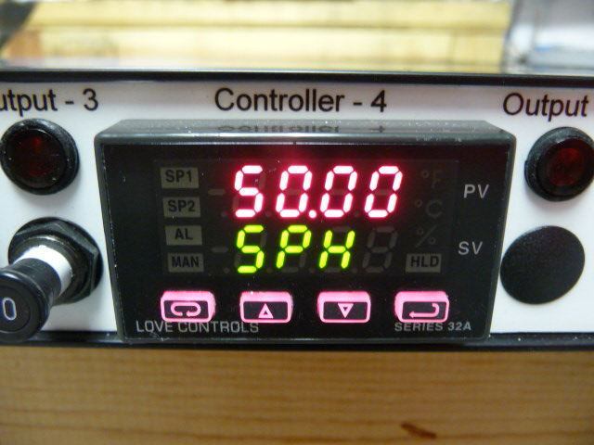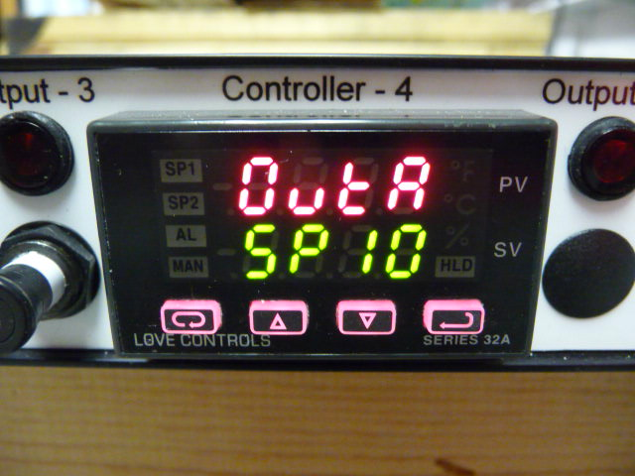
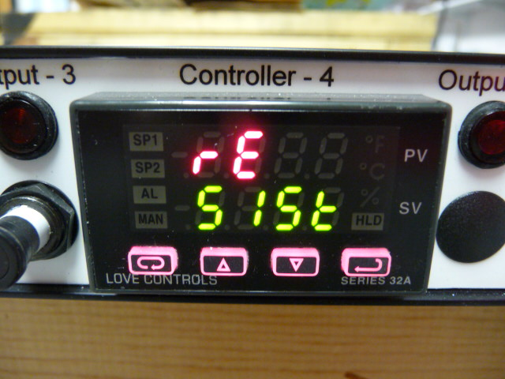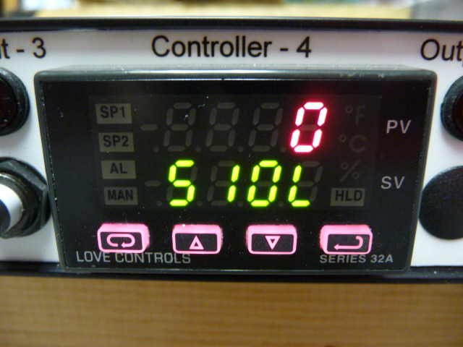
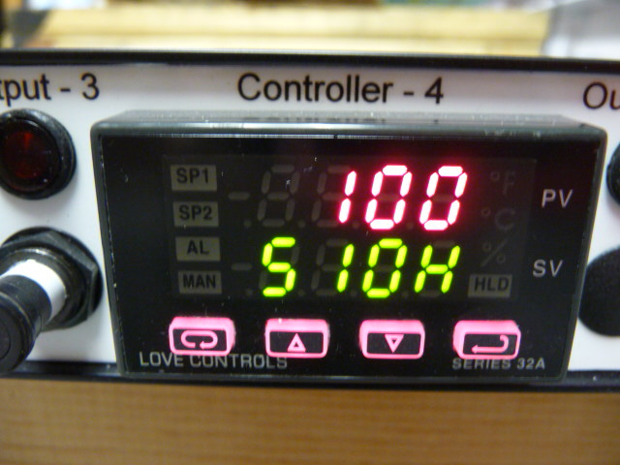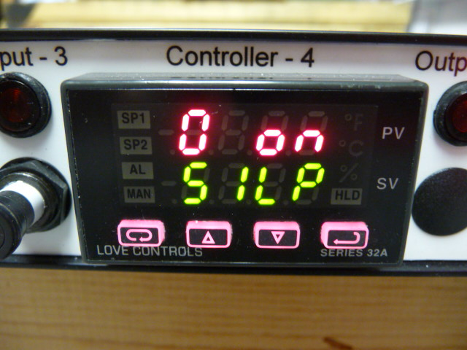
SECURE MENU (FLOW PID CONTROLLER #4, continued)



