Operating Manual for WLG Station
NOAA/CMDL Aerosol Sampling System
Last Updated – August 31, 2005
Table of Contents
1. General description 2
1.0. Maintenance Checklist 3
1.0.1. Daily Tasks 3
1.0.2. Every Week Tasks (these tasks are performed once per week) 3
1.0.3. Every Two Week Tasks (these tasks are performed once every two weeks) 3
1.0.4. Monthly Tasks 3
2. Maintenance 3
2.0. Check System Parameters and Logging Status - (Daily Task) 3
2.1. Condensation Particle Counter (CPC) butanol level (Daily Task) 4
2.2. Changing the PSAP Filter (Daily Task) 5
2.3. Checking Air Flows - (Daily Task) 6
2.4. Cleaning Aerosol Impactors - (Every Two Week Task) 8
2.4.1. Removal of Impactors 8
2.4.2. Cleaning of Impactors 8
2.4.3. Re-assembly 9
2.5. System Leak Test - (Every Two Week Task, done when impactors are cleaned) 10
2.6. Nephelometer Span Check - (Every Two Week Task) 12
2.6.1. Plumbing 12
2.6.2. Operation 13
2.7. Changing Nephelometer Lamp (when needed) 13
2.8. CPC Butanol Flush (when needed) 13
2.9. System Clock 13
2.10. Instant Messenger 14
3. Computer Operation 14
3.0. General 14
3.1. Startup 15
3.2. Shutdown 16
3.3. Archiving and Backing-up Data 16
3.3.1. Saving to hard disc 16
3.4. Other desktop icons 16
3.5. LiveCPD Documentation 16
3.6. Graphical Client Program (cpx) 17
3.7. Aerosol Data Logger Program 17
3.7.1. General Operation 17
3.7.2. Display 18
3.7.3. Root Menu <Enter> or <Esc> 18
3.7.4. Aerosol Status Window and Monitor Menu <Enter><A> and <M> 20
3.7.5. Nephelometer Status Window and Menu <Enter><N> and <M> 20
3.7.6. PSAP Menu <Enter><R> and <M> 21
4. Safety 21
4.1. Heater Control 21
4.2. Electrical Safety 22
5. Specifications 22
5.1. Power Draw at 115 V DC 22
6. Additional Computer info 23
6.0. Data flow 23
6.1. Aerosol Server Program (cpd) 23
6.2. User account 23
6.3. Location of this document 23

General description

The NOAA CMDL Aerosol Sampling System is deployed at a number of stations around the world. It is an automated system for measuring aerosol light scattering as a function of wavelength, aerosol light absorption at multiple wavelengths, and total particle number (condensation nuclei). At several stations the light scattering as a function of relative humidity is also measured. One- and ten-micron cut point impactors are used to measure these properties for aerosol particles less than 1 and 10 μm, respectively. The main components are a three wavelength nephelometer (TSI model 3563), a light absorption photometer (Radiance Research PSAP) and a Condensation Particle Counter (TSI model 3010). At some stations filter measurements are also made in conjunction with NOAA PMEL of the ionic composition of the aerosol. sea salt, non-sea salt (nss) sulfate, methanesulfonate, NH₄⁺, nss K⁺, Mg⁺², and Ca⁺ for sub-micron and super-micron size ranges. The aerosol filter measurements are not made at Mt. Waliguan.

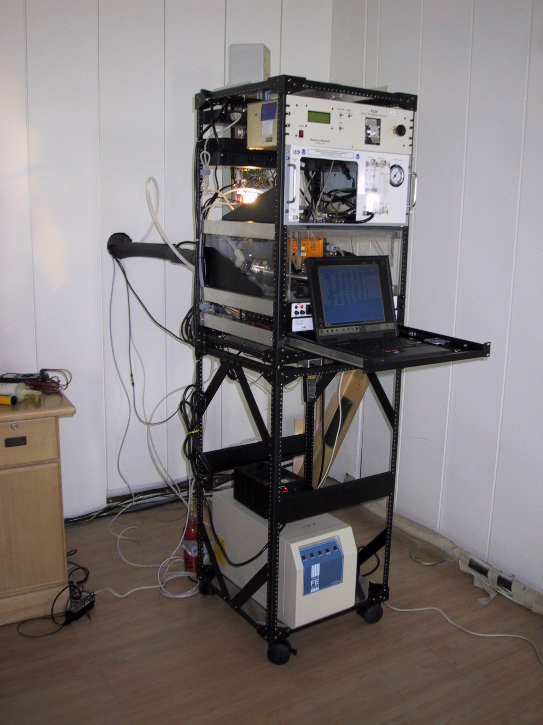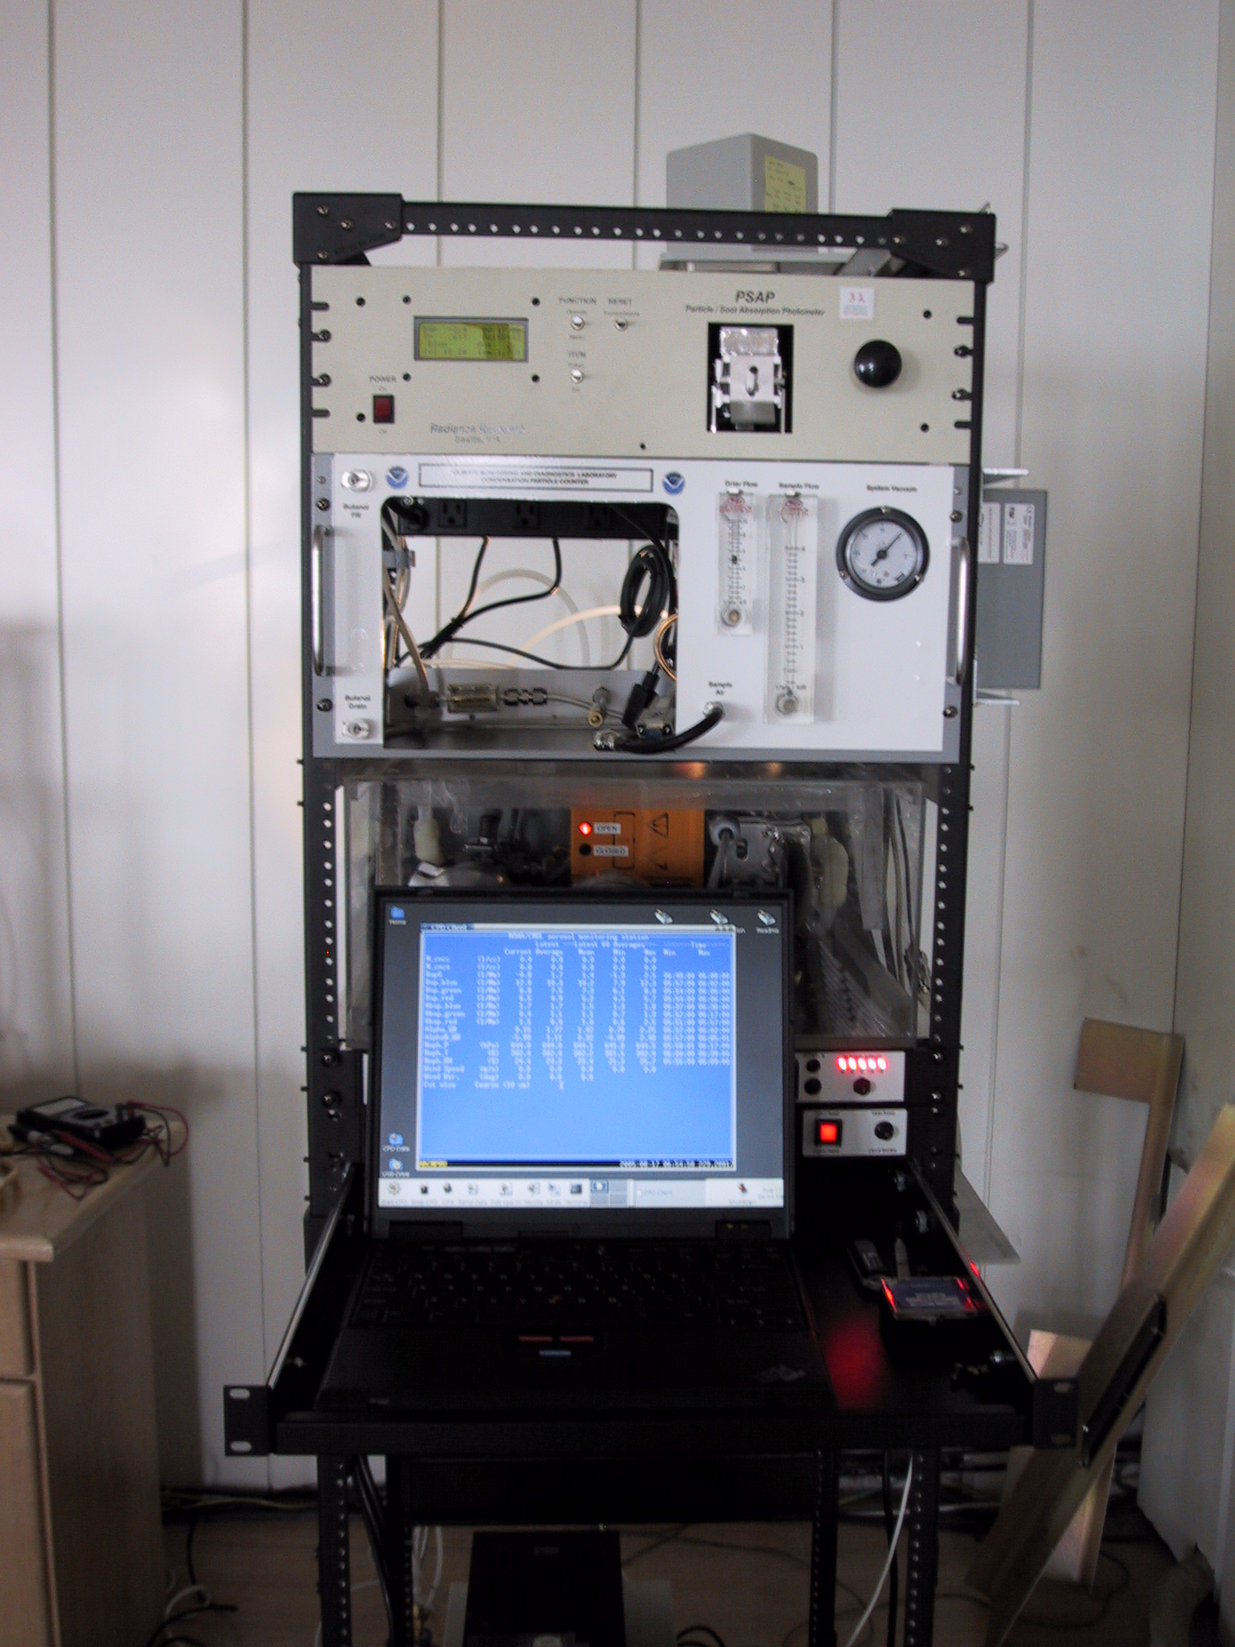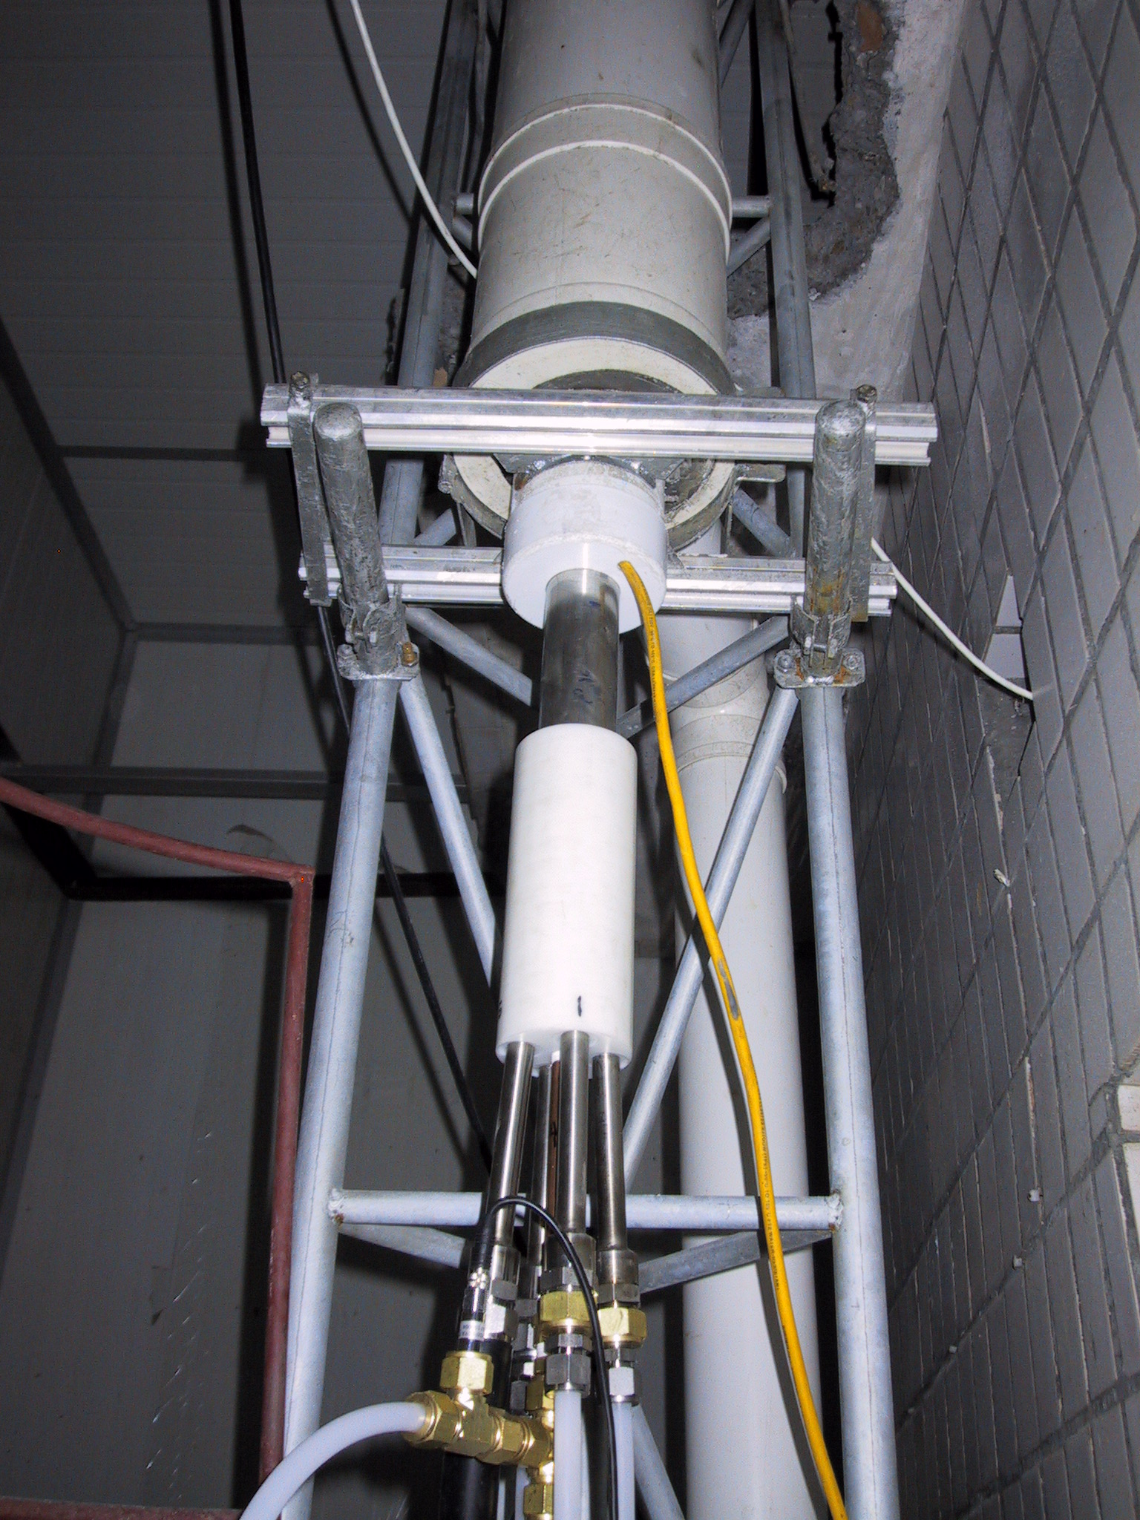
The NOAA CMDL aerosol system generates the following information:
- Total and backwards scattering coefficients time series at 450, 550 and 700 nm wavelengths in two size ranges
- Total and backwards scattering coefficients time series at 450, 550 and 700 nm wavelengths in two size ranges as a function of relative humidity
- Absorption coefficient time series at 467, 530, and 660 nm in two size ranges
- Condensation particle concentration time series
- Mass concentration of sea salt, non-sea salt (nss) sulfate, methanesulfonate, NH₄⁺, nss K⁺, Mg⁺², and Ca⁺ for sub-micron and super-micron size ranges

For the Mt. Waliguan station, Numbers 1-4 above are measured.

From the measurements the following parameters can be calculated:

- Single scattering albedo at three wavelengths in two size ranges
- Three Angstrom coefficients
- Hemispheric backwards scattering fraction for three wavelengths in two size ranges
- f(RH), the aerosol hygroscopic growth factor

Maintenance Checklist
The system is mostly automated but there are some tasks that need to be performed on a daily, weekly, two-weekly or monthly basis. The tasks for the Mt. Waliguan aerosol system are listed below and are described in more detail in Section 2 – Maintenance. Each station also has a binder of instrument manuals for each of the instruments and other system components to aid in more complicated trouble-shooting and maintenance (in consultation with station scientists).

Daily Tasks
1. Fill out daily checklist
2. Check logging status: letters at bottom of left of main CPD window. Letters should read
“ABCMNPRU”.
3. Check butanol level in CPC and add butanol if needed
4. Change PSAP filter if transmittance< 0.7
5. Check stack air flow and flows through the sample and spare lines

Every Week Tasks (these tasks are performed once per week)
1. Perform daily tasks
2. Change PSAP reference filter

Every Two Week Tasks (these tasks are performed once every two weeks)
1. Service 1-micron impactor
2. Perform leak test (if weather permits)
3. Perform nephelometer span check

Monthly Tasks
1. Check supply levels of PSAP filters, butanol, and CO2.
2. Service 10-micron impactor

Maintenance
This section describes the general maintenance/station tasks for the Mt. Waliguan Aerosol System.

Check System Parameters and Logging Status - (Daily Task)
Time required: 5 minutes
Tools/supplies: Daily check list
Overview: There are a few system parameters that are not recorded and hence need to be checked manually. A daily checklist is used to record the values and can be mailed back to CMA at the end of each month.

1. Fill out daily checklist (and weekly and monthly checklists on second sheet)
2. Check that letters on bottom of computer screen match the letters listed in section 1.0.1

Condensation Particle Counter (CPC) butanol level (Daily Task)
Time required: 5 minutes
Tools/supplies: Butanol fill bottle
Overview: The CPC condenses butanol vapor onto particles in the sample line to grow them to a size so that they can be seen and counted by the instrument optics. The condensed butanol goes out the exhaust stream to the butanol trap and fresh butanol must be added to the counter to replenish the supply.

Check the butanol level – it should be at or below the line across the View Port. Do not overfill!

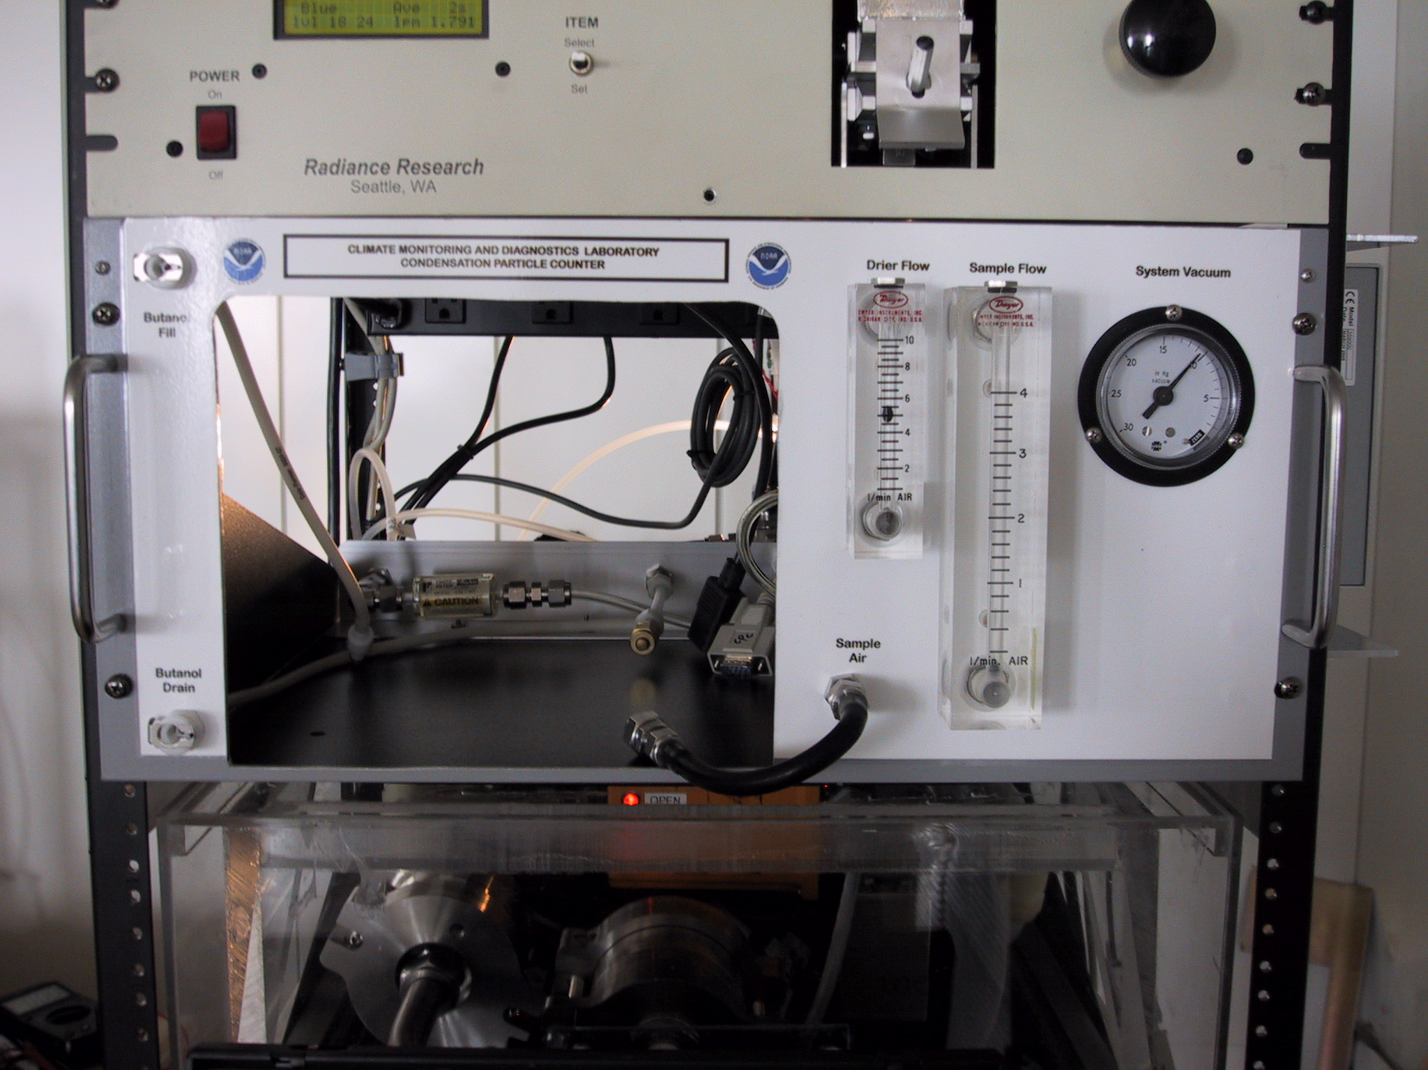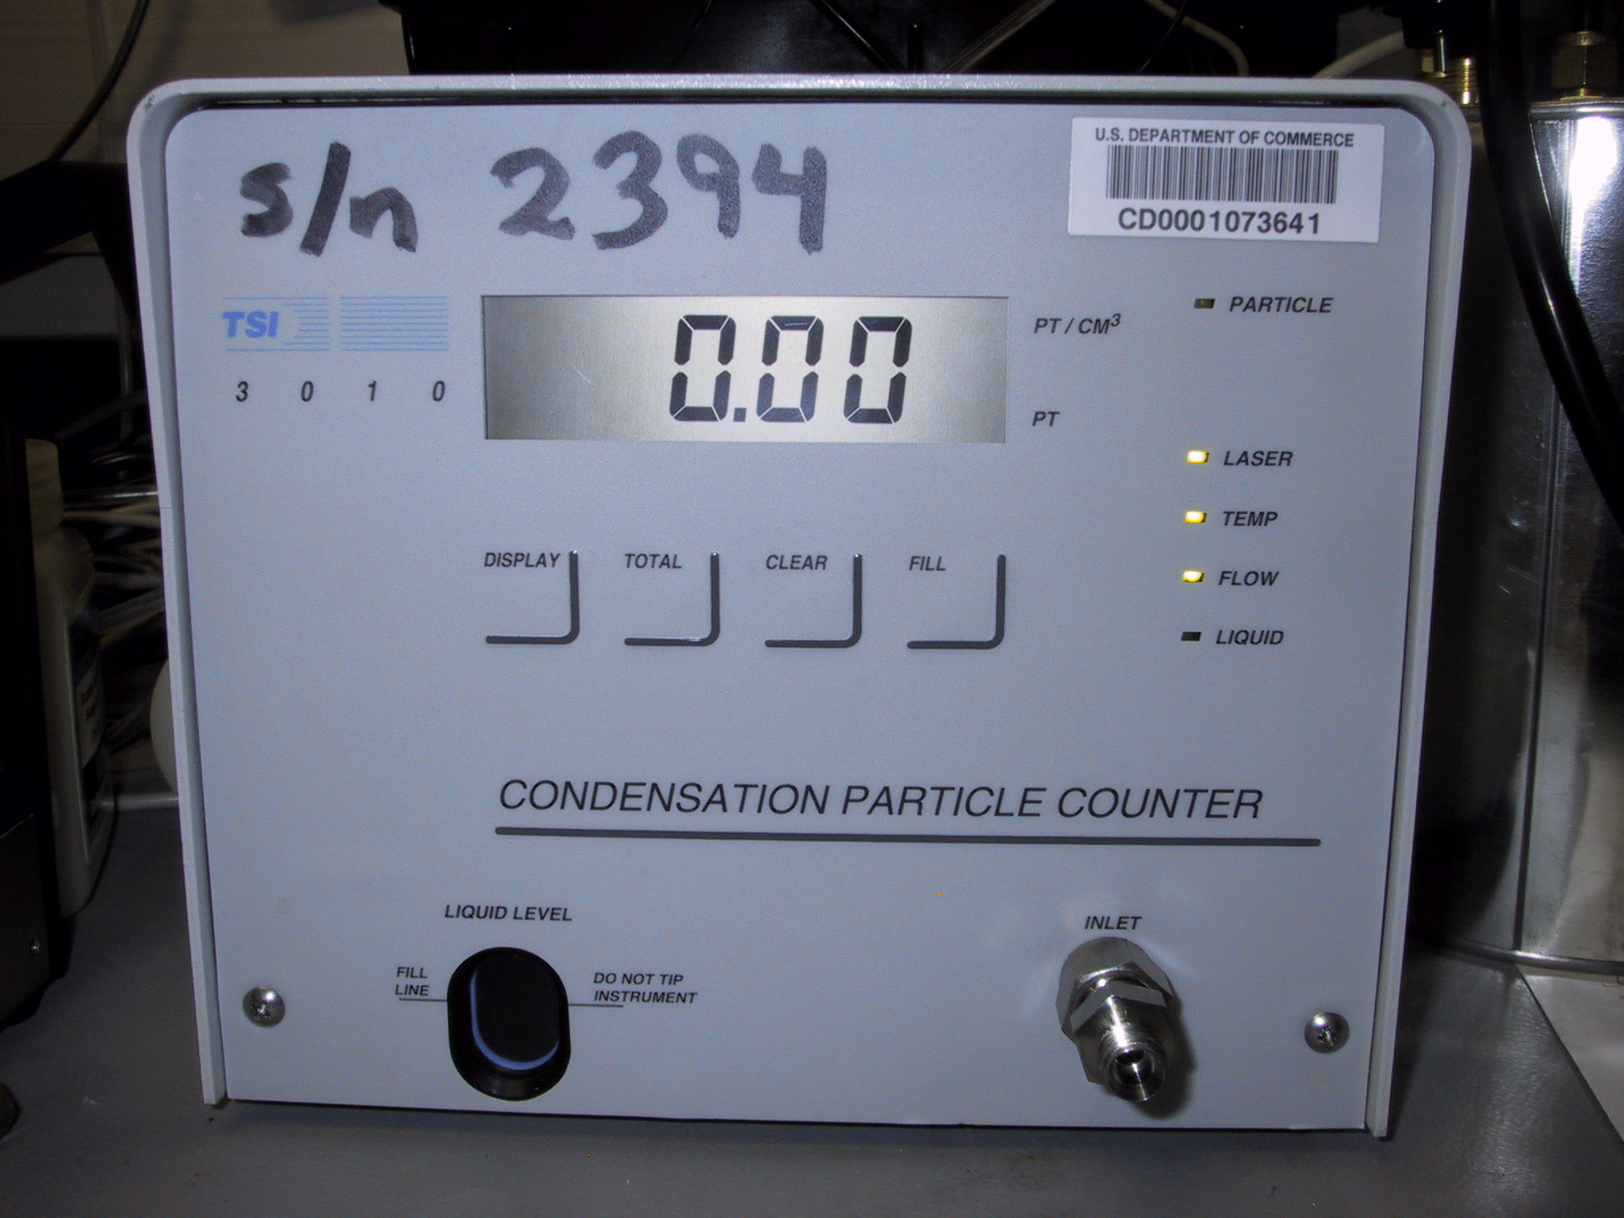

The CPC box with CPC removed A TSI 3010 CPC

The Butanol Level View Port is in the lower left corner of the CPC front panel. It is a glass window with the words “Liquid Level” directly above it. If the butanol level is very low in the view port window, butanol can be added by connecting the CPC Butanol Fill Bottle to the Fill Port on the CPC enclosure box in the rack. The Fill Port is the white fitting at the upper left hand corner of the CPC rack enclosure box. Be sure to loosen the cap on the butanol fill bottle so that butanol can flow out of the bottle. The CPC filling should automatically stop when the instrument is full of butanol.

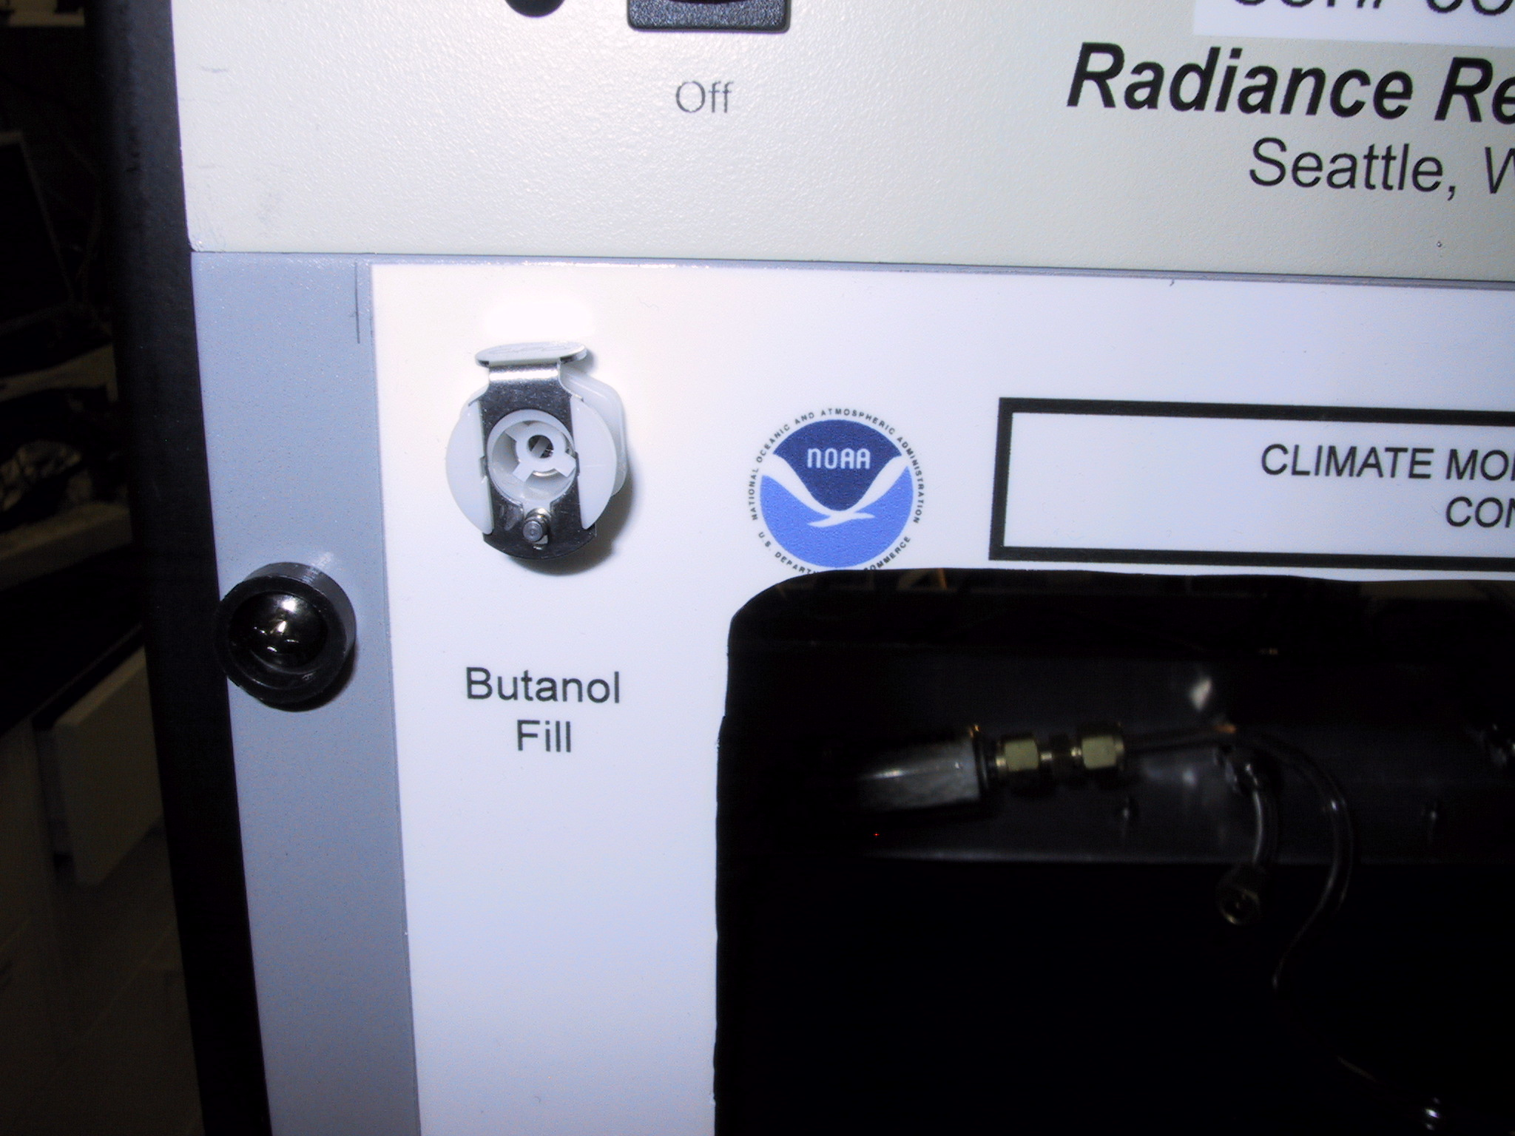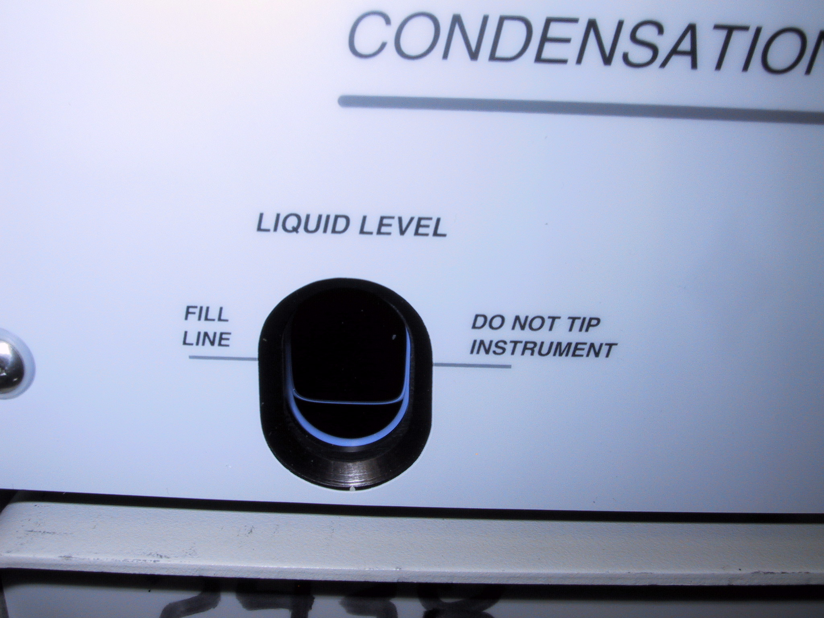

The Butanol Fill Port on the CPC Rack The Butanol Level View Port
Enclosure Box

Changing the PSAP Filter (Daily Task)
Time required: 5 minutes
Tools/supplies: PSAP Filter Kit
Overview: The PSAP filter transmittance decreases as particles collect on the filter. To ensure valid measurements the filters need to be changed.

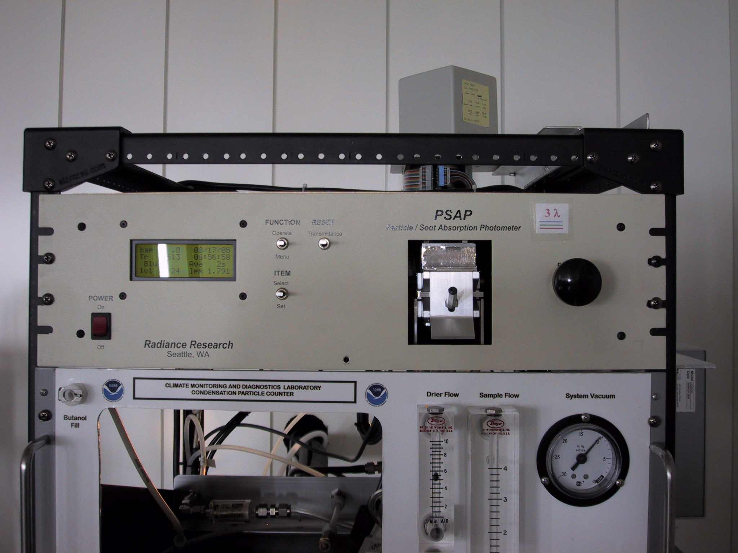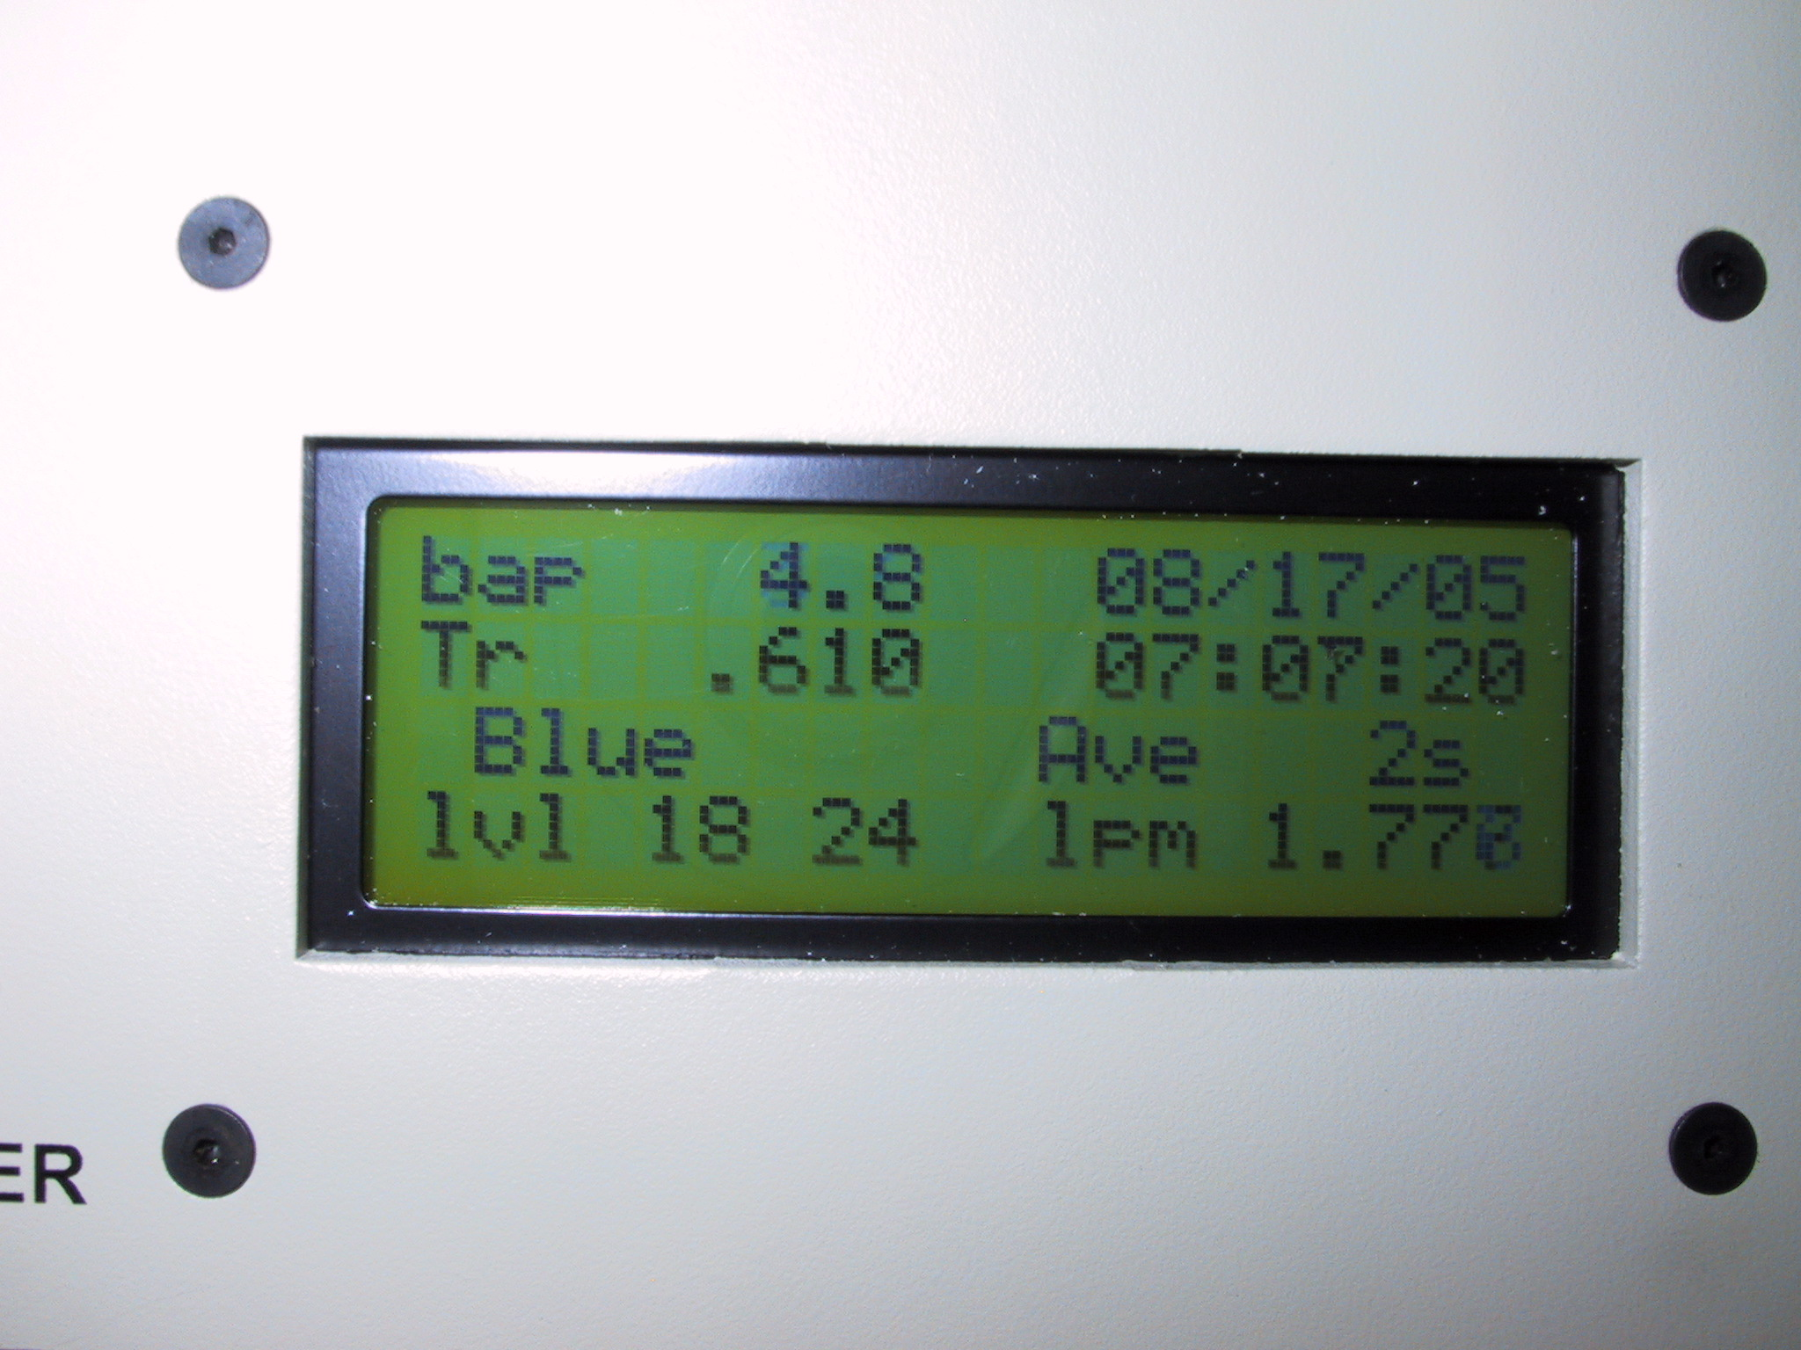

Is the PSAP filter transmittance above 0.7? (Look at Tr value, in picture is 0.610). If not, the filter needs to be changed.

Procedure:
1. On the laptop computer, while in the Main Aerosol Data Logger Window, press <Enter><R><M><3> to signal start of a filter change.
2. Turn the flow down to zero using the knob on the right side of the PSAP.
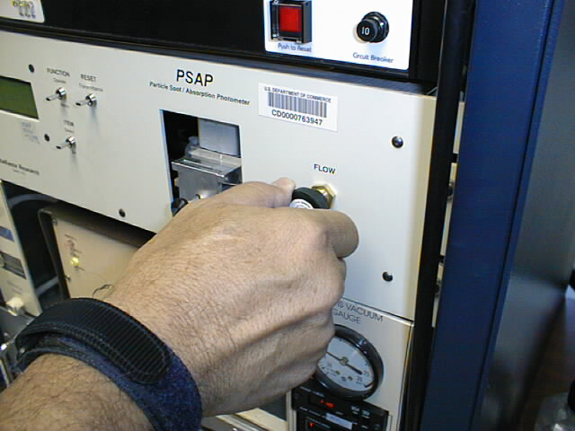
3. Unscrew the black knob on the sampling head, raise the lockdown panel, and remove the filter holder.
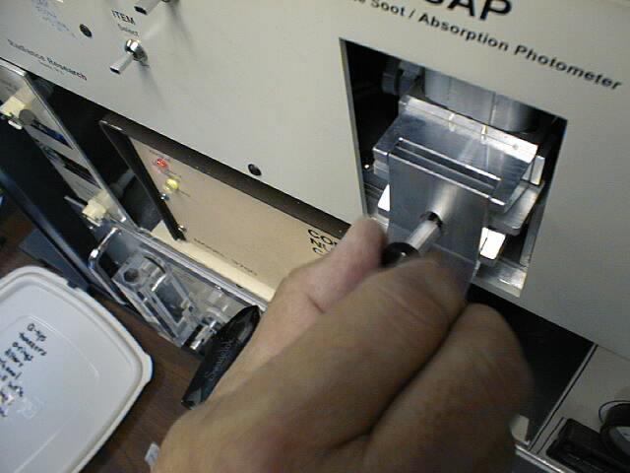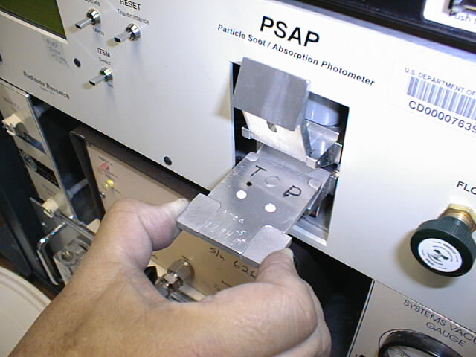
Sample
ref
Samplee
ref
4. Open the filter holder.
5. Place new filters in the filter holder. Replace the sample filter with a new one when Tr < 0.7. Be sure to put only one filter in the sample filter position in the filter holder, and make sure that the white side of the filter faces up. It is only necessary to replace the reference filter once per week.
6. Re-insert the filter holder into the sampling head; secure the lockdown panel with the black knob. Make sure the lower lip of the lockdown panel goes under the bottom edge of the sampling head.
7. Set PSAP flow to 0.75 lpm.
8. On the PSAP, press the “RESET Transmittance” switch up and verify that Tr=1.000 on the display of the PSAP.
9. Press <Enter><R><M><3> on the keyboard to signal end of the filter change. Verify Transmittance = 1.000 before answering the question “Have you pressed the RESET Transmittance switch?” with “Yes”.

Checking Air Flows - (Daily Task)
Time required: 5 minutes
Tools/supplies: Daily check list
Overview: Every day the flows through the aerosol system must be checked and recorded on the daily check sheet. The flow through the stack should be noted, as well as the flows through the 4 spare sampling lines.

To observe the stack flow:

1. Press <Enter><A> to open the Aerosol Window.
2. Look in the first column near the bottom, and record the value for “Q_stack (slpm)” on the daily check sheet.
3. You may choose to keep the Aerosol Window open, or you can close it by pressing <Esc>.

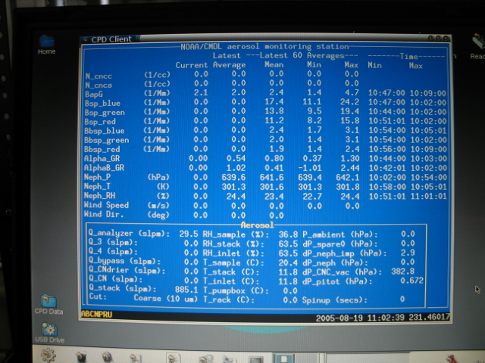
Aerosol Window
Main Aerosol Data Logger Window
Q_stack value. Should be 700-1000 slpm).

To observe spare line flows:
1. Go to the hallway behind the aerosol system where the stack enters the building.
2. Look at the flowmeter manifold (shown in photo below at left).
3. If the individual flowmeter readings are not ~30 lpm, please adjust the black knob to achieve 30 lpm in each line. The center of the ball should be at the 30 lpm mark.
4. If there does not appear to be enough vacuum to get 30 lpm flow through all four lines, the blower speed may need to be increased. This can be done using a small screwdriver and turning the tiny white screw in the blower housing (see photo below at right). Caution: The screw only needs to be turned a very small amount for large changes in flow rate to occur. Use very small adjustments!
5. On daily check sheet, state that the four spare sample lines were adjusted to 30 lpm flow.

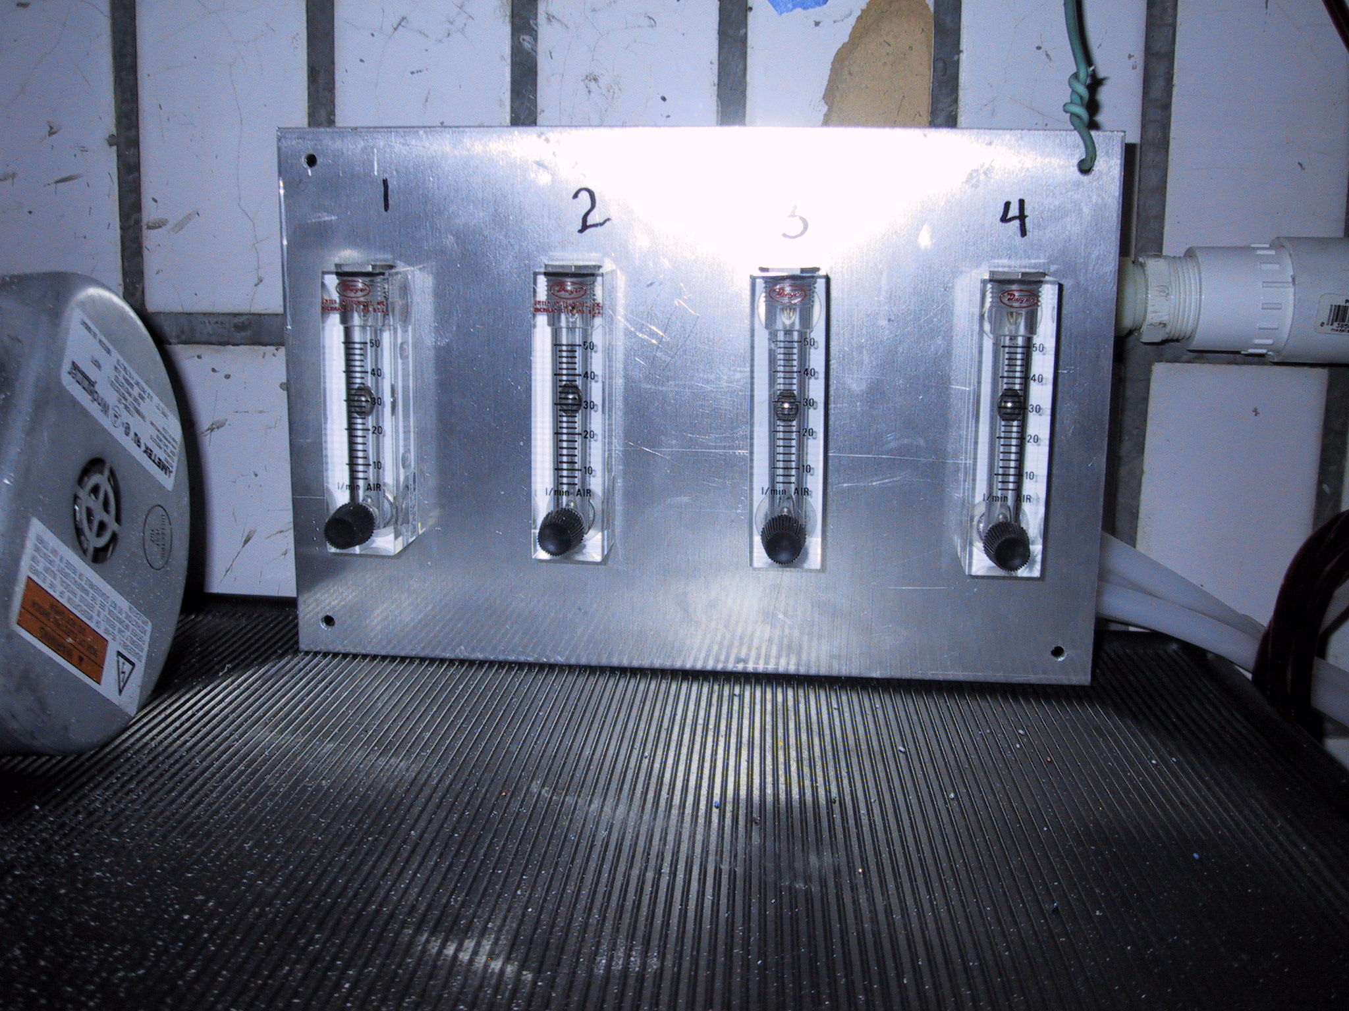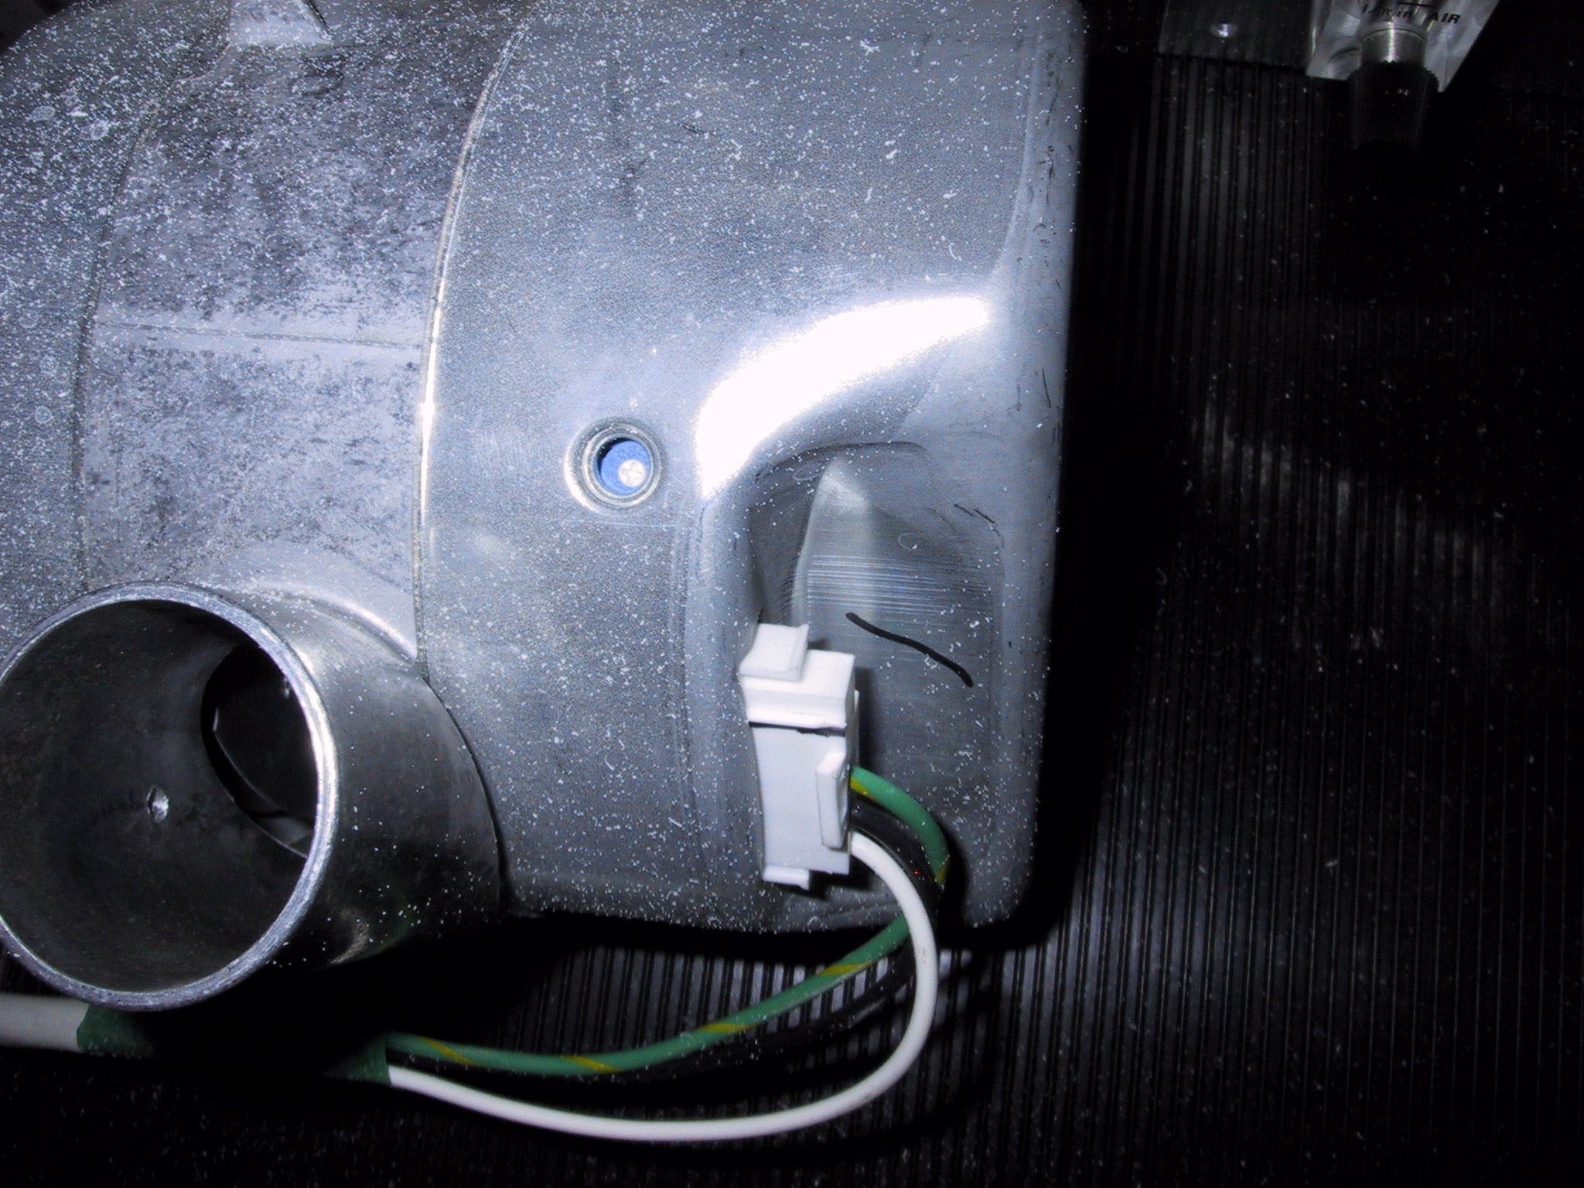

Flowmeter manifold for the spare sample lines. Stack blower showing detail of the speed
adjustment screw.

Cleaning Aerosol Impactors - (Every Two Week Task)
Time required: 20 minutes
Tools/supplies: Impactor kit, which includes alcohol for cleaning, silicone spray, high-vacuum grease, clean wipes, large wrench. We assume that ethanol/methanol and clean wipes or tissues are available at WLG.
Overview: It is necessary to clean the impactor plate to ensure the impactor size cut is accurate. Cleaning the impactor plate involves disconnecting the impactor units and disassembling them so that the impaction place can be accessed and cleaned. Cleaning should occur more frequently than every two weeks if large particle deposits are observed.

Removal of Impactors
- On the keyboard, press <Enter><Enter>. Enter message "Starting impactor servicing". Press <Enter> to accept the message.

Electronic Impactor Switching Valve
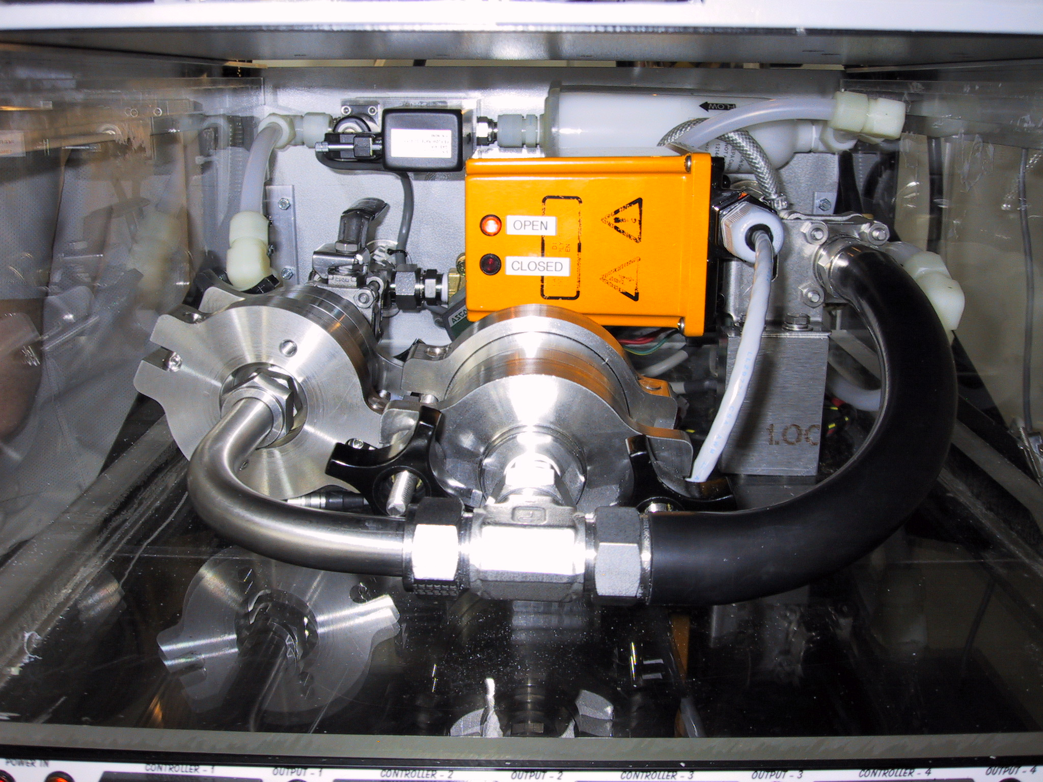
1-micron Impactor
10-micron Impactor
Ball Valve

- Press <Enter><A><M><3> to get to the Aerosol Window and select “bypass analyzers”. This closes a solenoid valve and notifies the computer that impactors are off-line. Close the Ball Valve behind the 10 um impactor by rotating 90 degrees to left.
- Using a large wrench, loosen the Swagelok fitting between the Ball Valve and the 10-micron Impactor. Disconnect the black tubing from the back of the 1-micron Impactor and at the upstream side of the Electronic Impactor Switching Valve. Carefully remove impactors. Be careful of the tubing and cables in the impactor area so as not to disturb them.
- Place impactors on a flat clean surface.

Cleaning of Impactors
The 1-micron impactor should be cleaned every two weeks. The 10-micron impactor should be cleaned once per month.

HINT: If you lay aside the cleaned pieces in order of removal, it will be easier to reassemble afterwards.

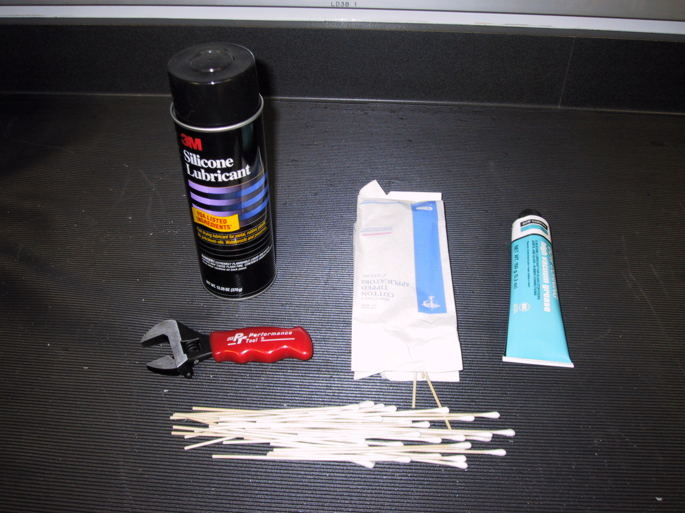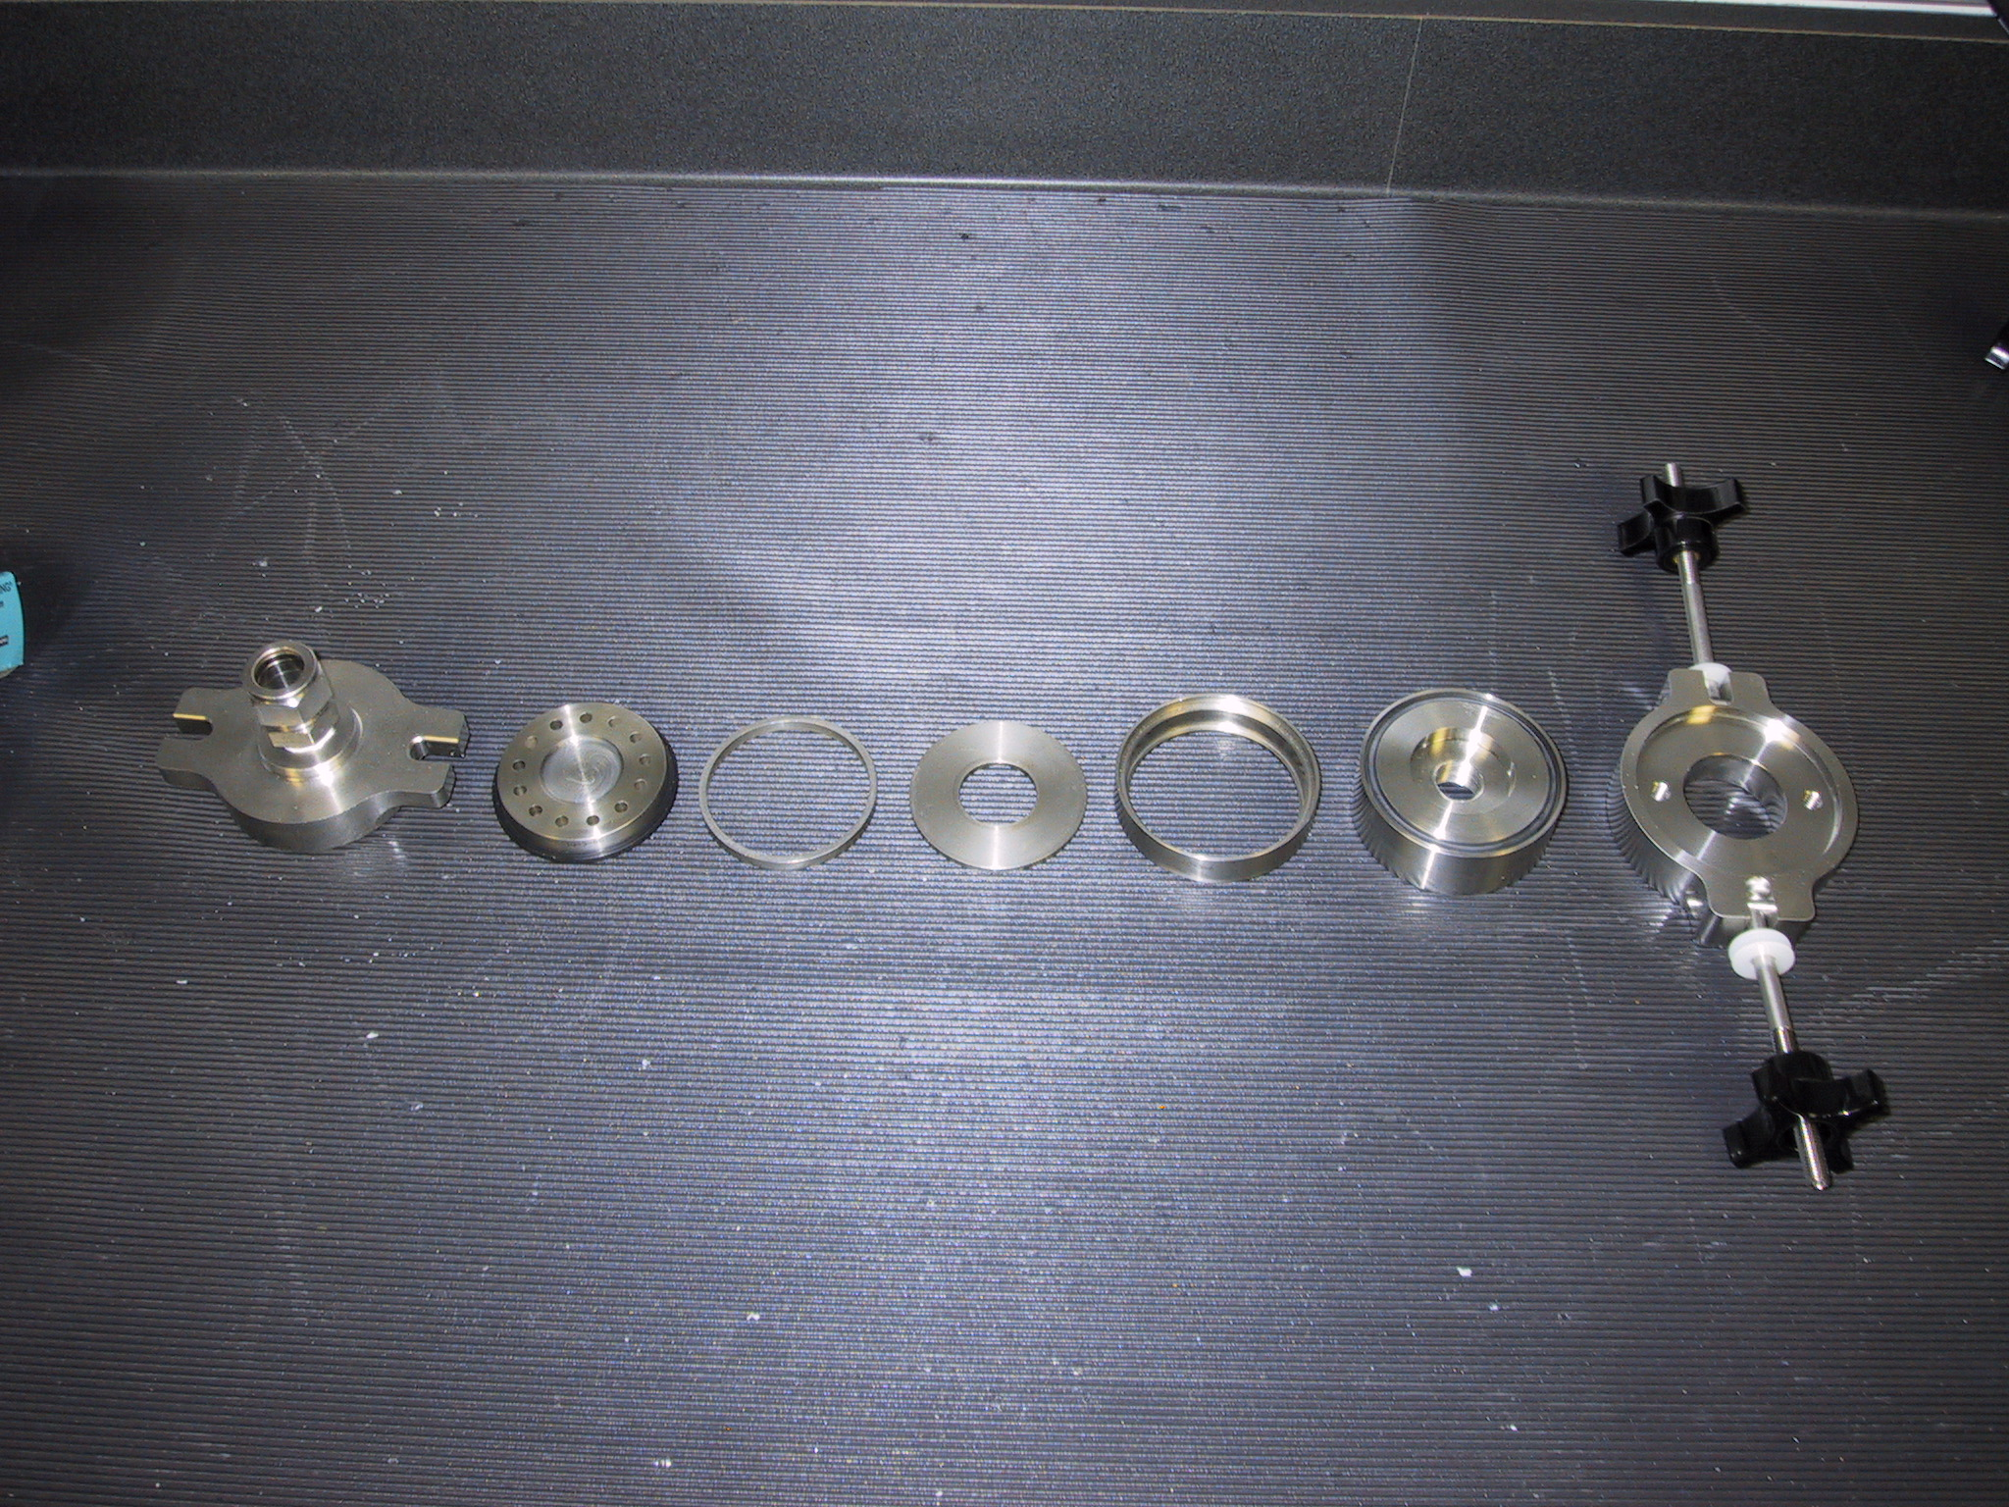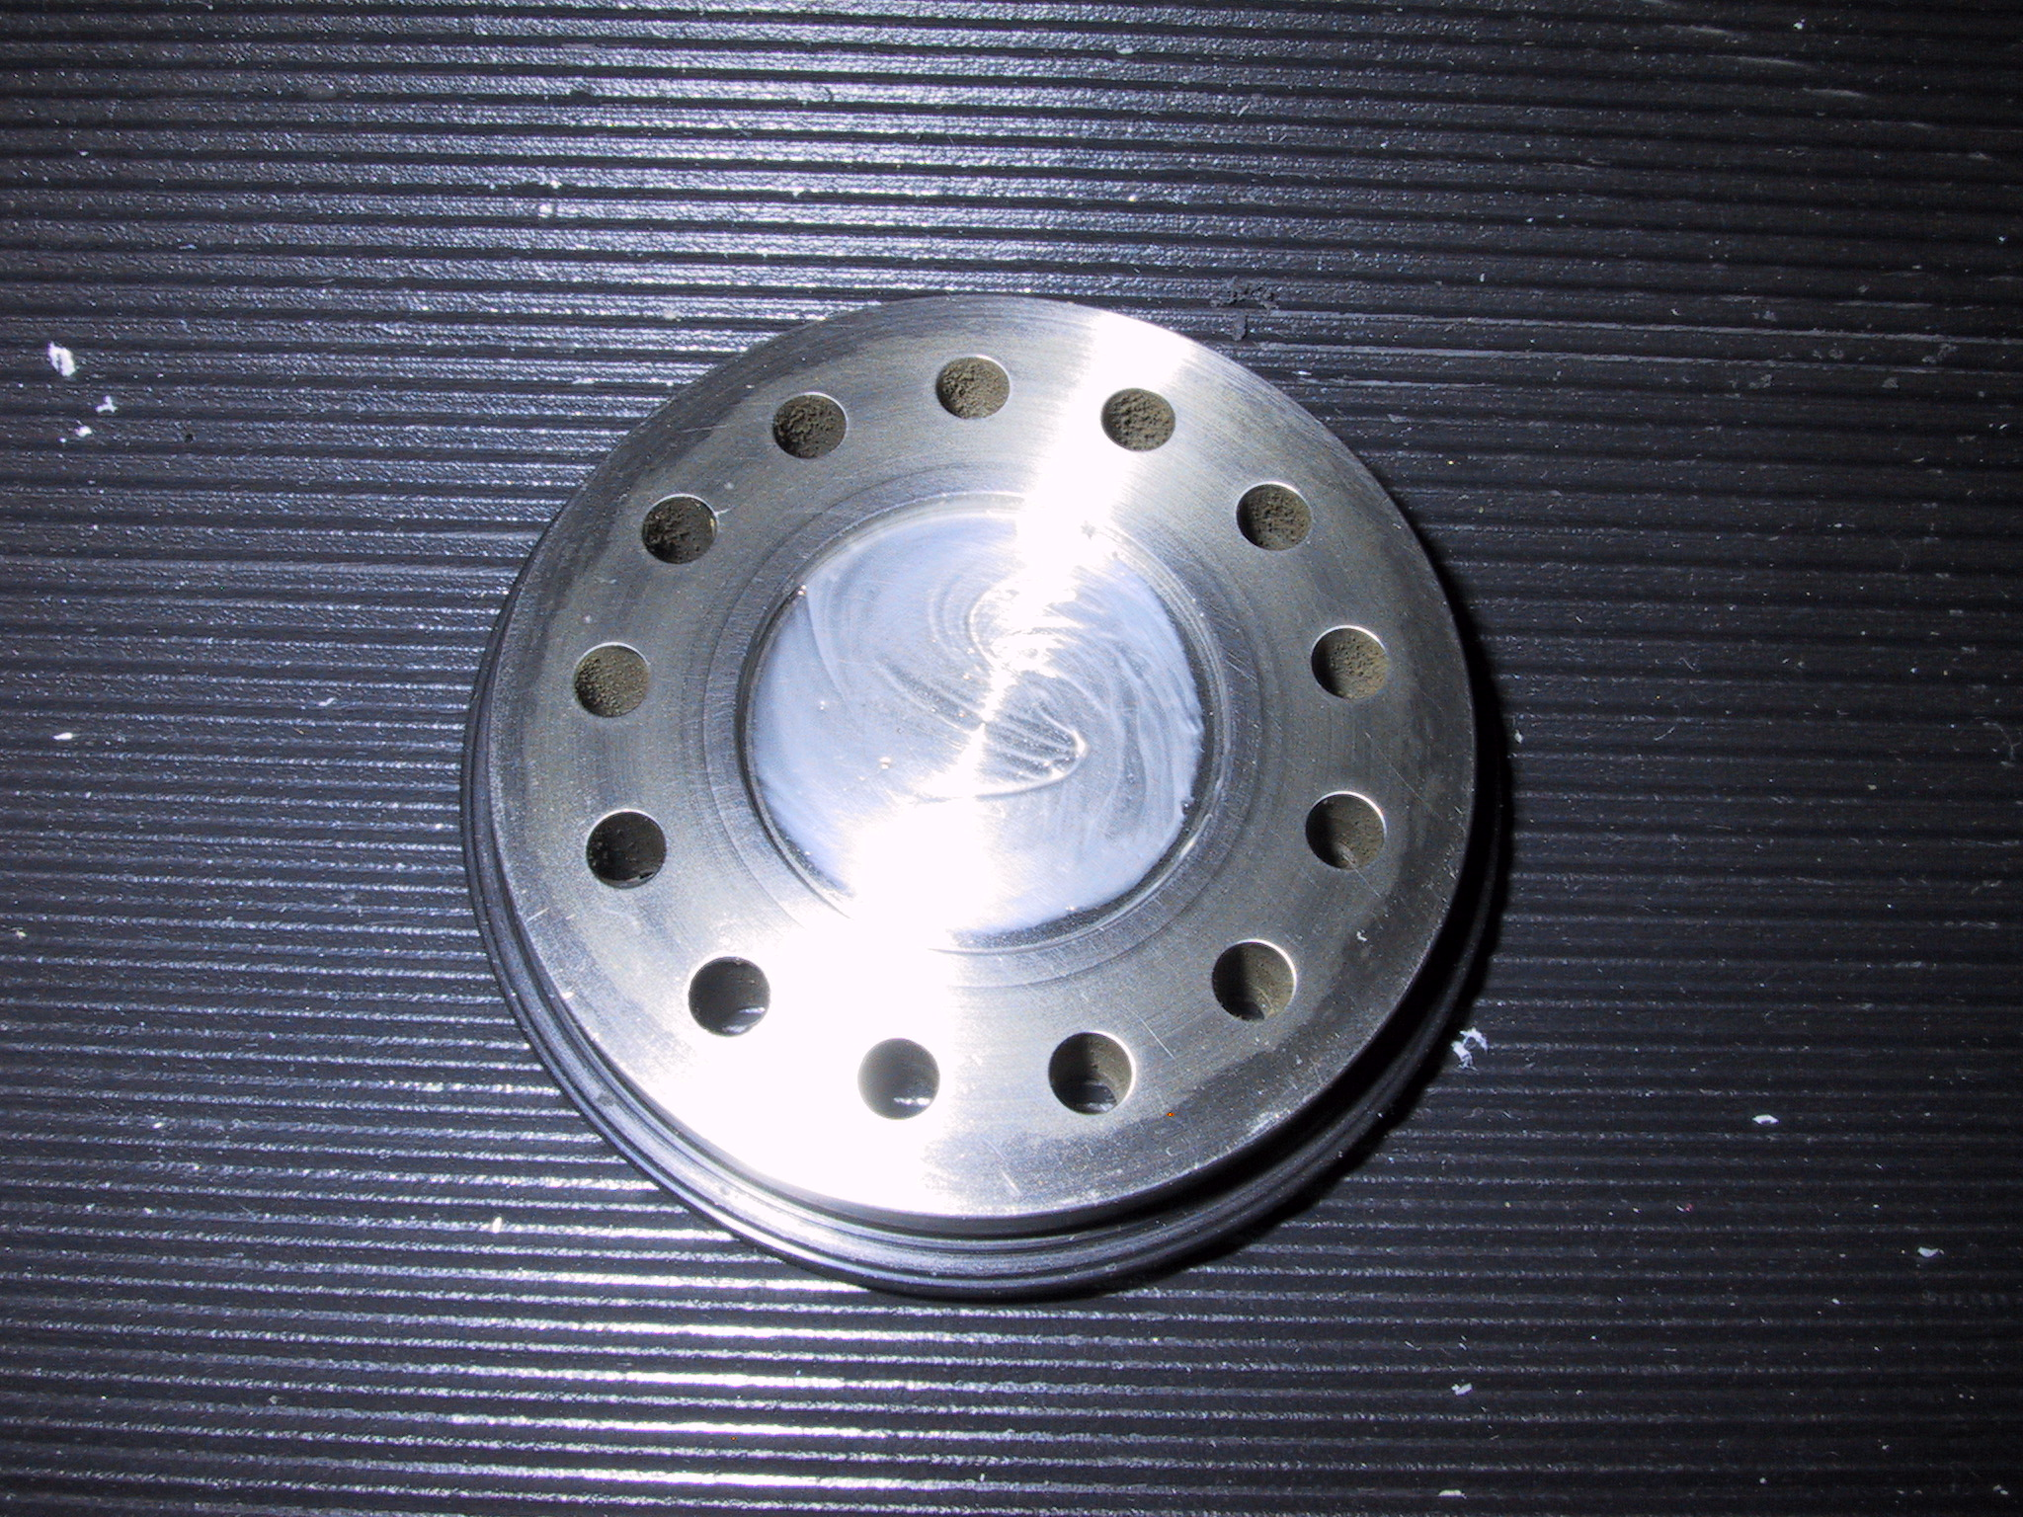
Impactor Kit Impactor Pieces Impaction Cup

- Unscrew black knobs on impactor, and fold down the side arms.
- Remove top piece, clean inside (including inlet) with alcohol and clean tissue or cotton swabs.
- Remove impactor jet plate, clean both sides with alcohol and tissue or cotton swabs.
- Remove spacer ring, wipe clean.
- Remove impaction plate, clean both sides with alcohol and tissue or cotton swabs.
- Remove bottom spacer that impaction plate sits in, wipe clean.
- Clean inside of outlet fitting.
- Replace bottom spacer in impactor housing.
- Spray an impaction plate with a thin coat of silicone lubricant spray. Wipe the excess silicone spray off the vertical edges of the plate
- Replace impaction plate.
- Replace spacer ring.
- Apply a generous coating of silicone vacuum grease to the impaction cup on the top surface of the impactor jet plate (only on 10 micron impactor).
- Replace impactor jet plate.
- Replace top cover
- Tighten assembly back together with black knobs

Re-assembly
- Reinstall impactors in system being careful not to strip threads on fittings. Tighten all fittings by hand and then tighten the nut that was loosened between the ball valve and the 10-micron impactor. Push the black tubing onto the stainless steel tubes that it was attached to.
- Open Whitey valve by rotating handle 90 degrees to right (so it is parallel with flow).
- Press <Enter><A><M><3> again when the impactors have been re-installed, to “unbypass analyzers” and to resume data logging. The ball valve message is asking if you have opened the ball valve. Enter ‘Y’ once the valve is open.
- Press <Enter><N><M><5> to start a nephelometer zero cycle
- Enter a log message: <Enter><Enter> "System back on-line after impactor servicing and zeroing.” <Enter>
- Do a leak check (weather permitting) to make sure all fittings have been tightened

Sketch of 10-micron impactor
Side view Top view

Inlet

Impaction cup
Jet plate

Top spacer ring

Impaction plate

Bottom spacer ring

Outlet

System Leak Test - (Every Two Week Task, done when impactors are cleaned)
Time required: Approximately 10 minutes
Tools/supplies: Large white HEPA filter with aluminum cup fitting
Overview: It is important to test the aerosol system for leaks to ensure that measurements are made on outside air and not on air from inside the laboratory. Two diagnostics are used to test the aerosol system for leaks: the pressure drop and the CPC counts.

DO NOT attempt this procedure during stormy weather; SAFETY FIRST!! ☺

Enter a log message <Enter><Enter> ”Starting leak check” <Enter>.

Open the Aerosol Window, if it is not already open <Enter><A>.

Enter a log message <Enter><Enter> “Ambient CPC count= value; dP_neph_imp= value” <Enter>. (The CPC counts value is what is being displayed on the front panel of the CPC instrument and the dP_neph_imp value is displayed in the right hand column of the Aerosol Window. These starting values will be compared with the values during a leak check.

Climb up to the saddle port at the base of the 20cm diameter PVC tube, and remove the stack inspection port. Place the filter with the metal cup securely on top of the exposed 5cm diameter metal inlet tube. You may need to put some high-vacuum grease on the tube or on the o-rings to get the metal adapter cup to slide completely onto the tube.

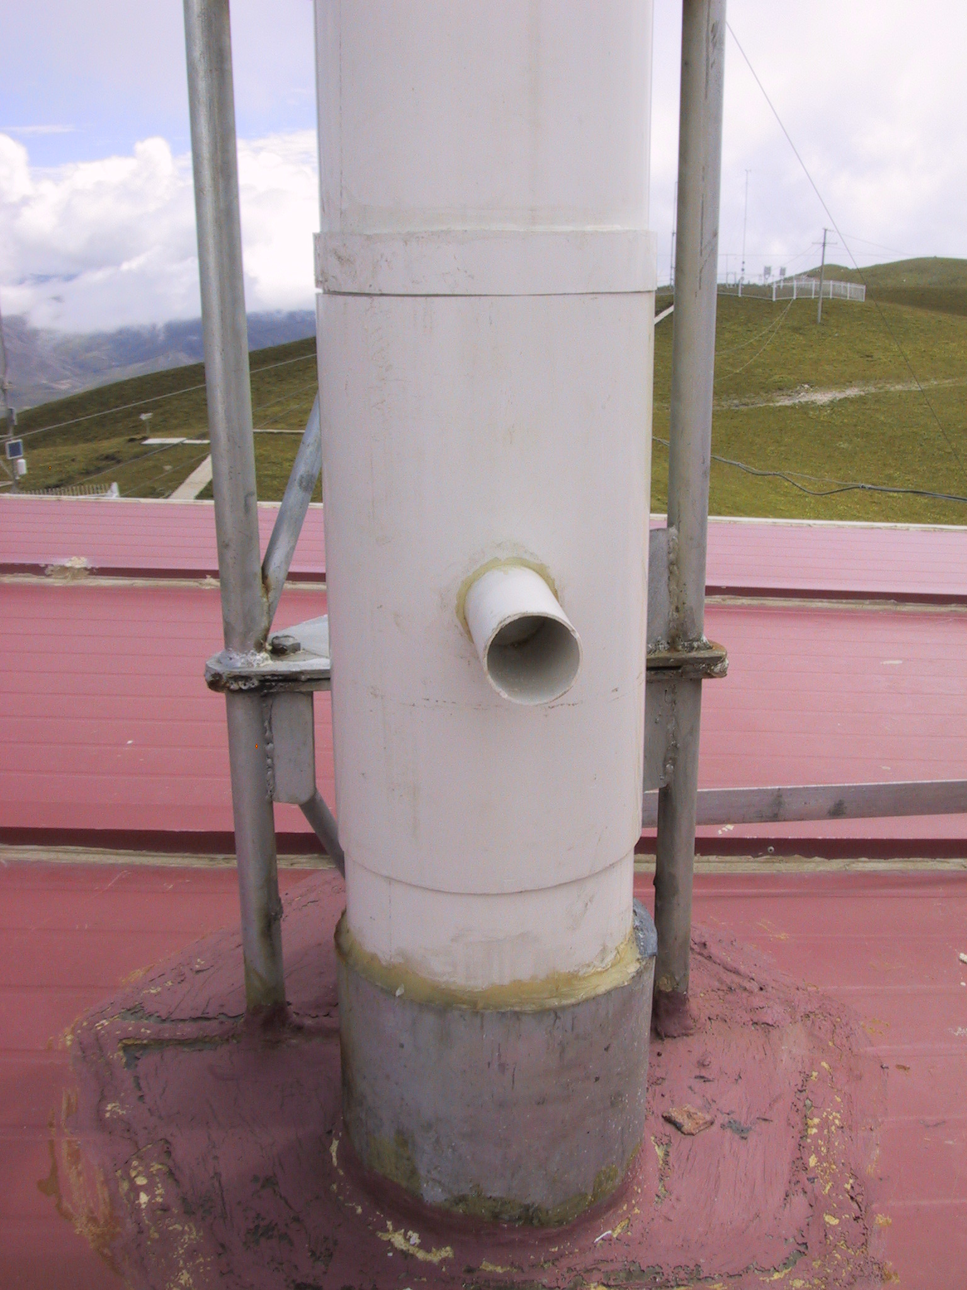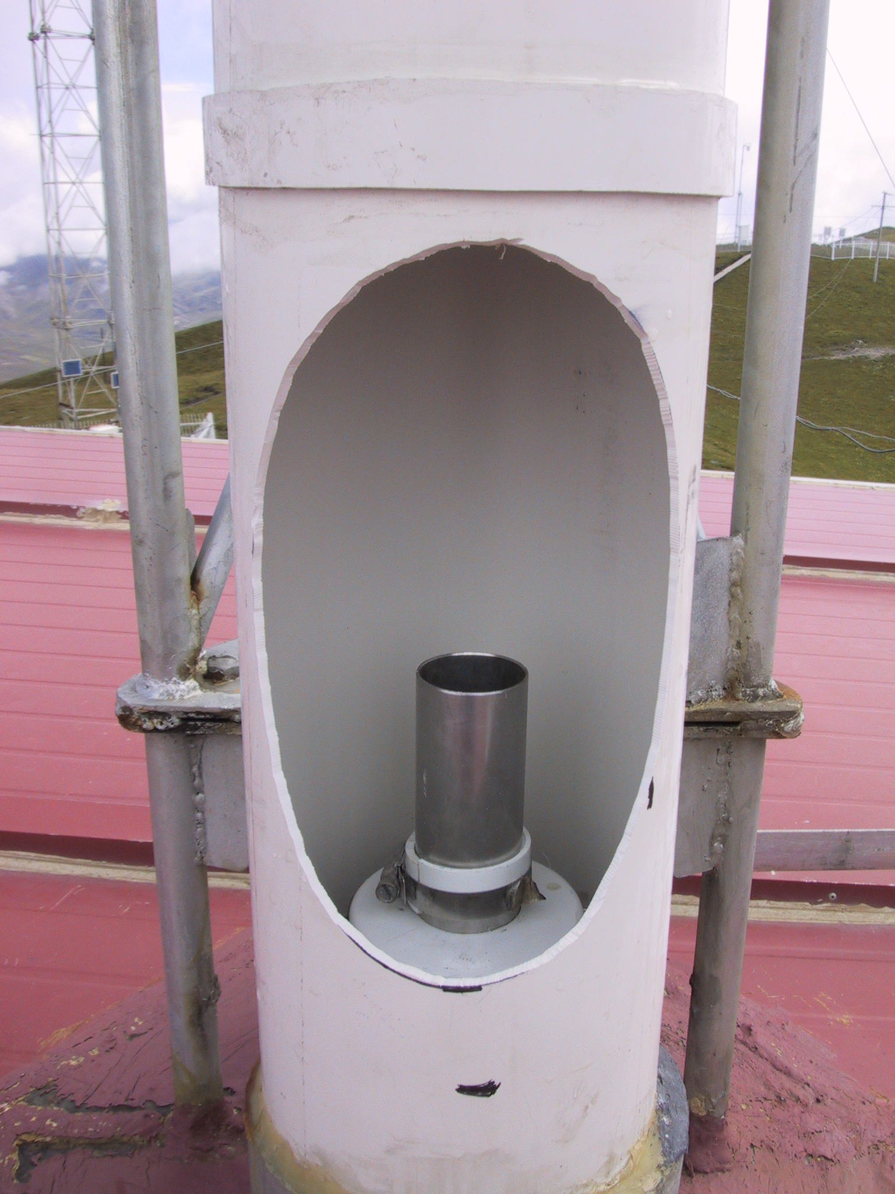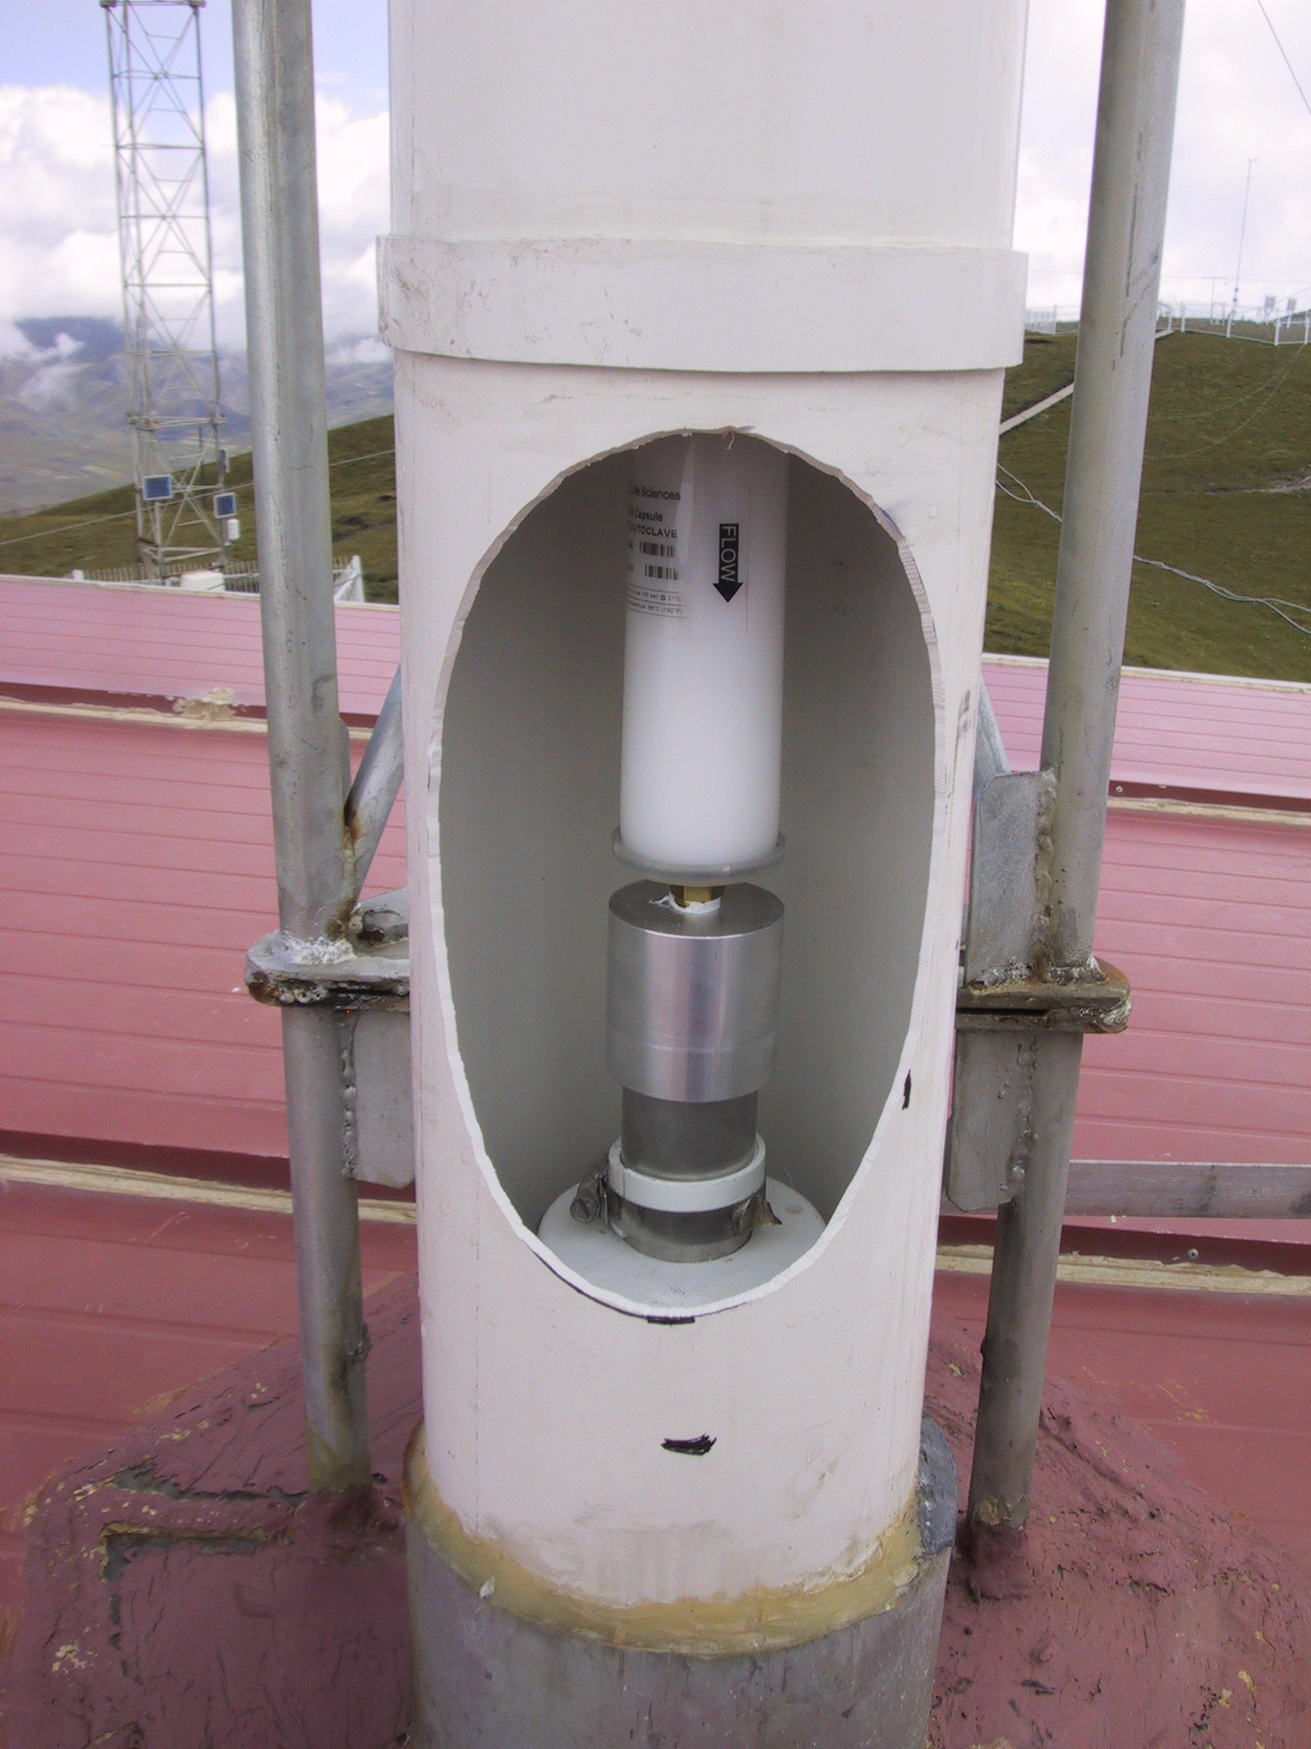
Stack Inspection Port Top of 5cm tube Zero Filter in place

Go back into the lab and observe the CPC reading and the dP_neph_imp value. The CPC is now sampling filtered air that has passed through the inlet and the splitter. It is NOT sampling air that has passed through the Impactor Box or the Nephelometer.

Enter a log message <Enter><Enter> “Filtered CPC count through inlet tubing = value; dP_neph_imp= value” <Enter>.

Next, we want to check for leaks that may occur in the Impactor Box. Turn the handle of the 3-way valve at the inlet of the CPC Drier tube from the “Sample” position to the “Zero” position. The photo below shows this valve in the “Sample” position. The handle should be rotated 90 degrees to move into the “Zero” position. Wait for the CPC counts to stabilize.

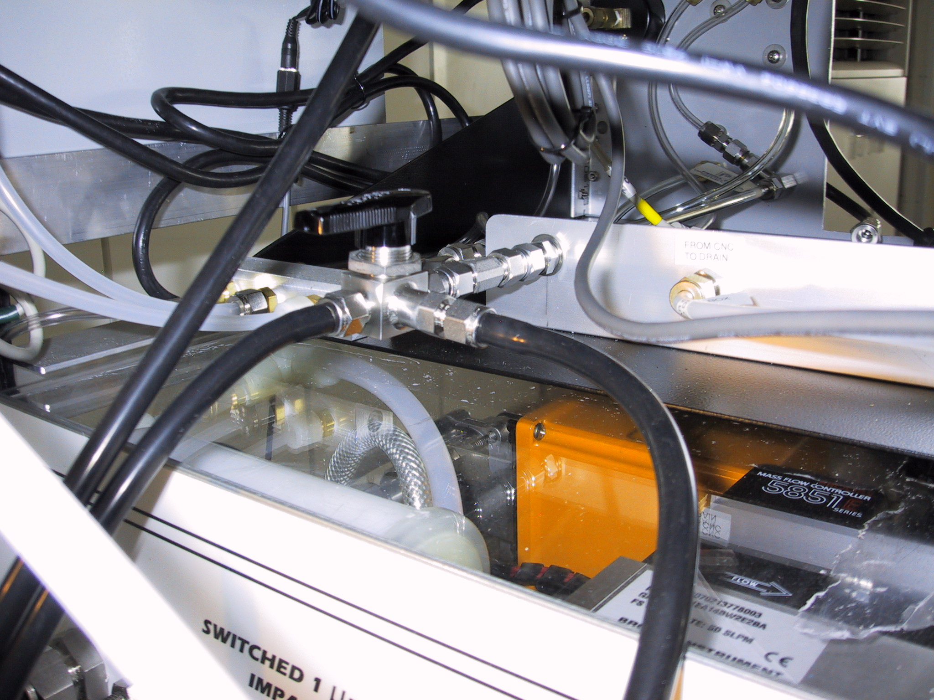
Zero Check Valve with handle in “Sample” position. Rotate handle to check for leaks in the impactor box.

Enter a log message <Enter><Enter> “Filtered CPC count through Impactor Box = value; dP_neph_imp= value” <Enter>.

If there is a large increase in CPC counts after turning the handle of the 3-way valve, it suggests that there may be a leak in the Impactor Box or the Nephelometer. The leak may be fixed by tightening tubing connections and fittings in the Impactor Box. If the count rate changed with tightening the fittings, enter another message stating what the new Filtered CPC counts and dP_neph_imp values are.

Acceptable ranges for these two variables when the 3-way valve is in the “Zero” position and when the filter is on the stack are:

dP_neph_imp > 20 CPC counts < 50

If the observed values are outside these ranges, there may be a leak in the system. A likely location to check is the connections on the impactors. If tightening those fittings doesn’t help, call Sun Junying at CMA.

When the leak check is finished, remove the stack zero filter and replace the inspection port on the 20cm PVC stack tube. Return the CPC 3-way valve to “Sample” position (i.e., parallel to CPC inlet drier tube).

Nephelometer Span Check - (Every Two Week Task)
Time required: Approximately 40 minutes
Tools/supplies: None
Overview: The nephelometer span check confirms that the nephelometer calibration is correct. The procedure is mostly automated, although the valve on the CO₂ tank needs to be manually opened and closed.

Plumbing
The plumbing for a span check is as follows: CO₂ tank → Regulator→ Flow Control Valve → Rotameter→ Small Filter → Copper tubing→ Nephelometer CO₂ inlet . The small filter can be placed at any point in the line between the CO2 regulator and the Nephelometer.

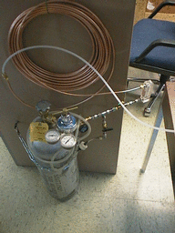

Operation
Press <Enter><N><M><3> on the computer keyboard to begin a CO2 span check. Open the main CO₂ tank valve (large valve on top of CO2 tank). After 3 minutes of flushing the nephelometer with filtered air, a valve on the nephelometer opens and CO2 should start flowing into the instrument. The CO₂ flow rate should be ~5-6 lpm at this time. If it is not, please adjust it to 5-6 lpm. The computer will prompt you for CO2 tank pressure and flow rate. It will also notify you when the span check is over and display the calibration results. About halfway through the span check, the measurement switches from CO2 to filtered air, and the computer requests that the main valve on the CO2 tank be closed. Please remember to close the valve on the CO2 tank after each span check! Conduct a second span check if the average deviation is more than 4% for either nephelometer.

Changing Nephelometer Lamp (when needed)
The CMDL scientist will let you know if this needs to be done. The nephelometer lamp usually last about six months. Typically, scientists watching the station data (lamp voltage and current) at CMDL can tell about a week ahead of time when the lamp is going to fail. We like to change the lamp before it fails due to the possibility that lamp failure could cause damage to the circuit boards. Detailed instructions for changing the nephelometer lamp are given in the TSI nephelometer manual on page 8-13.

CPC Butanol Flush (when needed)
Time required: 15 min
Tools/supplies: 9/16” wrench Phillips, waste butanol drain bottle
Overview: The butanol in the CPC absorbs water readily, so at humid sites the butanol should be flushed monthly to maintain the appropriate butanol properties and to keep the optics block clean. At less humid sites like Mt. Waliguan, the butanol can be drained when required. A CMDL or CMA scientist will advise when it is necessary to drain the butanol.

Detach the CPC vacuum line so no flow is going through the CPC. Attach the drain bottle to the CPC drain port on the front of the rack and loosen the cap. Butanol should flow into the drain bottle. Note: if butanol does not seem to want to flow, (1) detach the drain bottle (2) squeeze the bottle with the cap loose (3) tighten the cap keeping the bottle squeezed (4) reattach the drain bottle to the drain port (5) loosen the cap. This procedure should create a small suction to the bottle and get the butanol flow started.

Inspect the butanol you’ve drained out. If it looks pretty clear and not yellowish, refill the CPC with fresh butanol and reattach the vacuum line. If the butanol is not clear and/or has a yellowish tinge, refill and drain the CPC several times to try to clean the gunk out of the instrument. Contact the station scientist if the butanol remains discolored despite multiple drains.

System Clock
The system clock is synchronized automatically using the GPS unit.

Table 2 Difference between station local standard time (or daylight savings time) and UTC.
STN | BLD | WLG
hrs diff | -7 (-6) | +8

Instant Messenger
A text based instant messenger system is available within CPD. This is useful for troubleshooting with one person at the field computer and one person in Boulder. To use the instant messenger, both the person in the field and the person back in Boulder need to be logged into the field computer and running cpdclient. This assumes a network connection for the WLG aerosol computer.

Then both people follow these directions:
Bring up the main aerosol system menu by pressing <Enter>. Choose the option ‘Instant Messaging’ either by using the arrow keys or selecting <4> and hitting <Enter>. Then choose <M> to get a box for typing in messages. Hit <Enter> to send the typed message. When you are done with all the instant messaging, hit <Esc> to close the window.

Computer Operation

General
The computer runs the the Linux operating system. The data acquisition and instrument control is done with a family of programs, collectively referred to as 'cpd', which uses a client-server architecture to separate the continuous operating tasks (acquiring data, writing to disk, controlling instruments) from the user interface tasks. The server is called 'cpd'. There are currently two clients, 'cpdclient' for text-mode display (i.e., the screen with windows displaying values for different measurement parameters), and 'cpx' for graphical (stripchart) display. The text-mode client allows the user to issue commands to 'cpd'.

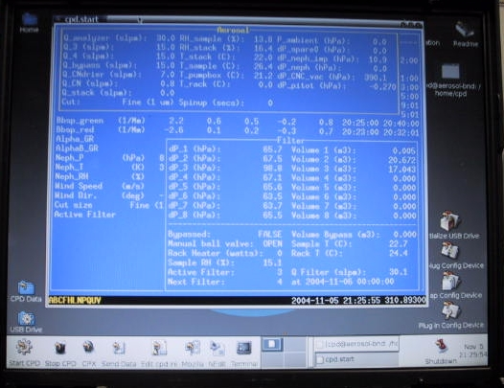 | 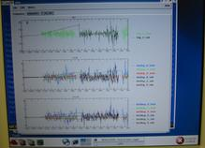
cpdclient (text mode) display  also called aerosol data logger window | graphical (stripchart) display in cpx

The system clock is set to UTC (6 hours different than Boulder time during daylight savings). The clock is synchronized with a network time server using the 'ntp' protocol. Some stations have a GPS receiver directly connected to the computer, in which case the GPS serves as the time standard. The system clock is displayed in the lower right corner of the Aerosol Data Logger window.

Instruments are connected to the computer via RS-232C ports.

Startup
This assumes you have a USB stick which is already initialized and a LiveCPD CD. The CD contains everything you need to run CPD on the computer, while the initialized USB stick contains station specific configuration information (e.g., the cpd.ini file) and, depending on configuration, the USB stick may also be the location where data is stored.

Insert USB stick in USB port (either on back of computer or in Edgeport module). Turn on PC. After a few minutes, the NOAA/CMDL aerosol data logger window will appear.
There are eight icons in the toolbar at the bottom left of the screen. The shutdown icon is the ninth icon at the very far right of the screen. Position the mouse over each one to see its function.
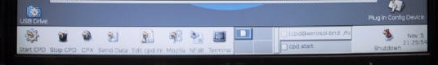

These functions, from left to right, are:
- Start data logger – the CPD program
- Stop data logger
- Stripchart data – the CPX program
- Send data to CMDL
- Edit the cpd.ini file (using Nedit)
- Web browser
- Nedit – which brings up a simple text editor window
- Icon to bring up a terminal window
- Shutdown everything!

To choose an action, click ONCE on the icon.

During normal operation you should not need to select 1 because the data logger starts up automatically when the computer is turned on. Number 4 also happens automatically, with a frequency between 1 and 4 times per day (you get an automatic email each time data is sent to CMDL and processed).

To start the data acquisition program, click on the “Start CPD” icon. This will start 'cpd' in a background window, and several seconds later starts 'cpdclient' in the terminal window.
To start the graphical client 'cpx', click on the “CPX” icon. This takes a little while to get started so don’t keep clicking if it doesn’t start right away!! To stop data acquisition, click on the “Stop CPD” icon. To shut everything off, click on the “Shutdown” icon. The “Shutdown” icon will ask whether you want to shut everything down, reboot or cancel the request to shutdown.

These programs can also be started from a command line in a terminal window by typing one of the following commands:
cpdclient - starts the text mode client
cpd.start - starts both the server and text mode client
cpd.kill - kills the server
cpx - starts the graphical client (X-windows only)

Shutdown
Terminate the data acquisition software by clicking on the “Stop CPD” icon.
To shut everything off, click on the “Shutdown” icon. The “Shutdown” icon will ask whether you want to shut everything down (halt), reboot or cancel the request to shutdown.
Wait for the computer to display “Power down.”.
Turn off power.

Archiving and Backing-up Data
Note: This is typically done automatically; these steps are needed only if manual archiving is required. The data archives are standard “ZIP” format. The data files are plain ASCII, tab-delimited, with headers. “A*.TXT files contain 1-minute averages. “M*.TXT” files contain snapshots (every 22.5 minutes) of system status info.

Saving to hard disc
If up-to-the-minute data are desired, press <Enter><2><2> in Root Menu to close current files and start new files.

Other desktop icons
In the lower left hand corner of the desktop above the toolbar there are two icons.
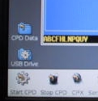
Clicking once on the CPD data icon opens a window with the file directory in which the current data is being logged.

If you need to transfer data or something from the field computer to a windows compatible USB stick, insert the USB stick into the USB port on the back of the computer or in the Edgeport device, and click once on the USB drive icon. This will bring up a window with the directory structure of the USB stick. (Note: you may need to refresh the directory window if a different USB stick had previously been inserted.) When you are done with transferring data (or whatever) remove the USB stick – the system will automatically dismount within 30 seconds or so. The USB icon has a little dot on it while the USB stick is mounted and the dot goes away when it automatically dismounts.

LiveCPD Documentation
There are icons on the upper right hand corner of the desktop documenting how this all works.
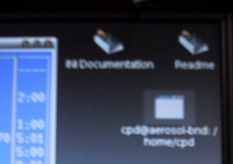
The INI Documentation icon opens a text document describing how to set up a cpd.ini file. The README icon describes the LiveCPD application in detail – how to configure the USB stick, more detailed descriptions of all the icons, etc. The documentation also explains the use of the icons in the lower right of the desktop.

Graphical Client Program (cpx)
The graphical client is a work in progress. Please send suggestions for improvement to John.A.Ogren@noaa.gov. Documentation for cpx can be viewed by clicking on the “Help” item on the cpx menu bar. This graphical interface allows you to see what’s happening with the data over time, so you could use it to watch CN counts get much lower when you put the leak test filter on the stack.

Aerosol Data Logger Program

General Operation
Press <Enter> to access menus, <Esc> to abort from any menu or entry box without any changes, <Enter> to accept the current entry or highlighted item. Any instrument window can be displayed by the shortcut key <Enter><X>, where “X” is the code letter for the desired instrument. Windows are closed by pressing the <Esc> key. Pressing the <Tab> key cycles the view among all the active windows. Windows can be repositioned on the screen using the arrow keys. Menu entries can be selected with the arrow keys or pressing the numerical digit for the desired selection.

The program will request an access code if you select a menu item that will result in a change to the data being logged to disk, in order to prevent inadvertent changes. The access code is ‘cmdl’ (lowercase is necessary).

Keystrokes | Action
<Enter> | Shows root menu
<esc> | Shows root menu and hides any active window
<Enter><X> | Selects root menu entry ‘X’ when root menu is not focused (X can be A,B,C,D,F,G,H,L,M,N,O,S,U,V,W or others depending on the station)
<Enter><D> | Disc operations menu
<Enter><Enter> | Online log entry (message window)
<F12> | Online log entry (message window)
<Control><E> | Toggles red error window (if present)
<Control><C> | Quit cpdclient
<M> | Shows menu for active window
<Tab> | Cycles through open windows
Arrow keys (in menu) | Move thru menu list
Number/letter (in menu) | Quick select on menu list
Keystrokes | Action
<Enter> (in menu/dialog box) | Chooses or toggles selected item
<Enter> (dialog box) | Begins enter input mode, text will be bolded; pressing <enter> again will end input mode
<Esc> | Exits menu/dialog box without applying changes
<Enter> (with bottom entry selected in dialog box) | Closes dialog box and applies all changes
<Enter><Enter> | Brings up message window

Display
The “base” display consists of a “root” window for displaying current values for ambient measurements and a status line at the bottom left of the screen.
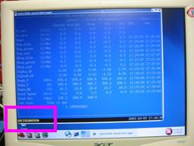 ←status line location (in pink box) in root window
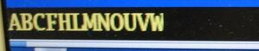 ←example status line

The bottom status line gives the code letters of the active instruments and the system date and time. If the code letter for an instrument is absent, then that instrument is not present or not responding.

The code letters are assigned in cpd.ini, and vary from station to station. Status windows for specific instruments can be displayed by pressing <Alt> plus the code letter for that instrument. Not all windows are operative at every station. Commonly-used code letters are:

Normal operation for a complete aerosol system is indicated by the code letters ABCDFHLMNOUVW which are interpreted as follows:
A – aerosol data system active and logging enabled
B – Best UPS active and logging enabled
C – CPC logging and contamination control algorithm active (not logged)
D – CCN active and logging
F – Filters active and logging enabled
H – Humidograph active and logging enabled
L – PSAP active and logging enabled
M – system monitor file logging (always present)
N – nephelometer (reference/dry) active and logging enabled
O – nephelometer (humidified/wet) active and logging enabled
U - μMAC1050 A/D I/O subsystem active
V - μMAC1050 A/D I/O subsystem active
W - Watlow PID controller active

The WLG station should show the code letters
ABCMNPRU

Root Menu <Enter> or <Esc>
Pressing <Esc> or <Enter> brings up the root menu, with the following choices (shortcut keys are in left column). Use the arrow keys to highlight the desired action and then press <Enter>. The WLG station does not have all of these options because some of the instruments are not deployed at Mt. Waliguan.

 | Online log entry | allows the user to make an entry in the system log file. Think of this as an on-line logbook, and use it liberally. Each entry can be at most 80 characters long, and each entry is recorded with a time stamp. Please make an entry for any deviations from normal operation, such as exceptions that you note on the daily checksheets. These logbook entries will be sent to the CMDL aerosol group by email shortly after the data are sent to Boulder.
1 | Client Options | controls some features of the client program.
2 | Disk operations | allows the user to flush any buffered data to disk, and to change to a new set of data files
3 | Save Window Setup | Saves layout of windows if you have a set up you like
4 | Instant Messaging | Starts Instant Messenger
A | Activate the aerosol status window | 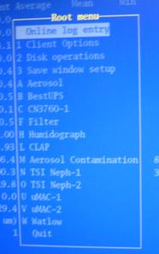
B | Activate the Best UPS status window
C | Activate the CNC status window (shows current concentration)
D | Activate the CCN status window
F | Activate the filter status window
G | Activate the GPS status window
H | Activate the humidograph status window
L | Activate the PSAP status window
M | Activate the Aerosol contamination window
N | Activate the nephelometer status window (Typically this is the ‘dry’ or ‘reference’ neph.)
O | Activate the second neph status window (Typically this is a ‘wet’ or ‘humidified’ neph.)
P | Activate the PID controller window
R | Activate the 3-wavelength PSAP window
U | Activate the umac status window (This is the main umac.)
V | Activate the 2nd umac status window (This is the umac that typically controls the filter carousel.)
W | Activate the Watlow status window (The Watlow controls things like temperature and relative humidities.) | exit the client program
 | Quit

Aerosol Status Window and Monitor Menu <Enter><A> and <M>
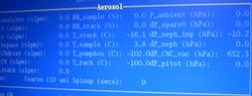 The aerosol status window shows the values of monitoring parameters like temperatures, humidities, pressures flows and sampling size cut (1 or 10 um). | 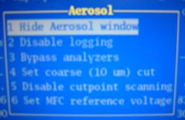 The aerosol menu allows you to disable logging, bypass the instruments, set the cut size, disable cut-size switching and change the reference voltage of the mass flow controllers.

Window hide/Window unhide <1> changes visibility of status window

Logging end/ Logging start <2> context-sensitive function to enable/disables logging of aerosol parameters

Analyzers bypass/Analyzers unbypass <3> context-sensitive function to bypass/unbypass the continuous analyzers

Cut coarse/Cut fine <4> context-sensitive function to toggle between sub 10 μm and sub 1 μm cut size

Scanning cut points <5> turns off switching between impactor size cuts

Analyzer flow <6> goes to menu for controlling flow thru instruments (e.g., mass flow controller). 1 volt corresponds to 10 lpm; the typical setting is 3 V to get 30 lpm. (This option is only used on aircraft systems.)

Nephelometer Status Window and Menu <Enter><N> and <M>
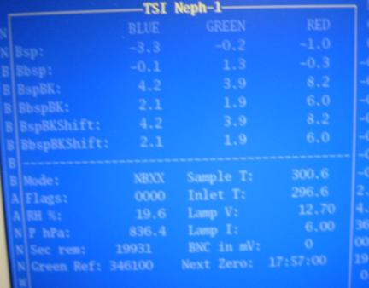 | This window shows the current state of the nephelometer, including measured light scattering and back scattering at 3 wavelengths, neph monitoring parameters like temperature and voltage and neph state.
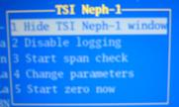the neph menu allows the user to do a span check and change neph parameters. | 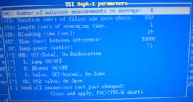 | The neph change parameters menu lets the user talk directly to the neph and affect its operating conditions.

Window hide/Window unhide <1> changes visibility of status window

Logging end/ Logging start <2> context-sensitive function to enable/disables logging of nepholometer parameters

Span Check /Abort Span Check <3> context-sensitive menu to start/abort a CO₂ span check.

Change parameters (formerly ‘Send command’ <4> Activates a menu for sending selected commands to the nephelometer. Not normally used except for troubleshooting.

Start Neph zero <5> starts neph zero

PSAP Menu <Enter><R> and <M>
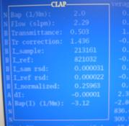The PSAP window shows the light absorption flows, transmittance through the filter and various other monitoring parameters. | 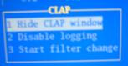the PSAP menu is used to disable logging of absorption data and to note when a filter change takes place.
Window hide/Window unhide <1> changes visibility of status window

Logging end/ Logging start <2> context-sensitive function to enable/disables logging of PSAP parameters

Start filter change/ End filter change <3> Context-sensitive menu to start/end a filter
Use this function to prevent data logging during a PSAP filter change, and to generate automatic log file entries when PSAP filters are changed.

Safety

Heater Control
If the pump fails, any of the heaters (stack, aerosol rack inlet) could overheat because the PID sensors don’t have flow past them. There is a high-temperature cut out switch on the heaters, which limits the temperature on the outer tube to about 80 degrees Celsius. If flow through the system stops, as in when a pump fails, please turn off the heaters by pulling out the circuit breakers on the PID control box (see photo below).

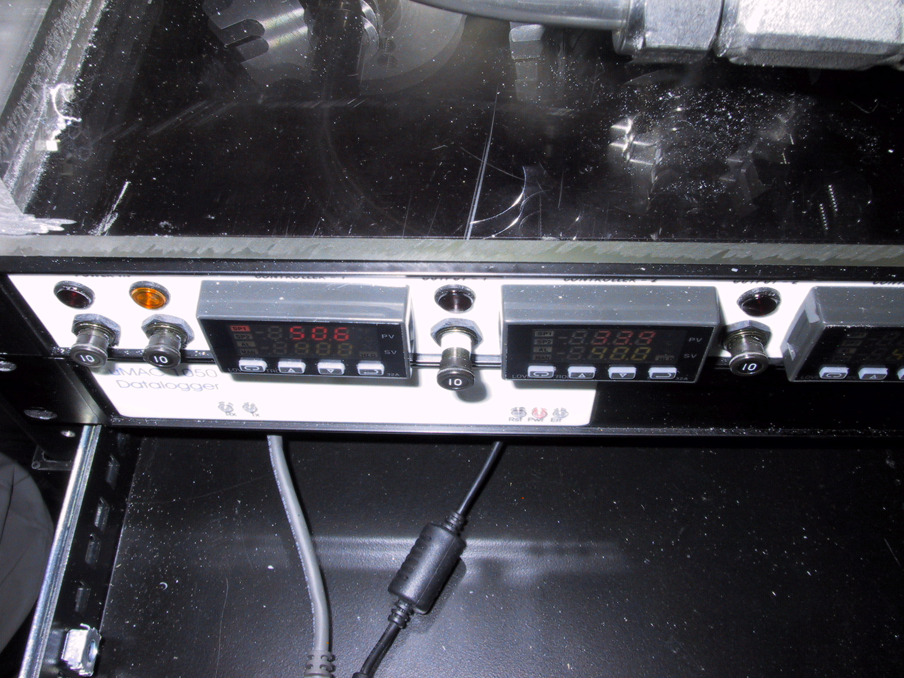
If air flow through the system stops, please pull out these circuit breakers to disable the heaters

Electrical Safety
We have insulated the electrical connections inside the rack, so that it is safe to perform standard tasks inside the rack (e.g., cleaning the impactors) with the power on. However for non-standard tasks (e.g., repairs), you should always remove power from the rack and the instruments you are working on..

Specifications

Power Draw at 115 V DC
Equipment | Draw (A) | Surge (A)
Carbon vane pump | 8.6 | 20
Diaphragm pump | 2.4 | 12
Bypass blower | 1.3 | 3
Cooling fan | 2.7 | 3.5
Aerosol System | 9.0

Additional Computer info

Data flow
The 'cpd' server logs data in the /aer/stn/log directory, where "stn" is the identifier of the station. Every six hours (or 24 hours in some cases), the current data are archived in a zip file, for subsequent transmission to CMDL in Boulder. The program that does the archiving is /aer/prg/cpd/cpd.archive, which is scheduled to run by the cron daemon. The configuration file for cron is /aer/prg/crontab/crontab.stn. The archived data are stored locally in the /aer/stn/log/sent directory. In Boulder, the data are initially put in the /ftp/incoming/aer/stn directory on the ftp.cmdl.noaa.gov server.

Aerosol Server Program (cpd)
Operation of cpd is controlled by a plain-text configuration file /aer/prg/cpd/etc/cpd.ini. Configuration information for different stations are contained in separate files; for example, the SPO configuration file is /aer/prg/cpd/etc/cpd.ini.spo. Normally, cpd.ini is a symbolic link file that points to the station-specific configuration file. Detailed information on the entries in cpd.ini can be found in /aer/prg/cpd/usr/doc/cpdini.txt.

The server program is designed to run as a daemon, which means that the user does not directly interact with the program. It is started with the 'cpd -d' command, and terminated with the 'cpd.kill' command. To verify that the server program is operating, type 'cpd.ps' from a command prompt. This will display the processes associated with the cpd program.

User account
The computer is configured to automatically log into the 'cpd' user account, which is used for running the cpd program at field stations.

Location of this document
This document is stored in /aer/doc/ops_man/oper_man_gen_cpd.doc.

