- Open the SouthPole_CONTOUR Excel file in the AFTP folder below.
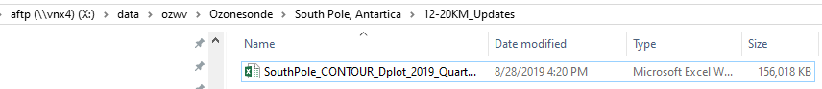

- Go to OWV SouthPole_Processed_V.4 folder to create quarter km pivot table csv file in SkySonde processor – creates the LEV_pivot file.

- Copy the entire contents (cells) of the recent flight SP###_YYYY_MM_DD_LEV_pivot.csv file

- Paste in to the last row of data in the Data worksheet in the Excel file: SouthPole_CONTOUR_Dplot_2019_QuarterKM file.

- Update Column A row count so it continues to match the cell row number to the left.
NOTE: There are calculation cells to the right of the last column in this worksheet. Column AD – BB have calculated cells used in the Pivot Table so be sure not to delete cell rows.

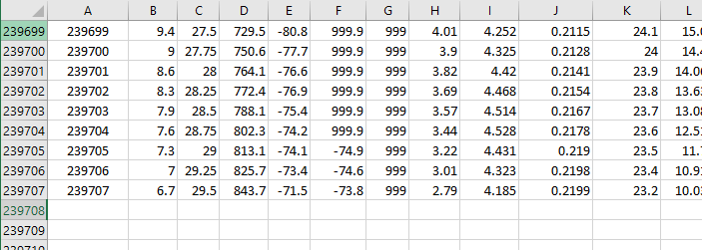
- Go to the Worksheet: PV_12-20km to “refresh all” the 6 Pivot Tables.
- Go to the last line of updated data in columns A-S.
- Copy the last line and paste in the last line of the Excel CSV file: spo5_2019_08_20.csv in 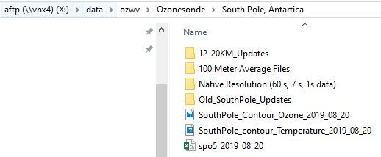
- 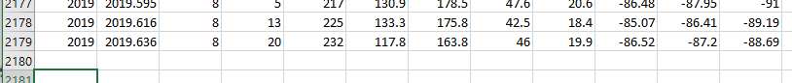

- Save the spo5_2019_MM_DD file with the new month and date. This is the file Kirk uses to update South Pole web plots.

- Save and close file.

