Comparison of Aerosol Optical Property Climatology
Between In-situ Surface Measurements and Model Simulations

Abstract
In the spring of 2015 AeroCom initiated the INSITU project designed to evaluate the performance of a suite of AeroCom aerosol models with surface, in-situ aerosol optical observations from the approximately 70 surface sites which have submitted their data to the World Data Centre for Aerosols (http://ebas.nilu.no/). Here, results from the first phase of analysis investigating how well models reproduce observed aerosol climatologies on a variety of time scales are presented. The results suggest that the combined model median over-estimates aerosol absorption and under-estimates aerosol scattering relative to the in-situ observations. This results in the simulated aerosol single scattering albedo being lower than the observed single scattering albedo. Additionally, the models suggest that the atmospheric aerosol has a greater contribution from coarse aerosol at most surface sites (as indicated by lower scattering Angstrom exponents) than is indicated by the in-situ measurements. The ability of the models to reproduce the observed systematic relationships among aerosol optical properties shows blah blah. Reasons for the observed discrepancies include blah blah.

1. Introduction, Background and Literature Review
Atmospheric aerosol particles are spatially and temporally inhomogeneous, due to variations in source strength, location and seasonality as well as changes due atmospheric transport and processing. Even if the variability in space and time is disregarded, aerosol particles are complex – they can vary in size, shape, composition and number. The physical and chemical characteristics of aerosol particles determine their optical properties (e.g., how they scatter and absorb light) and thus control their radiative effect in the atmosphere. The radiative effects of atmospheric aerosol particles are a key element to understanding climate forcing (IPCC, 2013).

Global climate models provide a method for evaluating aerosol effects on climate. By incorporating information on sources (e.g., emissions inventories), transport (e.g., meteorology) and parameterizations of aerosol properties and processes (e.g., hygroscopicity, removal rates, etc.) models are able to simulate location, amount and characteristics of aerosol particles across the globe and evaluate the resulting aerosol influence on the radiative energy balance. While model input (e.g., temporal and spatial resolution, complexity of parameterizations, etc.) continues to improve, it is important to recognize that there are many assumptions utilized in model simulations and that, therefore, model output needs to be evaluated against high-quality observational datasets.

The need for model evaluation has long been recognized and many studies have compared model output with observational data sets to identify the ability of models to simulate atmospheric constituents/characteristics as a function of space and time (e.g., references). AeroCom (Aerosol Comparisons between Observations and Models, http://aerocom.met.no/) was initiated in order to evaluate similarities and differences amongst models simulating global aerosol properties as well as to provide a framework for model/measurement comparisons of aerosol properties (Kinne et al., 2006). Many of the comparisons between AeroCom model simulations and observational data have been performed using remote sensing measurements of aerosol optical properties (i.e., from satellite retrievals and the AERONET surface network of sunphotometers) (e.g., Kinne et al., 2006; Koffi et al., 2012; xxxx; Kim et al., 2014; Lacagnina et al., 2015) because of the global coverage provided by satellites and the relatively dense global network of AERONET sites.

Some of the model/in-situ measurement comparisons performed by the AeroCom community include dust (Huneeus et al., 2011), black carbon (e.g., Samset et al., 2014; Jiao et al., 2014; Koch et al., 2009; Vignati et al., 2010; organics (Tsigaridis et al., 2014), and aerosol microphysics (Mann et al., 2014). Something about what these comparisons have shown? Something about how the models move chemical components around and then derive optical properties from them to link with next paragraph.

Less effort however has been put into evaluating simulated aerosol optical properties with in-situ surface measurements of these properties. This is due in part because in-situ measurements tend to have sparse global coverage relative to satellite measurements and the AERONET surface network. Additional reasons include access to and understanding of the available in-situ measurements. Despite the sparseness of in-situ surface measurements, there are some significant advantages to utilizing in-situ measurements, particularly from long-term surface sites. First, these measurements can be directly referenced to physical standards. Blah blah. Second, in-situ measurements of some parameters (e.g., absorption and single scattering albedo) can be made reliably at lower aerosol loadings than is possible with remote sensing or satellite retrivals. For example, AERONET retrievals of column single scattering albedo require AOD at 440 nm to be greater than 0.4 (e.g., Holben et al., 2006). This level of AOD is not representative of the vast majority of global annual average AOD (e.g., Andrews et al., 2017). Similarly, Sheridan et al. (2012) showed that CALIPSO wasn’t sensitive to aerosol extinction below ~25 Mm⁻¹. Third, surface in-situ measurements can be made continuously – they are not affected by the presence of clouds, orbit schedule or lack of incoming solar radiation (i.e., night!)

The primary objective of AeroCom is to improve modeling of aerosols and thus improve predictions of the aerosol-related climate effects. Because, ultimately, the climate effects of aerosol particles are caused by their optical properties, this paper focuses on the use of in-situ surface aerosol optical property measurements to evaluate the performance and biases of a suite of AeroCom aerosol models. The scientific questions to be answered are:
- How well do modelled global aerosol optical property climatologies compare (temporally and spatially) to climatologies derived from measurements of in-situ surface aerosol optical properties?
- Do models have significantly more than in-situ inter-annual aerosol variability?
- Can models reproduce the observed systematic variability of aerosol optical properties and what does this tell us about model parameterizations of aerosols?
The goal of this research is to inform iterative improvements to model aerosol modules in order to better the predictive capability of global climate models. To support this goal, the in-situ data used in this analysis has been made available as a benchmark data set for future analysis as models evolve.

2. Methods
2.1 Description of in-situ aerosol optical property data
The data used in this study consists of surface in-situ aerosol light scattering coefficients and aerosol light absorption coefficients. The measurements are typically made following GAW protocols (WMO, 2016) meaning the measurements are made at controlled humidity (usually RH<40%) and have appropriate instrumental corrections applied as described below. Figure 1 is a map of the surface in-situ sites used in this study. Table S1 in supplemental materials provides more information about the surface sites used in this study.

The Level 2, hourly-averaged QA/QC’d surface in-situ aerosol optical property data were downloaded from EBAS (Tørseth et al., 2012; http://ebas.nilu.no/) and underwent further review and interaction with the data providers as previous efforts involving multi-site analyses have shown external data review to be extremely helpful (Asmi et al., 2013; Collaud Coen et al 2013; Andrews et al., 2011). The hourly data are averaged to coarser time resolutions for comparison with less temporally resolved model output.

The light scattering measurements are made by integrating nephelometers (either TSI model#3563 or various models of the Ecotech nephelometer). The TSI nephelometer is a spectral instrument (450, 550 and 700 nm) allowing the calculation of wavelength dependence of scattering. Most sites with Ecotech nephelometers also submitted spectral scattering (450, 525 and 635 nm) although some sites operated single wavelength Ecotech instruments. TSI nephelometer data were corrected for known instrument non-idealities (truncation, light source) using the Anderson and Ogren (1998) method. Ecotech nephelometer data were corrected using Mueller et al. (2011).

The light absorption measurements are made using a variety of filter-based instruments including the Multi-Angle Absorption Photometer (MAAP, Thermo, Inc.); the Particle Soot Absorption Photometer (PSAP, Radiance Research) and the Continuous Light Absorption Photometer (CLAP, NOAA’s extended sampling time version of the PSAP). The MAAP and original PSAP are single wavelength instruments providing light absorption at 635 nm and 550 nm, respectively. The CLAP and newer versions of the PSAP are multi-wavelength instruments (PSAP: 467, 530 and 660 nm; CLAP: 467, 528 and 652 nm). The PSAP and CLAP are corrected for scattering artifacts, etc. (e.g., Bond et al., 1999, Virkkula et al., 2005; 2010, Ogren et al., 2010). Aethalometer data were not used as, when the project was initiated, EBAS did not have an approved Level 2 data format for reporting corrected, QA/QC’d aerosol absorption from aethalometer measurements. (An aethalometer correction and is now available for reporting absorption from the AE31 aethalometer model, but it many cases those corrected data are not yet submitted.)

From the available measurements of aerosol light absorption and scattering additional parameters can be calculated. Here we will focus on two: the aerosol single scattering albedo (SSA) and the scattering Angstrom exponent (SAE).

(1) SAE = log(σ₁/σ₂)/log(λ₂/ λ₁)
and
(2) SSA = σ_{sp,i}/(σ_{sp,i} + σ_{ap,i})

where σ is the aerosol light scattering or absorption (subscript ‘sp’ subscript ‘ap’, respectively) at wavelength i (λ_{i}).

SAE is a parameterization of aerosol size. Larger SAE values (SAE ~2) indicate that there is more scattering contribution from sub-micrometer particles while smaller SAE values (SAE<1.5) indicate larger particles (>1 μm) have a greater contribution to the observed light scattering (reference). Delene and Ogren (2002) showed that SAE strongly correlated with the fine mode fraction, which is useful as the fine mode fraction is often used as a proxy for anthropogenic aerosol.

The SSA provides information on the contribution of aerosol absorption to aerosol extinction. Values of SSA close to unity represent a primarily scattering aerosol (little to no absorption) such as sea salt. As SSA decreases from 1 this indicates that relatively more absorption is contributing to extinction. The single scattering albedo of black carbon is approximately 0.3 (Bond and Bergstrom, 2005).

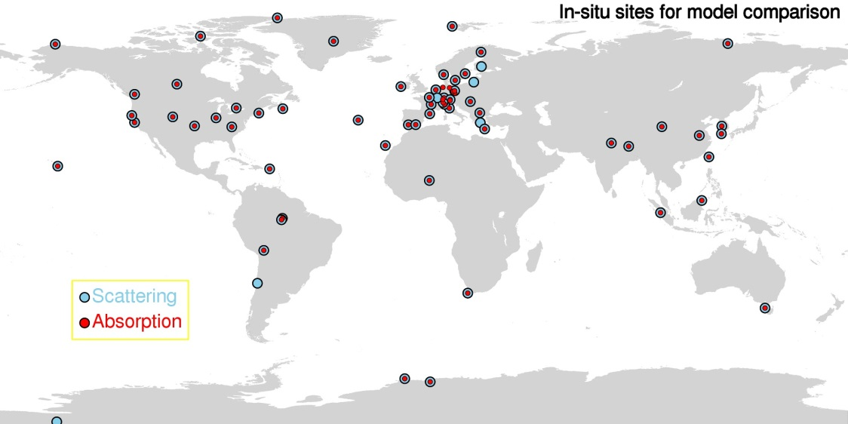
Figure 1. Map of sites with in-situ aerosol scattering and absorption. Need to update with actual sites used.

2.2 Description of AeroCom models used (grid size, temporal res, variables, etc)

Model output was requested from the AeroCom community of aerosol modelers for the INSITU experiment. The specific output requested was: https://wiki.met.no/_media/aerocom/INSITU_AeroComPIII_description.pdf. Table 1 provides a list of the models which provided output either for this Phase III AeroCom data call or had previously provided relevant data for an AeroCom Phase II data request.

Table 1. Description of models used in analysis
Model name  Gridbox size  Output Year | Citation(s) | MET | Mixing | Something  Else  Chemistry?  Emissions?
TM5  3.0° x 2.0°  2010 | Van Noije et al., 2014 | Offline (ERA-Interim) | Internal mixing within modes
GEOS-Chem  2.4° x 2.0°  2010 | Bey et al. (2001) | offline chemistry-transport model  (GEOS-5) | External mixing
CAM5  2.4° x 1.9°  2010 | Liu et al. (2012)  Ghan et al. (2012) | horizontal winds nudged towards ERA-Interim reanalysis | Internal mixing by volume
ECHAM6-SALSA  1.8° x 1.9°  2010 | Bergman et al. 2012.  Laakso et al., 2016 | Nudged towards ERA-Interim reanalysis data | Internal mixing by volume
GEOS5-Globase  1.25° x 1°  2010 | Chin et al., 2002, 2014  Colarco et al. 2010 | runs in “re-play” mode; MERRA met analysis | External mixing
GEOS5-MERRAero  0.6° x 0.5°  2010 | Buchard et al 2015, 2016 | Driven by meteorology from the MERRA-1 reanalysis | External mixing
OsloCTM2  2.8° x 2.8°  2008 | Myhre et al. 2013  Skeie et al 2011 | Offline meteorology from IFS ECMWF | Need to look at aerocom wiki
GOCART  2.5° x 2.0°  2006 | Chin et al., 2009 | Offline CTM. | External mixing
MPIHAM_v1  1.8° x 0.9°  2006 | Waiting for Kai
MPIHAM_v2 (HCA)  1.8° x 0.9°  2006 | Zhang et al. 2012 | Nudged to ECMWF analysis | Volume weighted mixing
SPRINTARS  1.1° x 1.1°  2006 | Takemura et al. 2005 | Nudged by the NCEP/NCAR reanalysis. | External mixing
EMEP  0.5° x 0.5°  2010 | Simpson et al. 2012 | off-line 3-hourly fields from ECMWF-IFS | External mixing
OsloCAM5.3  1.25° x .9°  2010 | Grini/Kirkevåg et al. (in prep) | Nudged to ERA interim meteorology | Internal mixing by volume
ECMWF
Philip stier’s model?

2.3 Merging of model and measurement-
- Picked closest model gridpoint (same as Eckhardt et al., 2015)
- Mention Schutgens paper about matching temporal sampling – for averaged comparisons we required 80% coverage (e.g., 292 days of in-situ data to represent an annual average, 73 days of in-situ data to represent a seasonal average and 24 days of in-situ data to represent a monthly average.
- Adjusting in-situ measurements to ambient TP. Because not all models provide or sites provide the necessary T&P values, a pressure value was calculated based on site elevation, and an annual average temperature was assumed.

2.4 Description of benchmark dataset format and availability (if created) (or should this be in supplemental materials along with a list of sites/locations/instruments, approx.. date ranges?

2.5 Model performance
- Taylor diagrams (Taylor, 2001) is a means of plotting model/measurement comparisons on a single plot in terms of three statistical parameters: standard deviation, root mean square error(?) and correlation in order to see if there are patterns in the comparison. Data can be normalized so can plot disparate data sets on same plot
- other methods for evaluating/quantifying model performance (quilt plots?)

3. Results
3.1 Climatological comparisons
Look at model comparisons on different time scales (annual, seasonal, monthly, daily). Look in terms of point to point comparisons (xy-plots) and also global context (contour plots). Climatology tells us how well models are doing at a given location.

3.1.1 Annual Comparisons

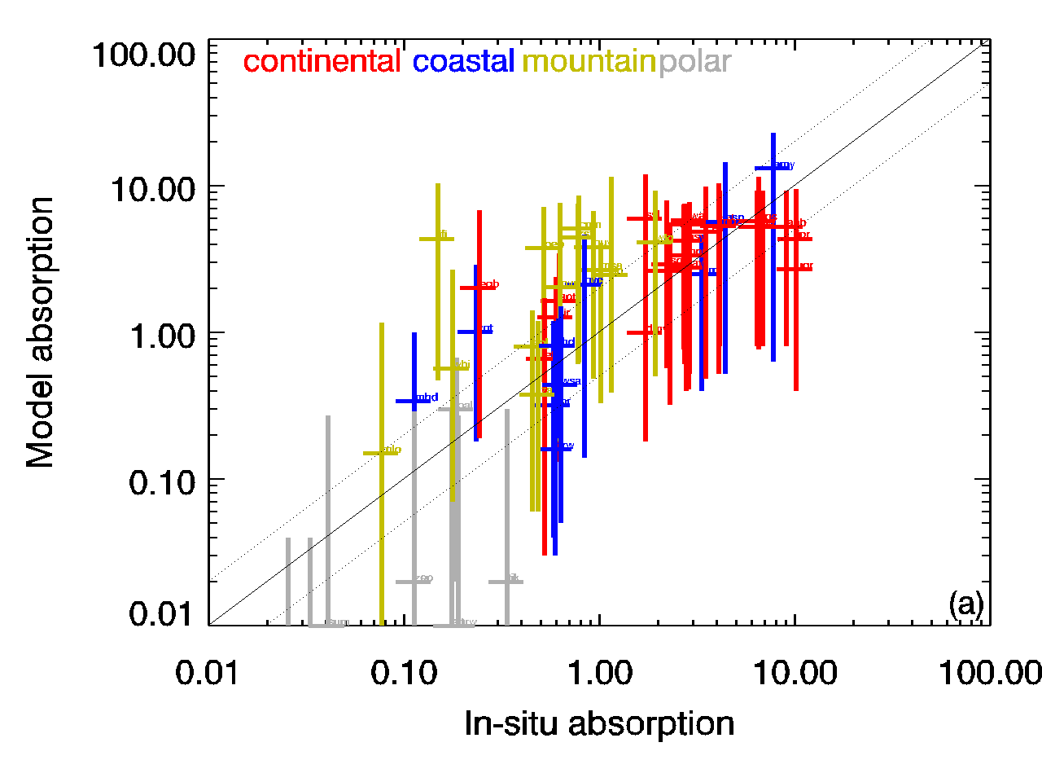 | 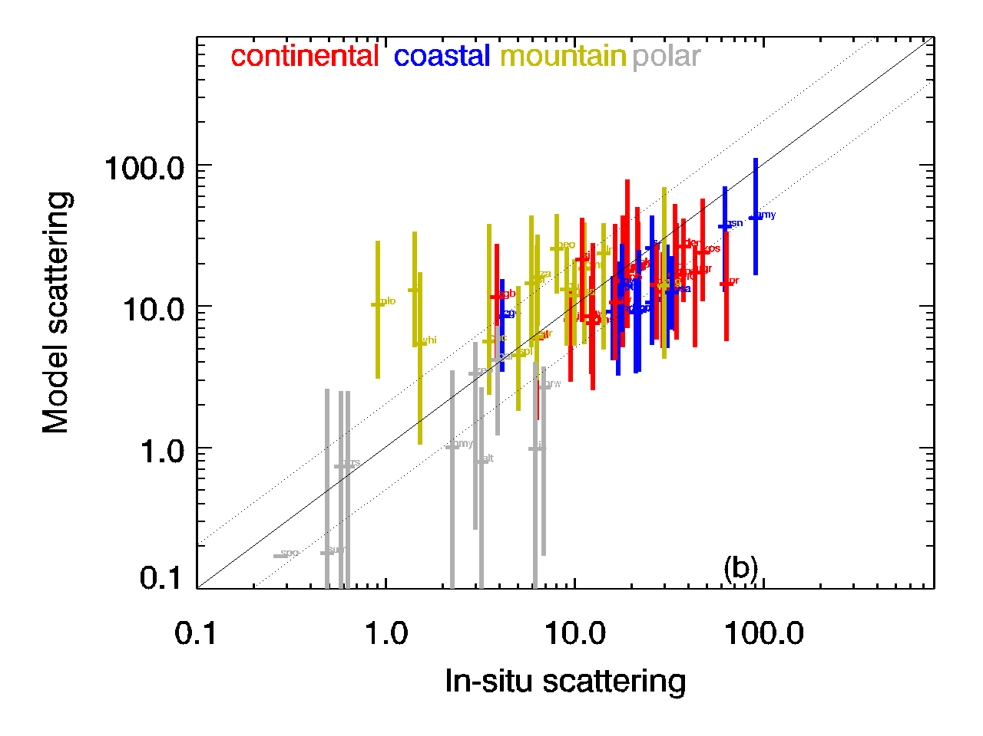
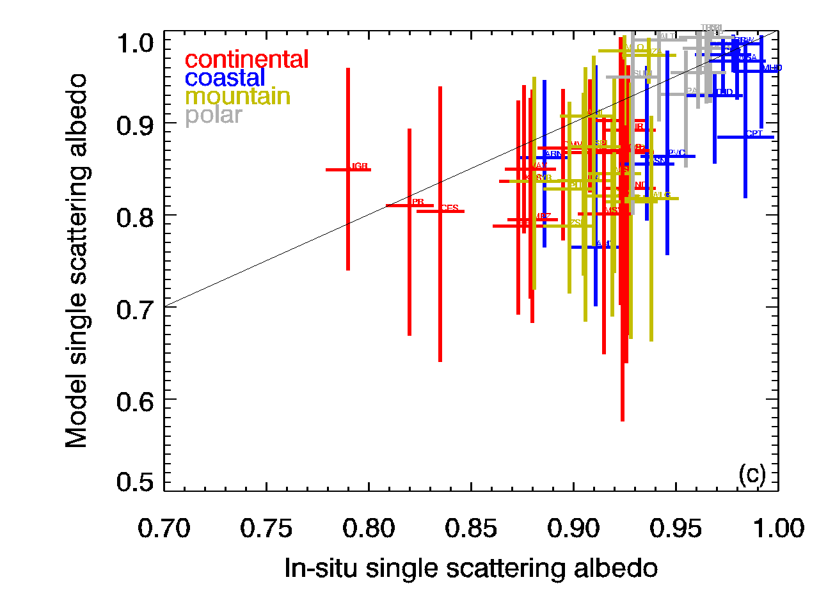 | 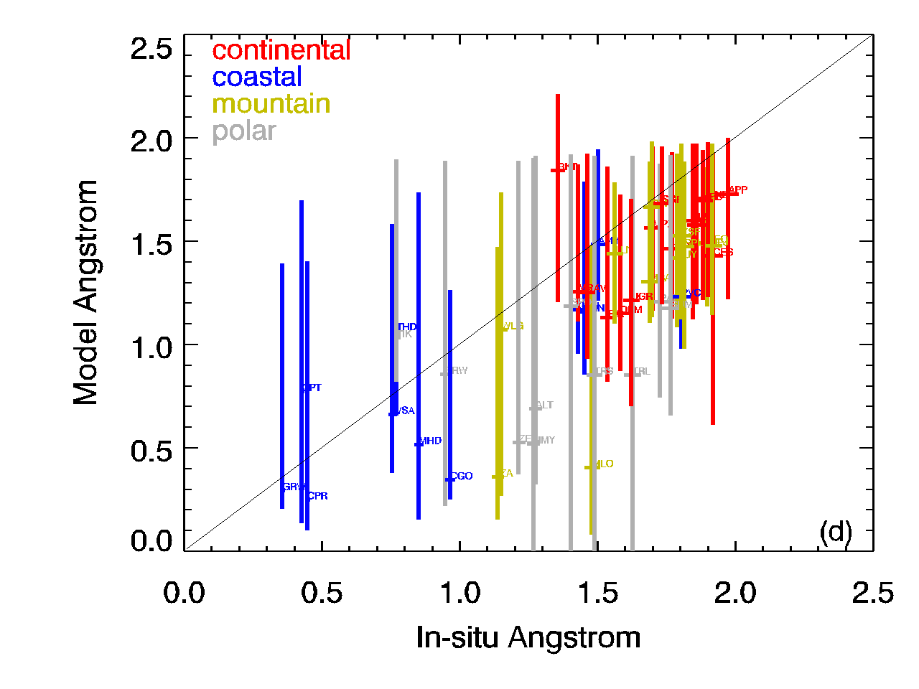
Figure 2. Comparison of annual in-situ and model aerosol optical properties colored by site type. Horizontal bars indicate uncertainty in in-situ measurement; vertical bars indicate range in model output over the X models in Table 1. Colors indicate site type (a) Aerosol absorption at 550 nm; (b) Aerosol scattering at 550 nm (c) Single scattering albedo at 550 nm (d) Scattering Angstrom exponent for 440/550 wavelength pair.

Figure 2 shows the relationship between annual median observations and model simulations of several aerosol optical properties (absorption, scattering, single scattering albedo and Angstrom exponent) for all models listed in Table 1. Figure 2a suggests that models tend to over-predict aerosol absorption - the median values of model simulated absorption tend to lie above the 1:1 line. This is the opposite of what is found when modelled aerosol absorption optical depth (AAOD) is compared with AAOD obtained from AERONET retrievals (e.g., Bond et al., 2013 and references there in). This will be further discussed in the discussion section. In contrast to the absorption comparison, Figure 2b indicates that the median simulated scattering values tend to be lower than the in-situ observations, with the model median primarily falling below the 1:1 line. Note that Figures 2a and 2b have log axes so departures from the 1:1 line may indicate significant differences. Comparing the range in model simulations (the vertical bars), there appears to be more model diversity in aerosol absorption than there is in aerosol scattering.

The over-prediction of absorption and under-prediction of scattering by models leads to the models simulating a lower single scattering albedo (darker aerosol) relative to the SSA determined by in-situ surface measurements (Figure 2c). There is consistency between models and measurements in that, as would be expected, the aerosol at coastal and polar sites tends to be less absorbing aerosol (i.e., higher SSA) than is found at most continental sites.

Figure 2d suggests that, based on Angstrom exponent values, models tend to simulate an aerosol that has a larger coarse aerosol contribution than indicated by the spectral in-situ observations at most sites. The model diversity in Angstrom exponent is also interesting – the range in simulated values for coastal and polar sites is approximated twice the range simulated for Angstrom exponent at continental sites

There aren’t many obvious relationships between site type and model/observation differences, probably because the site type designations (polar, coastal, mountain, continental) cover such a wide range of sampling conditions (e.g., continental Europe and rural Illinois fall into the same category). One notable exception is that the model medians tend to underestimate the observed aerosol loading (both absorption and scattering) at polar sites (gray data points on Figure 2). It is also comforting that the models are fairly consistent in their over-predictions of aerosol loading at these high altitude locations as high elevation sites typically would be expected to be cleaner (less aerosol) than the surrounding lower elevation terrain. This demonstrates the effect of topography on sub-grid variability when comparing the simulated ‘surface’ values when the grid boxes encompass complex terrain.

Figures 3-6 show percent difference maps of the same annual data depicted in Figure 2 segregated by model. By looking at the percent difference values on a global map, spatial patterns in model/in-situ discrepancies can be identified.

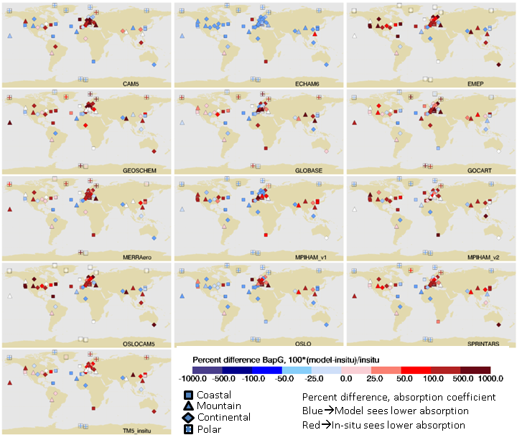
Figure 3 Percent difference ([100*(Model – in-situ)/in-situ]) of annual median aerosol absorption coefficient at 550 nm –updated may 3,2017

With the exception of the ECHAM6 simulation, most models predict higher absorption than is observed at the in-situ measurement sites (red-colored points). This is particularly noticeable at the cluster of sites in continental Europe and for most models and sites across the continental US. Only at some of the sites on either side of the Atlantic (mostly coastal) are the in-situ absorption measurement consistently larger than the model values (blue-colored points). Does the lack of polar pattern indicate an improvement since Koch? What about more recent sabine E. paper?

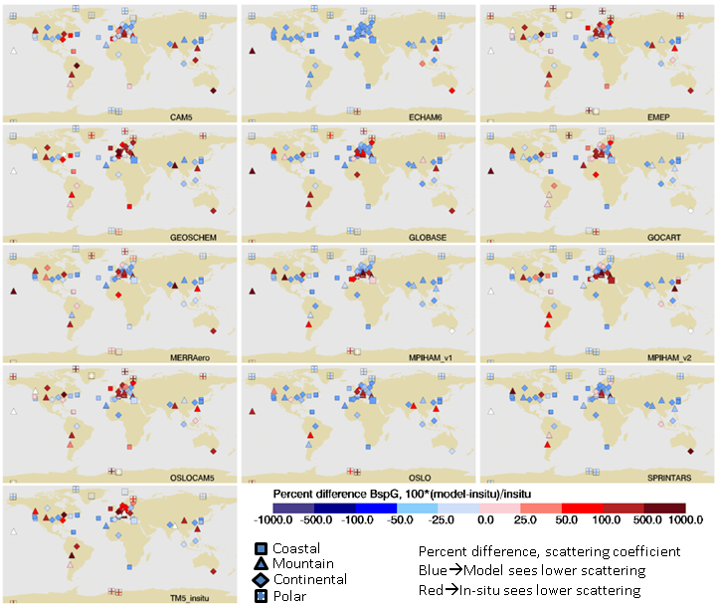
Figure 4 Percent difference ([100*(Model – in-situ)/in-situ]) of annual median aerosol scattering coefficient at 550 nm

In contrast to the absorption comparison, the models tend to simulate lower scattering than the in-situ measurements at most US and Asian sites. The exceptions are a few high elevation sites (WLG, LLN, PYR) in Asia where several of the models suggest higher annual scattering than is observed. Simulated scattering values for continental Europe are more likely to be higher than the in-situ observations regardless of station altitude. As with the absorption simulations, ECHAM6 is an outlier – the model consistently underpredicts measured aerosol light scattering at almost all sites. As suggested by Figure 2b, model simulations of scattering in the Arctic tend to be low relative to measurements, although several models (EMEP, GEOSCHEM, GLOBASE, MERRAero, and OSLOCAM5 and TM5) simulate higher values in the European Arctic than are observed.

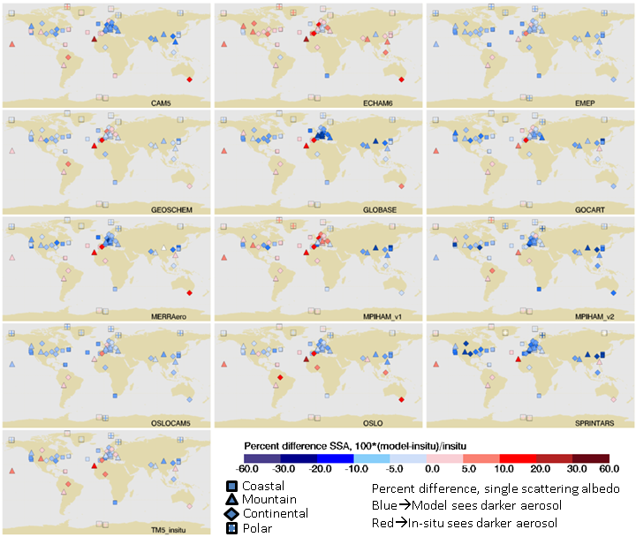
Figure 5. Percent difference ([100*(Model – in-situ)/in-situ]) of annual median aerosol single scattering albedo at 550 nm

As suggested by Figure 2d, the models tend to predict a lower single scattering albedo than obtained from the measurements, particularly in the 30-60º latitude band. The exceptions tend to be at coastal and high elevation sites. Again, ECHAM6 is an outlier in that simulated values of SSA are higher than observations at most sites. The large SSA differences observed in continental Europe reflect the absorption and scattering hotspots shown in Figures 3 and 4. Many of the differences in SSA between simulation and measurement fall in the -10-30% difference range. For those cases, the model SSA may be 0.1 to 0.3 lower than in-situ SSA. Differences of this magnitude can change the direction of forcing depending on the underlying surface (e.g., Randles et al??).
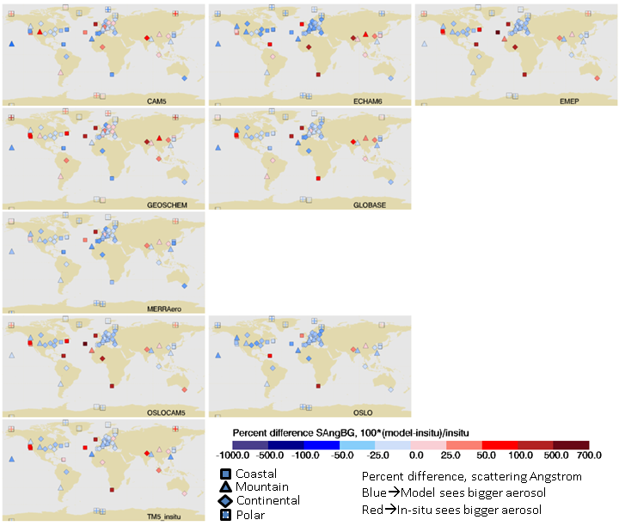
Figure 6 Percent difference ([100*(Model – in-situ)/in-situ]) of annual median aerosol scattering Ångström exponent at 550 nm. Plot gaps are for models that did not provide spectral optical properties.

Figure 6 shows percent difference plots for the scattering Angstrom exponent. No plots were made for four models (MPIHAM_v1, MPIHAM_v2, SPRINTARS and GOCART) because the Phase II control project did not request spectral values of surface optical properties. There is a fairly consistent picture that the models tend to simulate larger aerosol in Europe and most sites in North America than obtained from in-situ measurements. The locations where the opposite is true (i.e., the measurements suggest the presence of larger particles than simulated by the model) are coastal sites (e.g., Cape Point, South Africa) and/or sites that may have a strong dust influence (e.g., Niamey in sub-Saharan Africa).

3.1.2 Seasonal/Monthly climatologies
Making annual comparisons is a good first step for evaluating how models and measurements compare, but higher frequency comparisons can provide additional information about what may be contributing to discrepancies in annual comparisons (e.g., whether seasonal sources like forest fires are having too strong of an impact). Figures X-X display monthly values for both measurements and model simulations of various parameters organized by site type. The measurement monthly median and the model median are represented by black and blue thick lines respectively, while the thinner dashed lines are the monthly simulation values for each model. The small inset plot shows normalized measurement and model values to better enable comparisons of seasonality without the distraction of absolute parameter values.

3.1.2.1 Seasonal/Monthly climatologies of polar sites

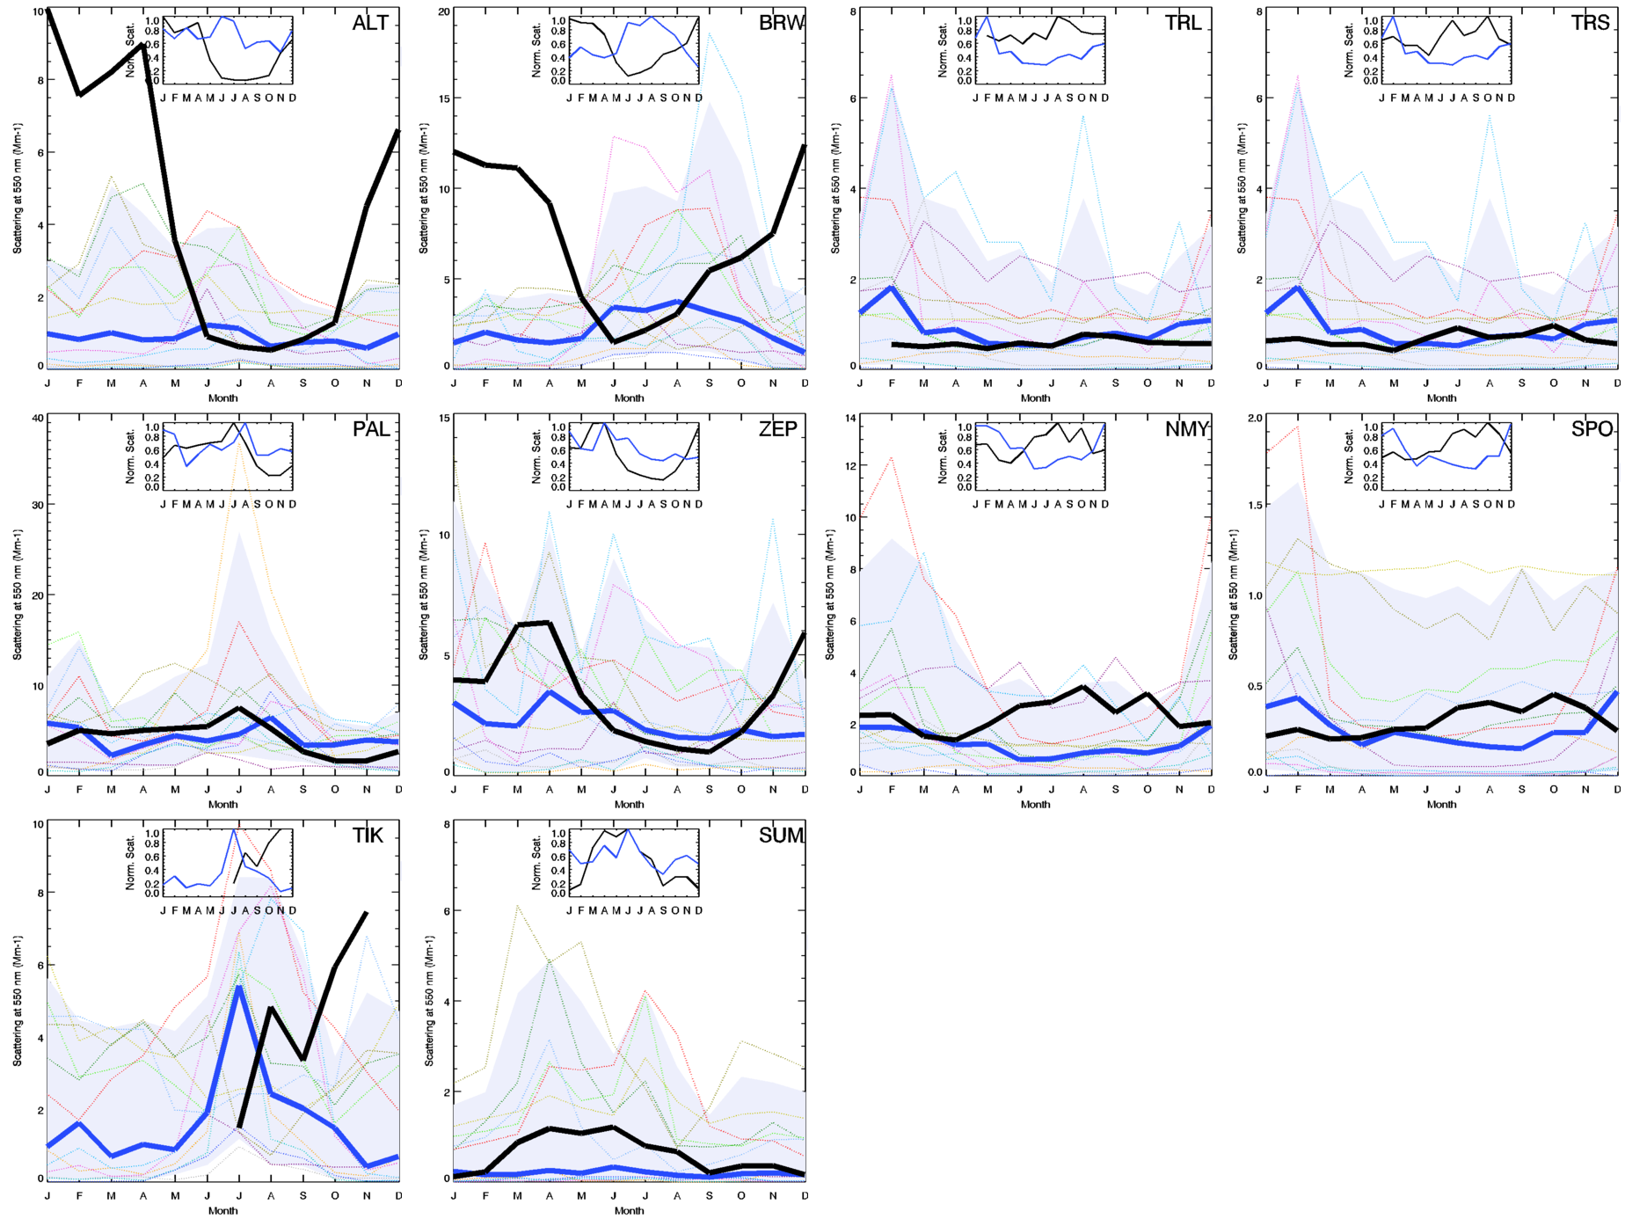

Figure 7 Seasonal cycle of aerosol light scattering for polar stations. The six plots on the right (ALT, BRW, PAL, ZEP, TIK, SUM) are for northern hemisphere polar sites while the four plots on the left (TRL, TRS, NMY, SPO) are for southern hemisphere polar sites. Monthly medians are calculated from daily values and require at least 24 days of data for there to be a monthly point. The thick black line is the in-situ measurement monthly median, the thick blue line is monthly median of all models, the pale blue shading is 5th and 95th percentile of model medians for each month and the thin colored lines are monthly medians for each model. The inset plots show the normalized seasonal cycles for the in-situ measurements and for the median of the models. The primary y-axis range varies with site, but the inset plots y-axis for the normalized data range from 0-1.

Figure 7 shows the seasonality of aerosol light scattering at 6 Arctic sites (left hand plots) and 4 Antarctic sites (right hand plots). Focusing on the Arctic sites, the first thing to notice is that the in-situ values (thick black line) tend to exceed the model median value (thick blue line for many months of the year. At ALT, BRW and TIK the measurements are outside the 95th percentile of the model values (shaded area) for some portion of the year. Additionally, Figure 7 shows that the model median values often exhibit a different seasonal cycle than the in-situ observations. At ALT, BRW, TIK and ZEP the measured aerosol scattering is highest in winter and spring and lowest in summer, while PAL and SUM exhibit the lowest measured scattering in the winter months. At ALT, BRW, and TIK the model medians have the opposite seasonal cycle to the in-situ measurements with the simulated scattering peaking in the summer time. At PAL, SUM and ZEP the normalized seasonality of model and measurements bear a somewhat closer resemblance to each either, although the seasonality of the in-situ measurements covers a larger range. Individually, some of the models capture the observed seasonality in Arctic aerosol scattering, but, as indicated by the shaded area, this is not a consistent pattern. The absorption climatology is not shown, but the modelled and measured seasonal cycles for absorption are quite similar to the modelled and measured scattering seasonality, albeit an order of magnitude lower in value.

For the Antarctic site comparisons, the model median scattering values are quite similar to the observations. The normalized inset plots reveal that the model median exhibits the opposite seasonality as the observations – the measurements peak in late summer and fall (austral winter) while the model median simulates maximum scattering in the winter months. The absorption values observed in Antarctica have the opposite seasonality of the scattering values and peak in the fall and winter months (austral summer). The absorption values are very low (monthly averages<0.1 Mm⁻¹), within the uncertainty of the filter based measurements (REF).. Most models simulate no aerosol absorption in Antarctica.

The climatology of Arctic aerosol has been extensively reported (e.g., Quinn AMAP, Schmeisser 2018, as well as multiple papers for individual sites). There have also been several papers comparing how well models simulate measured aerosol climatology in the Arctic, most recently Eckhardt et al. (2015) which compared modeled and measured black carbon and sulfate mass concentrations rather aerosol optical properties). Eckhardt et al. (2015) suggests that models have improved their ability to capture the seasonality of BC at Arctic sites than previous studies but that many models still tend to underpredict the magnitude of aerosol loading.

3.1.2.2 Seasonal/Monthly climatologies of coastal sites
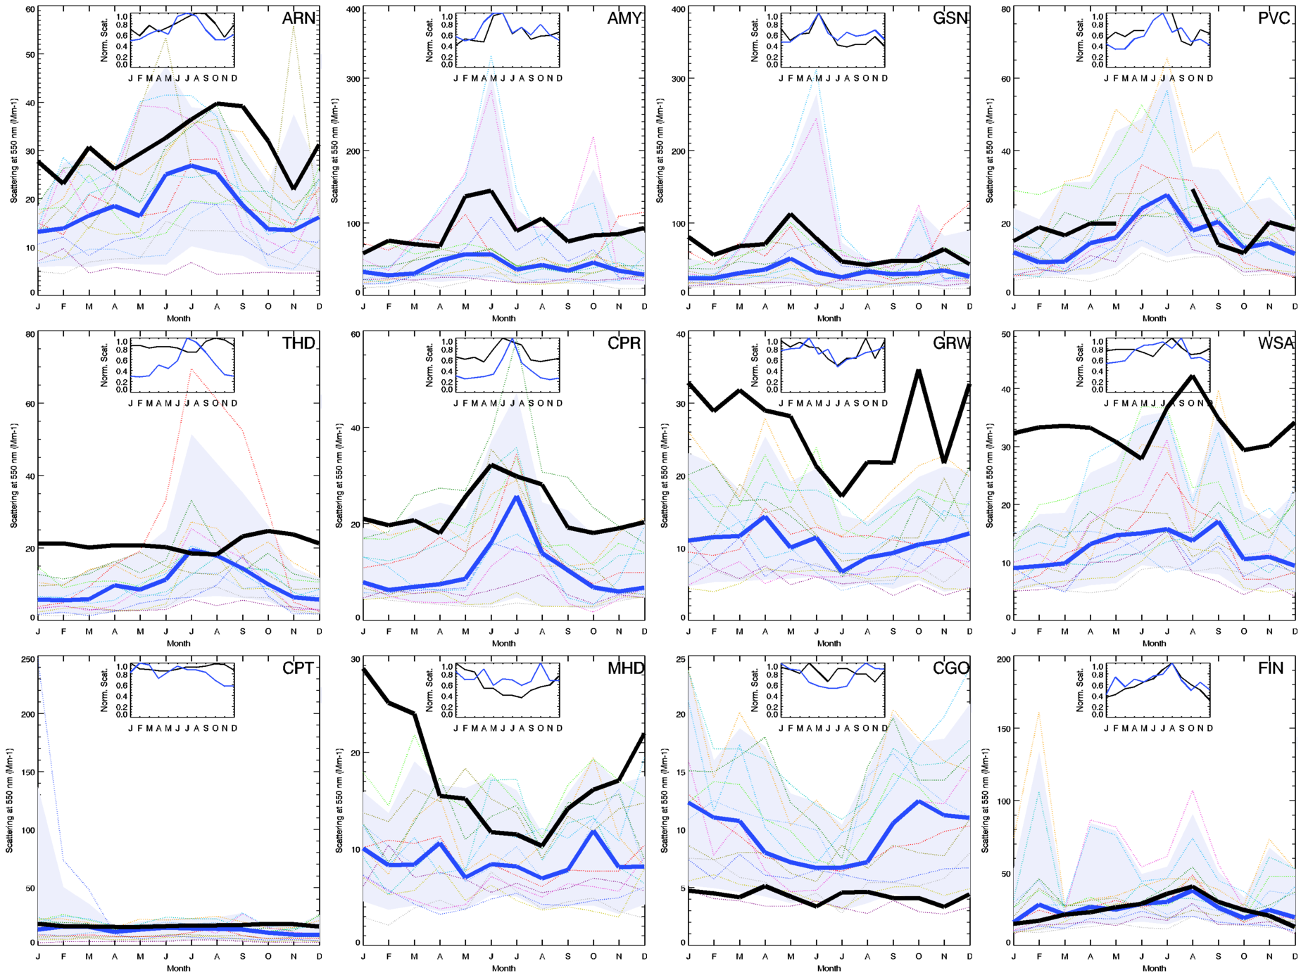
Figure 8 Coastal scattering at 550 nm. Plot details in Figure 7 caption. Sites are sorted from lowest to highest SSA (CGO and FIN did not have ‘good’ SSA data available)

Figure 8 summarizes the seasonal cycles in scattering observed at coastal sites around the globe (including sites from Europe, North America, Asia and the southern hemisphere). The plots are ordered from lowest to highest in-situ SSA (CGO and FIN did not have SSA data available). The model values of scattering tend to be lower than the observed scattering at most measurement sites. CGO is an exception to this, with the models simulating larger scattering than is observed across all months. The inset plots indicate that the model median provides a good representation of the timing of the observed seasonal cycle in scattering at many marine sites regardless of region. One exception is THD for which the observations indicate very little seasonal cycle while the model median suggests there should be a strong summer increase in scattering (and absorption?) at the site. THD is on the coast in northern California, so it’s possible this modelled summertime increase is due to over-estimating the impact of summer wildfires. MHD, on the coast of Ireland, is the opposite of THD in that the observations suggest a strong seasonal cycle with the highest loading observed in the winter months while the model values and model median exhibit a relatively invariant scattering throughout the year.

What about absorption at coastal sites? Are patterns similar to scattering?

3.1.2.3 Seasonal/Monthly climatologies of continental sites
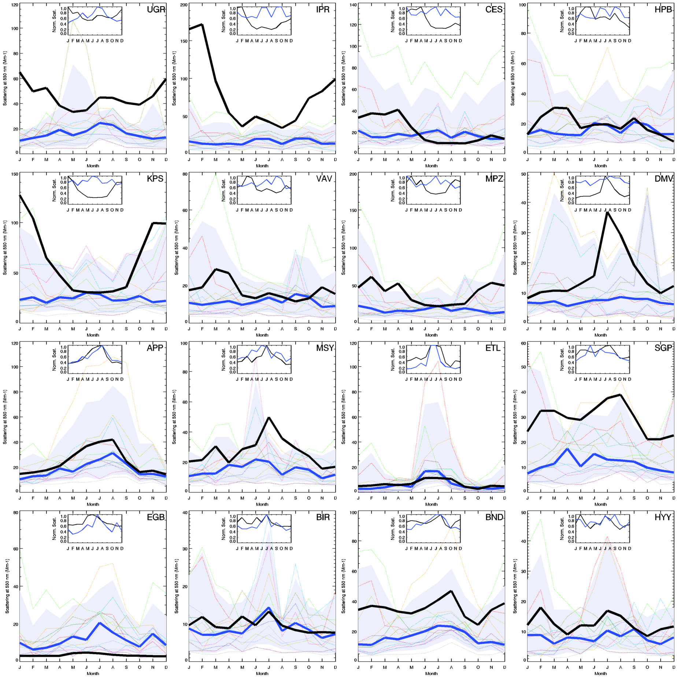
Figure 9 Scattering at continental sites. Station data plotted if at least 80% of annual cycle of in situ data available. Monthly data points plotted if 80% of monthly data available. Ordered from lowest to highest SSA (HYY no SSA available)

Figure 9 shows the seasonality of scattering at continental sites in Europe, North America and one site in Asia (DMV). At continental sites in North America (APP, ETL, SGP, EGB, BND) the model median does a fairly good job of simulating the shape of the observed seasonal aerosol light scattering coefficient cycle, but, again, the model median scattering tends to be lower than the in-situ observations. ETL and EGB have 1um impactors upstream of the nephelometers which may explain why EGB modelled scattering is greater than the in situ data and why ETL modelled and measured scattering are similar. Models also underpredicted scattering at most continental European sites. There is a dichotomy in how well the model median predicted the shape of the seasonal cycles at the continental sites in Europe. For about half of these locations (FKB, IPR, KPS, MPZ, UGR) the observed scattering peaked in winter and was at a minimum in the summer while the model median suggested either no seasonal cycle or a seasonal cycle that peaked in the summer. For most of the rest of the continental Europe sites (HPB, VAV, BIR, DEM, HYY, SIR) both the observed and simulated seasonal cycles were relatively flat with no strong seasonal dependence. The one exception was MSY which exhibited a strong seasonal cycle, peaking in the summer due to recirculation of stagnant air masses (Pandolfi et al., 2011). At MSY the model median suggested scattering was greatest in the warmer months but did not capture the strength of the seasonal cycle. Figure 9 only shows plots for sites that have complete in-situ seasonal cycles (i.e., meets the requirement of having at least 24 daily averages/month for all 12 months). Some other sites were sampled for shorter field campaigns. At MAO, a site in Brazil, the monthly model median and in-situ observations lie right on top of each other. At NIM blah blah

What about absorption at continental sites?

3.1.2.4 Seasonal/Monthly climatologies of mountain sites

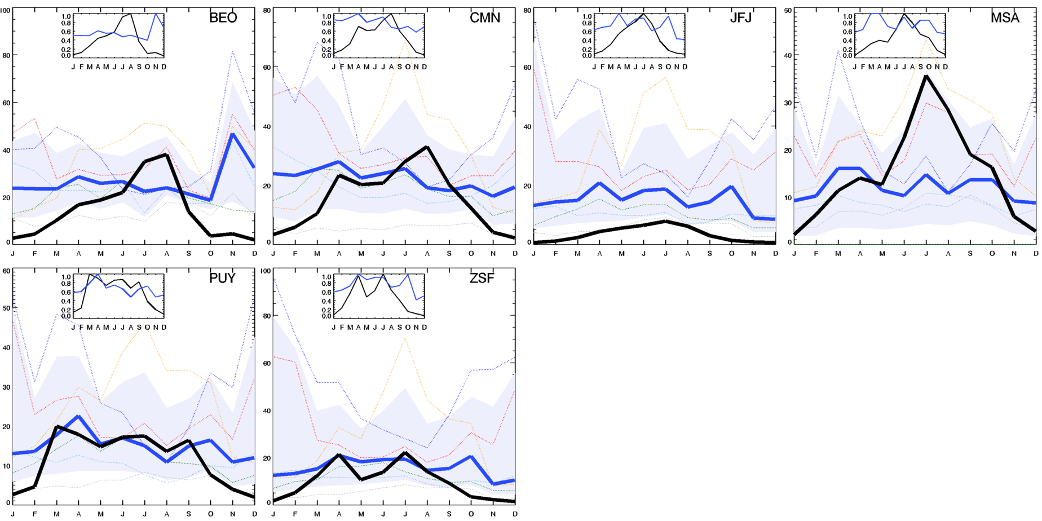
Figure 10a Same as Figure 7, but for European mountain sites.

We’ve previously suggested that models overestimate the annual scattering at high altitude observatories because of sub-grid topography (e.g., Figure 2a). Figure 10 suggests a more nuanced picture. For European mountain sites (Figure 10a), the models report much higher scattering in the winter, but in the summer the measurements tend to equal or exceed the model values. This is due to stronger thermal transport driving more polluted air up during the warmer months (e.g., Andrews et al., XXXX).
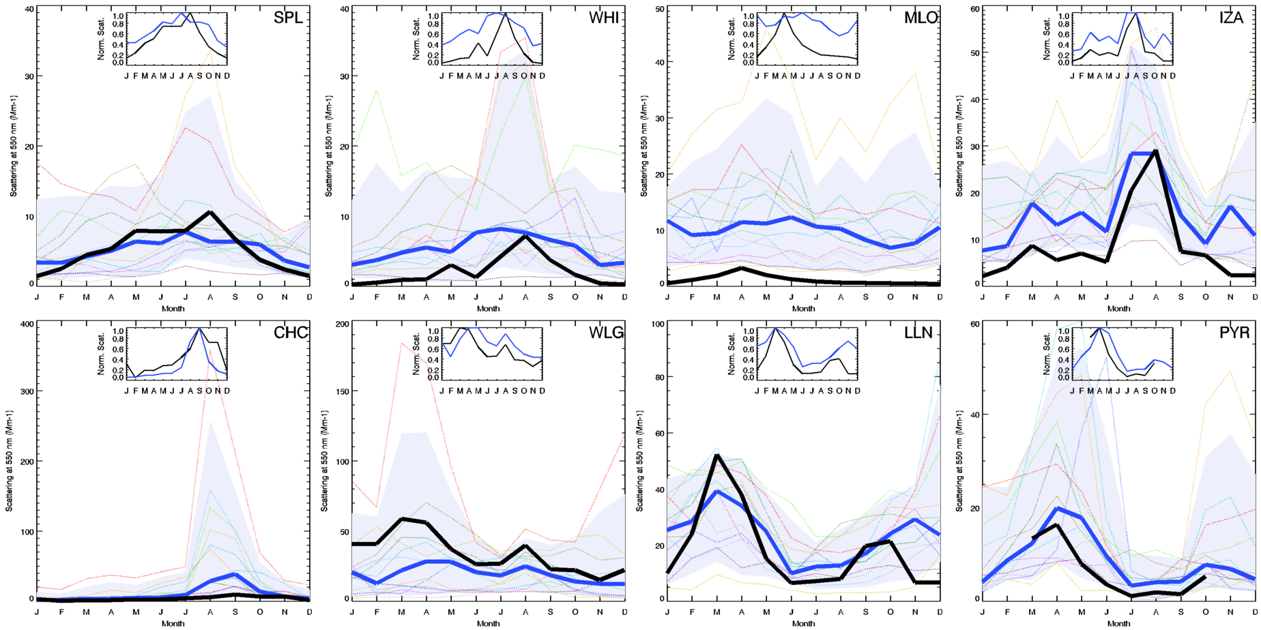
Figure 10b Same as Figure 7, but for mountain sites outside of Europe

The model-measurement comparison at mountain sites outside of Europe (Figure 10b), provides a different picture. With the exception of MLO, the model median does a good job of simulating the shape of the seasonal cycle for these sites, even capturing the bi-modality at the three Asian sites (WLG, LLN, PYR). This suggests perhaps ?? . In contrast, MLO is an isolated island mountain which experiences Asian dust transport in the spring (REF); however the transport of dust from Asia/Africa occurs at high altitude and doesn’t affect the sea level values likely simulated by the models for that location. Differences between the model median simulated scattering and the in-situ observations are not as consistent or as easily explained as for the European mountain sites. For example at IZA (Izana) and WLG (China) the modelled scattering is lower than the measurements across the year, while at WHI (British Columbia, Canada) and PYR (Nepal) the modelled scattering is the same or larger than the observations. Need to say something about TLL

ABSORPTION
SSA
SAE

Higher frequency
- Autocorr?

    - Lag-autocorrelation – (instead of daily climatology)
Intro paragraph
- Indicator of aerosol persistence
- Constrain comparisons by identification of expected ‘best case’ agreement between data sources with different temporal/spatial resolution. Differences in lag-autocorrelation amongst models may be due to grid size, grid boundaries, differences in atmospheric processes and/or some combination.
- Provides information about atmospheric processes, especially for higher frequency data (e.g., NPF, uplope/downslope…)
Autocorr results discussion
- Fairly common for models to predict strong diurnal oscillations when none are observed in in-situ data.
- No consistent pattern in terms of models over- or under- predicting aerosol persistence, but models tend to show less?/more? Variability than observations?

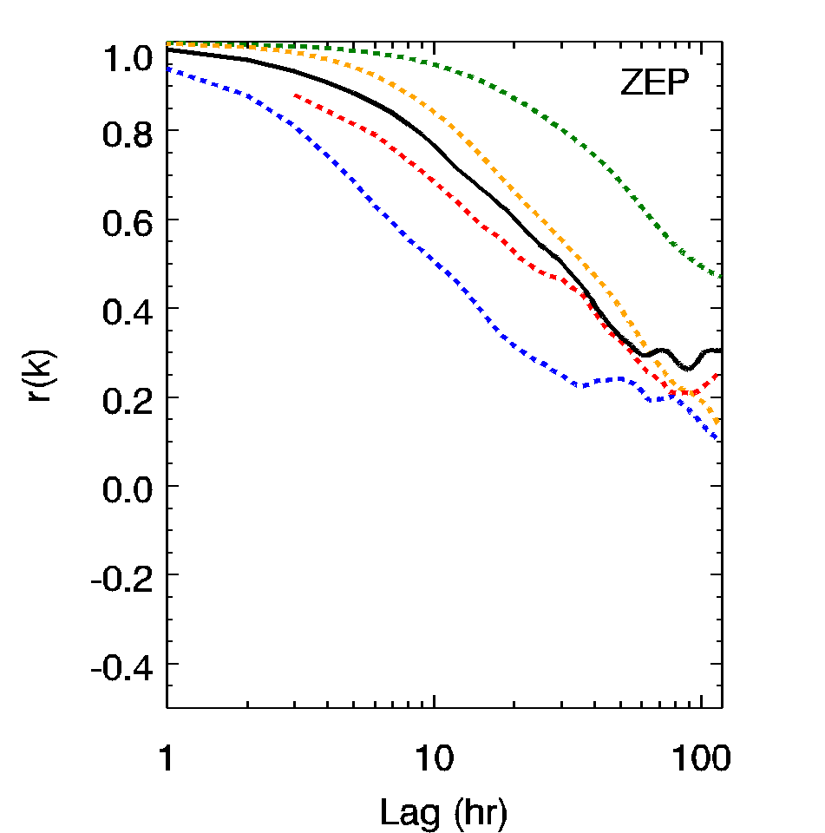(a) | 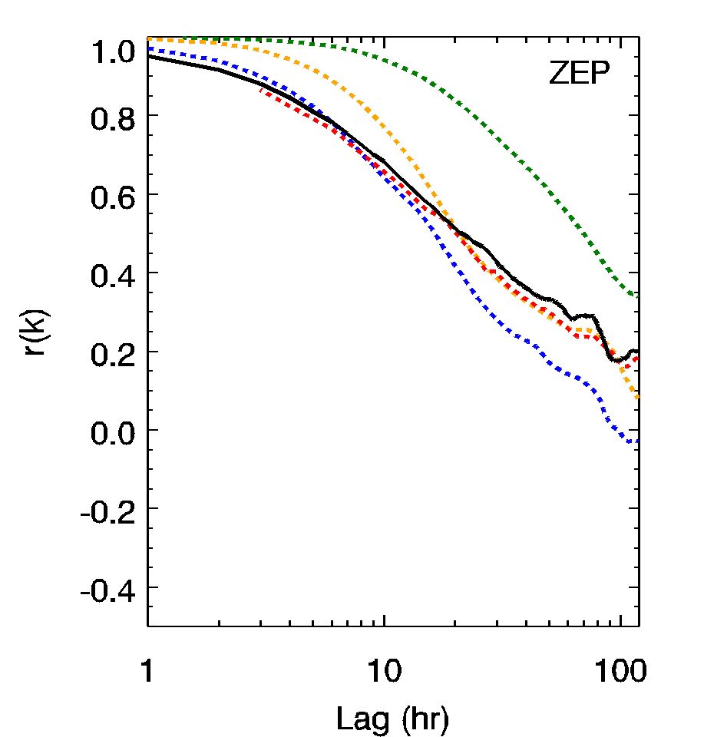(b)
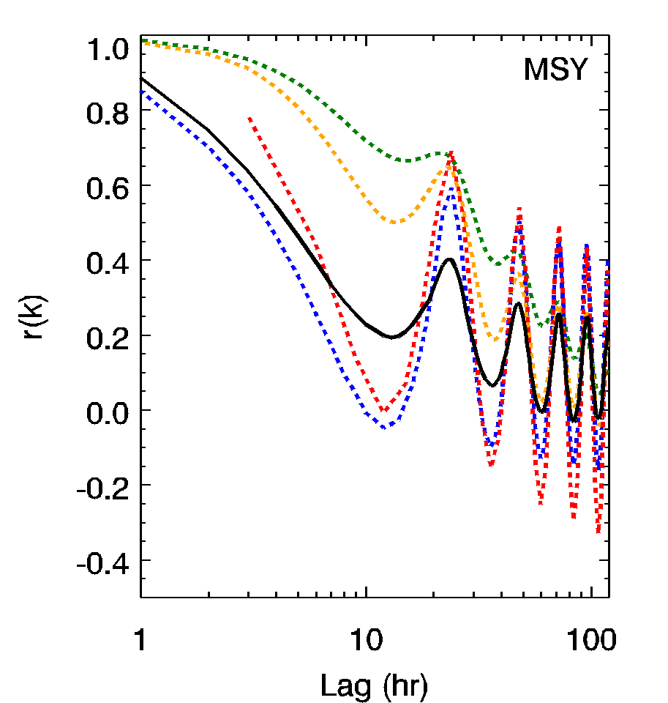(c) | 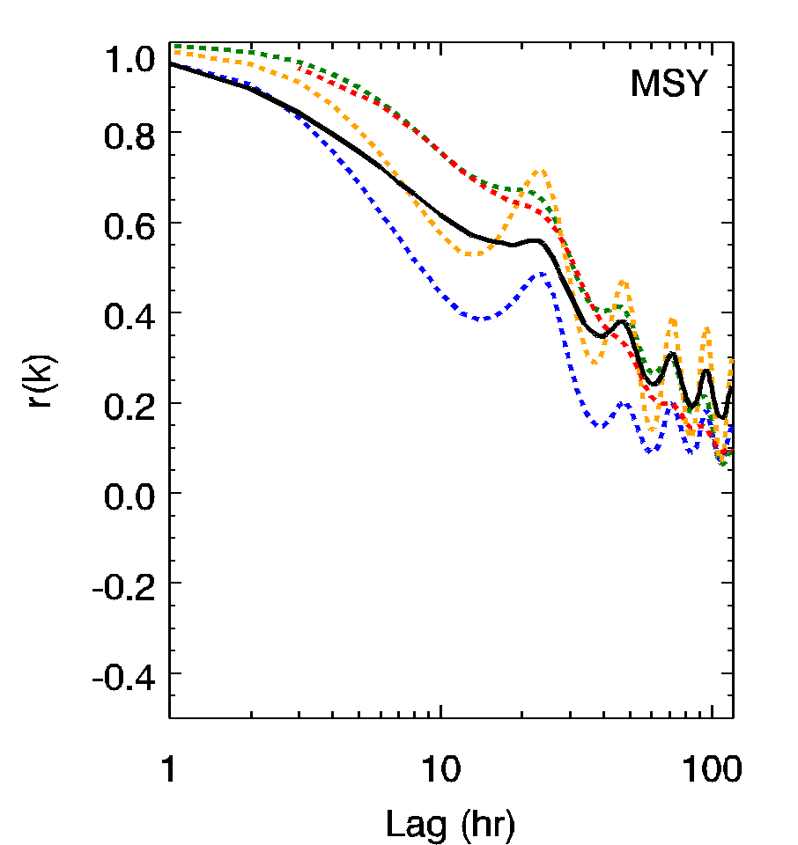(d)
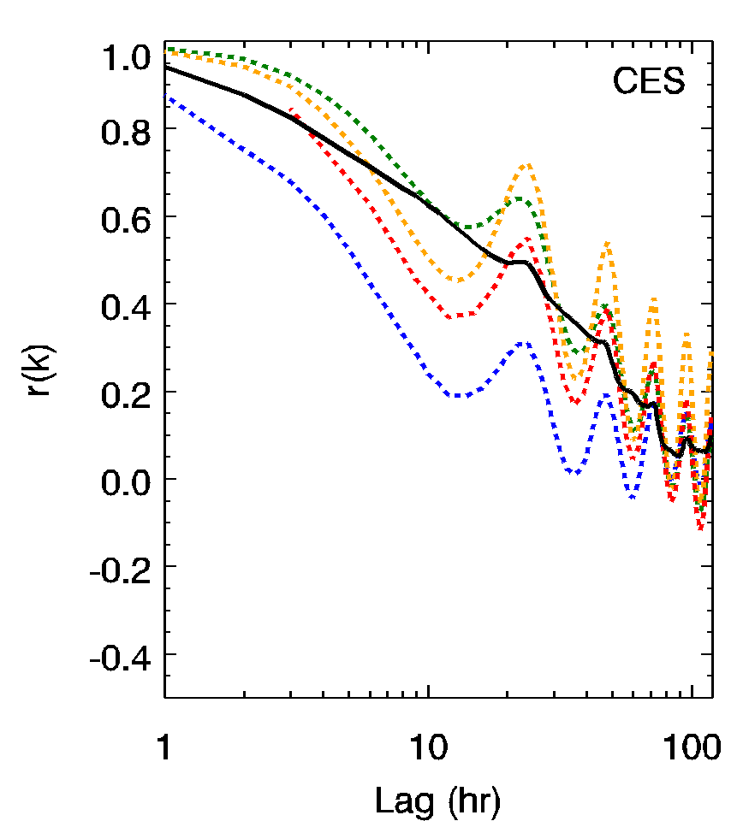 (e) | 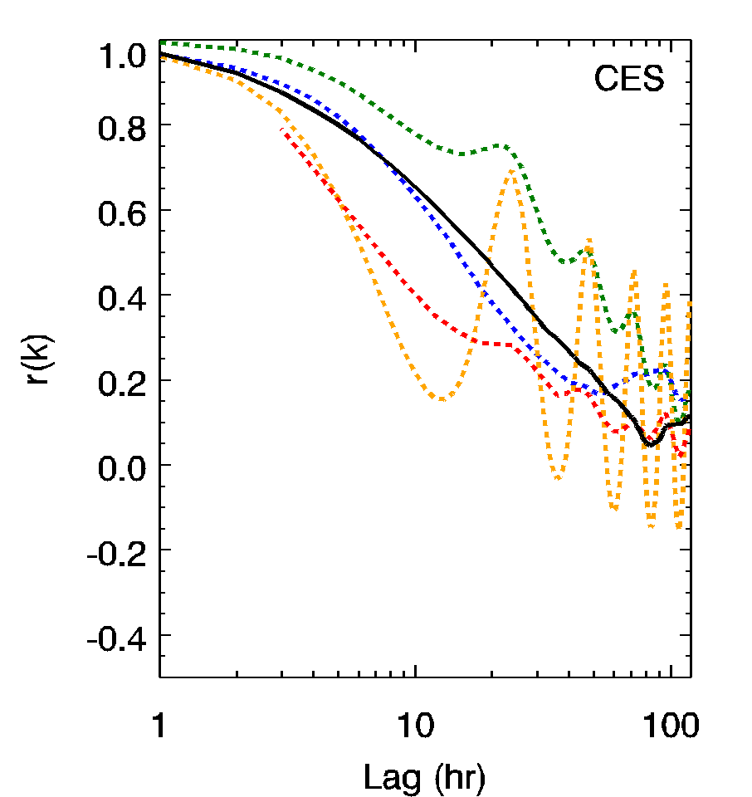(f)
Figure 11. Examples of lag autocorrelation for absorption (left column) and scattering (right column) at (a) and (b) ZEP (Zeppelin, Norway); (c) and (d) MSY (Montseny, Spain); (e) and (f) CES (Cabauw, The Netherlands). Lag (k) is the time between measurements being compared; ‘r(k)’ is the lag autocorrelation statistic. Colored dotted lines are model results, solid black line is in-situ measurements. Update with 4/2017 plots, say what models are included

    - Systematic variability
Intro: systematic variability may provide information about how well the model is simulating aerosol processing, sources, transport, etc. need a stronger statement here about intensive vs intensive systematic variability plots allow for ??
a) individual sites – intensive vs extensive; then intensive vs intensive
- Relationship between aerosol loading and SSA (or angstrom exponent) changes with location. Can see characteristics of high loading events at a given site.
preferential scavenging of large, scattering aerosol by clouds/precipitation?
change in size distribution to smaller particles which scatter less efficiently but absorb more efficiently?
b) overall picture with annual means

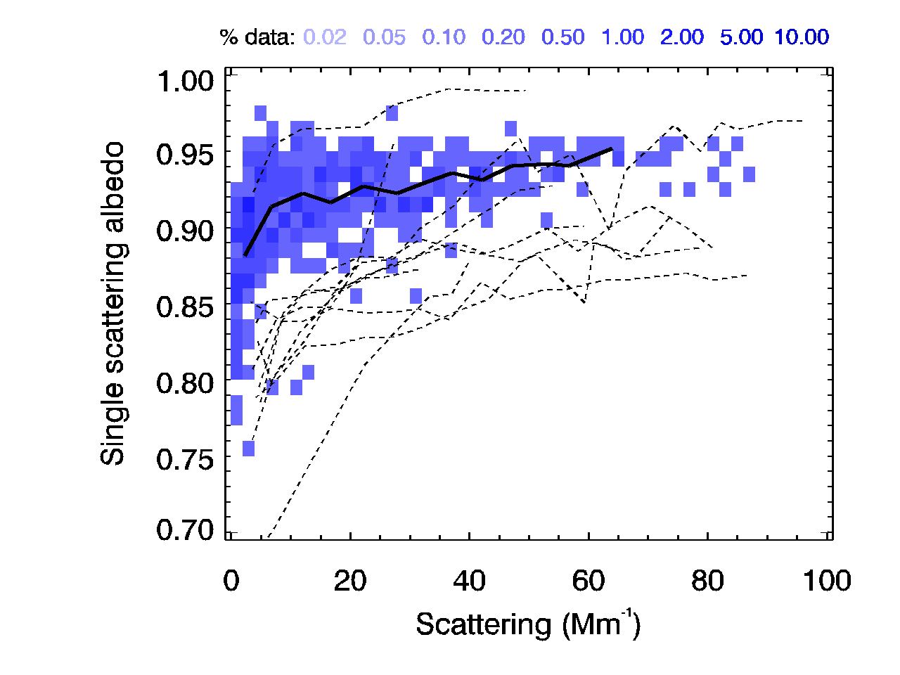  Montseny, Spain | 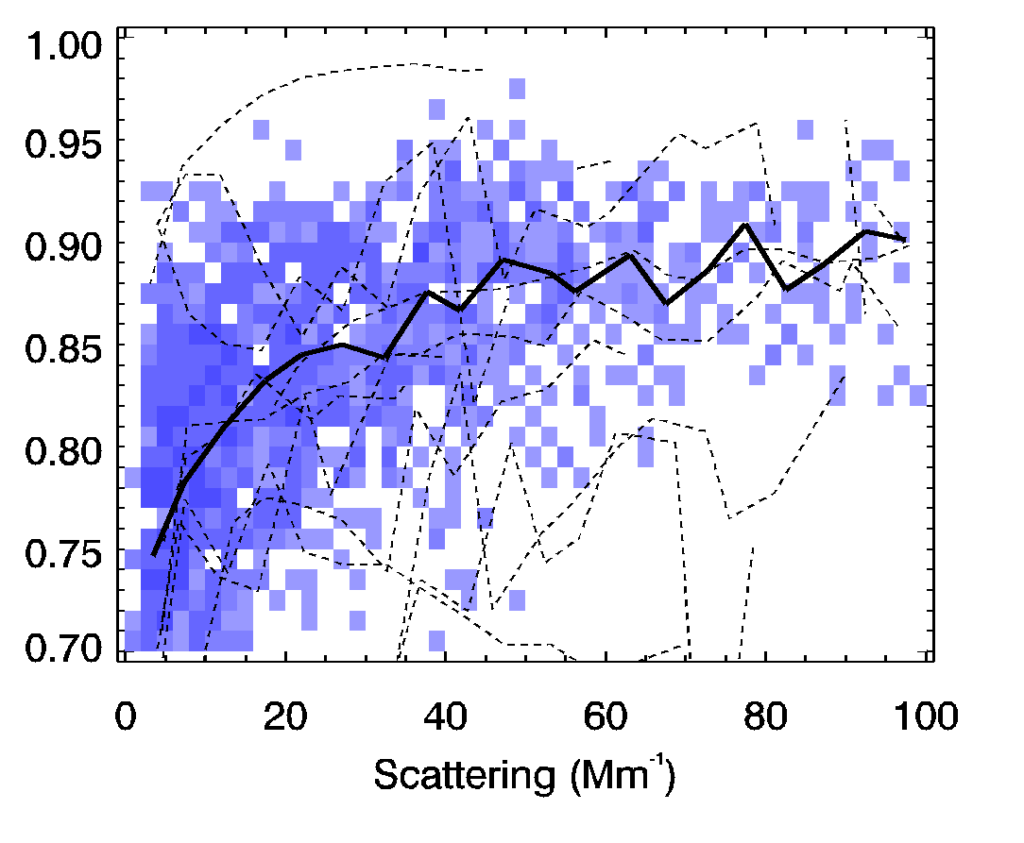  Cabauw, The Netherlands
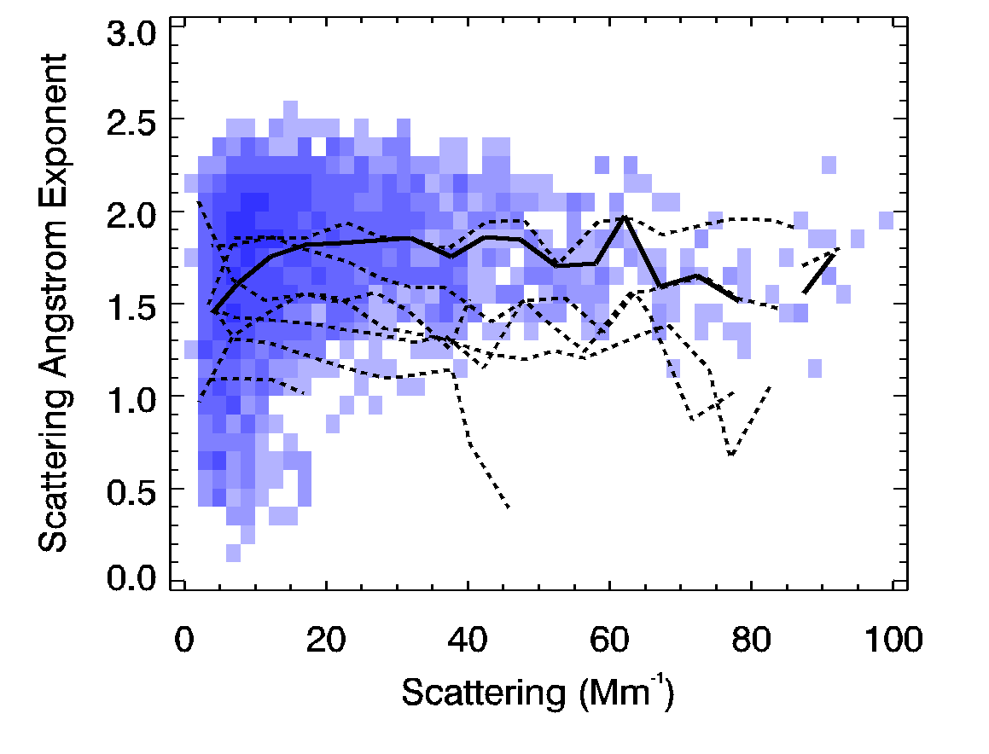  Hytallia, Finland | 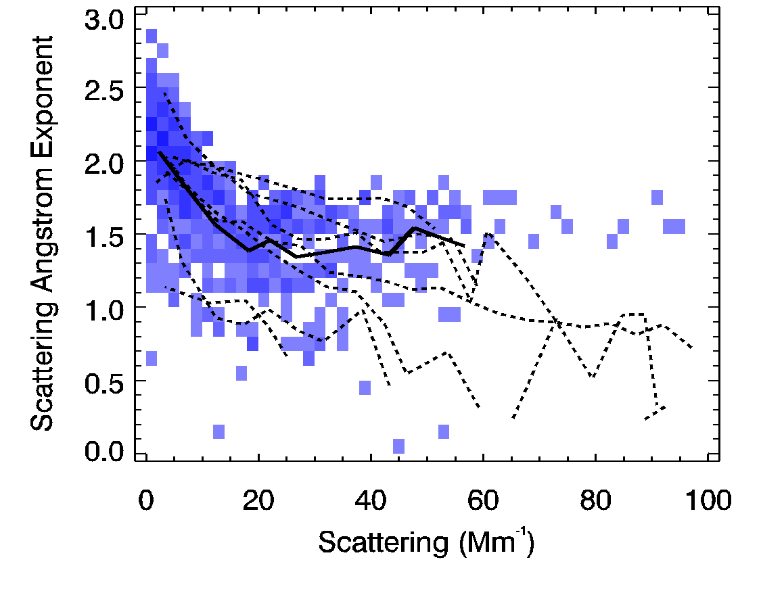Pyramid, Nepal
Figure 12. Examples of systematic variability (a) and (b) SSA versus scattering; (c) and (d) Scattering Angstrom exponent vs scattering. Update with 4/2017 plots

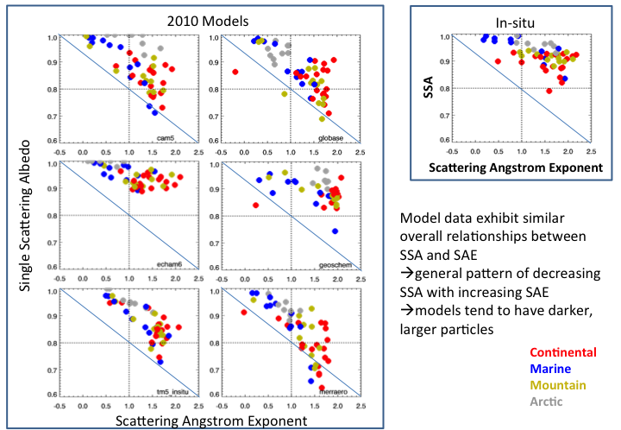
Figure 11
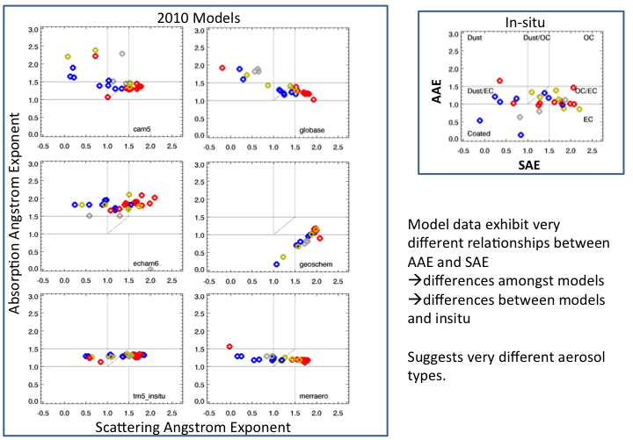
Figure 12 systematic relationship between absorption Angstrom exponent and scattering Angstrom exponent can add osloCAM5

    - Model performance scores based on comparison to observations
- Summary of model performance results
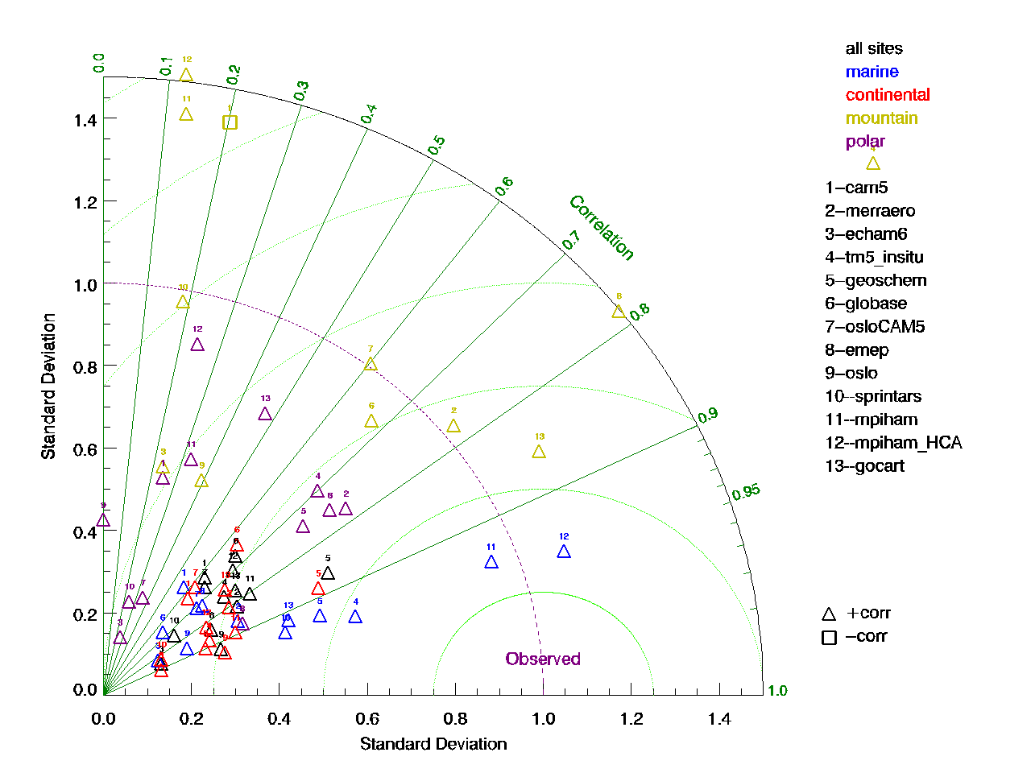
Figure X. Taylor diagram of modeled scattering compared to scattering measurements at surface monitoring sites. Need to decide if going to use taylor diagrams

The Taylor diagrams suggest several patterns. When looking at the models/measurement comparisons for all sites (e.g., Fig Xa) the models are clumped together. First, the model simulations of scattering appear to be more highly correlated with measurements at marine and continental sites and less correlated with polar and mountain site measurements. Indeed, CAM5(?) simulated output is inversely correlated with the mountain measurements (since we haven’t selected the appropriate model height for comparisons that is not saying anything positive/negative about CAM5). Marine sites are also best represented in terms of RMS. Models tend to simulate less variability (as indicated by standard deviation) than measurements, although interestingly that is not the case for the mountain sites (further comment?).

How does picture change for absorption/SSA?SAE?

4. Discussion
- Synthesize bias results
- Need to say something about 0%RH (models) vs ‘dry’ RH (measurements)
- Summarize locations/regions where models do exceptionally well or poorly
- Summarize variables that models simulate exceptionally well or poorly
- Compare these model/in-situ surface measurement comparisons to other model/optical property comparisons in the literature (How do these results compare to column comparisons? Aerosol number comparisons? Aerosol species comparisons?)
- Discuss what model processes might need improvement based on discrepancies in simulating aerosol optical property climatologies or so-called characteristic behaviors
- What unique information will this paper contribute to the field: constrain aerosol climatologies of models at surface, suggest magnitude and sign of biases, establish benchmark dataset that can be utilized by individual modelers to constrain models

5. Future Work
- RQ2: What specific model runs (e.g., additional model output variables, temporal resolution, parameterizations, etc.) are proposed to better compare to observations and, perhaps, improve simulations? (Ideally, proposed runs would be used in additional comparative analyses, part of a larger iterative project to understand model/measurement discrepancies and actively help aerosol models to better represent surface aerosol measurements)
- Suggestions/requests for specific model runs that could be used to implement a long-term project comparing model and in-situ surface optical property measurements
- Outline of long-term project with iterative steps to adjust models based on results of comparison, re-do comparative analyses, adjust models based on results, repeat, etc.

6. Conclusions

7. References

Anderson, T. L., Ogren, J.A., “Determining aerosol radiative properties using the TSI 3563 integrating nephelometer,” Aerosol Sci. Technol., 29, 57– 59, 1998.
Andrews, E., Ogren, J.A., Kinne, S., Samset, B., “Comparison of AOD, AAOD and column single scattering albedo from AERONET retrievals and in situ profiling measurements,” Atmos. Chem. Phys., 17, 6041-6072, http://www.atmos-chem-phys.net/17/6041/2017/, 2017.
Andrews, E., Ogren, J.A., Bonasoni, P., Marinoni, A., Cuevas, E., Rodriguez, S., Sun, J.Y., Jaffe, D.A., Fischer, E.V., Baltensperger, U., Weingartner, E., Collaud Coen, M., Sharma, S., Macdonald, A.M., Leaitch, W.R., Lin, N.-H., Laj, P., Arsov, T., Kalapov, I., Jefferson, A., Sheridan, P.J., “Climatology of aerosol radiative properties in the free troposphere”, Atmospheric Research, 102, 365-393, 2011.
Asmi, A., Collaud Coen, M., Ogren, J.A., Andrews, E., Sheridan, P., Jefferson, A., Weingartner, E., Baltensperger, U., Bukowiecki, N., Lihavainen, H., Kivekäs, N., Asmi, E., Aalto, P.P., Kulmala, M., Wiedensohler, A., Birmili, W., Hamed, A., O'Dowd, C., Jennings, S.G., Weller, R., Flentje, H., Mari Fjaeraa, A., Fiebig, M., Lund Myhre, C., Hallar, A.G., and Laj,P., “Aerosol decadal trends – Part 2: In-situ aerosol particle number concentrations at GAW and ACTRIS stations,” Atmos. Chem. Phys., 13, 895-916, 2013.
Bond, T. C., Anderson, T. L., and Campbell, D.: Calibration and intercomparison of filter-based measurements of visible light absorption by aerosols, Aerosol Sci. Technol., 30, 582–600, doi:10.1080/027868299304435, 1999.
Bond, T.C. and Bergstrom, R.W., “Light Absorption by Carbonaceous Particles: An Investigative Review,” Aerosol Science and Technology, 39, 1–41, doi: 10.1080/02786820500421521 2005.
Collaud-Coen, M., Andrews, E., Asmi, A., Baltensperger, U., Bukowiecki, N., Day, D., Fiebig, M., Fjaeraa, A.M., Flentje, H., Hyvärinen, A., Jefferson, A., Jennings, S.G., Kouvarakis, G., Lihavainen, H., Lund Myhre, C., Malm, W.C., Mihapopoulos, N., Molenar, J.V., O'Dowd, C., Ogren, J.A., Schichtel, B.A., Sheridan, P., Virkkula, A., Weingartner, E., Weller, R., and Laj, P.,” Aerosol decadal trends – Part 1: In-situ optical measurements at GAW and IMPROVE stations,” Atmos. Chem. Phys., 13, 869-894, 2013.
Breider, T. J., et al. "Annual distributions and sources of Arctic aerosol components, aerosol optical depth, and aerosol absorption." Journal of Geophysical Research: Atmospheres 119.7 (2014): 4107-4124. {Model measurement comparisons of aerosols and ozone in the Arctic}
Delene, D. J. and Ogren, J. A., “Variability of aerosol optical properties at four North American surface monitoring sites,” J. Atmos. Sci., 59, 1135–1150, 2002.
Eckhardt, S., et al., “Current model capabilities for simulating black carbon and sulfate concentrations in the Arctic atmosphere: a multi-model evaluation using a comprehensive measurement data set,” Atmos. Chem. Phys., 15, 9413–9433, 2015.
Ginoux, P., Horowitz, L. W., Ramaswamy, V., Geogdzhayev, I. V., Holben, B. N., Stenchikov, G., Tie, X., “Evaluation of aerosol distribution and optical depth in the Geophysical Fluid Dynamics Laboratory coupled model CM2.1 for present climate,” J. Geophys. Res., 111, doi:10.1029/2005JD006707, 2006.

Glantz, Paul, et al. "Remote sensing of aerosols in the Arctic for an evaluation of global climate model simulations." Journal of Geophysical Research: Atmospheres 119.13 (2014): 8169-8188.{comparison between NorESM model and measurements at Zeppelin}

Holben, B. N., Eck, T. F., Slutsker, I., Smirnov, A., Sinyuk, A., Schafer, J., Giles, D., Dubovik, O.: AERONET’s Version 2.0 quality assurance criteria, http://aeronet.gsfc.nasa.gov/new_web/ Documents/AERONETcriteria_final1.pdf (last access: 10 March 2014), 2006.

Huneeus et al., 2011 (dust);

IPCC, 2013: Climate Change 2013: The Physical Science Basis. Contribution of Working Group I to the Fifth Assessment Report of the Intergovernmental Panel on Climate Change, [Stocker, T.F., D. Qin, G.-K. Plattner, M. Tignor, S.K. Allen, J. Boschung, A. Nauels, Y. Xia, V. Bex and P.M. Midgley (eds.)]. Cambridge University Press, Cambridge, United Kingdom and New York, NY, USA, 1535 pp, doi:10.1017/CBO9781107415324.

Jiao et al., 2014 (arctic bc);

Kim et al., 2014
Kinne, S., et al., “An AeroCom initial assessment – optical properties in aerosol component modules of global models,” Atmos. Chem. Phys., 6, 1-20, 2006.
Koch, D., et al “Evaluation of black carbon estimations in global aerosol models,” Atmos. Chem. Phys., 9, 9001–9026, 2009. {highly cited paper about difficulty modeling BC in arctic (among other places), covered in Wang 2014}

Koffi et al., 2012

Lacagnina et al., 2015;
Mann et al., “Intercomparison and evaluation of global aerosol microphysical properties among AeroCom models of a range of complexity,” Atmos. Chem. Phys., 14, 4679–4713, 2014.
Myhre, G. et al., “Radiative forcing of the direct aerosol effect from AeroCom Phase II simulations,” Atmos. Chem. Phys., 13, 1853–1877, 2013.
Mueller, T., Laborde, M., Kassell, G., Wiedensohler, A., “Design and performance of a three-wavelength LED-based total scatter and backscatter integrating nephelometer”, Atmos. Meas. Tech., 4, 1291–1303, 2011.
Ogren, J. A., “Comment on “Calibration and Intercomparison of Filter-Based Measurements of Visible Light Absorption by Aerosols”, Aerosol Sci. Technol., 44, 589–591, doi:10.1080/02786826.2010.482111, 2010.
Ogren, J.A., “A systematic approach to in-situ observation of aerosol properties,” In: Aerosol Forcing of Climate, eds. R. Charlson and J. Heintzenberg, John Wiley & Sons, Ltd., 215-226, 1995.
Pandolfi, M., Cusack, M., Alastuey, A., Querol, X., “Variability of aerosol optical properties in the Western Mediterranean Basin,” Atmos. Chem. Phys., 11, 8189–8203, 2011.
Petzold maap paper?
Samset et al., 2014 (BC);
Schutgens et al., 2016 comparing spatial/temporal consistent data sets
Do we want to include this here? Mountain paper or supplement might be better? Regardless need to pick model level to match measurement height

Sheridan, P.J., Delene, D.J., and Ogren, J.A., “Four years of continuous surface aerosol measurements from the Department of Energy’s Atmospheric Radiation Measurement Program Southern Great Plains Cloud and Radiation Testbed site,” J. Geophys. Res., 106, 20735-20747, 2001.
Sherman, J.P., Sheridan, P.J., Ogren, J.A., Andrews, E., Hageman, D.C., Schmeisser, L., Jefferson, A., Sharma, A., “A multi-year study of lower tropospheric aerosol variability and systematic relationships from four North American regions,” Atmos. Chem. Phys., 15, 12487-12517, 2015.
Shindell, D. T., et al. "A multi-model assessment of pollution transport to the Arctic." Atmospheric Chemistry and Physics 8.17 (2008): 5353-5372.{Sensitivity of aerosol and gas concentrations in Arctic to changes in emissions using multiple models}
Simpson, D., et al., “The EMEP MSC-W chemical transport model – technical description,” Atmos. Chem. Phys., 12, 7825-7865, 2012.
Taylor, K.E., “Summarizing multiple aspects of model performance in a single diagram,” J. Geophys. Res., 106, 7183-7192, 2001.
Tørseth and Coauthors, “Introduction to the European Monitoring and Evaluation Programme (EMEP) and observed atmospheric composition change during 1972-2009,” Atmos. Chem. Phys., 12, 5447-5481, doi:10.5194/acp-12-5447-2012, 2012.
Tsigaridis, K. et al. “The AeroCom evaluation and intercomparison of organic aerosol in global models,” Atmos. Chem. Phys., 14, 10845–10895, 2014.
Virkkula PSAP papers (original and correction)

Wang 2014 paper site representativeness

WMO, WMO/GAW Aerosol Measurement Procedures, Guidelines, and Recommendations, (WMO TD No. 1177) - GAW Report No. 227, World Meteorological Organization, Geneva, https://library.wmo.int/opac/doc_num.php?explnum_id=3073, 2016.

Model papers in table 1 – need to sort and complete references
Bergman, T., Kerminen, V.-M., Korhonen, H., Lehtinen, K. J., Makkonen, R., Arola, A., Mielonen, T., Romakkaniemi, S., Kulmala, M., and Kokkola, H.: Evaluation of the sectional aerosol microphysics module SALSA implementation in ECHAM5-HAM aerosol-climate model, Geosci. Model Dev., 5, 845-868, doi:10.5194/gmd-5-845-2012, 2012.
Bey, I., D. J. Jacob, R. M. Yantosca, J. A. Logan, B. Field, A. M. Fiore, Q. Li, H. Liu, L. J. Mickley, and M. Schultz, Global modeling of tropospheric chemistry with assimilated meteorology: Model description and evaluation, J. Geophys. Res., 106, 23,073-23,096, 2001.
Buchard, V., and Coauthors, 2015: Using the OMI aerosol index and absorption aerosol optical depth to evaluate the NASA MERRA Aerosol Reanalysis. Atmospheric Chemistry and Physics, 15 (10), 5743–5760, doi:10.5194/acp-15-5743-2015.
Buchard, V., and Coauthors, 2016a: Evaluation of the surface PM2.5 in Version 1 of the NASA MERRA Aerosol Reanalysis over the United States. Atmospheric Environment, 125, 100–111, doi:10.1016/j.atmosenv.2015.11.004.
Chin, M., P. Ginoux, S. Kinne, O. Torres, B. N. Holben, B. N. Duncan, et al., Tropospheric aerosol optical thickness from the GOCART model and comparisons with satellite and sun photometer measurements, J. Atmos. Sci., 59, 461–483, 2002.
Chin, M., T. Diehl, Q. Tian, J. M. Prospero, R. A. Kahn, A. Remer, H. Yu, A. M. Sayer, H. Bian, et al., Multi-decadal variations of atmospheric aerosols from 1980 to 2009: sources and regional trends, Atmos. Chem. Phys., 14, 3657-3690, doi:10.5194/acp-14-3657-2014, 2014.
Chin, M., T. Diehl, O. Dubovik, T. F. Eck, B. N. Holben, A. Sinyuk, and D. G. Streets, Light absorption by pollution, dust and biomass burning aerosols: A global model study and evaluation with AERONET data, Ann. Geophys., 27, 3439-3464, 2009.
Colarco, P. R., A. da Silva, M. Chin, T. Diehl: Online simulations of global aerosol distributions in the NASA GEOS-4 model and comparisons to satellite and ground-based aerosol optical depth, J. Geophys. Res., 115, D14207, doi:10.1029/2009JD012820, 2010.
S. J. Ghan, X. Liu, R. C. Easter, R. Zaveri, P. J. Rasch, J.-H. Yoon, and B. Eaton, 2012: Toward a Minimal Representation of Aerosols in Climate Models: Comparative Decomposition of Aerosol Direct, Semidirect, and Indirect Radiative Forcing. J. Climate, 25, 6461–6476, doi: 10.1175/JCLI-D-11-00650.1.
Laakso, A., Kokkola, H., Partanen, A.-I., Niemeier, U., Timmreck, C., Lehtinen, K. E. J., Hakkarainen, H., and Korhonen, H.: Radiative and climate impacts of a large volcanic eruption during stratospheric sulfur geoengineering, Atmos. Chem. Phys., 16, 305-323, doi:10.5194/acp-16-305-2016, 2016.
Liu, X., Easter, R. C., Ghan, S. J., Zaveri, R., Rasch, P., Shi, X., Lamarque, J.-F., Gettelman, A., Morrison, H., Vitt, F., Conley, A., Park, S., Neale, R., Hannay, C., Ekman, A. M. L., Hess, P., Mahowald, N., Collins, W., Iacono, M. J., Bretherton, C. S., Flanner, M. G., and Mitchell, D.: Toward a minimal representation of aerosols in climate models: description and evaluation in the Community Atmosphere Model CAM5, Geosci. Model Dev., 5, 709-739, doi:10.5194/gmd-5-709-2012, 2012.
Myhre, G., et al. (2013), Radiative forcing of the direct aerosol effect from AeroCom Phase II simulations, Atmos. Chem. Phys., 13(4), 1853-1877
Skeie, R. B., et al. (2011), Anthropogenic radiative forcing time series from pre-industrial times until 2010, Atmos. Chem. Phys., 11(22), 11827-11857.
Takemura, T., T. Nozawa, S. Emori, T. Y. Nakajima, and T. Nakajima, 2005: Simulation of climate response to aerosol direct and indirect effects with aerosol transport-radiation model. J. Geophys. Res., 110, D02202, doi:10.1029/2004JD005029.
Van Noije et al., Simulation of tropospheric chemistry and aerosols with the climate model EC-Earth, Geosci. Model Dev., 2014

Appendix - Supplementary Materials
Table S1. List of sites used in this study
Station ID  Station name  ‘Type’ | Country  Lat Long Elev | Instruments (dates)
ALT  Alert  ‘Polar’ | Canada | TSI neph  PSAP-3w  CLAP-3w
AMY  Anmyeon-do  ‘coastal’ | South Korea | TSI neph  PSAP-3w  CLAP-3w
ANB  Annaberg-Buchholz  ‘continental’ | Germany
APP  Appalachian State  ‘continental’ | USA | TSI neph  PSAP-3w  CLAP-3w
APT  Aspvreten  ‘continental’ | Sweden
ARN  El Arenosillo  ‘coastal’ | Spain | TSI neph  CLAP-3w
BEO  BEO-Moussala  ‘mountain’ | Bulgaria | TSI neph  CLAP-3w
BIR  Birkenes  ‘continental’ | Norway
BKT  Bukit Kototabang  ‘continental’ | Indonesia
BND  Bondville  ‘continental’ | USA | TSI neph  PSAP-1w  PSAP-3w  CLAP-3w
BRW  Barrow  ‘polar’ | USA | TSI neph  PSAP-1w  PSAP-3w  CLAP-3w
BSL  Bosel  ‘continental’ | Germany
CES  Cabauw  ‘coastal’ | The Netherlands
CGO  Cape Grim  ‘coastal’ | Australia
CHC  Chacaltaya  ‘mountain’ | Bolivia
CMN  Monte Cimone  ‘mountain’ | Italy
CPR  Cape San Juan  ‘coastal’ | USA (Puerto Rico) | TSI neph  PSAP-1w  PSAP-3w  CLAP-3w
CPT  Cape Point  ‘coastal’ | South Africa | TSI neph  PSAP-1w  PSAP-3w  CLAP-3w
DEM  Demokritos  ‘continental’ | Greece
DMV  Danum Valley  ‘continental’ | Malaysia
EGB  Egbert  ‘continental’ | Canada | TSI neph  PSAP-1w  PSAP-3w  CLAP-3w
ETL  East Trout Lake  ‘continental’ | Canada | TSI neph  PSAP-1w  PSAP-3w  CLAP-3w
FIK  Finokalia  ‘coastal’ | Greece
FKB  Hesselbach  ‘continental’ | Germany | TSI neph  PSAP-1w  PSAP-3w  CLAP-3w
GSN  Gosan  ‘coastal’ | South Korea | TSI neph  PSAP-1w  PSAP-3w  CLAP-3w
GRW  Graciosa  ‘coastal’ | Portugal (Azores) | TSI neph  PSAP-1w  PSAP-3w  CLAP-3w
HFE  Shouxian  ‘continental’ | China | TSI neph  PSAP-1w  PSAP-3w  CLAP-3w
HPB  Hohenpeissenberg  ‘continental’ | Germany
HYY  Hyytiala  ‘continental’ | Finland
IPR  Ispra  ‘continental’ | Italy
IZA  Izana  ‘mountain’ | Spain (Tenerife) | TSI neph  MAAP
JFJ  Jungfraujoch  ‘mountain’ | Switzerland | TSI neph  MAAP
KPS  K-puszta  ‘continental’ | Hungary | TSI neph  PSAP-1w  PSAP-3w  CLAP-3w
LEI  Leipzig  ‘continental’ | Germany
LEW  Leipzig-West  ‘continental’ | Germany
LLN  Mt. Lulin  ‘mountain’ | Taiwan | TSI neph  PSAP-1w  PSAP-3w  CLAP-3w
MAN  Manacapuro  ‘continental’ | Brazil | TSI neph  PSAP-1w  PSAP-3w  CLAP-3w
MAO  Manaus  ‘continental’ | Brazil
MHD  Mace Head  ‘coastal’ | Ireland | TSI neph
MLO  Mauna Loa  ‘mountain’ | USA | TSI neph  PSAP-1w  PSAP-3w  CLAP-3w
MPZ  Melpitz  ‘continental’ | Germany
MSA  Montsec | Spain
MSY  Montseny | Spain
NIM  Niamey  ‘continental’ | Niger | TSI neph  PSAP-1w  PSAP-3w  CLAP-3w
NMY  Neumayer  ‘polar’ | Antarctica (Germany)
OPE  Obs. Perenne de L’Environ.  ‘continental’ | France
PAL  Pallas  ‘polar’ | Finland
PGH  Nainital  ‘continental’ | India | TSI neph  PSAP-1w  PSAP-3w  CLAP-3w
PLA  Preila  ‘continental’ | Lituania
PUY  Puy de Dome  ‘mountain’ | France
PVC  Cape Cod  ‘coastal’ | USA | TSI neph  PSAP-1w  PSAP-3w  CLAP-3w
PYE  Point Reyes  ‘coastal’ | USA | TSI neph  PSAP-1w  PSAP-3w  CLAP-3w
RSL  Resolute  ‘polar’ | Canada | TSI neph  CLAP-3w
SGP  Southern Great Plains  ‘continental’ | USA | TSI neph  PSAP-1w  PSAP-3w  CLAP-3w
SIR  SIRTA  ‘continental’ | France
SPL  Storm Peak  ‘mountain’ | USA | TSI neph  PSAP-1w  PSAP-3w  CLAP-3w
SPO  South Pole  ‘polar’ | USA (Antarctica) | TSI neph
SSL  Schauinsland  ‘continental’ | Germany
SUM  Summit  ‘polar’ | Greenland | TSI neph  CLAP-3w
THD  Trinidad Head  ‘coastal’ | USA | TSI neph  PSAP-1w  PSAP-3w  CLAP-3w
TIK  Tiksi  ‘polar’ | Russia | TSI neph  MAAP
TRL  Trollhaugen  ‘polar’ | Norway (Antarctica)
TRS  Troll  ‘polar’ | Norway (Antarctica
VAV  Vavihill  ‘continental’ | Sweden
WAL  Waldhof  ‘continental’ | Germany
WHI  Mt Whistler  ‘mountain’ | Canada | TSI neph  PSAP-1w  PSAP-3w  CLAP-3w
WLG  Mt Waliguan  ‘mountain’ | China | TSI neph  PSAP-1w  PSAP-3w
WSA  Sable Island  ‘coastal’ | Canada | TSI neph  PSAP-1w
ZEP  Zeppelin  ‘polar’ | Norway
ZSF  Zugspitze  ‘mountain’ | Germany | TSI neph  MAAP

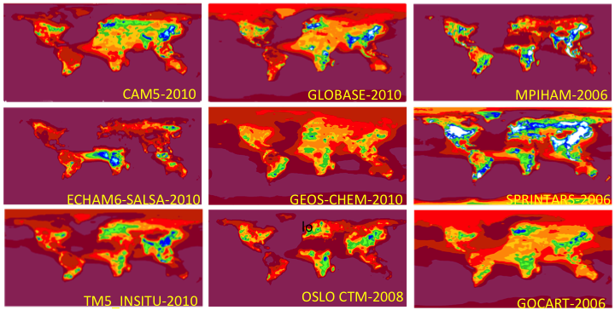

Figure S1 Modelled annual median (mean?) aerosol scattering coefficient at 550 nm (No MerrAero, as only data at site locations was provided). Need to rearrange so models in same order as Figure 3b.

Figure S2 Modelled annual median (mean?) aerosol absorption coefficient at 550 nm (No MerrAero, as only data at site locations was provided). Need to rearrange so models in same order as Figure 4b
Figure S3 Modelled annual median (mean?) aerosol single scattering albedo at 550 nm (No MerrAero, as only data at site locations was provided). Need to rearrange so models in same order as Figure 3b.
Figure S4 Modelled annual median (mean?) aerosol scattering Ångström exponent for 440/550(?) nm wavelength pair. (No MerrAero, as only data at site locations was provided). Need to rearrange so models in same order as Figure 3b.

