Aerosol systematic variability – observations and simulations

Abstract
Systematic variability
Only NOAA sites

1. Introduction, Background and Literature Review
- Motivation for why to compare aerosol models and measurements
- Why systematic variabilty

The primary objective of AeroCom is to improve modeling of aerosols and thus improve predictions of the aerosol-related climate effects. Because, ultimately, the climate effects of aerosol particles are caused by their optical properties
- How well do models simulate the overall relationships among aerosol optical properties

2. Methods
2.1 Description of in-situ aerosol optical property data
The data used in this study consists of surface in-situ aerosol light scattering coefficients and aerosol light absorption coefficients. The measurements are typically made following GAW protocols (REFERENCE) meaning the measurements are made at controlled humidity (usually RH<40%) and have appropriate instrumental corrections applied as described below. Figure 1 is a map of the surface in-situ sites used in this study. Table S1 in supplemental materials provides more information about the surface sites used in this study.

The Level 2, hourly-averaged QA/QC’d data were downloaded from EBAS (need proper name, citation) and underwent further review and interaction with the data providers as previous efforts involving multi-site analyses have shown external data review to be extremely helpful (Asmi et al., 201X; Collaud Coen et al 201X; Andrews et al., 20XX). The hourly data are averaged to coarser time resolutions for comparison with less temporally resolved model output.

The light scattering measurements are made by integrating nephelometers (either TSI model#3563 or various models of the Ecotech nephelometer). The TSI nephelometer is a spectral instrument (450, 550 and 700 nm) allowing the calculation of wavelength dependence of scattering. Most sites with Ecotech nephelometers also submitted spectral scattering (450, 525 and 635 nm) although some sites operated single wavelength Ecotech instruments. TSI nephelometer data were corrected for known instrument non-idealities (truncation, light source) using the Anderson and Ogren (1998) method. Ecotech nephelometer data were corrected using Mueller et al. (XXXX).

The light absorption measurements are made using a variety of filter-based instruments including the Multi-Angle Absorption Photometer (MAAP, Thermo, Inc.); the Particle Soot Absorption Photometer (PSAP, Radiance Research) and the Continuous Light Absorption Photometer (CLAP, NOAA’s extended sampling time version of the PSAP). The MAAP and original PSAP are single wavelength instruments providing light absorption at 635 nm and 550 nm, respectively. The CLAP and newer versions of the PSAP are multi-wavelength instruments (PSAP: 467, 530 and 660 nm; CLAP: 467, 528 and 652 nm). The PSAP and CLAP are corrected for scattering artifacts, etc. (e.g., Bond et al., 1999, Virkkula et al., XXXX;XXXX, Ogren et al., 2010). Aethalometer data were not used as, as yet, EBAS does not have an approved Level 2 data format for reporting corrected, QA/QC’d aerosol absorption from aethalmeter measurements.

From the available measurements of aerosol light absorption and scattering additional parameters can be calculated. Here we will focus on three(?):the aerosol single scattering albedo (SSA), the scattering Angstrom exponent (scattering AE (SAE)) and the absorbing Angstrom exponent (absorbing AE (AAE)) and fine mode fraction (FMF)?

(1) AE = log(σ₁/σ₂)/log(λ₂/ λ₁)
and
(2) SSA = σ_{sp,i}/(σ_{sp,i} + σ_{ap,i})

where σ is the aerosol light scattering (subscript ‘sp’ (or absorption (subscript ‘ap’) at wavelength i (λ_{i}) and size range ‘fine’ (i.e., diameter< 1um) or total (all aerosol). SAE is a parameterization of aerosol size. Larger SAE values (SAE ~2) indicate that there is more scattering contribution from sub-micrometer particles while smaller SAE values (SAE<1.5) indicate larger particles (>1 μm) have a greater contribution to the observed light scattering (reference). AAE has been used as an indicator of particle composition/type (reference). The SSA provides information on the contribution of aerosol absorption to aerosol extinction. Values of SSA close to unity represent a primarily scattering aerosol (little to no absorption) while decreasing values of SSA indicate relatively more absorption is contributing to extinction. The single scattering albedo of black carbon is approximately 0.3 (reference). FMF is another indicator of particles size and has been shown to be strongly correlated with SAE (e.g., Delene and Ogren, 2002)

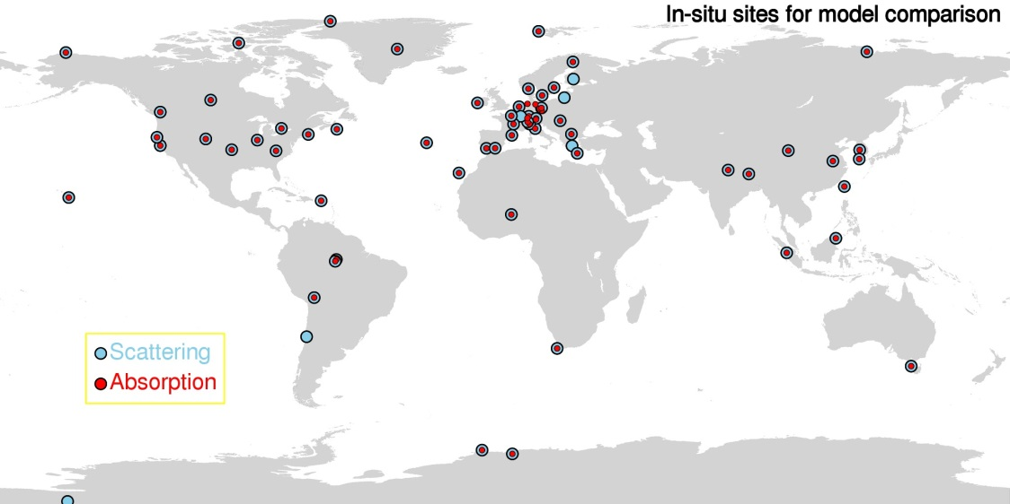
Figure 1. Map of sites with in-situ aerosol scattering and absorption. Need to update with actual sites used (pretty much just noaa network).

2.2 Description of AeroCom models used (grid size, temporal res, variables, etc)

Model output was requested from the AeroCom community of aerosol modelers for the INSITU experiment. The specific output requested was blah blah. Table 1 provides a list of the models which provided output either for this Phase III AeroCom data call or had previously provided relevant data for an AeroCom Phase II data request.

Table 1. Description of models used in analysis
Model name  Gridbox size  Output Year | Citation(s) | MET | Mixing | Something  Else  Chemistry?
TM5  3.0° x 2.0°  2010 | Van Noije et al., 2014 | Offline (ERA-Interim) | Internal mixing within modes
GEOS-Chem  2.4° x 2.0°  2010 | Bey et al. (2001) | offline chemistry-transport model  (GEOS-5) | External mixing
CAM5  2.4° x 1.9°  2010 | Liu et al. (2012)  Ghan et al. (2012) | horizontal winds nudged towards ERA-Interim reanalysis | Internal mixing by volume
ECHAM6-SALSA  1.8° x 1.9°  2010 | Bergman et al. 2012.  Laakso et al., 2016 | Nudged towards ERA-Interim reanalysis data | Internal mixing by volume
GEOS5-Globase  1.25° x 1°  2010 | Chin et al., 2002, 2014  Colarco et al. 2010 | runs in “re-play” mode; MERRA met analysis | External mixing
GEOS5-MERRAero  0.6° x 0.5°  2010 | Buchard et al 2015, 2016 | Driven by meteorology from the MERRA-1 reanalysis | External mixing
Oslo models (Oslo CAM5 and OsloCTM) can be added too I think | (need to check wavelengths provided for them)

2.3 Merging of model and measurement-
- Picked closest model gridpoint (same as Eckhardt et al., 2015)
- Adjusting measurements to ambient TP (since not all models provide T&P) use neph P and model T? (use same model T for all adjustments from highest res (space/time model) for which it’s available. (currently just assuming an annual T).

3. Results
    - Systematic variability
Intro: systematic variability may provide information about how well the model is simulating aerosol processing, sources, transport, etc. need a stronger statement here….what nick S said in beijing about intensive vs intensive systematic variability plots allow for ??

Discuss figure 2 and figure 3

4. Discussion

5. Conclusions

6. References

Anderson, T. L., Ogren, J.A., “Determining aerosol radiative properties using the TSI 3563 integrating nephelometer,” Aerosol Sci. Technol., 29, 57– 59, 1998.
Andrews, E., Ogren, J.A., Kinne, S., Samset, B., Giles, D.M., Holben, B., “Is there a bias in AERONET retrievals of aerosol light absorption at low AOD conditions?,” submitted to Atmos. Chem. Phys. in sept 2016.
Andrews, E., Ogren, J.A., Bonasoni, P., Marinoni, A., Cuevas, E., Rodriguez, S., Sun, J.Y., Jaffe, D.A., Fischer, E.V., Baltensperger, U., Weingartner, E., Collaud Coen, M., Sharma, S., Macdonald, A.M., Leaitch, W.R., Lin, N.-H., Laj, P., Arsov, T., Kalapov, I., Jefferson, A., Sheridan, P.J., “Climatology of aerosol radiative properties in the free troposphere”, Atmospheric Research, 102, 365-393, 2011.
Andrews mountain paper XXXX
Asmi, A., Collaud Coen, M., Ogren, J.A., Andrews, E., Sheridan, P., Jefferson, A., Weingartner, E., Baltensperger, U., Bukowiecki, N., Lihavainen, H., Kivekäs, N., Asmi, E., Aalto, P.P., Kulmala, M., Wiedensohler, A., Birmili, W., Hamed, A., O'Dowd, C., Jennings, S.G., Weller, R., Flentje, H., Mari Fjaeraa, A., Fiebig, M., Lund Myhre, C., Hallar, A.G., and Laj,P., “Aerosol decadal trends – Part 2: In-situ aerosol particle number concentrations at GAW and ACTRIS stations,” Atmos. Chem. Phys., 13, 895-916, 2013.
Bond, T. C., Anderson, T. L., and Campbell, D.: Calibration and intercomparison of filter-based measurements of visible light absorption by aerosols, Aerosol Sci. Technol., 30, 582–600, doi:10.1080/027868299304435, 1999.
Collaud-Coen, M., Andrews, E., Asmi, A., Baltensperger, U., Bukowiecki, N., Day, D., Fiebig, M., Fjaeraa, A.M., Flentje, H., Hyvärinen, A., Jefferson, A., Jennings, S.G., Kouvarakis, G., Lihavainen, H., Lund Myhre, C., Malm, W.C., Mihapopoulos, N., Molenar, J.V., O'Dowd, C., Ogren, J.A., Schichtel, B.A., Sheridan, P., Virkkula, A., Weingartner, E., Weller, R., and Laj, P.,” Aerosol decadal trends – Part 1: In-situ optical measurements at GAW and IMPROVE stations,” Atmos. Chem. Phys., 13, 869-894, 2013.
Breider, T. J., et al. "Annual distributions and sources of Arctic aerosol components, aerosol optical depth, and aerosol absorption." Journal of Geophysical Research: Atmospheres 119.7 (2014): 4107-4124. {Model measurement comparisons of aerosols and ozone in the Arctic}
Delene, D. J. and Ogren, J. A., “Variability of aerosol optical properties at four North American surface monitoring sites,” J. Atmos. Sci., 59, 1135–1150, 2002.
Eckhardt, S., et al., “Current model capabilities for simulating black carbon and sulfate concentrations in the Arctic atmosphere: a multi-model evaluation using a comprehensive measurement data set,” Atmos. Chem. Phys., 15, 9413–9433, 2015.
Ginoux, P., Horowitz, L. W., Ramaswamy, V., Geogdzhayev, I. V., Holben, B. N., Stenchikov, G., Tie, X., “Evaluation of aerosol distribution and optical depth in the Geophysical Fluid Dynamics Laboratory coupled model CM2.1 for present climate,” J. Geophys. Res., 111, doi:10.1029/2005JD006707, 2006.
GAW protocols reference

Glantz, Paul, et al. "Remote sensing of aerosols in the Arctic for an evaluation of global climate model simulations." Journal of Geophysical Research: Atmospheres 119.13 (2014): 8169-8188.{comparison between NorESM model and measurements at Zeppelin}

Huneeus et al., 2011 (dust);

IPCC, XXXX

Jiao et al., 2014 (arctic bc);
Kim et al., 2014
Kinne, S., et al., “An AeroCom initial assessment – optical properties in aerosol component modules of global models,” Atmos. Chem. Phys., 6, 1-20, 2006.
Koch, D., et al “Evaluation of black carbon estimations in global aerosol models,” Atmos. Chem. Phys., 9, 9001–9026, 2009. {highly cited paper about difficulty modeling BC in arctic (among other places), covered in Wang 2014}

Koffi et al., 2012

Lacagnina et al., 2015;
Mann et al., “Intercomparison and evaluation of global aerosol microphysical properties among AeroCom models of a range of complexity,” Atmos. Chem. Phys., 14, 4679–4713, 2014.
Myhre, G. et al., “Radiative forcing of the direct aerosol effect from AeroCom Phase II simulations,” Atmos. Chem. Phys., 13, 1853–1877, 2013.
Mueller, Ecotech neph trunc paper
Ogren, J. A., “Comment on “Calibration and Intercomparison of Filter-Based Measurements of Visible Light Absorption by Aerosols”, Aerosol Sci. Technol., 44, 589–591, doi:10.1080/02786826.2010.482111, 2010.
Pandolfi, M., Cusack, M., Alastuey, A., Querol, X., “Variability of aerosol optical properties in the Western Mediterranean Basin,” Atmos. Chem. Phys., 11, 8189–8203, 2011.
Petzold map paper?
Samset et al., 2014 (BC);
Schutgens et al., 2016 comparing spatial/temporal consistent data sets
Schmeisser 2017 paper about systematic variability
Sheridan et al. 2012 AAO paper
Sheridan, P.J., Delene, D.J., and Ogren, J.A., “Four years of continuous surface aerosol measurements from the Department of Energy’s Atmospheric Radiation Measurement Program Southern Great Plains Cloud and Radiation Testbed site,” J. Geophys. Res., 106, 20735-20747, 2001.
Sherman, J.P., Sheridan, P.J., Ogren, J.A., Andrews, E., Hageman, D.C., Schmeisser, L., Jefferson, A., Sharma, A., “A multi-year study of lower tropospheric aerosol variability and systematic relationships from four North American regions,” Atmos. Chem. Phys., 15, 12487-12517, 2015.
Shindell, D. T., et al. "A multi-model assessment of pollution transport to the Arctic." Atmospheric Chemistry and Physics 8.17 (2008): 5353-5372.{Sensitivity of aerosol and gas concentrations in Arctic to changes in emissions using multiple models}
Tsigaridis, K. et al. “The AeroCom evaluation and intercomparison of organic aerosol in global models,” Atmos. Chem. Phys., 14, 10845–10895, 2014.
Virkkula PSAP papers (original and correction)

Model papers in table 1 – need to sort and complete references
Bergman, T., Kerminen, V.-M., Korhonen, H., Lehtinen, K. J., Makkonen, R., Arola, A., Mielonen, T., Romakkaniemi, S., Kulmala, M., and Kokkola, H.: Evaluation of the sectional aerosol microphysics module SALSA implementation in ECHAM5-HAM aerosol-climate model, Geosci. Model Dev., 5, 845-868, doi:10.5194/gmd-5-845-2012, 2012.
Bey, I., D. J. Jacob, R. M. Yantosca, J. A. Logan, B. Field, A. M. Fiore, Q. Li, H. Liu, L. J. Mickley, and M. Schultz, Global modeling of tropospheric chemistry with assimilated meteorology: Model description and evaluation, J. Geophys. Res., 106, 23,073-23,096, 2001.
Buchard, V., and Coauthors, 2015: Using the OMI aerosol index and absorption aerosol optical depth to evaluate the NASA MERRA Aerosol Reanalysis. Atmospheric Chemistry and Physics, 15 (10), 5743–5760, doi:10.5194/acp-15-5743-2015.
Buchard, V., and Coauthors, 2016a: Evaluation of the surface PM2.5 in Version 1 of the NASA MERRA Aerosol Reanalysis over the United States. Atmospheric Environment, 125, 100–111, doi:10.1016/j.atmosenv.2015.11.004.
Chin, M., P. Ginoux, S. Kinne, O. Torres, B. N. Holben, B. N. Duncan, et al., Tropospheric aerosol optical thickness from the GOCART model and comparisons with satellite and sun photometer measurements, J. Atmos. Sci., 59, 461–483, 2002.
Chin, M., T. Diehl, Q. Tian, J. M. Prospero, R. A. Kahn, A. Remer, H. Yu, A. M. Sayer, H. Bian, et al., Multi-decadal variations of atmospheric aerosols from 1980 to 2009: sources and regional trends, Atmos. Chem. Phys., 14, 3657-3690, doi:10.5194/acp-14-3657-2014, 2014.
Chin, M., T. Diehl, O. Dubovik, T. F. Eck, B. N. Holben, A. Sinyuk, and D. G. Streets, Light absorption by pollution, dust and biomass burning aerosols: A global model study and evaluation with AERONET data, Ann. Geophys., 27, 3439-3464, 2009.
Colarco, P. R., A. da Silva, M. Chin, T. Diehl: Online simulations of global aerosol distributions in the NASA GEOS-4 model and comparisons to satellite and ground-based aerosol optical depth, J. Geophys. Res., 115, D14207, doi:10.1029/2009JD012820, 2010.
S. J. Ghan, X. Liu, R. C. Easter, R. Zaveri, P. J. Rasch, J.-H. Yoon, and B. Eaton, 2012: Toward a Minimal Representation of Aerosols in Climate Models: Comparative Decomposition of Aerosol Direct, Semidirect, and Indirect Radiative Forcing. J. Climate, 25, 6461–6476, doi: 10.1175/JCLI-D-11-00650.1.
Laakso, A., Kokkola, H., Partanen, A.-I., Niemeier, U., Timmreck, C., Lehtinen, K. E. J., Hakkarainen, H., and Korhonen, H.: Radiative and climate impacts of a large volcanic eruption during stratospheric sulfur geoengineering, Atmos. Chem. Phys., 16, 305-323, doi:10.5194/acp-16-305-2016, 2016.
Liu, X., Easter, R. C., Ghan, S. J., Zaveri, R., Rasch, P., Shi, X., Lamarque, J.-F., Gettelman, A., Morrison, H., Vitt, F., Conley, A., Park, S., Neale, R., Hannay, C., Ekman, A. M. L., Hess, P., Mahowald, N., Collins, W., Iacono, M. J., Bretherton, C. S., Flanner, M. G., and Mitchell, D.: Toward a minimal representation of aerosols in climate models: description and evaluation in the Community Atmosphere Model CAM5, Geosci. Model Dev., 5, 709-739, doi:10.5194/gmd-5-709-2012, 2012.
Myhre, G., et al. (2013), Radiative forcing of the direct aerosol effect from AeroCom Phase II simulations, Atmos. Chem. Phys., 13(4), 1853-1877
Skeie, R. B., et al. (2011), Anthropogenic radiative forcing time series from pre-industrial times until 2010, Atmos. Chem. Phys., 11(22), 11827-11857.
Takemura, T., T. Nozawa, S. Emori, T. Y. Nakajima, and T. Nakajima, 2005: Simulation of climate response to aerosol direct and indirect effects with aerosol transport-radiation model. J. Geophys. Res., 110, D02202, doi:10.1029/2004JD005029.
Van Noije et al., Simulation of tropospheric chemistry and aerosols with the climate model EC-Earth, Geosci. Model Dev., 2014

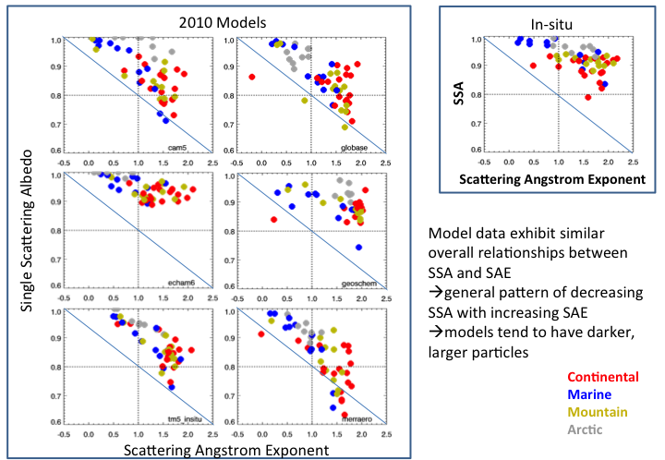
Figure 2 Annual median values of single scattering albedo (at 550 nm) vs scattering Angstrom exponent (440/550nm wavelength pair – check!)

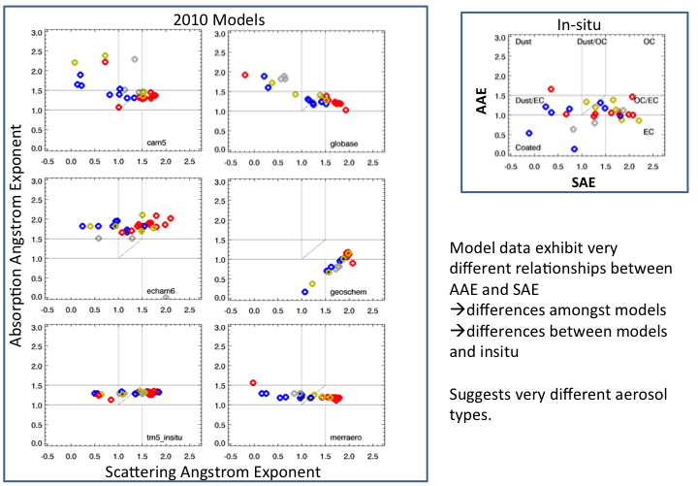
Figure 3 Annual median values of absorption Angstrom exponent vs scattering Angstrom exponent (440/550nm wavelength pair for both variables– check!)

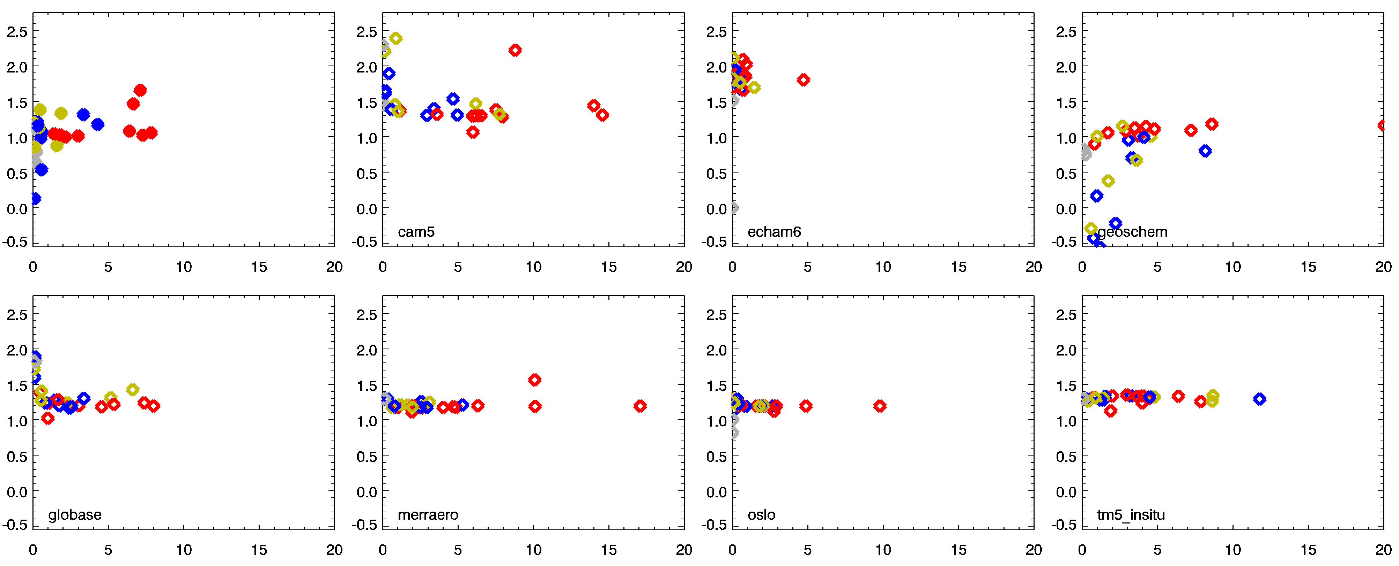
Abs vs AAE

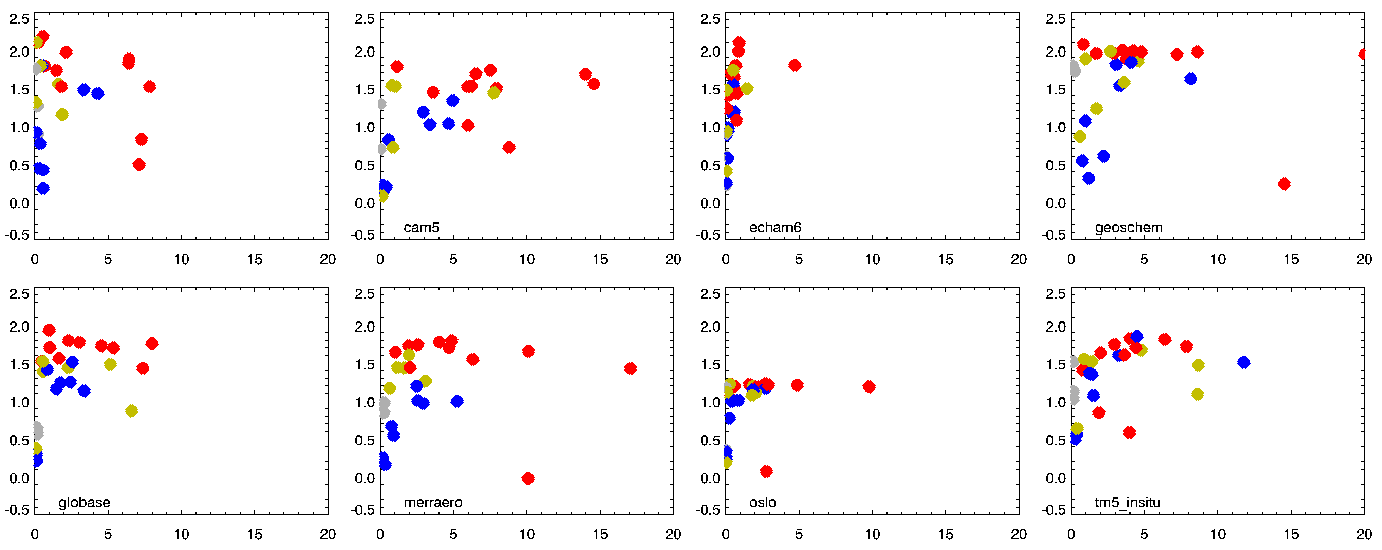
Abs vs SAE

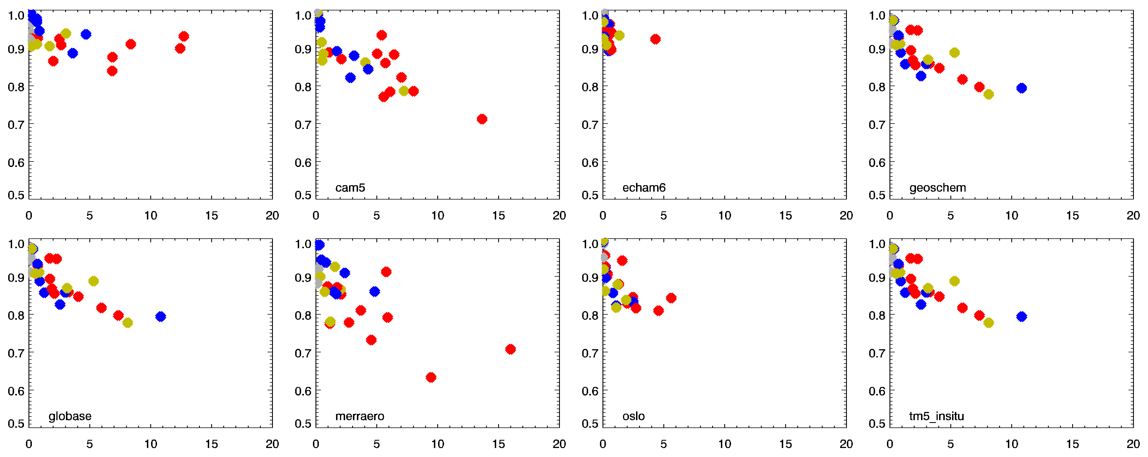
Abs vs SSA
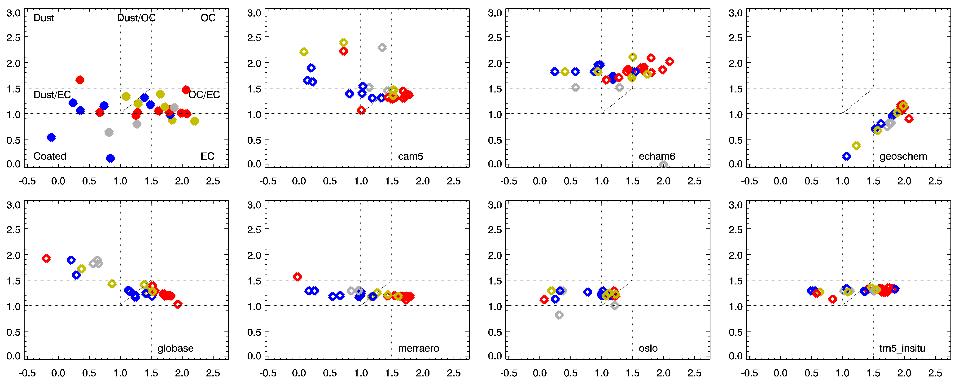
SAE vs AAE

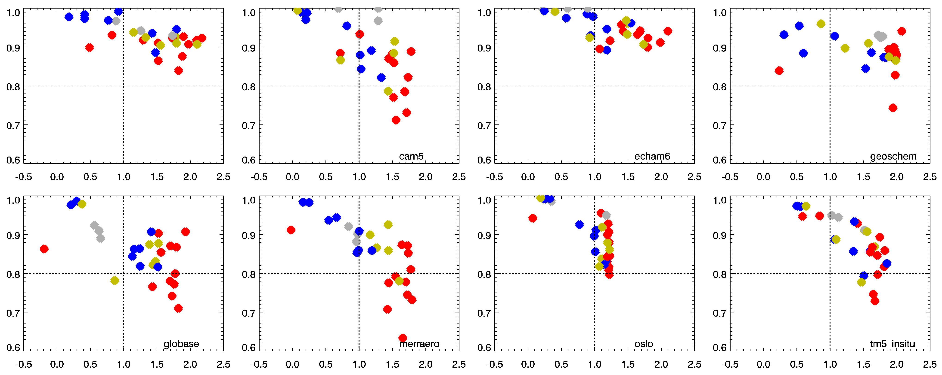
SAE vs ssa

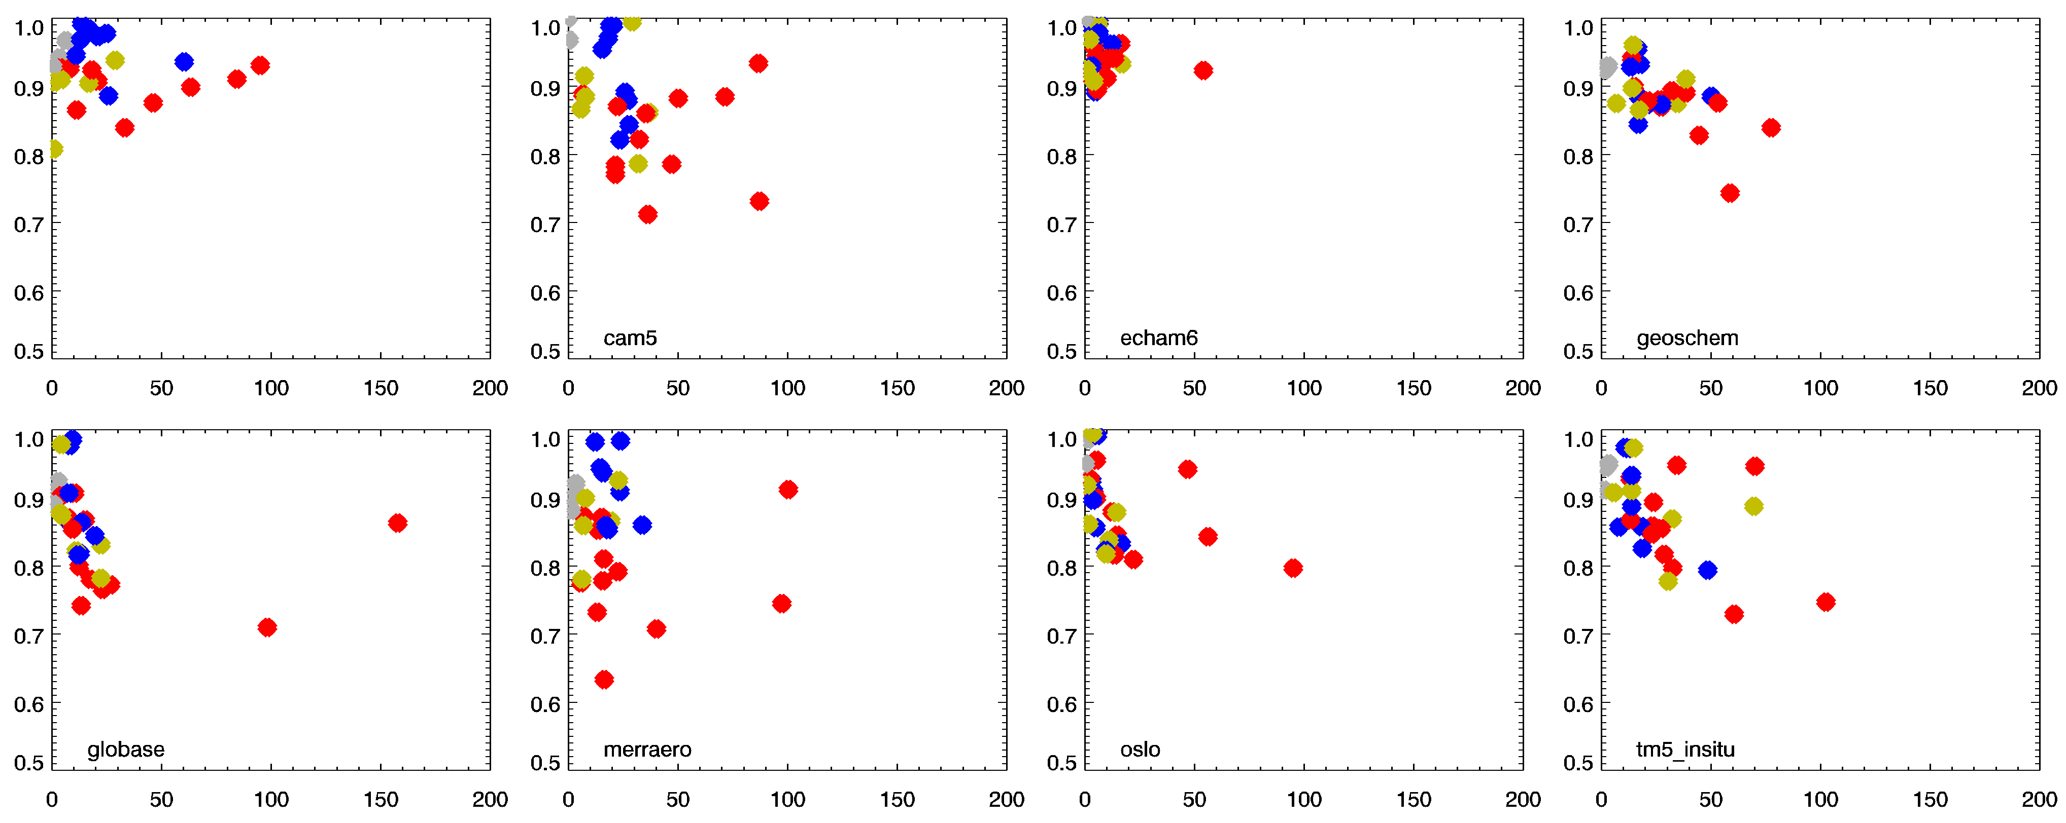
Scat vs SSA
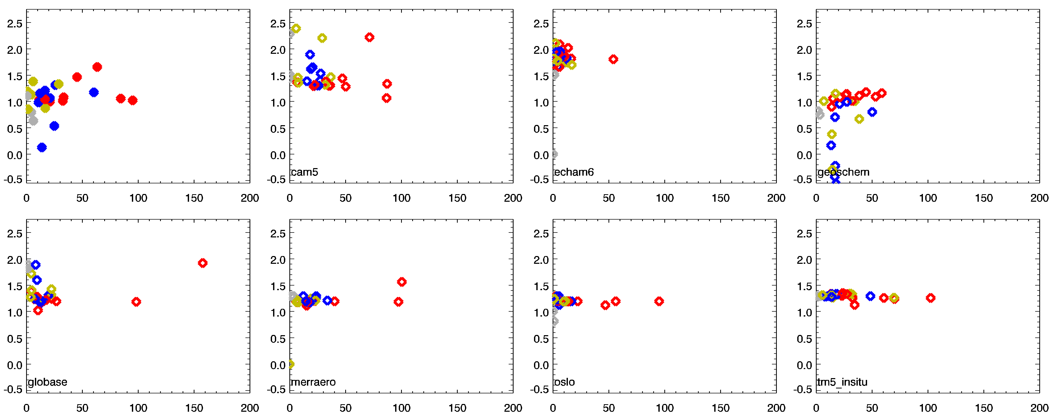
Scat vs AAE

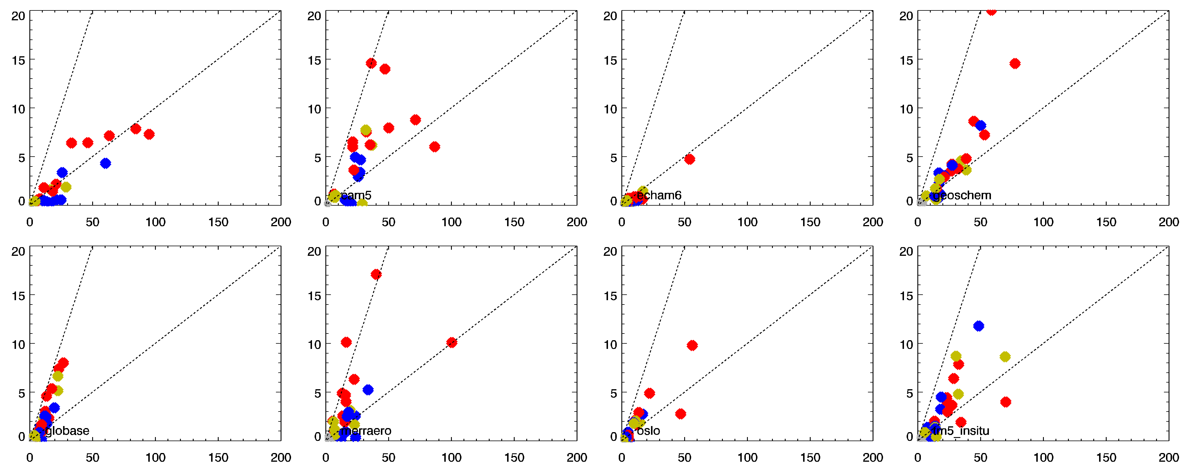
Scat vs abs

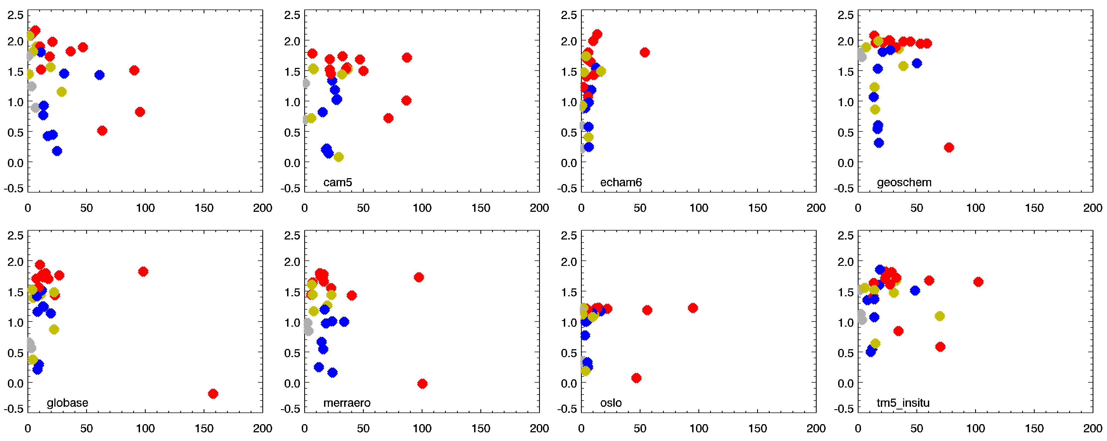
Scat vs SAE

Appendix - Supplementary Materials
Table S1. List of sites used in this study
Station ID  Station name  ‘Type’ | Country  Lat Long Elev | Instruments (dates)
ALT  Alert  ‘Polar’ | Canada | TSI neph  PSAP-3w  CLAP-3w
AMY  Anmyeon-do  ‘coastal’ | South Korea | TSI neph  PSAP-3w  CLAP-3w
ANB  Annaberg-Buchholz  ‘continental’ | Germany
APP  Appalachian State  ‘continental’ | USA | TSI neph  PSAP-3w  CLAP-3w
APT  Aspvreten  ‘continental’ | Sweden
ARN  El Arenosillo  ‘coastal’ | Spain | TSI neph  CLAP-3w
BEO  BEO-Moussala  ‘mountain’ | Bulgaria | TSI neph  CLAP-3w
BIR  Birkenes  ‘continental’ | Norway
BKT  Bukit Kototabang  ‘continental’ | Indonesia
BND  Bondville  ‘continental’ | USA | TSI neph  PSAP-1w  PSAP-3w  CLAP-3w
BRW  Barrow  ‘polar’ | USA | TSI neph  PSAP-1w  PSAP-3w  CLAP-3w
BSL  Bosel  ‘continental’ | Germany
CES  Cabauw  ‘coastal’ | The Netherlands
CGO  Cape Grim  ‘coastal’ | Australia
CHC  Chacaltaya  ‘mountain’ | Bolivia
CMN  Monte Cimone  ‘mountain’ | Italy
CPR  Cape San Juan  ‘coastal’ | USA (Puerto Rico) | TSI neph  PSAP-1w  PSAP-3w  CLAP-3w
CPT  Cape Point  ‘coastal’ | South Africa | TSI neph  PSAP-1w  PSAP-3w  CLAP-3w
DEM  Demokritos  ‘continental’ | Greece
DMV  Danum Valley  ‘continental’ | Malaysia
EGB  Egbert  ‘continental’ | Canada | TSI neph  PSAP-1w  PSAP-3w  CLAP-3w
ETL  East Trout Lake  ‘continental’ | Canada | TSI neph  PSAP-1w  PSAP-3w  CLAP-3w
FIK  Finokalia  ‘coastal’ | Greece
FKB  Hesselbach  ‘continental’ | Germany | TSI neph  PSAP-1w  PSAP-3w  CLAP-3w
GSN  Gosan  ‘coastal’ | South Korea | TSI neph  PSAP-1w  PSAP-3w  CLAP-3w
GRW  Graciosa  ‘coastal’ | Portugal (Azores) | TSI neph  PSAP-1w  PSAP-3w  CLAP-3w
HFE  Shouxian  ‘continental’ | China | TSI neph  PSAP-1w  PSAP-3w  CLAP-3w
HPB  Hohenpeissenberg  ‘continental’ | Germany
HYY  Hyytiala  ‘continental’ | Finland
IPR  Ispra  ‘continental’ | Italy
IZA  Izana  ‘mountain’ | Spain (Tenerife) | TSI neph  MAAP
JFJ  Jungfraujoch  ‘mountain’ | Switzerland | TSI neph  MAAP
KPS  K-puszta  ‘continental’ | Hungary | TSI neph  PSAP-1w  PSAP-3w  CLAP-3w
LEI  Leipzig  ‘continental’ | Germany
LEW  Leipzig-West  ‘continental’ | Germany
LLN  Mt. Lulin  ‘mountain’ | Taiwan | TSI neph  PSAP-1w  PSAP-3w  CLAP-3w
MAN  Manacapuro  ‘continental’ | Brazil | TSI neph  PSAP-1w  PSAP-3w  CLAP-3w
MAO  Manaus  ‘continental’ | Brazil
MHD  Mace Head  ‘coastal’ | Ireland | TSI neph
MLO  Mauna Loa  ‘mountain’ | USA | TSI neph  PSAP-1w  PSAP-3w  CLAP-3w
MPZ  Melpitz  ‘continental’ | Germany
MSA  Montsec | Spain
MSY  Montseny | Spain
NIM  Niamey  ‘continental’ | Niger | TSI neph  PSAP-1w  PSAP-3w  CLAP-3w
NMY  Neumayer  ‘polar’ | Antarctica (Germany)
OPE  Obs. Perenne de L’Environ.  ‘continental’ | France
PAL  Pallas  ‘polar’ | Finland
PGH  Nainital  ‘continental’ | India | TSI neph  PSAP-1w  PSAP-3w  CLAP-3w
PLA  Preila  ‘continental’ | Lituania
PUY  Puy de Dome  ‘mountain’ | France
PVC  Cape Cod  ‘coastal’ | USA | TSI neph  PSAP-1w  PSAP-3w  CLAP-3w
PYE  Point Reyes  ‘coastal’ | USA | TSI neph  PSAP-1w  PSAP-3w  CLAP-3w
RSL  Resolute  ‘polar’ | Canada | TSI neph  CLAP-3w
SGP  Southern Great Plains  ‘continental’ | USA | TSI neph  PSAP-1w  PSAP-3w  CLAP-3w
SIR  SIRTA  ‘continental’ | France
SPL  Storm Peak  ‘mountain’ | USA | TSI neph  PSAP-1w  PSAP-3w  CLAP-3w
SPO  South Pole  ‘polar’ | USA (Antarctica) | TSI neph
SSL  Schauinsland  ‘continental’ | Germany
SUM  Summit  ‘polar’ | Greenland | TSI neph  CLAP-3w
THD  Trinidad Head  ‘coastal’ | USA | TSI neph  PSAP-1w  PSAP-3w  CLAP-3w
TIK  Tiksi  ‘polar’ | Russia | TSI neph  MAAP
TRL  Trollhaugen  ‘polar’ | Norway (Antarctica)
TRS  Troll  ‘polar’ | Norway (Antarctica
VAV  Vavihill  ‘continental’ | Sweden
WAL  Waldhof  ‘continental’ | Germany
WHI  Mt Whistler  ‘mountain’ | Canada | TSI neph  PSAP-1w  PSAP-3w  CLAP-3w
WLG  Mt Waliguan  ‘mountain’ | China | TSI neph  PSAP-1w  PSAP-3w
WSA  Sable Island  ‘coastal’ | Canada | TSI neph  PSAP-1w
ZEP  Zeppelin  ‘polar’ | Norway
ZSF  Zugspitze  ‘mountain’ | Germany | TSI neph  MAAP

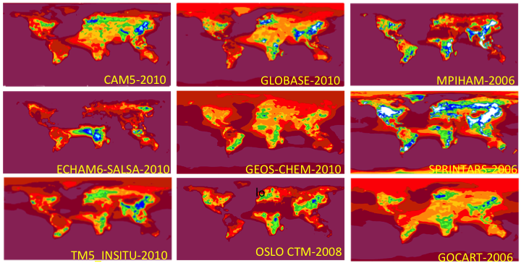

Figure S1 Modelled annual median (mean?) aerosol scattering coefficient at 550 nm (No MerrAero, as only data at site locations was provided). Need to rearrange so models in same order as Figure 3b.

Figure S2 Modelled annual median (mean?) aerosol absorption coefficient at 550 nm (No MerrAero, as only data at site locations was provided). Need to rearrange so models in same order as Figure 4b
Figure S3 Modelled annual median (mean?) aerosol single scattering albedo at 550 nm (No MerrAero, as only data at site locations was provided). Need to rearrange so models in same order as Figure 3b.
Figure S4 Modelled annual median (mean?) aerosol scattering Ångström exponent for 440/550(?) nm wavelength pair. (No MerrAero, as only data at site locations was provided). Need to rearrange so models in same order as Figure 3b.

