Historical Aethalometer Operations

at NOAA/ESRL/GMD Monitoring Stations

Lauren Schmeisser

August 2015

This document outlines the current and historical operations of aethalometers at 4 monitoring stations within the NOAA GMD Network- Barrow, Alaska (BRW), Mauna Loa, Hawaii (MLO), South Pole, Antarctica (SPO), and Summit, Greenland (SUM)- over the period 1988-2015.

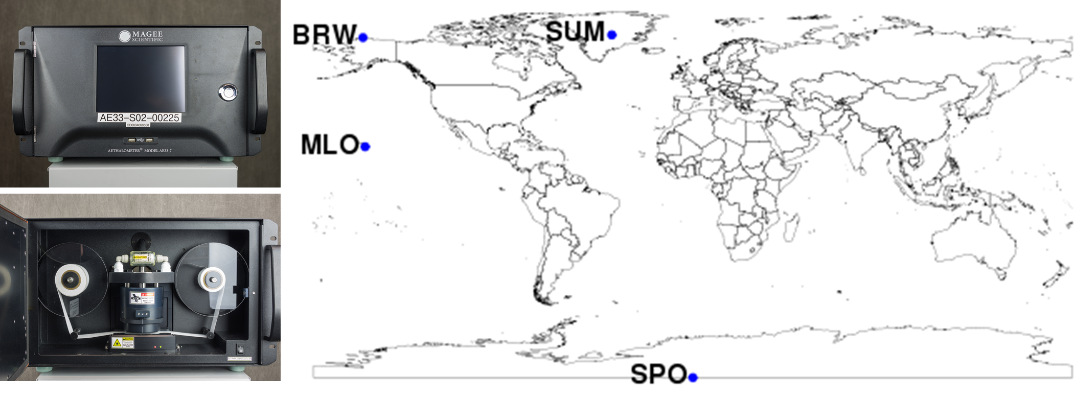

**Table of Contents**

[Introduction 4](#_Toc428278273)

[Aethalometer Theory 4](#_Toc428278274)

[Aethalometer Models 5](#_Toc428278275)

[Aethalometer Model AE8 5](#_Toc428278276)

[Aethalometer Model AE16 5](#_Toc428278277)

[Aethalometer Model AE31 6](#_Toc428278278)

[Aethalometer Model AE33 7](#_Toc428278279)

[Differences in Aethalometer Models 8](#_Toc428278280)

[Barrow, Alaska (BRW) 11](#_Toc428278281)

[Site Description 11](#_Toc428278282)

[Instrument History 11](#_Toc428278283)

[Setup Configurations 12](#_Toc428278284)

[AE8 Configuration 12](#_Toc428278285)

[AE31 Configuration 12](#_Toc428278286)

[AE33 Configuration 12](#_Toc428278287)

[Data 13](#_Toc428278288)

[Data Flow 13](#_Toc428278289)

[Known Data Problems 13](#_Toc428278290)

[Data Editing 14](#_Toc428278291)

[Instrument Comparisons 14](#_Toc428278292)

[AE8/ PSAP 14](#_Toc428278293)

[AE33/ AE31 15](#_Toc428278294)

[AE31/ CLAP 16](#_Toc428278295)

[AE33/ CLAP 17](#_Toc428278296)

[Operations 17](#_Toc428278297)

[Noise Checks 18](#_Toc428278298)

[Photo Documentation 19](#_Toc428278299)

[Mauna Loa, Hawaii (MLO) 20](#_Toc428278300)

[Site Description 20](#_Toc428278301)

[Instrument History 20](#_Toc428278302)

[Setup Configurations 21](#_Toc428278303)

[Early Aethalometer Configurations 21](#_Toc428278304)

[AE31 Configuration 21](#_Toc428278305)

[AE33 Configuration 21](#_Toc428278306)

[Data 22](#_Toc428278307)

[Data Flow 22](#_Toc428278308)

[Known Data Problems 22](#_Toc428278309)

[Data Editing 24](#_Toc428278310)

[Instrument Comparisons 24](#_Toc428278311)

[AE16/PSAP 25](#_Toc428278312)

[AE16/CLAP 25](#_Toc428278313)

[AE31/AE33 25](#_Toc428278314)

[AE31/CLAP 25](#_Toc428278315)

[AE33/CLAP 25](#_Toc428278316)

[Operations 25](#_Toc428278317)

[Noise Checks 26](#_Toc428278318)

[Photo Documentation 26](#_Toc428278319)

[South Pole, Antarctica (SPO) 28](#_Toc428278320)

[Site Description 28](#_Toc428278321)

[Instrument History 28](#_Toc428278322)

[Setup Configurations 29](#_Toc428278323)

[Early Aethalometer Configuration 29](#_Toc428278324)

[AE31 Configuration 29](#_Toc428278325)

[AE33 Configuration 29](#_Toc428278326)

[Data 29](#_Toc428278327)

[Data Flow 29](#_Toc428278328)

[Known Data Problems 30](#_Toc428278329)

[Data Editing 33](#_Toc428278330)

[Instrument Comparisons 33](#_Toc428278331)

[AE33/AE31 33](#_Toc428278332)

[Operations 35](#_Toc428278333)

[Noise Checks 35](#_Toc428278334)

[Photo Documentation 36](#_Toc428278335)

[Summit, Greenland (SUM) 38](#_Toc428278336)

[Site Description 38](#_Toc428278337)

[Instrument History 38](#_Toc428278338)

[Setup Configurations 38](#_Toc428278339)

[AE16 Configuration 38](#_Toc428278340)

[AE33 Configuration 39](#_Toc428278341)

[Data 39](#_Toc428278342)

[Data Flow 39](#_Toc428278343)

[Known Data Problems 40](#_Toc428278344)

[Data Editing 44](#_Toc428278345)

[Instrument Comparisons 45](#_Toc428278346)

[AE16/AE33 45](#_Toc428278347)

[AE33/CLAP 46](#_Toc428278348)

[AE16/CLAP 47](#_Toc428278349)

[Operations 48](#_Toc428278350)

[Noise Checks 48](#_Toc428278351)

[Photo Documentation 49](#_Toc428278352)

[References 52](#_Toc428278353)

# Introduction

This document details the operations of aethalometers at 4 monitoring stations within the NOAA Federated Aerosol Network- Barrow, Alaska (BRW), Mauna Loa, Hawaii (MLO), South Pole, Antarctica (SPO), and Summit, Greenland (SUM)- over the period 1988-2015. Information on aethalometer instrument history at each site, current and past instrument configurations, data coverage, instrument comparisons, instrument noise, and aethalometer operations is presented in this report.

# Aethalometer Theory

The aethalometer measures light transmitted through a filter on which particles are deposited, and interprets the attenuation of light through the filter as the equivalent atmospheric concentration of black carbon (BC) particles. The attenuation of light is roughly proportional to the amount of BC on the sample filter (ignoring filter loading and other effects), and attenuation is defined by the equation

ATN = -100\*ln (I/Io)

where Io is the intensity of light transmitted through an unloaded reference portion of the filter and I is the intensity of light transmitted through a loaded filter. As the instrument produces a time series of attenuation values, an attenuation coefficient is calculated using the change in attenuation with time, along with the spot size and flow rate using the following equation

bATN = A/Q \*(1/100) \* (∆ATN/∆t)

where A is the spot size area, ∆ATN is change in attenuation over time ∆t, Q is flow into the instrument and ∆t is change in time. Absorption coefficient can then be calculated from the attenuation coefficient by dividing attenuation coefficient by the multiple scattering parameter, C (Weingartner et al., 2003), which accounts for multiple scattering of the filter material, as in the following equation

babs = bATN/C

Finally, the mass equivalent black carbon concentration [BC] is calculated by dividing the absorption coefficient by the mass absorption cross section (σair) of black carbon in air.

[BC] = babs/σair = bATN/(C \* σair)

The σair values are a function of wavelength, and are stored in the instrument. Note that the new AE-33 aethalometer model stores the multiple scattering parameter, C, and σair values separately, while earlier models combine the two factors into one sigma (SG) value. Manufacturer settings for SG values are outlined in Table 1.

The Aethalometer manufacturer uses the term “black carbon” to describe the measurements by the instrument, and this document follows that convention for consistency with the Aethalometer User’s Manuals. However, note that the term “equivalent black carbon”, as recommended by Petzold et al. (2013), should be used when reporting quantitative results from the measurements.

# Aethalometer Models

Since its creation in the 1980s, the aethalometer has seen many model iterations over the years. Various aethalometer models- including the AE8, AE16, AE31, AE33, and hand-built early models- have been in operation at stations within the NOAA Federated Aerosol Network over the past decades, and differences between the various aethalometer models are noted here.

## Aethalometer Model AE8

The aethalometer model AE8 has an incandescent light source and is thus referred to here as a broadband instrument. The equivalent wavelength of the broadband aethalometers has been estimated to be around 830nm (Bodhaine, 1995) or 840nm (Weingartner et al., 2003). Most AE8s used 47mm quartz filter tape, which had to be changed manually, although some AE8s did eventually have an automatic tape changing sample head. The AE8 output its data in two file formats: the ‘BC’ file containing BC concentrations, and the ‘MF’ file containing metadata and summary information. BC file naming convention follows ‘BCYYYYMMDD.DAT’ format, where YYYY is the year, MM is the month, and DD is the day, and contains the following parameters: date, time, sensing beam zero, sensing beam lamp, air flow rate, optical attenuation, and BC concentration. MF file naming convention follow ‘MFYYYYMMDD.DAT’ format and contains the following information: date and time of measurements starting, signal voltages at start, date and time of measurements ending, signal voltages at end, summary of run of filter (ATN of aerosol deposit, total BC concentration deposited on that filter, total filter running time, total sampled air volume, mean BC concentration during filter running period, standard deviation of BC measurements), a display of the statistical distribution of BC measurements, comments on the performance of the instrument and stability of the lamp, and an estimate of remaining disk capacity. There are no longer model AE8 aethalometers in use at any NOAA stations, but there were once AE8s running at both MLO and BRW.

## Aethalometer Model AE16

Most model AE16 aethalometers were manufactured as broadband instruments, though some were eventually converted to have 1-wavelength LED light sources at around 880nm. In the case of the AE16 at SUM, for example, the instrument started out with an incandescent light source and eventually was updated at the manufacturer from an incandescent light source to an LED 880nm light source before making measurements at SUM. AE16s use quartz fiber filter tape, with an automatic tape advance feature. The AE16 provides data output including the parameters: date, time, BC concentration (ng/m3), sensing zero signal, sensing beam signal, reference zero signal, reference beam signal, air flow (LPM), bypass fraction, and ATN. Stations MLO, SPO and SUM all had or currently have AE16 aethalometers making BC measurements.

## Aethalometer Model AE31

In 1997, multi-wavelength aethalometers were added to the market. The aethalometer model AE31 (or its prototype model AE30) was the first multi-wavelength instrument in use in the NOAA network, making measurements at 370nm, 470nm, 520nm, 590nm, 660nm, 880nm, and 950nm. AE31s use quartz filter tape that automatically advances depending on the instrument’s settings (e.g., maximum attenuation, time interval, etc.). The AE31 incorporates a ‘mean ratio’ factor into its calculations of BC concentrations, which is not well understood. It is an instrument specific parameter, and its value can be found in the instrument’s AE-SETUP.txt file. Descriptions of the mean ratio from both Grisa Mocnik and Tony Hansen are given here:

*According to Grisa Mocnik at Aerosol d.o.o., “the mean ratio is a geometrical parameter related to the homogeneity of the deposition of the sample on the Aethalometer filter. It is fixed: for large spot instruments (Extended Range) the value is 0.85, for small spot (HS) it is 1.00. However, it is a setting which can be changed by the operator, leading to all sorts of complications. We have investigated the mean ratio and it does not seem to be dependent on the face velocity, but its measurement is impacted by the filter loading effects. The easiest way to determine it is by measuring at low ATN, that is, filters only lightly loaded with the collected aerosols.”*

*According to Tony Hansen at Magee Scientific, “the 'Mean Ratio' is a geometric factor that applies \*only\* to the 'Extended Range' ('large spot') models of Aethalometer; which, in turn, are primarily deployed in highly-polluted locations. The purpose of making the spot larger was to reduce the rate of surficial accumulation and extend the time between tape advances in those locations. Aethalometers in India and China are \*frequently\* measuring ambient BC levels in the range of 50 to 100 μg/m3. We found that a simple scaling of area/area did not give identical results; and we then realized that this was due to the fact that the 'extended oval' spot did not provide an axially-symmetric light path for all beam trajectories emanating from the underside of the filter. Some parts of the outer 'wings' were at a steeper angle; other parts along the straight sides were not, because the spot wasn't circular. In principle we could have accounted for this invisibly in firmware by simply using an adjusted value for the spot area; but for certain reasons which were valid at the time, we used fixed values of the actual geometrical spot area (0.5 cm2 for the small spot; 1.67 cm2 for the large spot ); and added the 'Mean Ratio' as a parameter to correct for non-circularity of the oval spot. Comparison of data between small- and large-spot instruments showed that this parameter has a value of 0.85. Data calculated for a 'large spot' instrument and based on its geometric spot size will appear to be \*too large\* and must be multiplied by this factor of 0.85 to get agreement with the 'small spot' standard. The ER large spot was introduced in about 2001~2002 and the 'Mean Ratio' was formalized in the software soon after that. This factor does \*not\* apply to 'High Sensitivity' (small spot) instruments.”*

*New description from Tony Hansen as of 7/30/2015: “The ‘mean ratio’ was introduced for the “Extended Range” version of the instrument. This had a larger oval collection spot, instead of the smaller circular spot. The spot area is 3.3 times larger, thereby reducing the rate of aerosol accumulation. This prolonged the spot lifetime in heavily-polluted areas. The ‘ER’ version was primarily supplied to users in locations with high levels of pollution. It is unlikely that ‘ER’ instruments were used at NOAA background sites. Initial testing revealed that the non-circular shape of the spot led to a non-uniform distribution of light passing through the filter from the source to the detector. This, in turn, was found to lead to a change in response of the analysis. Consequently, ‘ER’ instruments had the data calculation multiplied by the ‘Mean Ratio’ factor of 0.85 to bring the results into agreement. The ‘ER’ spot option was offered for all models: AE16 (1-wavelength, rack-mount); AE-21 and AE-22 (2-wavelength, rack-mount); AE31 (7-wavelength, rack-mount); AE42-2 (2-wavelength, ‘Portable’ chassis); and AE42-7 (7-wavelength, ‘Portable’ chassis). Since the software contained this number in the algorithm, it was used for “Small Circular Spot” (called ‘High Sensitivity’, ‘HS’) instruments also: but for those, the Mean Ratio was set to 1.0”*

Unfortunately, the manufacturer provides information about the mean ratio that conflicts with the firsthand knowledge we have of AE31 mean ratios within the network. For one, the standard range AE31 at MLO, with a small spot size of ~0.5cm2 still has a mean ratio of 0.84 in the AE-SETUP.txt file, despite the manufacturer claims that only extended range aethalometer models have a mean ratio.

The AE31 outputs the following parameters: date, time, BC concentrations at seven wavelengths, air flow, bypass fraction, sensing zero signal at seven wavelengths, sensing beam signal at seven wavelengths, reference zero signal at seven wavelengths, reference beam signal at seven wavelengths, and optical attenuation at seven wavelengths. Stations MLO, BRW and SPO all currently have AE31 aethalometers in operation.

## Aethalometer Model AE33

The AE33 is the newest aethalometer, manufactured by Aerosol d.o.o. The AE33 is a 7-wavelength instrument, like the AE31, but is the first aethalometer that provides in real time a loading compensation parameter, k, which is supposed to account for the decrease in instrument response with the loading of the filter. The instrument derives the compensation parameter, k, by measuring light attenuation on two filter spots and calculating how measurements on the two spots change with loading. The implications of the compensation parameter, k, likely vary at each monitoring site and are not yet well understood. The AE33 uses Teflon-coated glass fiber filter (TFE) tape for sampling, and the filter spot advances automatically depending on the instrument’s setting (e.g., maximum attenuation, time interval, or preset time). The AE33 includes a leakage factor in its algorithm, not used by any of the other aethalometer models, to account for any air flow lost laterally between the optical chamber head and the filter tape in the instrument.

The AE33 outputs the date, time, time base, reference intensities at seven wavelengths, sample intensities for two spots at seven wavelengths, flow through spot 1, flow through spot 2, total flow, pressure, temperature, statuses, uncorrected BC concentrations for spots 1 and 2 at seven wavelengths, corrected BC concentrations at seven wavelengths, compensation parameters at seven wavelengths, and the tape advance count (see user’s manual for more details). The AE33 does not output ATN directly; it must be calculated from raw intensities reported by the instrument. All stations outlined in this document (BRW, MLO, SPO and SUM) have AE33 aethalometers making BC measurements on site.

It is worth mentioning the many known inconsistencies between the AE31 and AE33 processing algorithms, especially in light of the AE33 models replacing the AE31s throughout the monitoring network. As mentioned above, the AE31 includes a mean ratio factor that is not well understood, and is not included in the AE33. In addition, the multiple scattering parameter ‘C’ values are different for each instrument because they use different filter materials (quartz for the AE31 and TFE for the AE33). The AE31 multiple scattering parameter C =2.14 came from Weingartner et al. (2003), while the AE33 multiple scattering parameter C=1.57 came from experiments running the AE33 and AE31 in parallel (Drinovec et al., 2015). Finally, the AE33 has two factors in its algorithm that the AE31 does not have- the leakage factor and the loading compensation parameter ‘k’.

## Differences in Aethalometer Models

One of the main differences between aethalometer models is the sigma (SG) values used to convert absorption coefficient to black carbon concentrations. The programmed SG values are a product of the mass absorption cross section in air (σair) and the multiple scattering parameter (C) (Weingartner et al., 2003) of the filter. Since the SG value depends on the filter type, and the different models use different filter material, the SG values in each instrument are different. Furthermore, the SG values are dependent on wavelength. The table below outlines the default SG values used in the aethalometer’s internal algorithm for calculating BC.

Table . Mass absorption coefficient values for black carbon on a filter (in m2/g) used by different aethalometer models

|  |  |  |  |  |  |  |  |
| --- | --- | --- | --- | --- | --- | --- | --- |
| **Model** | **Channel 1**  **370nm** | **Channel 2 470nm** | **Channel 3 520nm** | **Channel 4 590nm** | **Channel 5 660nm** | **Channel 6 880nm**  **(or broadband)** | **Channel 7 950nm** |
| AE8 |  |  |  |  |  | 19 |  |
| AE16 |  |  |  |  |  | 16.6 |  |
| AE31 | 39.5 | 31.1 | 28.1 | 24.8 | 22.2 | 16.6 | 15.4 |
| AE33\* | 29.0 | 22.8 | 20.6 | 18.2 | 16.2 | 12.2 | 11.3 |

\*Note that the SG values for the AE33 are separated into the C value and σair values in the instrument menu and setup files (which are multiplied to get the values in this table), and the σair values can be changed by the user if desired

Given the differences in aethalometer models, there is work being done to analyze the comparability of instrument measurements from different models. Comparisons of measurements from different aethalometer models (e.g., AE31 vs. AE33), as well as comparisons of aethalometer measurements to other filter-based absorption measurements (e.g., AE33 vs. Continuous Light Absorption Photometer (CLAP), explained in section on instrument comparisons), are necessary. A proper characterization of systematic differences between instruments can be used to adjust and stitch together a multi-instrument time series yielding a longer finalized measurement record. An important part of making direct comparisons between instruments is to first understand the differences in the BC algorithms from each aethalometer model type; the equations and parameters for these algorithms are outlined in the table below.

Table . BC Algorithms by Aethalometer Model Type

|  |  |  |
| --- | --- | --- |
| Model | Parameters | Algorithm Equations |
| AE8  AE16 | SB= Sensing beam output voltage with lamp on  SZ= Sensing beam zero; i.e. output with lamp off  RB= Reference beam output voltage with lamp on  RZ= Reference beam zero; i.e., output with lamp off  A= Active collecting area of filter = 0.95 cm2  F= Flow rate of air through filter in LPM  ATN= Optical attenuation due to aerosol deposit on filter  BC= Surface loading of black carbon, in μg/cm2  SG= Specific attenuation cross-section for black carbon on quartz fiber filter = 19 m2/gram  C= Concentration of aerosol black carbon, in μg/m3  T= Time | ATN = -100\*ln((SB-SZ)/(RB-RZ))  ATN= SG \* BC  BC(T)-BC(0)=(C\*F\*T)/(1000\*A)  d(BC)= (ATN(T)-ATN(0))/SG  V = F\*T/1000  C= d(BC)\*A/V |
| AE31 | SB= Sensing beam output voltage with lamp on  SZ= Sensing beam zero; i.e. output with lamp off  RB= Reference beam output voltage with lamp on  RZ= Reference beam zero; i.e., output with lamp off  A= Active collecting area of filter = 0.95 cm2  F= Flow rate of air through filter in LPM  ATN= Optical attenuation due to aerosol deposit on filter  B= Surface loading of black carbon, in μg/cm2  SG= Specific attenuation cross-section for black carbon on quartz fiber filter = 19 m2/gram  C= Concentration of aerosol black carbon, in μg/m3  T= Time | Calculate attenuation:  ATN(0)=-100\*ln((SB-SZ)/(RB-RZ))  Calculate increase in surface loading of black carbon:  d(B)=(ATN(T)-ATN(0))/SG  Calculate volume of air sampled:  V=F\*T  Calculate mean aerosol BC concentration during time period:  BC=d(B)\*A/V |
| AE33 | I= Spot signal  Io= Reference signal  Fout= Measured flow  ζ= Leakage factor  S= Spot size  t= Time  C= Multiple scattering parameter (Weingartner et al., 2003)  σair= Mass absorption cross section  k= Compensation parameter | ATN = -100\*ln(I/Io)  Fin = Fout \* (1- ζ)  batn= S\*(ΔATN/100)/Fin\*Δt  babs= batn/C  BC= babs/σair  BC= BCmeasured/(1-k\*ATN)  BC=(S\* ΔATN/100)/( Fout\*(1- ζ)\* σair\*C\*(1-k\*ATN)\*Δt |

Most instrument models do not automatically provide the attenuation or absorption coefficient as default data output; consequently, the (uncorrected) attenuation coefficient is calculated by NOAA in the NOAA data acquisition software, CPD, using one of two methods. The first method is to back calculate attenuation coefficient from the reported BC concentration using the instrument’s SG value. The second method is to forward calculate the attenuation coefficient using the instrument’s spot size, flow rate, time base and beam intensities. For historical reasons, the attenuation coefficients for aethalometers at stations throughout the monitoring network are not all calculated in the same ways, and the methods for calculation are outlined in the table below.

Table . Attenuation coefficient calculation method for aethalometers in NOAA network

|  |  |  |  |
| --- | --- | --- | --- |
| **Station** | **Aethalometer Model** | **Date** | **Attenuation Coefficient Calculation Method** |
| BRW | AE8 | 1988-2002 | Back out MAC from reported BC |
| AE31 | 2010-2015 | Recalculated from ΔATN |
| AE33 | 2014-2015 | Back out MAC from reported BC |
| MLO | Hand built | 1991-1996 | Recalculated from ΔATN |
| AE16 | 1997-2001 | Recalculated from ΔATN |
| AE31 | 2004-2015 | Recalculated from ΔATN |
| AE33 | 2014-2015 | Back out MAC from reported BC |
| SPO | Hand built | 1987-1990 | Back out MAC from reported BC |
| AE16 | 1997 | Back out MAC from reported BC |
| AE31 | 2006-2015 | Recalculated from ΔATN |
| AE33 | 2013-2015 | Back out MAC from reported BC |
| SUM | AE16 | 2003-2015 | Recalculated from ΔATN |
| AE33 | 2014-2015 | Back out MAC from reported BC |

Data from all aethalometer models have to be corrected, as the aethalometer measures BC concentrations that are systematically too high. The data need to be corrected for multiple scattering by the filter fibers, scattering by particles deposited on the filter, and the decrease in instrument response as more and more particles get deposited on the filter (the filter loading effect) (Collaud Coen et al., 2010; Weingartner et al., 2003). As of now, there is no agreed upon correction scheme that is applied to all aethalometer data within the NOAA network, nor has there been an analysis on how correction schemes may differ between aethalometer models. The current plan is to submit all uncorrected Level 0 and uncorrected but edited Level 1 data to the World Data Center for Aerosols, where one general correction scheme will be applied to all submitted aethalometer data once a correction scheme is decided upon by the scientific community.

# Barrow, Alaska (BRW)

## Site Description

Barrow is located in the northernmost part of Alaska (71.32 °N, 156.61 °W), and is a remote Arctic site with an aerosol population influenced by local pollution from the nearby town as well as long-range transport of particles to the Arctic region. Barrow also experiences the Arctic Haze phenomenon, which is visible in the record of aethalometer EBC measurements. Aerosol measurements were started at BRW in 1976, and long-term aethalometer measurements began in 1988 and continue through present day (2015), with a ~8-yr gap in the data record.

## Instrument History

According to the data record available at NOAA, the aethalometer AE8 was installed at BRW on March 24, 1988. Although there is reference in a paper by Bodhaine (1995) that aethalometer measurements started at BRW in 1986 during the second Arctic Gas and Aerosol Sampling Program (AGASP II), there is no current record at NOAA of those measurements. For that reason, we document here that the earliest aethalometer data at BRW are available starting March 1988. The AE8 was removed from BRW on January 1, 2002, though it is not known why the instrument was removed. This aethalometer is now (as of August 2015) stored in the ESRL/GMD aerosol laboratory at NOAA in Boulder, CO. There were no aethalometer operations for over 8 years at BRW, until the 7-wavelength AE31 was installed on February 18, 2010. The AE33 was installed at BRW on August 13, 2014 and continues to run in parallel with the AE31, though on separate inlets. Instrument serial numbers, installation date, removal date (if applicable), and wavelengths are presented in the table below.

Table . History of aethalometer instruments at BRW

|  |  |  |  |  |
| --- | --- | --- | --- | --- |
| **Model** | **Serial Number** | **Installed** | **Removed** | **Wavelength(s)** |
| AE8 | 880202 | March 1988 | January 2002 | Broadband |
| AE31 | 463 | February 2010 | N/A | 370, 470, 520, 590, 660, 880, 950nm |
| AE33 | AE33-S02-00222 | August 2014 | N/A | 370, 470, 520, 590, 660, 880, 950nm |

Table . Timeline of aethalometer operation at BRW

|  |  |  |  |  |  |  |  |  |  |  |  |  |  |  |  |  |  |  |  |  |  |  |  |  |  |  |  |
| --- | --- | --- | --- | --- | --- | --- | --- | --- | --- | --- | --- | --- | --- | --- | --- | --- | --- | --- | --- | --- | --- | --- | --- | --- | --- | --- | --- |
| **1988** | **1989** | **1990** | **1991** | **1992** | **1993** | **1994** | **1995** | **1996** | **1997** | **1998** | **1999** | **2000** | **2001** | **2002** | **2003** | **2004** | **2005** | **2006** | **2007** | **2008** | **2009** | **2010** | **2011** | **2012** | **2013** | **2014** | **2015** |
| **AE8** | | | | | | | | | | | | | | |  |  |  |  |  |  |  |  |  |  |  |  |  |
|  |  |  |  |  |  |  |  |  |  |  |  |  |  |  |  |  |  |  |  |  |  | **AE31** | | | | | |
|  |  |  |  |  |  |  |  |  |  |  |  |  |  |  |  |  |  |  |  |  |  |  |  |  |  | **AE33** | |

## Setup Configurations

### AE8 Configuration

Not much is known about the system and inlet configuration of the AE8 instrument while it was operational at BRW. However, it is known that the AE8 was on a separate inlet from the rest of the aerosol instruments that were operational during that time.

### AE31 Configuration

The AE31 instrument does not measure on the same inlet stack as the rest of the NOAA aerosol instruments. Rather, the AE31 samples off of the surface ozone stack. The surface ozone stack extends 8ft indoors and 16ft outdoors, and is 2’’ diameter aluminum with galvanized coating (no signs of corrosion as of June 2015) and has a blower. The AE31 samples off of the surface ozone stack through a 6ft run of non-conductive 3/8’’ diameter black plastic tubing (not Dekaron), likely the tubing type that is sent along with the aethalometers during shipment, though it has been difficult to confirm this.

### AE33 Configuration

When installed in August 2014, the AE33 was integrated into the NOAA aerosol rack. The inlet air to the AE33 is from a pick off on the filter rack sample line that feeds the filter carousel and the SMPS. The aerosol inlet stack is setup using the typical NOAA aerosol stack specifications, as described in Delene & Ogren (2002). The AE33 is in front of impactors so its measurements do not have a size cut. A detailed diagram of the aerosol system configuration, and the AE33 placement within that, is shown in the figure below.



Figure . BRW aerosol system configuration, including AE33 placement

## Data

### Data Flow

For the duration of AE8 measurements at BRW, the data were transmitted to NOAA via email to scientist Tom Mefford in the GMD meteorology division. The AE8 data files were then saved on a GMD file server (in the directory: /met/aethalometer/Barrow/Raw Data), and subsequently ingested into the NOAA aerosol database. Before August 2014, this is also how AE31 data were archived at NOAA.

Shortly after installation of the AE33 in August 2014, both the AE31 and AE33 aethalometers were connected to the NOAA aerosol data acquisition software (CPD) via null modem cables. Since then, the data have been recorded in near real time to the NOAA aerosol database. After data have undergone quality control procedures (i.e., editing and any necessary corrections or adjustments), they are submitted to the World Data Center for Aerosols (WDCA) NILU/EBAS database.

Data are accessed from the NOAA aerosols group database using the station code, the desired time period and the record codes listed in the table below.

Table . Aethalometer instrument record codes at BRW

|  |  |
| --- | --- |
| **Aethalometer Model** | **Record Code** |
| AE8 | A81 |
| AE31 | A81 |
| AE33 | A82 |

### Known Data Problems

During editing of the AE8 data from BRW, it was found that the reference and/or signal intensities from the instrument were often very noisy, making the EBC concentration data invalid. Although the problematic time periods have been edited out of the final data record, many months of data were lost due to this necessary quality control procedure.

On February 5, 2015 the techs at BRW switched the AE31 to ‘3x’ tape saver mode since the instrument was getting low on tape. Although it was unclear how the NOAA data acquisition system would handle the changes to the internal operations to the instrument, there appear to be no ruptures in the time series due to the tape saver mode. On March 3, 2015, the AE31 was switched out of tape saver mode, since the new filter tape rolls arrived on site.

On June 25, 2015, the BRW techs updated the AE33 software to prevent error messages on the instrument that prevented transfer of data through the serial ports. Although no effects on the data are expected due to this software upgrade, the update is noted here in case of *a posteriori* data issues. Additionally, software and firmware upgrades were performed successfully on the AE33 on July 20, 2015, in order to expand the capabilities of the instrument.

### Data Editing

BRW aethalometer data (at least from 1992 through August 2015) have been reviewed and edited to ensure data quality. The review process includes applying contamination flags to the data whenever the wind is blowing from the contaminated sector. At BRW, the contaminated sector is from 130°-360°, to flag any air masses coming from the direction of the town. Additionally, a contamination flag is applied any time the wind speed is less than 0.5 m/s. The second part of the review process includes invalidating any data when the instruments or peripherals (e.g., pumps, inlet stack) are malfunctioning. Specific information on how the BRW aethalometer data were edited can be found in the NOAA Aethalometer Data Editing Guide, which can be found as an appendix to the Standard Operating Procedure manual **here** **[[add link]].**

## Instrument Comparisons

This section outlines comparisons of BRW aethalometers running in parallel with other filter-based absorption photometers (e.g., other aethalometers, a Particle Soot Absorption Photometer (PSAP), or a Continuous Light Absorption Photometer (CLAP)). The CLAP is an instrument that was developed at NOAA, is similar to the PSAP, but has 8 filter spots instead of 1 in order to reduce the number of manual filter changes needed.

The objective of comparing absorption measurements from the aethalometers to other filter-based absorption photometers is to diagnose any systematic variability between the instruments’ absorption measurements, to provide a better understanding of long-term absorption records at BRW derived from multiple instruments.

### AE8/ PSAP

Using data from years 1998 and 1999, the absorption coefficients from a 1-wavelength (565nm) PSAP and the attenuation coefficients (uncorrected) from a broadband aethalometer AE8 are compared in the plot below. Data are 6-hour averages and the bottom 1% of the data are trimmed for the comparison to eliminate the influence of measurements that are below the detection limits of the instruments.

As expected, the attenuation coefficients from the AE8 are systematically higher than the corrected absorption coefficients from the PSAP; however, the correlation between the instruments is generally good with an R2 value equal to 0.87.

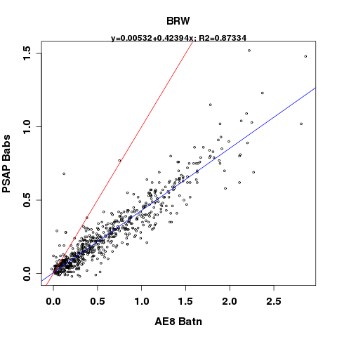

Figure . BRW PSAP-1w absorption coefficients vs. AE8 attenuation coefficients; red line is the 1:1 and blue line is the linear regression whose equation is displayed at the top of the plot

### AE33/ AE31

Using data from 2014w35 to 2015w30, at 6-hour averages, the following regression plots were created to compare both attenuation coefficients and BC concentrations from the AE31 and AE33 aethalometers. The bottom 1% of the merged dataset is trimmed from the comparison, in order to limit the influence of absorption and attenuation values that are below detection limit of the instruments. Attenuation coefficients and BC concentrations used in the comparison are at 660nm. The BC concentration comparison uses instrument reported BC from the AE31, and uncorrected BC from spot #1 on the AE33. Attenuation coefficients from the AE31 are calculated using spot size, flow rate and ATN values, while the attenuation coefficients from the AE33 are calculated from ‘instrument-corrected’ (using the k compensation parameter) BC concentrations by backing out the MAC value (product of σair and C).

The AE31 measures slightly lower BC concentrations and attenuation coefficients than the AE33. The correlation between the instrument measurements is good with an R2 value equal to 0.92 for attenuation coefficients and 0.94 for BC concentrations.

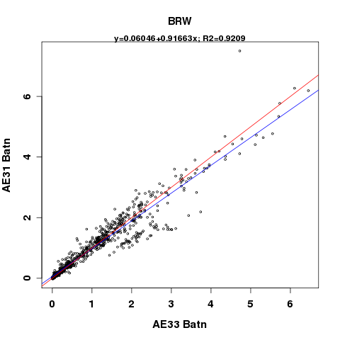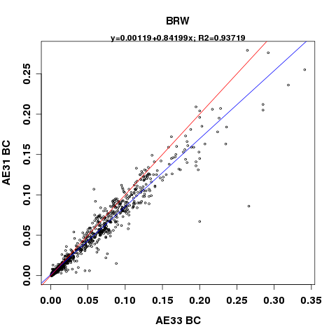

Figure . BRW AE31 vs. AE33, 6-hour averages of attenuation coefficients and BC concentrations; the red line is the 1:1 line and the blue line is the line whose equation is displayed at the top of the plot

### AE31/ CLAP

The following figure compares 6-hour averages of the absorption coefficient from the CLAP at 652nm with the attenuation coefficient (uncorrected) from the AE31 at 660nm (calculated from the flow rate, spot size, and ATN values). The bottom 1% of the merged dataset is trimmed from the comparison, and data are from 2014w35 to 2015w30. The correlation between the instruments is generally good, with an R2= 0.88, though there is an anomalous branch of the regression on the plot that is not yet understood.

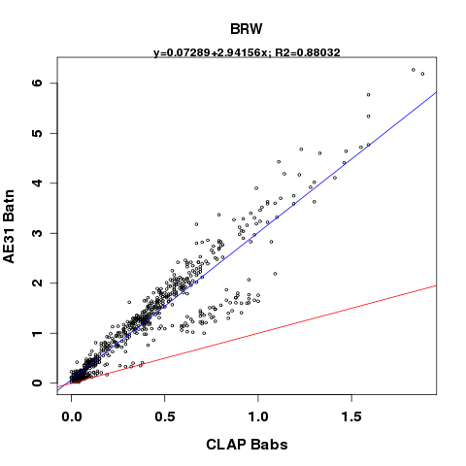

Figure . BRW 6-hour averaged AE31 attenuation coefficient vs. CLAP absorption coefficient. The red line is the 1:1 line and the blue line is the linear regression whose equation is displayed at the top of the plot

### AE33/ CLAP

The following figure compares 6-hour averages of the absorption coefficient from the CLAP at 652nm with the attenuation coefficient (uncorrected) from the AE33 at 660nm (calculated by backing out the MAC value from the instrument reported BC value at 660nm). The bottom 1% of the merged dataset is trimmed from the comparison, in order to limit the influence of absorption and attenuation values that are below detection limit of the instruments. Data are from 2014w35 to 2015w30. As expected, the AE33 has uncorrected attenuation coefficients ~3 times higher than the CLAP absorption coefficients, though the correlation between the instrument measurements is excellent with an R2= 0.97.

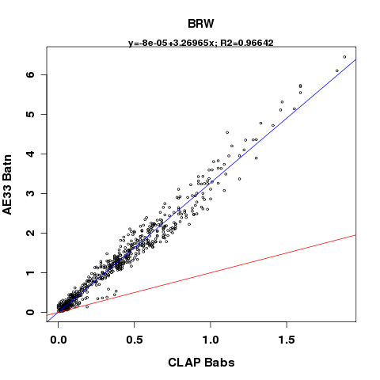

Figure . BRW 6-hour averaged AE33 attenuation coefficient vs. CLAP absorption coefficient; red line is the 1:1 and blue line is the linear regression whose equation is displayed at the top of the plot

## Operations

In order to better understand the comparability of measurements from different aethalometers, operational settings from all aethalometers at BRW are recorded in the table below. The operational settings included are those that have an effect on the instrument’s internal calculations of the EBC concentration. Spot size represents the area of the aethalometer filter tape spot as reported in the AE\_SETUP.txt file. The mean ratio is an internal ‘fudge factor’ applied in the AE31 instruments, and is not well understood. The flow rate is in standard liters per minute (slpm) according to the reporting conditions. The time base is how often the instrument outputs raw data. The raw BC unit is the units of EBC concentration in which the instrument outputs its raw data. The filter change setting refers to when the instrument advances a filter spot, and is either a time interval or a maximum attenuation. Finally, the data format refers to either the extended (uncompressed) or compressed file options that the aethalometer can output.

Table . Operational settings of aethalometers at BRW

|  |  |  |  |  |  |  |  |  |  |
| --- | --- | --- | --- | --- | --- | --- | --- | --- | --- |
| **Model** | **Spot Size** | **Mean Ratio** | **Filter Tape** | **Flow Rate** | **Time Base** | **Reporting Conditions** | **Raw BC Unit** | **Filter Change** | **Data Format** |
| AE8 | 0.95 cm2 | N/A | Quartz | 10 slpm | 10 min | T = 20 °C  P = 1013 hPa | ng/m3 | Manual filter change | Extended |
| AE31 | 0.5 cm2 | 1 | Quartz | 4.8 slpm | 5 min | T = 20 °C  P = 1013 hPa | ng/m3 | ATNmax = 99 | Extended |
| AE33 | 0.785 cm2 | N/A | TFE | 5 slpm | 1 s | T = 0 °C  P = 1013 hPa | μg/m3 | ATNmax = 120 | Extended |

## Noise Checks

A noise check was performed on both the AE31 and AE33 aethalometers during an annual site visit to BRW by Anne Jefferson from August 17-21, 2015. The AE33 noise check was run from 2015-08-17T18:15:00Z to 2015-08-20T17:00:00Z. The AE31 noise check started at 2015-08-17T18:50:00Z and ended at 2015 2015-08-20T17:00:00Z. Results from the noise checks are shown in the tables below.

Table . Results of aethalometer AE33 noise check at BRW (on spot #1)

|  |  |  |
| --- | --- | --- |
| **Wavelength** | **Mean BC during filtered air check**  **(μg/m3)** | **Standard deviation of BC during filtered air check**  **(μg/m3)** |
| 370nm | 0.003 | 0.124 |
| 470nm | 0.003 | 0.145 |
| 520nm | 0.004 | 0.152 |
| 590nm | 0.004 | 0.169 |
| 660nm | 0.005 | 0.19 |
| 880nm | 0.005 | 0.237 |
| 950nm | 0.006 | 0.257 |

Table . Results of aethalometer AE31 noise check at BRW

|  |  |  |
| --- | --- | --- |
| **Wavelength** | **Mean BC during filtered air check**  **(μg/m3)** | **Standard deviation of BC during filtered air check**  **(μg/m3)** |
| 370nm | 0 | 0.0178 |
| 470nm | -2e-4 | 0.0225 |
| 520nm | -2e-4 | 0.024 |
| 590nm | -2e-4 | 0.0268 |
| 660nm | -4e-4 | 0.0307 |
| 880nm | -4e-4 | 0.103 |
| 950nm | -5e-4 | 0.088 |

Noise checks on the early aethalometers running in the NOAA network were never completed in the field, but manufacturer data about instrument noise exist. For AE8 models, like at BRW from 1988 to 2002, noise levels were estimated at 1.5e-8 m-1 (~1.5 ng/m3 BC) for a 1-hour averaging time.

## Photo Documentation

|  |  |
| --- | --- |
| Figure . AE33 inlet and pickoff from aerosol system | Figure . Position of AE33 on the aerosol rack |
| Figure . Location of AE31, across the room from AE33 on separate inlet stack | Figure . Pick off for AE31, coming off of the ozone stack |
| Figure . Ozone stack blower; AE31 is connected to this | Figure . Locations of the aerosol stack (AE33 samples from this) and the ozone stack (AE31 samples from this) |

# Mauna Loa, Hawaii (MLO)

## Site Description

The Mauna Loa observatory is located atop the Mauna Loa volcano on the big island of Hawaii at 3397 m asl (19.536°N, 155.576°W). MLO experiences a diurnal variation in air flow, with upslope air flow during the day, and downslope air flow at night. Given this pattern, sometimes the station measures free tropospheric air, sometimes it measures aerosol originating from down the mountain, and sometimes MLO measures aerosol transported long distances, like Asian dust transported in the spring.

## Instrument History

Aethalometers have been deployed intermittently at MLO over the years, beginning in December 1991 (although Bodhaine (1995) states that aethalometer measurements began at MLO in 1990, it is not clear where those data are archived, and so the date cited here reflects only the MLO aethalometer data record that is currently available at NOAA). A summary of aethalometer operation at MLO is shown in Table 10 and described here. A hand built aethalometer (created by Tony Hansen in the Berkeley Labs, no model number) was deployed at MLO on December 26, 1991, and made measurements with an incandescent lightbulb. The instrument was removed sometime around September of 1996, though the reason for stopping measurements is not documented. The metafiles leading up to the instrument’s removal suggest there were issues with the aethalometer’s lamp intensity. The instrument was not immediately replaced, and there is a ~3 month gap in the aethalometer measurement record here. In January 1997, another broadband aethalometer model AE16 was deployed, and removed in July 2001 for reasons unknown. Starting in May 2004, a 7-wavelength AE31 aethalometer was installed, and continues to be in operation there (as of June 2015). A 7-wavelength AE33 was installed at MLO in June 2014 and will run in parallel with the AE31 (first on the same inlet, then on different inlets) for an instrument comparison before removing the AE31 from the site.

Table . Aethalometer instrument history at MLO

|  |  |  |  |  |
| --- | --- | --- | --- | --- |
| **Model** | **Serial Number** | **Installed** | **Removed** | **Wavelength(s)** |
| Handmade by Tony Hansen in May 1989 | 890501 | 1991-12-26 | 1996-09 | Broadband |
| AE16 | 160 | 1997-01-09 | 2001-07-20 | Broadband |
| AE31 | 484 | 2004-05-05 | N/A | 370nm, 470nm, 520nm, 590nm, 660nm, 880nm, 950nm |
| AE33 | AE33-S02-00223 | 2014-06-17 | N/A | 370nm, 470nm, 520nm, 590nm, 660nm, 880nm, 950nm |

Table . Timeline of aethalometer operation at MLO

|  |  |  |  |  |  |  |  |  |  |  |  |  |  |  |  |  |  |  |  |  |  |  |  |  |
| --- | --- | --- | --- | --- | --- | --- | --- | --- | --- | --- | --- | --- | --- | --- | --- | --- | --- | --- | --- | --- | --- | --- | --- | --- |
| **1991** | **1992** | **1993** | **1994** | **1995** | **1996** | **1997** | **1998** | **1999** | **2000** | **2001** | **2002** | **2003** | **2004** | **2005** | **2006** | **2007** | **2008** | **2009** | **2010** | **2011** | **2012** | **2013** | **2014** | **2015** |
| **Handmade aeth** | | | | | |  |  |  |  |  |  |  |  |  |  |  |  |  |  |  |  |  |  |  |
|  |  |  |  |  |  | **AE16** | | | | |  |  |  |  |  |  |  |  |  |  |  |  |  |  |
|  |  |  |  |  |  |  |  |  |  |  |  |  | **AE31** | | | | | | | | | | | |
|  |  |  |  |  |  |  |  |  |  |  |  |  |  |  |  |  |  |  |  |  |  |  | **AE33** | |

## Setup Configurations

### Early Aethalometer Configurations

Unfortunately, not much is known about the configuration of the earliest aethalometer instruments that were running at MLO. As of August 2015, we were unable to locate information about inlet stack or plumbing details for these instruments.

### AE31 Configuration

Before installation of the AE33, the AE31 was on its own inlet across the room from the NOAA aerosol rack. On the AE31 inlet stack, the air enters a cyclone set to a 2.5μm size cut, and passes through ~3ft of aluminum tubing before it enters ~20ft of Dekaron (type 1300) 3/8’’ OD tubing, brining the air into the building. The instrument remains on this inlet as of August 2015, but measured on that inlet alone since the AE33 was transferred to a new inlet in May 2015.

### AE33 Configuration

When the AE33 was installed on June 17, 2014, a brass “T” was put on the current AE31 inlet line to accommodate the new instrument so both aethalometers were behind the 2.5μm cyclone. After entering through the stack inlet, the tubing comes down through the roof and into the rack that houses the aethalometers, where the line is converted from the 3/8’’ OD Dekaron to the ¼’’ ID neoprene hose that was provided with the AE33. The air then passes through the bug screen before entering the brass “T”. The air travels straight through the brass “T” to the AE33 and flows into the AE31 at the 90 degree angle. In order to keep the same cut point and flow of ~5lpm at the inlet, the flows on the AE31 and AE33 were reduced to 2slpm (~2.86 volumetric). Since the AE33 flow rates have to match one of the pre-settings, the AE33 flow was set to 2lpm, and the AE31 flow was adjusted to be equivalent. This means there was a total volumetric flow of ~5.7lpm at the inlet.

Bugs were detected in the inlet dust cup that had made their way through the existing mesh screen that encircles the aethalometer inlet at MLO. Consequently, on July 31, 2014, tech Aidan Colton made a small change to the AE33 setup by installing the bug trap that comes supplied with the AE33.

During the 2015 NOAA annual maintenance trip to MLO, Patrick Sheridan moved the AE33 from the old aethalometer inlet to the NOAA aerosol rack, since enough data was collected with the AE31 and AE33 running in parallel for a sufficient instrument comparison. At its new inlet location, the AE33 is plumbed with conductive tubing.

## Data

### Data Flow

For most of the time aethalometers have been operating at MLO, the data were transmitted to NOAA via email to scientist Tom Mefford in the GMD meteorology division. The early aethalometer data files (both BC-black carbon- and MF-meta data- files) were saved on a GMD file server (in the directory: /met/aethalometer/Mauna Loa/GMD Data). The files there are organized by year and file type (BC or MF). After October 24, 2014, the aethalometers were connected to the NOAA CPD data acquisition system with null modem cables, and data were automatically transmitted to NOAA- the emailing of data files became unnecessary after this date.

After the aethalometer data have undergone quality control procedures (i.e., editing and any necessary correction or adjustments), they are submitted to the World Data Center for Aerosols (WDCA) NILU/EBAS database.

Data are accessed from the NOAA aerosols group database using the ‘da.get’ command, the station code, the desired time period and the record codes listed in the table below.

Table . Aethalometer instrument codes for MLO

|  |  |
| --- | --- |
| **Aethalometer** | **Record Code** |
| Hand built by Tony Hansen in May 1989 | A81 |
| AE16 | A81 |
| AE31 | A81 |
| AE33 | A82 |

### Known Data Problems

In March 2014, one of the MLO techs (Aidan Colton) found that the AE31 flow rate reading was very high (~9.9 - 10.4lpm), up dramatically from the typical ~3lpm on the instrument. Although the instrument reported flow was high, the actual flow rate as measured with a flow meter was still 3lpm volumetric. Aidan Colton talked with Gary and Tony at Magee Scientific about this issue, and it was decided that the problem was likely electrical. At that time they said that they had discontinued the servicing of the AE31 and they did not have any new parts (i.e., the new circuit board that was needed) because of the age and model of the instrument. They sent the MLO techs an old circuit board that they found lying around on a shelf in the Magee Scientific lab as a possible replacement, but Aidan found it was faulty and returned it to Magee Scientific.

The actual volumetric flow to the AE31 was not affected by this electrical issue and remained very consistent besides the slight variances due to pressure and temp fluctuations at the mountain. AE31 data affected includes all data from 3/24/2014-4/24/2014 and 5/16/14-present (as of this writing in August 2015). The AE31 was fixed momentarily from 4/25-5/13/2014 and from 2/24/2015-3/1/2015. Data prior to the installation of AE33 from 3/24/2014-6/17/2014 was operating at a volumetric flowrate of ~5.0 lpm volumetric (~3.5 lpm at STP). Data from 6/17/2014-6/24/2014 should be disregarded due to maintenance and sampling of internal room air. Data after the installation of the AE33 from 23:00 UTC on 6/24/14 until 5/6/14 (when AE33 was moved the aerosol stack inlet) was operating at a lower flow rate of 2.0 volumetric (~2.9 lpm at STP) because it shared an airline with the AE33.

The AE31 aethalometer was removed on 1/5/2015 and reinstalled on 2/24/2015 after servicing at Magee Scientific. After returning from servicing, the AE31 flow rate was reported accurately at ~2 lpm from 2/24/2015-3/1/2015. On 3/1/2015, it reverted back to erroneously reading ~10 lpm.

Since the instrument uses the internally reported flow to calculate BC concentrations, the EBC values reported by the instrument are not accurate during the time periods above when the flow was reported erroneously. Given the implications of the flow reporting issues, the techs (Aidan Colton and John Barnes), kept a log of flow information in which they verified actual instrument flow rate using a flow meter at the instrument. Aidan was lead on the project until August 2014, and he has provided a detailed log of the actual instrument flow rates from his time as lead. John Barnes took over as aethalometer project lead in August 2014, and no detailed flow log exists after that time.

In order to correct the data for this flow reporting error, an adjustment multiplier factor can be applied, as calculated below:

$$Flow adjustment factor=\frac{AE31 erroneous reported flow}{Flow meter reading at STP 20C and 1atm}=\frac{10.4}{3.6}=3$$

Using this same equation, a difference scaling factor needed to be applied to the data after June 24, 2014 when the AE33 was installed and the flow rate was reduced to ~2 lpm ( new factor = the erroneous AE31 reported flow /2.0 = ~10/2.0 = ~5). Correction factors have been applied accordingly to get “accurate” values.

On the weekend of January3-4, 2015, the MLO observatory experienced an unexpected power outage, which fried the internal circuitry of the AE31 unit. The MLO techs found that the digital screen on the AE31 was unresponsive with 1 symbol repeating across all lines, and the filter tape had advanced through the entire roll (~50% of a full roll) automatically. The instrument was still receiving power, so it was not a blown fuse. Magee Scientific agreed to try to repair the instrument for only the cost of shipping and parts, so tech John Barnes shipped the instrument to Magee on January 23, 2015. Magee Scientific replaced the display and re-calibrated the unit, allowing it to operate again, and temporarily fixing the flow problems with the AE31. The instrument was shipped back to MLO on February 14, 2015, and re-installed on February 24, 2015.

When the AE33 was installed on the same inlet as the AE31, a flow rate of ~5 lpm had to be maintained in order to preserve the cut point of the impactor on that line. Aidan installed a T on the inlet to accommodate both instruments, and the AE33 and AE31 flows were set to ~2 slpm on each (~2.8 lpm volumetric).

Although not expected to influence the data, the AE33 software and firmware was upgraded on August 4, 2015 by John Barnes. John reported that the update seemed to go smoothly, and this event is noted here only in case data issues are observed after the fact.

### Data Editing

All of the MLO aethalometer data (at least through June 2015) have been reviewed and edited to ensure data quality. The first part of the review process includes applying contamination flags to the data whenever the wind is blowing from the contaminated sector. At MLO, the contaminated sector is from 270°-0°-90°, to flag any upslope air masses that are coming from settlements down the mountain. Additionally, a contamination flag is applied any time the wind speed is less than 0.5 m/s, when the winds are considered calm. The second part of the review process includes invalidating any data when the instruments or peripherals (e.g., pumps, inlet stack) are malfunctioning. Specific information on how the SPO aethalometer data were edited can be found in the NOAA Aethalometer Data Editing Guide, which can be found as an appendix to the AE33 Standard Operating Procedure manual **[[here]]**

Other than the typical contamination or aethalometer data spikes, and the time periods when the AE31 flow rate was incorrect, there were no chunks of time where aethalometer data or housekeeping parameters were consistently problematic at MLO.

## Instrument Comparisons

This section outlines comparisons of MLO aethalometers running in parallel with other filter-based absorption photometers (e.g., PSAP or CLAP). The objective of comparing absorption measurements from the aethalometer to other aethalometer models or other filter-based absorption photometers is to diagnose any systematic variability between the instruments’ absorption measurements, to provide a better understanding of long-term absorption records at BRW derived from multiple instruments.

### AE16/PSAP

### AE16/CLAP

### AE31/AE33

### AE31/CLAP

### AE33/CLAP

## Operations

In order to better understand the comparability of measurements from different aethalometers, operational settings from all aethalometers at MLO are recorded in the table below. The operational settings included are those that have an effect on the instrument’s internal calculations of the EBC concentration. Spot size represents the area of the aethalometer filter tape spot. The mean ratio is an internal ‘fudge factor’ applied in the AE31instruments, and is not well understood. The flow rate is in standard liters per minute (slpm) according to the reporting conditions. The time base is how often the instrument outputs raw data. The raw BC unit is the units of EBC concentration in which the instrument outputs its raw data. The filter change setting refers to when the instrument advances a filter spot, and is either a time interval or a maximum attenuation. Finally, the data format refers to either the extended (uncompressed) or compressed file options that the aethalometer can output.

Table . Aethalometer operational settings at MLO

|  |  |  |  |  |  |  |  |  |  |
| --- | --- | --- | --- | --- | --- | --- | --- | --- | --- |
| **Model** | **Spot Size** | **Mean Ratio** | **Filter Tape** | **Flow Rate** | **Time Base** | **Reporting Conditions** | **BC Unit** | **Filter Change** | **Data Format** |
| Hand built by Tony Hansen | 0.95 cm2 | N/A | 47-mm Quartz (changed manually) | 11.5 lpm | 10 min | T = 20 °C  P = 1013 hPa | ng/m3 | ATNmax = 75 (software suggested, not exact since filter changed manually) | Extended |
| AE16 | 0.5 cm2 | N/A | Quartz | 13.5 lpm | 10 min | T = 20 °C  P = 1013 hPa | ng/m3 | ATNmax = 75 (software suggested, not exact since filter changed manually) | Extended |
| AE31 | 0.5189 cm2 | 0.84 | Quartz | 2 lpm (before and when running parallel to AE33  4 lpm (after AE33 moved to new inlet) | 5 min | T = 20 °C  P = 1013 hPa | ng/m3 | ATNmax = 75 | Extended |
| AE33 | 0.785 cm2 | N/A | TFE | 3 lpm | 1 s | T = 0 °C  P = 1013 hPa | μg/m3 | ATNmax = 120 | Extended |

## Noise Checks

Table . Results of AE33 noise check at MLO

|  |  |  |
| --- | --- | --- |
| **Wavelength** | **Mean BC during filtered air check**  **(μg/m3)** | **Standard deviation of BC during filtered air check**  **(μg/m3)** |
| 370nm |  |  |
| 470nm |  |  |
| 520nm |  |  |
| 590nm |  |  |
| 660nm |  |  |
| 880nm |  |  |
| 950nm |  |  |

Table . Results of AE31 noise check at MLO

|  |  |  |
| --- | --- | --- |
| **Wavelength** | **Mean BC during filtered air check**  **(μg/m3)** | **Standard deviation of BC during filtered air check**  **(μg/m3)** |
| 370nm |  |  |
| 470nm |  |  |
| 520nm |  |  |
| 590nm |  |  |
| 660nm |  |  |
| 880nm |  |  |
| 950nm |  |  |

Noise checks on the early aethalometers running in the NOAA network were never completed in the field, but manufacturer data about instrument noise exist. For AE8 models, like at MLO, noise levels were estimated at 1.5e-8 m-1 (about 1.5 ng/m3 BC) for a 1-hour averaging time.

## Photo Documentation

|  |  |
| --- | --- |
| Figure . AE33 and AE31 in rack at MLO | Figure . AE33 and AE31 screen configuration at MLO |
| Figure . AE33 and AE31 at MLO | Figure . From back of rack, AE33 and AE31 inlets |
| Figure . Bug trap and plumbing on AE33 inlet | Y:\photos\mlo\2015-05\P1040784.JPG  Figure . Close up of the bug trap on the aethalometer sample line |

# South Pole, Antarctica (SPO)

## Site Description

The SPO monitoring station is one of the NOAA GMD atmospheric baseline observatories, and aerosol measurements have been collected at the site since the late 1970s. The observatory is located right near the geographical South Pole, and is said to make measurements of some of the cleanest air in the world. Aerosol measurements at SPO can be influenced by local contamination from the camp, as well as from long-range transported particles.

## Instrument History

The first aethalometer within the NOAA network was installed at SPO in 1987. It was one of the earliest aethalometer models- a hand built instrument that was a research prototype from the Lawrence Berkeley National Laboratory. That early aethalometer made measurements at SPO until the end of 1990, and the reason for the removal of the instrument is not known. A short temporary installation of an AE16 aethalometer was made in 1997, but measurements were only made for 10 months. Long term aethalometer measurements did not begin again until January of 2006 when the AE31 was installed; this instrument has been measuring at SPO ever since. The AE33 was installed at SPO in February 2013, and now runs in parallel with the AE31.

Table . Aethalometer instrument history at SPO

|  |  |  |  |  |
| --- | --- | --- | --- | --- |
| **Model** | **Serial Number** | **Installed** | **Removed** | **Wavelength(s)** |
| Earliest model | Research prototype (made at LBNL) | Jan 1987 | Dec 1990 | Broadband |
| AE16 | 176 & 177 | Feb 1997 | Nov 1997 | Broadband |
| AE31 | 371 | Jan 2006 | N/A | 370nm, 470nm, 520nm, 590nm, 660nm, 880nm, 950nm |
| AE33 | AE33-S00-00064 | Feb 2013 | N/A | 370nm, 470nm, 520nm, 590nm, 660nm, 880nm, 950nm |

Table . Timeline of aethalometer operation at SPO

|  |  |  |  |  |  |  |  |  |  |  |  |  |  |  |  |  |  |  |  |  |  |  |  |  |  |  |  |  |
| --- | --- | --- | --- | --- | --- | --- | --- | --- | --- | --- | --- | --- | --- | --- | --- | --- | --- | --- | --- | --- | --- | --- | --- | --- | --- | --- | --- | --- |
| **1987** | **1988** | **1989** | **1990** | **1991** | **1992** | **1993** | **1994** | **1995** | **1996** | **1997** | **1998** | **1999** | **2000** | **2001** | **2002** | **2003** | **2004** | **2005** | **2006** | **2007** | **2008** | **2009** | **2010** | **2011** | **2012** | **2013** | **2014** | **2015** |
| **AE8** | | | |  |  |  |  |  |  |  |  |  |  |  |  |  |  |  |  |  |  |  |  |  |  |  |  |  |
|  |  |  |  |  |  |  |  |  |  | **AE16** |  |  |  |  |  |  |  |  |  |  |  |  |  |  |  |  |  |  |
|  |  |  |  |  |  |  |  |  |  |  |  |  |  |  |  |  |  |  | **AE31** | | | | | | | | | |
|  |  |  |  |  |  |  |  |  |  |  |  |  |  |  |  |  |  |  |  |  |  |  |  |  |  | **AE33** | | |

## Setup Configurations

### Early Aethalometer Configuration

Unfortunately, not much is known about the configuration and inlets of the earliest aethalometers (the hand build aethalometer and the AE16) at SPO. No information on instrument setup or plumbing was available as of August 2015.

### AE31 Configuration

Since its installation in January 2006, the AE31 aethalometer has been near the bottom of the rack at SPO that is to the right of the aerosol laptop running CPD. The TEI surface ozone instruments are on the top of the same rack, with their laptop below the ozone instruments and above the aethalometers. The CNCs run on the wooden shelf just to the left of the aethalometer rack, and the nephelometer runs above those. The AE31 inlet tubing runs up the main aerosol intake stack, and is just the bare end of some Dekaron tubing on the outside of the inlet stack, and it has been this way since its installation.

### AE33 Configuration

The AE33 was installed above the AE31 on the same rack. The inlet tubing for the AE33 is separate from the inlet tubing of the AE31, though both are Dekaron tubing. The inlet for the AE33 runs up the side of the same aerosol inlet stack as the AE31, but instead of being a bare Dekaron tubing end, the AE33 has an upside down can at the end of the inlet tubing to prevent frost buildup.

## Data

### Data Flow

For most of the time aethalometers have been operating at SPO, the data were transmitted to NOAA via email to scientist Tom Mefford in the GMD meteorology division. The aethalometer data files (both BC-black carbon- and MF-meta data- files) were saved on a GMD file server (in the directory: /met/aethalometer/South Pole/Raw Data). The files there are organized by year. After February 26, 2014, the aethalometers were connected to the NOAA CPD data acquisition system with null modem cables, and data were automatically transmitted to NOAA- the emailing of data files became unnecessary after this date, and the techs no longer had to transmit and save diskette data for NOAA.

After the aethalometer data have undergone quality control procedures (i.e., editing and any necessary correction or adjustments), they are submitted to the World Data Center for Aerosols (WDCA) NILU/EBAS database.

Data are accessed from the NOAA aerosols group database using the ‘data.get’ command, the station code, the desired time period and the record codes listed in the table below.

Table . Aethalometer record codes at SPO

|  |  |
| --- | --- |
| **Aethalometer** | **Record Code** |
| Earliest model | A81 |
| AE16 | A81 |
| AE31 | A81 |
| AE33 | A82 |

### Known Data Problems

One major issue with the AE33 from summer 2014 onwards is the optical chamber getting stuck in the ‘up’ position after the instrument was restarted, preventing the instrument from making measurements. At times the SPO techs were able to get the AE33 optical chamber to its home position by forcing it manually (still with some difficulty), or faking a manual flow check to get the chamber to move to the home position. Grisa Mocnik at Aerosol d.o.o narrowed the diagnosis down to 2 potential problems: (1) failure of the controller board, or (2) a loose cable between the controller and the chamber. There was worry that taking apart the instruments to address either of these issues would be risky in that we would not be able to get any spare parts (or a new instrument) down to SPO for many months until the station was open during the austral summer months again if the fix went awry. Consequently, we agreed that since the AE33 seemed to be running fine on the temporary forced chamber fix from techs Andy Clarke and Johan, we would not try any of the recommended fixes until the instrument failed again.

On June 22, 2014, tech Johan found the AE33 displaying an error message that could not be fixed without restarting the instrument. After restart, unsurprisingly, the optical chamber would not return to the home decision, so it was time to try the suggested fix from Grisa. In order to test and fix the connection of the flat cable between the chamber and controller board, the following steps were recommended, illustrated by the photos in the figure below:

1. Check the problem by pressing on the red connector – marked with a faint yellow outline in photo A below (Flat cable – ctrl-chamber). You need to remove the AE33 top cover and use a screwdriver to press on the connector. Checking the connection on the other side of the cable requires you to open the optical chamber
2. First, remove the lower part of the optical chamber (the bayonet).
3. Disconnect the cartridge filter and move to one side - see photo E- it shows a disassembled chamber in the AE33.
4. See the photo C below for the holes (arrows) in which the 2 screws holding the middle part of the chamber with the optical sources, the picture shows a screwdriver in one of them (smaller arrow). Hold the middle part of the optical chamber (otherwise it will fall down) – see photo B…. Unscrew both.
5. You can see the screw sticking out of the top of the optical chamber in front of the flat cable (see photo D).
6. Press the cable firmly into the red connector (see photo D).
7. Reassemble in reverse order.

After completing these steps with some difficulty (the bayonet would not release from the bottom of the optical chamber, so there was much less clearance to work; it was difficult to find a small enough Phillips screwdriver down at South Pole), Johan was able to get the optical chamber working again. Although the connector cable did not look loose, disconnecting the cables on both ends and reseating them seemed to do the trick. The AE33 was stopped and restarted 3 times after the fix, with the optical chamber returning properly to home position after each restart.

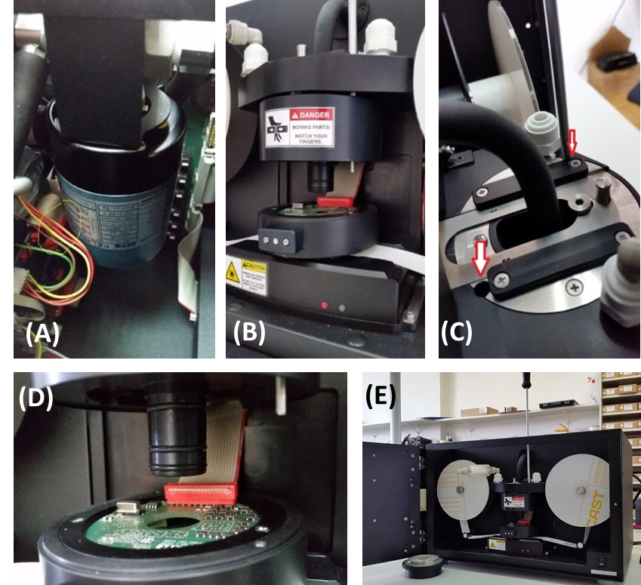

Figure . (A) View of the back of the AE33 optical chamber, (B) optical chamber with bayonet removed, (C) remove the middle part of the optical chamber by unscrewing screws shown in this photo, (D) optical chamber flat cable, with screw sticking out in front of it on top of middle of chamber, and (E) overall AE33 setup with optical chamber disassembled

A known error with the SPO AE33 serial number AE33-S00-00064 AE-SETUP.txt file is that the file reports the spot size area in in mm2, rather than correct unit of cm2.

At the end of August 2013, the SPO station underwent a large scale power outage that lasted 3 hours. The AE33 instrument powered on without trouble after the power outage, and appeared to be collecting and transmitting data fine, but the instrument menu screen displayed a yellow check mark and an AE33 status code of “32”. SPO tech Ross reported this status code to Tony Hansen (Magee Scientific) on August 30, 2013, when Tony Hansen identified the problem as an ‘LED calibration error’. Tony also mentioned that the instrument would continue to operate and provide valid data even under this condition, but recommended cycling the power on the instrument to see if the status would clear upon re-boot. When the status didn’t clear, Ross sent Tony some data files from the instrument. Tony declared that “Other than the one wavelength (blue) which stopped working, the rest of the data look fine”. Since Tony did not express any major concern, the plan was to come up with a replacement strategy for the austral 2013/2014 summer, but nothing happened to address the issue during that summer.

In June 2014, tech Joe Phillips brought up the issue again with Tony Hansen, since the status code had been present for so many months, and Grisa et al. from Aerosol d.o.o. became involved at that point. Aerosol d.o.o provided a firmware and software upgrade to address the issue, and the upgrades were successfully installed by Joe. Despite the success of the upgrades, the blue LED channel was still not functional. Rather than the software causing problems with the LED, the broken LED was causing problems with the software. After iterations of software and firmware upgrade attempts, finally the instrument was successfully running on software version 1.1.3.4 and firmware version 513 without any errors or status codes. It is unclear whether or not the software and firmware updates fixed the blue LED channel issue, or if the instrument was simply ignoring the error until the AE33 could be replaced. More information is needed on this topic, specifically on whether or not these data are reliable and if the AE33 needs to be replaced.

On June 22, 2015 at around 17UTC, SPO tech Johan found an error message on the AE33 screen, with the instrument unresponsive. The error message said “Error in AE33.xxx. Press DETAILS for more information or QUIT to quit.” Pressing both the DETAILS and QUIT buttons did not produce any response. The instrument had to be restarted, which sparked the optical chamber problem and subsequent fix described above, but there is no additional information on what caused the error message. The data and housekeeping parameters leading up to the error message appear normal. The plan moving forward is to monitor to see if the error message ever pops up again, and if it is an AE33.exe error that has been documented on all of the other instrument sin the network, a special software upgrade can be installed to prevent the error.

On August 12, 2015, SPO tech Johan found the AE31 displaying an error message with red blinking stop and error lights. The message said: “Unrecoverable error in SUBControlOutputs Err code=14 Press any key…”; however, pressing any key did not do anything. The techs cycled the power and the instrument came back up to a full running state quickly. It is estimated that the AE31 was down for about 12 hours.

On August 20, 2015, SPO techs found the AE33 stuck in an endless reboot loop. The loop was described as something like this: *Put up the Magee Scientific screen for a second or two// Flash black // Put up the Magee Scientific screen for a second or two // Flash black // Put up the Magee Scientific screen for a few seconds // Black screen for about 15 seconds // Put up the welcome to aethalometer start screen // Quickly earn green checks on "Communication", "Instrument Data", and "Storage" // Fail to earn a green check on "Configuration Settings", and after about 90 seconds of not getting that check // Flash very quick full white screen a couple of times// Return to top of cycle.* The techs tried shutting off the power and restarting the instrument, but the loop would just begin again. As of August 21, 2015, we are working with Magee Scientific to figure out how to fix the issue. Johan remade the CF card for the AE33, as recommended by the manufacturers, but the error occurred soon after, suggesting that the card itself is corrupted and a new card is needed. Additionally, after the error popped up just a few hours after installing the ‘new’ CF card, the instrument was restarted and the optical chamber got stuck again (as it was prone to do during the months prior). As of August 2015, the instrument is off and not making measurements, until we decide how to proceed. An email from Grisa Mocnik said they would replace and install the instrument for free if we decide to do that.

### Data Editing

All of the South Pole aethalometer data (at least through August 2015) have been reviewed and edited to ensure data quality. The first part of the review process is applying contamination flags to the data whenever the wind is blowing from the contaminated sector. At SPO, the contaminated sector is from 340°-110°, to flag any air masses coming from the settlement camp down at the South Pole. Additionally, a contamination flag is applied anytime the wind speed is less than 0.5 m/s, when the wind conditions are considered calm. The second part of the review process is invalidating any data when the instruments or peripherals (e.g., pumps, inlet stack) are malfunctioning. Specific information on how the SPO aethalometer data were edited can be found in the NOAA Aethalometer Data Editing Guide, which can be found as an appendix to the AE33 SOP Manual **[[here]].**

Edits invalidated spikes in the aethalometer data, as well as exceptionally noisy data. In the AE33 at SPO, the 520nm channel is particularly noisy and spikey. All erratic 520nm channel data should be edited out; however, it is advisable not to use the 520nm data for analysis, since it seems to be overall less reliable.

## Instrument Comparisons

### AE33/AE31

Using data from 2014w35 to 2015w29, the following regression plots were created to compare both attenuation coefficients and BC concentrations from the AE31 and AE33 aethalometers at SPO. The bottom 1% of the merged dataset is trimmed from the comparison, in order to limit the influence of absorption and attenuation values that are below detection limit of the instruments. Attenuation coefficients and BC concentrations at 660nm are compared. The BC concentration comparison uses instrument reported BC from the AE31, and uncorrected BC from spot #1 on the AE33. Attenuation coefficients from the AE31 are calculated using spot size, flow rate and ATN values, while the attenuation coefficients from the AE33 are calculated from ‘instrument-corrected’ (using the k compensation parameter) BC concentrations by backing out the SG value (product of σair and C).

The figures below show comparisons of the aethalometers for both 6-hour and 1-day averages. Neither averaging period yields good correlation between the two instruments. An averaging period of 1 week (regression not shown here) does not improve the correlation either.

Two factors are likely at play in this poor comparison- (1) BC measurements at SPO are often below the instrument’s detection limit, and (2) BC values are so low at SPO that not enough decimal places are reported, creating discrete quanta that make the points on the plots look striated.

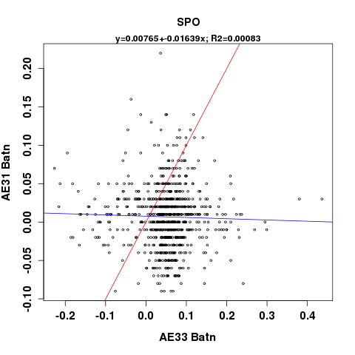 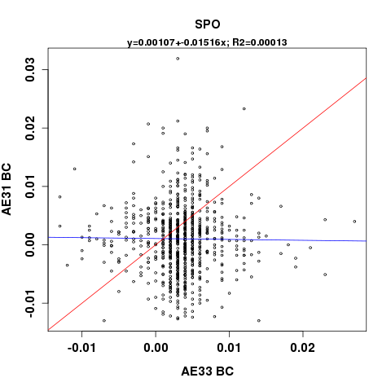

Figure . SPO AE31 vs. AE33, 6-hour averages of attenuation coefficients and BC concentrations; the red line is the 1:1 line and the blue line is the line whose equation is displayed at the top of the plot

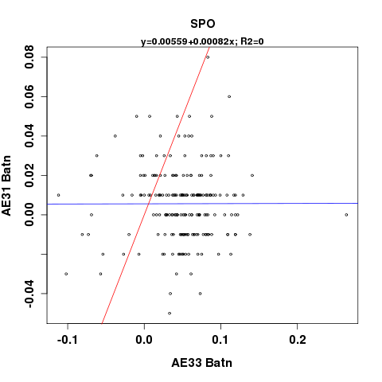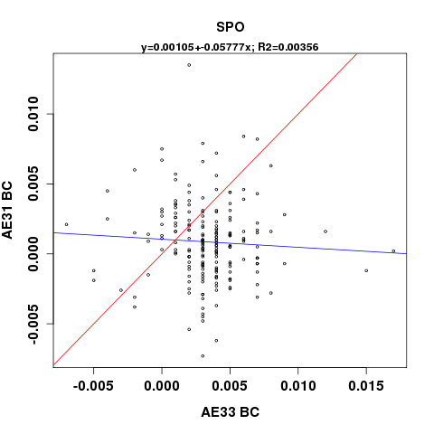

Figure . SPO AE31 vs. AE33, 1-day averages of attenuation coefficients and BC concentrations; the red line is the 1:1 line and the blue line is the line whose equation is displayed at the top of the plot

## Operations

In order to better understand the comparability of measurements from different aethalometers, operational settings from all aethalometers at SPO are recorded in the table below. The operational settings included are those that have an effect on the instrument’s internal calculations of the EBC concentration. Spot size represents the area of the aethalometer filter tape spot. The mean ratio is an internal ‘fudge factor’ applied in the AE31instruments, and is not well understood. The flow rate is in standard liters per minute (slpm) according to the reporting conditions. The time base is how often the instrument outputs raw data. The raw BC unit is the units of EBC concentration in which the instrument outputs its raw data. The filter change setting refers to when the instrument advances a filter spot, and is either a time interval or a maximum attenuation. Finally, the data format refers to either the extended (uncompressed) or compressed file options that the aethalometer can output.

Table . Aethalometer operational settings at SPO

|  |  |  |  |  |  |  |  |  |  |
| --- | --- | --- | --- | --- | --- | --- | --- | --- | --- |
| **Model** | **Spot Size** | **Mean Ratio** | **Filter Tape** | **Flow Rate** | **Time Base** | **Reporting Conditions** | **BC Unit** | **Filter Change** | **Data Format** |
| Earliest model (hand built) | 1.1 cm2 | N/A | 47-mm Quartz | 20 slpm | 1 hr | T = 20 °C  P = 1013 hPa | ng/m3 | Manual, change recommended @ ATN~75 | Compressed |
| AE16 | 0.5 cm2 | N/A | Quartz | 8 slpm | 1 hr | T = 20 °C  P = 1013 hPa | ng/m3 | ATNmax = 75 | Extended |
| AE31 | 0.5 cm2 | 1 | Quartz | 8.6 slpm | 1 hr | T = 25 °C  P = 1015 hPa | ng/m3 | ATNmax = 100 | Extended/ Compressed |
| AE33 | 0.785 cm2 | N/A | TFE | 5 slpm | 60 s | T = 21.11 °C  P = 1013 hPa | μg/m3 | ATNmax = 100 | Extended |

## Noise Checks

Table . Results of AE33 noise checks at SPO

|  |  |  |
| --- | --- | --- |
| **Wavelength** | **Mean BC during filtered air check**  **(μg/m3)** | **Standard deviation of BC during filtered air check**  **(μg/m3)** |
| 370nm |  |  |
| 470nm |  |  |
| 520nm |  |  |
| 590nm |  |  |
| 660nm |  |  |
| 880nm |  |  |
| 950nm |  |  |

Table . Results of AE33 noise checks at SPO

|  |  |  |
| --- | --- | --- |
| **Wavelength** | **Mean BC during filtered air check**  **(μg/m3)** | **Standard deviation of BC during filtered air check**  **(μg/m3)** |
| 370nm |  |  |
| 470nm |  |  |
| 520nm |  |  |
| 590nm |  |  |
| 660nm |  |  |
| 880nm |  |  |
| 950nm |  |  |

## Photo Documentation

The following photos document the current (as of August 2015) aethalometer inlet setup and configuration at SPO.

|  |  |
| --- | --- |
| Figure . The AE33 and AE31 on the aerosol inlet rack at SPO | Figure . View from back of rack, showing AE31 and AE33 plumbing and inlets |
| Y:\photos\spo\2015\3_Up_the_stack.jpg  Figure . Aethalometer inlet tubing coming down off the stack into the sampling building at SPO | Figure . AE33 and AE31 inlets on the stack at SPO |

# Summit, Greenland (SUM)

## Site Description

The monitoring site at SUM is located atop the Greenland Ice Sheet (72.58°N, 38 °W) at an elevation of 3238m asl. The station measures limited local contamination from the nearby camp that houses personnel year round to attend to the many science projects ongoing onsite; however, SUM primarily measures long-range transport aerosol to the Arctic. The aerosols at SUM tend to be small, given the site’s elevation and distance from sources.

## Instrument History

Aethalometers have been in operation at SUM since August 2003.The AE16 was installed in the science trench in 2003, and one of the largest potential ruptures to the time series of this instrument was the transition to the TAWO building in July 2007. The AE33 was installed at SUM in October of 2014, and ran in parallel with the AE16 on an inlet separate from the rest of the aerosol rack until August 2015, when the AE33 was moved to the aerosol rack in place of the old PSAP.

Table . Aethalometer instrument history at SUM

|  |  |  |  |  |
| --- | --- | --- | --- | --- |
| **Model** | **Serial Number** | **Installed** | **Removed** | **Wavelength(s)** |
| AE16 | 175 | August 2003 | N/A | 880nm |
| AE33 | AE33-S02-00227 | October 2014 | N/A | 370, 470, 520, 590, 660, 880, 950nm |

Table . Timeline of aethalometer operation at SUM

|  |  |  |  |  |  |  |  |  |  |  |  |  |
| --- | --- | --- | --- | --- | --- | --- | --- | --- | --- | --- | --- | --- |
| **2003** | **2004** | **2005** | **2006** | **2007** | **2008** | **2009** | **2010** | **2011** | **2012** | **2013** | **2014** | **2015** |
| **AE16** | | | | | | | | | | | | |
|  |  |  |  |  |  |  |  |  |  |  | **AE33** | |

## Setup Configurations

### AE16 Configuration

The AE16 ran at both the old and new TAWO locations, and has experienced at least three inlet configurations over its measurement record. Before 2007, the AE16 was making measurements from the underground science trench at SUM approximately 10m below the snow surface at the measurement site. No specifics about the inlet are known at this time, though it may be of note (since the aethalometer depends on light attenuation) that the science trench room was very dark when the technicians were not in working. This is of interest considering the AE16 *may* have a light leak that induces noisy data. From 2007-2010, the AE16 was located in the old TAWO location, and its inlet plumbing was made of copper tubing, though information on the stack and specific runs of tubing is unknown. After 2010, the AE16 was moved to the new and current TAWO location, where the inlet plumbing was unfortunately switched to non-conductive 3/8’’ Dekaron tubing. The change in tubing certainly changed the particle losses in the system, though the exact losses have not been quantified. Aerosol d.o.o in Slovenia offered to analyze the particle losses encountered in this non-conductive tubing; we were asked to ship a piece of the tubing with the AE16 to them once the AE16 is removed from SUM (after a comparison with the AE33 is complete).

### AE33 Configuration

The AE33 was installed by techs at SUM in October 2014. The instrument ran in parallel with the AE16 on an inlet separate from the aerosol stack system from October 2014-July 2015, plumbed with . In August 2015, the AE33 was moved to the aerosol rack inlet and replaced the PSAP. When the AE33 was plumbed in to run in parallel with the AE16, there were many issues with the plumbing (described in the Known Data Problems section below) that could have affected the aethalometer sampling at SUM. On November 11, 2014, in the midst of various pump flow problems with the aethalometers, the aethalometer inlet was shortened so that the aethalometers could both pull enough flow (see section Known Data Problems below for more details).

## Data

### Data Flow

From 2003-2014, the AE16 measurements at SUM were transmitted to NOAA via an email to Tom Mefford in the GMD meteorology division. The AE16 files were saved on a GMD file server in the directory: /met/aethalometer/Summit/Raw Data, where they are organized by year. From there, the data were ingested into the NOAA aerosol database.

For the duration of AE8 measurements at BRW, the data were transmitted to NOAA via email to scientist Tom Mefford in the GMD meteorology division. The AE8 data files were then saved on a GMD file server in the directory: /met/aethalometer/Barrow/Raw Data, where they were hence ingested into the NOAA aerosol database. Before August 2014, this is also how AE31 data were archived at NOAA.

Shortly after installation of the AE33 in August 2014, both the AE31 and AE33 aethalometers were connected to the NOAA data acquisition software (CPD) via null modem cables. Since then, the data have been recorded in near real time to the NOAA aerosol database. After data have undergone quality control procedures (i.e., editing and any necessary correction or adjustments), they are submitted to the World Data Center for Aerosols (WDCA) NILU/EBAS database.

Data are accessed from the NOAA aerosols group database using the station code, the desired time period and the record codes listed in the table below.

Table . Aethalometer record codes at SUM

|  |  |
| --- | --- |
| **Aethalometer** | **Record Code** |
| AE16 | A81 |
| AE33 | A82 |

### Known Data Problems

Unfortunately, the list of known problems with the aethalometers and their data at SUM is extensive. However, a lot of work has been done to make sure that the problems have been documented and the data adjusted accordingly in order to maximize data quality.

Before its operation at SUM (c. April 2003), the AE16was returned to the manufacturer, where the broadband light source was replaced with a 1-wavelength LED at 880nm. At the time of this modification, a software bug (i.e., programming error in the customized software) was introduced that offset the instrument-reported values from user calculated values by a factor of 2. More specifically, the BC concentrations reported by the instrument are a factor of 2 higher than the ones calculated from the intensities, flow rate, and spot size. The calculated delta ATN values, on the other hand, do agree with the instrument reported delta ATN values. When the 2010-2014 AE16data were submitted to EBAS, the raw unadjusted instrument-reported values were provided in the Level 0 file, and a special Level 0.5 file was created to report the ‘raw’ data adjusted by the factor of 2 to account for the software bug discrepancy. Future SUM AE16data submissions will also follow this format.

In summer 2010, the TAWO (Temporary Atmospheric Watch Observatory) station was moved from its old location to its current location. The AE16inlet at the old TAWO location was made of conductive copper tubing, but the copper tubing got beat up during the move, meaning a new inlet assembly was required at the new TAWO location. On 13 August 2010 at 15:55Z, the Summit techs (Andy Clarke and Brian Vasel) set up the new AE16 inlet with non-conductive Dekaron (ethylene copolymer) tubing. Although Andy looked through the aethalometer documentation to determine if they could change the inlet tubing from copper to Dekaron, they didn’t find anything that said that they couldn’t, so they went ahead and made the change. The differences in particles losses between the old copper and new non-conductive inlets has not yet been characterized, though the station scientists have concluded that the particle losses in the SUM aethalometer inlet have been greater since the inlet was changed from conducting to non-conducting tubing. The plan is to send a piece of the non-conductive inlet tubing to Aerosol d.o.o after the AE16is removed in order to get a full characterization of particles losses when using this material. Grisa Mocnik offered to do this for NOAA in exchange for getting to keep the AE16once it is removed.

Throughout the duration of operation of the aethalometers at the new TAWO location up at SUM, frequent weekly up/down spikes in the BC data are observed. An analysis of these time periods revealed that the large spikes in AE16and AE33 data overlapped with the times when the techs clear snow and ice off of the inlets. The periods of noisy data after the inlet cleaning likely result from the aethalometer filter material getting wet after the inlet ‘inhales’ the freed snow and it melts on the filter in the warmer sampling room temperatures. These data anomalies are well documented and the data spikes have been removed during the QA/QC process, thus they are not anticipated to affect the long term SUM BC data record.

During years 2014-2015, there were various issues with the pumps supplying flow to the SUM aethalometers. In mid-July 2014, the techs noticed a ‘bad noise’ coming from the GAST model DOA-P707-AA (4.2amps), and eventually the pump locked up completely and failed. This pump was replaced by a KNF UN022AVP (1.2amps) pump that the techs had on hand as a spare at the station. That pump also failed, and Brian Vasel from NOAA sent a replacement KNF UN022AVP pump. The replacement pump sent should have been the same model as the original GAST, but there was a misunderstanding between the techs and Brian at the time, so the replacement KNF was used. Eventually the second KNF pump failed, and the techs borrowed a pump from the UC Davis group to run the aethalometers until a proper replacement GAST could get to them. The new GAST DOA-P707-AA pump was put online (replacing the UC Davis pump) on February 20, 2015 at around 14:30UTC. Apart from the appreciable instrument downtime that was experienced due to the pump failures, the data also may have been affected by low flow rates incurred during the failure of the instruments. As of June 2015, there has not been an analysis to address the issue of how the pump failures may have affected the aethalometer data.

At the beginning of September 2014, SUM techs Domi and Sara noticed that the filter tape on the AE16was advancing too quickly and becoming jammed (see photo), meaning the tape motor was not running properly. Russ Schnell gave the following troubleshooting procedure to the techs, and though there is no documentation for exactly how the problem was solved, the issue was resolved and the AE16was running normally again on:

This problem can happen when the tape take up motor is not functioning properly. Check the following things:

1) Clean out the tape and reattached it to the take up reel. Then turn the unit on and use the switch in the front to select Tape Tension, that should turn on the take up motor and it should pick up any slack in the tape. If that works then go to step 2.

2) Watch the full start up procedure very carefully. The tape take up reel should make one complete revolution, then the tape tension motor on the right should take up any slack until the tape tension arm gets moved in enough to turn the motor off. Make sure the tape take up motor is actually moving. If not then it needs to be replaced.

3) Take off the plastic cover on the right and pull off the card board spool. You should see a 1 inch rubber O-ring around the central spool. That has to be there; otherwise the tape take up motor will not run properly. Replace if missing.

4) Make sure the take is threaded UNDERNEATH the rocker arm. See page 2 of the attached document.

5) That rocker arm should move to the right as the tape loosens up. Then when the motor takes up the slack, the arm moves to the left eventually clicking the micro switch to turn off the motor. If the rocker arm is stuck then the advance motor will not turn on. I am also sending you the Aethalometer Service procedures document. This will come in handy when fixing small problems that may crop up.

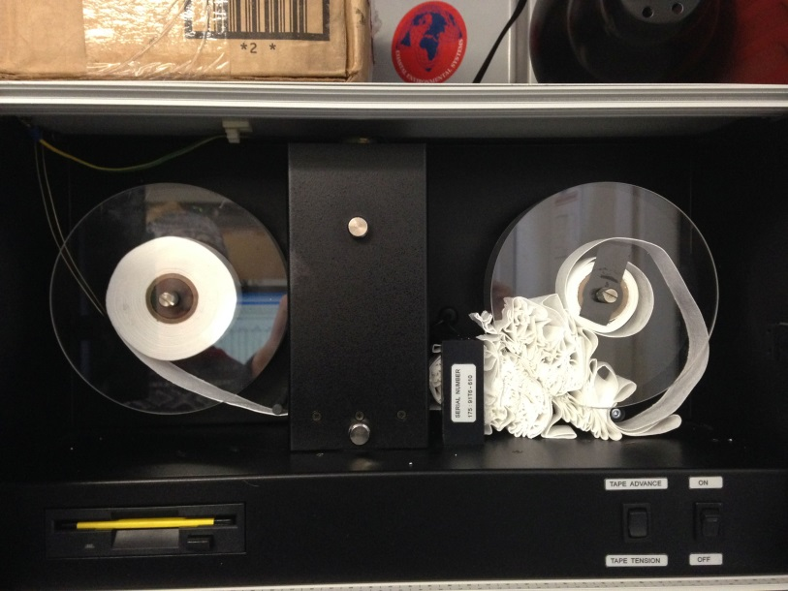

Figure . Tape on the AE16 jammed due to the tape advancing too quickly

On April 30, 2015, the AE16flow rate dropped ~1lpm, causing the techs (Yuki and Jason) to take notice of the instrument’s flow issues. The techs found a ~2cm long crack in the tube going from the vacuum pump to the aethalometer. The techs taped the crack but the flow rate did not change. The techs also noticed that the tubing connection to the back of the AE16is very weak. Wiggling the tubing connection even slightly changes the flow rate, sometimes down to ~2lpm. The techs got the AE16flow rate to stabilize at 3.6lpm and continued to monitor the instrument through May. On May 5, 2015, the AE16 showed an error message “air flow getting low”, so the techs stopped and restarted the instrument and were able to get the flow back up to 4.1-4.2lpm. AE16flow continued to be variable through summer 2015, but the problem was pinpointed to be the loose connection between the tubing and the back of the AE16. As of the time of writing (June 2015), Betsy Andrews is planning to bring new fittings and strengthen the connection during her trip to SUM in August 2015. No analysis has been done to see whether or not the extreme flow fluctuations on the AE16in Spring/Summer 2015 have affected the data.

The location of the aethalometer inlet changed on November 11, 2014. The pump that was pulling air for both aethalometers was not getting high enough flow rates to both instruments in October/November 2014. The previous inlet setup had the ambient outdoor inlet tube extending out from the roof towards the tower, and in order to provide higher flow rates to the aethalometers, SUM techs (Matt, Lance, Hannah) decided to shorten the ambient outdoor inlet tube to extend just to the outside of TAWO. No analysis has been done to see if the change in inlet tubing location and length has affected the data.

|  |  |
| --- | --- |
| Figure . Old aethalometer inlet extends out to the right of the photo all the way to the flux tower | Figure . New aethalometer inlet tubing is much shorter and does not extend to the flux tower |

On February 20, 2015 at 14:30UTC, the station techs (Yuki and Jason) found an error message on the AE16saying “air flow getting low”. This was the same day the techs replaced the aethalometer pump, and although the new pump did boost the AE16flow back up the 4.2lpm, it was still on the low side. Over time, the AE16flow decreased more and more. The techs suspected that the persistent low flow was due to a clog in the inlet line, due to the inlet ‘inhaling’ snow when the techs clean off snow and ice from the inlet. Consequently, on March 12, 2015, the techs put a HEPA filter between the pump and the line, stopped both aethalometers at 14:15UTC, and ran warm room air through the line for ~30min (14:20-14:50UUTC), restored the instrument configuration and restarted both instruments. The AE16flow returned to 4.2 lpm (the highest it had been since the pump was replaced on February 20, 2015).Though it is not a part of the standard operating procedures at SUM yet, it may be necessary to backflush the line with warm room air on a regular basis to clear the line from frost and ice, particularly if flow rates get low and there are no signs of pump or instrument malfunction.

Starting in 2006, the flow on the AE16 is quite variable, fluctuating up to ~2lpm every day, in a somewhat diurnal cycle. It has not yet been determined why these flow issues exist, or if they affect the data.

On November 26, 2014, the SUM techs (Lance and Hannah) found the AE16screen frozen and not responding. They restarted the instrument on December 1, 2014 at 14:20UTC and the instrument continued operating normally. The instrument was down for some time before the techs found it on November 26, 2014, but neither the station scientists nor the techs discovered the problem until then due to the Thanksgiving holiday schedule. About a week of measurements were lost. There is no indication as to why the instrument abruptly stopped working, though there is a drop of ~1 slpm in the flow rate the day before the AE16froze.

In late July 2015, technician Andy Clark made a visit to SUM and pointed out many problems related to the plumbing of the aethalometers at Summit:

1. The usual rubber tube just barely sticking out the back of the AE16 was adapted to 1/4" Swagelok, then connected to a 1/4" - 1/4" Swagelok port connector. However, the ferrules were not Swagelok. The 1/2" OD polyethylene tube to the pump was taped onto this 1/4" ss tube. Needless to say, this setup leaked.

2. The AE16 is connected to the pump with a 1/4" npt - 1/4" hose barb on the pump. The hose barb had tape around it so the 1/2" polyethylene tube sort of fit. Then tape was added on top of the fitting to make a more robust connection. Needless to say, it leaked.

3. The Tee that was installed to combine the two inlets for the Aethalometers AE16 and AE33 was put together with 3/8" Synflex and Swagelok. All the connections were barely finger tight and hadn't been swaged, meaning they likely leaked.

4. The cover, or baffle behind the door on the AE16 was missing. The baffle was located, along with along two of its screws, and the baffle was replaced (since presumably this helps reduce light coming in around the door). There is no information on when and why this baffle was removed.

Though this has not caused any known issues with the aethalometer data, it is worth mentioning that the AE33 had a software upgrade in January 2015. The software upgrade was provided by Aerosol d.o.o. to correct an error found at other NOAA stations (MLO, BRW) that prevented data from being transmitted through the serial port to the NOAA data acquisition software (CPD). The software upgrade was performed successfully by Lance and Hannah on January 9, 2015, and there have not been any perceived issues with the instrument since the upgrade. In addition, a software and firmware upgrade was performed on the AE33 at SUM on July 25, to allow for new features in the instrument (like retrieving the AE-SETUP.txt file remotely). The upgrade was successful and no perceived data issues were observed after the update.

### Data Editing

All SUM aethalometer data have been edited from 2003-2015. Some aethalometer data editing (namely years 2011-2014) was performed by Georgia Tech graduate student Jason Hu (under supervision of Mike Bergin). Betsy and Lauren spent time reviewing these edits and correcting quite a few editing errors (e.g., invalidating all instruments when only one needed invalidating). The data editing and review process revealed exceptionally noisy data for the SUM AE16 in 2009, with noisy ATN values and reference beam intensities. These data were not invalidated, but it is important to mention that the aethalometer performance during this time period was unique from surrounding years.

Since instrumented reported BC values from the AE16 are off by a factor of 2, the BC values are ‘edited’ (recalculated) using the attenuation coefficients using spot size, flow, time, ATN and sigma values.

## Instrument Comparisons

### AE16/AE33

Using data from 2014w46 to 2015w29 at SUM, at 6-hour averages, the following regression plots were created to compare both attenuation coefficients and BC concentrations from the AE16 and AE33 aethalometers. The bottom 1% of the merged dataset is trimmed from the comparison, in order to limit the influence of absorption and attenuation values that are below detection limit of the instruments. Attenuation coefficients and BC concentrations at 660nm are compared. The BC concentration comparison uses instrument reported BC from the AE16 at 880nm, and the *corrected* BC concentration from spot #1 at 880nm on the AE33. Attenuation coefficients from the AE16 are calculated using spot size, flow rate and ATN values, while the attenuation coefficients from the AE16 are calculated from ‘instrument-corrected’ (using the k compensation parameter) BC concentrations by backing out the SG value (product of σair and C).

In general, the agreement and correlation between the AE16 and AE33 attenuation coefficients is quite good, with a regression slope of 0.97 and a R2 value of 0.86. The BC values have the same correlation (as expected) but have a slightly worse agreement, with a regression slope of 0.74.

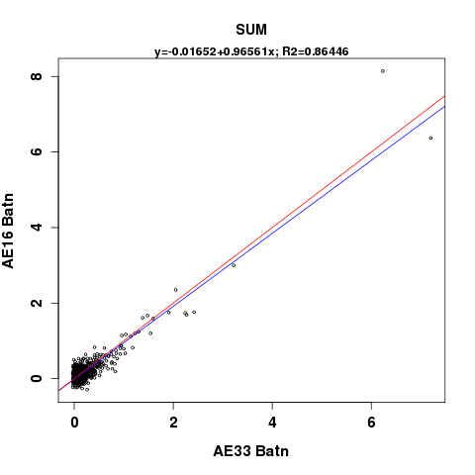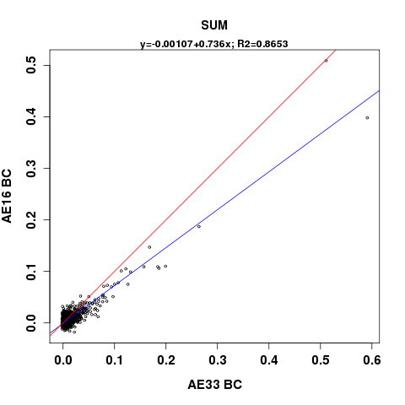

Figure . SUM AE16 vs. AE33, 6-hour averages of attenuation coefficients and BC concentrations (corrected BC from AE33); the red line is the 1:1 line and the blue line is the line whose equation is displayed at the top of the plot

The plot below shows a regression between instrument reported BC values from the AE16 at 880nm, and the un*corrected* BC concentrations from spot #1 at 880nm on the AE33. The correlation between the AE16 and uncorrected AE33 BC data is much worse than when the corrected AE33 data was used above, with a linear regression slope of 0.26 and a R2 value of 0.29.

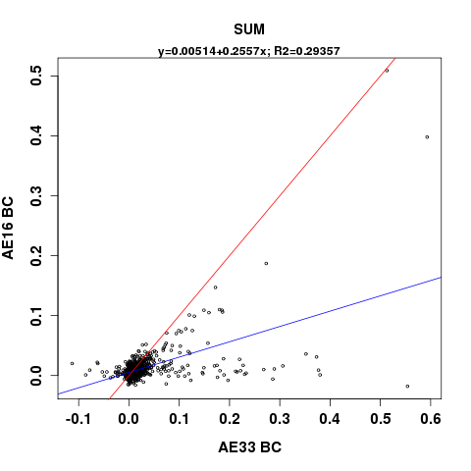

Figure . SUM AE16 vs. AE33, 6-hour averages of BC concentrations (uncorrected spot #1 from AE33); the red line is the 1:1 line and the blue line is the line whose equation is displayed at the top of the plot

### AE33/CLAP

The following figure compares 6-hour averages of the absorption coefficient from the CLAP at 652nm with the attenuation coefficient (uncorrected) from the AE33 at 660nm (calculated by backing out the SG value from the instrument reported BC value at 660nm). The bottom 1% of the merged dataset is trimmed from the comparison, in order to limit the influence of absorption and attenuation values that are below the detection limit of the instruments. Data are from 2014w46 to 2015w29.

The agreement and correlation between the CLAP absorption coefficient and AE33 attenuation coefficient is decent, with a linear regression slope of 1.11 and a R2 value of 0.68.The regression is much improved by including the top 1% of the data, or the absorption values that are well above the detection limits of the instruments. Without the higher absorption values, the agreement between the instruments is not as good.

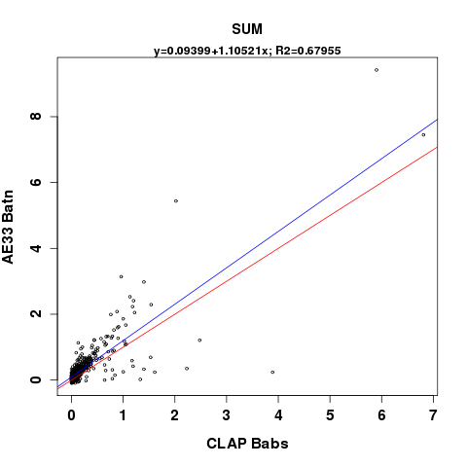

Figure SUM CLAP absorption coefficients vs. AE33 attenuation coefficients; red line is the 1:1 and blue line is the linear regression whose equation is displayed at the top of the plot

### AE16/CLAP

The following figure compares 6-hour averages of the absorption coefficient from the CLAP at 652nm with the attenuation coefficient (uncorrected) from the AE16 at 880nm (calculated from attenuation values, spot size and flow rate). The bottom 1% of the merged dataset is trimmed from the comparison, in order to limit the influence of absorption and attenuation values that are below detection limit of the instruments. Data are from 2014w46 to 2015w29.

Despite the difference in wavelengths, the agreement and correlation between the CLAP absorption coefficient and AE16 attenuation coefficient is satisfactory, with a linear regression slope of 0.97 and a R2 value of 0.76. The regression is much improved by including the top 1% of the data, or the absorption values that are well above the detection limits of the instruments. Without the higher absorption values, the agreement between the instruments is not as good.

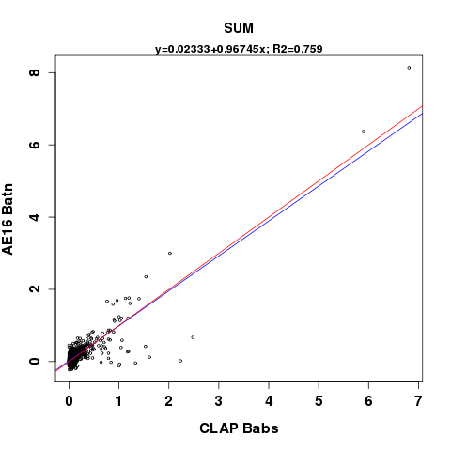

Figure SUM CLAP absorption coefficients vs. AE16 attenuation coefficients; red line is the 1:1 and blue line is the linear regression whose equation is displayed at the top of the plot

## Operations

The following table outlines operational parameters on the aethalometers at SUM. There is documentation that the AE33 settings have remained consistent since its installation; however, it is uncertain to what extent the operational settings on the AE16 have changed over time throughout its operation at SUM.

Table . Aethalometer operational settings at SUM

|  |  |  |  |  |  |  |  |  |  |
| --- | --- | --- | --- | --- | --- | --- | --- | --- | --- |
| **Model** | **Spot Size** | **Mean Ratio** | **Filter Tape** | **Flow Rate** | **Time Base** | **Reporting Conditions** | **Raw BC Unit** | **Filter Change** | **Data Format** |
| AE16 | 0.5 cm2 | N/A | Quartz | 4 slpm | 5 min | T = 20 °C  P = 1013 hPa | ng/m3 | ATNmax = 75 | Extended |
| AE33 | 0.785 cm2 | N/A | TFE | 4 slpm | 60 s | T = 21.11 °C  P = 1013 hPa | μg/m3 | ATNmax = 120 | Extended |

## Noise Checks

A noise check was performed on both the AE16 and AE33 aethalometers during an annual site visit to SUM by Betsy Andrews from August 14-21, 2015. The AE33 noise check was run from 2015 DOY 228.7 to 229.6, and results are shown in the table below. The AE16 noise check started at 2015 DOY 229.61 and ended at 2015 DOY 230.45.

Table . Results of aethalometer AE33 noise check at SUM, from the uncorrected spot #1 on the AE33

|  |  |  |
| --- | --- | --- |
| **Wavelength** | **Mean BC during filtered air check (μg/m3)** | **Standard deviation of BC during filtered air check**  **(μg/m3)** |
| 370nm | 0.006 | 0.013 |
| 470nm | 0.001 | 0.015 |
| 520nm | 0.001 | 0.019 |
| 590nm | 0.002 | 0.022 |
| 660nm | 0.002 | 0.021 |
| 880nm | 0.005 | 0.032 |
| 950nm | 0.006 | 0.036 |

Table . Results of aethalometer AE16 noise check at SUM

|  |  |  |
| --- | --- | --- |
| **Wavelength** | **Mean BC during filtered air check (μg/m3)** | **Standard deviation of BC during filtered air check**  **(μg/m3)** |
| 880nm | 0.006 | 0.100 |

## Photo Documentation

|  |  |
| --- | --- |
| Y:\photos\sum\SUM_setup\2015-03-27_IMG_1664.JPG  Figure . Aerosol stack inlet with ice buildup | Y:\photos\sum\SUM_setup\2015-03-27_IMG_1665.JPG  Figure . Aerosol stack inlet without ice buildup after techs have cleaned it |
| Y:\photos\sum\SUM_setup\2015-03-27_IMG_1666.JPG  Figure . Aethalometer inlet with ice buildup | Y:\photos\sum\SUM_setup\2015-03-27_IMG_1667.JPG  Figure . Aethalometer inlet after techs have removed ice buildup |
| Figure . Aethalometer setup in relation to the aerosol system, as of July 2015 when AE16 and AE33 were running in parallel | Figure . AE33 and AE16 in rack at SUM, running in parallel |
| Figure . New location of AE33 after moved to aerosol inlet August 2015 |  |

# References

Bodhaine B. 1995. Aerosol absorption measurements at Barrow, Mauna Loa, and the South Pole. Journal of Geophysical Research 100 (5): 8967-8975.

Collaud Coen M, Weingartner E, Apituley A, Ceburnis D, Fierz-Schmidhauser R, Flentje H, Henzing J, Jennings SG, Moerman M, Petzold A. 2010. Minimizing light absorption measurement artifacts of the aethalometer: Evaluation of five correction algorithms. Atmospheric Measurement Techniques 3:457-74.

Delene DJ and Ogren JA. 2002. Variability of aerosol optical properties at four north american surface monitoring sites. J Atmos Sci 59(6):1135-50.

Drinovec L, Močnik G, Zotter P, Prévôt A, Ruckstuhl C, Coz E, Rupakheti M, Sciare J, Müller T, Wiedensohler A. 2014. The" dual-spot" aethalometer: An improved measurement of aerosol black carbon with real-time loading compensation. Atmospheric Measurement Techniques Discussions 7(9):10179-220.

Petzold A, Ogren J, Fiebig M, Laj P, Li S, Baltensperger U, Holzer-Popp T, Kinne S, Pappalardo G, Sugimoto N. 2013. Recommendations for reporting" black carbon" measurements. Atmospheric Chemistry and Physics 13(16):8365-79.

Weingartner E, Saathoff H, Schnaiter M, Streit N, Bitnar B, Baltensperger U. 2003. Absorption of light by soot particles: Determination of the absorption coefficient by means of aethalometers. J Aerosol Sci 34(10):1445-63.