Cloud Condensation Nuclei (CCN) Counter

Manual

for Single-Column CCNs

DOC-0086 Revision K



2545 Central Avenue

Boulder, CO 80301-5727 USA

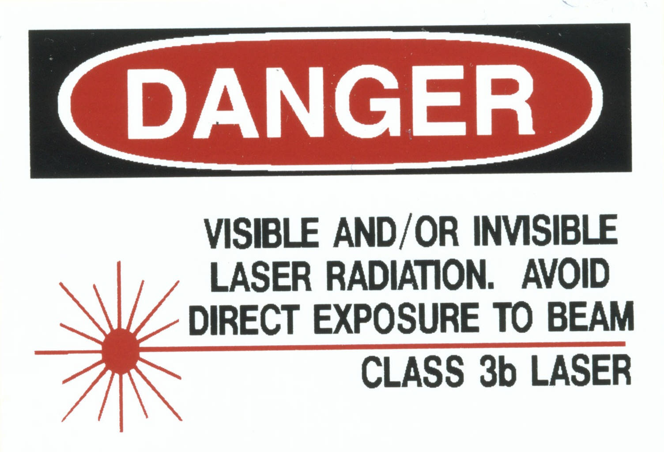

Copyright © 2016 Droplet Measurement Technologies, Inc.

**2545 Central Avenue**

**Boulder, Colorado, USA 80301-5727**

**Tel: +1 (303) 440-5576**

**Fax: +1 (303) 440-1965**

**www.dropletmeasurement.com**

All rights reserved. No part of this document shall be reproduced, stored in a retrieval system, or transmitted by any means, electronic, mechanical, photocopying, recording, or otherwise, without written permission from Droplet Measurement Technologies, Inc. Although every precaution has been taken in the preparation of this document, Droplet Measurement Technologies, Inc. assumes no responsibility for errors or omissions. Neither is any liability assumed for damages resulting from the use of the information contained herein.

Information in this document is subject to change without prior notice in order to improve accuracy, design, and function and does not represent a commitment on the part of the manufacturer. Information furnished in this manual is believed to be accurate and reliable. However, no responsibility is assumed for its use, or any infringements of patents or other rights of third parties, which may result from its use.

**Trademark Information**

All Droplet Measurement Technologies, Inc. product names and the Droplet Measurement Technologies, Inc. logo are trademarks of Droplet Measurement Technologies, Inc.

All other brands and product names are trademarks or registered trademarks of their respective owners.

**Warranty**

The seller warrants that the equipment supplied will be free from defects in material and workmanship for a period of one year from the confirmed date of purchase of the original buyer. Service procedures and repairs are warrantied for 90 days. The equipment owner will pay for shipping to DMT, while DMT covers the return shipping expense.

Consumable components, such as tubing, filters, pump diaphragms, and Nafion humidifiers and dehumidifiers are not covered by this warranty.

**Software Licensing Agreement**

DMT licenses CCN software only upon the condition that you accept all of the terms contained in this license agreement.

This software is provided by DMT “as is” and any express or implied warranties, including, but not limited to, the implied warranties of merchantability and fitness for a particular purpose are disclaimed. Under no circumstances and under no legal theory, whether in tort, contract, or otherwise, shall DMT or its developers be liable for any direct, indirect, incidental, special, exemplary, or consequential damages (including damages for work stoppage; computer failure or malfunction; loss of goodwill; loss of use, data or profits; or for any and all other damages and losses).

Some states do not allow the limitation or exclusion of implied warranties and you may be entitled to additional rights in those states.

**CONTENTS**

PART I: THE CCN INSTRUMENT 10

1.0 Product Description 10

1.1 Introduction 10

1.2 CCN Specifications and Features 11

1.3 Electrical Specifications 12

1.4 Physical Specifications 12

1.5 Operating Limits 13

2.0 Theory of Operation 13

2.1 How the CCN Generates Supersaturation 13

2.2 Details of CCN Design 14

2.2.1 Flow of Air and Water through the CCN 15

2.2.2 CCN Components 18

3.0 Setting up the CCN 20

3.1 Unpacking the CCN 21

3.1.1 Removing Instrument from Shipping Case 21

3.1.2 Connecting Instrument Components 22

3.1.3 USB Memory Stick 24

3.2 Setting Flow and Humidifying CCN 24

3.3 Checking that the CCN is Functioning Properly 26

3.3.1 Testing the Unit for Leaks (for CCN Use on Pressurized Aircraft) 27

3.4 Repacking the CCN for Shipping 28

3.5 Drying the CCN Prior to Shipping 29

3.5.1 Necessity of Drying CCN 29

3.5.2 To Drain All Liquid Water 29

4.0 Installation 30

4.1 Power Supply Considerations 30

5.0 CCN Power and Signal Connections 31

6.0 Printed Circuit Boards (PCBs) 33

7.0 CCN Maintenance 35

7.1 Every 4 days and Before Every Flight 35

7.2 Every Month 36

7.3 Every Three Months 37

7.4 Every Year 37

7.5 Pump Diaphragm and Motor Maintenance Requirements 38

8.0 Calibration Procedures 38

8.1 CCN SS% Calibration 38

8.1.1 Recommended calibration equipment 38

8.1.2 SS% Calibration Procedure 39

8.2 Flow Calibrations 40

8.2.1 Recommended Calibration Equipment 40

8.2.2 Flow Calibrations Procedure 40

8.3 Pressure Calibration 44

8.3.1 Recommended calibration equipment 44

8.3.2 Pressure Calibration Procedure 44

8.4 OPC Calibration 45

8.4.1 Recommended Calibration Equipment 45

8.4.2 OPC Calibration Procedure 45

8.4.3 OPC Cleaning Procedure 46

9.0 CCN Accessories 48

9.1 Spares and Consumable Supplies 48

9.2 Airborne CCN Inlet Assembly Kit 50

10.0 Troubleshooting 50

PART II: THE CCN SOFTWARE 59

11.0 Product Description 59

11.1 Introduction 59

12.0 SINGLE CCN.exe (Main Program) 60

12.1 Control Tabs 61

12.1.1 SS Tab (Supersaturation Settings) 61

12.1.1.1 SS Tab Settings that Must be Configured in First 10 Seconds 61

12.1.1.2 SS Tab General Settings 62

12.1.2 Temps Tab (Temperatures) 64

12.1.2.1 CCN Temperature Adjustment 66

12.1.3 Flows Tab 67

12.1.4 OPC Tab (Optical Particle Counter) 70

12.1.5 Monitor Tab (Alarm Monitoring) 72

12.1.5.1 CCN Alerts and Alarms 73

12.1.5.2 How to Interpret CCN Alarm Codes in Output Files 74

12.1.6 Chart Tab 75

12.1.7 Prog Tab (Program Control) 76

12.2 Histogram 77

12.3 Particle Concentration Time-Series Chart 78

12.4 Other Time-Series Charts and DMT Service Tab 78

12.4.1 Serial Output Tab 78

12.4.2 DMT Service Tab 80

12.4.2.1 DMT Service Tab: PID Section 81

12.4.2.2 DMT Service Tab: Gains Section 82

12.4.2.3 DMT Service Tab: FlowCal Section 82

12.4.2.4 DMT Service Tab Error / Exit 83

12.5 Program Input Files 84

12.6 Program Output Data 85

12.6.1 Serial Stream 85

12.6.2 Output Files 86

13.0 CCN SS Settings Config Editor.exe 87

14.0 CCN Calibration Editor.exe 89

14.1 Standard Screen 89

14.2 Screen with DMT Settings 91

15.0 CCN Playback.exe 93

15.1 Changing the Current Time 94

15.2 Selectable Chart Options 95

16.0 Chart Options (for Single CCN and CCN Playback Programs) 96

17.0 Remote Operation of CCN Programs through a Network Connection (Remote Desktop) 97

Appendix A: Glossary 99

Appendix B: Relationship between SS%, Particle Concentration, and Percentage of CCN Counted 107

Appendix C: Assy, Cable 28V Power 108

Appendix D: CCN Mounting Hole Locations 109

Appendix E: CCN Aircraft Inlet (for Constant Pressure Inlet) 110

Appendix F: Exploded View of OPC 111

Appendix G: Sheath Flow Filter Testing and Replacement 112

Problem 112

Recommendations 112

Appendix H: International Shipping Certification 113

Appendix I: Revisions to Manual 114

***List of Figures***

Figure 1: CCN Counter with Front-Mounted Touch Screen 11

Figure 2: Supersaturation Being Generated in the CCN Column 14

Figure 3: Air and Liquid Flow Schematic Diagram 16

Figure 4: CCN with Important Components Labeled 19

Figure 5: Solenoid Pumps 20

Figure 6: CCN with Shipping Hood on Frame 21

Figure 7: Bottle Hold-Down Clamp 23

Figure 8: SS Tab 25

Figure 9: Location of Power, Communications, Sample and Exhaust Connections 32

Figure 10: Controller and Power Supply Boards with LEDs and OPC Switch Labeled 34

Figure 11: CDPE Board. 35

Figure 12: Healthy Desiccant Tube 37

Figure 13: Calibration Set-Up 38

Figure 14: Activation Curve Used in SS% Calibration 39

Figure 15: Temperature Gradient Curve for Different SS% 40

Figure 16: Sheath Flow Metering Valve 41

Figure 17: Accessing Metering Valve Through Port (Newer CCNs Only) 41

Figure 18: Inputs for CCN Flow Calibration Procedure 42

Figure 19: Sheath Flow Calibration Spreadsheet 43

Figure 20: OPC 1st Stage Monitor Voltage 46

Figure 21: OPC Mounting Location on Column 47

Figure 22: Air Drying OPC with Canned Air 48

Figure 23: Nafion Insertion 55

Figure 24: Typical Healthy Membrane 55

Figure 25: Typical Bad Membrane. Note the kinks and flat spots. 56

Figure 26: Main Screen of SINGLE CCN Program 60

Figure 27: Supersaturation (SS) Settings Tab Display 61

Figure 28: Dry Start Up and Dry Shut Down Buttons 62

Figure 29: Supersaturation (SS) Settings Tab Display in Manual SS Mode 63

Figure 30: Temperature Tab Screen Showing Temperature Set Points and Read-Outs the CCN Temperatures 64

Figure 31: Flows Control Tab 68

Figure 32: Optical Particle Counter Tab 70

Figure 33: Monitor Tab 72

Figure 34: Chart Tab 75

Figure 35: Program Control Tab 76

Figure 36: Histogram 77

Figure 37: Time-Series Concentration Chart 78

Figure 38: Serial Output Tab 79

Figure 39: DMT Service Tab 80

Figure 40: DMT Service Tab – PID Section 81

Figure 41: DMT Service Tab – Gains Section 82

Figure 42: DMT Service Tab – FlowCal Section 83

Figure 43: DMT Service Tab – Error/Exit Section 84

Figure 44: Program for Setting the Supersaturation Tables 88

Figure 45: CCN Calibration Editor.exe 90

Figure 46: CCN Calibration Editor.exe with DMT Tabs 92

Figure 47: CCN Data Playback 94

Figure 48: Playback Timing Controls 95

Figure 49: Using Playback Controls for Zooming 95

Figure 50: Selectable Chart Tab 96

Figure 51: Percentage of CCN Counted vs. Particle Concentration for Different SS% 107

Figure 52: OPC Assembly, Exploded View 111

***List of Tables***

Table 1: Locations where Water Accumulation and Condensation is Permissible in CCN 18

Table 2: CCN Fuse Listing 53

PART I: THE CCN INSTRUMENT

# Product Description

## Introduction

The Droplet Measurement Technologies (DMT) Cloud Condensation Nuclei Counter (CCN) is based on the design of Dr. Greg Roberts of Scripps Institute of Oceanography and Dr. Athanasios Nenes of Georgia Institute of Technology. The technology is patent pending and licensed for manufacturing by Droplet Measurement Technologies, Inc.

The CCN measures aerosol particles called cloud condensation nuclei that can form into cloud droplets. The instrument operates by supersaturating sample air to the point the where the CCN become detectable particles, which are then sized using an optical particle counter and distributed into 20 bins. The DMT CCN counter can be operated on the ground or on aircraft. A photo of the instrument appears in .

The CCN control program, **Single CCN.exe,** offers a graphical user interface at the host computer. This software provides control of CCN instrument parameters while simultaneously displaying real-time particle size distributions. Data interfacing is done via line drivers meeting the RS-232 electrical specifications. **Single CCN.exe** and other CCN software programs are described in Part II of this manual.

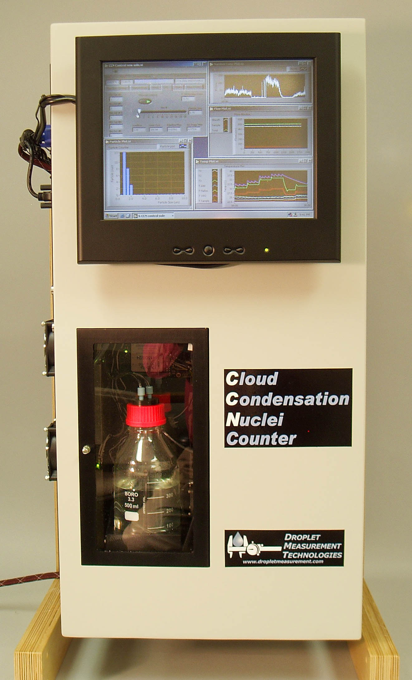

Figure : CCN Counter with Front-Mounted Touch Screen

## CCN Specifications and Features

|  |  |
| --- | --- |
| Technique: | Supersaturating aerosol particles in a 50-cm-high column with continuously wetted walls and a longitudinal thermal gradient; sizing subsequently activated particles using an optical particle counter |
| Measured Particle  Size Range: | 0.75 – 10 µm |
| Supersaturation Range: | 0.07 – 2.0% |
| Time Required for  Supersaturation Change: | ~30 seconds for 0.2% change |
| Flow Range: | • Total flow: 200 – 1000 volume cc/min (factory calibrated at 500 Vccm)  • Sample flow: 20 – 100 Vccm  • Sheath flow: 180 – 900 Vccm |
| Optical Particle Counter Laser: | 660 nm, 35 mW |
| Number of Particle Size Bins: | 20 |
| Sampling Frequency: | 1 Hz / 1 second |
| Data System Interface: | RS-232, 9.6 Kb/sec Baud Rate |
| Data System Features: | • Onboard computer for control and data logging  • Touch screen control and display  • Serial data output for external computer |
| Calibration: | Comparison of CCN output that of reference instruments (Differential Mobility Analyzer (DMA) and a CN Counter) |

## Electrical Specifications

|  |  |
| --- | --- |
| Power Requirements: | 28 VDC |
| Current: | 15 A at startup, nominal 7 A during regular operation |

## Physical Specifications

|  |  |
| --- | --- |
| Size: | * *For lab use (with frame):* * 35.0” H x 19.3” W x 15.6” D / * 88.9 cm H x 48.9 cm W x 39.7 cm D * *For aircraft use (without frame):* * 32.0” H x 18.4” W x 6.5” D / * 81.3 cm H x 46.7 cm W x 16.4 cm D |
| Weight: | * *For lab use (with frame):* 35.2 kg / 77.5 lb * *For aircraft use (without frame):* 29.0 kg / 64.0 lb |
| Features: | * Rack-mount compatible * Center of gravity located 15.5” from bottom of back base plate * Instrument plumbing system sealed for operation on pressurized aircraft |

## Operating Limits

The CCN operates by maintaining a positive temperature differential between the top of the column and the bottom. The top of the column always starts at ambient temperature or slightly above. For high supersaturations, temperature differentials of 20º C or more are required. Therefore the instrument will perform best if its environmental temperature is kept as low as possible.

It is not recommended, however, that the CCN be subjected to temperatures below 5 °C. The Nafion humidifier needs to be kept wet but not freezing. Even if the rest of the instrument is drained, there is the potential of damage to the Nafion. If the CCN is at temperatures below freezing, the instrument should be drained and dried as detailed in section , and the Nafion humidifier removed from the instrument.

# Theory of Operation

## How the CCN Generates Supersaturation

The CCN counter operates on the principle that diffusion of heat in air is slower than diffusion of water vapor (Roberts and Nenes, 2005). Inside the column, a thermodynamically unstable, supersaturated water vapor condition is created as follows. Water vapor diffuses from the warm, wet column walls toward the centerline at a faster rate than the heat. Figure 2 shows point C along the centerline where the diffusing heat originated higher on the column (red-line, point A) than the diffusing mass (blue line, point B). Assuming the water vapor is saturated at the column wall at all points and the temperature is greater at point B than at point A, the water vapor partial pressure is also greater at point B than at point A. The actual partial pressure of water vapor at point C is equal to the partial pressure of water vapor at point B. The temperature at point C is lower than at point B, however, which means that there is more water vapor (corresponding to the saturation vapor pressure at point B) than thermodynamically allowed.

Figure : Supersaturation Being Generated in the CCN Column

Seeking equilibrium, the supersaturated water vapor condenses on the cloud condensation nuclei in the sample air to form droplets, just as cloud drops form in the atmosphere. An Optical Particle Counter (OPC) using side-scattering technology counts and sizes the activated droplets.

## Details of CCN Design

The CCN column is mounted vertically with the ambient aerosol entering at the top. The wall temperature along the column gradually increases to create a well-controlled and quasi-uniform centerline supersaturation. The aerosol sample thus becomes progressively supersaturated with water vapor as it traverses down the column.

The sample is placed at the center of the column where supersaturation is highest, and filtered humidified sheath air surrounds the sample. The recommended flow ratio is 1 part of sample air to 10 parts of sheath air. This ratio ensures that the aerosol is exposed to a uniform supersaturation profile. The CCN’s vertical mounting, cylindrical geometry, and a porous alumina bisque liner (which provides the wetted surface down the column wall) minimize buoyancy effects and help droplets grow to detectable size.

At any given point in time, the CCN unit operates at a single supersaturation. This is because the temperature and water vapor gradient along the wetted walls are approximately constant along the wall. As shown by Roberts and Nenes (2005), the centerline supersaturation depends on the temperature difference between the top and bottom of the column, the flow rate, and the absolute pressure in the column.

A unique feature of the instrument is that the column has three temperature control zones, with the temperature increasing from the top zone to the bottom zone. This allows supersaturation to occur and also allows for rapid shifting between supersaturations. Software controls allow the user to change from one supersaturation to another, and the supersaturation can be varied between 0.07% and 2%. Approximately 30 seconds is required for a supersaturation shift.

The total variable airflow rate through the column is from 200 to 1000 volume cubic centimeters per minute (Vccm), with the recommended total flow being 500 Vccm. The column operates in laminar flow. The sheath flow is generated in the instrument by taking a portion of the sample air, filtering it, and humidifying it before it is used as sheath in the column.

Activated droplet counting is done with an Optical Particle Counter (OPC). The OPC has been specially designed for the CCN and uses side-scattering technology for the particle sizing. A diode laser with a wavelength of 660 nm is used as the light source. The sizing range for activated particles is 0.75 to 10 µm, and particles are distributed in 20 size bins. The first bin stores detectable particles up to .75 µm, while the second stores .75 – 1.0 µm particles. After that, the bin widths are.5 µm (1.0 - 1.5 µm, 1.5 – 2.0 µm … 9.5 – 10.0 µm). The wide sizing range and multiple binning of the OPC provide additional details on the growth of particles as well as information about how well the instrument is functioning. Particle sizing data is updated at 1-second intervals.

For information on how the supersaturation rate affects the maximum particle concentration, see Appendix B.

### Flow of Air and Water through the CCN

shows a flow chart of how air and water pass through the CCN. For a photograph of individual instrument components on the instrument, see .

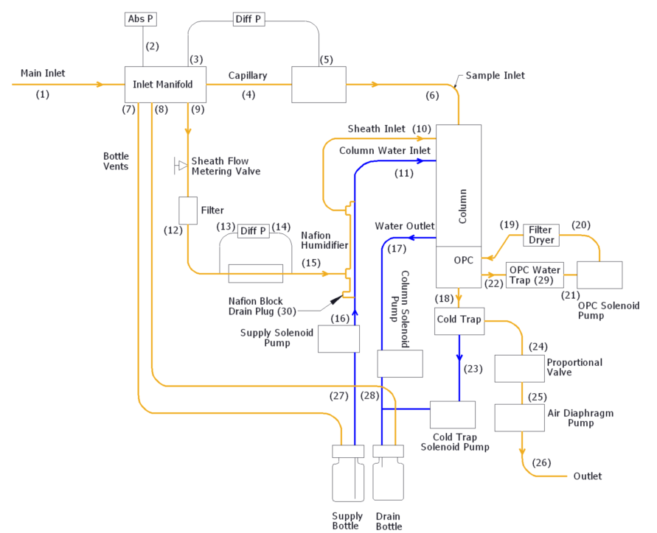

Figure : Air and Liquid Flow Schematic Diagram

The inlet manifold serves as the connection point for the sample flow, sheath flow, bottle vents, and the absolute pressure transducer for the sample pressure measurement.

Sample flow is measured by pressure drop across the capillary (4) with a differential pressure transducer. The sample air proceeds directly into the top of the growth column (6).

The sheath airflow is split off of the sample flow (9). The sheath air passes through a metering valve, which applies resistance to regulate the ratio between the sample and sheath air. The ideal flow ratio is 10 parts of sheath air to 1 part of sample air. Note that only the total airflow in the CCN is regulated; this is done through the proportional valve (24). Absolute flow to the sample and sheath flows is controlled by adjusting both the total air flow and the sample-sheath flow ratio.

After the sheath air travels through the metering valve, it passes through a filter (12) and a frit element with a differential pressure transducer for the flow measurement (13/14). The sheath air is then passed through the outside of the Nafion Perma-Pure unit to humidify the air (15). The Nafion is maintained close to the temperature of the top of the column. This ensures that minimal change is needed to reach the dew point at the top of the column.

The air in the column passes through the Optical Particle Counter (OPC) (22). A closed loop air-drying system is used for the OPC. If water droplets should enter the OPC, these are removed out the drain on the bottom of the OPC and collected in the water trap (29). The air then cycles through the OPC pump, drying column, and filter (19-21) before being put back into the OPC. This ensures that the OPC will not fog if operated on an aircraft. The displacement of the OPC pump is 60 µl per cycle, and the pump is controlled independently of the computer. However, this pump in the CCN counter operates only when the TEC relay power is turned on.

After the air in the column passes through the OPC, it enters a cold trap (18). This drops the dew point of the air so that water will not condense in the proportional valve (24) or sample pump (25). As stated above, the proportional valve regulates the total airflow through the CCN. The computer measures the total airflow and this data is fed back to the proportional valve.

A diaphragm pump (25) is used to provide system vacuum and then vents the air out the exhaust port on the side panel (26). The entire system is sealed so that the unit can operate in a pressurized environment. When operating at reduced pressures, it is necessary to vent the exhaust port at a pressure close to the inlet pressure.

The water supply and drain bottles are connected to the inlet manifold to equalize pressure for the supply and drain (27, 28). The water supply is fed with a solenoid pump (16) through the center of the Nafion and then to the top of the column (11) to supply humidification water. Solenoid pumps (23, 28) are also used to remove excess water from the bottom of the column and the cold trap. Each of these pumps has a flow capacity of 60 µl per cycle.

***WARNING***

**Do not allow unit to run when supply water bottle is empty, or unit may not function properly when water is added.**

Table 1 shows locations along the air and water flow paths where water and water condensation are to be expected.

|  |  |
| --- | --- |
| Location No. |  |
| I | Air Flow Path: ***No water should ever be present here.*** |
| 2 | Pressure Measurement Port: ***No water should ever be present here.*** |
| 3 | Pressure Measurement Port: ***No water should ever be present here.*** |
| 4 | Sample Air Flow Path: ***No water should* ever *be present here.*** |
| 5 | Pressure Measurement Port: ***No water should ever be present here.*** |
| 6 | Sample AirFlow Path: ***No water should ever be present here.*** |
| 7 | Bottle Vent: ***No water should ever be present here.*** |
| 8 | Bottle Vent: ***No water should ever be present here.*** |
| 9 | Sheath Air Flow Path: ***No water should ever be present here.*** |
| 10 | Sheath Air Flow Path: ***Condensation Present.*** |
| 11 | Water Supply: ***Water should always be present here.*** |
| 12 | Sheath Air Flow Path: ***No water should ever be present here.*** |
| 13 | Pressure Measurement Ports: ***No water should ever be present here.*** |
| 14 | Pressure Measurement Ports: ***No water should ever be present here.*** |
| 15 | Sheath Air Flow Path: ***No water should ever be present here.*** |
| 16 | Water Supply: ***Water should always be present here.*** |
| 17 | Water Drain: ***Water should be intermittent here.*** |
| 18 | Air Flow Path:***Condensation Present.*** |
| 19 | OPC Dry Purge Air: ***No water should ever be present here.*** |
| 20 | OPC Dry Purge Air: *May have condensation.* |
| 21 | OPC Dry Purge Air: *May have condensation.* |
| 22 | OPC Dry Purge Air: *May have condensation.* |
| 23 | Water Drain: *Water should be intermittent here.* |
| 24 | Air Flow Path:***No water should ever be present here.*** |
| 25 | Air Flow Path:***No water should ever be present here.*** |
| 26 | Air Flow Path:***No water should ever be present here.*** |
| 27 | Water Supply: ***Water should always be present here.*** |
| 28 | WaterDrain: ***Water should be intermittent here.*** |
| 29 | OP**C** Water TrapBottle: *May have condensation and 1 or 2 drops of* *water.* |
| 30 | Nafion block drain**: *No water should ever be present here.*** |

Table : Locations where Water Accumulation and Condensation is Permissible in CCN

### CCN Components

shows the important components of the CCN. and show solenoid pumps and the desiccant tube, respectively; these components are hidden in .

Figure : CCN with Important Components Labeled

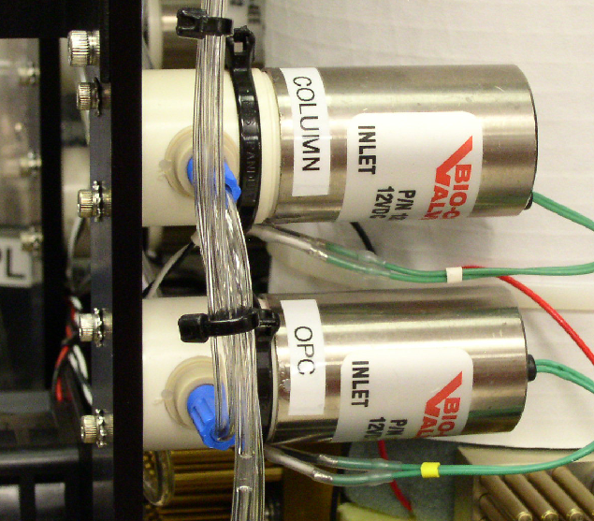

Figure : Solenoid Pumps

# Setting up the CCN

Several steps are required for initial CCN set-up:

* Unpacking and mounting the instrument
* Connecting CCN components such as the power cables, supply and drain bottles, and touch screen monitor
* Setting the flow and humidifying the instrument (humidification can take up to 12 hours and must be performed every time the CCN is dry when started)
* Checking that the CCN is functioning properly

These steps are described in detail in the following sections.

Any time the CCN is shipped, it must be dried out and properly repacked prior to shipment. Failing to follow proper procedure will result in damage to the instrument. See sections and for details.

## Unpacking the CCN

### Removing Instrument from Shipping Case

To minimize the potential for damage in shipping, the CCN arrives on a 36” x 36” custom pallet with a fitted case, special frame, and protective hood (Figure 6). The frame can be substituted as a bench stand for the unit. To remove the instrument from the case, follow the steps below.

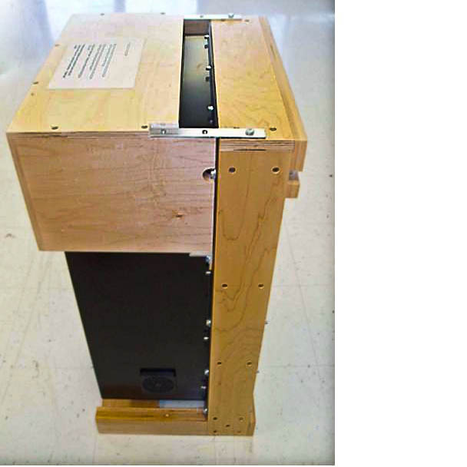

Figure : CCN with Shipping Hood on Frame

1. Cut straps securing case to pallet and **save pallet**.

1. Lift the CCN unit out of the case, using the back bar on the stand as a handle.
2. Remove two bolts on the underside of the hood. These bolts go through an angled aluminum bracket into the upright side of the frame, and there will be one bolt on either side.
3. Hold the shipping hood and pull up the two head bolts that go through the aluminum strap into the frame. The bolts are essentially pins that can be pulled straight up.
4. Inspect the CCN for shipping damage.
5. If the CCN is to be mounted in a different rack, remove the CCN from frame.
6. **Save parts for return shipping**.

### Connecting Instrument Components

1. Connect the power cable to the instrument. The power cable (ASSY-272) supplied in the startup kit is already installed and pretested on the bench top AC/DC power supply, which is also in the kit. The white wire (labeled “+28V”) connects to +28V VDC and the black wire (labeled “RETURN”) connects to the return of the power supply. If a longer cable is being used, refer to Appendix C. **Check the polarity of the power before connecting the instrument.**

***WARNING***

***THE CCN COUNTER IS NOT REVERSE POLARITY PROTECTED AND WILL BE SIGNIFICANTLY DAMAGED BY INCORRECT WIRING***.

***Warning***

Make sure the *CCN Main Power* is ***OFF*** prior to connecting or disconnecting any external power or I/O Cable

1. Remove the front cover from the instrument. There will be 12 screws around the perimeter of the instrument, and 3 on the left side into the connection panel.
2. Unpack the supply bottle, drain bottle, bottle hold-down clamp, and clamp screw. These are packed separately from the main CCN instrument in the start-up kit. The supply and drain bottle caps have been packaged in a plastic bag and tied to the frame. Remove the tie and bag.
3. Install the drain bottle in the bottle holder. The best location for the drain bottle is in the rear of the two slots in the bottle tray. See .
4. Fill the supply bottle with distilled or deionized water and set it in the front of the bottle tray.
5. Make sure the bottle caps are tight on the bottles. Otherwise, air will leak into the inlet system.
6. For airborne applications, install the bottle hold-down clamp. See .

Figure : Bottle Hold-Down Clamp

1. If desired, mount the touch screen to the front of the CCN case:
   1. Remove the two Phillips-head screws that hold the tripod leg to the back of the screen. This will expose the back of the screen and the location of the four mounting holes.
   2. Remove the four hole plugs from the front of CCN case.
   3. Connect the cables to the screen.
   4. Mount the screen to the case, using the four 4.7 mm screws with lock washers that are provided in the startup kit.
   5. Save the parts that were removed from the screen and the case.
2. Connect the touch-screen video and serial cables to the side panel. Turn on power to the touch screen either from the external power supply or from the side panel, using the cable provided.
3. Set the cover back on the guides at the top of the CCN chassis. Do not secure the cover screws yet, however, as flow adjustments need to be made (see section ).
4. Remove plugs from inlet and outlet fitting on the side of the unit.

### USB Memory Stick

A USB memory stick is tie-wrapped and attached with Velcro to the CCN exhaust line. The memory stick should be stored in this location, as it contains important information about the instrument:

* White papers describing the theory behind the CCN design
* A copy of the CCN manual
* Detailed spreadsheets for use in instrument calibration
* LabVIEW software programs used to operate the CCN

## Setting Flow and Humidifying CCN

1. If you have not already done so, install the drain and supply bottles on the CCN. The supply bottle should be filled with distilled or deionized water.
2. Start the CCN. The breaker on the side panel also serves as the power switch. The computer will load the **Single CCN.exe** control program and start automatically.
3. During the first 10 seconds after the program starts, click the **Dry Start Up** button shown in . Selecting **Dry Start Up** will set the liquid supply pump to high and disable the CCN concentration alarm.

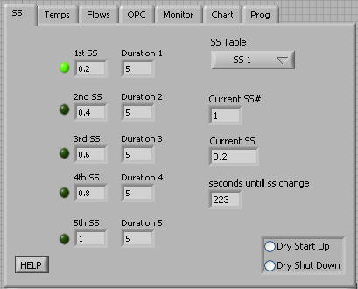

Figure : SS Tab

1. On the main CCN window, go to the **Flows** tab.
2. The flow ratio between the sheath and sample flow is displayed directly in the center window. Adjust the green knob on the sheath flow metering valve (see ) until this ratio reads 10.0 +/- 0.3.
3. Check the position of the OPC drying system time switch. This switch controls the solenoid pump in the drying system. The switch is labeled SW1 and is located in the middle of the Controller Printed Circuit Board, as shown in . The solenoid pump can cycle every 2 seconds or every 16 seconds. Set this switch to the 16-second position.[1]
4. After the column is fully wetted, the OPC should be counting. Note that it may take 4 to 12 hours for the CCN to become properly humidified and count particles. At this time, all the status lights on the monitor tab should be illuminated (). Illuminated status lights indicate the CCN Instrument is functioning properly. You can now begin to collect data.

If any of the **Monitor** tab status lights are not illuminated, there is an issue with the CCN instrument and it should not be run until problem is corrected. Copy the latest data file from C:\CCN DATA. Shut off power to the CCN instrument and send the data file to DMT at [CCN-INFO@dropletmeasurement.com](mailto:CCN-INFO@dropletmeasurement.com).

1. Re-Install the cover on the CCN.

## Checking that the CCN is Functioning Properly

The following test should be performed before using the CCN for the first time. It should also be done whenever instrument performance needs to be verified. *Note: The procedure below assumes you have already started up the CCN as described in the previous section.*

1. Install the filter provided on the inlet of the CCN. Operate the instrument for 15 minutes, then monitor the number of counts. Total counts should be less than five per second.
2. Connect a volume displacement flow meter (Gilian, Buck, or laboratory constructed) to the inlet of the CCN.
3. Note the total flow on the **Flows** tab.
4. Measure the flow with the displacement flow meter.
5. Repeat step 4 five times. The average measured flow should be ±10% of the stated flow on the **Flows** tab.
6. Remove the filter from the inlet of the CCN and set the following supersaturation gradient scans:

|  |  |
| --- | --- |
| ***Supersaturation Setting*** | ***Duration of Scan*** |
| 0.2% | 10 minutes |
| 0.4% | 5 minutes |
| 0.6% | 5 minutes |
| 0.8% | 5 minutes |
| 1.0% | 5 minutes |

Run two complete supersaturation cycles. As the supersaturation increases, verify that the number concentration of particles measured remains stable or increases.

### Testing the Unit for Leaks (for CCN Use on Pressurized Aircraft)

If CCN unit will be installed in pressurized aircraft, perform the following leak test in addition to the zero-count check described in section .

1. Install a valve or plug on the inlet of CCN unit while it is running.
2. Allow the unit’s internal air pump to evacuate the system. This may take several minutes. Monitor the progress on the **Flows** tab’s **Sample Pressure** field.
3. When the unit has pumped down below approximately 400 mb, go into the **Flows** tab and turn off the **Air Pump*.*** This will turn off power to the pump, which will also act as a seal.
4. If unit does not pump down below 400 mb, there is a leak that needs to be fixed prior to retesting.
5. Wait 60 seconds to allow pressure to stabilize, and then monitor how fast the sample pressure rises. Typically 5 mb or less per second is good.
6. If unit leaks at an unacceptable rate, try isolating and fixing leak then retest using above method.
7. To shut down the CCN, always start by shutting down the control program. Go to the **Prog** tab and press the **Shutdown** button. You can then simply turn off the main power switch on the side of the unit. You can also close Windows first by turning off the computer and then turning off the power switch on the side of the unit when the screen goes blank.

***Note:***

***Most leaks are operator induced.***

***Bottle caps need to be tightened fully to seal properly.***

***Warning***

Use extreme care in preventing water from entering the inlet to the CCN counter. Liquid water will plug the sheath air filter and shut off flow. If liquid water does enter the inlet:

***IMMEDIATELY SHUT OFF THE INSTRUMENT***.

If a small amount of water (less than a few ccs) has entered, disconnect the pressure transducer and sample inlet fittings from the inlet manifold and dry the manifold using warm air and replace the filter on the sheath air.

***If additional water has entered the system,***

***contact Droplet Measurement Technologies immediately.***

***Warning***

The CCN Counter must be prepared for shipping by drying the column and draining the OPC (see Section 4.0).

## Repacking the CCN for Shipping

1. Ensure that the CCN is dried prior to shipping (see Section ).
2. Bolt the CCN to the frame, installing four bolts on each side at the 1, 3, 4, and 5 positions as counted from the top of the frame.
3. Install the shipping hood over the front of the case, and insert the bolts through the top straps into the frame.
4. Insert the bolts into the number 2 position on each side of the frame through the angled brackets on the hood.
5. Slide the CCN unit into the case, noting the orientation. The back of the CCN frame goes toward the side of the case with the extra foam block.
6. Attach the top half of the case, noting the orientation of the case halves.
7. Strap the case to a pallet whenever shipping the CCN commercially in order to ensure instrument safety. (The pallet size is 36” x 36” if you did not save original shipping pallet.) This prevents dropping and turning the case upside down.

Please Note:

To Ensure Safe Shipment of CCN:

CCN must be strapped and shipped on original CCN Pallet

If CCN is returned to DMT NOT on a CCN pallet:

You will be charged for a new CCN pallet

COST: one hundred dollars ($100.00) per pallet

## Drying the CCN Prior to Shipping

### Necessity of Drying CCN

The CCN can collect liquid water in the reservoir around the OPC and in the cold trap. This water is continually removed by the drain pump and pumped into the drain bottle. In normal operation, small amounts of liquid water in these areas will not cause a problem, as they will not migrate into the OPC. If the unit is shipped with liquid water in these areas, however, it can migrate into the OPC if the instrument is inverted or handled roughly in shipping.

### To Drain All Liquid Water

Prior to shipping the CCN, drain all liquid water from the OPC and cold trap by the following these steps:

1. Start the **Single CCN.exe** program.
2. Click **Dry Shut Down** button during the first 10 seconds after the program starts.
3. When the system instructs you to do so, shut down the sheath flow metering valve. The liquid supply pump will be turned off and the drain pumps will be turned on high. The flow total flow will be set to 175 Vccm. The CCN concentration status and flow status alarms will be disabled. After 6 hours, the unit will turn off the control program and display a message that the unit is dried out and ready to ship.
4. Remove the supply, drain bottles, bottle hold-down clamp and screw.
5. Place the bottle caps in a plastic bag and secure them to the frame above the supply pump with a cable tie wrap.

The instrument can now be mounted on the frame for shipping.

# Installation

## Power Supply Considerations

The CCN is designed to operate on 28 VDC power. Ground-based applications require a line voltage to 28 VDC supply, which can be either a linear or switching supply. The capacity of the supply should be at least 15 A. The CCN may draw this current load for up to a few minutes at startup, and then will typically draw 6-10 A in normal operation.

A recommended power supply is a V-Infinite (#VPM-S500-24R) preset to 28 V. This unit has a wide input range that has been successfully used with the CCN.

The quality of 28 VDC on aircraft varies considerably. If there are high frequency spikes when the 400 Hz power is converted to 28 VDC, this can cause problems with the CCN. If problems occur when operating the CCN in an aircraft environment, check the line voltage to 28 VDC supply.

For more information on power and signal connections, see section .

# CCN Power and Signal Connections

The CCN’s power, signal and exhaust connections are located on the side of the instrument, as illustrates.

Power is applied to the CCN through a military-style circular connector, Model PT06A-12-4S (SR). The power on this connector is split into two 28 VDC legs of which all four pins must be used:

* Pins A and C: **+28 VDC**
* Pins B and D: **Power Return**.

12 awg wire must be used between the power source and the power connector. The white wire is positive and the black wire negative on all DMT-supplied cables. See Appendix C for details.

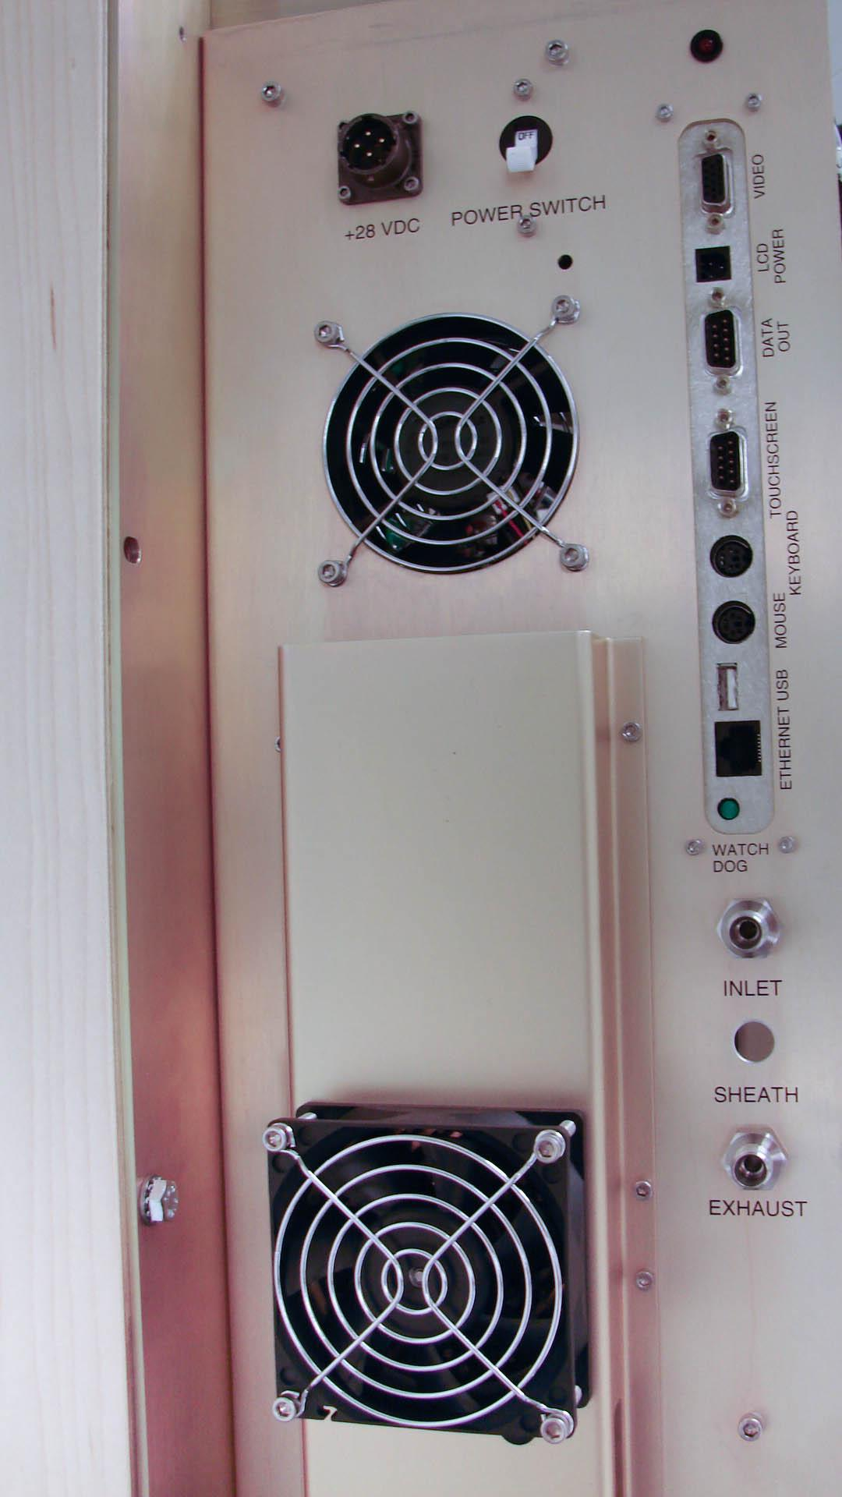

Figure : Location of Power, Communications, Sample and Exhaust Connections

The **MAIN POWER** switch is a 20-Amp circuit breaker for protection of the CCN instrument.

The pilot light (see ) indicates if instrument power is **ON** or **OFF**.

The data communication connectors are as follows:

* **Video**: Connection for video monitor, either the touch screen supplied with the instrument or any standard video monitor. Resolution for an external monitor needs to be set at 600 x 800.
* **Screen Power**: 12 VDC power output for the touch screen. The cable is supplied with the CCN.
* **Touchscreen**: The serial port connection for the touch screen cursor operation.
* **Data Out**: The main serial port. Serial data output is RS-232, 9600 baud, 8-N-1. A null modem must be used in connecting to the serial port on external computers for correct communication.
* **Keyboard**: The standard keyboard connection. This can be used with the touch screen or with a standard monitor.
* **Mouse**: The mouse connection, which is active with the touch screen or a standard monitor.
* **USB**: USB 1.1 port for auxiliary USB devices.
* **ETHERNET**: A standard network connection.
* The **SAMPLE** and **EXHAUST** connections are ¼ inch Swagelok connections.

If the CCN is being operated in a pressurized aircraft, the **EXHAUST** port must be connected to an overboard dump. A leak check should also be performed on the CCN before operating in a pressurized cabin; see section . Leaks that were not apparent prior to pressurization may be come problematic in a pressurized cabin.

# Printed Circuit Boards (PCBs)

The CCN’s controller, power supply, and CDPE boards are located to the left of the Nafion block, as shown in . shows a close-up of the controller and power supply boards, while depicts the CDPE board.

|  |  |
| --- | --- |
| *Label* | *What Illuminated LED Indicates* |
| A* | 28 V power is present in unit |
| B | 5 V power supply on Power Supply Board is present |
| C | 12 V power supply on Power Supply Board is present |
| D | 5 V power supply for computer is present |
| E | Watchdog pulse is present (blinks at 1 Hz in tandem with watchdog light) |
| F | Power is supplied to cold trap—will cycle around |
| G | 5 V power supply on Controller Board is present |
| H | 12 V power supply on Controller Board is present |
| I | Power is supplied to Nafion heater |
| J | Power is supplied to inlet heater |
| K | Power is supplied to OPC heater |
| L* | TEC Relay is **ON** |
| * Labelled "L1" on board. (Most LEDs are unlabeled on the boards themselves.) | |

Figure : Controller and Power Supply Boards with LEDs and OPC Switch Labeled

Figure : CDPE Board. D1, D2, and D3 are lit all the time when there is power supplied to the instrument.

# CCN Maintenance

DMT recommends the following service and maintenance schedule for the CCN. The maintenance schedule is based on the continuous operation of the instrument and may need to be modified for other operating conditions.

## Every 4 days and Before Every Flight

1. Empty the water bottles. The water in these bottles is not hazardous since it has only been exposed to ambient air, so it can be disposed of in any drain. Check area for leakage.
2. Check OPC water trap for any liquid removed from the OPC. If liquid is present, empty the bottle.
3. Check the bottom of case for any water leakage, as this would indicate leakage of the liquid flow system.
4. Refill the supply bottle with clean deionized or distilled water. This water can be procured at a grocery store. However, ***it is important that the water not be artesian water or any water with added minerals***. The water consumption rate is as follows:

* 4.8 ml per hour when **Liquid Flow Set** (on **Flows** tab) is low
* 7.2 ml per hour when **Liquid Flow Set** is medium
* 18.0 ml per hour when **Liquid Flow Set** is high

1. ***Make sure the caps on both bottles are******securely tightened****.* If caps are not tightened securely, the air stream can become contaminated.

## Every Month

1. Check the filters on the air inlets at the right-hand side of the case. If filters are dirty, wash and replace them.
2. Check the calibration on sheath and sample airflows.
3. Check the desiccant tube for the OPC dryer. Replace the tube if necessary, replacing the filter and dryer unit at the same time. Healthy desiccant tubes should have a deep orange indicator gel, as shown in . Lighter orange gels indicate the tube needs to be replaced.

Figure : Healthy Desiccant Tube

## Every Three Months

Replace the sheath airflow filter. ***Note:*** The sheath flow filter may need to be replaced more frequently in high-concentration environments or if the filter is passing particles. Sheath flow filters can be susceptible to leaks; see Appendix G.

## Every Year

1. Calibrate the internal temperature curve of CCN by comparing CCN data to that generated by a Differential Mobility Analyzer (DMA) and CN counter. See section for details.
2. Clean and calibrate the OPC.
3. Replace the Nafion humidifier membrane.
4. Calibrate the Absolute Pressure Transducer.

## Pump Diaphragm and Motor Maintenance Requirements

A pump failure will not cause any damage in the CCN, so it is acceptable to wait until the pump fails fail to replace the diaphragm and motor. These can also be replaced when their estimated lifetime expires. The pump diaphragm lifetime is approximately 4000 hours, while the pump motor lifetime is approximately 8000 hours.

# Calibration Procedures

For optimum CCN performance, periodically calibrate the CCN flow sensors, pressure transducers and the optical particle counter. See the sections below for details.

## CCN SS% Calibration

### Recommended calibration equipment

* Aerosol Generator System for nebulizing ammonium sulfate particles (DMT Aerosol Generator AG-100))
* Differential Mobility Analyzer (TSI3080L or equivalent)
* CN Particle Counter (TSI3025L or equivalent)

Refer to for the calibration set-up.

Figure : Calibration Set-Up

The CN Counter is used as a reference instrument. It will count 100% of all the particles that are fed into it from the DMA. The ratio of the number of particles the CCN could count if they activated can now be determined.

### SS% Calibration Procedure

The CCN temperature is tested with gradients of 3, 4, 6, and 8. The 50% activation point () for that size of ammonium sulfate is converted from the Köhler curve to a SS%. A linear regression between the measured SS and the temperature gradient is run on the data and that becomes the SS% calibration curve for the CCN instrument (). The curve is very linear down to 0.1%. Running SS% below 0.1% will require special calibration and interpretation. (Below 0.1% SS growth kinetics become very important and can influence the data.)

Calibration parameters:

* Sample Flow Rate: 45 Vccm
* Sheath Flow Rate: 450 Vccm
* Sheath:Sample Flow Ratio: 10:1

Figure : Activation Curve Used in SS% Calibration

Figure : Temperature Gradient Curve for Different SS%

## Flow Calibrations

### Recommended Calibration Equipment

* Volumetric displacement flow meter (the range should be from 10-1000 Vccm)
* USB stick that accompanies the CCN (this contains initial factory calibration data to be used as a reference, as well as a spreadsheet to run the regression analysis)

### Flow Calibrations Procedure

*Sample flow calibration:*

1. Connect the volumetric displacement flow meter to the inlet port on the side of the CCN instrument.
2. Close the sheath flow metering valve. If you have a unit built before fall of 2011, you will need to remove the instrument cover to access the green sheath flow metering valve (Figure 16). If you have a newer unit, you can access the valve through an access port (Figure 17).

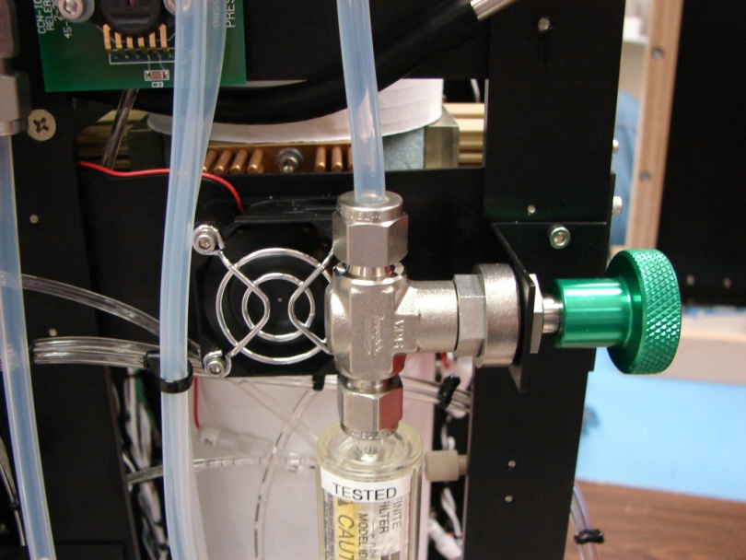

Figure : Sheath Flow Metering Valve

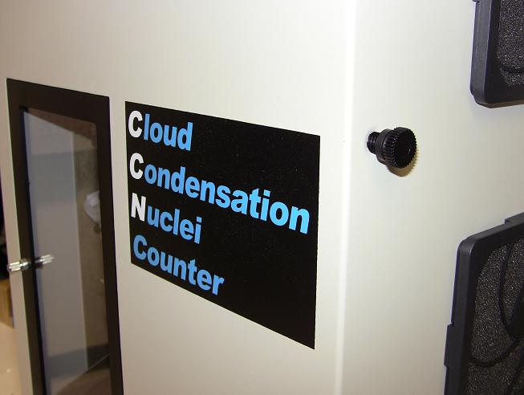 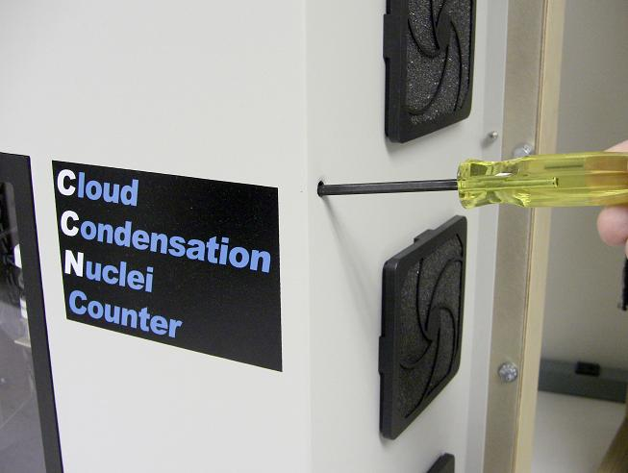

Figure : Accessing Metering Valve Through Port (Newer CCNs Only)

1. In the CCN software, click on the **DMT** Servicetab. Click just below the text window in the middle of the screen. In the white text box that appears, type in the password *Service*. Then select the **FlowCal** sub-tab.
2. Change **Sample Flow y-int** to 0 and **Sample Flow slope** to 1.
3. Go to the **Flows** tab on the CCN control window and turn on the **Manual Override**. Button. Using the **Valve Set M (V)** field,adjust the valve voltage until the sample flow as measured on the external flow meter (*not* on the computer display) is approximately 75 Vccm.
4. Record the flow from the flow meter in the flow column of the spreadsheet. Next, record the value displayed in the **Sample Flow (Vccm)** field in the volts column. (Because Step #4 sets the regression coefficients to 1 and 0, the **Sample Flow (Vccm)** indicator is now actually displaying the *voltage* from the sample flow differential pressure transducer.) This value typically ranges from 2.3 to 4.0 V. Do not record the **Valve Set M (V)** value for use in the regression. (You can record it for informational purposes, if you want to remember which settings are used to achieve specific flow rates.) See .

Figure : Inputs for CCN Flow Calibration Procedure

1. Repeat steps 5 and 6 for measured flow values on the flow meter of approximately 60, 45, 30, and 20 Vccm.
2. The Excel spreadsheet should run the regression for you. Verify that *r2* > .99.
3. Insert the new slope and intercept coefficients into the **DMT** Servicetab, in the **FlowCal** tab. Use the measured flow meter data as the Y value and the voltage measurement as the X value. Click **Save.**
4. Adjust the valve voltage to get a sample flow reading of 45. Verify the **Sample Flow (vccm)** reading on the **Flows** tab agrees with the external flow meter before proceeding to sheath flow calibration.

*Sheath flow calibration:*

1. If you have not already done so, connect a flow meter to the flow inlet.
2. Completely open the sheath flow metering valve.
3. In the CCN software, click on the **DMT** Servicetab. Then click just below the text window in the middle of the screen. In the white text box that appears, type in the password *Service*. Then select the **FlowCal** sub-tab.
4. Change **Sheath Flow y-int** to 0 and **Sheath Flow slope** to 1.
5. Go to the **Flows** tab on the CCN control window and turn on the **Manual Override**, if it is not already on. (See figure above.) Using the **Valve Set M (V)** field,adjust the valve voltage until the sheath flow as measured on the external flow meter (*not* on the computer display) is approximately 750 Vccm.
6. If you have not already done so, open the spreadsheet located on the USB memory stick you received with the CCN. Measure the actual flow with the flow meter. Record the total flow from the flow meter in the “total” column of the spreadsheet. See arrow 1 in Figure 19. Record the displayed sample flow in the “sample” column (arrow 2). The spreadsheet will automatically calculate sheath flow (sheath flow = total flow – sample flow).

3

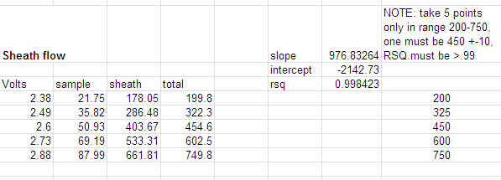

2

1

Figure : Sheath Flow Calibration Spreadsheet

1. Record the value displayed in the **Sheath Flow (Vccm)** field in the volts column (arrow 3 in Figure 19). (Because Step #4 sets the regression coefficients to 1 and 0, the **Sheath Flow (Vccm)** indicator is now actually displaying the *voltage* from the sheath flow differential pressure transducer.) Do not record the **Valve Set M (V)** value for use in the regression. (You can record it for informational purposes, if you want to remember which settings are used to achieve specific flow rates.)
2. Repeat steps 5 – 7 for measured flow values on the flow meter of approximately 600, 450, 300, and 200 Vccm.
3. The Excel spreadsheet should run the regression for you. Verify that r2 > .99
4. Insert the new coefficients into the **DMT** Servicetab, in the **FlowCal** sub-tab. Use the flow data as the Y value and the voltage measurement as the X value. Click **Save**.

*Verification and Reassembly*

Click the **Manual Override** button off. Ensure the flow is set to 500 Vccm and the flow ratio is 10.0 ±.25. Measure the actual sample and sheath flows with flow meter and compare to the displayed values on the CCN. They should be within 5% of each other. If not, repeat calibration procedure. Once calibration is complete, reinstall the CCN cover if you have removed it.

## Pressure Calibration

### Recommended calibration equipment

* Pressure transducer with a range from 100-1000 mb.
* Vacuum pump for applying test vacuum to system.

### Pressure Calibration Procedure

1. Following the flow calibration, disconnect the pressure transducer line from the inlet manifold. Depending on the connection to the vacuum system, adapt or remove the fitting from the end of the pressure transducer line and connect to the vacuum source.
2. Start the CCN counter, and calibrate the pressure transducer at 5 or more points over the range 100-1000 mb.
3. Reconnect the pressure transducer line to the inlet manifold.
4. Run a linear regression on the calibration and insert the coefficients into the **CCN Calibration Editor.exe** program. The pressure data will be the Y values and the voltages the X values.
5. Replace the cover on the CCN instrument.

## OPC Calibration

### Recommended Calibration Equipment

* Aerosol generator system for nebulizing polystyrene latex (PSL) particles, such as the DMT aerosol generator.
* PSL calibration particles, 2.0 micron.

### OPC Calibration Procedure

1. Start the CCN counter and turn off the liquid supply pump.
2. Set conditions for a low supersaturation of 0.1%, and start the airflow rate.
3. To speed the drying process, use a drying tube such as a Drierite tube. Connect this to the inlet or, if a drying tube is not available, use air and run the CCN for about 15 minutes to reduce the humidity in the tube.
4. Connect the aerosol generator to the sample inlet and start the aerosol generator.
5. Note the bin where the calibration particles are measured. A good calibration exists if the particles are in the proper bin or slightly high. If the particles are in a lower size bin, the OPC could be dirty and will need cleaning and recalibration. Contact Droplet Measurement Technologies Inc.
6. Restart CCN for normal operation.

### OPC Cleaning Procedure

After running the OPC dry air recirculation pump on high for 12 hours, if the 1st stage monitor voltage is still at or near 5.0V, there may be water droplets on the window between the laser and OPC. The 1st Stage monitor voltage is displayed in the bottom right of the OPC tab, as shown in .

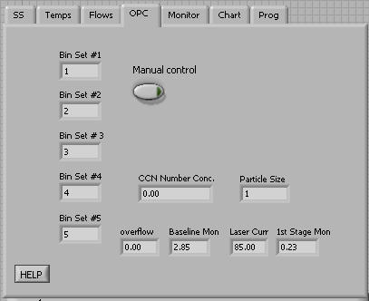

Figure : OPC 1st Stage Monitor Voltage

The best way to check and correct this problem is to dry the OPC with canned air, as described below. *Contact DMT before performing this procedure.*

* + 1. While the unit is on and the air pump is off, monitor the voltage of the 1st Stage Monitor.
    2. Remove the two 2-56 screws holding the Beam Dump to the OPC block ().[2]

***WARNING:***

***When Beam Dump is removed the laser beam will come out of the OPC through this opening.***

***DO NOT LOOK DIRECTLY INTO THE OPENING OF THE LASER BEAM*.**



* + 1. Note the beam dump orientation (wedge points down towards inside of OPC) and make sure its o-ring (2-011/OR011) is accounted for.

Figure : OPC Mounting Location on Column

* + 1. Turn power off to unit. Insert the tube on the end of an inert dusting gas (such as Tech-Spray, Envi-ro-tech 1671 Duster) about halfway into the Beam Dump opening.
    2. Give a couple of short burst of clean dry air (). If there is excessive water in the OPC, you will notice water mist coming back out of the hole as you spray into it. Keep applying short bursts until no water mist comes out.
    3. Turn power back on and verify 1st Stage Monitor Voltage has returned to normal operating value (.2-.4).
    4. Repeat if necessary. Contact DMT for further help if normal operating value cannot be achieved.

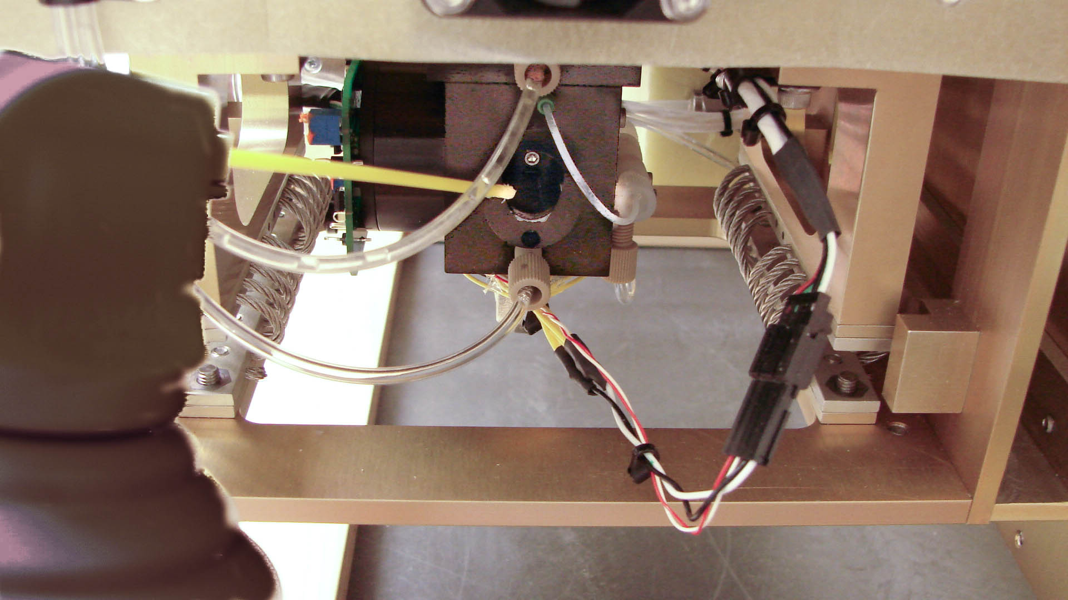

Figure : Air Drying OPC with Canned Air

* + 1. Reinstall the Beam Dump, ensuring that the o-ring is in place and the orientation is correct.

# CCN Accessories

## Spares and Consumable Supplies

A series of spares and a consumable supplies kits are available for the CCN unit.

|  |  |
| --- | --- |
| * Startup Kit (KIT-0001): | This kit, which is provided with the initial instrument purchase, contains all the parts needed to operate the instrument initially. Major items include bottles, power supply cables, touchscreen hardware, etc. |
| * Consumables Kit (KIT-0002): | This maintenance kit will support the CCN for one year of continuous operation. Major items:   * 4 sheath filters * 1 Nafion membrane * 1 pump diaphragm repair kit |
| * Spare Parts Kit (KIT-0003): | This kit contains items that could fail and need replacement. Major items:   * 4 Thermo-electric coolers (TECs) for column * 1 80-GB hard drive preloaded with instrument calibration * 1 current control module for TECs * 1 desiccant tube * 1 air pump * 1 Solenoid pump |
| * Spare Electronic Repair Kit (KIT-0004): | This kit contains electronic items that could fail and need replacement. Major items:   * 1 Power supply PCB * 1 Control PCB * 1 OPC and OPC control electronics * 1 80 GB-hard drive preloaded with instrument calibration |
| * Spare Computer Kit   (KIT-0023): | This kit has a completely assembled computer including 80-GB SS hard drive preloaded with instrument calibration. Major items:   * 1 1-GHz computer * 1 PC-104 A-D card * 1 2 Com port card * 1 80-GB hard drive preloaded with instrument calibration |

## Airborne CCN Inlet Assembly Kit

The Airborne CCN Inlet Assembly Kit (AAA-0086) offers accessories that are useful during aircraft operation. The Constant Pressure Inlet is also useful during ground operation when the ambient pressure must be controlled.

|  |  |
| --- | --- |
| * CCN Rail Mount   (ASSY-0186): | The rail mount provides a secure seat for the CCN on the aircraft. |
| * CCN Aircraft Inlet   (ASSY-0134): | This supplies the aircraft inlet tubes (on the outside of the aircraft) and the required plumbing to connect to the Constant Pressure Inlet. See Appendix E for a diagram of the CCN Aircraft Inlet. |
| * Constant Pressure Inlet   (AAA-0087): | This device allows users to control and change the ambient pressure under which the CCN operates. |

# Troubleshooting

| ***Problem*** |  | ***Possible Cause*** |  | ***Solutions*** |
| --- | --- | --- | --- | --- |
| **“Duplicate file name”** light is yellow. |  | Battery on computer is dead and time is same every time computer reboots |  | Replace battery for computer. |
| **“Laser Current Status”** light is yellow. |  | Laser Current has exceeded maximum normal operating life |  | Contact DMT for OPC repair and replacement. If the laser is still on, unit is working properly. The laser is near the end of its life, however, and a replacement should be planned soon. |
| **“OPC Communication”** light is yellow. |  | OPC is not communicating with computer |  | Determine if OPC, wiring, or the computer is causing the communication issue. It may be necessary to test OPC with DMT PADS software. Contact DMT for further instructions. |
| **“1st Stage Monitor Voltage Status”** light is yellow, or **1st Stage Monitor Voltage** is too high |  | OPC fogged or flooded |  | Run OPC dry air recirculation on high for 12 hours. If this does not clear the problem, refer to Section for further instructions. |
| **“Flow Status”** light is yellow.  *Monitor Issues* |  | Sheath filter restricted or wet, sheath flow valve closed. |  | Replace sheath filter, and open sheath valve. |
| **“Temp Control Status”** light is yellow or red. |  | Blown fuse |  | Check appropriate fuse. Contact DMT for further information. |
| **“Sample Temp Status”** light is red or yellow. |  | Ambient temp is out of unit range. Sample Temp Senor malfunction. |  | Operate unit in range. Contact DMT for further information. |
| **“OPC Status”** light is yellow or red. |  | OPC flooded |  | Determine why OPC flooded, fix the problem, then run OPC dry air recirculation on high for 12 hours. If this does not clear the problem, refer to Section for further instructions. |
| **“Column Temps Stabilized Status”** light is yellow. |  | Temperatures stabilizing at slightly more than 0.3 degrees from set point. |  | No action required. If temperatures are too far from set point, Temperature Control Status will alarm. |
| **“Column Temps Stabilized Status”** light NEVER turns green.  *Monitor Issues* |  | One of the temperature zones—T1, T2, or T3—on the column does not regulate. Possible fuse blown for that circuit. |  | Check appropriate fuse. |
|  | Temperature control module failed. |  | Substitute in a known good temperature controller from one of the other zones. |
|  | Thermoelectric cooler (TEC) element has failed on column. |  | When both sides of the TEC element are at or very near the same temperature, the resistance measured across the unit will be low, approximately 10 ohms. Since good TEC elements can produce a voltage when there is a temperature difference between the two sides, this will cause the polarity of the resistance reading to reverse.  1. If at all possible, make sure that the CCN instrument has not operated for the previous few hours so that there are no temperature differences between the sides of the TEC elements.  2. Disconnect the in-line connector, located near the rear of the CCN, just above the drain bottle for the temperature zone that is not functioning. There will be three connectors, each one for the top (T1), middle (T2), and bottom T3.  3. Using a standard digital volt meter (DVM), measure the resistance across the pins going to the temperature zone under test. Reverse the leads and retake the temperature measurement. If the resistance is nearly the same with the polarity switched, the zone is good. If the resistance stays the same with the same polarity, the zone has a bad TEC element. If no bad TEC element is found, contact DMT for further information.  4. If a zone is found to have a bad TEC element, use a DVM probe and measure the resistance across each of the TEC elements. The elements are labeled on the quick connects as TEC1, TEC2, TEC3, and TEC4.  5. When the defective TEC element is located, unplug the bad TEC. Plug in the good TEC to the other, good TEC, leaving the bad TEC unplugged.  6. Check the resistance of the TEC elements measuring at the Molex connector (CON-0256) to ensure that the string is good.  7. Reconnect the in-line connector.  8. Start the CCN instrument and run a supersaturation scan to verify that the temperature zone is controlling properly. |
| **“Column Temps Stabilized Status”** light turns green occasionally but does not stay green**.** |  | One or more of the Column Temperature zones—T1, T2, or T3—is stabilizing at more than 0.3° from set point. |  | No customer-adjustable solutions. Contact DMT for further help.  *Note: If temperatures are being controlled but stabilization point is only slightly more than .3 degrees from set point, (< .4), the unit is probably functioning properly.* |
| Major system failure, computer not booting, all system values reading significantly off, negative values for temperatures. |  | Power supply problem |  | The power supply board and the CCN control board have LED units for each of the power supplies; see . The supply voltage is identified on the silkscreen near the LED and if the LED is not lit, the problem is most likely in the fuse or power supply. lists the fuses in the CCN, values and applications. The fuses used are a printed circuit type, and it is not possible to tell visually if they have failed. It is necessary to check the fuses with some type of continuity device. |

|  |  |  |  |  |  |  |
| --- | --- | --- | --- | --- | --- | --- |
| **Power Supply PCB** | | |  | **Control PCB** | | |
| **Fuse** | **Value** | **Application** |  | **Fuse** | **Value** | **Application** |
| F1 | 5 A | 12 DC-DC converter |  |  |  |  |
| F2 | 2A | OPC power |  | F2 | 6.3A | Top TEC controller |
| F3 | 3.15A | Computer power |  | F3 | 6.3A | Middle TEC controller |
| F4 | 2A | 5V DC-DC Converter |  | F4 | 6.3A | Bottom TEC controller |
| F5 | 3.15A | Touch screen power |  | F5 |  | 28 VDC spare circuit |
|  |  |  |  |  |  |  |
|  |  |  |  | F7 | 2A | Nafion heater |
|  |  |  |  | F8 | 2A | Inlet heater |
|  |  |  |  | F9 | 2A | OPC heater |

Table 2: CCN Fuse Listing

| ***Problem*** |  | ***Possible Cause*** |  | ***Solutions*** |
| --- | --- | --- | --- | --- |
| System flow is zero with pump operational  *Flow Issues* |  | Cold trap for water removal in line frozen, or pump diaphragm failed |  | Shut off the CCN unit and wait 15 minutes. Restart the unit, and if flow resumes, the cold trap has most likely frozen. Please contact DMT for instructions on adjusting the temperature on this unit. If the flow does not resume, remove lines from sample pump and check flow with CCN system disconnected. If the pump does not have substantial vacuum, most likely the diaphragm has failed. Replace diaphragm or pump. |
| Flow ratio of 10.0 cannot be achieved, and flow ratio is less than 10.0 but stable. |  | Sheath flow filter has restriction. |  | Replace sheath flow filter. |
| Unstable flow or flow noise. Flow ratio unstable. |  | Water droplets have caused a restriction in the sheath flow line. Refer to . |  | 1. Shut Off CNN instrument.  2. Remove the Nafion drain plug.  3. Gently apply suction to the 1/4 X 28 drain plug using a syringe or other suction device. Note if any water is removed.  4. Reinstall the ¼ inch Nafion drain plug. |
| Unstable flow or flow noise returns after removing water droplets from the sheath line. |  | Nafion membrane tube may have dried out and shrunk or collapsed. Liner shrinks approximately .75” when it is dry. |  | Follow the membrane inspection procedure outlined below. Replace or reseat the membrane if necessary. |

To inspect the membrane:

1. Remove the 1/8” compression nuts with tubing from the top and bottom “T” on the Nafion block. The water will drain out when nut is removed. Have a paper towel under it to catch water.
2. Unscrew tee fittings on the Nafion Block.
3. Inspect the top and bottom of the Nafion. The membrane liner should be held in place with o-rings. The membrane should extend slightly out of the o-rings and protrude above the fittings equally on top and bottom. If the membrane has shrunk out of the o-ring on either end, this will allow water to flow directly into the sheath line. *Be careful not to let the Nafion membrane get pushed inside the block on both ends, as one end needs to be exposed for removal.*
4. Remove the o-rings on the top and bottom.
5. Remove the membrane by sliding it from the top or bottom of the Nafion block. Do not touch the membrane itself with your bare hands.
6. Inspect the membrane. It should be round and have no areas that are deformed or collapsed. It will have a gentle curve to it. If the membrane looks defective, it needs to be replaced (see and ).
7. Soak the membrane in distilled or deionized water for 10 minutes to allow it to maximize its length.
8. Gently slide one end of Nafion membrane onto Nafion Insertion Tool ().
9. Insert tool into Nafion block and push through other end. There is a blind hole at the bottom that the tool needs to find.
10. Adjust the Nafion membrane in Nafion block so that it extends equally out the top and bottom.
11. Reinstall the o-rings on top and bottom around the membrane.
12. Screw tee fittings on back of the Nafion block.
13. Reinstall 1/8” nuts with tubing into tees.
14. Turn on supply pump to wet membrane.

If the problem persists, contact DMT.

Figure : Nafion Insertion

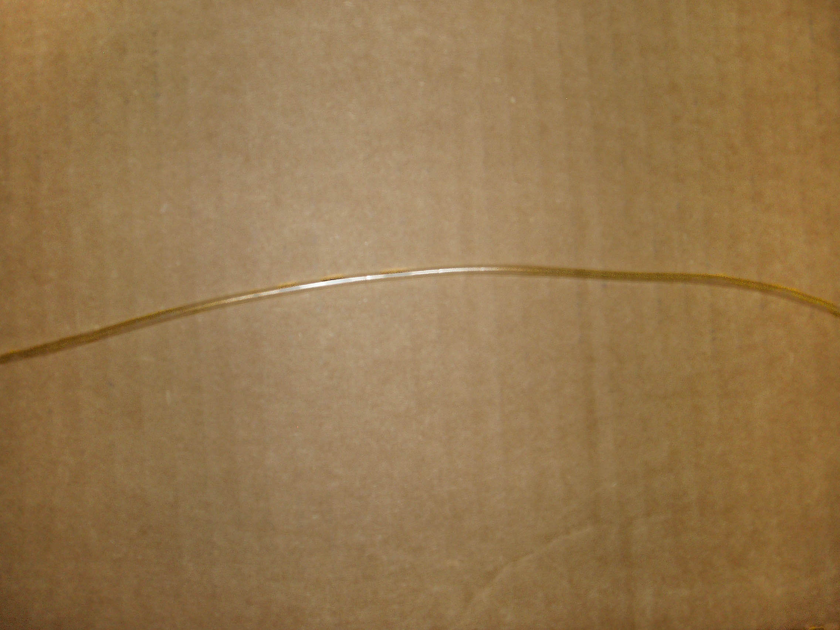

Figure : Typical Healthy Membrane

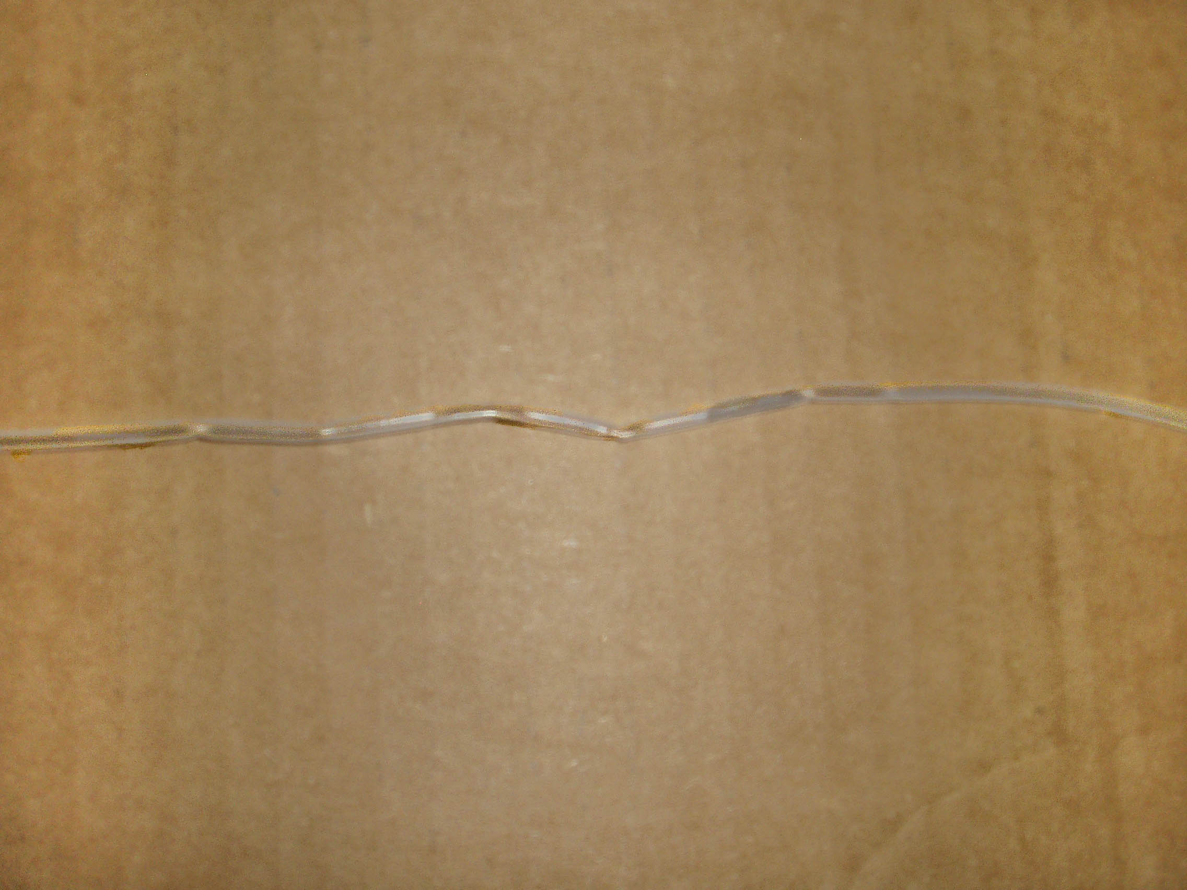

Figure : Typical Bad Membrane. Note the kinks and flat spots.

| ***Problem***  *Pump issues* |  | ***Possible Cause*** |  | ***Solutions*** |
| --- | --- | --- | --- | --- |
| Solenoid pump is “clicking” but has no flow |  | Reeds in the pump have adhered together |  | Ensure power is on and pump is energized. Remove inlet and out fittings from solenoid pump and gently blow some compressed air into the INLET side of the pump to separate reeds. |
| Sample pump turns off briefly and back on  *Counting issues* |  | Temperature of OPC is equal or lower than bottom of column temperature, T3. |  | This is normal operation, as the computer is programmed to shut off the pump if the OPC temperature is less than T3. |
| CCN is overcounting or undercounting particles |  | Sheath filter is failing and passing particles (***Note: this is only a possibility if the CCN is over-counting)*** |  | Replace sheath filter. Refer to Appendix G for more details. |
|  | Flows are incorrect |  | Check Sample and Total Flows. |
|  | Comparison set-up / reference instruments are not balanced or set up properly—for example, there is a problem with the DMA. |  | Verify comparison setup by comparing a known good unit to the suspect CCN. Contact DMT for details. |
|  | OPC isn’t properly calibrated |  | Swap out suspect OPC with a known good OPC. Contact DMT for details. |
|  | CCN unit itself isn’t properly calibrated |  | Return unit for factory calibration. |
| No particle counts appear under conditions where particles would be expected.  *Counting issues* |  | Column is dried out. |  | Check water supply, and check the solenoid pump operation for column water feed. If the column has dried out, it may take several hours to wet the column. |
|  | OPC windows are fogged. |  | There is the potential that the OPC window has fogged due to a system upset. Click on the **OPC** tab, and then look at the values displayed in the **Baseline Mon** and **1st Stage Mon** windows. Standard operating values for these parameters are provided in the setup sheets with the instrument. The **1st Stage Mon** is the best diagnostic if the OPC has fogged. In normal operation, this value will be .2-.3 V. If the OPC has fogged, however, this value will be up to 5 V. If the value drops from 5 V when the OPC heater turns on, the fogging is minor and will clear usually in 30 minutes or less. If the OPC circulation pump is not at high speed, it should be set to high speed (2 seconds) to expedite clearing the OPC. If the OPC does not clear in 12 hours, or you need to clear the OPC more quickly, refer to . Contact DMT for additional instructions. |
| With filter on inlet, unit still counts particles at a rate of more than 3 a minute. |  | A very small amount of ambient air is fed back into the manifold; under normal operating conditions this is unnoticeable. |  | To achieve a zero count of less than 3 per minute, the bottle vents going to the manifold need to be removed and the manifold needs to have plugs (PLUM-0185 provided in start-up kit) installed. |
|  | Possible leak. |  | Leak test unit; see section . |
|  | Possible bad filter |  | Replace filter. |
| Leak is suspected. |  | Leak in unit. |  | Perform the leak test described in section . |

***Warning***

***Do not stress flow sensors by releasing vacuum quickly or damage may occur.***

***Use a valve and open it slowly to get pressure back to ambient.***

***Do not leave unit unattended with plug on inlet and pump on; flooding of unit could occur. Supervise leak test.*** ***If pressure needs to be applied to find leaks, pressurize to no more than 5 PSI.***

PART II: THE CCN SOFTWARE

# Product Description

## Introduction

The computer system for the Cloud Condensation Nuclei Counter (CCN) is a PC-104 stack unit with an Intel Atom N2600 1.6 GHz processor, 2.0 GB of memory, two Diamond Systems MM-16 AT multifunction interface cards. A 128-Gb solid-state hard drive is provided for program and data storage. The operating system is Windows 7 Embedded. Do not install any other programs, as conflicts may occur. Do not set or change time either manually or with a time-sync program while the VI is running, or the program will not operate properly.

*Note: This computer configuration is accurate as of January 2016. Previous units and later units may have different components as parts become obsolete or are upgraded.*

The software for the CCN counter is provided as a LabVIEW executable. The software revision level is shown in the status bar of the CCN counter program. This manual is intended for versions 5.0.0 and above.[3] Help screens are available while running the instrument. They contain the most important information that is included in this manual.

Four programs are provided:

* **Single CCN.exe** operates the CCN unit. This is the main program.
* **CCN SS Settings Config Editor.exe** sets up the supersaturation tables, which are stored in C:\DMT\CCN Support\CCN_SS_Settings.ini.
* **CCN Calibration Editor.exe** sets the instrument-specific coefficients for the flow and pressure calibrations. These are stored in C:\DMT\CCN Support\CCN_Calibration.ini.
* **CCN Playback.exe** displays and replays saved data files.

The following sections discuss the details of each of these programs.

In addition to these standard programs, DMT offers an optional Particle Analysis and Display System (PADS) module for the CCN. This module allows integrated use of the CCN with other DMT instruments.

# SINGLE CCN.exe (Main Program)

The **Single CCN.exe** control program provides a completely automated system for running the CCN instrument under laboratory or flight conditions. The program loads and runs automatically after the operating system boots. The display is organized into a tab structure for control and monitoring of the system, as shown in .

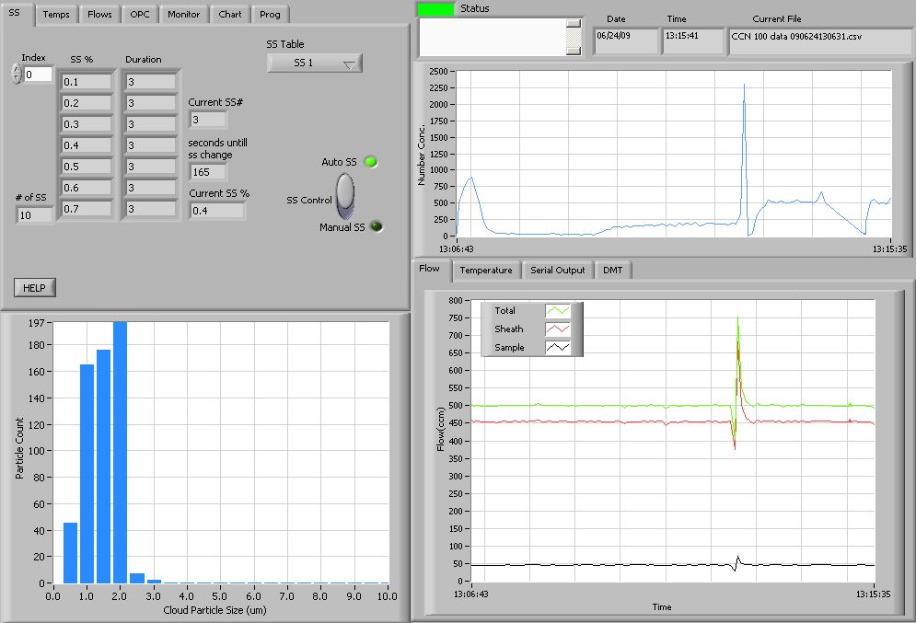

Figure : Main Screen of SINGLE CCN Program

In the upper right of the display are fields showing the date, time, and current data file that the program is writing to. The **Status** button indicates the instrument status (green = normal, yellow = an alert has been generated, red = an alarm has been generated). The **Status window** displays any alarms or alerts concerning the operation of the software or the instrument. During startup, the window shows the time available to select a supersaturation table.

The main screen is divided into four sections. In the upper left are the control tabs. Beneath the control tabs is a histogram display of particle counts by size. The histogram display is for the current moment in time. In the upper right of the screen is a chart of particle number concentration with respect to time. Beneath this chart are additional time-series charts as well as a **Serial Output tab** and **DMT Service tab**, labeled “DMT,” which can be used during troubleshooting. The remainder of this section discusses these various screen components in detail.

## Control Tabs

### SS Tab (Supersaturation Settings)

The control program will start with the supersaturation tab setting active (see ).

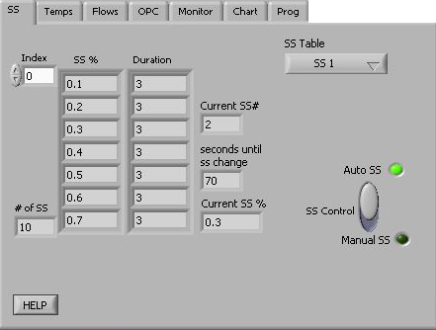

Figure : Supersaturation (SS) Settings Tab Display

#### SS Tab Settings that Must be Configured in First 10 Seconds

After starting the program, the user has 10 seconds to select the desired supersaturation table from the **SS Table** pull-down menu. If no selection is made, the last SS table used is selected by default. After the 10-second timer expires, the supersaturation values, durations, and OPC bin settings are loaded and cannot be altered. Details on setting up the supersaturation tables are given in section .

During the first 10 seconds of program operation, the user can also select **Dry Start Up** or **Dry Shut Down**. This can be done using the radio buttons shown in . (These buttons disappear from the display after the ten-second window has expired, as shown in Figure 27.)

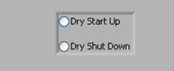

Figure : Dry Start Up and Dry Shut Down Buttons

**Dry Start Up** should only be selected when the unit has been totally dried out, such as after shipping. Selecting **Dry Start Up** will set the liquid supply pump to high and disable the CCN concentration alarm. After 4 – 12 hours, the unit will reset itself to normal mode.

**Dry Shut Down** should only be selected when the unit needs to be totally dried out prior to shipping. Selecting **Dry Shut Down** will prompt the user to shut the sheath flow metering valve and install Drierite on the inlet. The supply pump will be turned off and the drain pumps (i.e., the column and cold trap pumps) will be turned on high. The total flow will be set to 175 Vccm. The CCN concentration status and flow status alarms will be disabled. After 6 hours, the unit will turn off the TEC relay and display a message that the unit is dried out and ready to ship.

#### SS Tab General Settings

**Index** displays the supersaturation level that appears in the top row of the SS%-Duration table. In , for instance, the top row has an index of 0, so this row corresponds to the first entry in the supersaturation table. If you were to change **Index** to 1, the top row would have an **SS%** value of 0.2 and a **Duration** of 3. Note that the top row is not necessarily the CCN’s active supersaturation level—the instrument may have progressed through this supersaturation and currently be operating on another level.

**Current SS%** displays the instrument’s current supersaturation, while **Current SS#** displaysthe current supersaturation level in the SS Table**.** In , the CCN is currently operating on supersaturation level 2, which has a corresponding supersaturation of 0.3%. Note that if the CCN is changing between supersaturations, the actual supersaturation in the column may differ from the value displayed in **Current SS%** (see section ).

**# of SS** displays the number of supersaturation levels in the current SS Table.

**SS Table** displays the currently selected SS Table. During the first 10 seconds of program operation, this button is a control that can be used to select a table; after that, it is an indicator that cannot be changed. Details on setting up the supersaturation tables are given in section .

**Seconds until SS change** counts down the remaining time in seconds for the current supersaturation selection. After the last selection completes, the instrument continues and loops back to the 1st selection.

***Note:*****Current SS#** and **Seconds until SS change** are not visible when **Manual SS** mode is turned on. See .

Figure : Supersaturation (SS) Settings Tab Display in Manual SS Mode

The **SS Control** switch specifies how supersaturations are set. In **Auto SS** mode, the CCN uses the SS Table to determine **Current SS%**. **Delta T(C)** is selected automatically based on this SS% value. In **Manual SS** mode, the user enters either the supersaturation or **Delta T Set (C)**, which in turn determines the supersaturation. In Manual SS mode, the **Manual Input Selection** radio button (, bottom middle) specifies whether the user will enter Delta T Set (C) or enter the supersaturation directly. If the manual input selection is Delta T Set (C), an **SS** indicator will appear above the **Delta T set (C)** control (bottom right), which enables the user to quickly see what SS% the currently selected Delta T Set (C) is equal to. The default value for Delta T Set (C)is the last setting the program was previously running when **Auto SS** modeis switched off. Note that while the SS Table remains visible during **Manual SS** mode, the program is not using it.

### Temps Tab (Temperatures)

The **Temps** tab contains heater and temperature indicators and controls, as shown in . ***Note: To manually set the temperature gradient, Delta T Set (C), use the SS Tab.***

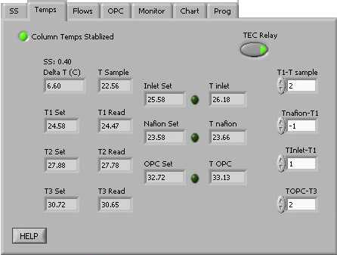

Figure : Temperature Tab Screen Showing Temperature Set Points and Read-Outs the CCN Temperatures

The temperature designations are as follows:

T1 Top of column temperature

T2 Middle of column temperature

T3 Bottom of column temperature

T OPC Optical Particle Counter temperature

T Inlet Temperature of the particle inlet at the head of the column

T Nafion Nafion humidifier temperature

T Sample Air sample temperature at the CCN manifold. (*Note: Regardless of the actual air temperature, T Sample will be close to ambient temperature, as the air warms to ambient by the time it reaches the manifold.*)

“Set” refers to a given temperature’s set point, while “Read” refers to the observed value. (The **T inlet**, **T nafion** and **T OPC** fields display observed values.)

The three indicator lights to the right of the Inlet Set, Nafion Set, and OPC Set fields are for the Inlet heater, Nafion heater, and OPC heater, respectively. These lights are illuminated when the respective heater is ON.

The four temperature differentials are read from the C:\CCN_SS_Settings.ini file at startup and can be changed when the CCN is in **Manual SS** mode. Changes apply to the current session only. To change the permanent default values for these differentials, do so from the **CNN Calibration Editor.exe** program; see section .

**T1 – Tsample** is a temperature differential that determines thetemperature of the top of the column relative to the sample air temperature. **TNafion – T1, Tinlet – T1,** and **TOPC – T3** determine the temperature of the Nafion humidifier, the inlet manifold, and the OPC relative to temperatures at points on the column. Recommended values for these temperature differentials are given below.

***Recommended Value*** ***Range***

(**T1 – T Sample)** 2.0° C 0 °C to 10 °C

(**T Nafion – T1)** -1.0° C -5 °C to 5°C

(**T Inlet – T1)** 1.0° C 0 °C to 5 °C

(**T OPC – T3)** 2.0° C 1 °C to 10 °C

The **Column Temps Stabilized** light indicates if T1, T2, and T3 are less than 0.4° from their set values. Even when the light is on, additional time may be needed before the entire unit is stabilized and data are consistent.

The light will turn off during SS% changes. For small SS% changes, the light will typically be off for less than one minute. If the **Column Temps Stabilized** light never comes on, refer to the Troubleshooting section.

**TEC Relay** switches the instrument’s 28 VDC power buss on and off. This supplies power to the heaters, the TEC units, and the sample pump. The default value is on, but it can be useful to turn off **TEC Relay** during troubleshooting.

**Delta T(C)** is the temperature gradient used to calculate values for T1 Set, T2 Set, T3 Set, Inlet Set, Nafion Set, and OPC Set.

* In **Auto SS** mode, **Delta T(C)** is an indicator only, where **Delta T(C)** is determined by the **Current SS%** and the temperature gradient slope and intercept coefficients. (See sections and .)
* In **Manual SS** mode, **Delta T(C)** becomes a control and can be set through the **Temps** tab or through the serial port; see section .

#### CCN Temperature Adjustment

The program will readjust the temperature set values if any of these four following conditions are met:

1. Delta T(C) changes
2. T Sample +2*(T1 - TSample) < T1 Set
3. T Sample > T1 Set
4. The unit has looped back to SS #1

Conditions 2 and 3 ensure that the temperature at the top of the column stays slightly above the temperature of the sample. If the top of the column temperature is not above the sample temperature, the air comes into the top of the column from the Nafion humidifier, which is at 100% RH, can condense and cause fog to form at the top of the column. Thus, if the sample temperature rises by more than the (**T1 Set – TSample**) value, the system will reset all of the temperatures up to maintain this temperature difference. If the sample temperature drops by twice the difference of the (**T1 – TSample**) value, the T1 value will be reset lower.

It is also important that the operating temperature of the CCN be higher than the dew point of the air being sampled. If the CCN is operated in a room with substantial air conditioning, and the temperature of the air in the room is less than the dew point of the sampled air, aerosol changes can occur.

When the CCN adjusts set temperatures, the new values are calculated using the equations below.

* + **T1 Set** new = **Sample Temp Setpoint[4]** + (**T1 – TSample**)
  + **T2 Set** new = **T1 Set** new + ½ **Delta T(C)**
  + **T3 Set** new = **T1 Set** new + **Delta T(C)** * (1 – (**%TG**[5])/100)
  + **Nafion Set** new **= T1 Set** new + (**T Nafion – T1**)
  + **Inlet Set** new **= T1 Set** new + (**T Inlet – T1**)
  + **OPC Set** new **= T3 Set** new + (**T OPC – T3**)

In order to protect the laser diode in the OPC, if **OPC Set** new > 55 °C, then **Delta T(C)** is reduced using the following algorithm:

* + - * 1. **Delta T(C)** new **=** 50 + **Delta T(C)** - **OPC Set** new
        2. All temperatures are readjusted using **Delta T(C)** new
        3. Steps 1 and 2 are repeated until **OPC Set** < 55°

It is important that the OPC operate at a higher temperature than the bottom of the column, T3. This temperature differential ensures that the OPC optics will not fog. Studies at DMT have shown that the OPC temperature can be as high as 5 °C above T3 with no loss of concentration. At an OPC temperature of 7 °C above T3, there is a 20% loss of droplets.

***If the supersaturation scans involve changing from a high supersaturation where the OPC temperature is high to a low supersaturation and low OPC temperature, adequate time must be allowed for the OPC to cool to 2°C above T3 before taking data. Otherwise there will be undercounting of the activated particles.***

### Flows Tab

The **Flows** tab contains indicators and controls associated with the system flows, as shown in .

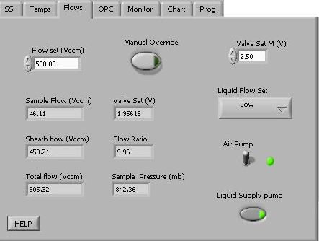

Figure : Flows Control Tab

**Flow Set (Vccm)** displays the set value for the current total flow. This value is read from the **SS_Settings.ini** filewhen the **SS Table** is selected, but can be changed at any time. The recommended flow range is near 500 volume CC/min (Vccm), although the instrument can process flows from 200-1000 Vccm.

***Note:***

***Flow affects unit SS%. The CCN unit was DMT factory calibrated with a Total Flow set to 500 Vccm, so Total Flow should be approximately this amount.***

**Valve Set (V)** displays the voltage sent to the proportional valve that regulates the total airflow through the CCN. Every proportional valve will use a different **Valve Set (V)** to maintain a given flow. **Valve Set (V)** is an indicator that cannot be changed.

**Manual Override** switches the manual valve set mode ON/OFF. In manual override mode, the **Valve Set (V)** will be ignored and a constant voltage, **Valve Set M (V),** will be used in its place.

**Valve Set M (V)** controls the voltage supplied to the proportional control valve. This parameter is only used when the instrument is in manual override mode.

**Sample Flow (Vccm)** displays the measured sample flow.

**Sheath Flow (Vccm)** displays the measured sheath flow.

**Total Flow (Vccm)** displays **Sheath Flow (Vccm)** + **Sample Flow (Vccm).** While the Total Flow ranges from 200-1000 volume cc/min (Vccm), the instrument has been calibrated at 500 Vccm, and actual flow should be close to this amount to ensure data accuracy.

**Flow Ratio** displays **Sheath Flow (Vccm) / Sample Flow (Vccm).** A manually controlled valve inside the instrument controls the split between the sample and sheath flows. The recommended flow ratio is 10:1.

**Liquid Supply Pump** switches the supply pump ON/OFF. The two drain pumps run continuously.

**Sample Press** **(mb)** displays sample pressure.

**Air Pump** switches the air pump ON/OFF. The default is ON. To prevent fogging of the OPC, if **T** **OPC** < **T3 Read** the air pump switch will be overridden and the air pump will be turned off. The user may also want to switch off the air pump during a leak test or when drying the OPC with canned air.

**Liquid Flow Set** controls the frequency of the solenoid pumps used in the water supply and drains. The pump frequency can be set to **Low, Medium,** or **High.**

* **Low** is good for normal operation. This supplies sufficient water to the column for ambient CCN measurement when the sample temperatures are below 33 °C.
* **Medium** is required for environments where the temperature is above 33 °C, or the sample air to the CCN is dried with a diffusion drier. This supplies the extra water used by the Nafion humidifier and the column at higher temperatures.
* **High** is useful if water supply has run dry or if it is necessary to wet the column quickly.

**Liquid Supply Pump** switches the supply pump ON/OFF. The two drain pumps—i.e., the column and cold trap pumps—run continuously.

### OPC Tab (Optical Particle Counter)

The **OPC** tab contains controls and indicators for the operation of the OPC. shows this tab.

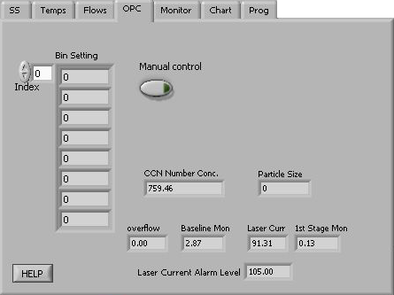

Figure : Optical Particle Counter Tab

The OPC measures the sizes of particles at the exit of the column. The particles are sized into 20 bins, with the bins’ upper boundaries at 0.75 µm, 1.0 µm, 1.5 µm, 2.0 µm, and continuing in .5 µm increments until the last bin’s upper boundary of 10 µm.

The **Bin Settings table** displaysthe bin settings for each supersaturation setting.The bin setting can be used to limit the **Number Conc.** calculation to reflect larger particles only. Bins lower than the **Bin Setting** do not have their particles included in the concentration calculation. If all particles are to be included, **Bin Setting** should be 0, which is the default value. Bin settings are loaded when the **SS Table** is selected and cannot be changed. The program **CCN SS Settings Config Editor.exe** allows users to configure bin settings for different supersaturation settings.

**Index** displays the number of the first bin setting displayed in the array. In , for instance, the first bin setting displayed corresponds to the first row (index 0) in the SS Table.

**Particle Size** displays the particle size that corresponds to the top value listed in the Bin Setting array.

**Manual Control** activates the slider bar that allows setting a manual **Bin #.**

**CCN Number Conc.** displays the number concentration using the counts from particle bins above the **Particle Size** and any **overflow** counts.

**Overflow** displays the number of particles counted that are larger than 10 µm.

**Baseline Mon** displays a voltage used by DMT for OPC diagnostic purposes.

**Laser Curr** displaysthe laser current (mA) used in the OPC. A sudden change in current could reflect a problem with the instrument. A reading of 60 – 120 mA indicates the instrument is functioning properly. See Appendix A for more details.

**1st Stage Mon** indicates whether the OPC is fogged. The normal operating range for this voltage is 0.1 - 0.75 volts. If the OPC is fogged, this voltage may be as high as 5 volts. If this happens, turn up the temperature on the OPC to 5° above T3. This can be done by clicking on the **Temps** tab, switching to **Manual SS** mode, and changing the **TOPC – T3** temperature differential. Next, watch for a drop in the **1st Stage Mon** level. If the value drops as the OPC heater cycles on, it is an indication that the OPC is not heavily fogged and it usually will recover in an hour or two. To speed the drying of the OPC, turn the cycling of the OPC drying pump to the 2-second setting. This switch is labeled SW1 and is located in the middle of the Controller Printed Circuit Board; see . After the OPC is dry, the switch should be reset in the 16-second position.

**Laser current alarm level** displays the level at which an alert will be given when the laser draws this amount or more of current. Such an alert indicates the laser is nearing the end of its life.

### Monitor Tab (Alarm Monitoring)

The **Monitor** tab has indicatorsfor monitoring and logging the status of systems. shows this tab. When buttons are lit, as in , the instrument is functioning properly.

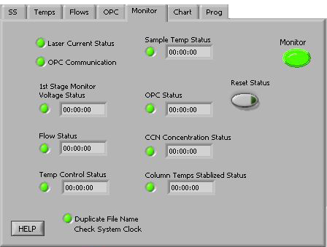

Figure : Monitor Tab

The status of the instrument is categorized as **Normal**, **Alert**, or **Alarm**. **Normal** indicates no alerts or alarms are present. **Alert** is triggered by a possible problem and takes no actions in the instrument. An alert is indicated by a yellow monitor button. **Alarm** is triggered by a probable problem and will put the CCN in safe mode. Safe mode shuts off the **TEC relay** and **Liquid Supply Pump**. The relevant monitor button will turn red.

The timers in the status fields count how long the specified alert/alarm conditions have been met. They are reset to 00:00 if the conditions are not met, i.e. if no problem has been detected. If any timer exceeds its set threshold, an alert/alarm is triggered and the indicator light turns yellow for an alert and red for an alarm. Each alert is associated with a unique alert code. Alert codes are integers in the form of 2n, where n = 0, 1, 2 … 14. The sum of all triggered alerts is saved in the last column of the data file. This sum is then made negative if any alarms have been triggered.

More information is given below about specific status fields, their corresponding alert codes, and whether the system ultimately generates an alarm for this problem.

#### CCN Alerts and Alarms

**Laser Current Status** alerts if the laser draws too much current, indicating the laser diode is nearing the end of its useful life. Contact DMT. No alarm. Alert Code = 1.

**OPC Communication** alerts if the OPC is not communicating with the computer. No alarm. Alert Code = 256.

**1st Stage Monitor Voltage Status** counts when the 1st Stage monitor is > 4.7 V. Alerts after 5 minutes. No alarm. Alert Code = 2.

**Flow Status** counts when total flow deviates >20% from the set flow or when the flow ratio is not within 5-15. Alerts after 30 minutes. No alarm. Alert Code = 4.

**Temp Control Status** counts when at least one of T1, T2, T3, T Inlet, T Nafion, and T OPC is more than 10 degrees from its set point. Alerts after 10 minutes. Alarms after 20 minutes. Alert Code = 8.

**Sample Temp Status** counts when the sample temperature exceeds the 0-50 °C range. Alerts after 1 minute. Alarms after 5 minutes. Alert Code = 16.

**OPC Status** counts when the 1st Stage Monitor > 4.7 V and CCN counts are less than the configured threshold. DMT sets this threshold to the factory default of 10 counts/sec, but it can be changed by the user using the **CCN Calibration Editor.exe** program. No Alert. Alarms after 60 minutes. Alert Code = 32.

**CCN Concentration Status** counts when CCN counts are less than the configured threshold (factory default 10 counts/sec). Alerts after 20 minutes. Alarms after 120 minutes. Alert Code = 64.

**Column Temps Stabilized Status** counts when T1, T2, or T3 is >0.4 degrees from its set point. Alerts after 20 minutes. No alarm. Alert Code = 128.

**Duplicate File Name Status** alerts when a file already exists with the same name as the file that the CCN program wants to create. A new file will be created, which will have the same name as the original file but have “duplicate.xxx” appended to it. Check and fix, if necessary, the system clock. No alarm. Alert Code = 512.

**Safe Mode** flasheswhen an alarm has been triggered and the unit is in safe mode.

**Reset Status** clears all alerts/alarms and resets their timers to zero. This button will not turn the TEC relays back on. It does turn the liquid supply pump back on.

#### How to Interpret CCN Alarm Codes in Output Files

When the CCN is running, any alerts and alarms will be displayed individually in the **Status** window at the top of the main program screen. In the .csv and serial stream output, however, alerts and alarms are stored as a sum of all the alarm codes generated. For instance, say the CCN is generating an alarm code of 183. 183 = 128 + 64 + 1, which means that alerts have been generated for **Column Temp Stabilized**, **CCN Concentration** and **Laser Current Status.** (Because the alarm code for each individual problem is a unique 2n number, the sum of alarm codes will always indicate a unique set of issues.) A negative alarm code indicates problems severe enough that the instrument has gone into safe mode.

### Chart Tab

The **Chart** tab, shown in , contains controls for configuring the **Flows, Temperature,** and **CCN** charts**.**

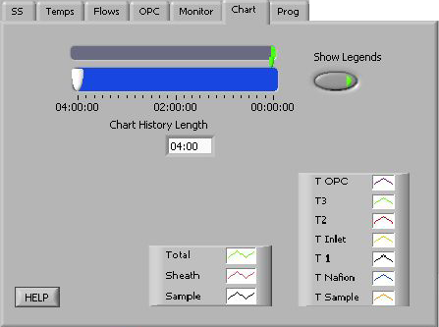

Figure : Chart Tab

**Chart History Length** controls the how far back the charts extend. The white slider on the blue background selects the history length, which has a default value of four hours. The green indicator shows the length of data available. shows the **Chart** tab before a session has started. No data is available yet, but the chart display is set to show up to four hours of data once it becomes available.

**Show Legends** controls the display of chart legends on top of the chart. If **Show Legends** is enabled, charts will show legend boxes such as those depicted in .

### Prog Tab (Program Control)

The **Program Control** tab contains controls for file saving and data streaming, as shown in .

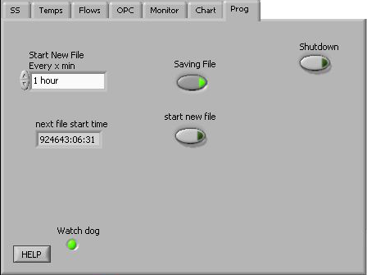

Figure : Program Control Tab

**Saving File** controls whether the data is saved or discarded. This button is on by default. (See section for information on file names and content.)

**Start New File** forces a new file to be started.

**Start New File Every x min** controls the length of data files. The default value is 60 minutes, and the allowed range is 1-180 minutes. The setting options work as follows. **1 hour, 2 hours,** and **3 hours** start the first file at when data recording begins and the remaining files on the hour. For instance, if you set **Start New File Every x min** to **2 hours** and start sampling at 7:56 a.m., the first file will begin at 7:56, the next at 9:00, and the next at 11:00. If you select **User Defined** and specify the number of minutes in the minutes pop-up field, however, files will not start on the hour. So, if you set **Start New File Every x min** to **User Defined** and set **minutes** to 120, files will begin at 7:56, 9:56, 11:56 and so on.

**Shutdown** stops the execution of the program and closes the files properly. This button should be used whenever exiting the program.

**WARNING:**

It is important to use the **Shutdown** button when shutting down the instrument; this will ensure that the pumps are shut off in order and the files are saved properly.

**Watch dog** alternates ON and OFF every second when the computer is cycling properly. The watch dog light on the instrument should blink at the same time as the indicator on the computer screen. (The watch dog light is located on the side of the CCN; see .) If the indicator light is steady **OFF** or **ON**, reboot the computer.

## Histogram

Beneath the Control Tabs is the histogram of raw particle counts by size, as shown in .

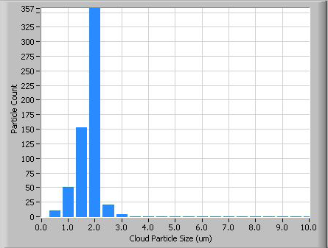

Figure : Histogram

For information on configuring the histogram display, see section .

## Particle Concentration Time-Series Chart

In the upper right of the main CCN screen is the particle concentration chart, as shown in .

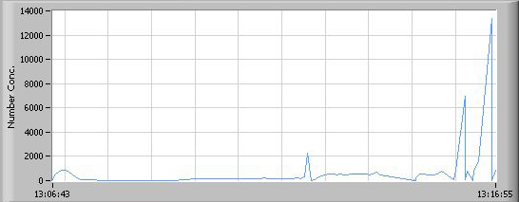

Figure : Time-Series Concentration Chart

For information on configuring the chart display, see section .

## Other Time-Series Charts and DMT Service Tab

In the bottom right of the main Single CCN screen are the flow time-series chart, the temperature time-series chart, and the DMT Service Tab.

* The **Flow Chart** plots Sample Flow, Sheath, Flow and Total Flow with respect to time.
* The **Temperature Chart** plots the temperatures of various CCN components over time. See section for details and the normal range for these temperatures. The Temperature Chart also indicates the temperature of the sample air.
* The **Serial Output Tab** is described below.
* The **DMT Service Tab** is described below.

### Serial Output Tab

Users have three options for how the CCN handles serial output:

* The instrument generates no serial output.
* The instrument generates a standard stream of serial output. *Note: This option must be used to interface with PADS.*
* The instrument generates a user-configured stream of serial output.

These options are described in more detail below. The radio buttons in the upper left of the **Serial Output** tab () allow users to select the option they prefer.

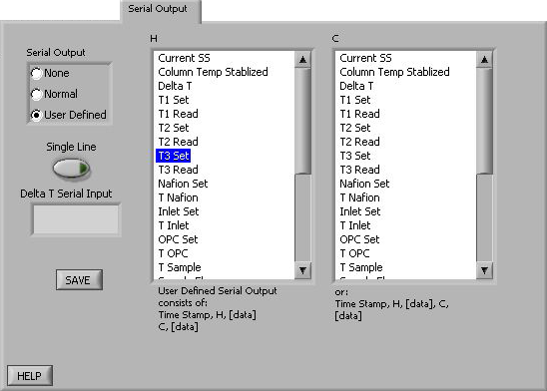

Figure : Serial Output Tab

If serial output is set to **None**, the white columns above will disappear from the **Serial Output** tab.

If serial output is set to **Normal**, the CCN will output two lines (Line H and Line C) of serial stream data. In this case, the columns displayed in the **Serial Output** tab are for informational purposes only; users cannot manipulate the display to configure the serial stream. The first serial stream will always start with a time stamp, followed by an “H,” followed by the output channels displayed in the left column of . (For a list of these channels, see section .) A carriage return separates the first set of data from the second, which starts with a “C” and continues with the output channels specified in the column on the right in .

If serial output is set to **User Defined**, users can select the desired output channels from a list of all available channels. To include channels in the serial stream, select the channels by clicking on them. Holding down the <Shift> and <Control> keys allows you to select multiple channels at once. Note that the order of channels must follow that in the list of all available channels.

### DMT Service Tab

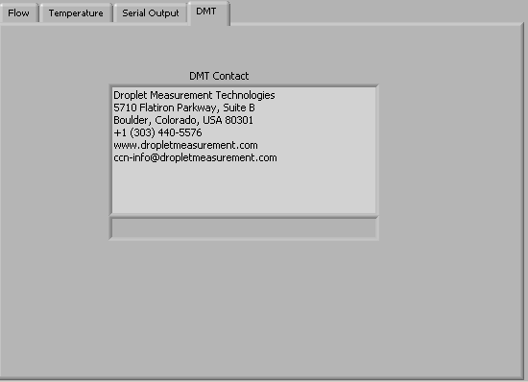

Figure : DMT Service Tab

The DMT tab is used to access the CCN service tabs. These tabs are hidden and locked during normal operation. They can be accessed by clicking the text window in the middle of the screen and typing the password *Service*. When the password is entered correctly, tabs for **PID**, **Gains**, **Flow** and **Error/Exit** will appear (). These tabs can be used to update the calibration parameters in real time, without having to restart the program. (In contrast, changes made to these same parameters using the **CCN Calibration Editor.exe** program require restarting **Single CCN.exe** before the updates will take effect.) The new values can be saved as defaults by pressing the **Save** button. If the **Save** button is not pressed, any values entered will only apply to the current session.

#### DMT Service Tab: PID Section

The PID screen, pictured in , allows users to modify the CCN’s proportional valve flow control loop. Specifically, the parameters on this tab determine how the CCN’s proportional valve voltage will shift from its current state to a higher or lower one.[6] During any such transition, the optimal change is one that is 1.) quick, 2.) smooth, and 3.) does not overshoot its target—i.e., does not raise or lower the voltage too far. The challenge, however, is that these three factors cannot be simultaneously optimized, as a very quick transition typically overshoots its target.

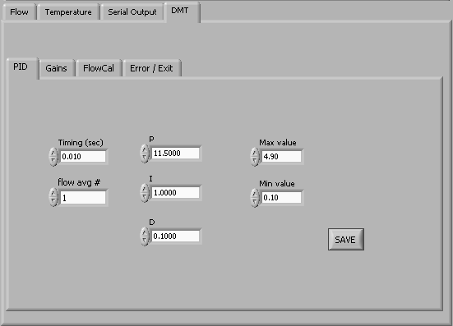

Figure : DMT Service Tab – PID Section

The proportional valve is controlled by a PID loop. **P** *(Proportional)*, **I** *(Integral)*, and **D** *(Derivative)* are variables used to control the valve’s voltage transition. **P** determines the scale of the transition, and is akin to the multiplier that is used to get from the old voltage to the new voltage. **I**the speed of the response time, with a higher **I** yielding a faster transition. **D**determines how smooth the transition curve will be.

The default values that appear in the P, I, and D fields on the PID tab are adequate for stable flow control in most cases. However, under certain circumstances, it may be necessary to tune the PID loop for better control.

**Max** and **Min value** refer to the proportional valve voltage window the PID loop can control. Each proportional valve has an operating range of about 1 V, but turn-on voltages between valves can vary from 1.25 - 3.5 V. Thus one proportional valve may operate at 1.25 – 2.25 V, while another operates at 2.5 – 3.5 V. Setting **Min** and **Max** values so they create a wide window (0.1 – 4.9 V) accommodates all proportional valves. Narrowing this window does not typically improve flow performance.

#### DMT Service Tab: Gains Section

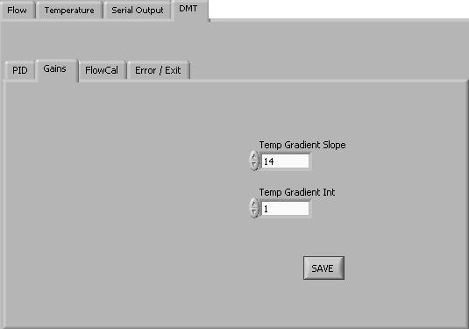

Figure : DMT Service Tab – Gains Section

This tab allows users to enter the slope and intercept of the equation to convert SS% to Temperature Gradient. Refer to section for the complete SS% calibration procedure.

#### DMT Service Tab: FlowCal Section

The **FlowCal** tab is shown in .

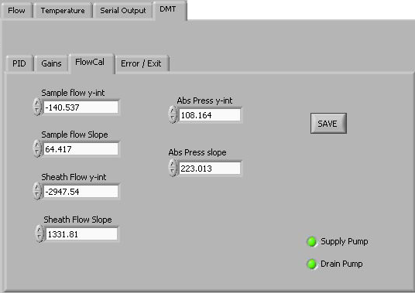

Figure : DMT Service Tab – FlowCal Section

This tab allows users to enter the slopes and intercepts of the equations to convert voltage to flow. To have the voltage of the transducer displayed in the CCN **Flows** tab, enter a slope of 1 and an intercept of 0. Refer to section for the complete flow calibration procedure.

The **Supply Pump** and **Drain Pump** indicators blink during normal operation when the pumps are on.

#### DMT Service Tab Error / Exit

The **Error/Exit** tab is shown in . Its windows and information can be helpful when troubleshooting with DMT’s help, but they should not be modified without assistance.

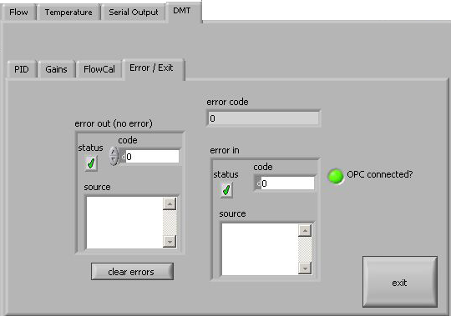

Figure : DMT Service Tab – Error/Exit Section

Press exit on this tab to exit the **DMT Service** tab and end service mode. Although the unit will function normally when in the service mode, it is recommended that users exit once service is completed to avoid accidental input. The service mode is also exited upon closing of the VI or rebooting the computer.

## Program Input Files

The **Single CCN.exe** program requires two input files: CCN_SS_Settings.ini and CCN_Calibration.ini. The former stores the supersaturation settings for the instrument, while the latter stores instrument calibration and configuration information.

Both of these files are in the C:\ directory, but they should not be modified directly. Instead, use the program **CCN SS Settings Config Editor.exe** to modify CCN_SS_Settings.ini and **CCN Calibration Editor.exe** to modify CCN_Calibration.ini.

## Program Output Data

### Serial Stream

A serial output stream of data is available for sending to a host computer or other device. A serial null modem cable must be used and is provided with the startup kit. The control for this is the **Serial Output** button found on the **Program Control** tab (section ). The data appears on the DB-9 connector labeled “Data Out” and uses a RS-232 configuration with 9600 baud transmission and 8-N-1 data protocol. Connecting this port to another computer requires the use of a null modem between the computers so that pins 2 and 3 are swapped.

Users can select three options for serial stream output: no output, normal output, or user-defined output. See section for details. The list of available serial stream output channels appears below. The two lines of data are separated by a carriage return. The “H” and “C” that begin the columns are simply the characters H and C (i.e., these are not the names of data channels).

|  |  |
| --- | --- |
| **First Data Line** | **Second Data Line** |
| H  Time  SS setting  Temp Stable ?  T1 read  T2 read  T3 read  Sample Temp  T inlet  T OPC  T Nafion  Sample flow  Sheath flow  Abs Press  Laser current  1ST Stage Monitor voltage  Temperature Gradient  Proportional Valve Voltage  Alarm Code | C  Bin setting  CCN Number Conc.  ADC overflow  Bin 1[7]  Bin 2  Bin 3  Bin 4  Bin 5  Bin 6  Bin 7  Bin 8  Bin 9  Bin 10  Bin 11  Bin 12  Bin 13  Bin 14  Bin 15  Bin 16  Bin 17  Bin 18  Bin 19  Bin 20 |

For definitions of these channels, see the Glossary in Appendix A.

***Note:***The user can also change the temperature gradient via the serial port (labeled **DATA OUT**) when the **AUTO SS** button is off. To change the value, five characters must be entered (example: 10.00, or 10.0 and a carriage return). To see what SS the temperature gradient equals, press the **SS** tab and look in the lower right-hand corner for the display labeled SS.

### Output Files

The CCN instrument provides on-board file storage that can be retrieved by Remote Desktop or over an Internet connection.

The frequency at which the program starts a new file can be set on the **Program** tab. Use the **New File Every (min)** control depicted in . If the setting for this parameter is 20, the program will save a new file every 20 minutes using the file convention described below.

The files are named “CCN data yyMMddhhmmss.csv” and are created in the C:\CCN data directory. Note that the CCN data directory is not automatically created by the software and must be created to store the data. The format of yyMMddhhmmss is as follows:

* yy = the two digits for year
* MM = the two digits for month
* dd = the two digits for day
* hh = the two digits for hours
* mm = the two digits for minutes
* ss = the two digits for seconds

*Example*: May 6, 2004 at 4:18:27 would be 040506041827. This convention lists files created sequentially from start time, which provides an easy way to locate specific files.

Output files contain the following data channels:

|  |  |  |
| --- | --- | --- |
| Time  SS Setting  TempStab?  Delta T Set  T1 Set  T1 Read  T2 Set  T2 Read  T3 Set  T3 Read  Nafion Set  T Nafion  Inlet Set  T Inlet  OPC set  T OPC | Sample Temp  Sample flow  Sheath flow  Abs. Press  Laser Current (mA)  ADC overflow  Baseline Monitor  1st Stage Monitor  Bin Setting  Bin 1  Bin 2  Bin 3  Bin 4  Bin 5  Bin 6  Bin 7 | Bin 8  Bin 9  Bin 10  Bin 11  Bin 12  Bin 13  Bin 14  Bin 15  Bin 16  Bin 17  Bin 18  Bin 19  Bin 20  Number Conc.  Alarm Code |

As with serial-stream data, all Bin channels store raw particle counts rather than concentration. For definitions of these channels, see the Glossary in Appendix A.

# CCN SS Settings Config Editor.exe

The program **CCN** **SS Settings Config Editor.exe** allows the user to create up to four predefined tables for operating the CCN in a scanning mode with variable supersaturation and time periods. (Users can also enter manual values for SS% and Delta T Set (C); see section ). shows the configuration editor program.

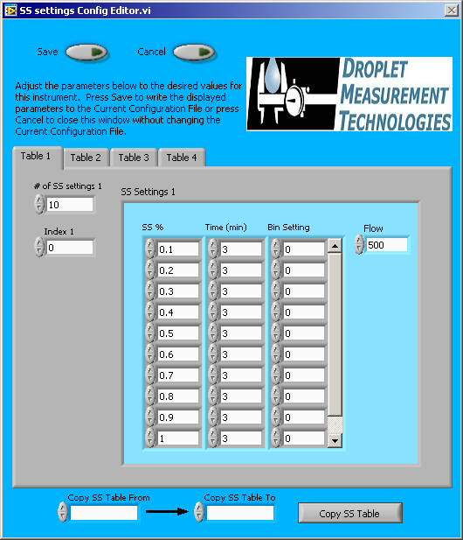

Figure : Program for Setting the Supersaturation Tables

When configuring supersaturation tables, it is recommended that the states progress from lower supersaturations to higher ones. The CCN instrument performs best with gradual increases in column temperature followed by a major cooling back to a low supersaturation.

Tables 1 through 4 allow preconfigured settings to be loaded into the operating program. These settings include the supersaturation rate, duration for the supersaturation setting, the bin settings to be used in the CCN concentration calculations, and the set total flow.

Once the table has been configured, click on **Save** to save this table, and move on to the next desired configuration. The tab provides the option of four different supersaturation tables. The fields at the bottom of the screen can be used to copy values from one table to another in the event that two tables share a portion of data. Following the configuration of all the desired tables, exit the **CCN SS Settings Config Editor** program.

# CCN Calibration Editor.exe

The **CCN Calibration Editor.exe** program allows users to set calibration coefficients that determine equations for flows, temperature gradient, proportional valve settings and so on. The calibration coefficients for each of these measurements are stored in a table that is accessed by the program. These systems are calibrated before the unit leaves DMT, but it will be necessary to recalibrate them periodically. The USB memory stick that accompanied the CCN upon delivery contains spreadsheets that are useful during calibration.

Note that many of the calibration coefficients displayed in **CCN Calibration Editor.exe** can also be modified by using the **DMT Service** tab on the control program, **Single CCN.exe.** The control program only saves these changes if the **Save** button is pressed. In contrast, the calibration editor program always saves changes and the new values will be used upon startup of the control program.

## Standard Screen

Opening **CCN Calibration Editor.exe** brings up the screen shown in .

The left-hand column contains several controls for altering pressure coefficients. The flow measurements on the CCN for the sample and sheaths flows use a differential pressure transducer for each flow. In addition, an absolute pressure transducer is used for the sample pressure measurement. To calibrate the transducers, set the slope value to 1 for each of these parameters and the intercept to 0. In this way the values on the **Flows** tab will read out in volts. A new set of calibration coefficients can then be derived and entered into the program.

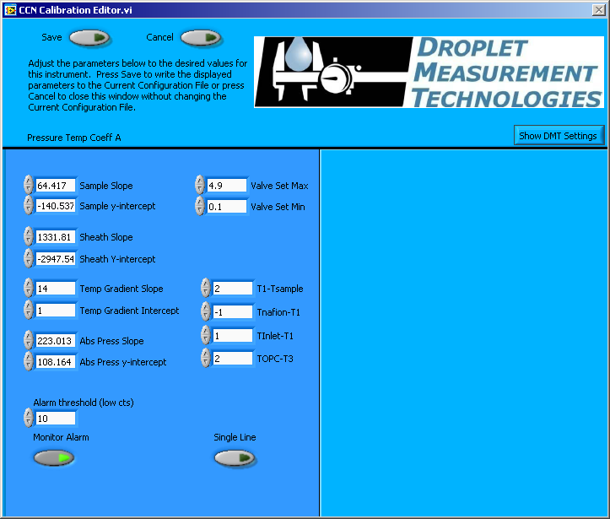

Figure : CCN Calibration Editor.exe

**Temp Gradient Slope** and **Intercept** calibrate the proper temperature gradient to achieve the desired supersaturation. Users who want to calibrate the CCN unit must contact DMT prior to making any adjustment.

**Valve Set Min** sets the lower limit of Proportional Valve Control Voltage. By default, this value is set to 0.1. It can be changed here or in the PID tab; see section .

**Valve Set Max** sets the upper limit of Proportional Valve Control Voltage. By default, this value is set to 4.9. It can be changed here or in the PID tab; see section .

**T1 – Tsample**  is a temperature differential that determines thetemperature of the top of the column relative to the sample air temperature. **TNafion – T1, Tinlet – T1,** and **TOPC – T3** determine the temperature of the Nafion humidifier, the inlet manifold, and the OPC relative to temperatures at points on the column. These differentials are in degrees Celsius. Under normal operations these differentials should not be changed, but increasing **TOPC – T3** can prevent fogging of the OPC.

**Alarm Threshold (low cts)** sets the threshold value for CCN Number Conc. Alert (see section ). DMT sets this value to 10 counts per second, which is the factory default.

**Monitor Alarm** turns themonitoring feature on/off. Turning off monitoring disables the alarms and the **Monitor** tab. **Monitor Alarm** should always be ON.

**Single Line** allows users to specify whether serial stream data should be in a single line (no carriage return between data) or in a double line (a carriage return separating lines). See section for details.

## Screen with DMT Settings

Additional parameters can be viewed by clicking on the **Show DMT Settings** button, which is visible in the upper left of the screen. Pressing this button brings up the window shown on the right-hand side of .

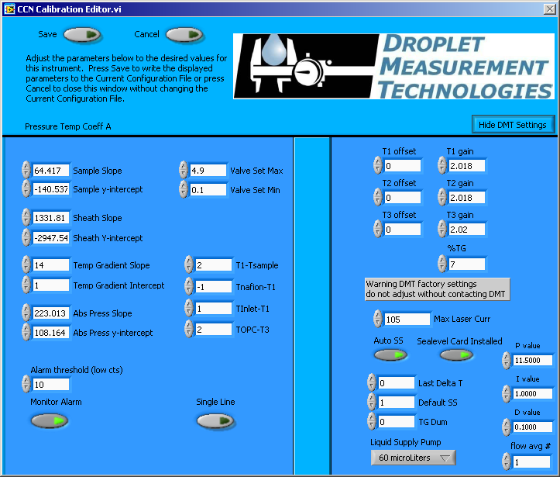

Figure : CCN Calibration Editor.exe with DMT Tabs

As noted on the screen itself, these settings should not be altered without contacting DMT first.

**T1, T2,** and **T3 Offsets** and **T1, T2,** and **T3 Gains** adjust the read points of T1, T2, and T3. These should never be adjusted by the user.

**%TG** enhances the response time between SS% changes. It causes the bottom temperature zone of the column to run a certain percentage lower temperature than a linear gradient. For example, if this percentage is set to 5% and there is a 10° temperature gradient, the bottom temperature zone of the column will be set at 9.5° (not 10°) hotter than the top temperature zone.

***NOTE: the desired temperature gradient will still be displayed in the delta T box. But the actual set point of T3 will be offset lower by the %TG temperature gradient percentage. The %TG parameter should never be adjusted by the user***.

**Max Laser Curr** indicates the alarm threshold for the laser current. If the actual current exceeds the value entered in this field, the CCN will generate an alarm.

**Auto SS, Last Delta T, Delta SS,** and **TG Dum** are parameters accessed by the CCN software. They should never be changed.

The **Sealevel Card Installed** indicator is illuminated whenever the Sealevel card is present. This indicator should be ON if your computer has this card. (Some older computers have four COM ports on board, and so this additional COM port is not needed.) If the **Sealevel Card Installed** indicator does not match the actual instrument configuration, the serial stream may have an incorrect baud rate.

**Liquid Supply Pump** indicates whether the CCN’s supply pump has a 20 or 60 µl displacement capacity per cycle. It is set to match the specifications of the pump, and should not be changed unless a new pump is installed.

**P, I, D**, and **Flow Avg #** are used in the PID control loop. **Flow Avg #** is used in smoothing the PID function. For information on P, I, and D, see section .

# CCN Playback.exe

The CCN Playback.exe program allows you to play back data files that the CCN created during an earlier session. The program display () is similar to that when the Single CCN program is running. The display includes the following:

* Tabular data on temperatures, flows, the OPC counter, and alarms
* A histogram displaying particle counts by particle size
* Time-series charts for particle concentration and flows, with particle concentration on top[8]

There are also several differences between the displays in **Single CCN.exe** and **CCN Playback.exe**. The latter does not feature **Serial Output** or **DMT Service** tabs. It does include a **Selectable Chart** tab behind the histogram, which is described in section .

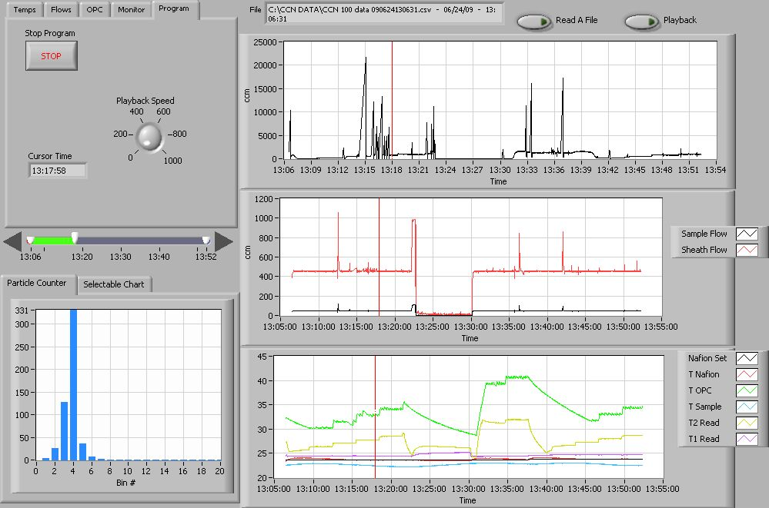

Figure : CCN Data Playback

The **Read a File** button in the top right opens a file explorer for selecting the data file to be read. The program then displays this file path in a window at the top of a screen. The currently displayed time is displayed on the **Program Tab**, and is indicated by a red cursor in time-series charts.

## Changing the Current Time

Once a file is loaded, there are two options for displaying data. To move forward in time automatically, press the **Playback** button in the upper right of the window. The current time will advance forward automatically, and updated data will populate the display. The speed can be changed using the **Playback Speed** dial on the **Program** **tab**, visible in above.

Users can also change the current time manually using the timing controls on the left side of the screen. shows these controls in more detail.

Figure : Playback Timing Controls

The arrow buttons can be used to advance or go back in time. The white controls that show the start and end of displayed data can also be used for zooming in on the data. To do this, move the two controls closer to each other, as shown in .



Figure : Using Playback Controls for Zooming

## Selectable Chart Options

Behind the **Particle Counter** is the **Selectable Chart Tab.** This tab, shown in , selects channels to display in the bottom chart on the right side of the window. The default channels are the temperature values charted with respect to time.

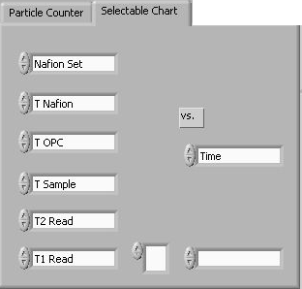

Figure : Selectable Chart Tab

# Chart Options (for Single CCN and CCN Playback Programs)

In both the **Single CCN.exe** and **CCN** **Playback.exe** programs, you can right-click on charts such as the histogram and time-series charts to bring up additional options.

On many charts, you can change the scale by typing a different number into the starting and ending values on each axis. For instance, if you want to change the time period in one of the graphs above to end at an earlier time, you simply select the field with the old time, type in the new time, and hit the <Enter> key. In acquisition mode, you must disable autoscaling (see below) before you modify fields in this way.

Many charts also display options for scaling and copying the data when you right-click on them, which brings up a drop-down menu. These options are as follows:

**Autoscale** This autoscales the relevant axis. In autoscaling mode, the minimum and maximum values of the axis are set automatically so that all data points can be seen in the display.

**Copy Data** This copies the chart to the clipboard using a screen capture. This chart can then be pasted into other documents like Word or PowerPoint presentations.

**Export Simplified Image** This copies a simplified image of the data to the clipboard or an output file. You can choose the format you desire—bitmap (.bmp), encapsulated postscript (.eps), or enhanced metafile (.emf). Note that when you select the .eps option, you must copy the data to a file. Unless you specify otherwise, output files will be saved in the time-and-date-specific output file directory for the current session.

**Clear Graph** This erases the currently displayed data points from the graph.

# Remote Operation of CCN Programs through a Network Connection (Remote Desktop)

The CCN instrument can be connected to using the instrument’s Ethernet port, which is located with the other interface connections. The instrument can be connected to an Intranet or to a single computer with a network crossover cable.

Remote Desktop is a program that can be run on a host machine that will connect to the CCN instrument over the Internet. Remote Desktop is available online and must first be installed on the host machine. In order to connect to the CCN instrument, run **Remote Desktop** from the host machine. In the computer selection type **CCNStack** or the IP address of the CCN instrument, then click **Connect**. The user should be *administrator*, and the password for the CCN computer is *password*.

Once Remote Desktop connects to the instrument, you will have complete access to the active desktop on the CCN computer from the host machine. All CCN programs will then be accessible from the host machine. Files can be transferred from the CCN onboard computer to the host machine using the **right click copy** and **paste** features. To transfer files, navigate to the CCN data folder. Select the files to transfer, and copy them by right-clicking and selecting **Copy**. Then minimize the remote desktop function, navigate to the desired file location, and paste the files using the right-click function. After right-clicking to paste the files, it may take up to a minute for the program to respond.

Another option for copying files is to put them on a shared folder. You can share a folder on the remote machine by double-clicking on it and then selecting **Share This Folder** under the **File and Folder tasks.** This will bring up a window where you can select **Share This Folder** using a radio button. After clicking **OK**, navigate back to the host machine desktop. Bring up Windows Explorer and in the path field type “\\” followed by the IP address of the remote desktop computer. The shared folder should now be visible, and you can copy its files to any other location.

The following book is recommended for users needing assistance with networking to the CCN: *Microsoft Windows 7 Networking Inside Out* by Ed Bott, published by Microsoft Press.

The CCN computer name is “*CCNStack*” and the password is “**password**”.

Appendix A: Glossary

**%TG:** A temperature-gradient adjustment factor that enhances the response time between SS% changes. **%TG** causes the bottom temperature zone of the column to run a certain percentage lower temperature than a linear gradient. For example, if this percentage is set to 5% and there is a 10° temperature gradient, the bottom temperature zone of the column will be set at 9.5° (not 10°) hotter than the top temperature zone. Typically this number will be set to 7%.

**1st Stage Monitor (V):** A monitor that indicates whether the optical particle counter (OPC) is fogged or dirty. When **1st Stage Mon** exceeds its threshold for a sustained period, the CCN computer generates an **Alarm Code.**

**Abs Press:** The absolute pressure in the CCN column. The absolute pressure is one factor that determines the instrument’s supersaturation.

**ADC Overflow:** The number of particles that have been detected but rejected for counting because they were oversized. Oversized particles send out a peak digital signal that exceeds that given in a threshold table as the upper boundary of the uppermost sizing bin. These particles are included in **Number Conc**.

**Alarm Code:** The sum of any current alarm codes the CCN computer has generated. Each alarm code is a unique 2n number that reflects a specific issue with the CCN. For instance, an alarm code of 4 indicates a problem with the total flow or with the sample-sheath flow ratio. An alarm code of 16 indicates a problem with the sample temperature. Problems with both the flow and the sample temperature would result in an **Alarm Code** value of 20 (= 4 + 16), providing no other alarm codes have been generated. A negative alarm code indicates problems severe enough that the instrument has gone into safe mode. See section for more details.

**Baseline Monitor:** A voltage indicator used by DMT for diagnosing the OPC. A healthy reading is 2.5 – 3.2 V.

**Bin [*i*]:** The raw particle count in bin number *i.*

**Bin Setting:** A parameter that can be used to limit the **Number Conc** calculation to reflect larger particles only. Bins lower than the **Bin Setting** do not have their particles included in this calculation. If all particles are to be included, **Bin Setting** should be 0. The program **CCN SS Settings Config Editor.exe** allows users to configure bin settings for different supersaturation settings. **Bin Setting** is also a channel in the output data.

**Chiller:** Another name for the CCN’s **cold trap.**

**Cold trap:** A device that condenses water out of the OPC exhaust, ensuring that water does not condense in the instrument’s proportional valve or pump. See section for details.

**Column Temps Stabilized Status:** An indicator on the **Monitor** tab that corresponds to the **Temp Stable?** output channel. This monitor triggers when **T1 Read**, **T2 Read**, or **T3 Read** is > 0.4 °C from its set point.

**Current SS#:** The level of the CCN’s current supersaturation. In **Auto SS** mode, the CCN determines the sequence of supersaturations for the session using a supersaturation table. All supersaturation tables start at level 0. Users can enter up to 256 different supersaturations per table, so the maximum level is 255.

**Current SS%:** The CCN’s current supersaturation. Note that if the instrument is changing supersaturations, **Current SS%** will differ from **Current SS#**.

**Delta T Set (C):** The temperature differential used to calculate values for T1 Set, T2 Set, T3 Set, Inlet Set, Nafion Set, and OPC Set. **Delta T Set (C)** is equal to **T3 Set** – **T1 Set**.

**DMA:** A differential mobility analyzer**.** DMAs are traditional devices for sizing aerosol particles.

**Dry Start Up:** An option that can be selected during the first ten seconds of the CCN. **Dry Start Up** should only be selected when the unit has been totally dried out, such as after shipping.

**Dry Shut Down:** An option that can be selected during the first ten seconds of the CCN. **Dry Shut Down** should only be selected when the unit needs to be totally dried out prior to shipping.

**Inlet Set (C):** The set point temperature at the CCN inlet manifold.

**Köhler Curve:** A mathematical function representing the cloud-droplet formation process. Köhler curves are used to calibrate the CCN and determine the relationship between temperature gradient and supersaturation.

**Laminar Flow:** A flow in which the separate layers of air or fluid flow in parallel rather than mixing together. The CCN uses a laminar flow element.

**Laser Current (mA):** The electrical current flowing through the instrument’s laser diode. A sudden change in current could reflect a problem with the instrument. A reading of 60 – 120 mA indicates the instrument is functioning properly. A high laser current can indicate the laser is nearing the end of its life. A sustained high Laser Current will generate an **Alarm Code.**

**Nafion Set (C):** The set temperature of the Nafion humidifier. When this temperature differs substantially from its set point for a sustained period, the CCN computer generates an **Alarm Code**.

**Number Conc. / CCN Number Conc. (#/cm3)**:The particle number concentrationin sized particles per cubic centimeter of air. This is calculated as follows:

**Number Conc = [(Sum of qualifying Bin Counts) + (ADC Overflow)] / Sample Flow**  60

The 60 is a unit conversion factor, since **Bin Counts** and **ADC Overflow** are given in particles per second while **Sample flow** is in cm3/min. The CCN’s **Number Conc.** includes oversized particles but does not include particles in bins smaller than the **Bin Setting.** When **Number Conc.** falls below its threshold for a sustained period, the CCN computer generates an **Alarm Code.**

**OPC:** An optical particle counter. The OPC component of the CCN counts and bins activated aerosol particles in the sample air after they have grown to detectible size.

**OPC Set (C):** The set point temperature of the optical particle counter. When **OPC Temp (C)** differs substantially from this set point for a sustained period, the CCN computer generates an **Alarm Code**.

**PADS:** See Particle Analysis and Display System.

**Particle Analysis and Display System (PADS):** Optional DMT software that can be purchased with the CCN. Like the CCN’s standard software, PADS is written in LabVIEW. PADS provides data analysis and reporting features for many DMT instruments simultaneously. It is useful if CCN data are being analyzed in conjunction with data from other instruments.

**PID:** A proportional-integrative-derivative control system. PID systems have three parameters that are used to determine a system’s corrective response to errors. (See <http://en.wikipedia.org/wiki/PID_controller> for more information.) On the CCN, a PID algorithm is used to modify the CCN’s proportional valve flow control loop. Users can modify the three PID parameters from the PID section of the DMT Service tab. See section for details.

**Proportional Valve (V):** The voltage the computer sends to the proportional valve to keep the CCN’s air flow constant.

**Sample air:** The air that the CCN samples for aerosol particles. The sample air is confined to a small volume at the center of the CCN column. It is surrounded by sheath air, with the sheath:sample volume ratio set at approximately 10:1.

**Sample Flow (Vccm):** The volumetric sample flow rate. Typically the ratio of sample flow to sheath flow should be about 1:10, since the volume of sheath air should be about ten times more than that of the sample air. If the observed ratio diverges significantly from the set-point ratio for a prolonged period, the CCN computer generates an **Alarm Code**.

**Sample Temp (C):** An output channel thatindicates the temperature of the sample air. When **Sample Temp (C)** exceeds its range for a sustained period, the CCN computer generates an **Alarm Code**.

**Sheath air:** The air that surrounds the sample air in the CCN column. The sheath air acts as a buffer to confine the sample.

**Sheath Flow (Vccm):** The volumetric flow rate of the sheath air. Typically the ratio of sheath flow to sample flow should be about 10:1, since the volume of sheath air should be about ten times more than that of the sample air. If the observed ratio diverges significantly from the set-point ratio for a prolonged period, the CCN computer generates an **Alarm Code**.

**SS setting:** An output data channel that stores the instrument’s current supersaturation. A higher **SS setting** means that more particles will be detected.

**SS Table:** A supersaturation table, or a table that determines the progression of supersaturations settings the instrument will use in a sampling session. Users can select among existing SS tables from the **SS Tab**, and they can create or modify available SS tables using the **CCN SS Config Editor.exe** program.

**Supersaturation:** The state at which air contains more water vapor than thermodynamically allowed. The CCN counter uses supersaturation to grow aerosol particles to detectible size.

**T Inlet (C):** The temperature of the CCN’s inlet manifold. When **T Inlet (C)** differs substantially from its set point for a sustained period, the CCN computer generates an

**Alarm Code**.

**T Nafion (C):** The observed temperature at the Nafion humidifier. When **Nafion Temp (C)** differs substantially from its set point for a sustained period, the CCN computer generates an **Alarm Code**.

**T OPC (C):** The observed temperature of the CCN’s optical particle counter. When **OPC Temp (C)** differs substantially from its set point for a sustained period, the CCN computer generates an **Alarm Code**.

**T1 Read (C):** The temperature in the CCN’s top control zone.

**T2 Read (C):** The temperature in the CCN’s middle control zone.

**T3 Read (C):** The temperature in the CCN’s bottom control zone.

**T1 Set (C):** The set point temperature in the CCN’s top control zone.

**T2 Set (C):** The set point temperature in the CCN’s middle control zone.

**T3 Set (C):** The set point temperature in the CCN’s bottom control zone.

**TEC Relay:** A control button on the **Temps** tab thatswitches the instrument’s 28 VDC power buss on and off.

**Temp Gradient:**  A CCN channel that stores the temperature gradient along the CCN’s wetted walls, i.e. **T3 Read (C)** – **T1 Read (C)**. The gradient is the controlling factor that determines the instrument’s supersaturation.

**Temp Stable?:** A Boolean output channel indicating when **T1**, **T2**, or **T3 Reads** differs by > 0.4 °C from its set point. A value of 1 indicates all three channels are close to their set points. If **Temp Stable?** is 0 for a sustained period, the CCN computer generates an **Alarm Code**. Note that **Temp Stable?** indicates temperature stability but does not necessarily indicate data stability, which also depends on other factors.

**Temperature Gradient / Thermal Gradient:** The temperature gradient between T1 (the top of the CCN column) and T3 (the bottom). See **Delta T (C)** for details.

**Time:** The time at which the computer writes the data from any given sampling instance to the output file.

**Total Flow (Vccm):** The sum of the **Sample Flow** and the **Sheath Flow.** When the **Total Flow** deviates from its set point for a prolonged period, the CCN computer generates an **Alarm Code.**

**Vccm:** Volume cubic centimeters / minute. Vccm is a unit of flow.

**Watch dog:** An indicator on the **Prog** tab of the CCN control program. The indicator alternates ON and OFF every second when the computer is cycling properly. The watch dog light on the instrument should blink at the same time as this indicator. If the indicator light is steady **OFF** or **ON**, reboot the computer.

**Zero-Count Test:** A CCN test performed by installing a filter that is known to be working well onto the CCN inlet, so that no aerosol particles can enter. The zero-count test should result in a particle reading of 5/sec or less.

Appendix B: Relationship between SS%, Particle Concentration, and Percentage of CCN Counted

Tests at DMT have shown that the aerosol count rate in the CCN varies with SS% and particle concentration. For concentrations at or below 6,000 particles/cc, all supersaturations have a 90% or higher aerosol count rate. For instance, all the supersaturation values plotted in have a 96% aerosol count rate at concentrations of 5,000 particles/cc. At higher particle concentrations, however, supersaturations below 0.2% show a decreased maximum count rate.

Note that observed and theoretical maximum concentrations differ considerably. On a theoretical level, the instrument can count 60,000 particles/cc at a sample flow rate of 50 Vccm with a maximum coincidence of 10%. This 60,000 particles/cc figure is based solely on the theoretical performance of the OPC, however; growth kinetics of particles in the CCN column will reduce the actual concentration at which the instrument can accurately detect particles.

Figure : Percentage of CCN Counted vs. Particle Concentration for Different SS%

Appendix C: Assy, Cable 28V Power

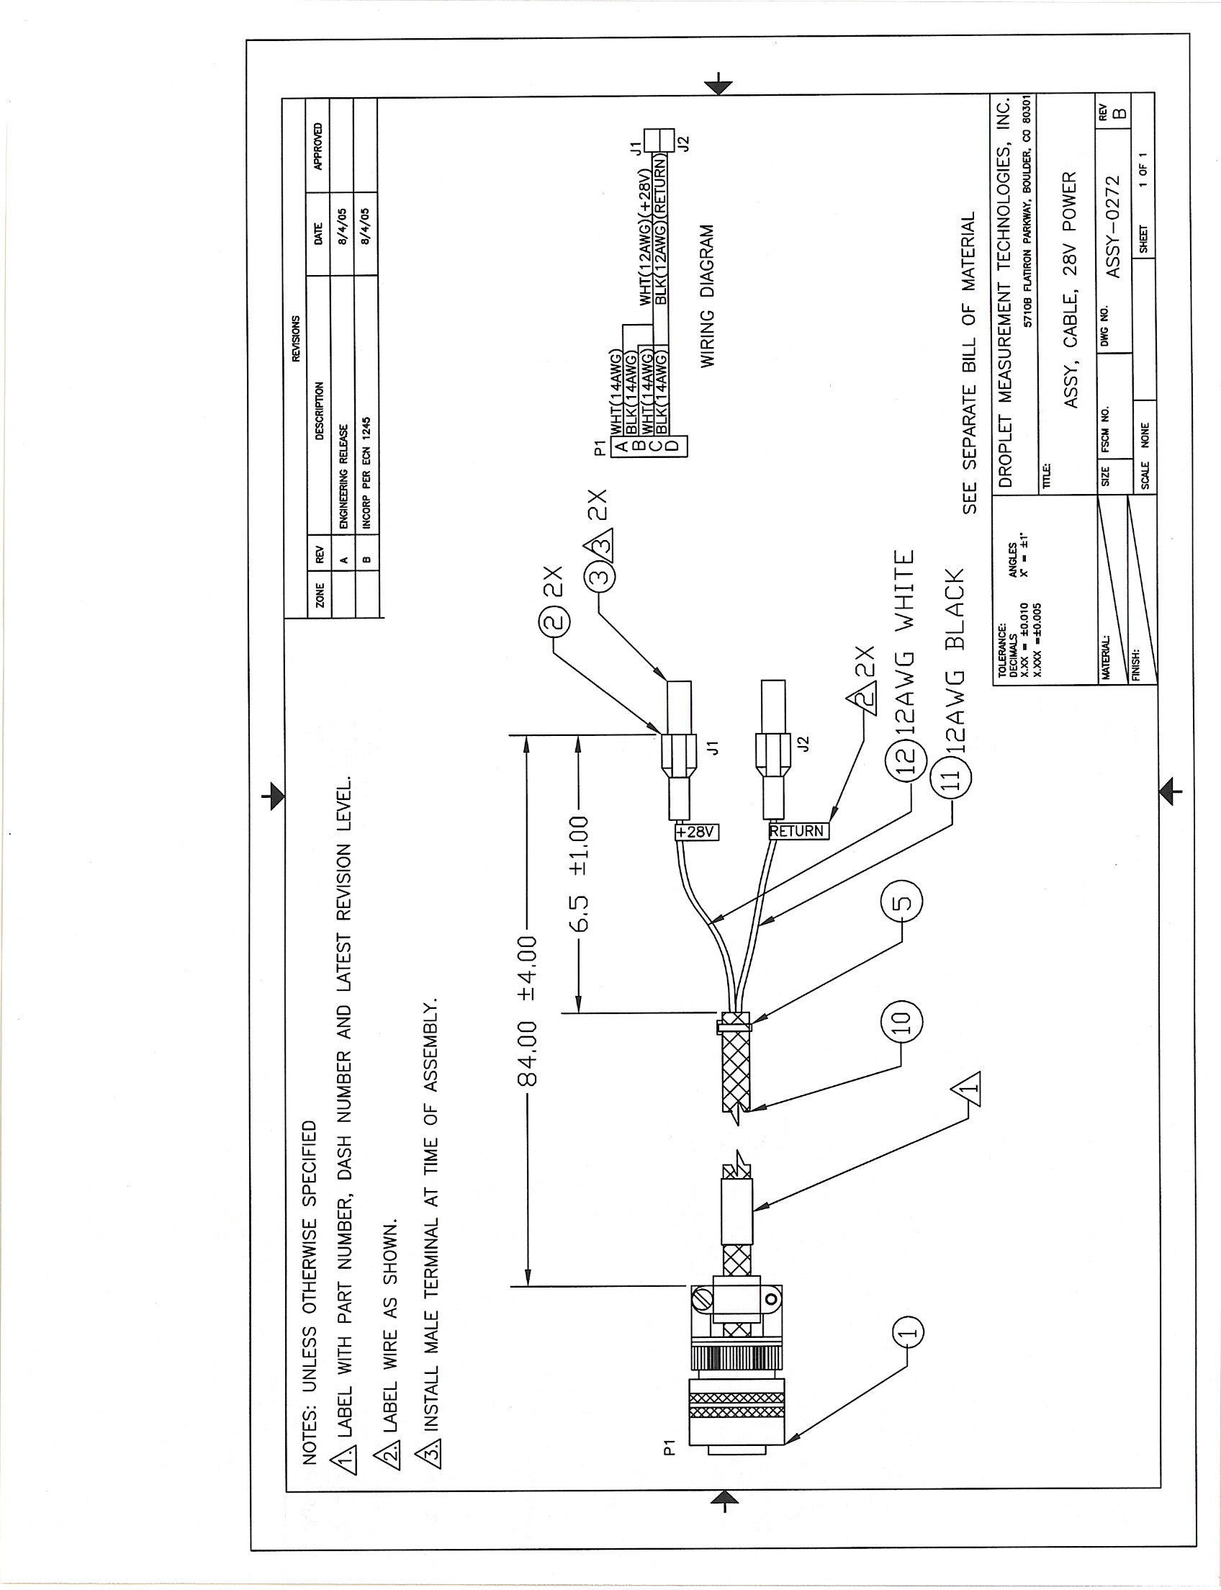

Appendix D: CCN Mounting Hole Locations

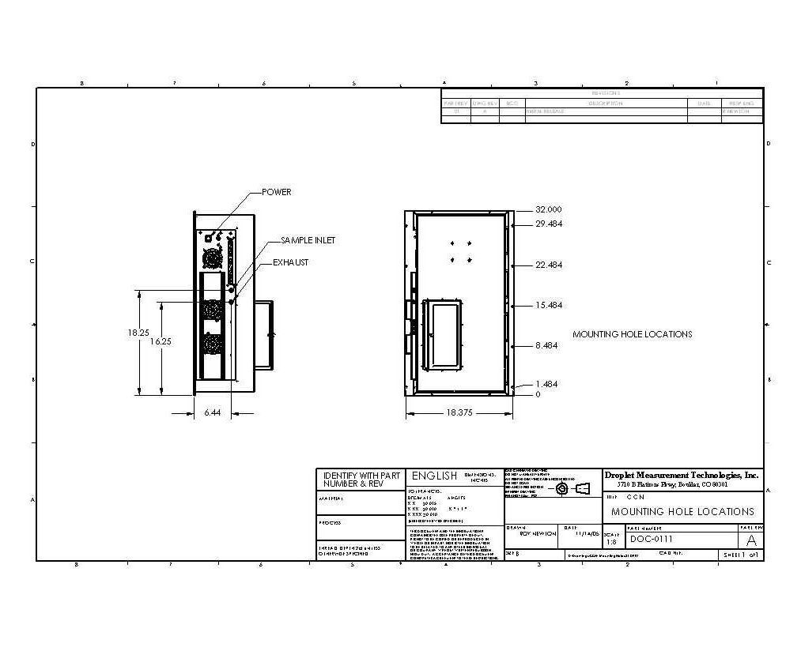

Appendix E: CCN Aircraft Inlet (for Constant Pressure Inlet)



Appendix F: Exploded View of OPC

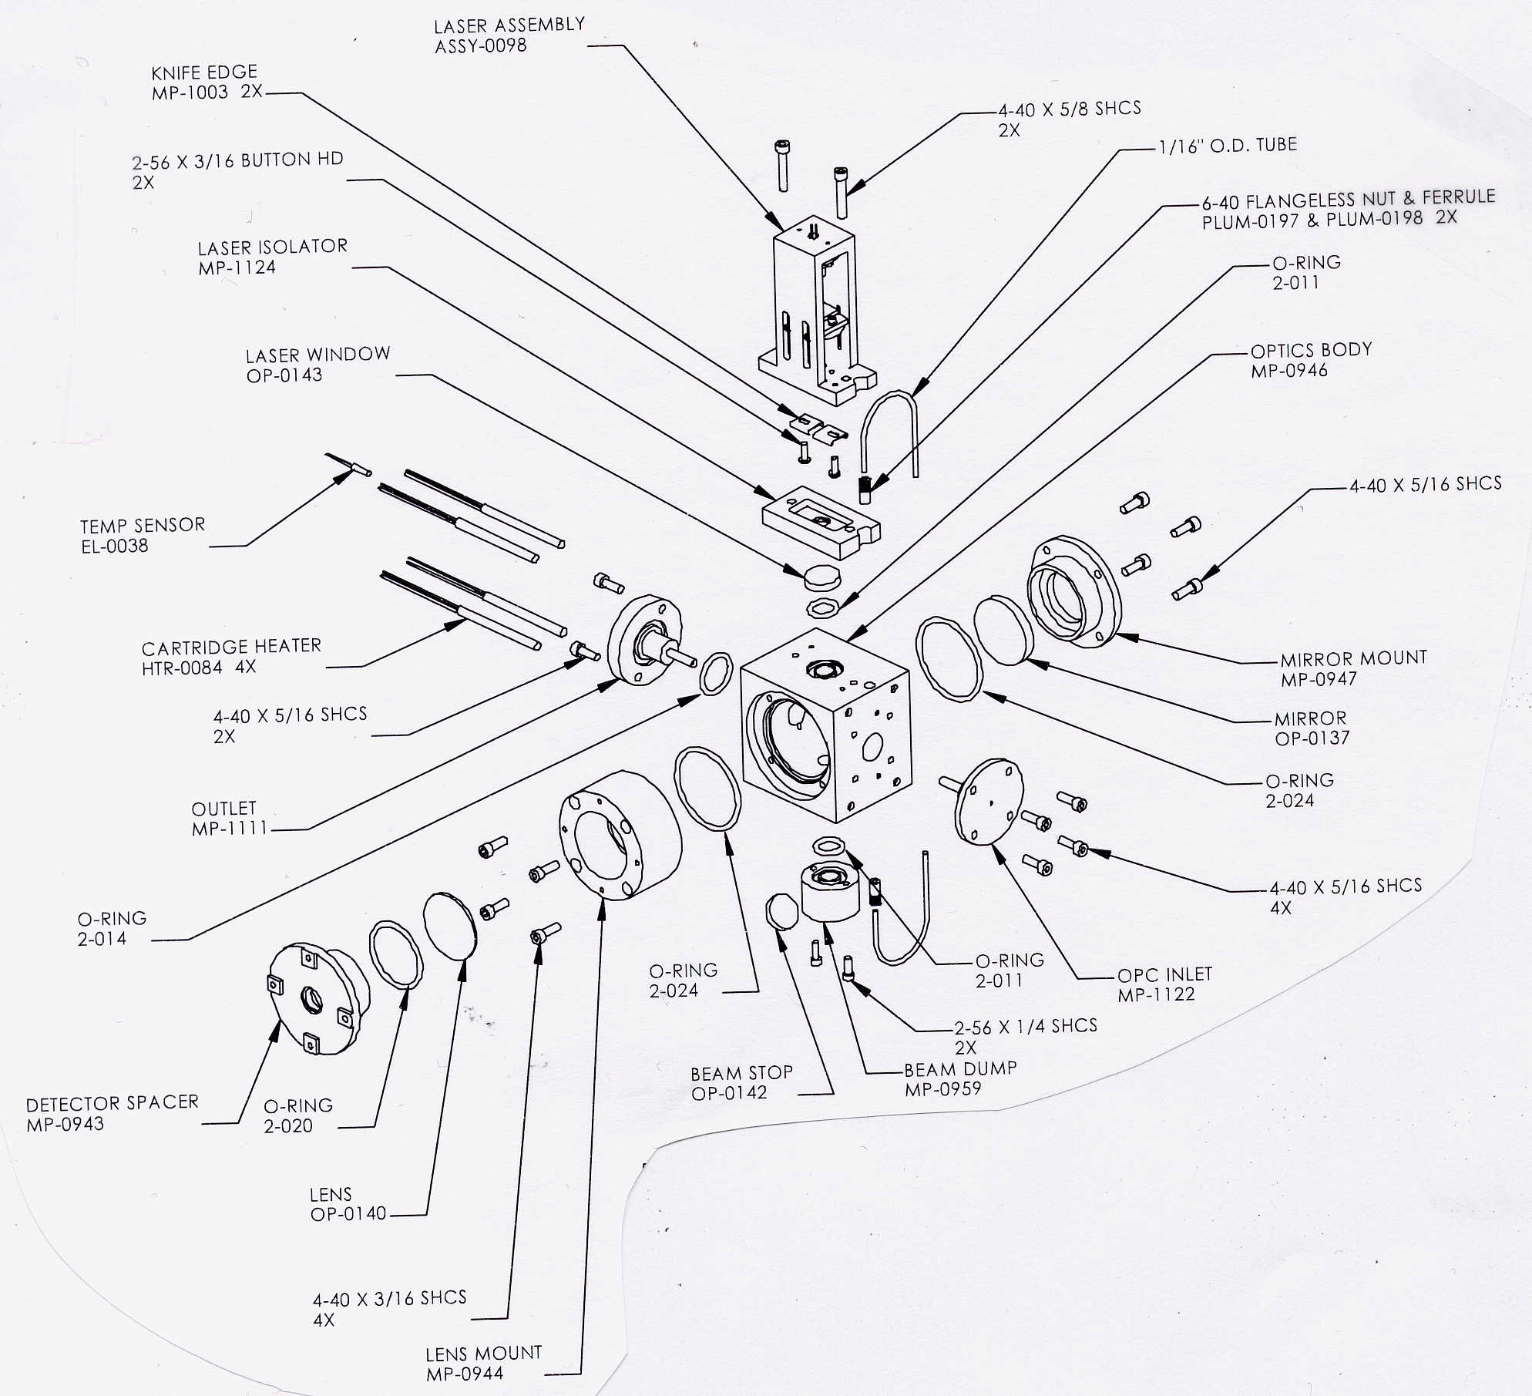

Figure : OPC Assembly, Exploded View

Appendix G: Sheath Flow Filter Testing and Replacement

Problem

Droplet Measurement Technologies (DMT) has recently become aware of a potential problem with CCN sheath flow filter. The symptoms are that the CCN instrument counts too many particles but will still zero count when a filter is installed on the inlet. These symptoms are noticed when doing an intercomparison between the CCN counter and another instrument. DMT researched changing to a different filter, but different pressure drops and physical sizes made this unrealistic.

Recommendations

DMT is recommending all CCN Sheath flow filters currently in service either be replaced by one tested by DMT (FL-0022, cost $20.00 each) or be removed and tested with a CN counter. The background counts when tested on a CN counter should be very close to zero (<.5 per ccm).

NOTE: if you use a different filter that has more of a pressure drop, you may not be able to get a flow ratio of 10.

If you do not have access to a CN counter, the following procedure can be used to test the sheath filter. A “bad” sheath filter will still zero count when a good filter is connected to the inlet. This is due to the sheath air being pre-filtered by the inlet filter. You must isolate the sheath flow filter.

1. Remove sheath line from manifold block.

2. Install ASSY-0122 plug (included in startup kit) into manifold as a plug.

3. Perform a leak check to ensure no leaks were induced.

4. Install DMT tested filter on inlet of CCN.

5. Run a scan that includes a 1% SS for at least 5 minutes

6. Counts should be less than 5 per update. If counts are higher, replace sheath filter with DMT tested filter (new filters from DMT will have a “tested” label on them).

*Caution:* The filters may test well initially and then start to pass particles at a later date. Thus we strongly recommend that the filters are replaced or the above test is performed every 3 months. All filters in starter and service kits should also be tested; new filters from DMT will have a “tested” label on them.

Please contact Droplet Measurement Technologies if you have any questions or concerns, or if you need to order replacement filters. Email [CCN-Info@dropletmeasurement.com](mailto:CCN-Info@dropletmeasurement.com); Phone: 303-440-5576

Appendix H: International Shipping Certification

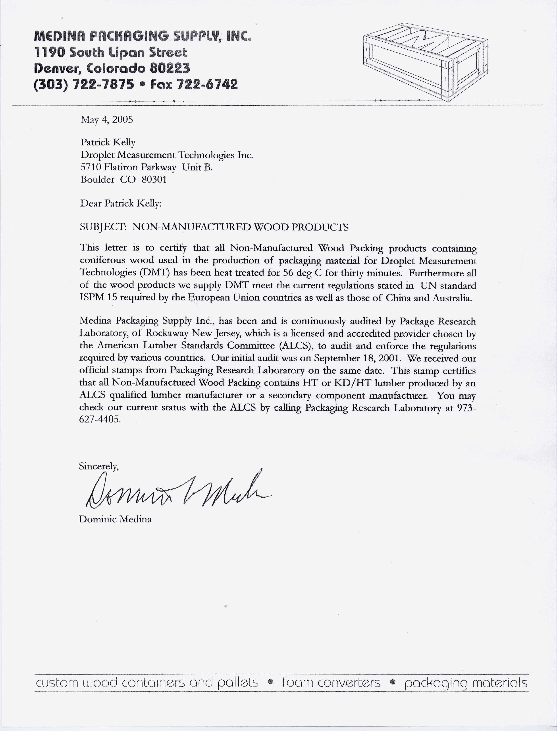

Appendix I: Revisions to Manual

|  |  |  |  |
| --- | --- | --- | --- |
| **Rev. Date** | **Rev. No.** | **Summary** | **Section** |
| 10/22/09 | G-1 | Revised Flow Calibration Procedure | 8.2.2 |
| Updated DMT’s address | Front matter |
| 10/26/09 | G-1 | Expanded typical **Sample Flow (Vccm)** and **Sheath Flow (Vccm)** values; switched steps 3 & 4. | 8.2.2 |
| 1/15/10 | G-2 | Updated pictures | Various |
| 10/27/10 | H | Modified Sheath Flow Filter Testing and Replacement Procedures | App. G |
| 12/29/10 | H-1 | Modified theory of operation section | 2.0 |
| 8/15/11 | H-2 | Updated instructions for checking unit functionality | 3.3 |
| 9/1/11 | H-3 | Added descriptions of Inlet heater, Nafion heater, and OPC heater indicator lights | 12.1.2 |
| 9/27/11 | I | Modified Flow Calibration procedure | 8.2 |
| 10/4/11 | I-1 | Inserted photos of Metering Valve Access Port | 8.2 |
| 4/18/12 | I-2 | Clarified procedures for fixing stuck reeds | 10.0 |
| 2/24/16 | K | Install PC-104 Intel Atom N2600 1.6 GHz processor with Windows 7. Rev CCN IO Interface board | 11.1 |

1. 1. In general, the switch should be set to the 16-second position, because when the pump operates every 2 seconds water may infiltrate the CCN without generating an alarm. However, the 2-second position is recommended in certain circumstances. It is useful in airborne applications where altitude changes can cause migration of saturated water vapor into the OPC. In addition, if the OPC has fogged, switching to the 2-second position will speed the removal of water vapor. (The switch should be returned to the 16-second position after the fog has dissipated.) For more details on the OPC drying system, see section 2.2.1.
2. Appendix E contains an exploded view of the OPC that may be useful when following these steps.
3. Screen shots in this document are taken from versions 5.0.3 (Single CNN.exe), 5.0.1 (SS Settings Config Editor.vi and CCN Calibration Config Editor.vi), and 5.0.2 (Single CCN Playback.exe).
4. **Sample Temp Setpoint** is a temporary variable used by the software. It is equal to whatever **TSample** was when conditions 2 or 3 were last true.
5. **%TG** is a temperature-gradient adjustment factor. For details, see section 14.0.
6. The proportional valve voltage determines how open or closed the proportional valve will be, which in turn regulates total sample flow.
7. All bin channels store are raw particle counts rather than concentrations.
8. ***Note:*** The software currently mislabels the y-axis for the particle concentration chart. Units should be in particles/cc, not ccm. This bug will be fixed in an upcoming version of the program.