

**Figure 5.** Annual mean N2O flux (g m-2 yr-1 N) averaged over 1999-2012 determined from GAW N2O observations and a chemical transport model (from Thompson et al., Atmos. Chem. Phys., 14, 1801–1817, 2014).

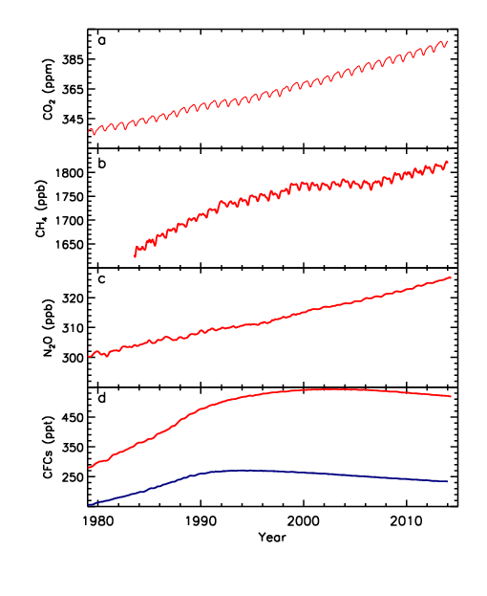

**Figure 2.** Time-series of the 5 LLGHGs that have contributed >95% of radiative forcing since 1750. In panel (d), CFC-11 is in blue and CFC-12 is in red.

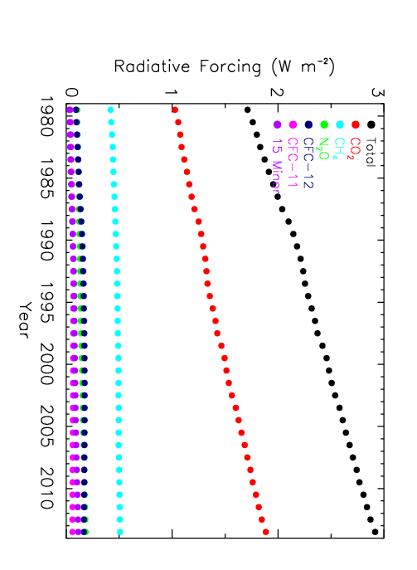

**Figure 3.** Increase in radiative forcing by LLGHGs since 1750 plotted for 1979 to 2013. CO2 is the largest contributor to total RF by LLGHGs, and it is the dominant contributor to the trend in RF since 1990. Based on NOAA AGGI (http://www.esrl.noaa.gov/gmd/aggi/).

Alternative version

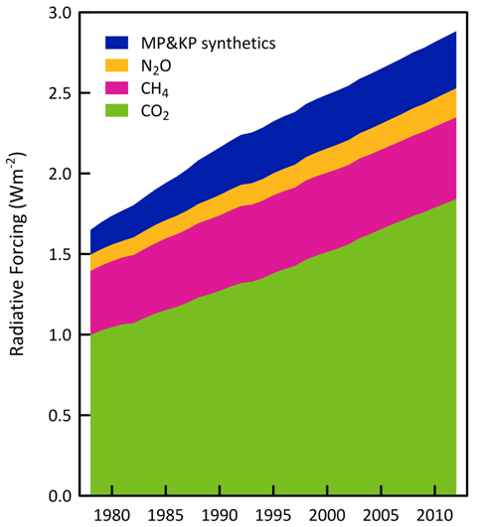

**Figure 3.** Increase in radiative forcing by LLGHGs since 1750 plotted for 1979 to 2013. CO2 is the largest contributor to total RF by LLGHGs, and it is the dominant contributor to the trend in RF since 1990. “MP&KP synthetics” refers to synthetically made gases listed under the Montreal Protocol and Kyoto Protocol.

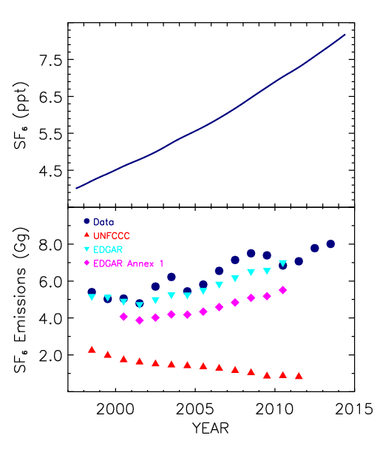

**Figure 4.** (a)Globally averaged SF6 mole fractions determined from GAW measurements. (b) Comparison of annual observation-inferred global SF6 emissions (blue circles)) with global emissions estimated by EDGAR (cyan triangles), emissions reported by Annex I nations to the UNFCCC (red triangles), and emissions by Annex I nations as estimated in in EDGAR (Emissions Data for Global Atmospheric Research; pink diamonds) (see published work by Levin et al., ACP, 2010).

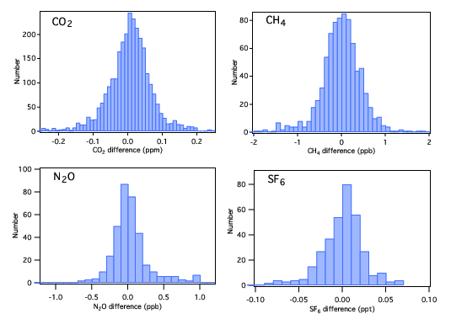

**Figure 1.** Histograms of CO2, CH4, N2O, and SF6 differences between initial calibration and those made at least one year later demonstrate reproducibility for key GHGs. Differences have not been drift corrected where necessary; applying drift corrections for CO2 and N2O reduces the spread in differences.

Network map

