Mauna Loa Observatory, Hawaii

Solar Photovoltaic Feasibility Study

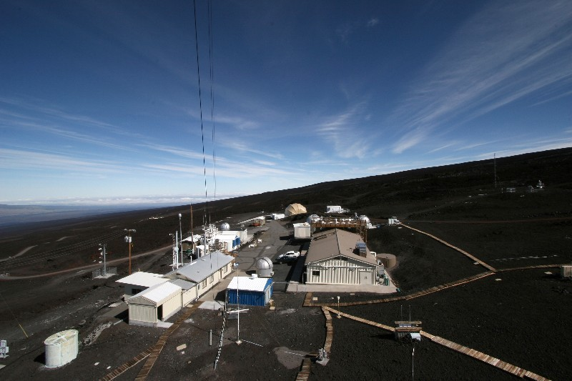

NREL
Golden, CO
2011

Updated in 2014

Executive Summary
The National Renewable Energy Laboratory (NREL), in a partnership with the National Oceanic and Atmospheric Administration (NOAA) conducted a feasibility study looking at a variety of different renewable energy technologies for use at the Mauna Loa Observatory (MLO). The following technologies were considered.
- Solar Photovoltaic (PV)
- Solar Thermal
- Biomass
- Wind
- Geothermal

Of the technologies that were considered, all but Solar Photovoltaic were eliminated upon a site visit by NREL staff. The following report summarizes the analysis that was conducted including performance, economics, site conditions, and general feasibility.

Seven sites in or near the site boundary of MLO were considered, all of which were found suitable for PV systems. The economics of the potential systems were analyzed using an electric rate of $0.425/kWh, as well as incentives that are offered by the State of Hawaii and by the serving utility, Hawaii Electric Light Company (HELCO). Table ES-1summarizes the system performance and economics of a potential system that would produce enough power to meet the entire site electrical load. The data is presented both with and without incentives that are available in Hawaii.
Currently, Hawaii has a very attractive set of incentives. The state offers a 35% tax credit up to $500,000 for commercial properties. This is in addition to the 30% federal tax credit incentive. In order to take advantage of these tax credits, the system owner must pay taxes. There are methods through which NOAA could capture the tax credits, in order to improve the economics of the system. These methods are explained in section 4 of the report. A full list of incentives can be found in Appendix B.
The results of this feasibility study show that this is a very good candidate for a solar PV system. The system payback periods are within a reasonable range with or without incentives, and implementation of a system would help to hedge against rising energy costs. The Mauna Loa Observatory should consider PV energy projects for several reasons in addition to economic reasons. The projects could accomplish the following:
- Reduce environmental emissions including carbon dioxide (CO₂), oxides of sulfur (SO_{x}), oxides of nitrogen (NO_{x}), particulate matter (PM), and mercury (Hg) from regional power plants operated by HELCO.
- Help meet E.O. 13514 to increase renewable energy generation at Federal sites.
- Assist in adhering to the challenge set forth in the Presidential Memorandum – Federal Leadership on Energy Management (issued December 05, 2013) to update federal building-performance and energy-management practices to consume 20 percent of its electricity from renewable sources by the year 2020.
- Employ local trades to install and maintain the systems instead of spending that money to import energy into the district.
- Inform visitors about these promising PV energy technologies.
- Hedge against rising electric rates by guaranteeing an energy source for 25 years or more.
- Set an example for the nation on real steps that can be taken to diversify the energy portfolio.
Two feasible courses of action can be taken to implement PV systems at the site. One is to use a PPA to implement the PV system in an arrangement that can use the tax credits. The second is to purchase the system outright and forfeit the tax credits. Based on NREL’s analysis, here are some possible next steps:
- Prepare a request for proposal (RFP) based on performance specifications which allow for the contractor to design the system using information from this report.
- Strategize alternatives for contracting authorities.
- Submit the RFP to solar contractor community and review designs as they come in.
- Accept the best proposal and commission the system upon installation.
- Train staff on continued O&M of the systems.
DOE’s Federal Energy Management Program (FEMP) offers agencies assistance in each of these areas.

Table ES-1. PV System Performance and Economics by System Type
System Type | Potential System Size (kW)ª | Annual Energy Output (kWh) | Annual Cost Savings ($) | Annual O&M ($) | System Cost ($) | Simple Payback (yrs) | Net Present Value ($)
Fixed-tilt w/ incentives | 145 | 268,913 | $114,288 | $2,164 | $303,010 | 2.7 | $866,922
w/o incentives | 145 | 268,913 | $114,288 | $2,164 | $865,742 | 7.2 | $1,472,472
ª System is calculated to offset all electrical use at the 4 NOAA meters on site.

Table of Contents
Executive Summary iii
Table of Contents iii
List of Figures iv
List of Tables v
1 Study Location 1
2 PV Systems 7
2.1 Types of PV Systems 8
2.2 PV System Components 9
2.3 PV Size and Performance 10
3 PV Site Locations 11
3.1 Rooftop NDSC 12
3.2 Rooftop Keeling 13
3.3 South Area In Site Boundary 15
3.4 South Area Lava Barrier 18
3.5 North Area Near AMIBA 20
3.6 North Area Along Entrance 22
3.7 North Area Along Summit Access 25
3.8 Summary System that Could Offset MLO Energy 28
4 Economics and Performance 29
4.1 Assumptions and Input Data for Analysis 29
4.2 Incentives and Financing Opportunities 30
5 Conclusions and Recommendations 32
Appendix A. Assumptions for Calculations* 33
Appendix B. Renewable Energy Incentives* 35

List of Figures
Figure 1: Mauna Loa Observatory Aerial Image 1
Figure 2: Solar Resource in the Hawaiian Islands 3
Figure 3: Wind Resource in the Hawaiian Islands 5
Figure 4. Major components of grid-connected photovoltaic system 7
Figure 5: Potential System Placement Aerial Site Total 11
Figure 6. Rooftop NDSC: Recommended PV system placement 12
Figure 7. Rooftop NDSC: Roof Image of recommended PV array site 13
Figure 8. Rooftop Keeling: Recommended PV system placement 14
Figure 9. Rooftop Keeling: Roof Image of recommended PV array site 15
Figure 10. South Area In Site Boundary: Recommended PV system placement 16
Figure 11. South Area In Site Boundary: Ground view of recommended PV array site 17
Figure 13. South Area Lava Barrier: Recommended PV system placement 18
Figure 14. South Area Lava Barrier: Ground view of recommended PV array site 19
Figure 15. Solar Measurement South Area Lava Barrier 20
Figure 16. North Area Near AMIBA: Recommended PV system placement 21
Figure 17. North Area Near AMIBA: Ground view of recommended PV array site 22
Figure 18. North Area Along Entrance: Recommended PV system placement 23
Figure 19. North Area Along Entrance: Ground view of recommended PV array site 24
Figure 21. North Area Along Summit Access: Recommended PV system placement 25
Figure 22. North Area Along Summit Access: Ground view of recommended PV array site 26
Figure 23. Solar Measurement North Area Along Summit Access 27
Figure 24. Installation cost for grid-tied PV systems 2009-2010 29

List of Tables
Table ES-1. PV System Performance and Economics by System Type iv
Table 3. Energy Density by Panel and System 8
Table 4. Rooftop NDSC System Options 13
Table 5. Rooftop Keeling System Options 14
Table 6. South Area In Site Boundary System Options 16
Table 7. South Area Lava Barrier System Options 19
Table 8. North Area Near AMIBA System Options 21
Table 9. North Area Along Entrance System Options 23
Table 10. North Area Along Summit Access System Options 25
Table A-1. Assumptions for Calculations 33
Table A-2. Other Assumptions, including Assumptions for Costs and System Types 34
Table B-1. Renewable Energy Development Incentives and Financing Tools Applicable to Photovoltaics 35
Table B-2. State Rebates for Commercial-Sector PV Projects 35
Table B-3. State Tax Credits for Commercial-Sector PV Projects 40
Table B-4. State Policy and Incentive Comparisons: Massachusetts, North Carolina, and Colorado 46
Table B-5. Key Policy Comparison for Subject States 48

- Study Location
The Mauna Loa Observatory (MLO), located on the Big Island of Hawaii near the summit of the Mauna Loa Volcano, is one of the premier climate study facilities in the world. The observatory has been in operation since the 1950s continuously collecting data relating to the atmosphere. The remote location and lack of vegetation and human activities make this a nearly ideal location for these types of measurements. The facility is situated on a 4.05 acre parcel of land. The land surrounding the facility is managed by the Department of Hawaiian Home Lands. The remote location of the facility contributes to the high cost of energy at the facility and also increases the cost of construction at the site.

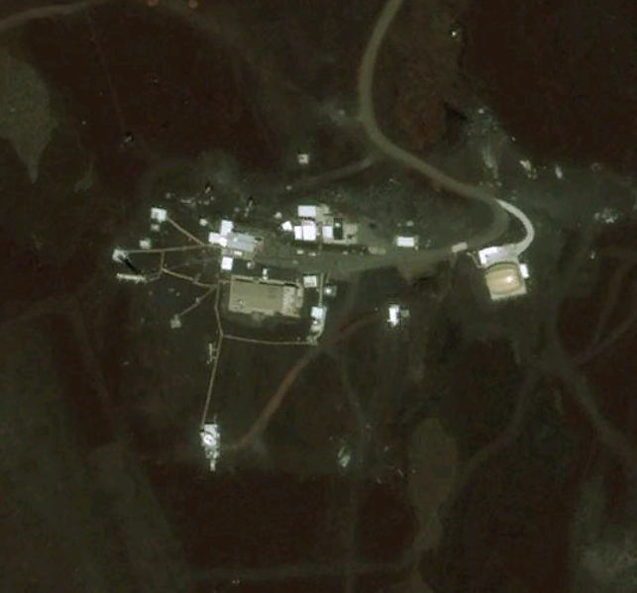
Figure 1: Mauna Loa Observatory Aerial Image

Mauna Loa Observatory Renewable Energy Resource Assessment

The purpose of performing this site assessment was to identify the most suitable renewable energy technology for a given set of geographic, economic, and regulatory parameters as well as customer specific requirements. The following are the results of the preliminary RE resource assessment for the Mauna Loa Observatory.

Solar
The solar resource at the Mauna Loa Observatory ranges from 4.67 to 4.73 kWh/m2/Day. This is considered an “excellent” resource as compared to Phoenix, AZ which has an “excellent” or Portland, OR which has a “fair” resource. See Table 1 below.

Table 1: MLO Solar Resource Comparison
Location | Insolation (kWh/m²/Day) | Resource Classification
Mauna Loa Observatory | 4.92 – 6.41 | Excellent
Phoenix, AZ | 4.88 - 7.54 | Excellent
Portland, OR | 3.5 – 4.0 | Fair

To further define the solar resource at the Mauna Loa Observatory, a solar resource map can be seen below in Figure 2 showing the solar resource throughout of the Hawaiian Islands. As can be seen on the map, Mauna Loa has nearly the best solar resource in the islands.
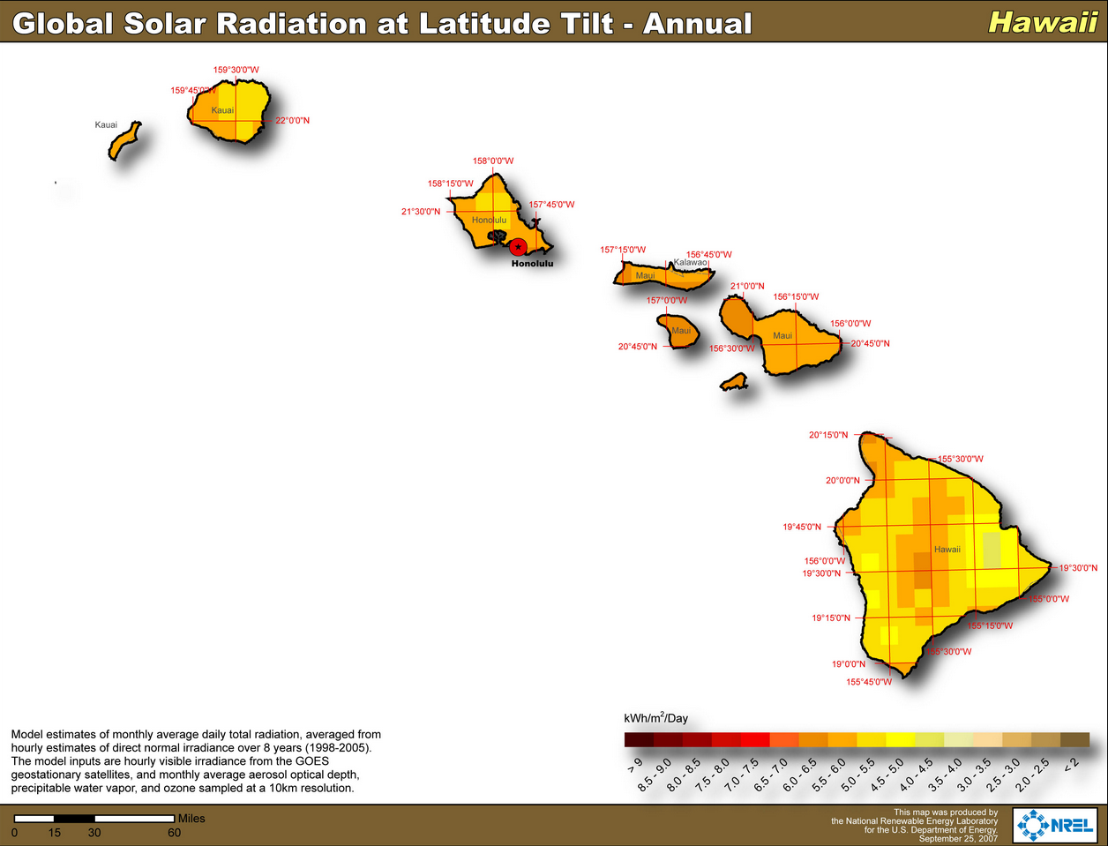

Figure 2: Solar Resource in the Hawaiian Islands

Wind

Based on a pre-screening calculation of the one minute wind resource data that was taken at the observatory, wind energy is not feasible at MLO. The wind data file was filtered and the values were used to put MLO into a wind resource class. Wind resources are rated on a scale of 1 to 7, with Class 1 being the lowest and Class 7 the highest. Class 4 and above is generally considered to be the range in which productive wind power is practical, with Class 2 as the lower limit for small turbines. At a height of 38 meters, MLO has an average wind speed of 4.49 m/s, which is classified as a wind power class rating of 1, making wind generation in the area impractical.

Table 2: Wind Power Classifications
Wind Power | 10 m (33 ft) |  | 50 m (164 ft)
Class | Wind Power Density (W/m2) | Speed m/s (mph) | Wind Power Density (W/m2) | Speed m/s (mph)
1 | 0 | 0 | 0 | 0
2 | 100 | 4.4 (9.8) | 200 | 5.6 (12.5)
3 | 150 | 5.1 (11.5) | 300 | 6.4 (14.3)
4 | 200 | 5.6 (12.5) | 400 | 7.0 (15.7)
5 | 250 | 6.0 (13.4) | 500 | 7.5 (16.8)
6 | 300 | 6.4 (14.3) | 600 | 8.0 (17.9)
7 | 400 | 7.0 (15.7) | 800 | 8.8 (19.7)
 | 1000 | 9.4 (21.1) | 2000 | 11.9 (26.6)

Further analysis of the potential for wind power in this immediate region is not recommended. The wind resource in the Hawaiian Islands can be seen below in Figure 3.

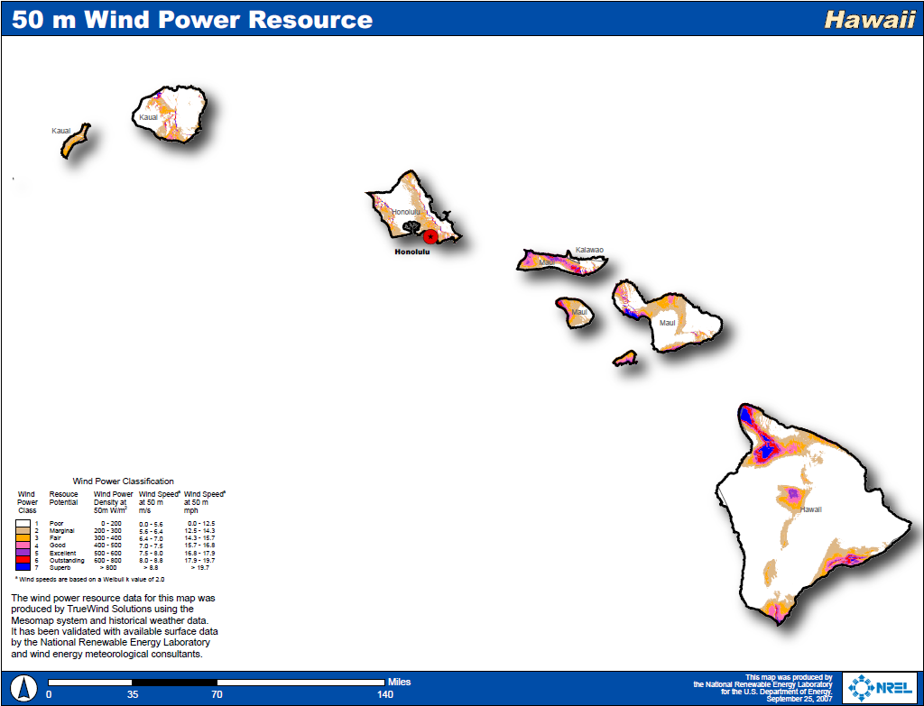

Figure 3: Wind Resource in the Hawaiian Islands

Geothermal (GT)

Due to the small heating load needed for the MLO campus and the difficulty associated with implementing a system in a lava field, further analysis of the potential for geothermal power or direct geothermal heating in this location is not recommended.

Biomass
Based on a review of NREL’s Geographic Information System (GIS) renewable resource maps, the biomass resource near MLO is negligible. The remote location and the poor quality of the roads leading up to MLO will result in an extremely high cost of fuel delivery. Further analysis of the potential for biomass power or heating is not recommended for MLO.

Based on the initial RE screening, the only significant RE resource available to MLO is solar energy. Using data that was gathered during the site visit, the remainder of the report will focus on the potential for solar PV energy and use various tools developed at NREL to predict the power output of these potential systems. This will allow for an economic analysis to be made to determine the feasibility of installing such systems. Areas identified as potential locations for PV system placement for the feasibility study are discussed below in Section 3.

- PV Systems
Solar photovoltaics (PV) are semiconductor devices that convert sunlight directly into electricity. They do so without any moving parts and without generating any noise or pollution. They must be mounted in an unshaded location; rooftops, carports and ground-mounted arrays are common mounting locations. It is anticipated that PV systems will work very well at MLO where the average global horizontal annual solar resource is 4.92-6.42 kWh/m2/day. This number, however, is not the amount of energy that can be produced by a PV panel. The amount of energy produced by a panel depends on the several factors. These factors include the type of collector, the tilt and azimuth of the collector, the temperature, the level of sunlight and weather conditions. An inverter is required to convert the direct current (DC) to alternating current (AC) of the desired voltage compatible with building and utility power systems. The balance of the system consists of conductors/conduit, switches, disconnects and fuses. Grid-connected PV systems feed power into the facility’s electrical system and do not include batteries.
Figure 4 shows the major components of a grid-connected PV system and illustrates how these components are interconnected in a grid-connected PV system.
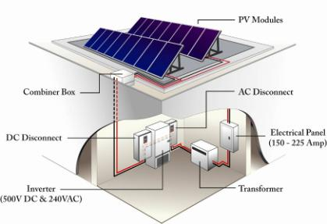
Figure 4. Major components of grid-connected photovoltaic system
PV panels are made up of many individual cells that all produce a small amount of current and voltage. These individual cells are connected in series to produce a larger current. PV panels are very sensitive to shading. When shade falls on a panel, the shaded portion of the panel cannot collect the high-energy beam radiation from the sun. If an individual cell were shaded, it would act as a resistance to the whole series circuit, impeding current flow and dissipating power rather than producing it. By determining solar access—the unimpeded ability of sunlight to reach a solar collector—one can determine whether an area is appropriate for solar panels. For this assessment, the NREL assessment team used a Solmetric™ solar path calculator to assess shading at particular locations by analyzing the sky view where the solar panels would be located.
If a site is found to have good solar access for a PV system, the next step is to determine the size of that system, which highly depends on the average energy use of the on-site facilities. Providing more power than a site would use is generally not advisable due to the economics of most net-metering agreements. In the case of the assessed sites, all of the electricity generated at the site would be used to offset the site electrical usage. The serving utility is Hawaii Electric Light Company (HELCO). The system size will be determined either by the amount of area that the site is able to utilize, the system size that HELCO is willing to interconnect, or the site electrical load.
  - Types of PV Systems
Ground-mounted Systems
On a $/DC-Watt basis, ground-mounted PV systems are usually the lowest cost option. Several PV panel and mounting options are available, each having different benefits for different ground conditions. Table 3 outlines the energy density values that can be expected from each type of system.
Table 3. Energy Density by Panel and System
System Type | Fixed-tilt Energy Density  (DC-Watts/Sq. Ft) | Single-axis Tracking Energy Density  (DC-Watts/ Ft.²)
Crystalline Silicon | 4 | 3.3
Thin Film | 1.7 | 1.4
Hybrid HE* | 4.8 | 3.9
* Because hybrid high efficiency (HE) panels do not represent a significant portion of the commercial market, they were not included in the analysis. Installing panel types that do not hold a significant portion of the commercial market would not be feasible for a large-scale solar generation plant.
For the purposes of this analysis, all fixed-tilt systems were assumed to be mounted at latitude with a tilt of 19 degrees. To get the most out of the available ground area, considering whether a site layout can be improved to better incorporate a solar energy system is important. If unused structures, fences, or electrical poles can be removed, the unshaded area can be increased to incorporate more PV panels. When considering a ground-mounted system, an electrical tie in location should be identified to determine how the energy would be fed back into the grid. For this report, only fixed tilt ground-mounted systems and fixed tilt roof mounted systems were considered.
Fixed-tilt systems are installed at a specified tilt and are fixed at that tilt for the life of the system. Single-axis tracking systems have a fixed tilt on one axis, and a variable tilt on the other axis. The system is designed to follow the sun in its path through the sky. This allows the solar radiation to strike the panel at an optimum angle for a larger part of the day than can be achieved with a fixed-axis system. A single-axis tracking system can collect nearly 30% more electricity per capacity than can a fixed-axis tracking system. The drawbacks include increased operations and maintenance costs, less capacity per unit area (DC-Watt/ft2), and greater installed cost ($/DC-Watt).
Roof-mounted Systems
In many cases, a roof is the best location for a PV system. Roof-mounted PV systems are usually more expensive than ground-mounted systems, but a roof is a convenient location because it is out of the way and is usually unshaded. Large areas with minimal rooftop equipment are preferred, but equipment can sometimes be worked around if necessary. If a building has a sloped roof, a typical flush-mounted crystalline silicon panel can achieve power densities on the order of 11 DC-Watt/ft2. For buildings with flat roofs, rack-mounted systems can achieve power densities on the order of 8 DC-Watt/ft2 with a crystalline silicon panel.
Typically, PV systems are installed on roofs that either are less than 5 years old or have over 30 years of life left.
  - PV System Components
The PV system considered here has these components:
- PV arrays, which convert light energy to DC electricity
- Inverters, which convert DC to alternating current and provide important safety, monitoring and control functions
- Various wiring, mounting hardware, and combiner boxes
- Monitoring equipment
PV Array
The primary component of a PV system, the PV array, converts sunlight to electrical energy; all other components simply condition or control energy use. Most PV arrays consist of interconnected PV modules that range in size from 50 peak DC-Watts to 300 peak DC-Watts. Peak watts are the rated output of PV modules at standard operating conditions of 25°C (77F) and insolation of 1,000 Watts/m². Because these standard operating conditions are nearly ideal, the actual output would be less under typical environmental conditions. PV modules are the most reliable components in any PV system. They have been engineered to withstand extreme temperatures, severe winds and impacts. ASTM E1038-05 subjects modules to impacts from one-inch hail balls at terminal velocity (55 mph) at various parts of the module. PV modules have a life expectancy of 20–30 years, and manufacturers warranty them against power degradation for 25 years. The array is usually the most expensive component of a PV system; it accounts for approximately two-thirds the cost of a grid-connected system. A large choice of PV manufacturers is available.
Inverters
PV arrays provide direct current power at a voltage that depends on the configuration of the array. This power is converted to alternating current at the required voltage and number of phases by the inverter. Inverters enable the operation of commonly used equipment such as appliances, computers, office equipment and motors. Current inverter technology provides true sine wave power at a quality often better than that of the serving utility. The locations of both the inverter and the balance of the system equipment are important. Inverters are available that include most or all of the control systems required for operation, including some metering and data-logging capability. Inverters must provide several operational and safety functions for interconnection with the utility system. The Institute of Electrical and Electronic Engineers, Inc (IEEE) maintains standard “P929 Recommended Practice for Utility Interface of Photovoltaic (PV) Systems,” which allows manufacturers to write “Utility-Interactive” on the listing label if an inverter meets the requirements of frequency and voltage limits, power quality, and non-islanding inverter testing. Underwriters Laboratory maintains “UL Standard 1741, Standard for Static Inverters and Charge Controllers for Use in Photovoltaic Power Systems,” which incorporates the testing required by IEEE 929 and includes design (type) testing and production testing. A large choice of inverter manufacturers is available. Due to the unique conditions that exist at MLO, the solar resource can exceed the test conditions that the solar panels are tested at, allowing the panels to produce power above the nameplate capacity of the panel. In order to allow the inverter to have enough capacity to accept all of this power, the nameplate rating of the inverter in this location should be sized 20% above the nameplate rating of the PV system.
Operation and Maintenance (O&M)
The PV panels come with a 25-year performance warranty. The inverters, which come standard with a five-year or ten-year warranty (extended warranties available), would be expected to last
10-15 years. Over the 25 year expected life of a solar PV system, it can be assumed that the inverter of a will fail at least once. Although the cost of this inverter replacement is included in the O&M cost of system, the cost is spread out evenly over the 25 year analysis period. This will result in smaller than predicted O&M costs for most of the system life, and large costs around year 10 & year 20 for the cost of a replacement inverter. For this reason it may be beneficial to keep the O&M budget for the PV system separate from the site O&M budget. In order to be sure that a system does not require maintenance, system performance should be verified on a vendor provided web site. Wire and rack connections should be checked. For this economic analysis, an annual O&M cost of 0.25% of total installed cost is used based on O&M cost of other fixed-axis grid tied PV systems. For the case of single-axis tracking, an annual O&M cost of 0.35% of total installed cost is used based on existing single-axis tracking systems O&M.
  - PV Size and Performance
The PV arrays must be installed in unshaded locations on the ground or on building roofs that have an expected life of at least 25 years. For this assessment, the predicted array performance was found using a PV production calculation tool for grid-connected PV systems created in NREL’s Integrated Applications Office. The tool used one minute solar data that was collected at the site and supplied to NREL staff by the NOAA staff. The performance data was used to calculate the amount of money that could be saved on utility bills each year. The project economics were based on this analysis and the calculations can be found in Appendix A.

- PV Site Locations
The site was visited by NREL staff on September 30th, 2010. The seven separate locations were identified as potential areas in which PV systems could be placed. Four of the areas identified are located within the 4.05 acre site boundary, while the other three areas are located outside the boundary. The areas that are located outside of the site boundary would require an agreement to be made with the Department of Hawaiian Home Lands in order to be implemented. All proposed system locations are shaded in orange in the figures.
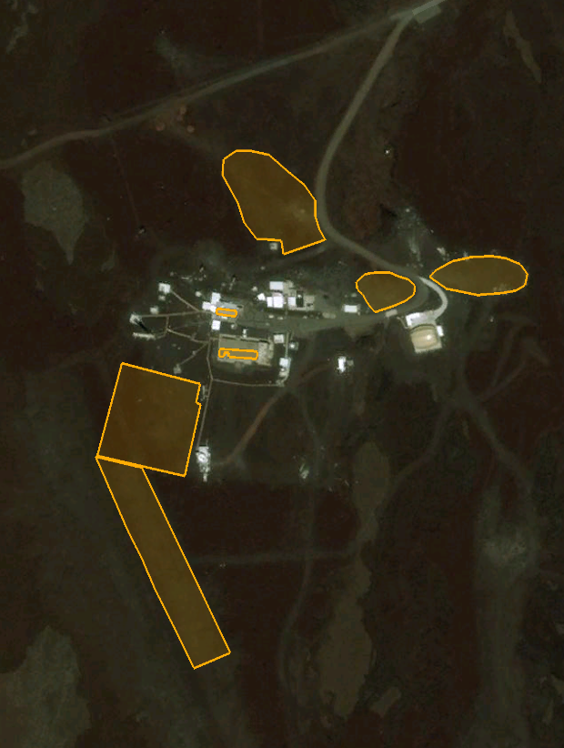
Figure 5: Potential System Placement Aerial Site Total

  - Rooftop NDSC
The NDSC buiding is located centrally on the site, and houses various laboratories, offices, and meeting rooms. This building has a significant amount of equipment that results in high electrical use in the facility. In addition to the laboratory space, there is a rooftop deck where several measurement devices are located. Although some of the rooftop area is used for this equipment deck, there is still a reasonable amount of south facing roof available. The roof is sloped at approximately 18 degrees, which is nearly the optimal tilt for a fixed tilt solar array in Hawaii. According to measurements that were taken at the site, this location has approximately 1180 square feet of rooftop area available. The roof on the NDSC is the original roof that was installed 1997. The roof is in good condition, and is not slated for replacement at this time. The roof material is tin, and with proper maintenance it should last an additional 25 years. The roof has a great orientation, and it is not expected to be significantly shaded from surrounding structures. The NDSC building has a main electrical panel rated at 400 amps, and a main panel breaker rated at 400 amps. In the current configuration, the panel could accept an additional 80 amps of rated current from a solar array. If more capacity is required, either the main breaker would need to be reduced in size, or the panel would need to be upsized. In order to reduce the size of the main breaker, the existing circuits in the building would need to be assessed to determined if they could be carried by a smaller breaker.
Assuming the usability percentage of the site to be 90%, the available area is 1062 square feet. Table 4 outlines the PV system possibilities. The system size is limited by the available roof area, and would be able to supply 8% of the site load. The potential system is laid out below in Figure 6. The cost for this system would be $6.96/W.

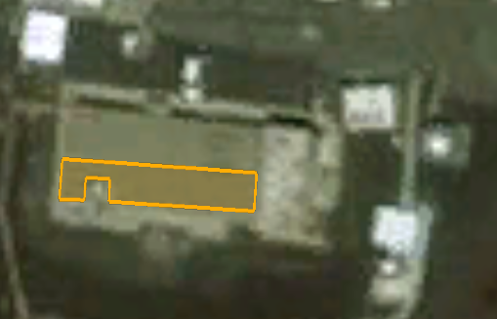
Figure 6. Rooftop NDSC: Recommended PV system placement

Table 4. Rooftop NDSC System Options
System Type | Potential System Size (kW) | Annual Energy Output (kWh) | Annual Cost Savings ($) | Annual O&M ($) | System Cost ($) | Simple Payback (yrs) | Net Present Value ($)
Fixed-tilt w/ incentives | 12 | 22,218 | $9,443 | $208 | $29,124 | 10.7 | $59,944
w/o incentives | 12 | 22,218 | $9,443 | $208 | $83,213 | 3.8 | $114,033

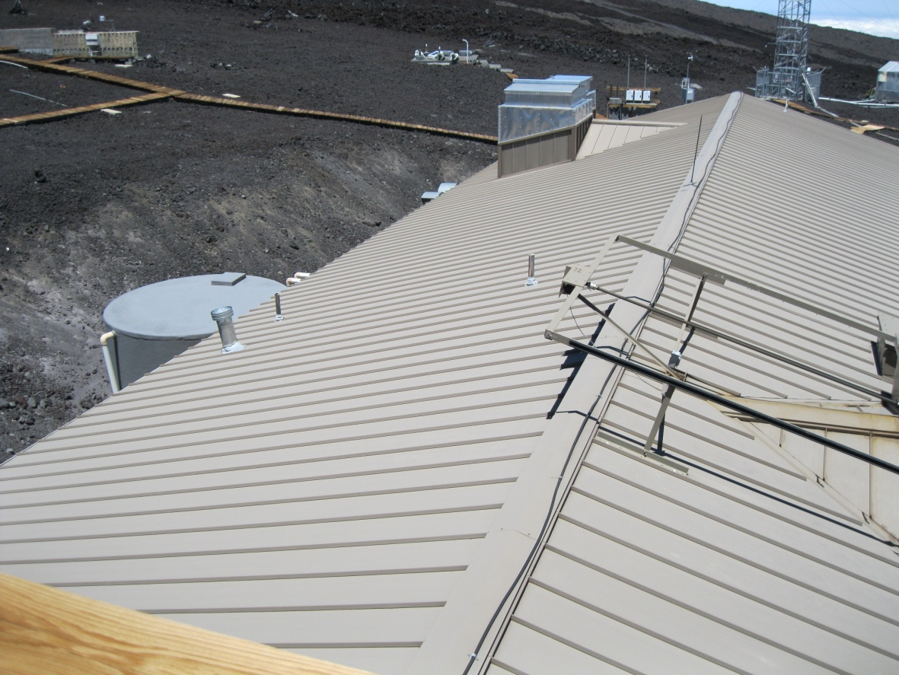
Figure 7. Rooftop NDSC: Roof Image of recommended PV array site
Aspect: Looking West
Credit: Lars Lisell, NREL

  - Rooftop Keeling
The Keeling building is located across the parking lot from the NDSC building. This building is used to house computing equipment at the site, and also contains work stations for Observatory staff both permanent and temporary. The equipment in the building uses a significant amount of energy. The Keeling building has a relatively small roof, but it could potentially be a very good location in which to place a solar array. Like the NDSC, the roof is sloped at approximately 18 degrees. According to measurements that were taken at the site, this location has approximately 500 square feet of rooftop area available. The roof on the Keeling building is the original roof that was installed on the building in 1957. The roof appeared to be in good condition, but it is unclear whether it will last for an additional 25 years. According to the site staff, building rooftops last a very long time at MLO. A system should not be implemented on the Keeling building unless it is determined that the roof will last an additional 25 years, or if the roof is replaced. The roof has a great orientation, and it is not expected to be significantly shaded from surrounding structures. The Keeling building is connected to the meter on the south side of the Butler building, which has a main electrical panel rated at 400 amps and a main panel breaker rated at 400 amps. In the current configuration, the panel could accept an additional 80 amps of rated current from a solar array. If more capacity is required, either the main breaker would need to be reduced in size, or the panel would need to be upsized. Assuming the usability percentage of the site to be 90%, the available area is 450 square feet. Table 5 outlines the PV system possibilities. The system size is limited by the available roof area, and would be able to supply 3% of the site load. The potential system is laid out below in Figure 8. Figure 9 shows a ground view of the Keeling building.
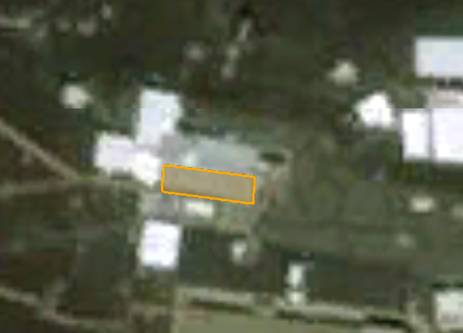
Figure 8. Rooftop Keeling: Recommended PV system placement

Table 5. Rooftop Keeling System Options
System Type | Potential System Size (kW) | Annual Energy Output (kWh) | Annual Cost Savings ($) | Annual O&M ($) | System Cost ($) | Simple Payback (yrs) | Net Present Value ($)
Fixed-tilt w/ incentives | 5 | 9,366 | $3,981 | $92 | $12,817 | 3.30 | $23,728
w/o incentives | 5 | 9,366 | $3,981 | $92 | $36,620 | 9.42 | $47,531

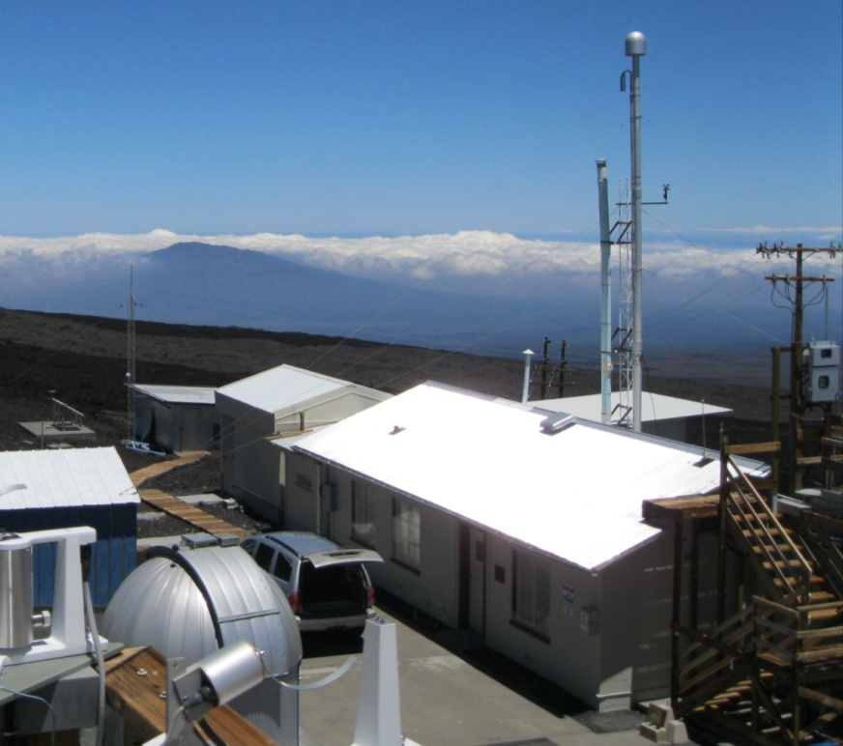
Figure 9. Rooftop Keeling: Roof Image of recommended PV array site
Aspect: Looking Northwest
Credit: Lars Lisell, NREL

  - South Area In Site Boundary
In the southwest corner of the MLO site, there is a large open area that has been flattened and is currently not being utilized. This area has a couple of minor obstructions in the form of a boardwalk and tower guide wires, but the vast majority of the area is open. This area would make an excellent area in which to implement a PV system. The area beyond the area of this parcel is a very rugged lava field that would require extensive site leveling before it would be suitable for a system. Due to the flattened condition of the parcel, a ballast mounted system could be implemented with little or no site preparation. A ballasted system requires no ground penetrations, and stays in place using weights stacked on the PV mounting racks. The racks sit on top of the ground. The proposed area is inside of the MLO site boundary. The electricity produced by the system could be fed into either the meter on the south side of the Butler building, or into the NDSC meter. The area in the image was found using Google Earth.

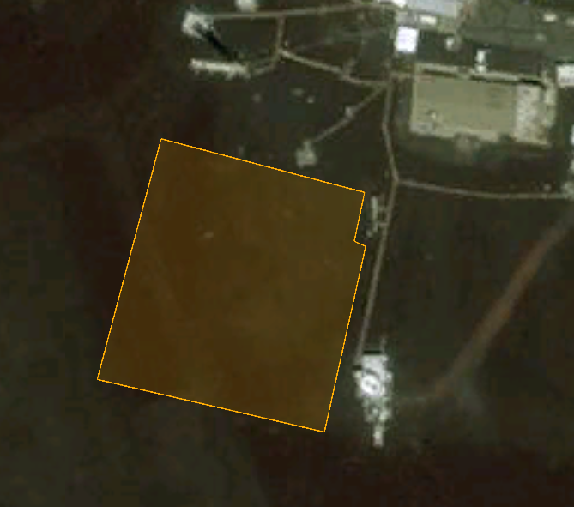
Figure 10. South Area In Site Boundary: Recommended PV system placement

Table 6. South Area In Site Boundary System Options
System Type | Potential System Size (kW) | Annual Energy Output (kWh) | Annual Cost Savings ($) | Annual O&M ($) | System Cost ($) | Simple Payback (yrs) | Net Present Value ($)
Fixed-tilt w/ incentives | 145 | 268,913 | $114,288 | $2,164 | $303,010 | 2.7 | $866,922
w/o incentives | 145 | 268,913 | $114,288 | $2,164 | $865,742 | 7.2 | $1,472,472

Assuming the usability percentage of the site to be 90%, the available area is 30,420 square feet. Table 6 outlines the PV system possibilities. The system size is limited by the available area, and would be able to supply 100% of the site load. The potential system is laid out in Figure 10. Figure 11 shows a ground view of the site. The area has very few sources of shading, with the only significant source along the eastern boundary of the potential site from the NCAR high altitude observatory. The shading from the high altitude observatory will have a minimal impact on the production of the system as can be seen below in Figure 12.

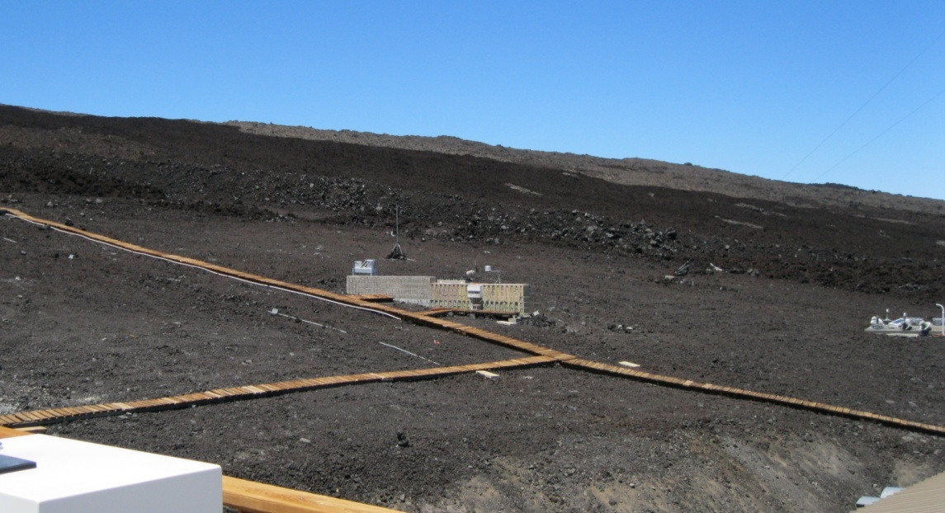
Figure 11. South Area In Site Boundary: Ground view of recommended PV array site
Aspect: Looking Southwest
Credit: Lars Lisell, NREL
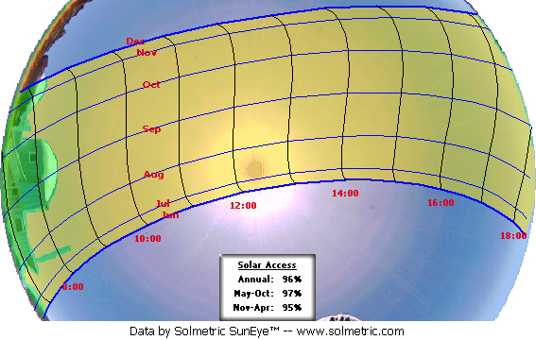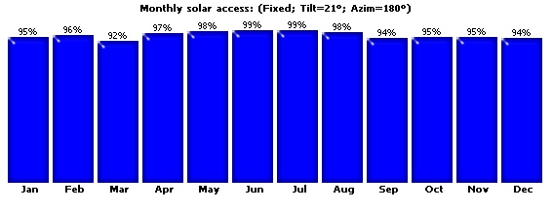
Figure 12. Solar Measurement South Area In Site Boundary

  - South Area Lava Barrier
Just south of the site boundary is an area that has been modified to re-direct the flow of lava in the event that Mauna Loa erupts. The area has been flattened, and the rock has been piled up into large berms in the shape of a “V” to re-direct lava around the MLO site. The result of this action has left a nicely leveled area to the north of the berm. This site would work nicely as a place to implement a ballasted mounted PV system. Since this land is outside of the MLO boundary, it may difficult to get approval to utilize the land. The land outside of the MLO boundary is managed by the Department of Hawaiian Home Lands, so they would need to agree to allow MLO to utilize the land for the life of the system (25 yrs). The electricity produced by the system could be fed into either the meter on the south side of the Butler building, or into the NDSC meter. The area in the image was found using Google Earth.
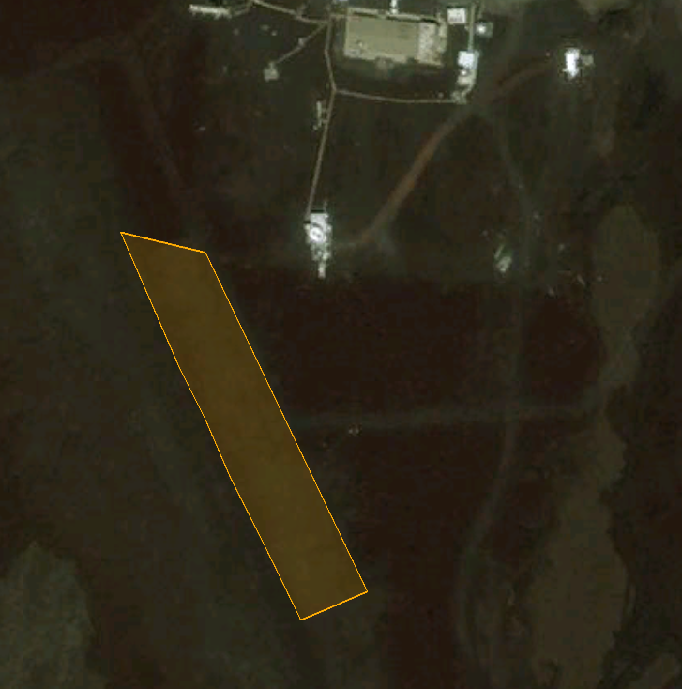
Figure 13. South Area Lava Barrier: Recommended PV system placement

Table 7. South Area Lava Barrier System Options

System Type | Potential System Size (kW) | Annual Energy Output (kWh) | Annual Cost Savings ($) | Annual O&M ($) | System Cost ($) | Simple Payback (yrs) | Net Present Value ($)
Fixed-tilt w/ incentives | 150 | 276,869 | $117,669 | $2,225 | $311,455 | 2.7 | $894,055
w/o incentives | 150 | 276,869 | $117,669 | $2,225 | $889,873 | 7.7 | $1,429,655

Assuming the usability percentage of the site to be 90%, the available area is 31,320 square feet. Table 7 outlines the PV system possibilities. The system size is limited by the electrical load, and would be able to supply 100% of the site load. The potential system is laid out in Figure 13. Figure 14 shows a ground view of the site. The area has very few sources of shading, with the only significant source along the western boundary of the potential site from the berm. The shading from the berm will have a minimal impact on the production of the system as can be seen below in Figure 15.

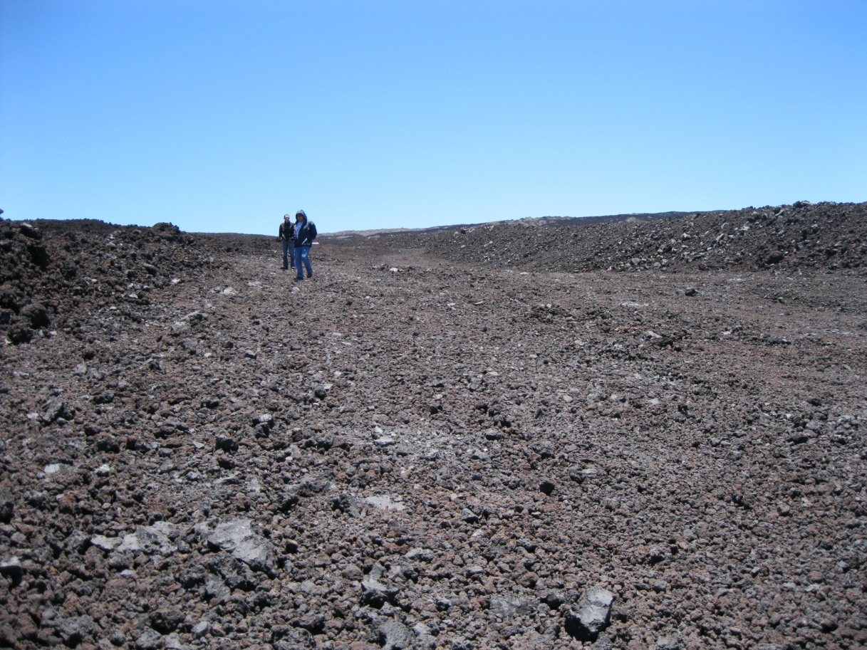
Figure 14. South Area Lava Barrier: Ground view of recommended PV array site
Aspect: Looking South
Credit: Lars Lisell, NREL
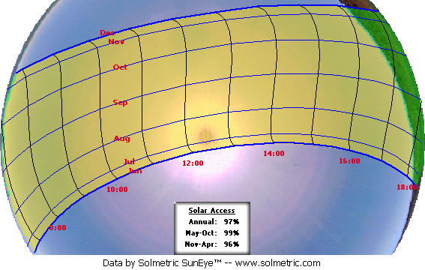
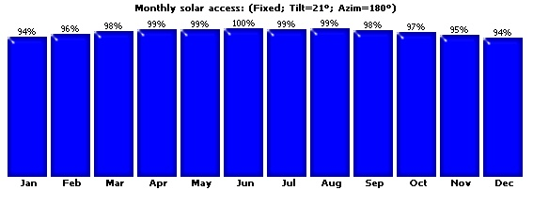
Figure 15. Solar Measurement South Area Lava Barrier

  - North Area Near AMIBA
Just east of the AMIBA structures is an area that has been flattened, leaving a circular area that would be a good site in which to incorporate a PV system. It appeared as though the area was used as a construction staging area at one point, but does not appear to support any activities at this time. This site would work nicely as a place to implement a ballasted mounted PV system. Since this area is partially outside of the MLO boundary, it may difficult to get approval to utilize the land. The land outside of the MLO boundary is managed by the Department of Hawaiian Home Lands, so they would need to agree to allow MLO to utilize the land for the life of the system (25 yrs). The electricity produced by the system could be fed into either the Ground Winds meter or the GONG meter on the north sides of the site. The area in the image was measured using Google Earth.

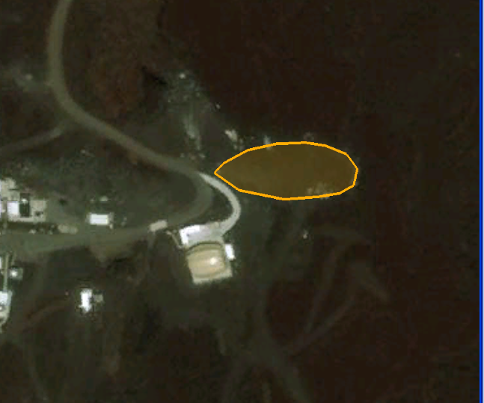
Figure 16. North Area Near AMIBA: Recommended PV system placement

Table 8. North Area Near AMIBA System Options

System Type | Potential System Size (kW) | Annual Energy Output (kWh) | Annual Cost Savings ($) | Annual O&M ($) | System Cost ($) | Simple Payback (yrs) | Net Present Value ($)
Fixed-tilt w/ incentives | 39 | 71,604 | $30,432 | $624 | $87,421 | 2.9 | $211,586
w/o incentives | 39 | 71,604 | $30,432 | $624 | $249,774 | 8.4 | $373,938

Assuming the usability percentage of the site to be 90%, the available area is 8,100 square feet. Table 8 outlines the PV system possibilities. The system size is limited by the electrical load, and would be able to supply 27% of the site load. The potential system is laid out in Figure 16. Figure 17 shows a ground view of the site. The area has very few sources of shading, and it is anticipated that shading will have a minimal impact on the production of the system.

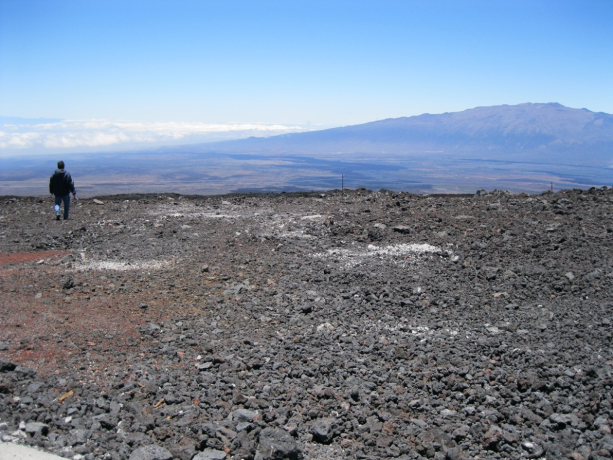
Figure 17. North Area Near AMIBA: Ground view of recommended PV array site
Aspect: Looking Northeast
Credit: Lars Lisell, NREL

  - North Area Along Entrance
To the west across the entrance road from the AMIBA structures, is an area that has been leveled, and could potentially be used as an area in which to implement a ballast mounted PV system. This area has a slight slope, but it could still be used as a place for a small PV system. The location is located on the MLO site, so it would allow the system to be implemented without a land easement or lease. The electricity produced by the system could be fed into either the Ground Winds meter or the GONG meter on the north sides of the site. The area in the image was measured using Google Earth.

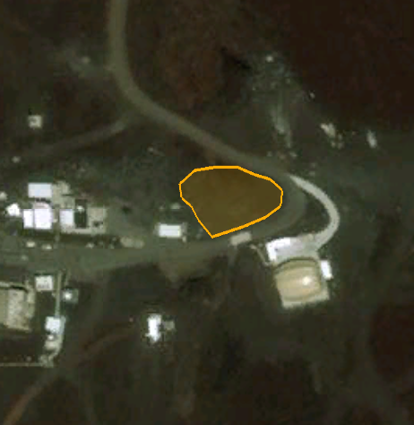
Figure 18. North Area Along Entrance: Recommended PV system placement

Table 9. North Area Along Entrance System Options
System Type | Potential System Size (kW) | Annual Energy Output (kWh) | Annual Cost Savings ($) | Annual O&M ($) | System Cost ($) | Simple Payback (yrs) | Net Present Value ($)
Fixed-tilt w/ incentives | 30 | 55,692 | $23,669 | $493 | $69,036 | 3.0 | $161,589
w/o incentives | 30 | 55,692 | $23,669 | $493 | $197,245 | 8.5 | $289,798

Assuming the usability percentage of the site to be 90%, the available area is 6,300 square feet. Table 9 outlines the PV system possibilities. The system size is limited by available area, and would be able to supply 21% of the meter load. The potential system is laid out in Figure 18. Figure 19 shows a ground view of the site. The area has a small amount of shading present from the surrounding building, but the shading will have a minimal impact on the production of the system as can be seen below in Figure 20.

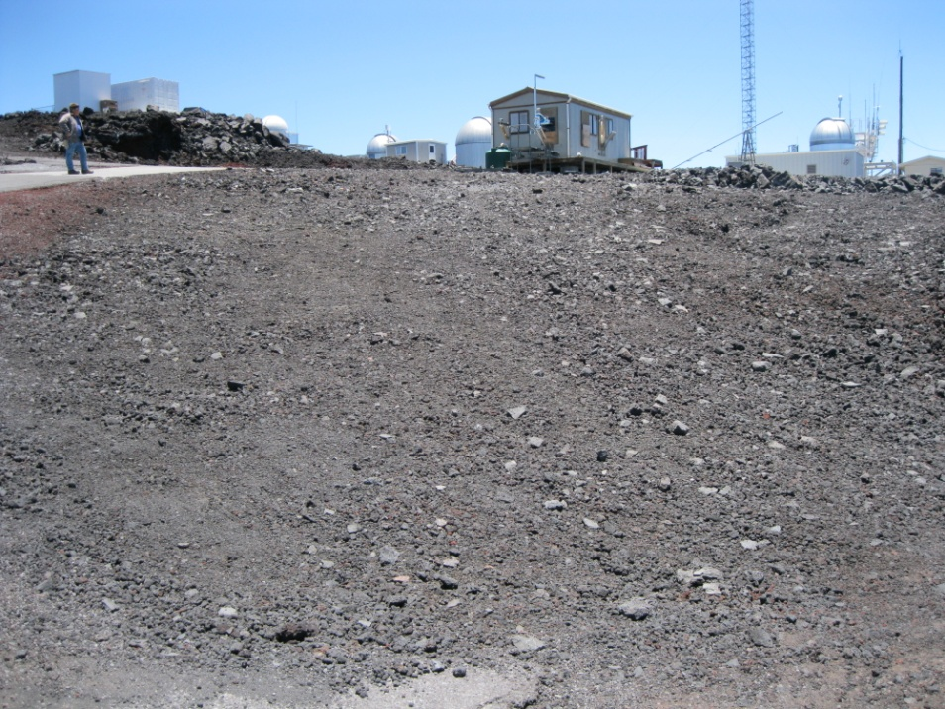
Figure 19. North Area Along Entrance: Ground view of recommended PV array site
Aspect: Looking Southwest
Credit: Lars Lisell, NREL
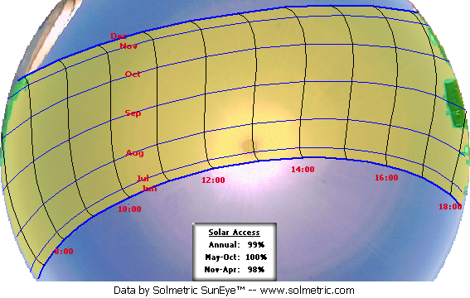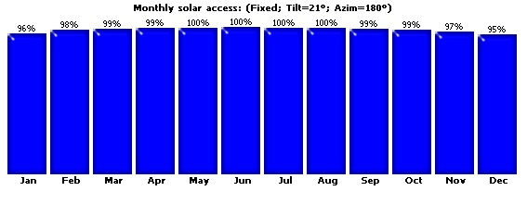
Figure 20. Solar Measurement North Area Along Entrance

  - North Area Along Summit Access
The north area along the summit access road appears to be the location where the fill was hauled as each building was constructed at the MLO site. This has resulted in a large flat area that could potentially be utilized with a ballast mounted PV system. This area is outside of the MLO boundary, but due to the disturbed state of the area it could potentially be less difficult to get the Department of the Hawaiian Home Lands to agree to allow the space to be utilized. The electricity produced by the system could be fed into either the Ground Winds meter or the GONG meter on the north sides of the site. The area in the image was calculated using Google Earth.
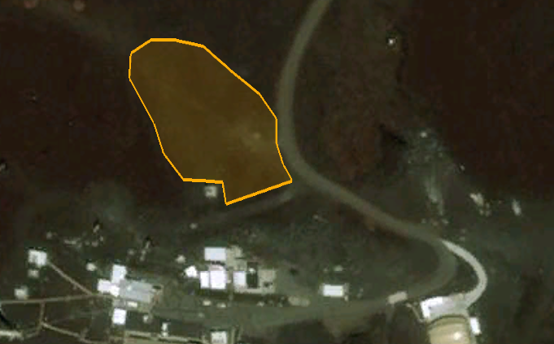
Figure 21. North Area Along Summit Access: Recommended PV system placement

Table 10. North Area Along Summit Access System Options
System Type | Potential System Size (kW) | Annual Energy Output (kWh) | Annual Cost Savings ($) | Annual O&M ($) | System Cost ($) | Simple Payback (yrs) | Net Present Value ($)
Fixed-tilt w/ incentives | 115 | 214,812 | $91,295 | $1,752 | $245,295 | 2.8 | $683,240
w/o incentives | 115 | 214,812 | $91,295 | $1,752 | $700,842 | 8.6 | $1,138,788

Assuming the usability percentage of the site to be 90%, the available area is 24,300 square feet. Table 10 outlines the PV system possibilities. The system size is limited by available area, and would be able to supply 80% of the meter load. The potential system is laid out in Figure 21. Figure 22 shows a ground view of the site. The area has a small amount of shading present from the surrounding structures, but the shading will have a minimal impact on the production of the system as can be seen below in Figure 23.

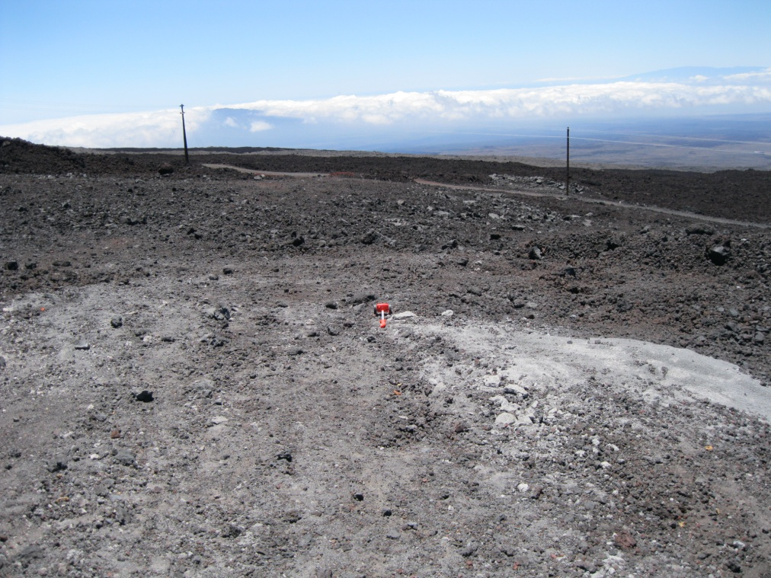
Figure 22. North Area Along Summit Access: Ground view of recommended PV array site
Aspect: Looking Northwest
Credit: Lars Lisell, NREL
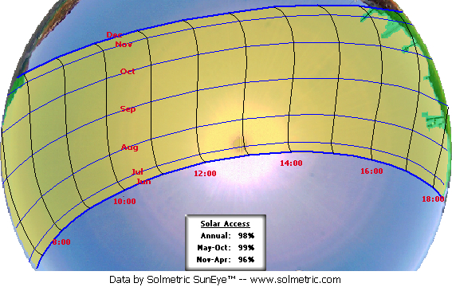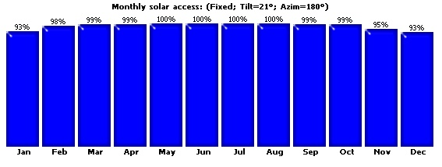
Figure 23. Solar Measurement North Area Along Summit Access

  - Summary System that Could Offset MLO Energy
Seven sites in or near the site boundary of MLO were considered, all of which were found suitable for PV systems. The economics of the potential systems were analyzed using an electric rate of $0.425/kWh, as well as incentives that are offered by the State of Hawaii and by the serving utility, Hawaii Electric Light Company (HELCO). Table 11 summarizes the system performance and economics of a potential system that would produce enough power to meet the entire site electrical load. The data is presented both with and without incentives that are available in Hawaii.
Table 11. PV System Performance and Economics by System Type
System Type | Potential System Size (kW) | Annual Energy Output (kWh) | Annual Cost Savings ($) | Annual O&M ($) | System Cost ($) | Simple Payback (yrs) | Net Present Value ($)
Fixed-tilt w/ incentives | 145 | 268,913 | $114,288 | $2,689 | $303,010 | 2.7 | $866,922
w/o incentives | 145 | 268,913 | $96,809 | $2,689 | $865,742 | 7.7 | $1,472,472

- Economics and Performance
  - Assumptions and Input Data for Analysis
For this analysis, the following input data were used. The installed cost of the PV system was estimated based on system size. Through tracking of installed costs on all of the projects that the integrated applications office is involved with, a cost curve vs. system size was developed. This cost curve can be seen below in Figure 24. The data was adjusted based on the location cost index for Hawaii. These prices include the PV array and the balance-of-system components for each system, including the inverter and electrical equipment, and installation. The economics of grid-tied PV depend on incentives, the cost of electricity, and the solar resource, including panel tilt and orientation. For this analysis, the cost of electricity was taken from the site utility bills from 2008-2009. The consumption and rates were averaged to produce a value of $0.36/kWh that was used for the analysis.
A system DC to AC conversion of 79% was assumed. This includes losses in the inverter, wire losses, PV module losses, and losses due to temperature effects, for example. Figure 24 summarizes average system installation costs for grid-tied PV systems in the United States in 2008; however, the costs have dropped significantly since 2008. A PV production calculation tool developed at NREL was used to calculate energy performance.

Figure 24. Installation cost for grid-tied PV systems 2009-2010

Identifying and leveraging state incentives and grants is an important part of making PV systems cost effective. A private, tax-paying entity that owns PV systems a can qualify for a 30% federal business energy investment tax credit (ITC) and accelerated depreciation on the PV system, which are worth about 15%. The total potential tax benefits to the tax-paying entity are about 45% of the system cost. Alternatively, the tax-paying entity can opt to receive a cash payment of up to 30% of eligible project costs from the U.S. Department of Treasury Section 1603 program once the eligible system is in service. The American Reinvestment and Recovery Act (ARRA) of 2009 allows for this cash payment in lieu of the ITC. To receive the payment from Treasury, construction of the property must begin no later than December 31, 2010. Because the federal government does not pay taxes, private ownership of the PV system would be required to capture tax incentives or Section 1603 grant payments.
  - Incentives and Financing Opportunities
The Database of State Incentives for Renewables and Efficiency (DSIRE) provides a summary of net metering, interconnection, and other incentives available to Hawaii utility customers. The utility for the MLO is Hawaii Electric Light Company (HELCO).
Renewable energy systems, including commercial solar PV, are subject to interconnection rules promulgated at the state level. Interconnection rules were found on the DSIRE Web site that requires that customers send in an application the HELCO to receive approval for a system interconnection prior to system implementation. The utility should be contacted directly to determine what requirements are in place. Hawaii has an aggressive renewable portfolio standard (RPS). It sets the goal of 40% of total electricity generation from renewable energy by 2030. This standard does not have a set-aside for solar energy.
Hawaii has a net-metering policy for residential and commercial systems up to 100 kW in capacity that generate electricity using photovoltaics (PV), wind, biomass, hydropower or small hydropower. Net excess generation will be carried over to a customer-generator's next bill, for up to 12 months, as a kilowatt-hour (kWh) credit (DSIRE). In order to determine if a larger system could potentially be entered into a net metering agreement, the utility should be contacted directly. By spreading the electrical production over the four meters located at MLO, all systems implemented can be kept under the 100 kW limit for net metering.
Currently, Hawaii has a very attractive set of incentives. The state offers a 35% tax credit up to $500,000 for commercial properties. In order to take advantage of these tax credits, the system owner must pay Hawaii state taxes. However, through power purchase agreements, an outside tax-paying entity can capture the credits and then sell the electricity to the site for an agreed upon price. The same thing goes for the 30% tax credit federal incentive. A full list of incentives can be found in Appendix B.
There are several options for financing a solar PV system. A potential alternative financing option is the third-party ownership, power-purchase agreement. The agreement works by having a solar contractor install, finance, and operate the system, while the site purchases the electricity generated by the system. The system is financed by the solar contractor, the payments are paid by the electricity, and the RECs that are sold to the utility. This way, the economics of the system can be improved as the solar contractor is able to capture the tax credits. In this configuration, the land that the solar system is on would need to be leased to the third party owner of the system for the duration of the contract.

- Conclusions and Recommendations
The sites considered in this report are all feasible areas in which to implement solar PV system systems.
It is recommended that the party ultimately responsible for facilitating the implementation of a PV system contact HELCO ahead of time and get the paperwork started on interconnection and net-metering agreements to identify if there will be any barriers before the system construction begins. According to the site production calculations, the most cost effective system in terms of return on investment would be a large ground mounted system with crystalline silicon panels. This is the lowest cost option due to the fact that the installed cost of a system goes down on a $/kW basis as system size go up. The site may want to consider roof mounted systems in order to preserve open areas at MLO, but it is likely implementing these systems will increase the payback period slightly. Due to the fact that MLO has 4 electrical meters on the site, it may be beneficial to put several smaller systems around the site in order to place the systems in convenient grid connection locations. Based on data from 2008 – 2009 the following system sizes would be required to meet the electrical loads of each of the 4 meters.
Table 12. Electrical Meter Usage
Meter Location | % of site electrical consumption | System Size (kW)
MLO Meter #121979 | 36% | 52
Ground Winds Meter #93023 | 3% | 5
NDSC Meter #88120 | 39% | 56
GONG Meter #85060 | 22% | 32
Total | 100% | 145

If the system sizes were limited to the values in Table 12, this would also eliminate the requirement for a grid study to be performed by the utility company due to all of the systems being under the 100 kW net metering limit. Crystalline technology is a proven technology that can be successfully implemented with a ballasted-style mounting system.
When the system goes out to bid, a design-build contract should be issued that requests the best performance (kWh/yr) at the best price and which allows vendors to optimize system configuration, including panel slope. A third-party ownership, power-purchase agreement or purchasing the system outright will provide the most feasible way for a system to be implemented on these sites.
In the coming years, increasing electrical rates and increased necessity for clean power will continue to improve the feasibility of implementing solar PV systems at these sites.

Appendix A. Assumptions for Calculations*
Table A-1. Assumptions for Calculations
ECM# | Site Location | System Size (kW) | Annual Energy Savings (kWh/yr) | Implementation Costs ($) | Annual Operation and Maintenance Costs ($) | Annual Cost Savings ($) | Simple Payback Period (yrs) | Discounted Payback Period (yrs) | Net Present Value (NPV) | Savings to Investment Ratio (SIR)
1.1 | NDSC Rooftop w/o incentives | 12 | 22,218 | $83,213 | $208 | $9,443 | 9.01 | 10.1 |  | 2.84
1.2 | Keeling Rooftop w/o incentives | 5 | 9,366 | $36,620 | $92 | $3,981 | 9.42 | 10.6 |  | 2.72
1.3 | South Area in Site Boundary w/o incentives | 145 | 268,913 | $865,742 | $2,164 | $114,288 | 7.72 | 8.52 |  | 3.30
1.4 | South Area Lava Barrier w/o incentives | 150 | 276,869 | $889,873 | $2,225 | $117,669 | 7.71 | 8.5 |  | 3.31
1.5 | North Area Near Amiba w/o incentives | 39 | 71,604 | $249,774 | $624 | $30,432 | 8.38 | 9.32 |  | 3.05
1.6 | North Area Along Entrance w/o incentives | 30 | 55,692 | $197,245 | $493 | $23,669 | 8.51 | 9.48 |  | 3.00
1.7 | North Area Along Summit Access w/o incentives | 115 | 214,812 | $700,842 | $1,752 | $91,295 | 7.83 | 8.64 |  | 3.26
Total w/o incentives |  | 496 | 919,474 | $3,023,309 | $7,558 | $390,776 | 8.37
1.1 | NDSC Rooftop w/ incentives | 12 | 22,218 | $29,124 | $208 | $9,443 | 3.15 | 3.25 |  | 8.11
1.2 | Keeling Rooftop w/ incentives | 5 | 9,366 | $12,817 | $92 | $3,981 | 3.30 | 3.40 |  | 7.76
1.3 | South Area in Site Boundary w/ incentives | 145 | 268,913 | $303,010 | $2,164 | $114,288 | 2.70 | 2.78 |  | 9.43
1.4 | South Area Lava Barrier w/ incentives | 150 | 276,869 | $311,455 | $2,225 | $117,669 | 2.70 | 2.77 |  | 9.45
1.5 | North Area Near Amiba w/ incentives | 39 | 71,604 | $87,421 | $624 | $30,432 | 2.93 | 3.02 |  | 8.70
1.6 | North Area Along Entrance w/ incentives | 30 | 55,692 | $69,036 | $493 | $23,669 | 2.98 | 3.07 |  | 8.57
1.7 | North Area Along Summit Access w/ incentives | 115 | 214,812 | $245,295 | $1,752 | $91,295 | 2.74 | 2.82 |  | 9.30
Total w/ incentives |  | 496 | 919,474 | $1,058,158 | $7,558 | $390,776 | 2.93

Table A-2. Other Assumptions, including Assumptions for Costs and System Types
Cost Assumptions  Variable | Quantity of Variable | Unit of Variable
Cost of Site Electricity | $0.425 | $/kWh
Annual O&M (fixed) | 0.25% | % of installed cost
System Assumptions  System Type | Annual energy  (kWh/kW) | Energy Density  (W/ft.²)
Ground fixed | 1874 | 4.0
Roof Mounted | 1874 | 10.0
Other Assumptions | 1 acre | 43,560 sq ft.
 | 1 MW | 1,000,000 W
 | Ground utilization | 90% of available area
 | Incentives | Federal Tax Credit  Hawaii State Incentives

Appendix B. Renewable Energy Incentives*
Table B-1. Renewable Energy Development Incentives and Financing Tools Applicable to Photovoltaics
Agency | Incentive Name | Incentive (I), Finance Tool (FT) | Public | Private | Funding Range
DOE | Loan Guarantee Program | FT | X | X | Not specified
DOE | Renewable Energy Production Incentive (REPI) | I | X |  | 2.1 cents per kilowatt
HUD | Community Development Block Grants (CDBG) | I | X |  | Based on community needs formula
Treasury | 1603 Renewable Energy Grant Program  *option to ITC | I |  | X | 30% of the cost basis of the renewable energy project
Treasury | Business Energy Investment Tax Credit (ITC) *option to 1603 | I |  | X | 30% of project expenditures
Treasury | Clean Renewable Energy Bonds (CREB) | FT | X |  | Varies
Treasury | Modified Accelerated Cost-Recovery System (MACRS) | FT |  | X | Various depreciation deductions
Treasury | Qualified Energy Conservation Bonds (QECB) | FT | X |  | Varies
USDA | Rural Energy for America Program (REAP) Grants | I | X | X | 25% of project cost. Payment range $2.5K-$500K
USDA | Rural Energy for America Program (REAP) Loan Guarantees | FT | X | X | Up to 75% of project costs. Max $25M/Min $5K
* Sources: Database of State Incentives for Renewable Energy and Efficiency 2009; and U.S. Department of Housing and Urban Development 2009

Table B-2. State Rebates for Commercial-Sector PV Projects
The programs included here are ongoing rebate and grant programs administered by state agencies or by third-party organizations on behalf of state governments. In addition to the programs highlighted above, about 75 utilities in the United States offer PV rebates. In some states, such as Colorado and Arizona, solar rebates are available nearly statewide from utilities that must comply with state renewable portfolio standards, but these are not shown in the table. Finally, programs that are purely performance-based, such as the state of Washington's production incentive and California's feed-in tariff, are not included in this table.
State | Program Name | Incentive Amount | REC Ownership | Funding Source
California | California Solar Initiative | Varies by sector and system size | Remains with project owner | Rate-payer funds
California | CEC - New Solar Homes Partnership | Varies. Incentives are adjusted based on expected performance, and will decline over time based on the total installed capacity. | Remains with system owner | Rate payer funded
Connecticut | CCEF - On-Site Renewable DG Program | For for-profit owners: $3.00/W for first 100 kW, $2.00/W for next 100 kW. Not-for-profit system owners: $4.50/W for first 100 kW, $4.00/W for next 100 kW. Additional $0.10/W premium for buildings that meet LEED Silver certification; CCEF also compensates system owners based on the estimated present value of the system's RECs. | RECs transfer to CCEF for systems 50 kW-PTC and larger. CCEF compensates system owners based on estimated present value of the system's RECs over 15 yrs. | Connecticut Clean Energy Fund (public benefits fund)
Delaware | Green Energy Program Incentives | Delmarva: 25% of installed cost (35% for non-profits, government); DEC: 33.3% of installed cost; Minis: 33.3% of installed cost, except 25% for Dover, Seaford; PV system cost may not exceed $12/W | Remains with project owner | Green Energy Fund (Delmarva), DEC Renewable Resources Fund, Municipal Utility Green Energy Fund (public benefits funds)
District of Columbia | Renewable Energy Incentive Program | $3/W DC for first 3 kW; $2/W DC for next 7 kW; $1/W DC for next 10 kW | Remains with system owner | Sustainable Energy Trust Fund (public benefits fund)
Florida | Solar Energy System Incentives Program | $4/watt DC | Remains with system owner | General Revenue Funds (appropriated annually)
Illinois | DCEO - Solar and Wind Energy Rebate Program | NOTE (02/2010): Funding for FY 2010 has been fully allocated; no additional rebates are available. Residential and commercial: 30%; Non-profit and Public: 50% | Remains with customer/producer | Illinois Renewable Energy Resources Trust Fund (public benefits fund)
Maine | Solar and Wind Energy Rebate Program | $2/W AC | Remains with customer/producer | Funded by assessment of up to 0.005 cents/kWh on transmission and distribution utilities; Plus $500,000 per fiscal year (FY2009-10 and FY2010-11) for two years using American Recovery and Reinvestment Act of 2009 (Recovery Act) funding.
Maryland | Mid-Size Solar Energy Grant Program | $500/kW for first 20 kW DC; $250/kW for next 30 kW; $150/kW for next 50 kW | Remains with project owner | Recovery Act
Maryland | Solar Energy Grant Program | $1.25/W DC for first 2 kW; $0.75/W for next 6 kW; $0.25/W for next 12 kW | Remains with project owner | General Revenue Funds (appropriated annually); FY 2009 funds supplemented with RGGI proceeds
Massachusetts | CEC - Commonwealth Solar II Rebates | $1/W DC base; $0.10/W DC adder for MA components; $1.00/W DC adder for moderate home value or for moderate income | Remains with project owner | Massachusetts Renewable Energy Trust
Massachusetts | CEC - Commonwealth Solar Stimulus | $1.50/W (DC) for first 25 kW; $1.00/W (DC) for > 25 kW to 100w kW; $0.50/W (DC) for > 100 kW to 200 kW | Remains with project owner | The American Recovery and Reinvestment Act (ARRA)
Nevada | NV Energy – Renewable Generations Rebate Program | (2010-2011 program year) Residential and small business: $2.30/W AC; Public Facilities/Schools: $5.00/W AC | NV Energy | Rate-payer funded
New Jersey | New Jersey Customer-Sited Renewable Energy Rebates | Standard residential: $1.55/W DC; Residential w/energy efficiency: $1.75/W DC; Residential New Construction: varies by efficiency, $1.00 - 1.75/W DC; Standard non-residential: $0.90/W DC; Non-residential w/efficiency: $1.00/W DC | Remains with project owner | New Jersey Societal Benefits Charge (public benefits fund)
New Jersey | Renewable Energy Manufacturing Incentives (for End-Use PV Installations) | Varies by equipment type, sector, and system size; Ranges from $0.05 - $0.55/W DC. | Not applicable | New Jersey Societal Benefits Charge (public benefits fund)
New York | NYSERDA - PV Incentive Program | Residential (first 5 kW): $1.75/W DC; Non-Residential (first 50 kW): $1.75/W DC; Non-profit, government, schools: (first 25 kW): $1.75/W DC; Bonus incentive: $0.50/W for Energy Star Homes and BIPV systems | First 3 years: NYSERDA, thereafter customer/generator | RPS surcharge
Ohio | ODOD - Advanced Energy Program Grants - Non-Residential Renewable Energy Incentive | $3.50 per DC watt, may be reduced by shading | Not specified | Ohio Advanced Energy Fund
Oregon | Energy Trust - Solar Electric Buy-Down Program | Residential: $1.50/W DC for Pacific Power; $1.75/W DC for PGE; Residential, Third Party: $1/W DC for Pacific Power; $1.25/W DC for PGE; Commercial: $1/W - $0.50/W for Pacific Power; $1.25/W - $0.75/W for PGE; nonprofit/government: $1.25/W - $0.75/W for Pacific Power; $1.50/W - $1/W for PGE | Residential: RECs for first 5 yrs. owned by customer/producer; Non-residential: RECs for first 5 yrs. owned by consumer/producer, Energy Trust owns RECs for years 6-20 | Energy Trust of Oregon (public benefits fund)
Pennsylvania | Pennsylvania Sunshine Solar Rebate Program | Residential: $2.25/W DC; Commercial: $1.25/W DC for first 10 kW, $1.00/W DC for next 90 kW, $0.75/W DC for next 100 kW; Low-Income: 35% of installed costs | Not specified, but net metering customers generally retain title to RECs | Pennsylvania Energy Independence Fund (state bonds)
Puerto Rico | Puerto Rico - State Energy Program - Sun Energy Rebate Program | Solar PV: Residential and Commercial $4/watt (DC) Solar PV: Governmental $8/watt (DC) | Not addressed | The American Recovery and Reinvestment Act State Energy Program funds
Tennessee | Tennessee Clean Energy Technology Grant | 40% of installed cost | Not specified | State of Tennessee Economic and Community Development Energy Division
Vermont | Vermont Small-Scale Renewable Energy Incentive Program | Individuals/Businesses: $1.75/watt DC; Multi-family, low-income: $3.50/W DC | Not addressed | Utility settlement funds and the Vermont Clean Energy Development Fund
Wisconsin | Focus on Energy - Renewable Energy Cash-Back Rewards | Residential/Business: $1.00/kWh/1-yr.; non-profit/government: $1.50/kWh/1-yr.; (Estimated 1-yr. production using PV Watts). Efficiency First participants: add $0.25/kWh/1-yr. | Not addressed | Focus on Energy Program
Source: Database of State Incentives for Renewable Energy and Efficiency 2010
Please note: The information provided in this table presents an overview of state incentives, but it should not be used as the only source of information when making purchasing decisions, investment decisions, tax decisions or other binding agreements. For more information about individual programs listed above, visit the DSIRE Web site at http://www.dsireusa.org/.
Table B-3. State Tax Credits for Commercial-Sector PV Projects
State | Program Name | Eligible Recipients | Incentive Amount | Third-Party Owner Eligible | Non-Profit/Government Eligible
Arizona | Non-Residential Solar & Wind Tax Credit (Corporate) | Any non-residential installation is eligible, including those for non-profits and governments. Individuals, corporations and S corporations and partnerships may claim the credit. Third party financiers/installers/mfrs. of eligible system may claim the credit. | 10% | Yes | Yes
Florida | Renewable Energy Production Tax Credit | A non-residential taxpayer with facility placed in service or expanded after May 1, 2006. The credit is for electricity produced and sold by the taxpayer to an unrelated party during a given tax year. Florida corporate income taxpayers who own an interest in a general partnership, limited partnership, limited liability company, trust or other artificial entity that owns a Florida renewable energy facility can apply for this credit. | $0.01/kWh | Not specified | Not specified
Georgia | Clean Energy Tax Credit (Corporate) | Any GA taxpayer who has constructed, purchased, or leased renewable energy property and placed it in service. | 35% | Yes | Not specified
Hawaii | Solar and Wind Energy Credit (Corporate) | Hawaii taxpayer that files a corporate net income tax return or franchise tax return; Credit may be claimed for every eligible renewable energy technology system that is installed and placed in service. Third-party taxpaying entities may claim the credit if they install and own a system on a commercial taxpayer’s building or on a non-profit or government building. Multiple owners of a single system may take a single tax credit. The credit is apportioned between the owners in proportion to their contribution to the system's cost. | 35% | Yes | Yes
Iowa | Renewable Energy Production Tax Credits (Corporate) | Producers or purchasers of renewable energy from qualified facilities; Installations must be at least 51% owned by a state resident or other qualifying owner, and placed in service on or after July 1, 2005 and before January 1, 2012. Electricity must be sold to an unrelated person to qualify for the tax credit. | $0.015/kWh for 10 years after energy production begins. | Yes, credits may be claimed by system owner or by purchaser of electricity. System owners must meet certain eligibility criteria. | Schools and cooperative associations are eligible owners. Credits may be transferred or sold one time.
Kentucky | Renewable Energy Tax Credit (Corporate) | Any installation on a dwelling unit or on property that is owned and used by the taxpayer as commercial property | $3.00/watt (DC) | Not specified | Not specified
Kentucky | Tax Credit for Renewable Energy Facilities | Companies that build or renovate facilities that utilize renewable energy | 100% Kentucky income tax or limited liability entity tax | Not specified | Not specified
Louisiana | Tax Credit for Solar and Wind Energy Systems on Residential Property (Corporate) | A taxpayer who purchases and installs an eligible system or who purchases a new home with such a system already in place | 50% | No | No
Maryland | Clean Energy Production Tax Credit (Corporate) | All individuals and corporations that sell electricity produced by a qualified facility to an unrelated person; Net metering arrangements qualify. | $0.0085/kWh for 5 years after facility is placed in service. | Not specified | No
Montana | Alternative Energy Investment Tax Credit (Corporate) | A corporation, partnership, or small business corporation that makes a minimum investment of $5,000 | 35% | No | No
New Mexico | Advanced Energy Tax Credit (Corporate) | Any taxpayer | 6% | No. | No.
New Mexico | Renewable Energy Production Tax Credit (Corporate) | A taxpayer who holds title to a qualified energy generator that first produced electricity on or before January 1, 2018; or a taxpayer who leases property upon which a qualified energy generator operates from a county or municipality under authority of an industrial revenue bond and if the qualified energy generator first produced electricity on or before January 1, 2018. | Varies annually over 10 years; $0.027/kWh average | Not specified | Not specified
New Mexico | Solar Market Development Tax Credit | Residents and non-corporate businesses, including agricultural enterprises | 10% of purchase and installation costs | No | No
North Carolina | Renewable Energy Tax Credit (Corporate) | Any NC taxpayer who has constructed, purchased, or leased renewable energy property and placed it in service. | 35% (distributed 7% per year for 5 years for non-residential installations) | Yes. For leasing, a taxpayer may take credit for property that the taxpayer leases if written verification is received from the owner that states that owner will not take credit for renewable energy installation. | No
North Dakota | Renewable Energy Tax Credit | Corporate taxpayers filing a North Dakota income tax return. System must be installed on a building or on property owned or leased by the taxpayer in North Dakota. | 15% (distributed 3% per year for 5 years) | A pass-through entity that installs the system at a property it owns or leases is considered the taxpayer. The credit amount allowed is determined at the pass-through entity level and must be passed through proportionally to corporate partners, shareholders or members. | No
Oklahoma | Zero-Emission Facilities Production Tax Credit | Any non-residential taxpayer who sells electricity to an unrelated person; Any nontaxable entities, including agencies of the State of Oklahoma, may transfer their credit to a taxpayer. | $0.0050/kWh for first 10 years of operation | Yes | Yes, nontaxable entities, including agencies of the State of Oklahoma or political subdivisions thereof, can take advantage of the tax credit by transferring it to a taxable entity.
Oregon | Business Energy Tax Credit | Trade, business or rental property owners who pay taxes for a business site in Oregon are eligible for the tax credit. The business, its partners or its shareholders may use the credit. A project owner also can be an Oregon non-profit organization, tribe or public entity that partners with an Oregon business or resident who has an Oregon tax liability. This can be done using the pass-through option. | 50% (distributed 10% per year for 5 years) | Yes | A project owner can be a non-profit, tribe or public entity that partners with a business or resident to take advantage of the pass-through option. The pass-through option allows a project owner to transfer the 35 percent Business Energy Tax Credit project eligibility to a pass-through partner for a lump-sum cash payment. The pass-through option rate for five-year Business Energy Tax Credits effective October 1, 2003 is 25.5 percent. The pass-through option rate for one-year Business Energy Tax Credits (those with eligible costs of $20,000 or less) effective October 1, 2003 is 30.5 percent.
Puerto Rico | Puerto Rico - Solar Tax Credit (Corporate) | Any Puerto Rican taxpayer who has acquired, assembled, and installed eligible solar electric equipment. | 75% during FY 2007-08 and 2008-09; 50% during FY 2009-10 and FY 2010-11; 25% starting FY 2011-12 | Not specified | Potentially; the tax credit may be transferred, sold or otherwise given to "any other person."
Rhode Island | Residential Renewable Energy Tax Credit (Corporate) | Rhode Island taxpayer who (1) owns, rents, or is the contract buyer of the dwelling(s) served by the system; The dwelling or dwellings must be in the main or secondary residence of the person who applies for the tax credit, or of a tenant; or (2) owns, or is the contract buyer of the system and pays all or part of the cost of the system; or (3) is the contractor that owns the dwelling for speculative sale in which the system is installed | 25% | Yes. Credit is available to RI taxpayers who are the contract buyers of eligible systems and pay all or part of the cost of the system. | No
South Carolina | Solar Energy and Small Hydropower Tax Credit (Corporate) | Taxpayers who purchase and install an eligible system in or on a facility owned by the taxpayer | 25% for 2010; was 30% in 2009 | No | No
Utah | Renewable Energy Systems Tax Credit (Corporate) | Any company that owns a qualified system | Residential: 25%; Commercial: 10% | No | No
Vermont | Business Tax Credit for Solar (Corporate) | Corporations that pay corporate income tax in Vermont that do not receive grants/funding from CEDF. | 30% of expenditures (for systems placed into service on or before 12/31/2010). | Not specified | No
Source: Database of State Incentives for Renewable Energy and Efficiency 2010b
Please note: The information provided in this table presents an overview of state incentives, but it should not be used as the only source of information when making purchasing decisions, investment decisions, tax decisions or other binding agreements. For more information about individual programs listed above, visit the DSIRE Web site at http://www.dsireusa.org/.
Table B-4. State Policy and Incentive Comparisons: Massachusetts, North Carolina, and Colorado
MASSACHUSETTS
Incentive | Specifics | Sector
New Generation Energy - Community Solar Lending Program | $5,000 - $100,000 | Private
Massachusetts DOER - Solar Renewable Energy Credits (SRECs) | $300 - $600 (per MWh) | Both
Mass Energy Consumers Alliance - Renewable Energy Certificate Incentive |  | Both
Renewable Energy Property Tax Exemption | 100% exemption for 20 years | Private
CEC - Commonwealth Solar II Rebates | $5,500 (per host customer), up to $250,000 per parent company | Both
CEC - Commonwealth Solar Stimulus | $162,500 per project (up to $1 million for any host customer entity, or parent company/organization) | Both
Policy | Specifics | Sector
Massachusetts - Net Metering |  | Both
Renewable Energy Trust Fund | Public Benefit Fund | Private
Renewable Portfolio Standard | In-state PV: Mandated Target of 400 MW
NORTH CAROLINA
Incentive | Specifics | Sector
Renewable Energy Tax Credit (Corporate) | 35% / $2.5 million per installation | Private
Local Option - Revolving Loan Program for Renewable Energy and Energy Efficiency | Interest rate can be no more than 8% | Private
Local Option - Clean Energy Financing | Debt repaid via property assessment | Private
Renewable Energy Tax Credit (Personal) | 35% / $2.5 million per installation | Private
NC GreenPower Production Incentive | Payments contingent on program success | Both
Progress Energy Carolinas - SunSense Commercial PV Incentive Program | $0.18/kWh for 20 years | Both
TVA - Generation Partners Program | $1000 plus $0.12/kWh above the retail rate for solar and $0.03/kWh above the retail rate for all other eligible renewables | Private
Property Tax Abatement for Solar Electric Systems | 80% of appraised value | Both
North Carolina Green Business Fund | Grant varies | Both
Energy Improvement Loan Program (EILP) | State Loan Program $500,000 maximum | Both

Policy | Specifics | Sector
North Carolina - Net Metering
Renewable Energy and Energy Efficiency Portfolio Standard | Solar: 0.2% by 2018
COLORADO
Incentive | Specifics | Sector
Boulder County - ClimateSmart Loan Program | Commercial: $3,000 - $210,000 | Private
Local Option - Improvement Districts for Energy Efficiency and Renewable Energy Improvements | Debt repaid via property assessment | Both
Renewable Energy Property Tax Assessment | Varies | Private
Boulder - Solar Sales and Use Tax Rebate | 15% refund on sales and use tax for the solar installation | Private
Local Option - Sales and Use Tax Exemption for Renewable Energy Systems | Varies | Private
Sales and Use Tax Exemption for Renewable Energy Equipment | 100% | Both
New Energy Economic Development Grant Program | Competitive grant, Recovery Act funded | Private
Xcel Energy - Solar*Rewards Program | $2/W DC with a maximum rebate of $200,000; REC payments will step down over time as certain MW levels are reached for each system classification. | Private
Policy | Specifics | Sector
Colorado - Net Metering |  | Private
Mandatory Green Power Option for Large Municipal Utilities | Allows retail customers the choice of supporting emerging renewable technologies | Both
Boulder - Climate Action Plan Fund | Public Benefits Fund | Private
Renewable Energy Standard | Solar-electric (IOUs only): 4% of annual requirement (0.8% of sales in 2020); half of solar-electric requirement must be located on-site at customers' facilities
Solar, Wind and Energy-Efficiency Access Laws
Source: Database of State Incentives for Renewable Energy and Efficiency 2009
Table B-5. Key Policy Comparison for Subject States
RPS | Colorado | Massachusetts | North Carolina
Policy In Place | Yes | Yes | Yes
Effective Date | 12/1/04 | 4/1/02 | 2/29/08
Targets | 20% by 2020; Solar-electric: 4% of annual requirement | 15% by 2020 and an additional 1% each year thereafter; in-state PV mandated target of 400MW | 12.5% of 2020 retail electricity sales by 2021 with .2% from solar
PBF | Colorado | Massachusetts | North Carolina
Policy In Place | City of Boulder Only | Yes | No
Effective Date | 4/1/07 | 3/1/98 | N/A
Charge | Maximum tax rates for electricity customers:  Residential: $0.0049/kWh  Commercial: $0.0009/kWh  Industrial: $0.0003/kWh | $0.0005 per kilowatt-hour (0.5 mill/kWh) in 2003 and in each following year | N/A
NET METERING | Colorado | Massachusetts | North Carolina
Policy In Place | Yes | Yes | Yes
Effective Date | 7/2/06 | 1982 | 10/20/05
System Capacity | 120% of the customer's average annual consumption | 2 MW for "Class III" systems; 1 MW for "Class II" systems; 60 kW for "Class I" systems | 1 MW
REC Ownership | Customer owns RECs (must be relinquished to utility for 20 years in exchange for incentives) | Customer owns RECs | Utility owns RECs (unless customer chooses to net meter under an unfavorable demand tariff)
TAX INCENTIVES APPLICABLE TO PV | Colorado | Massachusetts | North Carolina
 | Property-Amount varies depending on rate set annually by the Division of Property Taxation | Property-100% exemption for 20 years | Corporate 35%  Property – 85% of appraised value
Effective Date | 2001 | 1984 | Corporate 1/1/09  Property 7/1/08
Source: Database of State Incentives for Renewable Energy and Efficiency 2010c

http://nreldev.nrel.gov/gis/pdfs/eere_pv/eere_pv_h_hawaii.pdf
http://nreldev.nrel.gov/gis/pdfs/eere_wind/eere_windon_h_hawaii.pdf
ASTM Standard E1038, 2005, "Standard Test Method for Determining Resistance of Photovoltaic Modules to Hail by Impact with Propelled Ice Balls ," ASTM International, West Conshohocken, PA, 2005, DOI: 10.1520/E1038-05. http://www.astm.org/Standards/E1038.htm
Go Solar California, a joint effort of the California Energy Commission and the California Public Utilities Commission, provides consumer information for solar energy systems. See http://www.gosolarcalifornia.org/ equipment/pvmodule.php.
ANSI/IEEE Std 929-1988 IEEE Recommended Practice for Utility Interface of Residential and Intermediate Photovoltaic (PV) Systems (http://standards.ieee.org/reading/ieee/std_public/description/powergen/929-1988_desc.html)
Inverters, Converters, Controllers and Interconnection System Equipment for Use With Distributed Energy Resources: UL 1741 (http://ulstandardsinfonet.ul.com/scopes/1741.html)
Go Solar California approves inverters.
2008 “RS Means Building Construction Cost Data”
This program was codified in Section 1603 of the American Recovery and Reinvestment Act of 2009.
http://www.dsireusa.org/incentives/index.cfm?re=1&ee=1&spv=0&st=0&srp=1&state=WV.

