The Role of Systematic Earth Observations

in the Global Stocktake
Version: 25 February 2022

Ad Hoc Coordination Group for the Systematic Observation Community’s Contribution to the Global Stocktake
This synthesis paper was coordinated by representatives of organizations and consortia from across the systematic observation community. The views expressed do not reflect the views and opinions of any single entity, but rather are intended to synthesize some of the main areas where the systematic observation community can provide information relevant to the Global Stocktake.

Table of Contents
Introduction 6
Background 6
Role of systematic observations in the Global Stocktake 7
Content of this synthesis paper 9
The Global Climate Observing System (GCOS) 10
The global observing system: successes and issues 11
Successes 11
Issues 12
Mitigation – Systematic Earth Observations Supporting Greenhouse Gas Emission Reductions 17
Current Capabilities for Atmospheric GHG Measurements 19
Direct Measurements of GHGs from Ground-based Stations 19
Direct Measurements of GHGs from Airborne Platforms 21
Estimates of Column-average CO2 and CH4 from Ground-based Remote sensing 22
Estimates of Column-average CO2 and CH4 Dry Air Mole Fractions from Space-based Sensors 23
Deriving CO2 and CH4 Fluxes from Atmospheric Measurements with Atmospheric Inverse Modeling Systems 28
Pilot Top-down CO2 and CH4 Budgets to Support the First Global Stocktake 31
Constraining Atmospheric CO2 emissions from Compact Sources 42
Changes Anticipated in the Ocean Sink as it Responds GHG Emission Reductions and Climate Change 42
Future Developments in GHG Budget Estimates 43
Improved Inventories of Agriculture, Forestry, and Other Land Use (AFOLU) 44
The CEOS AFOLU Effort – Compiling space-based products to support Mitigation and Adaptation objectives of the Global Stocktake 45
Agriculture 46
Land Cover 48
Forests as Above Ground Biomass 50
Other Land Uses 53
Towards harmonization the AFOLU products and long term AFOLU Roadmap 54
Summary and Conclusions on the Role of Systematic Observations Supporting Mitigation 55
Adaptation – Systematic Earth Observations to improve resilience to the adverse impacts of climate change 56
The role of systematic observations in adaptation 60
Value chain 60
Importance of Global observations 62
Role of reanalysis 63
Observing and projecting changes, and global climate risks 63
Hydrological Observations 63
Biodiversity observations for climate adaptation 64
Using EO-based information, tools and indicators to measure climate change impacts on biodiversity at the global level 65
Measuring the outcomes of the implementation of adaptation policies in relation to biodiversity protection 66
Global Data Exchange 68
Earth System Modeling 69
Information and Services 70
Climate Information 70
Early Warning Systems 71
Seasonal timescales 74
Annual to decadal timescales 75
State of adaptation efforts: climate services 76
Assessing overall progress made in achieving the global goal on adaptation 79
Using observations to monitor implementation of adaptation 79
Climate services-related adaptive capacity 80
Improved adaptation outcomes from actions based on systematic observations and associated services 80
Systematic observations of hazardous events and impacts 81
Cataloging Hazardous Events (CHE) 81
Cataloging associated impacts 82
Applications towards the development of a GGA indicator 83
Summary and Conclusions on the Role of Systematic Observations and Services supporting Adaptation 83
Means of Implementation - Systematic Earth Observations to support climate finance allocation, technology and capacity development for climate action 85
Systematic Observations and associated climate science information to improve Parties’ access to Climate Finance 85
Climate science basis for climate action 85
Climate science for climate finance 86
Results achieved from support to Parties 87
Earth observation-related initiatives with private climate finance 91
Technology Development and Transfer 94
Frontier technologies for Earth observations in support of climate decision making 96
Capacity Building 99
Using Earth Observations to support and enhance adaptation in developing countries 99
International Earth observation data policies supporting local adaptation 100
Supporting local data processing, forecast, early warnings and advisories 101
Capacity Building to Encourage the Use of the Top-Down Atmospheric Budgets 102
Collaborative Interface with National GHG Inventory teams and experts in the AFOLU sector 104
Summary and Conclusions on the Role of Systematic Observations supporting Means of Implementation 105
Cross-cutting issues - Systematic Earth Observations to support reporting and best practices across thematic areas, including Loss and Damage 107
Evidence and methodologies towards assessing and addressing implementation and support needs, particularly in developing countries 107
Methodologies to support NAPs 107
Support to NDCs and MRV systems 108
The Cross-cutting nature of AFOLU observations responding to the evolving needs for MVS 108
Enhanced understanding, action and support for averting, minimizing and addressing loss and damage through Systematic Earth Observations 109
Monitoring slow onset events 109
Monitoring extreme events, notably hydro-meteorological hazard events 110
Good practices, experience and potential opportunities to enhance climate action through the application of Earth observations 114
Enhancing adaptation action by indigenous peoples and local communities in climate action through Earth observations 131
The GEO Indigenous Alliance 131
Summary and Conclusions on the Role of Systematic Observations for Cross-cutting issues 135
Summary of Contributions of Systematic Observations and Path Forward 136
References Cited 139

Introduction

Background
To strengthen the global response to the threat of climate change, while encouraging sustainable development and efforts to reduce poverty, Article 2 of the Paris Agreement identifies three objectives:
- Mitigation: Limit global average temperature increases to well below 2 °C above pre-industrial levels and pursue efforts to limit these increases to less than 1.5 °C to reduce the risks and impacts of climate change;
- Adaptation: Increase the ability to adapt to the adverse impacts of climate change and foster climate resilience and low GHG emissions development, without threatening food production; and
- Means of Implementation: Align finance flows to encourage low GHG emissions and climate-resilient development.
These three objectives directly address the threats posed by anthropogenic climate forcing, climate response, and climate impact identified by the latest assessment reports from the Intergovernmental Panel on Climate Change (IPCC). Recognizing that anthropogenic emissions of greenhouse gases (GHGs) are the primary source of anthropogenic climate forcing, Article 4 of the Agreement requires Parties to undertake rapid reductions in GHG emissions to achieve a balance between GHG emissions and removals by sinks. Article 5 reinforces Article 4 by advocating the conservation of sinks and reservoirs of GHGs and providing incentives for reducing emissions from deforestation and forest degradation. To implement this strategy, Article 4 requires that Parties prepare and communicate their successive nationally determined contributions (NDCs) to the global response to climate change under the United Nations Framework Convention on Climate Change (UNFCCC) at five-year intervals. These NDCs are expected to reflect greater ambition over time and to report GHG emissions and removals in a way that promotes environmental integrity, transparency, accuracy, completeness, comparability and consistency.
To track progress toward the MItigation objectives of the Agreement within the context of an enhanced transparency framework, Article 13 requires that each Party submit a Biennial Transparency Report, including a national inventory of anthropogenic GHG emissions by sources and removals by sinks. Article 14, specifies that the Conference of Parties (COP) shall periodically take stock of the implementation of the Paris Agreement to assess collective progress towards achieving its purpose and long-term goals. These global stocktakes (GSTs) are conducted at five-year intervals, starting in 2023. The outcome of each GST is then used to enhance the collective ambition towards achieving the long-term goals of the Agreement and strengthen international cooperation for climate action.
Article 7 recognizes that the Adaptation goals listed in Article 2 constitute a global challenge that will require international cooperation and asks for the establishment of a global goal on Adaptation. This Article reinforces the need to share information and lessons learned and to strengthen scientific knowledge through climate research, systematic observation of the climate system and early warning systems to inform climate services and support decision making. Individual Parties are required to formulate national adaptation plans (NAPs) that assess climate change impacts and vulnerabilities and prioritize actions in a way that accounts for vulnerable people, places, and ecosystems.
To promote the mitigation of GHG emissions while fostering sustainable development, the Means of Implementation objectives described in Articles 9, 10 and 11 focus on minimizing loss and damage, improving climate finance, technology transfer and capacity building, respectively. Early warning systems and emergency preparedness are critical for adaptation and minimizing loss and damage. Optimizing finance flows requires identifying developing countries that are particularly vulnerable to climate change that also have significant capacity constraints. The GSTs could play a critical role in the implementation of these objectives by identifying opportunities for transformative climate actions, promoting effective implementation of sustainable climate actions and facilitating countries’ access to finance by helping to quantify risks and benefits. A block diagram summarizing the relationships between the Articles of the Paris Agreement, the objectives listed above and the specific actions requested is shown in Figure 1.1.
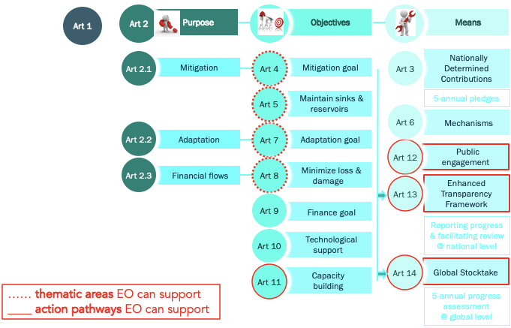

Figure 1.1: The role of Earth Observations (EO) in the Paris Agreement © M. Hegglin, University of Redding, UK.

Role of systematic observations in the Global Stocktake
Systematic observations of the Earth’s atmosphere and surface from ground-based, airborne and space-based sensors are critical for supporting the overall goals of the Convention and the objectives specified in Article 2 of the Paris Agreement. For Mitigation, direct measurements of surface and atmospheric temperatures provide the primary means of tracking increases in the global average temperature. Similarly, observations of atmospheric GHG concentrations can be analyzed to track trends in their net emissions and removals, in accordance with the best available science. Top-down budgets of GHG emissions and removals derived from these atmospheric measurements can be used to assess the completeness and transparency of the bottom-up methods used to compile the biennial inventory reports described in Article 13. High spatial resolution observations of land cover type, above-ground biomass and disturbances associated with fires, droughts, and severe weather can provide direct support for the development of bottom-up emissions inventories for agriculture, forestry and other land use (AFOLU).
Systematic observations are the foundation of a climate services value chain that connects observations to decision making to support mitigation and adaptation action. Through this value chain, systematic observations provide the data that underpin climate models, forecasts on various timescales, and tailored products and services in support of mitigation and adaptation decision-making. Systematic observations of the Earth thus provide the scientific basis for identifying climate hazards and impacts and for designing, implementing, and tracking the performance of adaptation investments and strategies. For example, AFOLU observations can be combined with observations of weather, water and climate that are coordinated through the World Meteorological Organization (WMO) Integrated Global Observing System (WIGOS) to identify changing patterns of exposure to emerging climate hazards such as floods, droughts, heat waves and other climate extremes. Data on past, present and projected future climate conditions based on these observations can also be analyzed to identify opportunities to enhance adaptive capacity. Operational hydro-meteorological systems and services founded on systematic observations are proven technologies that assist to reduce loss and damage, strengthen resilience and reduce the overall vulnerability to climate change, contributing to the Means of Implementation objectives of the Agreement. Free and open access to these observations also supports the enhanced transparency framework described in Article 13.
Recognizing these opportunities, the international Earth observation and modeling communities have enthusiastically embarked on a broad range of activities to support the GST. Individual research teams, laboratories and national and multinational agencies refocused research projects to provide products that address one or more aspects of the Mitigation, Adaptation or Means of Implementation objectives of the Paris Agreement.
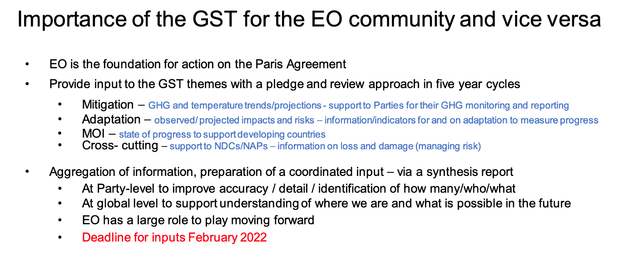

Content of this synthesis paper
This synthesis paper summarizes the current state of the art and near-term plans for systematic observations of the Earth that specifically address the Guiding Questions compiled by the Chairs Subsidiary Body for Scientific and Technical Advice (SBSTA) and the Subsidiary Body for Implementation (SBI) in their September 15, 2021, non-paper titled “Preparing for the First Global Stocktake”. We start with a quick overview of the Global Climate Monitoring System (GCOS). The Mitigation section describes the current state-of-the-art in top-down atmospheric GHG measurement and analysis methods for budgets emissions and removals on local, national and global scales. It also identifies high-resolution datasets that could be used to develop or validate bottom-up AFOLU emissions inventories. The Adaptation section highlights the role of weather, climate, and biosphere observations on and for adaptation, modeling capabilities and research needed to implement climate services that can identify emerging climate hazards at sub-national to national scales and to forecast their evolution on daily to decadal time scales to reduce vulnerability to climate change and guide sustainable development. The Means of Implementation section focuses on the role of systematic observations to support improved access to climate finance by developing countries as well as resilient investments by the sustainable finance sector. Furthermore, this section illustrates how the Systematic Observation community is promoting related technology development and transfer including cloud computing, and building capacity to monitor and address mitigation and adaptation through EO for an effective implementation. The Cross-cutting section covers issues related to support to Parties in developing their national reporting including NDCs and NAPs, as well as enabling action on Loss and Damage and managing risks with systematic observations, best practices, and action undertaken by Indigenous Peoples through the use of EO-based information and applications.

The Global Climate Observing System (GCOS)
The Global Climate Observing System (GCOS) was established in 1992 to coordinate the climate observations for improving climate science and prediction, supporting policy development such as mitigation and adaptation, and for providing public information. GCOS regularly reviews the status of climate observations and publishes plans for their improvement. Global climate observations are made by systems owned and managed by a wide variety of organizations from the National Meteorological and Hydrological Services (NMHSs) coordinated by WMO, Ocean Observations coordinated by the Global Ocean Observing System (GOOS), satellite observations coordinated by the CEOS/CGMS Joint Working Group on Climate, a range of Global Terrestrial Networks, to smaller national observations and academia.
While there are many climate-related variables that can be measured, GCOS has established a basic set of Essential Climate Variables (ECV) that are needed. These cover the atmosphere, oceans, hydrosphere, cryosphere and biosphere and aim to allow monitoring of the carbon and water cycles and the energy balance.
GCOS has just published its 5th status report reviewing how well each essential climate variable (ECV) is being observed^{[1]}.
Use Case 2.1: GCOS ECVs: Essential Climate Variables

An Essential Climate Variable (ECV) is a physical, chemical or biological variable or a group of linked variables that critically contributes to the characterization of Earth’ s climate . GCOS created the concept of ECVs more than two decades ago and currently specifies 54 ECVs.

ECV datasets provide the empirical evidence needed to understand and predict the evolution of climate, to guide mitigation and adaptation measures, to assess risks and enable attribution of climate events to underlying causes, and to underpin climate services. They are required to support the work of the UNFCCC and the IPCC.

The global action required to adequately monitor each ECV is captured in the regularly issued GCOS Implementation Plan, the next of which is planned in 2023. Progress against the Implementation Plan is captured in the GCOS Status Report.

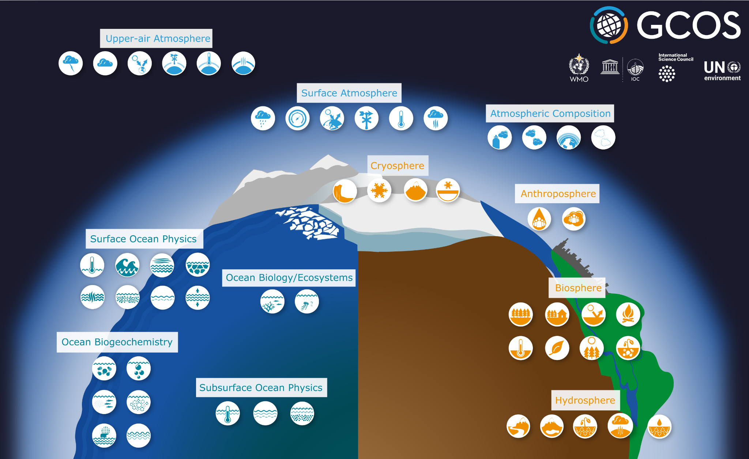
Figure 2.1: Scope of GCOS ECVs.

The global observing system: successes and issues

Successes
There have been many improvements in climate observations in the last 5-10 years. This effort needs to be maintained and supported by sustainable, long-term, and adequate finance. The major improvements include:
∙ Satellite observations have improved their coverage both spatially, temporally and in terms of observed variables. Satellite data are accessible and well curated. Many ECVs, especially terrestrial ECVs, such as land cover, leaf area index and FAPAR are now available from satellites, providing a near-global coverage with good resolution.
∙ WMO and its worldwide network of NMHS ensure the required long-term monitoring, with established practices and instruments, for many ECVs in the atmospheric domain. Much of these data are exchanged internationally and support weather and climate modeling.
∙ Observations of atmospheric variables have further improved in the past decade thanks to new in situ observations from the ground and from commercial aircraft.
∙ Most ground-based networks are well-managed and their data archives are appropriately stewarded such as the National centers for Environmental Information (NCEI) hosted by NOAA in the US; the National Snow and Ice Data Center in the US; International Comprehensive Ocean-Atmosphere Data Set (ICOADS) and many other data centers. The Copernicus Climate Change Service (C3S) also provides access to data and derived products as well as tools to use the data. More specifically C3S now provides access to surface marine meteorological weather reports and observations made by merchant and naval ships, drifting buoys and other platforms and vessels over the global ocean and data collected from land surface meteorological observations across the globe. Data are available at the observational level and also at daily and monthly aggregations as well as access to data from reference networks such as GRUAN .
∙ GCOS and WMO are now working together to establish a reference network for atmospheric and land surface meteorological observations, which will be the surface equivalent to the Global Climate Observing System (GCOS) Reference Upper-Air Network (GRUAN).
∙ The ocean observing community is working to structure ocean observations in a fit-for-purpose observing system, with agreement on best practices for observations and data and meta-data standards.
∙ It was decided to expand the Argo program to the full water column and under sea ice, including biogeochemical variables. These subsurface measurements are critical to monitor and forecast the climate system.
∙ Technological innovations have contributed to expanding the ocean observing system and its capability, in particular with development of autonomous platforms and suitable sensors for a range of ECVs.

Issues
The GCOS Status Report has, however, highlighted four main areas of concern; persistent geographical gaps in observations; lack of assured long-term support for some observing systems; not every ECV has a global data center providing free and open access to data; and the need to ensure better support for the UNFCCC Paris Agreement and policy development in the future.
The GCOS report on the Status of the Global Climate Observing System 2021 documents significant gaps in the global climate observing network. The long-term continuity of some satellite observations is not assured. Gaps include:
∙ No follow up mission for Aeolus (wind profiles) is planned;
∙ No continuity is assured for cloud radar and lidar on research satellites;
∙ Only one limb sounder with similar capabilities to the Aura Microwave Limb Sounder (MLS) is planned. The MLS provides near-global coverage every day for water vapor vertical profiles from the upper troposphere through the mesosphere but has now exceeded its expected lifetime;
∙ High-inclination altimetry is still problematic with only two research satellites flying (CryoSAT-2 and ICESat-2). In the future, European missions Copernicus Polar Ice and Snow Topography Altimeter (CRISTAL) and Copernicus Imaging Microwave Radiometer (CIMR) would extend operational monitoring capabilities to the late 2020s (if confirmed). Sentinel-3A/B altimeter data could be optimized for sea ice in the future;
∙ High-latitude sea-ice thickness monitoring is at risk (when CryoSat-2 and ICESat-2 or, for thin ice <50 cm, SMOS, stop working) and a gap might occur if CRISTAL is delayed; and
∙ Additional needs include monitoring of lower tropospheric ozone (to supplement the limited coverage of surface and to determine statistically significant trends), stratospheric CH4 profiles globally.
There is a regional imbalance of some satellite observations. In high mountain areas satellite data acquisition of cryospheric observations is poor. For certain atmospheric ECVs in polar regions, satellites have poor or no coverage.
Sustained funding is needed for in situ observations. While many atmospheric observations have sustained long-term funding, most ocean and terrestrial observations are supported through short-term research funding, with a typical lifetime of a few years, leaving the development of long-term records vulnerable. This is particularly true for parameters that are not traditionally monitored for weather prediction. Since these observations are executed by a large range of actors, a functional and effective observing system for climate needs appropriately funded support and coordination bodies are essential. Many otherwise successful projects have not led to long-term sustained improvements. One clear message from the GCOS Regional Workshops is that most of the projects in developing countries that have a component devoted to observations have not led to sustainable long-term improvements in the observational capacity of these countries due to lack of resources and planning. More sustainable solutions are needed such as the proposal for WMO’s Global Basic Observing Network (GBON) and the Systematic Observations Financing Facility (SOFF) discussed in the final section of this report, below.
There are still gaps in the global coverage of in situ observations.
∙ In situ observations for almost all the ECVs are consistently deficient over certain regions, most notably parts of Africa, South America, Southeast Asia, a situation that has not improved since the 2015 GCOS Status Report (GCOS-195);
∙ Large gaps still exist in ocean observations (Figure 7), especially the Southern Ocean, ice-covered regions and the polar oceans, continental boundaries, and marginal seas. Near global coverage (60ºS–60ºN) of the upper 2,000 m has been achieved since 2007 due to the international Argo network. The upper 2000 m captures roughly 90% of the anthropogenic change in ocean heat content over the last 2 decades, but the deep ocean was missing. It was decided to expand the Argo program to the full water column (Deep Argo) and under sea ice, as subsurface measurements are critical to monitor and forecast the climate system. The objective is to implement a standing Deep Argo array of 1228 floats by 2025. More regular sampling by high-quality oceanographic cruises and an increase in the deployment of observing platforms are needed, in particular along continental boundaries, the polar oceans and marginal seas. Ocean conditions affecting the loss of ice from Greenland and the Antarctic need to be better monitored to improve projections of future rates of ice loss and sea level rise.

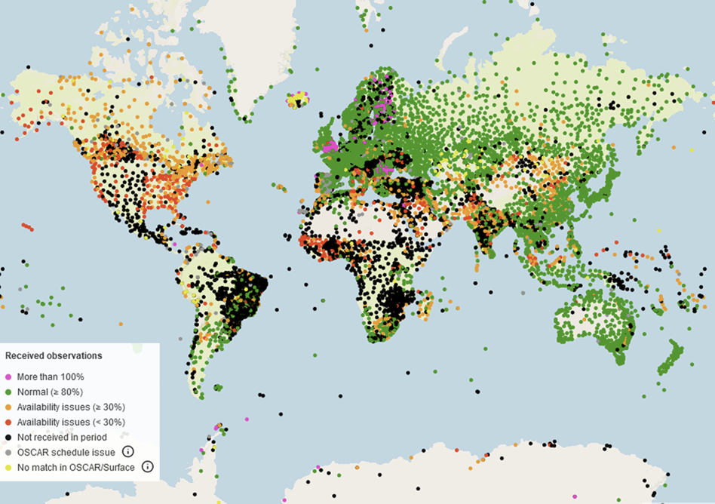
Figure 2.2: Global data coverage example: Surface pressure observations exchanged for global NWP, March 31 2021, 18 UTC, against GBON requirements; Stations in green: 100% reports, orange: Min. 25% reports, red: sporadic reports; black: no reports; (source: WIGOS Data Quality Monitoring System).
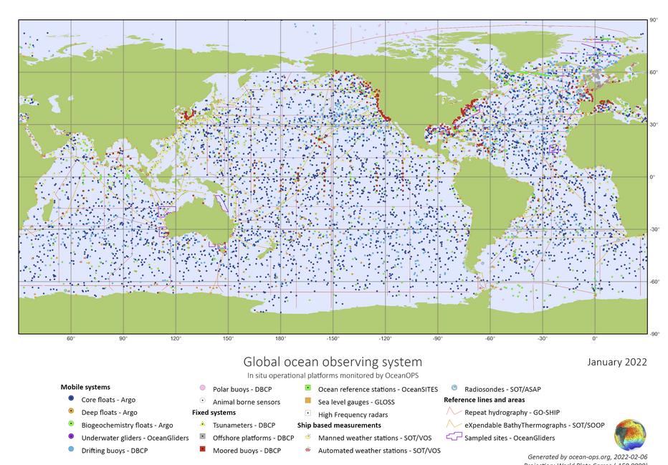
Figure 2.3: Global Ocean data coverage example: snapshot of the status of in situ ocean observing platforms that are part of Global Ocean Observing System (GOOS) Observations Coordination Group (OCG) networks, tracked by the OceanOPS centre; (source: OceanOPS ocean-ops.org).
On-ice in situ observations remain a challenge due to logistical difficulties. Improving both quality and coverage of surface flux measurements of heat, carbon, freshwater, and momentum is necessary.
Historical climate observations are needed as long-term climate records are essential to understand the changes in climate that can be difficult to detect compared to annual variability. Long data records are also essential to fully assess the current level of exposure to natural climate variability and associated extreme event; something that represents the natural first step in the assessment of future climate risks. Data may need to be rescued from paper copies or archaic digital formats (e.g. satellite data). Data rescue activities include the ongoing process of preserving data that are of risk of being lost due to deterioration of the medium and digitizing current and past data into computer compatible form for easy access (I-DARE, 2019; I-DARE (2019) Available at: https://www.idare-portal.org/content/inter national-data-rescue-i-dare-portal). These activities need to be adequately planned and funded with the results openly and freely available. In February 2020, Copernicus Climate Change Service (C3S) launched a new Data Rescue Portal which aims to make historical observations available via the Climate Data Store. Ultimately, C3S’s goal is to combine assets from archives all around the world to make one comprehensive dataset that anyone can use, containing every single observation that has ever been found anywhere. Such activity by historical climatologists has resulted in many datasets of meteorological records being rescued/digitized from all over the world. New approaches including citizen science and classroom-based approaches, if widely deployed, may help achieve digitization steps at the required temporal and spatial scale.
GCOS is currently producing a new Implementation Plan to address these issues that will be published in mid-2022. A public review will be held in early 2022 and we encourage wide participation in this review.

Mitigation – Systematic Earth Observations Supporting Greenhouse Gas Emission Reductions
Guiding Questions:
1. What are the past and present trends of greenhouse gas (GHG) emissions by sources and removals by sinks -and their underlying drivers- and mitigation efforts undertaken by Parties -and their impacts on emissions and removals,28 including based on the information referred to in Article 13, paragraph 7(a), and Article 4, paragraphs 7, 15 and 19, of the Paris Agreement (para 36(a))?
3. What are the trends of the concentration of GHGs in the atmosphere and global average temperature and what global emission pathways are consistent with the goals set out in Articles 2 paragraph 1 (a) and Article 4, paragraph 1?
Since the beginning of the industrial era, fossil fuel combustion, land use change and other human activities have increased the atmospheric concentration of carbon dioxide (CO₂) by more than 50%, from about 277 parts per million (ppm) in 1750 to over 415 ppm in 2021. A much larger increase would have been observed if the Earth’s natural carbon cycle, including absorption by the ocean and photosynthetic uptake by plants, had not removed over half of the CO₂ emitted by these anthropogenic emissions. Over this same period, human activities have increased atmospheric methane (CH₄) concentrations by more than 160%, from values near 0.72 to more than 1.88 ppm. The atmospheric concentrations of other well-mixed GHGs, including nitrous oxide (N₂O) and halocarbons (i.e., CFC-11, CFC-12, CFC-113 and HCFC-22) have also increased dramatically over this time period. These changes in atmospheric composition affect the Earth’s energy balance and are now the primary drivers of climate change, with anthropogenic CO₂ and CH₄, alone, contributing more than 90% of the present-day global warming. Rapidly reducing these emissions is the principal focus of the Mitigation objectives of the Paris Agreement.
To support the first GST, Parties to the Paris Agreement are compiling national inventories of GHG emissions and removals from sectors defined in the 2006 IPCC Guidelines for National Greenhouse Gas Inventories (IPCC 2006). These sectors include Energy, Industrial Processes and Product Use (IPPU), AFOLU, and Waste. Each sector is subdivided into categories. For example,, land uses (Forrest, Cropland, Grassland, Wetlands, Settlements, and Other Land ) are categories within the AFOLU sector, which also includes Enteric Fermentation, Manure Management and Aggregate Sources of non-CO₂ gases on Land.
For each sector and category, emissions and removals of GHGs are usually estimated in the GHG National Inventories by multiplying activity data by emission factors (tier 1 and 2) or modeled (tier 3). Measured stocks, fluxes and concentrations are used to develop the emission factors or to run or verify the models. For example, for the Energy sector, the activity data might indicate the number of tonnes of coal delivered to power plants while the emission factor specifies the expected number of tonnes of CO₂ or CH₄ emissions per tonne of coal. In the AFOLU sector, the activity data might specify the number of hectares of forest converted to cropland while the emission factor specifies the loss of biomass carbon per hectare from that conversion. These methods usually provide accurate estimates of CO₂ emissions from fossil fuel use, but can have large uncertainties in other sectors, such as AFOLU and Waste. They aim to capture only the emissions and removals of GHGs resulting from human activities. They therefore provide an incomplete picture of the processes controlling atmospheric GHG concentrations, their changes over time, and potential response to climate change.
Another way to track emissions and removals of CO₂, CH₄ and other GHGs is to directly measure their concentrations in the atmosphere at high spatial and temporal resolution using ground-based, airborne and space-based sensors. These measurements are processed with atmospheric inverse modeling systems to generate top-down estimates of GHG fluxes into or out of the atmosphere (Figure 3.1). The inverse modeling system incorporates atmospheric transport from state-of-the-art meteorological models with an inverse algorithm that optimizes the GHG fluxes needed to reproduce the observed distribution of each GHG in the presence of the modeled wind field.
While these “top-down” atmospheric GHG tracking methods cannot always distinguish emissions by sector and category as in the bottom-up GHG inventories, they complement those methods by providing an integral constraint on the net emissions and removals by all sources and sinks on spatial scales spanning individual large power plants or urban areas to nations or the entire globe. Similarly, they can provide the information needed to track changes in the strength of ocean and land sinks as they respond to human activities and climate change. They therefore provide an independent way to assess the collective progress toward the overall objectives of the Paris Agreement. Here, we describe the current state of the art of top-down atmospheric GHG tracking methods and introduce a series of pilot products to demonstrate their potential utility in the context of the GST.
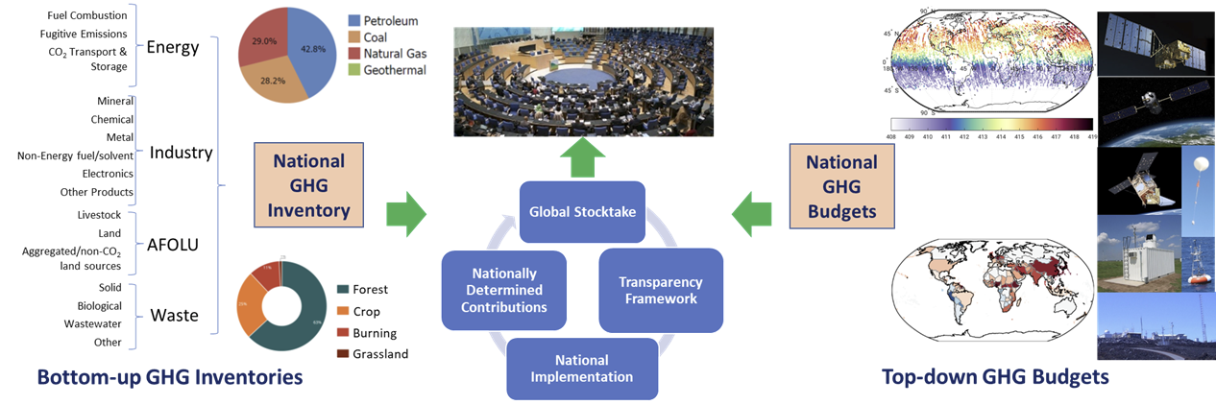
Figure 3.1: Bottom-up GHG inventories and top-down atmospheric GHG budgets provide independent information supporting the Global Stocktakes.

To coordinate these efforts and maximize the utility and policy relevance of atmospheric greenhouse gas measurements like those collected by the WMO Global Atmospheric Watch (GAW) Programme, the WMO formed the Integrated Global Greenhouse Gas Information System (IG³IS). International coordination bodies such as the Committee on Earth Observations Satellites (CEOS) and the Coordination Group on Meteorological Satellites (CGMS) began working with the Global Climate Observing System (GCOS) to assess the requirements, existing capabilities and measurement gaps for monitoring GHG emissions and climate hazards. The Group on Earth Observations (GEO) Global Forest Observations Initiative (GFOI) and its partners focus their capacity building, methodological guidance, data gathering and research and development efforts to improve bottom-up inventories of emissions from the land use, land use change and forestry sectors through a better integration of ground-based and remotely-sensed observations (GFOI 2020).
A series of pilot products have been developed to demonstrate the utility of systematic Earth observations for estimating GHG emissions and removals on a range of spatial scales. The Joint Working Group on Climate (WGClimate) of the Committee on Earth Observation Satellites (CEOS) and the Coordination Group on Meteorological Satellites (CGMS) is working with the GHG measurement and modeling communities to develop spatially-resolved global budgets of emissions and removals of atmospheric CO₂ and CH₄ and their changes over time. In parallel, the CEOS AFOLU Task team has embarked on an effort to identify and harmonize the best available above-ground biomass and land cover data, including crop and other land use like mangrove products to support bottom-up inventories for the AFOLU sector. These two efforts are being closely coordinated with each other and with other, ongoing efforts by IG³IS, GFOI, and other organizations to avoid duplication and to develop Earth observations products that are the best suited to complement the efforts to improve estimates being carried out by the Parties to the Paris Agreement.
The primary objective of these pilot products is to engage the scientific community, national inventory agencies, the UNFCCC and other relevant stakeholders to establish best practices for the joint use of bottom-up inventories and systematic Earth observations. The long-term goal is to contribute to more transparent, complete, consistent and accurate estimates of GHG emissions and removals at the national and global scales. These products should also allow for more comparability across scales and support efforts to adapt to climate change and foster low GHG emissions and climate-resilient development.

Current Capabilities for Atmospheric GHG Measurements
Top-down atmospheric GHG measurement and modeling infrastructure and analysis capabilities are still evolving rapidly, but are already providing key insights into the emissions and uptake of CO₂ and CH₄ by natural processes and human activities. Ground-based and airborne in situ measurements of CO₂ and CH₄ are being combined with space-based remote sensing estimates of these quantities to yield dramatic improvements in the spatial and temporal resolution and coverage of the globe. These datasets are being analyzed with advanced atmospheric inverse modeling systems to yield top-down estimates the emissions and removals of these two critical greenhouse gases on policy relevant scales, increasing their potential value in the context of tracking collective global progress in achieving the mitigation goals of the Paris Agreement. Recognizing these developments, the 2019 Refinement of the 2006 IPCC Guidelines for National Greenhouse Gas Inventories (IPCC 2019) provides guidance on how to use top down models and data in the context of national GHG inventories (Volume 1, Chapter 6). These efforts are beginning to address Guiding Questions 1 and 3. The following sub-sections summarize the current capabilities of the ground-based, airborne and space-based measurement capabilities. It is followed by a brief description of the functionality and current state of the art in atmospheric inverse models.

Direct Measurements of GHGs from Ground-based Stations
Since 1958, atmospheric GHGs have been measured from a growing network of ground-based and airborne sensors. Ground-based and airborne measurements collected by the WMO GAW Network continue to provide the most accurate estimates of GHG concentrations and their trends on global scales. Global trends in atmospheric concentrations of CO₂ and CH₄ derived from this network are in Figure 3.2 a and b, respectively. The GAW Network now includes contributions from 55 member states, spanning the globe. Its results are archived and distributed by the World Data Center on Greenhouse Gases (WDCGG) and are freely available from the website https://gaw.kishou.go.jp/. The current distribution of ground-based and aircraft CO₂ monitoring stations in the GAW network are shown in Figure 3.2 c. Most of these stations measure CH₄, N₂O, halocarbons and other GHGs as well as CO₂. More information can be found in the annual WMO Greenhouse Gas Bulletins.
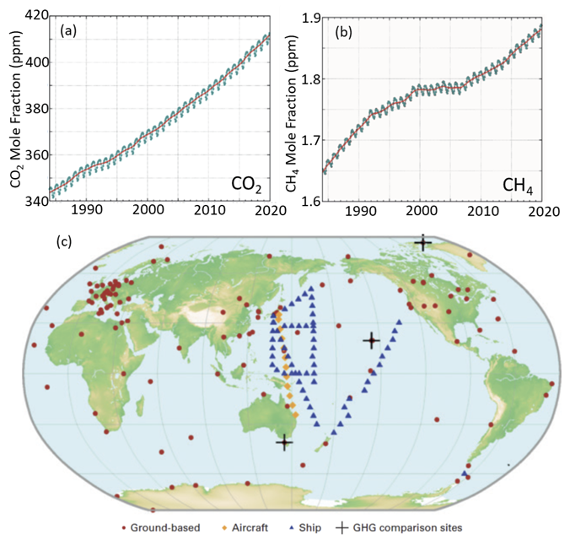
Figure 3.2: Tracking long-term trends in CO₂ and CH₄ concentrations: (a) Globally averaged CO₂ concentrations, expressed as dry air mole fractions by volume, for the period extending from 1984 to 2019. (b) Globally averaged CH₄ dry air mole fractions for 1984 to 2019. (c)Distribution of stations in the GAW CO₂ monitoring network in 2020.(Adapted from WMO Greenhouse Gas Bulletin No. 16, 23 November 2020.)

Measurements of the complete suite of GHGs monitored by the UNFCCC, including CO₂, CH₄, N₂O, halocarbons as well as isotopic species, such as carbon-14, are derived from air samples collected in specially-designed glass flasks. Routine flask measurements are collected at weekly intervals in the midafternoon at an elevation of 3 meters. These flasks are shipped to laboratories, such as the U.S. National Oceanic and Atmospheric Administration (NOAA) Global Monitoring Laboratory (GML) for analysis. In situ measurements of CO₂, CH₄, CO and a few other species are also collected by continuous monitoring instruments deployed near the surface or on tall towers. These instruments derive GHG concentrations from measurements collected by non-dispersive infrared (NDIR) or laser cavity ringdown spectrometers.
About 40% of the measurement records submitted to WDCGG in 2020 were collected at a global network of about 75 sites operated by the NOAA GML cooperative air-sampling network (data available from https://gml.noaa.gov/dv/data.html). The NOAA contributions include data from the “Baseline Observatories” at sites near Barrow, Alaska, Mauna Loa, South Pole, and American Samoa, which were purposely located well away from known strong emission sources or sinks to monitor global trends in GHGs. The Integrated Carbon Observing System (ICOS) network provides a number of GHG products from its ~38 stations across Europe (data available from https://www.icos-cp.eu/data-products). Measurements of CH₄, N₂O and halocarbons are also provided to GAW by the 13 stations in the Advanced Global Atmospheric Gases Experiment (AGAGE) network (data available from https://agage.mit.edu/data/agage-data). Other WMO GAW partners collect flask and/or continuous measurements of GHGs from a smaller number of surface stations. Records of greenhouse gases suitable for atmospheric modeling are collected from international partners and published in the GLOBALVIEW+ project at https://gml.noaa.gov/ccgg/obspack/our_products.php. The most recent release of this CO₂ product contains almost 28 million measurements from 1957 to 2021, in 524 datasets made by 63 laboratories from 21 countries.
The accuracy of the measurements collected at these stations has improved over time as they have incorporated new technologies, and they now constitute the WMO global standard for GHG measurements. The spatial distribution and accuracy of the measurements collected by these ground-based and airborne systems has also improved as the number of stations has increased. The GAW network now provides very good coverage in Western Europe and North America. However, it still provides limited coverage in rapidly developing regions in Asia, Africa and South America, which are now responsible for more than 60% of all GHG emissions. It also provides little coverage of tropical and boreal regions, whose emissions and removals of CO₂ and CH₄ are evolving in response to climate change. A substantial expansion of this network would be needed to monitor GHG emissions and removals uniformly across the globe on scales spanning individual power plants or large urban areas to nations.
To address these needs, much of the recent effort to expand the ground-based GHG networks has focused on urban areas, which are thought to be responsible for between 40 and 70% of all CO₂ emissions (United Nations Human Settlements Programme, 2011). Quantifying GHG emissions from these areas is particularly challenging because they often include a diverse range of sources and the transport of these emissions is strongly influenced by buildings and other structures. These factors introduce significant spatial and temporal variability in the signals, requiring large numbers of sensors and high sampling rates. Intensive campaigns, such as the Indianapolis Flux Experiment (INFLUX; see Davis et al., 2017) have provided new insights into the requirements of urban networks. For example, INFLUX and other urban campaigns have shown the critical need to develop improved methods for distinguishing anthropogenic from biogenic fluxes and to closely coordinate the design of the measurement and analysis systems across these domains. IG³IS has incorporated these lessons into its Implementation Plan and taken a lead role in efforts to develop and implement best practices for sensor deployment, calibration, and analysis for large urban areas (DeCola et al., 2019).

Direct Measurements of GHGs from Airborne Platforms
NOAA is also a key supplier of in situ GHG measurements from airborne platforms that routinely collect data using flasks and continuous monitoring instruments at 17 sites across North America (data available from https://gml.noaa.gov/dv/data/). More recently, NOAA introduced the simple, low-cost AirCore measurement system (Karion et al., 2010; Baier et al., 2020). This system consists of a long, thin, coiled tube that is carried aloft to altitudes as high as 25 kilometers (km) on a weather balloon. It is then released on parachute to collect an altitude-dependent record of the air column as it returns to the surface. Once retrieved, this air column is read out by an analyzer to yield high resolution vertical profiles of CO₂, CH₄ and other gases. AirCores are now routinely deployed from an increasing number of stations.
These routine airborne GHG measurements are augmented by occasional aircraft campaigns such as the U.S. National Science Foundation’s HIAPER Pole-to-Pole Observations (data available from https://www.eol.ucar.edu/field_projects/hippo) and ORCAS (data available from https://data.eol.ucar.edu/master_lists/generated/orcas/) campaigns, NASA’s Atmospheric Tomography (ATom) mission (data available from https://daac.ornl.gov/cgi-bin/dataset_lister.pl?p=39) and CNES/CNRS Monitoring of Atmospheric composition and Greenhouse gases through multi-Instrument Campaigns (MAGIC; data available from https://magic.aeris-data.fr/#) and many others.
These dedicated research observations are now being augmented by GHG sensors that are deployed in the cargo holds of commercial aircraft as part of Japan’s Comprehensive Observation Network for TRace gases by AIrLiner (CONTRAIL; data available at https://www.cger.nies.go.jp/contrail/protocol.html) program and Europe’s In-service Aircraft for Global Observations (IAGOS, data available at https://www.iagos.org/iagos-data/) program. So far, GHG measurement systems have been deployed on a relatively small number of aircraft, but that number is expected to grow as the size and operational complexity of the sensors is reduced.

Estimates of Column-average CO₂ and CH₄ from Ground-based Remote sensing
GHG concentrations can also be monitored remotely by measuring the amount of sunlight that these gases absorb in the atmospheric column between the top of the atmosphere and the surface. The Total Carbon Column Observing Network (TCCON) exploits this approach. Each TCCON station incorporates a laboratory-grade, high spectral resolution Fourier Transform spectrometer (FTS) and a solar tracker to autonomously collect high-resolution spectra of direct sunlight at near infrared and shortwave infrared wavelengths (Wunch et al., 2011a). These spectra are analyzed to yield high-precision estimates of the average CO₂ and CH₄ concentrations between the surface and the top of the atmosphere, expressed in terms of column-average dry air mole fractions, XCO₂ and XCH₄. To relate these estimates to the WMO standard scales, in situ vertical profiles of CO₂, CH₄ and other GHGs are collected above the stations using fixed-wing aircraft and AirCore instruments at regular intervals. With these rigorous protocols in place, TCCON was accepted into the GAW Network following the 15th WMO/IAEA Meeting on Carbon Dioxide, Other Greenhouse Gases and Related Measurement Techniques (GGMT-15). In 2020, TCCON included 27 stations in 14 countries spanning latitudes between Eureka, Canada (80.05°N) and Lauder, New Zealand (45.038°S). The distribution of stations is shown in Figure 3.3a.
More recently, smaller, more portable EM27/SUN FTS instruments with solar trackers popularized by the researchers at Karlsruhe Institute of Technology (KIT) have been adopted by numerous groups in Germany, USA, UK, India, Namibia, Japan, China and Mexico. Several of these groups have deployed multiple instruments in local networks to study spatial variations in CO₂ and CH₄ distributions around large urban centers, including Los Angeles, Toronto, Boston, and Munich. EM27/SUN instruments have also been deployed in regions with few other ground-based GHG monitoring stations, such as Africa and India, and have been deployed in campaigns over even broader areas. To develop common standards for calibrating, operating and analyzing the data from these sensors, a new network, called the COlaborative Carbon Column Observing Network (COCCON) has been established (Frey et al. 2019). As of May 2021, COCOON spectrometers have been deployed at 18 sites, spanning the latitudes of Lauder, New Zealand and Kiruna, Sweden (67.8 N) and have been deployed on numerous measurement campaigns at sites as remote as Arrival Heights, Antarctica (77.8° S). The distribution of sites in late 2020 is shown in Figure 3.3b. Results from the COCCON instruments are regularly validated though comparisons with TCCON results and AirCore profiles to ensure their accuracy and traceability to the WMO in situ GHG standards.

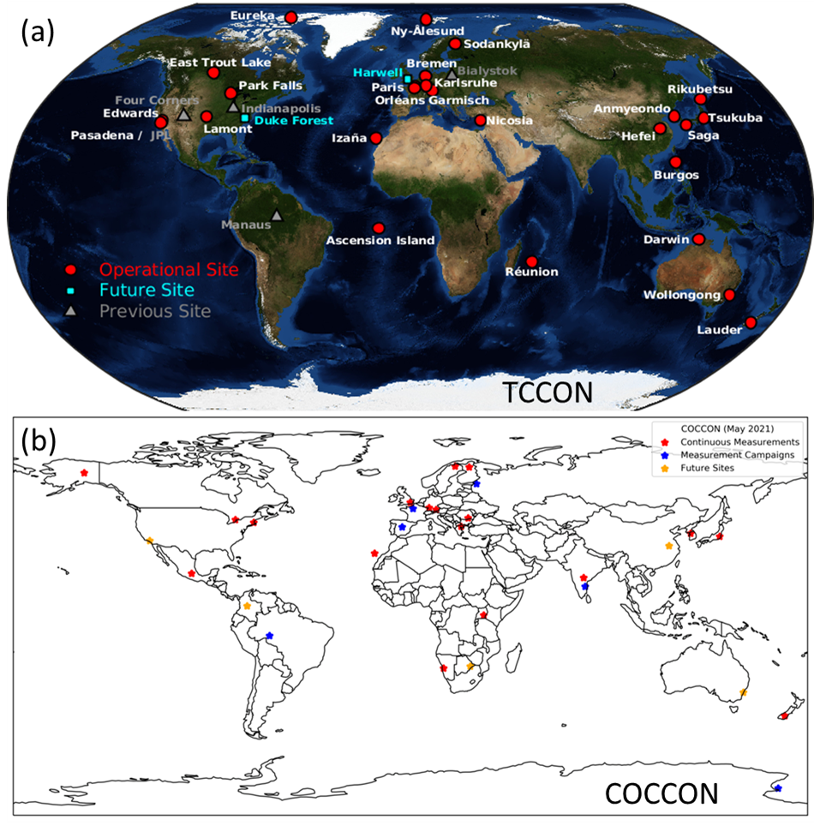
Figure 3.3: Locations of (a) TCCON and (b) COCCON sites. In both cases, the sites returning continuous measurements are shown in red.

Estimates of Column-average CO₂ and CH₄ Dry Air Mole Fractions from Space-based Sensors
Recent advances in space-based remote sensing methods are providing new opportunities to augment the spatial and temporal resolution and coverage of the ground-based GHG networks. In 2018, the CEOS Atmospheric Composition-Virtual Constellation (AC-VC) GHT team published a comprehensive assessment of the current state of the art and near-term plans for monitoring CO₂ and CH₄ from space (CEOS 2018; https://ceos.org/ourwork/virtual-constellations/acc/). High resolution spectroscopic observations of reflected sunlight in CO₂ and CH₄ absorption bands at shortwave infrared (SWIR) wavelengths were found to be best suited for estimating their surface sources and sinks of these gases because they can be analyzed to yield column-averaged estimates of their dry air mole fractions (called XCO₂ and XCH₄) that are most sensitive to their variations near the surface (Figure 3.4).
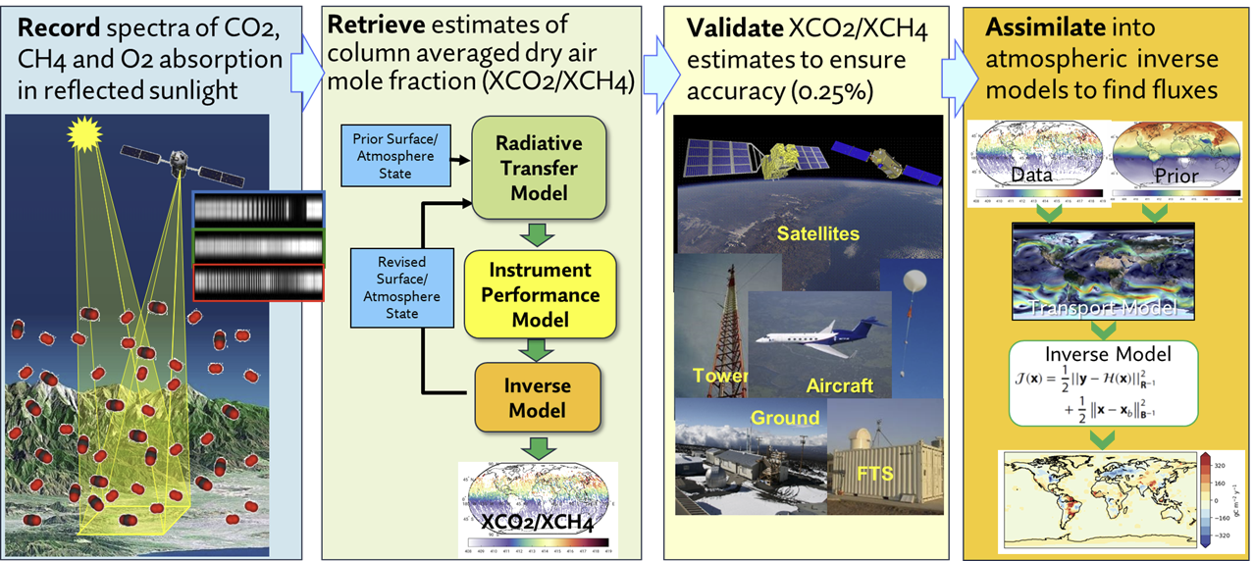
Figure 3.4: The process for collecting and analyzing space-based observations to yield estimates of XCO₂ and XCH₄, validating the accuracy of these products against available standards, and then estimating CO₂ and CH₄ fluxes from these products.
These space-based remote sensing observations can only be collected while the sun is up, precluding measurements at night or at high latitude during winter, and near-surface observations can only be obtained in the absence of clouds. However, they still provide a practical means for monitoring CO₂ and CH₄ across the entire globe at high spatial resolution on weekly to monthly time scales using the same measurement technique. Another critical asset of these space-based data products in the context of the global stocktake is that most are well documented and delivered to open, freely-accessed data archives and distribution centers as soon as they are produced, enhancing their transparency and accessibility.
A growing fleet of GHG sensors is being deployed by CEOS agencies. For example, Japan’s Greenhouse gases Observing SATellite (GOSAT) was launched in January 2009 and has been returning estimates of XCO₂ and XCH₄ at ten to twenty thousand discrete cloud-free locations on the Earth each month since April 2009 (data available from https://data2.gosat.nies.go.jp). GOSAT was joined by GOSAT-2 in October 2018, which has been returning about twice as many cloud-free XCO₂ and XCH₄ estimates as GOSAT since March 2019 (data available from https://prdct.gosat-2.nies.go.jp/). NASA’s Orbiting Carbon Observatory-2 (OCO-2) was launched in July 2014 and has been returning about three million cloud-free XCO₂ estimates each month since September 2014 (data available from https://disc.gsfc.nasa.gov/datasets?page=1&keywords=OCO-2). In May 2019, NASA deployed the OCO-2 flight spare instrument on the International Space Station (ISS) as the OCO-3 mission, and it has been returning a comparable number of observations since August 2019 (data available from https://disc.gsfc.nasa.gov/datasets?keywords=OCO-3&page=1).
The Copernicus Sentinel 5 Precursor (S5P) was launched in October 2017 and has been returning estimates of XCH₄ since May 2018 (data available from https://scihub.copernicus.eu/). Unlike the GOSAT and OCO sensors, whose measurements sample small fractions of Earth’s surface each month, the S5P TROPOMI instrument provides near global coverage of cloud-free regions across the sunlit hemisphere each day with a spatial resolution of about 50 square km. Other satellites, including the NASA/U.S. Geological Survey (USGS) LandSat series, the Copernicus Sentinel 2 satellites, and the three satellites in the commercial GHGSat fleet (GHGSat-D, GHGSat-C1 and C2), return high spatial resolution images of intense CH₄ plumes in discrete locations. These measurements are not as easy to quantify as those from the GOSAT and S5P instruments, but help to locate CH₄ super-emitters (c.f. Cusworth et al. 2020).
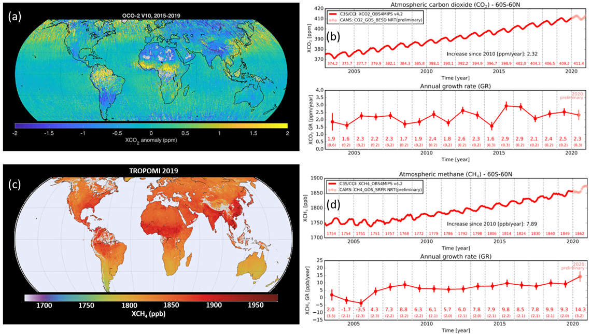Figure Figure 3.5: Space-based observations of the column averaged CO₂ (a) and CH₄ (c) dry air mole fractions are now being acquired at high spatial resolution over the globe. These results are being analyzed to track CO₂ and CH₄ trends, shown in (b) and (d). These space-based CO₂ and CH₄ time series are not as long as those compiled from ground-based and airborne in situ observations (Figure 3.2), but complement those results with much greater resolution and coverage of the globe.
A principal challenge of this space-based approach for monitoring GHG concentrations is the need for unprecedented precision and accuracy. In general, CO₂ emissions and removals are more difficult to quantify than CH₄ emissions because the background concentrations of CO₂ are much larger (400 ppm vs 1.8 ppm) relative to the changes imposed by its sources and sinks. For example, while an intense emission source, such as large coal-fired power plant or large urban areas, can increase the near-surface CO₂ concentrations by more than 10% (40 ppm) relative to the background, these variations decay rapidly with altitude, such that they rarely yield XCO₂ variations larger than 1-2 ppm (0.25 to 0.5%) on the spatial scale of a satellite footprint (1 to 100 km²). Natural sinks of CO₂, such as forests or ocean basins, produce even smaller relative changes in XCO₂. To quantify these small changes, the space-based measurements and remote sensing retrieval algorithms must have end-to-end accuracies no worse than about 0.1- 0.2 percent.
To quantify the precision and accuracy of these space-based XCO₂ and XCH₄ estimates, they are routinely validated through comparisons with spatially-coincident estimates returned by the TCCON stations (Figure 3.3 a) during routine overflights. The current state-of-the-art for XCO₂ is demonstrated by OCO-2, which typically returns estimates with single sounding random errors of about 0.5 ppm (0.12% of the 415-ppm background value) and biases no larger than 1 ppm (0.25%; Figure 3.5a,b). The current state of the art for CH₄ is illustrated by the S5P TROPOMI instrument, which typically returns data with single sounding random errors of 5.6 parts per billion (ppb; 0.3% of the 1.88 ppm background) and biases of similar magnitude in comparisons TCCON, AirCore and other standards (Figure 3.5c,d). Once validated, space-based XCO₂ and XCH₄ estimates from GOSAT, GOSAT-2, OCO-2, OCO-3 and TROPOMI can be combined to track trends in these gases at high spatial resolution over the globe, addressing Guiding Question 3.
These space-based XCO₂ and XCH₄ estimates are less precise and accurate than their ground-based and airborne counterparts, but complement those systems with much higher spatial and temporal resolution and denser coverage of the globe. For example, NASA’s OCO-2 and OCO-3 missions each collect about a million measurements over the Earth each day. On average, about 85,000 of these measurements are sufficiently cloud free to yield full-column estimates of XCO₂. On monthly time scales, the measurements sample most of the globe, including areas that are too geographically or politically inaccessible to support ground-based observations.
While spatial resolution and coverage are the primary assets of space-based GHG measurements, the first-generation systems currently in operation do not fully exploit this capability. The GOSAT, GOSAT-2, OCO-2, and OCO-3 sensors were designed as a proof-of-concept, to demonstrate that space-based measurements of GHGs could yield measurements with the precision and accuracy required to quantify their sources and sinks. In that context, they are a success. However, these sensors each sample only a fraction of the Earth’s surface each day. For example, NASA’s OCO-2 gathers data continuously at 2-km intervals along a narrow (less than 10 km wide) path that runs from south to north, almost parallel to the satellite’s near-polar orbit track. As OCO-2 orbits the Earth about fourteen and a half times each day, its narrow measurement tracks are separated by almost 2500 km as they cross the equator. The ground track spacing decreases to less than 150 km as the orbit tracks interleave on monthly time scales, but this approach samples only about 7% of Earth’s surface. The coverage is further reduced by clouds, which limit the area sampled each month to less than 1% each month.
So, while OCO-2 observations can quantify the emissions from a single power plant or city if it flies overhead, it can only observe a tiny fraction of these sites. As noted above, the TROPOMI instrument on S5P provides nearly global coverage each day, but the relatively large surface footprint of each measurement (about 50 square km) limits its sensitivity to CH₄ sources and increases the probability of contamination by clouds. To meet their full potential as components of a future global GHG monitoring system, space-based sensors with much greater coverage and spatial resolution must be combined with an expanded ground-based and airborne GHG measurement system.
Another limitation of existing space-based systems is a lack of continuity and resiliency. Most of the existing satellite sensors are scientific experiments designed to demonstrate the capabilities of space-based GHG measurements rather than operational systems designed to deliver systematic observations to specific customer communities. More importantly, some are well beyond their design lifetimes (GOSAT, OCO-2, TanSat) or have no plans for replacements (i.e., OCO-2, OCO-3, GeoCarb), increasing the likelihood of future data gaps.
Fortunately, over the next decade a growing fleet of satellite sensors operated by CEOS and CGMS agencies are committed to measuring CO₂ and CH₄ from space with increasing resolution and coverage. These systems are described in detail in CEOS 2018. Here, we briefly summarize these systems and provide an update on the deployment timeline (Figure 3.6). Improvements in optics and detectors now allow us to make carbon dioxide and methane measurements over paths that are 25 to 100 times as wide as those sampled by OCO-2, covering Earth’s entire surface within days or weeks.
One of the first sensors incorporating these capabilities for CO₂ as well as CH₄ is Japan’s GOSAT-GW mission, which will be launched in early 2024. Its wide-swath mode will provide near global coverage at a spatial resolution of 10 km by 10 km every week. It also has a high-resolution mode that returns measurements at a spatial resolution of 1-3 km over a 90-km wide swath. This mode is ideal for monitoring emissions from complex regions, such as large urban areas. Soon after the launch of GOSAT-GW, NASA plans to launch the GeoCarb mission, which will be hosted on a commercial communications satellite in geostationary orbit at a longitude around 85 W. From that vantage point, GeoCarb can return the data needed to estimate the column average dry air mole fraction of CO₂, CH₄ and carbon monoxide (CO) over most of North and South America at a spatial resolution of 5 to 10 km every day. In 2025, the European Copernicus program will begin to deploy the first operational CO₂ and CH₄ monitoring constellation, CO2M. The CO2M constellation will eventually include up to three satellites, flying in formation to collect measurements at 2 km by 2 km resolution over the entire globe at weekly intervals. China has also launched its first generation of space-based GHG sensors on TanSat, Feng Yun-3D and GaoFen-5, and is making its future plans.

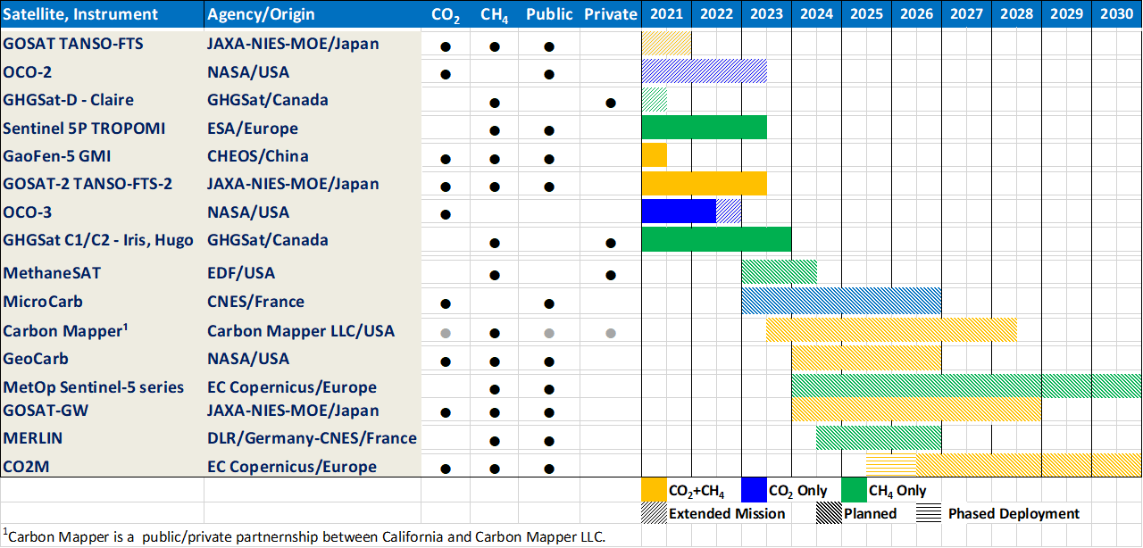
Figure 3.6: Timeline of the existing and planned missions designed specifically to measure atmospheric CO₂ and CH₄ from space. Blue bars indicate that the mission measures only CO₂. Green bars indicate that they measure only CH₄. Those that measure both gases are shown in gold.

In addition to these elements of the space-based GHG infrastructure provided by public sector space agencies, a number of private companies and non-governmental agencies are building and launching satellite sensors for measuring GHGs. Following the path pioneered by GHGSat, most are focusing on high resolution observations of CH₄. For example, a coalition led by the Environmental Defense Fund (EDF) plans to launch MethaneSat in late 2022. This sensor will collect measurements at a spatial resolution of about one square km over 200 km x 200 km targets to constrain both broad-area emissions and point sources of CH₄. Carbon Mapper, an innovative public-private partnership between Carbon Mapper Inc. and the State of California, plans to start deploying the first two satellites in its constellation in 2023. While focusing on CH₄, both MethaneSat and the Carbon Mapper constellation can also measure intense plumes of CO₂. Unlike GHGSat, both MethaneSat and Carbon Mapper plan to make their GHG data freely available to the scientific and policy communities.
Even with this much expanded, space-based GHG monitoring fleet, close coordination of these rapidly evolving ground-based, airborne, and space-based GHG assets is critical to the success of top-down inventory products. For example, only ground-based and airborne instruments can measure all of the gases that are tracked by the UNFCCC, while space-based measurements are sensitive to surface fluxes of only CO₂ and CH₄. Ground-based measurements of carbon-14 and other trace gases and stable isotopes may be critical for distinguishing anthropogenic from biogenic CO₂ fluxes. Ground-based sensors also provide continuous monitoring even in persistently cloudy regions, which cannot be observed from space. Ground-based and airborne in situ and ground-based remote sensing measurements are being combined to provide critical data for validating space-based CO₂ and CH₄ estimates and tying them back to the internationally recognized WMO standards. Meanwhile, space-based CO₂ and CH₄ estimates complement ground-based and airborne measurements with additional spatial and temporal resolution and coverage, which is critical for estimating CO₂ and CH₄ emissions and removals on spatial scales ranging from large urban centers to nations.
For these reasons, CEOS 2018 recommends a future, purpose-built global greenhouse gas monitoring system that closely integrates ground-based, airborne and space-based measurements with Earth system models to yield both national-level top-down CO₂ and CH₄ inventories as well as estimates of hot-spot emissions from large power plants and urban centers. This integrated approach is patterned after that used for operational numerical weather and air quality forecasting and has been largely adopted for planning and developing the European Copernicus CO2M constellation.
The minimum space-based GHG gas constellation architecture described in CEOS 2018 includes three satellites providing global coverage from low earth orbit (LEO), with measurement swaths wide enough to cover the Earth’s surface at least once each week. This LEO constellation should be complemented with at least three geostationary satellites, stationed to collect data over North and South America, Europe and Africa, and East Asia and Oceania. Additional space-based assets are needed to ensure the resiliency of this space-based constellation to the loss of a single spacecraft. It anticipates that different nations will collaborate closely to support different ground-based, airborne and space-based elements of this GHG measurement system.

Deriving CO₂ and CH₄ Fluxes from Atmospheric Measurements with Atmospheric Inverse Modeling Systems
As CO₂, CH₄, and other GHGs are emitted into or removed from the atmosphere, their contributions to the observed concentration field are affected by their background values, emission rates, ambient wind field and the chemical reactions and biological processes that destroy them or remove them from the air. On spatial scales spanning large urban centers to the globe, atmospheric inverse modeling systems simulate these processes to yield top-down maps of CO₂ and CH₄ surface flux estimates. On smaller scales, CO₂ and CH₄ fluxes are usually inferred using discrete plume mass balance models. Both approaches are described in Appendix 2 of CEOS 2018, so they are only briefly summarized here.
A global atmospheric inverse modeling system typically utilizes an atmospheric chemical transport model, the capability to assimilate atmospheric GHG concentration measurements and an algorithm for optimizing spatially- and temporally-resolved estimates of the net surface fluxes (sources + sinks) of GHGs to match the observed CO₂ or CH₄ concentration field to within the uncertainty bounds in the presence of the wind field. These systems are typically initialized with “prior” GHG concentration and flux distributions derived from bottom-up inventories, climatologies and biogeochemical models. Most atmospheric inverse modeling systems use precomputed (off-line) atmospheric winds fields from a meteorological reanalysis in a global, 3-dimensional chemical tracer transport models, such as the Goddard Earth Observing System (GEOS) Chemistry (GEOS-Chem), or Tracer Model 5 (TM5). However, some systems, such as the European Centre for Medium-Range Weather Forecasts (ECMWF) Integrated Forecasting System (IFS), use “on-line” meteorological models that assimilate meteorological measurements simultaneously with GHG observations to numerically solve the equations of transport and mass continuity at high spatial resolution to more explicitly resolve the transport.
Most inverse modeling systems use some form of Bayesian inference, which adjusts surface fluxes to minimize a cost function, a mathematical expression that describes the mismatch between the GHG observations and the simulated observations based on prior estimates of surface fluxes, accounting for their respective uncertainties. These include variational data assimilation (3-D and 4-D VAR), ensemble Kalman filter, and the Markov Chain Monte Carlo methods. Each of these techniques has unique advantages and disadvantages in the context of the global stocktake.
For CO₂, which includes both emission sources and natural sinks, the quantity that is usually returned by inverse models is the net carbon exchange (NCE) between the surface and the atmosphere by all processes, including anthropogenic fossil fuel emissions, land use, industry, and waste as well as natural processes (Figure 3.7).
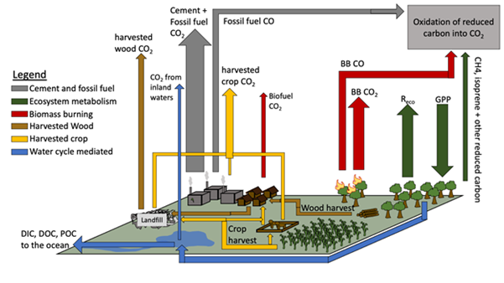

Figure 3.7: Processes that emit CO₂ into the atmosphere and remove it at the surface and how they relate to stock changes and net surface-atmosphere flux. The largest anthropogenic emissions are from fossil fuel combustion and cement manufacturing. Agriculture, forestry and other land use constitute the second largest emitter. The natural carbon cycle both removes CO₂ through photosynthesis and emits it through heterotrophic respiration and wildfires (biomass burning, BB shown here).

NCE can be positive (source) or negative (sink) and is usually expressed in units of grams of carbon per square meter per year (gC m⁻² y⁻¹) or some multiple of that quantity. Global maps of NCE from NASA OCO-2 Flux Multi-model Intercomparison Project (OCO-2 Flux MIP; Peiro et al. 2022) are shown in Figure 3.8. In that experiment, an ensemble of 10 state-of-the-art atmospheric inverse models was used to estimate NCE from CO₂ observations collected by the ground based network and by OCO-2. All results were then mapped to a 1°by 1°. These results can then be mapped to individual countries to yield estimates of net national emissions and emission uncertainties (Figure 2.8).
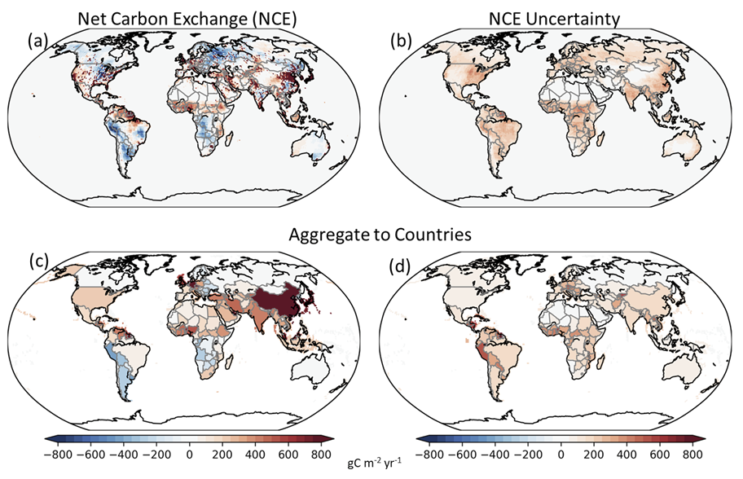
Figure 2.8: Maps of ensemble-median NCE estimates derived from ensemble of atmospheric inverse models used in the OCO-2 version 10 (v10) Multi-model Intercomparison Project (see Peiro et al. 2022). NCE fluxes (a) and their uncertainties (b) are first derived on a spatial grid specified by the inverse model (1° latitude by 1° longitude shown in the example). To produce national net emission budgets, these fluxes can then be aggregated to country levels (c) along with their uncertainties (d).
While national-scale estimates of NCE are useful for assessing the net result of all processes that emit or remove CO₂ from the air, these quantities, alone, provide little direct insight into the specific processes responsible for these observed changes. They can therefore be used to assess the overall progress toward the goals of the Mitigation Paris Agreement, but provide much less direct insight into the effectiveness of emissions reduction efforts or other actions in specific sectors. To obtain that information, the NCE estimates from inverse models must be combined with other information. For example, if fossil fuel (FF) emissions are well constrained by bottom-up inventories, these emissions can be subtracted from the NCE values to derive estimates of emissions changes associated with the AFOLU sector. To facilitate the development of or direct comparisons with bottom-up AFOLU inventories, other contributions, such as exports of crops or lumber or carbon exports from river runoff, must be accounted for because these processes are accounted for in the AFOLU inventories but not in the NCE estimates from inverse models (Deng et al., 2021). This process yields estimates of the net carbon change, ΔC. One challenge posed by this approach is that errors or uncertainties in the FF emissions or the lateral exports of crops, wood or river carbon will produce compensating errors in the ΔC estimates.
Atmospheric inverse modeling systems have evolved rapidly over the past two decades to more fully accommodate and exploit the availability of CO₂ and CH₄ measurements from the expanding ground-based, airborne and space-based platforms. While the current measurement network cannot support inversions at resolutions higher than about 100 km (1°by 1°), future systems will deliver global measurements at scales as fine as 2 km by 2 km. These data could support inversions at much finer resolution, providing useful national-level constraints on emissions for much smaller countries than the current systems. Other space-based measurements at resolutions as high as a few 10s of meters will drive advances in methods for modeling emission plumes from point sources such as power plants, cities, and fossil fuel extraction areas.
Scientists from around the world are using these systems to study both anthropogenic emissions and those associated with the natural carbon cycle’s response to deforestation, severe weather, wildfire, and climate change. Examples of the products are given in the use cases described in the following sections. A key feature of these top-down atmospheric measurements in the context of a GST is their potential for transparency. Most of the ground-based, airborne and space-based data collected by public sector missions (and some private sector missions) are made freely available on publicly available archives. The methods used needed to analyze these data are complex and computationally expensive, but are currently being implemented in collaborative efforts by science teams from around the world with numerous intercomparison projects to assess the tradeoffs between different methods. If these practices are continued, it will clearly increase the value and transparency of the top-down atmospheric emissions products.

Pilot Top-down CO₂ and CH₄ Budgets to Support the First Global Stocktake
Recent advances in ground-based, airborne and space-based CO₂ measurement and modeling capabilities have substantially enhanced the value of top-down methods for both inventory development and assessment applications. To demonstrate these advances, the Joint CEOS/CGMS Working Group on Climate (WGClimate) Greenhouse Gas Task Team collaborated with the inverse modeling community to compile pilot top-down budgets of CO₂ and CH₄ emissions and removals for the period 2015-2020.
These first-generation CO₂ and CH₄ budgets do not yet have the accuracy, resolution, and coverage needed to serve as an independent Monitoring and Verification System (MVS) on the spatial scales spanning small to medium sized countries, but they clearly illustrate the strengths and weaknesses of this top-down approach. They also serve as an important bridge between GHG emissions reductions, which are the primary means of mitigation, and the resulting changes in atmospheric concentrations, which are the primary drivers of climate change. These pilot, top-down budgets should therefore be adequate for starting a conversation among stakeholders, the national inventory community and the GHG measurement and modeling communities. The primary objective of that conversation is to identify the best available atmospheric products and best practices for combining bottom-up and top-down GHG data to produce more complete and transparent inventories for future GSTs. They should therefore be adequate for refining the requirements for a future, purpose-built GHG MVS.
For the pilot products, national-scale CO₂ budgets are derived by combining ground-based and airborne CO₂ measurements with estimates of column-averaged CO₂ dry air mole fraction (XCO₂) from the NASA Orbiting Carbon Observatory-2 (OCO-2). These measurements are analyzed with an ensemble of state-of-the-art flux inverse modeling systems to derive estimates of CO₂ fluxes at 1-degree latitude by 1-degree longitude as part of the OCO-2 Flux Multi-model Intercomparison Project. These fluxes are then projected onto national regions and analyzed further to produce country-level, annual CO₂ budgets. The pilot national-scale CH₄ budgets are derived from XCH₄ estimates derived from measurements collected by GOSAT. These data were analyzed by the NASA Carbon Monitoring System Flux (CMS-Flux) team to derive CH₄ fluxes at a spatial scale of 1-degree latitude by 1-degree longitude, which were then projected onto national scales by emission sector. These two Use Cases are described in the following text boxes.

Use Case 3.1: Pilot, National-scale CO₂ Budgets
The Committee on Earth Observations (CEOS) Atmospheric Composition – Virtual Constellation (AC-VC) GHG team worked with the OCO-2 Flux MIP team to generated top-down gridded and country-level estimates of net CO₂ emissions and removals, net carbon exchange (NCE) and changes in terrestrial carbon stocks.
Processes that add or remove CO₂ from the atmosphere are summarized in the diagram below. Two global, top-down products have been developed in these pilot budgets:
- Annual net land-atmosphere CO₂ fluxes.
- Annual changes in terrestrial carbon stocks.
These products are provided over the period 2015-2020 on both a global grid and as country-level totals with error characterization.
Top-down inverse models analyze ground-based, airborne, and space-based measurements of CO₂ to produce spatially-resolved estimates of the Net Carbon Exchange (NCE) between surface and atmosphere. NCE can be further subdivided into fossil fuel emissions (FF), lateral carbon fluxes due to rivers, crop, and wood, and changes in land carbon stocks (ΔC).
Methodology
These estimates are derived from space-based, airborne, and surface-based measurements of CO₂ using an ensemble of state-of-the-art flux inversion systems that use different transport models, meteorology, and inverse methods. This ensemble is similar to that described in Peiro et al., (2021), but uses the updated version 10 (v10) XCO₂ dataset from the NASA Orbiting Carbon Observatory. Annual-average estimates of NCE derived from this ensemble were derived at 1° latitude by 1° longitude and then aggregated to national levels for the period spanning 2015-2020 (Figure 3.9).
The NASA Orbiting Carbon Observatory-2 (OCO-2) spacecraft collects data either while viewing the local nadir, or while looking at the local glint spot, where sunlight is specularly reflected from the surface. Nadir observations provide higher spatial resolution, but limited sensitivity over the ocean. Glint observations provide much greater sensitivity over the ocean, but are used over both land and ocean.
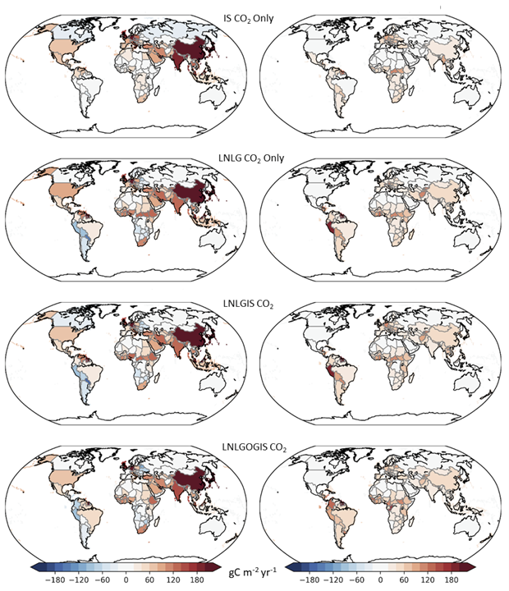
Figure 3.9.Ensemble mean of the annual-average NCE (left) and their uncertainties (right) for 2015 - 2020. These results were derived at 1° by 1° resolution from the OCO-2 Flux MIP, using progressively larger CO₂ datasets and then mapped to national boundaries. Top row: only in situ CO₂ measurements (IS). 2nd row: only OCO-2 version 10 (v10) land nadir and land glint observations (LNLG). 3rd row: a combination of in situ CO₂ measurements (IS) and OCO-2 v10 land nadir and land glint XCO₂ estimates (LNLGIS). Bottom row: a combination of in situ CO₂ measurements (IS) and OCO-2 v10 land nadir, land glint and ocean glint XCO₂ estimates (LNLGOGIS). For all experiments, uncertainty estimates are derived from the interquartile range of the model ensemble, and may underestimate the total uncertainty. Both fluxes and flux uncertainties are expressed in units of grams of carbon per square meter per year (gC m⁻² yr⁻¹).

To assess the impact of spatial sampling, four sets of flux estimates were derived here, using progressively larger atmospheric CO₂ datasets, referenced as follows: (IS) experiments using only in situ CO₂ measurements in the GLOBALVIEW+ CO2 Observation Package (ObsPack; https://gml.noaa.gov/ccgg/obspack/); (LNLG) experiments using only column-averaged CO₂ dry air mole fraction, XCO₂, from OCO-2 nadir and glint observations over land; (LNLGIS) experiments combining in situ CO₂ measurements with OCO-2 XCO₂ nadir and glint observations over land; and (LNLGOGIS) experiments combining in situ CO₂ measurements with OCO-2 XCO₂ nadir and glint observations over land and glint observations over ocean. Annual-average global maps of non-fossil fuel CO₂ fluxes from each type of experiment are shown for 2020 in Figure 3.9, along with uncertainty estimates.
For these pilot products, fossil fuel CO₂ emissions are prescribed from a bottom-up emissions inventory and held fixed, while terrestrial carbon fluxes (including those from the AFOLU sector) and ocean carbon fluxes are optimized to match the spatial and temporal fluctuations present in the observations within their uncertainties. This approach was adopted because the available ground-based, airborne and space-based measurements of atmospheric CO₂ cannot clearly discriminate emissions from fossil fuel and AFOLU sources, and the fossil fuel CO₂ sources are generally much better known. Future updates in the observing system are expected to dramatically improve the resolution and coverage, facilitating inversions that could simultaneously constrain fossil fuel and AFOLU emissions for future GSTs.
Time-dependent, sub-national-scale fossil fuel CO₂ emissions from the Open-source Data Inventory for Anthropogenic CO₂ (ODIAC) database were adopted for these pilot products. Fire emissions were derived from the Global Fire Emission Database v4.1s (GFED v4.1s). Given these inputs, the net carbon exchange (NCE) between the surface and atmosphere is estimated using the inverse models at 1-degree latitude-longitude resolution.
To estimate net emissions and removals of CO₂ by the land biosphere, the gridded NCE results are mapped to national scales and CO₂ emissions associated with fossil fuels were subtracted to yield estimates of the net biospheric exchange (NBE) (Figure 3.10).
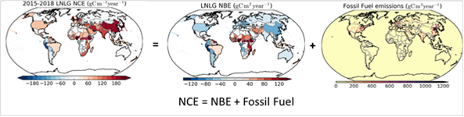
Figure 3.10: The Net carbon exchange (NCE) includes contributions from the Net biospheric exchange (NBE) and the Fossil Fuels. Inverse models derive estimates of NCE. Spatially-resolved estimates of NBE (middle) can be derived by subtracting the fossil fuel contributions (right) from NCE. Fossil fuel emissions are prescribed to derive national-scale estimates of NCE and NBE.
These top-down NBE estimates were adjusted for lateral imports or exports of carbon that do not immediately appear as CO₂ emissions. These include land-to-ocean transport of carbon by rivers (a natural process perturbed by human activities) and import/export of harvested agricultural and wood products (a human activity). For the pilot products, the methods proposed by Deng et al. (2021) and demonstrated by Chevallier (2021) for the operational Copernicus Atmosphere Monitoring Service flux estimates were adopted.
The resulting changes in terrestrial carbon stocks reflect the combined impact of direct anthropogenic activities and changes to managed ecosystems in response to rising CO₂, climate change, and disturbance. These top-down stock change estimates must be multiplied by 3.66 (the ratio of the molar masses of CO₂ and carbon) to yield estimates of CO₂ emissions or removals for each country (Figure 3.11).
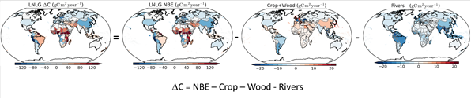
Figure 3.11: Spatially-resolved estimates of the net land carbon stock change, ΔC, can be derived from estimates of the Net Biospheric exchange by subtracting contributions from lateral carbon transports associated with wood and crops and rivers. National-scale maps of ΔC, NBE, Crop and Wood exports, and River exports are shown here.
The resulting estimates of country-scale net land-atmosphere carbon stock change, ΔC, can then be compared directly to bottom-up estimates derived for the AFOLU sector (Figure 3.12). Regional-scale comparisons of these adjusted results with the original NCE estimates can be used to assess the fraction of the total CO₂ emissions from the terrestrial biosphere that are being tracked by the AFOLU inventories.
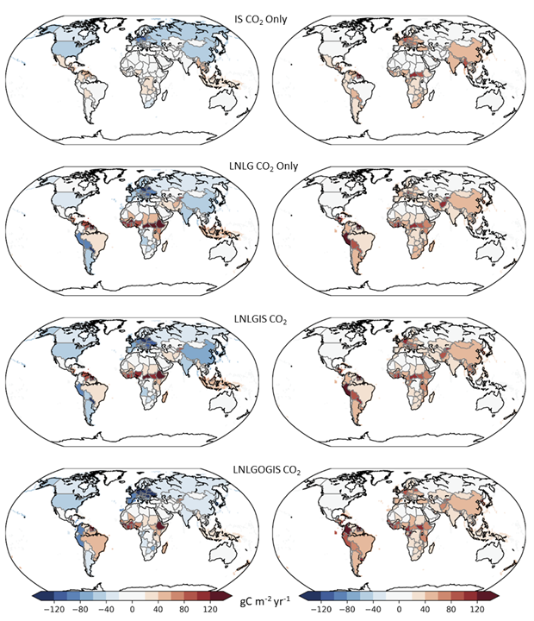
Figure 3.12: Estimates of the net land-atmosphere carbon stock change, ΔC (left) and their uncertainties (right) for each of the atmospheric inverse model experiments described in Figure 3.9. Note that while the total NCE from heavily industrialized countries, like China and the US are positive, the net land-atmosphere carbon stock change associated with the biosphere, net land carbon stock change, ΔC, is negative. In regions with much lower fossil fuel emissions, ΔC tracks NCE. More generally, these results indicate that mid- and high-latitude land biospheres are net sinks of CO₂, while tropical biospheres are either neutral or net sources of CO₂.
.
Summary of Results
Atmospheric inverse model experiments were used to estimate NCE and ΔC were obtained for 137 countries, using the techniques and datasets described above. These estimates are available from the CEOS GST website. Estimates generated for larger countries are likely to be more reliable than those for smaller countries due to limitations in the spatial resolution of the available CO₂ datasets and inverse modeling systems.
These pilot inverse model experiments indicate that the terrestrial carbon stocks increased across the northern extra-tropics (20-90N) but decreased in the northern tropics (0-20N) over 2015-2020. Country-level flux estimates generally show robust signals for large extratropical countries (e.g., USA, Russia, China). Agreement between the simulations employing only in situ (IS) CO₂ measurements and those using estimates of XCO₂ derived from OCO-2 observations generally decreases for mid-sized countries (e.g., Turkey), particularly in regions with sparse observational coverage by the surface in situ network (such as the tropics). Large divergences between the IS and LNLG results occur in some regions, particularly North Africa. This could be related to biases in current OCO-2 XCO₂ retrievals or poor coverage by the in situ network. The sparsity of independent CO₂ measurements in these regions precludes definitive conclusions. Hence, while top-down estimates of CO₂ emissions and removals are providing significant insights into the largest sources of emissions and their response to human activity and climate change, these pilot products should be interpreted with caution given limitations of the current atmospheric measurement and analysis systems.
In addition to the global maps shown above, two types of products were generated to illustrate the information content of top-down atmospheric CO₂ budgets. The first consists of time series, showing how NCE and ΔC have changed between 2015 and 2020 for a few sample countries (Figure 3.13). The ΔC estimates in these time series plots are compared directly to AFOLU inventory estimates from the UNFCCC, illustrating one use of these data.
Figure 3.13 shows that for the USA and India, fossil fuel combustion is the primary contributor to NCE. For the USA, the inverse models suggest that the biosphere is a more efficient sink than the inventories. In Indonesia and Australia, biospheric sources and sinks (ΔC) are more significant contributors to the net emissions of CO₂. Both countries were strongly affected by the intense 2015-2016 El Niño. There were no AFOLU inventories available for Indonesia when these results were produced, but the inverse models indicate that its biosphere is a net source of CO₂, with most intense emissions seen in 2015. For Australia, the ΔC time series appears to reflect the enhanced rainfall in 2016 and the much hotter, dryer conditions associated with the positive phase of the Indian Ocean Dipole in 2019 and 2020.
Figure 3.14 shows all of the contributions to the NCE averaged over the 5-year period extending from 2016-2020. The averaging reduces the impact of the strong 2015-2016 El Niño and provides another way to compare the relative contributions of fossil fuel use, biospheric sources and sinks and lateral transports of carbon associated with crops, wood and river runoff. Comparisons of these 5-year averages from one GST to the next may be of use in identifying new targets for more ambitious emission reduction efforts.
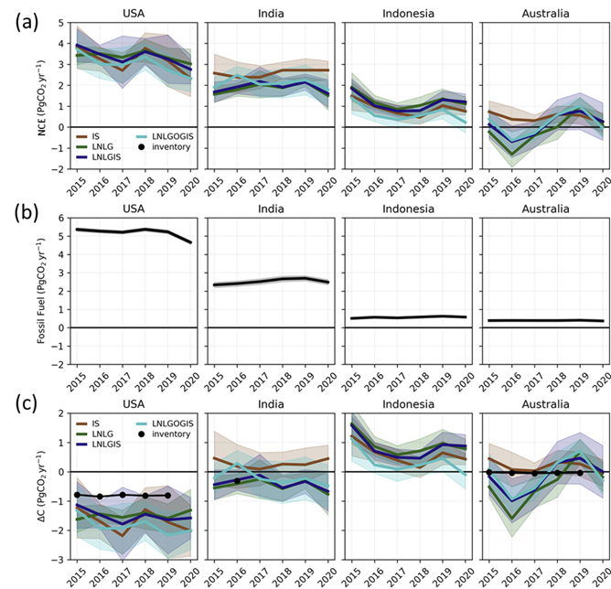
Figure 3.13: Time series of (a) NCE, (b) Fossil fuel emissions and (c) ΔC for USA, India, Indonesia and Australia from the inverse modeling experiments described in Figures 3.9 and 3.12. AFOLU estimates reported from available bottom-up inventory reports are shown as black dots. Unlike the maps shown earlier, these results are expressed in Pg CO₂ yr⁻¹ to facilitate comparisons with other CO₂ inventories.
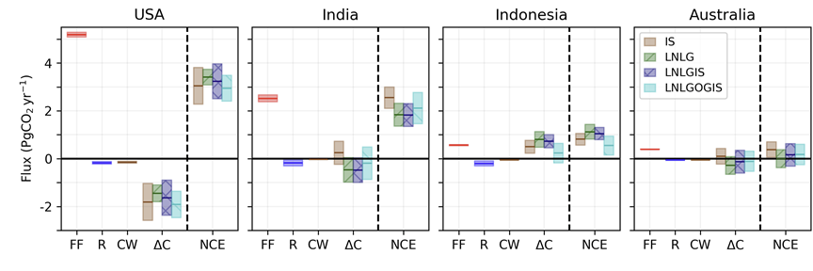
Figure 3.14: Contributions NCE associated with fossil fuel use (FF), lateral transport by rivers (R), crop and wood exports (CW) and the land biosphere (ΔC) are compared for the four countries identified in Figure 3.13 for each of the four inverse modeling experiments introduced in Figure 3.9. The vertical extent of the boxes indicates the interquartile range of the ensemble, a measure of uncertainty.
For future stocktakes, these estimates will be refined as new space-based observing systems are deployed to expand observational coverage and resolution of the atmospheric XCO₂ distribution. Complimentary expansions of ground-based and aircraft-based CO₂ measurements are critically needed in under-sampled regions both to complement the coverage of the space-based data and to assess their accuracy. Improvements to flux inversion systems will further refine results, as reductions to systematic transport errors will be critical for refining carbon flux estimates.

Use Case 3.2: Pilot Top-down Methane Emissions Estimates by Sector and Country
Methane is emitted by a broad range of natural processes and human activities (Figure 3.15). For this use case, the NASA Carbon Monitoring System Flux (CMS-Flux) team analyzed remote sensing observations from Japan’s Greenhouse gases Observing SATellite (GOSAT) to produce national-scale CH4 emission budgets. They used an analytic Bayesian inversion approach and the GEOS-Chem global chemistry transport model to quantify emissions and their uncertainties at a spatial resolution of 1° by 1° and then projected these to each country. Unlike the pilot CO2 inventories, these CH4 budgets optimize emissions from fossil fuel extraction, transport and use as well as those from wetlands and inland freshwaters, agriculture, waste and fires.
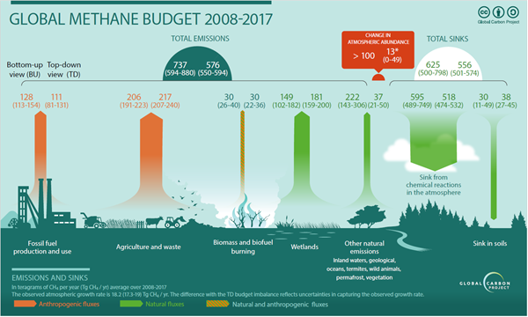
Figure 3.15: Global methane (CH₄) budget for the period 2008–2017 (plot taken from Saunois et al., 2020). Processes that emit methane (CH₄) into the atmosphere (upward arrows) as well as their relative contributions can be seen from the numbers. The orange colored arrows indicate anthropogenic sources and the green colored arrows indicate the sources of natural origin. The major loss processes are depicted by the down arrows. For details on data sources, please refer to Saunois et al. (Earth Syst. Sci. Data, 12, 1561–1623, 2020. doi:10.5194/essd-12-1561-202).
Methodology
Methane emissions and their uncertainties for 2019, were derived by sector, at 1-degree latitude-longitude resolution and then projected to country-scale resolution. Top-down fluxes are based on spatially resolved estimates of the column average methane dry air mole fraction, XCH₄, derived from measurements returned by Japan’s GOSAT satellite. These data are analyzed using the GEOS-Chem global chemistry transport model and quantified using an analytic Bayesian inversion approach. This approach allows us to project these fluxes to emission sectors by accounting for the spatial structure of the emission uncertainties as opposed to assuming that emissions are 100% correlated within a model grid cell (fluxes are evenly projected back to emissions with equal weighting) as is typically assumed with top-down flux methods. This combination of algorithms allows us to project fluxes to emissions at arbitrary scales as long as the emission inventories and corresponding uncertainties are provided at these same scales.
This approach also allows us to report uncertainties that are due to the limited spatial resolution of the fluxes and structure of the prior emission uncertainties (also called representation error or smoothing error). However, systematic errors resulting from the chemistry-transport model used to relate emissions to concentrations are not reported, although the flux inversion approach does mitigate these errors. Based on other analysis reported in the literature we expect that systematic errors in the model add uncertainty that is at least as large as the uncertainties reported in this document. Emissions presented here should be considered as “Pilot” data intended to complement existing research. For example, researchers could use reported discrepancies between these top-down and bottom up estimates as a starting point for further investigation.
Summary of Results
The existing observation and analysis system (GOSAT data + GEOS-Chem) can quantify total emissions for about 58 of the 242 countries. Both top-down and bottom-up estimates indicate that (i) the largest CH₄ emissions are from the agricultural sector (including waste/manure management), primarily livestock (enteric fermentation) and (ii) the top five emitting countries are responsible for about half (~170 Tg CH₄/yr) of the global anthropogenic CH₄ emission budget (Figure 3.15).
However, it is challenging to reconcile recent reports of very large methane emissions from wetland plus aquatic sources (e.g. rivers, lakes, reservoirs, aquaculture) (~219-394 Tg CH₄/yr) with the top-down fluxes reported here. A caveat to this conclusion is that rice farming and livestock emissions are indistinguishable from nearby, unspecified, aquatic emissions using remote sensing, highlighting a need for further research. It is also challenging to reconcile these global top-down fossil emissions (Coal + Oil + Gas) based on remote sensing observation (80 to 100 Tg CH₄/ yr) with the much larger values inferred from in situ isotopic information (~160 +/- 20 Tg CH₄/yr) and prior inventories (e.g., ~97 +/- 23 to 128 +/- 15 Tg CH₄/yr). We find that fossil emissions tend to be spatially distinct from other emission sources and therefore are well resolved by remote sensing. At present time we cannot resolve this discrepancy between remote sensing estimates and these other approaches. The sum of Agriculture, waste emissions, and fire emissions is 276 +/- 26 Tg CH₄/yr, larger than the prior emissions of 197 +/- 46 Tg CH₄/yr. These results are larger than but consistent (within reported uncertainties) with previous estimates of ~242 Tg CH₄/yr based on remote sensing or in situ data.
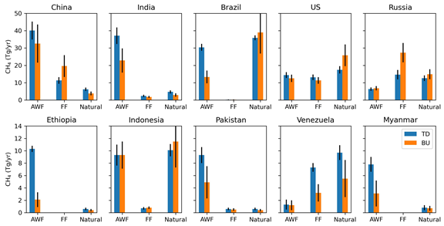
Figure 3.16: Top-down (TD, blue) and bottom-up (BU, orange) methane emissions by sector from the top 10 emitting countries are compared. The sectors shown include Agriculture, Waste and Fires (AWF), Fossil Fuels (FF), and Natural sources, such as wetlands and seeps.
Hence, while these top-down atmospheric CH₄ estimates are providing significant insights into the largest sources of emissions and their response to human activity and climate change, these pilot products should be interpreted with caution given limitations of the current atmospheric measurement and analysis systems. While this system does not yet completely meet the requirements for a CH₄ MVS system, ongoing advances in ground-based, airborne, and space-based measurements of CH₄, combined with progress in atmospheric inverse methods are yielding substantial improvements in precision, accuracy, resolution and coverage.

Constraining Atmospheric CO₂ emissions from Compact Sources
On smaller scales, space-based XCO₂ estimates are being combined with ground-based and airborne measurements to quantify CO₂ emissions from individual power plants (Nassar et al., 2017; 2021; Reuter et al., 2019; Hakkarainen et al., 2021) and large urban areas (Hedelius et al., 2018; Wu et al., 2018; Wu et al., 2020) . Space-based sensors do not yet have the coverage needed to track all of these local sources, but they do provide the data needed to assess the precision that could be delivered by future space-based instruments. For example, Nassar et al. (2017; 2021) has used OCO-2 XCO₂ estimates to quantify emissions from individual coal-fired power plants. Detailed comparisons to direct measurements obtained from in situ stack monitors and other proxies indicate differences that are typically in the range of 1.4 to 26.7%, with a mean of 15,1%. OCO-2 XCO₂ observations are also being combined with nitrogen dioxide (NO₂) estimates derived from the Copernicus Sentinel 5 Precursor TROPOMI measurements to track and quantify CO₂ emission plumes tens of km downwind of large power plants (Reuter et al., 2019; Hakkarainen et al., 2021).
Other studies have focused on top-down estimates of emissions from large urban areas, which are thought to be responsible for about 70% of all anthropogenic CO₂ emissions. For example, Hedelius et al. (2018) estimate the net CO₂, CH₄ and CO flux from the Los Angeles South Coast Air Basin (So-CAB). During the study period, which extended from July 2013–August 2016, CO₂ emissions estimates derived from TCCON XCO₂ measurements indicate that the net CO₂ flux from the So-CAB is 104 ± 26 megatons of CO₂ per year (MtCO₂ yr⁻¹). A slightly higher estimate of 120 ± 30 MtCO₂ yr⁻¹ is obtained using XCO₂ observations derived from OCO-2 observations. These CO₂ emission estimates are slightly lower than those from previous work. In another study, Wu et al. (2020) analyzed OCO-2 XCO₂ data with an advanced transport model to quantify per capita CO₂ emissions from 20 major urban areas. In general, they find that cities with greater population density have lower per capita emissions. This is consistent with earlier bottom-up estimates. However, they find that cities with heavy power industries or greater affluence have substantially higher per capita emissions. These studies suggest that space-based measurements could eventually play a significant role in emissions monitoring efforts.

Changes Anticipated in the Ocean Sink as it Responds GHG Emission Reductions and Climate Change
Because CO₂ dissolves in seawater and is used for photosynthesis and produced by respiration by ocean plant life, the ocean both absorbs and emits CO₂ to the atmosphere.The sinking and oxidation of particulate organic carbon generated through photosynthesis generates a vertical gradient with higher values of dissolved inorganic carbon in deep waters and lower values in the surface. This process, known as the “biological carbon pump”, is critically important to regulating long term atmospheric CO₂ levels (Sundquist et al., 1985). On annual to decadal time scales, the flux of CO₂ into or out of the ocean is determined primarily by the difference in the partial pressure of CO₂ (pCO₂) above and below the surface of the water and water temperature. Since the beginning of the industrial age, human activities have increased the atmospheric CO₂ concentration and thus the partial pressure of CO₂ in the atmosphere, increasing the flux into the ocean. When averaged over the globe and over the annual cycle, the ocean is now absorbing about 23% of all anthropogenic CO₂ emissions (Friedlingstein et al. 2020).
Monitoring this critical CO₂ sink is a high priority in the Systematic Observation community as there is growing evidence that as atmospheric CO₂ concentrations and surface temperatures change in response to human activities and climate change, the ocean uptake of CO₂ will be reduced (Ridge and McKinley, 2021; Marsay et al., 2015; Randerson et al. 2015; Laufkötter et al. 2016; Bennedsen et al. 2019; IPCC AR6 WG1). The amplitude and timing of these changes are still a subject of considerable debate within the scientific community, but the Systematic Observation community needs to be prepared to document and explain ocean carbon sink changes as they occur.
Monitoring changes in the emissions and removals of CO₂ by the ocean poses significant challenges to the measurement and modeling communities. When integrated over the globe, the ocean emits about 330 billion tons of CO₂ into the atmosphere each year and reabsorbs a comparable amount along with about 9 billion tons of anthropogenic CO₂. While these globally-averaged gross fluxes are large, they are distributed over 70% of the Earth surface area and are typically characterized by pCO₂ changes no larger than a few percent near the ocean surface. When integrated over the atmospheric column, rarely produce changes the column-averaged of CO₂ (XCO₂) larger than 0.1 ppm. These surface changes are beyond the capabilities of the current generation of space-based remote sensing systems, and must be monitored by in situ sensors aboard ships or carried by autonomous ocean-going probes. In addition, the transport of carbon from the surface mixed layer to the deeper ocean, which regulates the long-term ocean carbon uptake, can only be measured through in situ observations. While the number, frequency and quality of these ocean in situ pCO₂ sensors has increased in recent years through campaigns such as the Global Data Analysis Project (GLODAP), ​​the CARbon dioxide IN the Atlantic Ocean (CARINA) project and the Surface Ocean pCO₂ Mapping intercomparison (SOCOM), measurements are still sparse and rarely systematic. A substantially expanded operational in situ monitoring program for ocean carbon is needed to track the ocean sink changes of relevance to the Paris Agreement.

Future Developments in GHG Budget Estimates
The need to monitor CO₂ and CH₄ emissions and provide a global capability to support action on climate change in line with the Paris Agreement has stimulated the development of several initiatives on different continents. In Europe, a programme to build a monitoring and verification support capacity for anthropogenic CO₂ emissions at global, regional and local scale (CO2MVS, Janssens-Maenhout et al., 2020) is expected to deliver a working prototype system by the end of 2023. Such a prototype will then be further developed and made operational by 2027 as part of the EU-funded Copernicus Atmosphere Monitoring Service (CAMS) operated by ECMWF. Once fully operational, the new service will take advantage of the much-improved satellite monitoring capabilities (e.g., the CO2M constellation and other Sentinel missions as well as non-European missions coordinated under CEOS). Building upon the data assimilation and modeling tools developed in the context of numerical weather and air quality prediction, the CO2MVS will be fully integrated with new emission monitoring capabilities for CO₂, CH₄ and various atmospheric pollutants in CAMS to provide a consistent view of the anthropogenic impact on the atmosphere.

Improved Inventories of Agriculture, Forestry, and Other Land Use (AFOLU)
Agriculture, Forestry, and Other Land Use (AFOLU) is a unique category within the Energy sector since the mitigation potential is derived from both an enhancement of removals of GHG, as well as reduction of emissions through management of land and livestock. The AFOLU sector is responsible for just under a quarter of anthropogenic GHG emissions, mainly from deforestation and agricultural emissions from livestock, soil and nutrient management [IPCC 2014].
​​Earth observation (EO) satellites have been acquiring data on the state and dynamics of the global landscape for over 40 years. A summary of recent, current, and near-future satellites is shown in Figure 3.17. The IPCC Special Report on Climate Change and Land (SRCCL,2019 ), which highlights the multiple interactions between climate change and land use and the social dimensions of land degradation, desertification and food security in a changing climate, also references the strengths and limitations of EO data. The 2019 Refinement to the 2006 IPCC Guidelines for National Greenhouse Gas Inventories (IPCC 2019) referred to the significant advancement of the use of EO data for monitoring land use and land change. The IPCC AR6 WGI report indicates that under scenarios with increasing CO₂ emissions, the ocean and land carbon sinks are projected to be less effective at slowing the accumulation of CO₂ in the atmosphere. Because climate change can reduce the efficiency of land sinks, mitigation activities focused on AFOLU must include efforts to enhance the resiliency of these sinks.
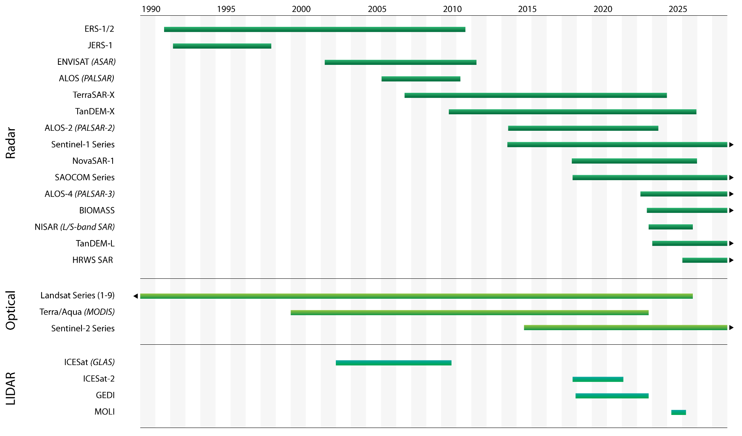
Figure 3.17: Earth observation satellite sensor types supporting AFOLU information needs.

The CEOS AFOLU Effort – Compiling space-based products to support Mitigation and Adaptation objectives of the Global Stocktake
CEOS is developing a Roadmap to identify the substantive benefits of using Earth observation data and to provide the related satellite products in a form that addresses the needs of the policy community. Communicating the capabilities and understanding potential barriers is essential to facilitate the effective use of these data in support of the Paris Agreement. This includes a) the lack of ground-based observations needed to estimate the uncertainties in the data., b) differences in observations by different remote-sensing instruments, particularly optical, radar and lidar, c) disparities between spatial resolutions and frequency of observations, and d) the costs of the data and processing and limited knowledge and skills exchange, which collectively limit use in many developing countries.
A key focus of the CEOS effort to contribute to the land sector of GST is to ensure that the land data products derived from space-based EO are complete and accurate. Their EO satellite sensors operate in different domains of the electromagnetic spectrum (primarily optical, radar, thermal and lidar) and provide information on one or more properties of agriculture, forests and vegetation biomass (Figure 3.17). This requires a clear and expert overview of these capabilities to enable optimal use in the different AFOLU domains.
An overview of datasets that are available to support the GST is provided in Figure 3.18, noting that there is potential to combine these within frameworks that integrate them with other data that can support the identificación and quantification of AGB changes due to transitions between different land use categories and within a single land use.
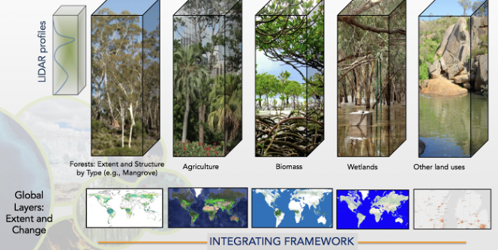
Figure 3.18: Broad overview of global datasets generated from EO that can support the GST.
The primary expected outcome of the CEOS AFOLU efforts is an enhanced uptake of EO satellite data sets in support of the first GST in 2023 on a global and country level. For the firstGST, pilot products are being developed based on existing capabilities, assuming that 2021 will be a reference year for this stocktake. These deliverables include (i) agriculture, (ii) land use, (iii) forests as above ground biomass, and (iv) other land uses. Examples of the data available in each of these areas are summarized in the following subsections.

Agriculture
Agriculture has been a major focus for EO research and operational development for over 40 years. The effort has evolved from a discovery research focus utilizing scientific missions to the current day where operational monitoring systems employing operational EO mission data are supporting policy and program decisions around the world. For instance, the Group on Earth Observations Global Agricultural Monitoring Initiative (GEOGLAM) policy mandate initially came from the Group of Twenty (G20) Agriculture Ministers during the French G20 Presidency in 2011; the mandate has expanded parallel to the G20 mandate to include food security concerns. Now, GEOGLAM works on early warning for international agency response to food emergencies. However additional work will be needed as the land biosphere responds to climate change. The IPCC has identified many information and knowledge gaps required for food availability, food system resilience, mitigation, and trade-offs between GHG emissions and food production (IPCC 2014, 2019).
There are many past, present and planned initiatives that can contribute to AFOLU NDCs by providing state and change information in support of climate change mitigation and adaptation measures. For example, global EO data sets on agricultural crop production systems (including crop rotations, cover crop utilization/duration/biomass accumulation, and tillage practices), and rangeland grazing areas (including quality, intensity of use, and management) can make a significant contribution to GST, and agricultural NDCs at the national level, and mitigation practices, including at the farm level. The main areas in which EO can contribute include (i) agriculture land cover and land use, (ii) crop condition, (iii) agriculture management practices, (iv) agricultural biomass burning, and (v) soil carbon. Each of these areas are described in greater detail below.
Agriculture Land Cover and Land Use: State and change monitoring is critical for understanding AFOLU dynamics and their impact on climate change, and vice versa. The IPCC identified this type of information as a major gap and highlighted the need for improved global high-resolution data sets of crop production systems and grazing areas (IPCC 2014). Besides global crop productivity monitoring (via condition assessment and yield forecasting), cropland and crop type mapping (Figure 3.19) are among the most mature applications of EO for agriculture. This example of seasonal crop mapping is from the WorldCereal project using Sentinel 2 data. Towards the first GST in 2023, pilot WorldCereal products are planned to as follows:
- Global annual cropland extent at 10 meters resolution taking into account seasonality with distinguishing between rainfed and actively irrigated cropland.
- Global cultivated crop type maps of maize and wheat at 10 meters resolution per season.
- An open source system to produce seasonal crop type maps in to the future
- Global in situ reference data sets to support the crop analytics.
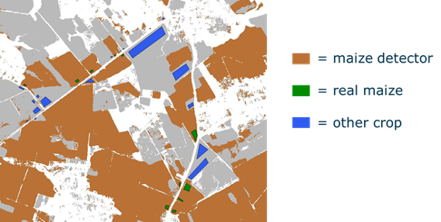
Figure 3.19: Example of a crop type map, identifying areas covered by maize and other crops.
Crop Condition: Near-real time monitoring of crop productivity is critical to understanding the impact of climate shocks on local and global food chains within season and throughout time. The IPCC’s report on Climate Change and Land (IPCC, 2019) identifies key knowledge gaps around food availability, resilience, mitigation, and trade-offs in decision making. Operational EO is already important in the support of proactive climate adaptation decision making. The GEOGLAM Crop Monitor for Early Warning (CM4EW) is already making a significant impact on global food security by providing near real time assessments of crop production, largely from satellite EO. At the national level GEOGLAM has been working with least developed countries (LDCs) to co-develop their own crop monitoring systems using open data and tools. Where implemented these systems have proven to be an effective climate adaptation measure by informing proactive policies and programs.
Agriculture Management Practices: Management practices, attribution and quantification of their net GHG fluxes have been flagged by the IPCC as a major gap. Information requirements relate to nutrient application, pest management, irrigation, cover crop utilization, structural conservation management (e.g. strip and buffer cropping), and crop residue management (tillage and burning, see next sub-bullet). The IPCC points out that this information provides “improved understanding of the mitigation potential, interplay, and costs as well as environmental and socio-economic consequences of land use-based mitigation options such as improved agricultural management” (IPCC 2014). This is an active area of EO application research and development, particularly with the advent of commercial satellites with increased temporal and spatial resolution coupled with the adoption of sustainability commitments by actors throughout the agricultural value chain.
Agricultural Biomass Burning: A widely used practice globally during harvesting, post-harvesting, and preparatory (pre-planting) periods that has profound effects on local and regional air quality (Korontzi et al., 2006). Agricultural land use is responsible for at least 8-11 % of global fire events worldwide (ibid) and at least 3 % of carbon emissions worldwide (van der Werf et al, 2010). Even so, current methods under report and therefore underestimate the agricultural emissions from agricultural burning by missing small and short duration fires (Lasko et al., 2017), highlighting this as an important area for further research). Satellite sensor data have revolutionized the field of burned area mapping, active fire mapping, and fire emissions estimation (Boschetti et al., 2020), but further work is needed to close the gap in understanding agricultural fire dynamics and their impacts on carbon (dioxide and monoxide), methane, nitrogen dioxide, sulfur dioxide, and particulate matter emissions. Their impacts on microclimate and human health also need to be recognised.
Soil Carbon: Estimates of Soil Organic Carbon (SOC) stocks and fluxes are an important yet poorly constrained component of the global carbon-climate system. Monitoring soil carbon dynamics is key to understanding climate mitigation efforts (Hagen et al, 2020), and “Smart Farming” practices can help to sequester significant quantities of carbon. Models that relate agricultural practices to carbon sequestration are well established (e.g. EPIC, APSIM, DSSAT, ecosys, Cropsys, and DNDC). Satellite data can provide important information on the land management and use essential agriculture variables (EAVs) required to parameterize and update these models. Some of the key inputs, mentioned above, include crop type; tillage intensity and type; crop residue, crop yield and crop biomass.

Land Cover
Land Cover/use and change datasets are relevant to the UNFCCC Paris Agreement and specifically its GST. Land Cover data can be useful for national GHG inventories for estimating land use activity data, and towards global AFOLU assessments and GHG/Earth System modeling approaches.
At present, Land Cover products are being developed as part of a number of ongoing relevant projects and programs by various CEOS agencies (Figure 3.20). These include the work with countries to use Landsat and Sentinel-type observations for deriving IPCC land use category-related activity data (i.e. work of GFOI partners), operational programs providing continuous, annual global forest and land cover change data (i.e. EC Copernicus global climate and land monitoring services and UMD/WRI’s Global Forest Watch annual/weekly tree cover loss), synthesis long-term land cover change datasets (i.e. HILDA+, LUHv2), and a series of next generation product demonstrations for global 10 m resolution land cover (i.e. ESA-WorldCover), Global mangrove cover and change (i.e. JAXA Global Mangrove Watch), high resolution fire/burnt area (GFED with Sentinel, EC Copernicus Global Land Service) and land degradation analysis using both optical and Radar data (i.e. using ALOS; also linking the SDG 6.6.1 and 15.3.1). There are also a series of efforts to advance how land cover change, fire, biomass and other datasets can provide forest/AFOLU flux products becoming available (Nancy Harris et al. 2021).
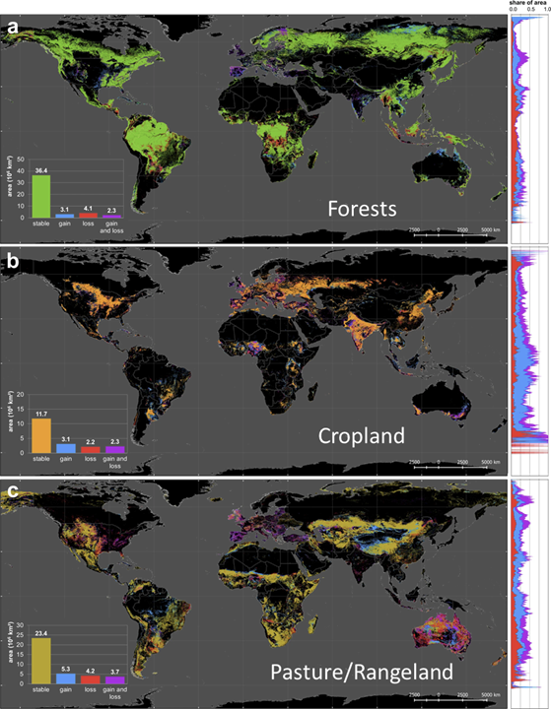
Figure3.20: Global land cover change from 1960-2020 for (a) forest, (b) cropland and (c) Pasture and Rangeland and change (gain and loss) between 1960 and 2019 (derived from HILDA+ data, Winler et al., 2021, Nature Communications).
Despite the increasing availability of data, some gaps in this context remain. There is a need to synthesize and coordinate the derivation and presentation of Land Cover and Change as a dedicated contribution to policy processes like the UNFCCC GST. There is also a need to understand discrepancies and promote increasing consistency between remote-sensing approaches and the criteria used in National Greenhouse Gas Inventories, particularly in how managed and unmanaged lands are distinguished, and the accounting of natural versus anthropogenic impacts. A forest and land cover change synthesis would include an analysis of the suitability of the available datasets and efforts towards the various aspects of the GST; including:
1. the support of national GHG inventories for improved activity data estimation for forest/land cover/use change following the IPCC GPG. Satellite time series observations are essentially used by many countries for estimating IPCC activity for forest area changes operationally at the moment already.
2. the provision of improved global land change data for AFOLU assessments, and input to GHG estimations and modeling products. These global datasets take advantage of the long-term satellite data records to provide consistent land cover/use change estimates at global level.
3. the enhancement of the consistency and comparability of national GHG inventory data and global GHG analysis by providing consistent best available global land cover/change data related and harmonized with national GHG inventories. This link only vaguely exists at the moment and requires additional investments and datasets and the use of stratified area estimation at national and global level to allow for more comparability.
The land cover/use observation community has started to work on these items and is ready to provide dedicated input to UNFCCC Global Stocktake processes as needed.

Forests as Above Ground Biomass
Forest Cover Information is essential to support countries in the acquisition of forest activity data (AD) to develop their Forest Reference Levels and Forest Reference Emissions Levels as well as the REDD+ results. The former includes both estimation of the total area of land cover belonging to the forest class (parameterised by, for example, canopy closure), as well as information about the spatial distribution, or macro patterns, of the forest cover. Canopy closure, typically estimated from optical fine- or medium resolution EO data, is also an indicator of the state or health of the forest cover. Activity data can be estimated using a time-series of EO data, where information about changes to the forest class from/to other land uses (i.e., afforestation, reforestation, deforestation) can be derived. Optical medium resolution sensors are most commonly used, but long wavelength band (e.g. L-band) SAR sensors are particularly efficient in detecting and delineating changes as they are unaffected by cloud cover and illumination conditions. Both sensor types are also useful for detecting within class changes (a.k.a. forest remaining forest), caused by degradation events and processes, regrowth or forest management practices. These are typically slower processes than those driving forest removals and require longer time-series of data for detection and quantification.
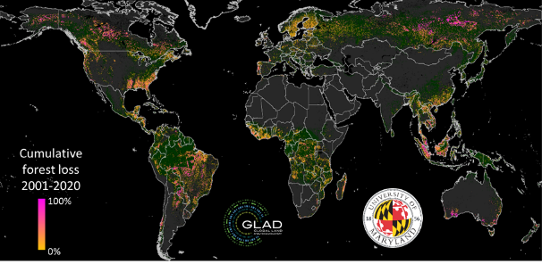
Figure 3.21: Global tree cover extent and loss from Landsat in cooperation with GLAD in UMD.
Biomass products from EO - specifically derived from Lidar and SAR sensors – can be used to estimate Emission Factors (EF) for higher tier reporting and will need to meet requirements of the IPCC in order to contribute successfully to National Greenhouse Gas Inventories (NGGI) (IPCC, 2019). In particular, the ground data need to be available for calibration and validation of EO products and characterisation of uncertainty including the manner in which bias and precision are reported. It is also deemed essential that consistency is maintained in relation to each individual country’s definitions of forest and biomass. EO-derived forest data can also contribute to NGGIs through the development of biomass change products, with these allowing estimation of emissions from change events (e.g., deforestation) or processes (degradation, growth). Central to this is, again, the need for consistent products and supportive in-situ data. Considerations need to be made in the separation between anthropogenically and naturally driven changes and their different contributions to emissions. The sensitivity of EO data to subtle changes in forest biomass (e.g., through progressive removal or growth of woody components) also needs to be carefully assessed.
Global above ground biomass maps in 1st GST reference year 2021 with 2020 as backup and historical datasets from previous years will be developed. There are contributions of CCI biomass, GEDI biomass, NASA JPL biomass and others (see Table 3.1). Intercomparison, validation and harmonization of these products to increase product improvement and uptake with available reference data (see Figure 3.22).
These biomass products represent the next generation of maps for improved global and regional estimations. They have been developed using different training data, statistical approaches, and satellite input datasets, and therefore are expected to disagree in many ecosystems. To use the best available product for each ecosystem and/or application, transparent and global-scale intercomparison and validation of these products is highly desirable. These are key steps toward a dedicated contribution to policy processes like the UNFCCC GST. The EO biomass community is undertaking a global biomass product harmonization activity in an attempt to understand and communicate discrepancies between products, and produce a single estimate of biomass and uncertainty at a policy relevant, jurisdictional-level scale. This effort builds upon the CEOS biomass cal/val protocol and reference data and tools available and used by CEOS partners. Key global biomass production and validation expert teams are engaged in this effort with a shared goal of production of a harmonized biomass product for use in the UNFCCC GST process, with anticipated release in 2022.
Table 3.1: Summary of available biomass maps in CEOS AFOLU activity (CEOS AFOLU).
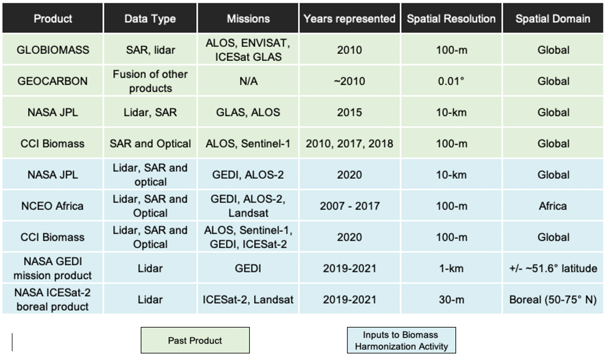

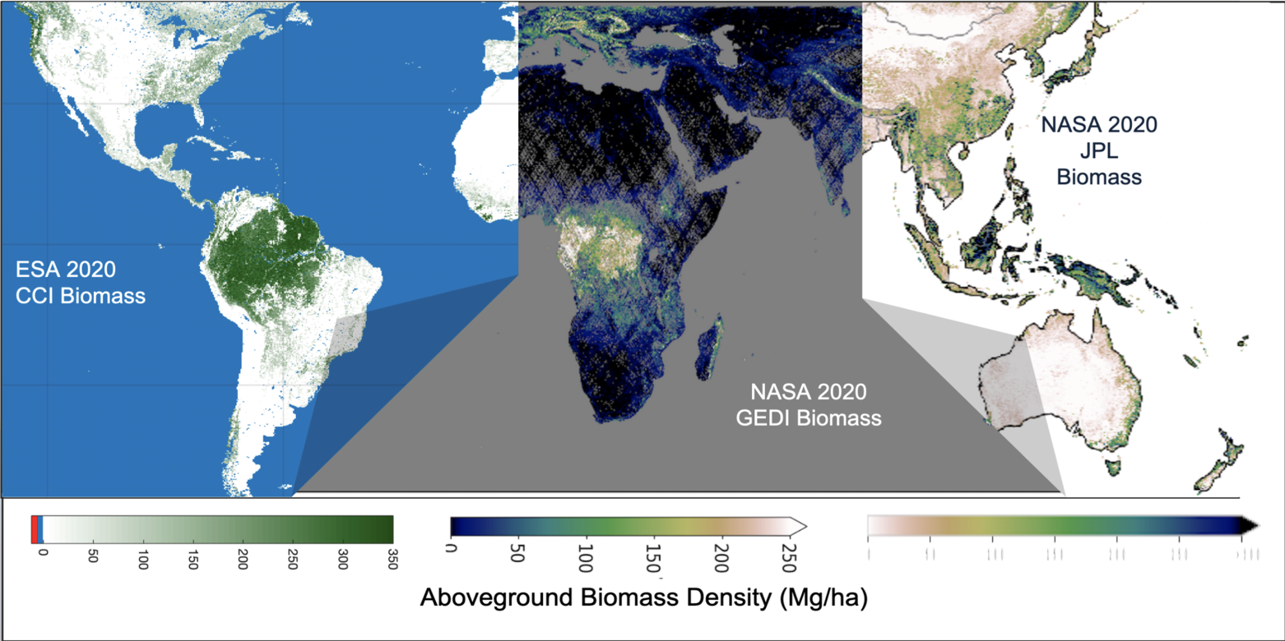
Figure 3.22: Intercomparison, validation and harmonization among biomass maps (CEOS AFOLU).
- Country cases of carbon stock in forests supporting reporting of NDCs (in cooperation with GFOI)

​​Use Case 3.3: GEO-TREES: Forest Biomass Reference System from Tree-by-Tree Inventory Data

Ground reference measurements are essential for accurate calibration and validation of space measurements. In 2021, The Group on Earth Observations (GEO) launched a new activity named GEO-TREES, which aims to support the establishment and development of a global activity of in situ biomass reference measurement sites, the Forest Biomass Reference System (FBRS), to complement existing and planned space-based forest biomass observation instruments and the work of other GEO Flagships as the Global Forest Observations Initiative (GFOI). These sites will provide integrated, multi-observational, multi-scale reference data to support global space-based forest biomass mapping and will include high-quality georeferenced data on tree biodiversity.
By enabling verification and validation of global biomass maps, GEO-TREES will directly contribute to Article 4 paragraph 2 and Article 14 of the Paris Agreement, respectively on National Reporting and the Global Stocktake and as such also to the RSO and Global Stocktake workstreams.

Wetlands

Inland and coastal wetlands can play an important role in both climate mitigation and adaptation. Hence there is an urgent need for comprehensive and up-to-date geospatial information on their extent (including by type), biomass and health, to produce reliable estimates of emissions and removals from these ecosystems. Wetlands, in the context of the CEOS AFOLU team (and similarly to the IPCC Wetlands Supplement; IPCC, 2013), can occur under any IPCC land-use category. Examples include mangrove forests (Forest Land IPCC category), peatlands (Forest Land or Wetland IPCC category, depending on their management) and seagrass meadows (Wetlands IPCC category). This thematic area can complement and contribute to the other AFOLU thematic areas, specifically land use and biomass, providing scientific information (data and methods) that consider the special characteristics of these important and carbon-rich ecosystems.
The most comprehensive dataset showing global mangrove distribution and change over time (Activity Data) available in the public domain is produced by the Global Mangrove Watch (Bunting et al., 2018). It, is a time-series of global mangrove extent maps at 25 m spatial resolution, to date covering eleven annual epochs between 1996 and 2020, derived from a combination of optical (Landsat) and long wavelength band (L-band) radar (ALOS PALSAR) data (Figure 3.23). Annual maps will be released from 2021. The GMW dataset is the default mangrove dataset used by UNEP to support countries reporting on SDG Indicator 6.6.1 (Change in the extent of water-related ecosystems over time).
Simard et al. (2019) have generated maps of mangrove canopy height and AGB at 30 m resolution for the year 2000, derived from Digital Elevation Data (DEM) from the 2000 Shuttle Radar Topography Mission (SRTM). These will be followed by mangrove height and AGB maps at 12 m spatial resolution, for the year 2015 and derived from TanDEM-X Digital Elevation Model, foreseen for public release in 2022.
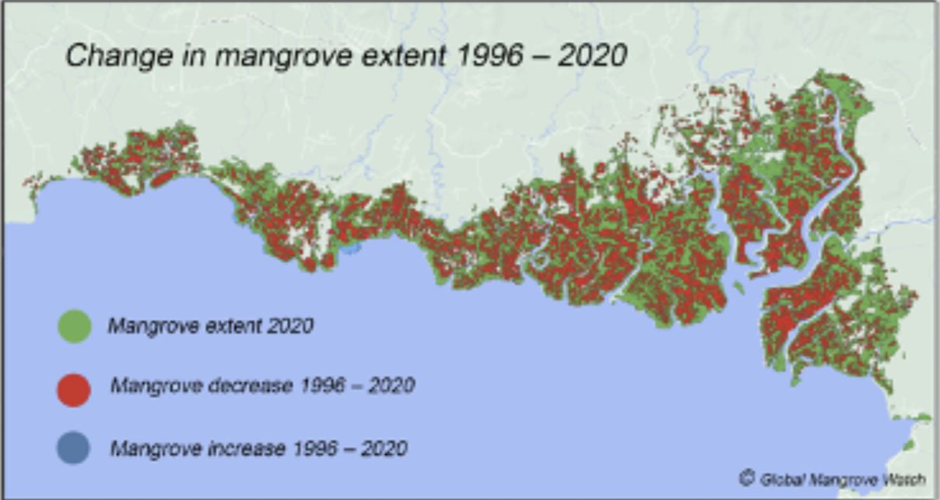
Figure 3.23: Mangrove change in Southeast Asia 1996-2020 (www.globalmangrovewatch.org).

Towards harmonization the AFOLU products and long term AFOLU Roadmap
The use of EO to inform policy decisions and track progress toward the goals of the Paris Agreement, for the AFOLU sector specifically, will become increasingly important in the next 15-20 years. To support this activity in a timely fashion, CEOS agencies have initiated an effort to coordinate and harmonize space-based products that support the development of bottom-up AFOLU inventories. Advances in these EO products are expected over the next 15-25 years, as GHG emissions are reduced to levels where the remaining sources are largely compensated by ocean and land carbon sinks, including those in the AFOLU sector. For example, activity data on forest cover might differente natural forests from plantations and different forest types. Upcoming missions, such as ALOS-4, NISAR and BIOMASS, will further enhance the capabilities to monitor emissions and removals from the AFOLU sector. To compare bottom-up AFOLU inventories with top-down atmospheric GHG estimates, we must discriminate Fossil Fuel / Net Biospheric Exchange / Ocean contributions to the Net Carbon Exchange (NCE) and define “Managed Land” and what fraction of the observed emissions are from Managed/Unmanaged land. We must also correct for lateral transport of crops, wood products and river carbon, because these contributions do not immediately enter the atmosphere.

Summary and Conclusions on the Role of Systematic Observations Supporting Mitigation
Climate data records derived from systematic observations of the Earth provide the scientific basis for tracking past and present trends of GHG emissions by sources and removals by sinks. Spatially- and temporally resolved atmospheric GHG measurements are being analyzed to quantify net emissions and removals at scales spanning large power plants or urban areas to the globe. These data are providing new tools for assessing the completeness and accuracy of the bottom-up GHG inventories, which form the basis of the BTRs and NDCs for the GST. While this field is still in its infancy, supported by contributions from the science community rather than a sustainable global operational system, the use cases presented here show that it can make a substantial contribution to the first global stocktake.
While these top-down estimates of GHG emissions and removals provide a critical new source of data for tracking GHG emissions, removals and trends, they complement rather than replace the bottom-up GHG inventories. The bottom-up inventories will continue to provide the most detailed and actionable information about the emissions from critical categories and sectors, such as stationary power in the Energy sector. Top-down methods provide the most complete estimates of the net emissions and removals at national to global scales, providing new ways to assess the collective progress toward the primary Mitigation goals of Paris Agreement. Systematic observations of the GHGs and surface temperatures also provide the information needed to assess impact of the observed emission pathways on global average temperature, and the need to adjust the level of ambition by the Parties in their mitigation and adaptation actions.
Systematic Earth Observations are also providing valuable input to bottom-up inventories of GHG emissions and removals from AFOLU, the second largest source of anthropogenic GHGs. High-spatial resolution space-based measurements are being analyzed and harmonized to yield much better constraints activity data for forests and crops, providing additional insight into land use and land use change. This new information should be of particular value to the developing world, where nations have less capacity to develop detailed bottom-up inventories and AFOLU is the largest source of GHG emissions. It should also become increasingly important over time as fossil fuel emissions are reduced and we approach a balance between anthropogenic emissions and removals.

Adaptation – Systematic Earth Observations to improve resilience to the adverse impacts of climate change
Guiding Questions:
7. What are the observed and projected changes in the global climate system and biosphere?
8. What are the global levels of climate risks, observed and potential impacts and vulnerability of human and ecological systems caused by climate change and at what temporal scales, (Articles 7.9(c), 13.8 and para 36(b))?
9. What is the state of adaptation efforts, support, experience and priorities based on i.e. the information referred to in Article 7, paragraphs 2, 10, 11 and 14, of the Paris Agreement, and the reports referred to in Article 13.8 of the Paris Agreement (para 36(c)), taking into account the best available science, gender perspectives, traditional knowledge, knowledge of indigenous peoples, and local knowledge systems?
10. What are the support needs of developing country Parties (11/CMA.1, para 31) and to what extent has progress been made towards assessing the support needs of developing country Parties (Articles 7.2 and 7.10)?
11. To what extent has progress been made towards enhancing the adequacy and effectiveness of adaptation and support provided for adaptation (Articles 7.14(c))?
12. What is the overall progress made in achieving the global goal on adaptation stated in Article 7.1, how do national adaptation efforts contribute to this goal (11/CMA.1, paragraph 14) including by contributing to sustainable development and ensuring an adequate adaptation response in the context of the temperature goal referred to in Article 2 (Article 7.1)? What work on methodologies, including metrics, will be needed to better understand that progress and what is further needed?
13. How can Parties increase the ability to adapt to the adverse impacts of climate change and foster climate resilience and low GHG emissions development, in a manner that does not threaten food production, consistent with the goal set out in Article 2.1 (b)?
The Paris Agreement calls for adaptation to be based on the best available science and mentions specifically for “(…) strengthening scientific knowledge on climate, including research, systematic observation of the climate system and early warning systems, in a manner that informs climate services and supports decision-making (…) (Article 7. 7(c))”. Decision-making, policy development and actions to address climate change should be based on sound science and observational data.
In order to understand, predict and plan for climate change, scientists and policymakers depend on climate information about past, present and future climate. This latter is crucially dependent on climate models. While these models are to some extent based on numerical weather prediction models, climate modeling requires a much broader based set of observations. These include:
- Ocean observations – the oceans are a major sink of carbon and absorb the major part of the Earth’s increasing energy;
- Biosphere observations – the biosphere is both a significant sink and source of carbon and plays a major role in the transport of water through the earth system;
- Cryosphere observations - melting of ice is a significant contributor to sea level rise and impacts water supplies to a third of the world's population;
- Hydrosphere observations – clean, fresh water supplies are essential to life. Evaporation of water is also a significant component of the movement of the increasing energy due to climate change around the Earth system; and
- Atmospheric observations – meteorological observations allow the forecasting of temperature, floods and droughts under a changing climate while measurements of atmospheric composition monitor changing levels of GHG, a driver for modeling projections.
The Earth’s climate is a single system where the oceans, atmosphere, cryosphere, hydrosphere and biosphere all interact.
The Global Climate Observing System has defined a set of 54 variables as Essential Climate Variables (ECV) covering all aspects of the climate system. Monitoring of these ECV is critical for modeling and prediction of the climate system and, ultimately, underpins successful adaptation. An ECV is a physical, chemical or biological variable or a group of linked variables that critically contributes to the characterization of Earth’ s climate. ECVs are critically Relevant for characterizing the climate system and its changes, Feasible and Cost effective to observe. There are many initiatives providing access to Climate Data Records (i.e. https://gcos.wmo.int/en/essential-climate-variables/table).
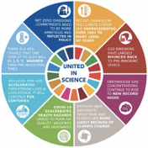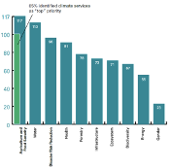
Figure 4.1: Key Points from Science 2021 report,

The highest adaptation priorities identified in the Parties’ Nationally Determined Contributions (NDC) (agriculture, food security, water, disasters, health) focus on issues largely related to changes in temperatures, precipitation, evapotranspiration and extreme events (Figure 4.1). However, providing timely warnings of hurricanes, storms, floods and heatwaves depends on the entirety of meteorological observations made by national meteorological organizations integrated by the WMO Integrated Global Observing System (WIGOS) from surface observations of pressure to radiosondes to satellites. Longer-term warnings of drought require seasonal prediction driven by ocean observations, particularly Argo and moored arrays. Projecting likely changes in the long-term requires an understanding of the entire Earth System: Atmosphere, Oceans, Cryosphere, Hydrosphere and Biosphere.
A similar picture with respect to data requirements emerges from the Key Points from United in Science 2021 report (Figure 4.1, Table 4.1) which highlights sea level, temperature, floods and droughts as key climate related issues. Poor air quality linked to temperature and wildfires is also a climate-related concern.
Table 4.1: Key observations linked to key points from the United in Science 2021 report complemented with additional information.
 | Key Observations
Net zero emissions | GHG Fluxes
CO2 Emissions | GHG Fluxes
GHG Concentrations | Atmospheric composition
Global Temperature rise exceeding 1.5C | Global mean temperature
Sea Level Rise | Sea level rise, global and local, river discharge, glacier and ice-sheet mass balance
Human Health | Temperature extremes, humidity, pollution from wildfires, aerosols, atmospheric composition
Extreme Heat | Temperature extremes, humidity
Heavy rain and floods | Precipitation, river discharge, soil moisture
Droughts | Precipitations, evaporation

These impacts are already occurring and are projected to worsen. The Atlas of Mortality and Economic Losses from Weather, Climate and Water Extremes (1970-2019), released 1 September 2021 shows that:
∙ From 1970 to 2019, weather, climate and water hazards accounted for 50% of all disasters (including natural and technological), 45% of all reported deaths and 74% of all reported economic losses. More than 91% of these deaths occurred in developing countries;
∙ the hazards that led to the largest human losses during the period have been droughts (650 000 deaths), storms (577 232 deaths), floods (58 700 deaths) and extreme temperature (55 736 deaths); and
∙ the hazards contributing to economic losses include storms (US$ 521 billion) and floods (US$ 115 billion), while the three costliest 10 disasters occurred in 2017: Hurricanes Harvey (US$ 96.9 billion), Maria (US$ 69.4 billion) and Irma (US$ 58.2 billion). These three hurricanes alone accounted for 35% of the total economic losses around the world from 1970 to 2019.

Use Case 4.1: GEO Mountains: contribution to the development of Essential Mountain Climate Variables

GEO Mountains is the Group on Earth Observations (GEO) Global Network for Observations and Information in Mountain Environments.
Mountainous regions are key ecosystems that are uniquely affected by climate change. Mountains cover 30% of the planet, host a quarter of the planet’s biodiversity, and the enormous range of ecosystem services they provide are vital to human well-being. For this reason, the establishment of Essential Mountain Climate Variables (EMCVs) contributes to the design of mitigation, adaptation, intervention, and environmental management strategies in these areas. Full integration of the in situ data component and interdisciplinary consensus on the establishment of EMCVs are essential for designing a more homogeneous data landscape in this field. A key step forward towards achieving a consensus list of ECMVs is represented by the article published on One Earth in June 2021, summarizing discussions held at a 2019 GEO Mountains-Mountain Research Initiative (MRI) workshop.
This article represents a starting point to stimulate further debate on the establishment of a consensus list of EMCVs that would integrate empirical observations with in situ, remotely sensed data and numerical models. These would ultimately contribute to better monitoring and addressing of climate-related mountainous change in the context of the Paris Agreement. GEO Mountains, together with the Mountain Observatories Working Group, also aims to facilitate the development of a global reference network of long-term environmental and socioeconomic monitoring sites or mountain observatories. To support the achievement of such a goal, research by the Mountain Observatory Working Group has highlighted existing gaps in the monitoring of mountain climate, supporting the development of observatories regionally and globally.

Use Case 4.2: GEO Human Planet Initiative: Essential Societal Variables contributing to the global assessment of adaptation

The Group on Earth Observations (GEO) Human Planet Initiative (HPI) generates datasets, knowledge and indicators used by practitioners, decision makers and scientists. HPI focuses on generating Essential Societal Variables (ESVs) including population and settlements, often combined with essential variables on climate, biodiversity, land, to provide an integrated understanding of planet Earth. Practitioners use ESVs to monitor urbanization, disaster risk, progress towards the SDGs, and to design adaptation strategies for climate change. ESVs are relevant to the Global Stocktake. Practitioners use ESVs to enumerate and size cities and settlements of the world, that is where most of the Earth’s resources are consumed. ESVs are available at five years intervals dating back to 1975 and used to assess human presence and impact for the past and to generate scenarios for population and settlement growth. HPI data and projections are used in assessing climate warming impact, in modeling Socio Economic Pathways, and for estimating population in mountains, in the Arctic, and in low elevated coastal areas that are vulnerable to a changing climate and environment. Scientists and practitioners also use ESV data to assess past and current emissions, to estimate energy demands and the potential of renewable energy production for climate mitigation.

Furthermore, in January 2021, the Human Planet Initiative launched the Atlas of the Human Planet 2020, collecting 100 case studies showing the use and possible applications of the Global Human Settlement Layer (GHSL) data sets in thematic areas connected to international policy frameworks, including the Paris Agreement. The 2021 release of GHSL integrating Copernicus Sentinel-2 data for the reference year 2018 has provided essential information for the mapping of human presence and infrastructure on earth. These maps can be used for the purpose of evidence-based modeling of the impact of human activities on ecosystems, human access to resources and exposure to threats in the context of frameworks such as the Paris Agreement.

Seven of the case studies included in the Atlas focus on the environment and show the applicability of products as the Global Human Settlement Model Grid (GHS-SMOD). The GHS-SMOD, when used with data from the Emissions Database for Global Atmospheric Research (EDGAR), enables the quantification of emissions from urban centers compared to rural areas and facilitates efforts to track their evolution over the past 25 years.

Use Case 4.3: GEO BON: Essential Biodiversity Variables and biodiversity observation networks

The Group on Earth Observations Biodiversity Observation Network (GEO BON) began in 2008 with the goal of improving the acquisition, coordination and delivery of biodiversity observations and related services to decision makers and the scientific community. GEO BON focuses on two areas: Essential Biodiversity Variables (EBVs) and their derived products, and Biodiversity Observation Networks. It is a collaboration where most of the work is performed by participating organizations and volunteers. EBVs are state variables that capture key dimensions of biodiversity and that are sensitive to change. Their focus is on biological status and they do not include threats and drivers of biodiversity change, which also require monitoring; these are under discussion so change can be attributed to its causes and a response determined. EBVs are now defined and implementation is in progress; note that while some EBVs are also indicators, in many cases indicators are a derived product from one or more EBV or other dataset.
Adaptation of ecosystems and the biodiversity they support may fall into two main areas:
- Increasingly active ecosystem management, which can take many forms but is a complex issue;
- Reduction of other stressors such as land conversion, invasive species, resource extraction, or pollution.
There is a potential to utilize EBVs to inform NAPs and global progress on adaptation under the Global Stocktake.

The role of systematic observations in adaptation
Data on past, present and projected future climate obtained from systematic observations provide a scientific basis for developing adaptation plans and monitoring their implementation. Systematic observations are critical to identify and quantify risks. All projections and models are based on extensive, long-term, climate records. Therefore, one key step for parties to adapt to climate change is to ensure adequate long-term climate observations, both in situ and from Earth observation satellites. This also includes the rescue of historical data not yet available in digital format.

Value chain
As noted above, effective response and decisions ultimately depend on observations. There are multiple links connecting observation and decision making and consequently a variety of value chains. Some observations such as the example of the Mauna Loa CO₂ time series, have a nearly direct value for decision making while others acquire such value through a series of intermediate steps that may involve databases and models, and almost always include some level of processing and tailoring to maximize the user relevance.
Observations must be collected and exchanged globally to provide adequate coverage to the global modeling centers. This requires real-time data exchange as well as data centers and data stores that collect and make accessible the long possible time series of each variable. Global centers generate model outputs that are then distributed to users in countries and regions. These model outputs can be used directly, downscaled or used to calibrate local models. Nationally, local model results can be used to drive weather and climate services and ultimately improve decision making and adaptation. Interaction with decision-makers and co-design and -production of products and services and operational delivery of those products and services to end-users supports adaptation action and, ultimately, improved climate-related user outcomes and socio-economic benefits.
Strengthening the operational nature of all the steps in these diverse value chains is expected to support and improve adaptation. Irrespective of the number of steps or the number of intermediate actors involved in the value chain, the quality of the outcomes crucially depends on the quality of the observations that underpin it.
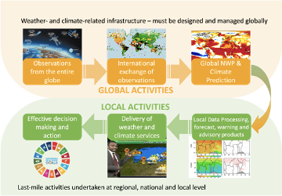
Figure 4.2: The value chain from systematic observations to effective decision and policy making.

Given the importance systematic observations have to inform the national and international action on climate, monitoring the uptake of this data by different communities could provide an indirect proxy on the status of the adaptation effort. The existing evidence -indicating a rapidly expanding user base- suggest a growing effort towards adaptation.

Importance of Global observations
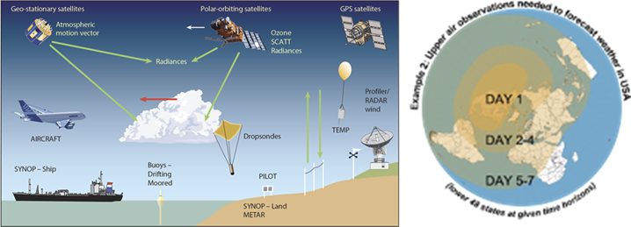
Figure 4.3: Global upper air observations are needed to forecast weather and climate
Reliable weather forecasts beyond three to four days for any location on the globe require observations from the whole world. In order to predict it, weather must be modeled globally: all modern weather prediction beyond 24 hours depends on global Numerical Weather Prediction (NWP), carried out at Global Producing Centres defined under the WMO Global Data Processing and Forecasting System (GDPFS).
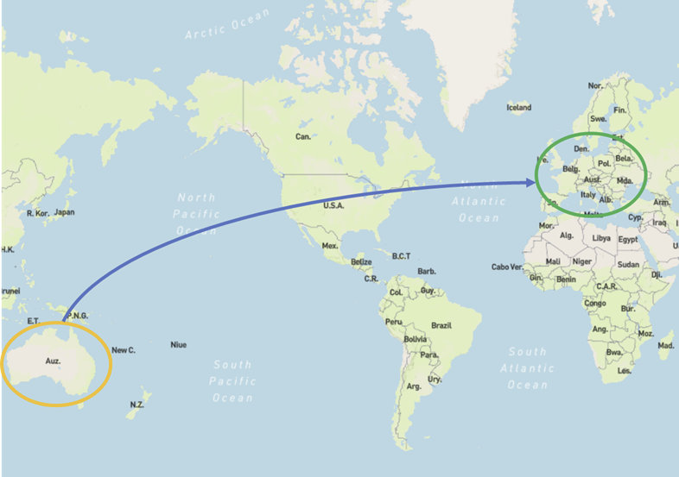
Figure 4.4: Lack of observations in the orange area limits 7-10 day forecast skill in the green area.

Any local lack of observations will initially lead to poor local prediction quality; and at longer lead times the effect will be felt globally. This limitation applies equally to reanalysis (see next section).

Role of reanalysis
Long-term reanalysis of comprehensive observational data is used to produce regularized, dynamically consistent estimates of the entire atmospheric state and its uncertainty at regular intervals in space and time. Such reanalysis can be used for a range of climate applications that cannot be based directly on the observations, due to temporal and spatial discontinuities in the observational records. Especially during the early satellite era and the pre-satellite era, gaps in the observing system prevent us from estimating the value of essential climate variables at each location of the planet. Reanalyses provide tools to fill these gaps in a consistent and traceable way whilst at the same time providing rigorous estimates of the errors induced in the process.
Reanalysis produces a consistent data record spanning multiple decades by reprocessing archived and quality-controlled observations using a fixed configuration of an NWP model and data assimilation system. Availability of long records of global high-quality observations is therefore critical. High quality reanalysis data are used for:
∙ estimating global climatologies and probability density functions for various meteorological parameters that underpin a growing suite of probabilistic forecast products that can be used for risk assessment, emergency warning systems, planning and decision- making;
∙ Providing information on the climate of the past and present which are required to support decisions for adaptation; and
∙ Initializing seasonal and decadal climate prediction systems.

Climate reanalysis data can also be used to develop statistics and trends on windstorms, coastal flooding and other weather-related events to estimate future vulnerabilities and losses . Similarly, it provides information about trends and variability in temperature and precipitation, as well as other key variables affected by climate change such as soil moisture, sea level and sea ice, needed for adaptation to climate change in the transport and infrastructure. In agriculture and forestry, reanalysis data are routinely used to map the movement of climate zones affecting crop planning and water supply.

Observing and projecting changes, and global climate risks

Hydrological Observations
Systematic observations of the hydrological cycle – producing real-time data, historical time series and aggregated data – are fundamental for addressing water-related challenges related to floods and droughts, as well as water supply, governance, transboundary sharing, water quality or ecosystems. There are still important gaps in water data collection and sharing worldwide, however. Data is not being collected on basic hydrological variables, such as water level and discharge, in, on average, 40% of WMO Member countries (Figure 4.5).
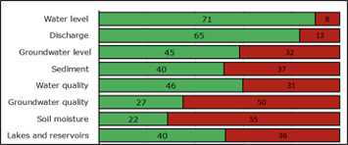
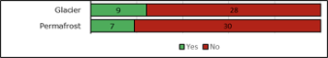

Figure 4.5: Number of WMO Members, out of 101 with hydrological advisors, collecting hydrological data, by variable. Note: there are an estimated 37 countries with glaciers and permafrost or seasonally frozen ground.

WMO Members report lacking continuous, automatic sensor-based water level monitoring, as well as data transmission systems, and are unable to guarantee the maintenance, operation and repair of the existing stations, especially in remote areas. WMO Members further report that they still have outdated instruments and equipment, and do not have the human and financial resources to modernize their monitoring networks. They also have challenges in ensuring data validation and quality control. Although 85% of Members from among the 101 that have a hydrological advisor and have provided capacity data have a national database in place, such information systems are still missing in 15 countries for which capacity data are available, most of them in central America, Africa and Asia.
Even in cases where hydrological data are available, there are challenges in developing data products and disseminating them. Most of these challenges are related to underfunding of the services, lack of human resources, high turnover and a lack of capacity building and training. Some National Hydrological Services and NMHSs have addressed these issues by becoming more customer-focused organizations, adapting their data policy and strategy, and improving communication channels and public awareness.

Biodiversity observations for climate adaptation
Climate and biodiversity are interlinked, with climate having an impact on biodiversity patterns and processes and biodiversity having an important role in climate regulation. Climate change is one of the main drivers of biodiversity and ecosystem change, along with land/sea use change, direct exploitation, pollution and invasive alien species. It can affect abundances and distributions of plant and animal species in all realms (terrestrial, freshwater, marine) by influencing the adaptation, migration and extinction of populations. Climate change acts on biodiversity both directly and indirectly, by affecting other drivers, and now its impact can be measured through Earth observations (EO). On the other hand, biodiversity and ecosystem conditions, including biotic communities, affect climate change. Natural ecosystems with better conditions can store more carbon and maintain ecological processes that regulate climate. Healthy ecosystems can serve as natural solutions for climate change adaptation and mitigation.

Using EO-based information, tools and indicators to measure climate change impacts on biodiversity at the global level
GEO’s Biodiversity Observation Network (GEO BON) developed a standardized framework that links essential climate and biodiversity variables to assess and predict the impact of climate change on biodiversity and ecosystem processes. The framework uses biodiversity observations (remote sensing and in situ), collected in a standardized manner, to calculate essential biodiversity variables which in turn are used to calculate various indicators for global biodiversity change used in national reporting for international bodies such as the UN Convention on Biological Diversity.
One such indicator is the Bioclimatic Ecosystem Resilience Index (BERI) that estimates the capacity of ecosystems to retain biological diversity in the face of climate change. BERI assesses the extent to which a given spatial configuration of natural habitat will promote or hinder climate-induced shifts in species distributions (Ferrier et al. 2020). The results can then be aggregated to report on status and trends for any desired set of reporting units (e.g., ecoregions, countries, or ecosystem types). This indicator is currently being updated to cover all biomes (forest and non-forest).
For oceans, the Marine Biodiversity Observation Network (MBON) of GEO BON uses the framework for standardized observations of GEO and GEO BON to advance interoperability between essential ocean and biodiversity variables (Miloslavich et al., 2018; Muller-Karger et al., 2018; Benson et al., 2021). MBON uses EO to define and track ocean biogeographic regions and how they change daily, seasonally, and annually. A climatology of biogeographic ‘seascapes’ is a basis for indicators to characterize trends in habitat essential for different marine life (Kavanaugh et al., 2021). One goal of MBON is to facilitate the discussion around convergence to adopt a specific period or framework to define ocean climate baselines, anomalies, or trends (i.e., defining ‘normals’ such as those used by the meteorological community). This is required to examine long time series of environmental and biological records (diversity, abundance, distribution, production) to quantify uncertainty in data and quantify short- and medium-term variability that may mask long-term trends in climate change.
To ensure the EO based information on biodiversity could be used by the relevant community of practice a series of climate indicators for biodiversity were calculated from reanalyses data and made publicly available by Copernicus Climate Change Service. The framework was designed in such a way that the indicators could be automatically updated (currently not implemented) as soon as new data become available.

Measuring the outcomes of the implementation of adaptation policies in relation to biodiversity protection
The global impacts of biodiversity loss and climate change are interlinked, but the feedbacks between them are rarely assessed. For example, areas with greater tree diversity tend to be more productive, providing a greater carbon sink, but loss of tree diversity could reduce these natural carbon sinks. Mori et al. (2021) conducted a global analysis quantifying how tree and shrub species richness could affect biomass production on biome, national and regional scales. They combined EO of tree productivity and diversity, global biodiversity models and machine learning with global climate and economic scenarios. Their analysis revealed that greenhouse gas mitigation could help maintain tree diversity globally and thereby avoid a 9–39% reduction in terrestrial primary productivity across different biomes, which could otherwise occur over the next 50 years. Countries that will incur the greatest economic damages from climate change stand to benefit the most from conservation of tree diversity and primary productivity, which contribute to climate change mitigation. These results emphasize an opportunity for a triple win for climate, biodiversity and society, and highlight that these co-benefits should be the focus of reforestation programmes.
Colombia is a good case-study for how EO applications can measure biodiversity in relation to climate change to inform decision making. One of the most biodiverse countries in the world, with ecosystems that significantly contribute to climate change mitigation, such as the Amazonian rainforest, the montane forests or the Andean paramos, to the national water supply, which is one of the largest in the world, and provide other Nature’s Contribution to People (e.g., clean water provision, crop pollination, provision of food and raw materials, soil erosion control, disaster-risk reduction, etc.), Colombia is also affected by high levels of deforestation and land degradation, especially in the Andean and Amazon regions. In a collaborative project involving governmental agencies and institutes, academia and international organizations (UNEP-WCMC, UNDP), EO were used to identify integrative priority areas for biodiversity conservation (reduce threatened species extinction risk), climate change mitigation (carbon storage) and water provision (water supply). Part of the Nature Map consortium, this project showed how synergies between different policies can be optimized by integrating them into conservation planning so that Colombia can fulfill its national and international commitments by protecting habitats, species and mitigating climate change impacts through nature-based solutions.
Use Case 4.4: Integrating priority areas for biodiversity, climate change, and water provision

Colombia is a major global hotspot of biodiversity, with ecosystems that significantly contribute to climate change mitigation, water supply, and other Nature’s Contribution to People (NCPs). Colombia hosts some of the most carbon-rich ecosystems in the world, such as the tropical rainforest in the Amazon and Pacific-Darien regions, besides the montane forests and paramos in the Andean region. Natural water supply in Colombia is one of the highest globally. National water yield is estimated at 56 l/s-km2, which exceeds the world average yield (10 l/s-km2) and the Latin America (21 l/s-km2) yield. In addition to climate change mitigation, and water supply, these ecosystems provide other NCPs, such as clean water provision, crop pollination, provision of food and raw materials, soil erosion control, disaster-risk reduction, and many others.

However, Colombian ecosystems and species are threatened by high levels of deforestation and degradation. There are 1,302 threatened species: 390 vertebrates, 98 invertebrates, and 814 plants, which are mainly located over the Andean and Amazon regions, where the current deforestation and degradation rates are the highest. Annual deforestation rates in Colombia are around 200-300k ha/yr since 2016, due to social and political changes resulting from the signing of the peace agreement.
The natural forest loss in the period 2016-2020 was around 1-1.5M ha, producing a loss of about 380M tons of AGB and 900M tons of CO₂ emissions. Also, clean water provision is mostly impacted in the Colombian Andes due to agricultural uses (blue water footprint: 7M l/yr - 70%), leaving about 100k-1M l/yr of water available.

To protect biodiversity and ecosystem services, and counteract the threats to biodiversity loss, Colombia has a broad range of environmental land-use policies and commitments (e.g., the Water Resources Integral Management Policy, Soil Integral Management Policy, Forests Policy, Inland Wetlands Policy, National Policy for the Integral Management of Biodiversity and its Ecosystem Services, and the National Policy on Climate Change), and recently has announced the intention to adhere to the 30x30 post-2020 GBF target, and a national goal of zero deforestation by 2030. Thus, the country faces an urgent need to integrate existing land use planning policies with the targets of national and international commitments. The objective of this exercise was to show how to identify priority areas integratively for biodiversity conservation (reduce threatened species extinction risk), climate change mitigation (carbon storage) and water provision (water supply), and show how synergies between different policies can be optimized by integrating them into conservation planning, following the framework proposed by the NatureMap consortium.
Integrating conservation priorities for the 30x30 target considering biodiversity, carbon and water, shows a higher efficiency (352k km²) in meeting targets than when these synergies are ignored (407k km²).

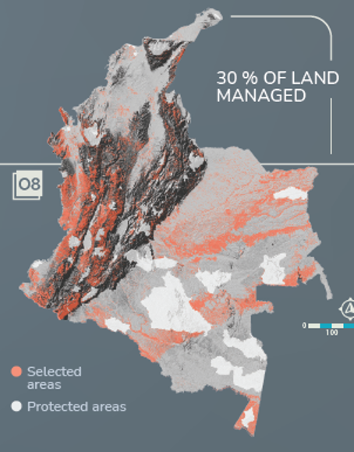
Figure 4.6: Selected priority area for achieving the 30x30 target considering biodiversity (species representation), carbon storage and water supply.

Completing 30% of the country by 2030 under area-based conservation measures (proposed target 3 of the GBF), will achieve covering 99% of 2474 species, reducing the risk of extinction of 100% of critical endangered, 75% of vulnerable species and 25% of near threatened species, and suggest that about 0.6 GtonCO₂e/yr could be stored, then, for achieving 10 GtonCO₂e/yr to minimize climate change (proposed target 8 of the current GBF), an important effort in restoration actions for carbon sequestration would be needed, or a tradeoff between biodiversity representation, water supply and carbon sequestration in order to increase the annual value of carbon sequestration input from achieving target 3.

This case study was developed by an agreement between Humboldt Institute as part of the NatureMap consortium and supported by WCMC. More information available at: http://nm-portafolios.s3-website-us-east-1.amazonaws.com/index_en.html

Global Data Exchange
Typically, the benefits to a country of meteorological observations exceeds their cost many times ^{[2]}. Using the data for climate multiplies these benefits. To ensure that the maximum benefit from observations is obtained, the data should be freely and openly exchanged, as many potential users have limited resources. The benefits of such open data arrangements have been clearly demonstrated^{[3]}. Much meteorological data is exchanged, however there are issues in other areas. The WMO extraordinary Congress (11 to 22 October 2021) has approved three sweeping initiatives to dramatically strengthen the world’s weather and climate services through a systematic increase in much-needed observational data and data products from across the globe. The three initiatives are known as the WMO Unified Data Policy, the Global Basic Observing Network (GBON), and the Systematic Observations Financing Facility (SOFF). The new data policy reaffirms the commitment to the free and unrestricted exchange of data, which has been the bedrock of WMO since it was established more than 70 years ago. With the Unified Data Policy, the WMO community is moving towards an integrated Earth system approach rather than talking about monitoring and predicting weather, climate, and water as separate issues. In order to meet the growing need for better information and services, the new policy will encompass all WMO-relevant Earth system data – weather, climate, hydrology, ocean, atmospheric composition, cryosphere as well as space weather. This Earth-system approach will help the global community strengthen and better sustain all Earth system monitoring and prediction, with massive socioeconomic benefits as a result. It will lead to additional exchange of all types of environmental data, which in turn will enable all WMO Members to deliver better, more accurate and more timely weather-and climate-related services. In addition, Earth system modeling capabilities are progressing rapidly, and the need for exchange of Earth system data will continue to grow. WMO’s unified data policy is therefore built around a modular approach that allows for incremental updates in the decades ahead. Hydrological data are often not shared (Figure 4.7) as they are important not just for local water issues but also for the oceans and the energy and water cycles. In 2016, the ‘FAIR Guiding Principles for scientific data management and stewardship’ were published and intended to provide guidelines to improve the Findability, Accessibility, Interoperability, and Reuse of digital assets (Wilkinson et al. 2016; Wilkinson, M., Dumontier, M., Aalbersberg, I. et al. The FAIR Guiding Principles for scientific data management and stewardship. Sci Data 3, 160018 (2016). https://doi.org/10.1038/sdata.2016.18.
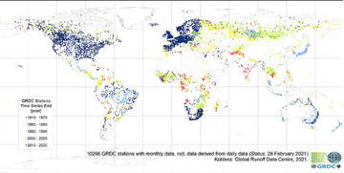
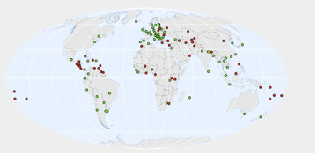
Figure 4.7: Status of hydrological data availability Top: Monthly hydrological runoff data delivered to the WMO Global Runoff Data Center status as of February 2021. The map shows the stations that reported in 2020 (blue), in 2009 (light blue), in 1999 (green), in 1989 (yellow), and in 1979 (red). Bottom: Organizations/institutions providing links to data (green) and organizations/institutions collecting data without providing links (red).

Preservation of the fundamental climate data record is essential. Reanalysis and other added value products can always be recreated or improved from the basic data record. To address and understand climate change the longest possible time series need to be preserved in perpetuity. Not every ECV has a recognized global data repository (such as Copernicus or ICOADS, where almost all qualifying data has been collected). Even when there is a recognized global data repository, it can be incomplete and inadequately supported. Data should be open and freely available to all users. Adequate data stewardship, archiving and access requires sustainable, long-term, sufficient funding, as well as requirements that will ensure a consistent approach among the data centers. Clearly defined principles such as the TRUST Principles (Lin et al., 2020) and FAIR Principles (Wilkinson et al., 2016) as well as clear and enforced data management plans and data citation are required.

Earth System Modeling
A number of global modeling centers run reanalysis, climate predictions and climate projections and disseminate their results globally. Climate models and reanalysis are based on numerical weather prediction (NWP) and require the same inputs, together with additional data on the oceans, cryosphere, hydrosphere, and biosphere to predict changes in the carbon cycle and other climate-related variables. These modeling centers take up-to-date monitored data and use it to solve the equations of motion and make predictions for the future. Forecasts on different time scales have different uses – early warning systems depend on short lead times while seasonal forecasts are used for planning (e.g. in agriculture). Seasonal and longer term forecasts are issued less frequently but provide the basis for planning adaptation measures to cope with climate variability. Given that a disproportionate fraction of the climate impact is associated with extreme events , increasing our ability to deal with climate variability represents a key component of our adaptation to climate change. These models are becoming more complex including the oceans and terrestrial observations such as land use.
The Coupled Model Intercomparison Project (CMIP) was initiated by World Climate Research Program (WCRP) to drive the improvement of models by coordinating the robust scientific evaluation of climate model simulations and projections. CMIP is currently in its 6th phase (CMIP6) and plans for CMIP7 have started. CMIP models output underpins a wide range of climate research that extends well beyond the WCRP. The results provide policy-relevant climate projections that are relied upon by the Intergovernmental Panel on Climate Change (IPCC) and other international bodies, by national climate change assessments, and by an ever-growing range of national and regional climate service providers, and in many cases, national meteorological and hydrological services.
A collaboration between the Green Climate Fund and the Swedish Meteorological and Hydrological Institute (SMHI), under WMO auspices, has developed a Climate Information Platform (CIP) that provides access by all Parties to climate change projections from CMIP and higher resolution projections from the Coordinated Regional Climate Downscaling Experiment (CORDEX) for country-level applications. The CIP is a publicly accessible web-based platform (www.climateinformation.org) providing access to data, tools and guidance to assist in the development of climate policies. It provides interactive maps and graphs summarizing pre-calculated climate indicators. CMIP and CORDEX are largely sustained by research funding, and it is critical that they be transitioned to a sustainable operational basis to be able to continue to provide the best available scientific information on projected future climate conditions to Parties and the IPCC.
Extreme climate indices based on the recommendations of the Expert Team on Climate Change Detection and Indices (ETCCDI) of WCRP and calculated using CMIP6 data, have been made available by the Copernicus Programme on the same platform which provide access to satellite based observations and reanalyses. This is expected to simplify the interface between climate projections and systematic observations.
The WCRP will open a new international office in the United Kingdom on 1 March 2022 that will coordinate CMIP. The new office will be hosted alongside ESA’s Climate Office at its European Centre for Space Applications and Telecommunications (ECSAT) facility in the United Kingdom (https://climate.esa.int/en/news-events/esa-to-host-new-cmip-international-project-office/).

Information and Services

Climate Information
A subset of the ECVs provide an on-going summary of the state of the global climate. These indicators include surface temperature – essential for monitoring progress towards the achievement of the Paris Agreement global temperature goal – atmospheric CO2 concentrations, ocean heat, pH and sea levels, sea ice extent, glacier mass and precipitation.
Through intergovernmental processes, WMO Member countries have agreed to release period (annual, five-year and 10-year) summaries of the state of the global climate and its impacts. These global state of the climate reports document the status of the above indicators and synthesize information collected by Parties and the observing systems they operate to provide a global overview of the climate system, the climatic contributing factors to risks, and associated societal and environmental impacts. The State of the Climate reports are prepared with information provided by NMHSs and associated institutions, WMO Regional Climate Centres, and partners, including the Food and Agriculture Organization of the United Nations (FAO), International Monetary Fund (IMF), Intergovernmental Oceanographic Commission of UNESCO (IOC-UNESCO), International Organization for Migration (IOM), UN Environment Programme, the UN High Commissioner for Refugees (UNHCR), the World Food Programme (WFP) and the World Health Organization (WHO). Information on the state of the climate is also incorporated into a multi-organization high-level compilation of the latest climate science information, United in Science, containing analyses by WMO, the Global Carbon Project (GCP), the Intergovernmental Panel on Climate Change (IPCC), UNEP, WHO, the Met Office (United Kingdom, UK), the jointly sponsored WMO/Intergovernmental Oceanographic Commission (IOC) of UNESCO/International Science Council (ISC), and the World Climate Research Programme (WCRP).
In Europe the Copernicus programme pioneered the release of a regional state of the climate report. Most recently, WMO and a wide range of global and regional partners have begun releasing regional State of the Climate Reports, for Africa in 2019 and 2020 and for Latin America and the Caribbean, the Southwest Pacific, and Asia in 2020. These reports document the state of the climate in each region using systematic observations from NMHSs and WMO regional and global centers, as well as impacts and capacity and policy needs for addressing climate-related risks.
Together, these regional and global reports provide Parties with authoritative information needed to track progress towards achieving the long term goal of the Paris Agreement. In this regard, the reports were welcomed in the Glasgow Climate Pact by the Conference of the Parties serving as the meeting of the Parties to the Paris Agreement. The information in them – that human activities have caused 1.1 °C of warming to date (with respect to the 1851-1900 reference period) and that impacts are already being felt in many regions – was acknowledged by Parties with alarm and utmost concern.

Early Warning Systems
Early warning systems (EWS) are a top adaptation priority in Parties' NDCs, including in 88% of the NDCs submitted by LDCs and SIDS. Annual reports on the State of Climate Services are submitted annually to SBSTA at the invitation of the Conference of the Parties serving as the meeting of the parties to the Paris Agreement with a view to “facilitating the development and application of methodologies for assessing adaptation needs” (11/CMA.1).
As documented in the 2020 report on the State of Climate Services: Risk information and early warning systems, prepared by WMO and 16 partner organizations and initiatives^{[4]}, data provided by 138 WMO Members, including 74% of LDCs and 41% of SIDS globally, show that just 40% of them have MHEWSs, and one third of every 100 000 people in the 73 countries that provided information is not covered by early warnings (Figure 4.8).
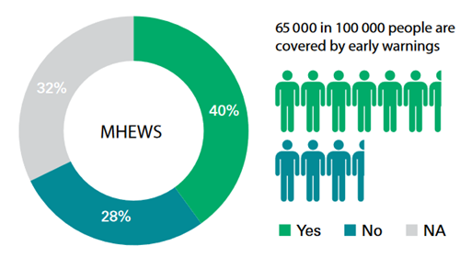

Figure 4.8: Percentages of countries that have Multi-hazard Early Warning Systems (MHEWS) and of people in those countries covered by early warnings (“NA” = no data).
In countries that do operate MHEWSs, warning dissemination and communication is consistently weak in many developing countries, and advances in communication technologies are not being fully exploited to reach out to people at risk, especially in LDCs. And there is insufficient capacity worldwide to translate early warning into early action through preparedness and response measures (Figure 4.9), especially in Least Developed Countries (LDCs).

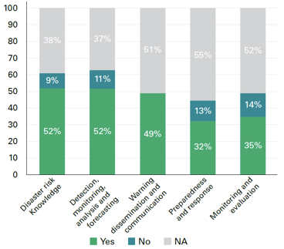

Figure 4.9: WMO Member country capacities across the five functional areas of the MHEWS value chain globally, calculated as a percentage of specific functional capacities satisfied in each area, across 193 WMO Member countries and territories (“NA” = no data).
Capacities vary considerably among regions. Africa faces the most significant capacity gaps. Although capacity in Africa is good in terms of risk knowledge and forecasting, the rate of MHEWS implementation overall is lowest in comparison with other regions and warning dissemination is particularly weak. Just 44 000 people in 100 000 in Africa are covered by early warnings in countries where data are available.
The 2021 State of Climate Services Report, focused on climate services for water, contains additional information on Party capacities with respect to end-to-end early warning systems specifically for droughts and floods, two of the most destructive hydro-meteorological hazards. End-to-end riverine flood forecasting and warning systems are absent or inadequate in 34% of WMO Member countries that provided data, with only 44% of Members with existing systems reaching more than two-thirds of their at-risk population (Figure 4.10). End-to-end drought forecasting and warning systems are absent or inadequate in 54% of WMO Members that provided data – with only 27% of Members with existing systems are reaching more than two-thirds of their at-risk population.

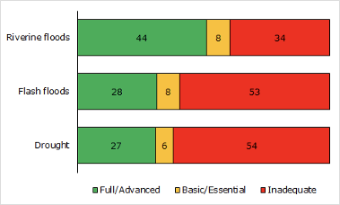

Figure 4.10: Number of Members with early warnings available to the population at risk, by hazard type, based on data from WMO Members providing data. Member capacities are categorized as Inadequate (0-33%), Basic/Essential (34-66%), and Full/Advanced categories (67-100%) according to the estimated percentage of the population at risk that receive EW. Note: For each hazard, the category ‘Inadequate’ includes Members (providing data) reporting that no end-to-end EWS for the hazard is in place, as well as those whose end-to-end EWSs do not reach more than 33% of the at-risk population.
Needs for strengthening the climate services value chain vary by region. In general, Parties in all regions identify gaps in the linkages between the warnings emanating from hydro-meteorological hazard warning systems and the effective use of those warnings through adequate disaster preparedness and response.

Seasonal timescales
Systematic observations of the ocean and the cryosphere have been used to initialize global coupled models which could then be used to provide information about the climate conditions that are most likely to occur in the coming months. Early warning of climate anomalies, such as above- or below-normal seasonal precipitation or temperature has been established in all sub-regions, through the Regional Climate Outlook Forums (RCOFs) (Figure 4.11). Since their establishment in 1998, the RCOFs have served as the established vehicles for co-developing regional climate information products and services for a climatological sub-region with common climate drivers and coherence in seasonal climate variability, and for facilitating user interaction at a regional scale. Further, many RCOFs also consider potential implications of climate variations (including extremes and trends) on the most pertinent socioeconomic sectors. RCOFs bring together international, national and regional climate experts, sectoral users, and stakeholders’ representatives to provide consensus-based climate predictions.
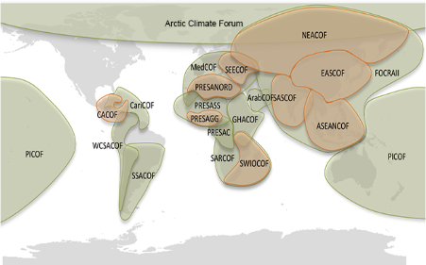

Figure 4.11: Regional Climate Outlook Forums providing outlooks on the probabilities of above- or below-normal precipitation and temperature anomalies on sub-regional and regional scales.
The RCOFs provide NMHS and Parties with state of the art information on the likely characteristics of the coming three month season, usually one month in advance. In most cases, RCOFs are coordinated by the concerned WMO Regional Climate Centres (RCCs) and have significantly contributed to regional collaboration and capacity development in the area of seasonal forecasting.
Current practices in many RCOFs are known to have several drawbacks in the provision of seasonal climate outlooks, however, including: (1) a subjective, consensus-based forecast process that is neither traceable nor reproducible; (2) forecasts are packaged in a fixed, one-size-fits-all tercile probability format that seldom addresses the requirements of specific applications; (3) forecasts are generally unavailable in digitized form, and therefore, if needed, cannot be used in terms of quantitative inputs feeding into application models or decision-support tools; (4) forecasts are not amenable to standardized verification and skill assessments, thereby making forecast quality ambiguous, and also making future improvements difficult; (5) forecast preparation requires a high degree of manual activity, which limits the frequency of forecast updates and the diversity of products.
To address these areas for improvement, support is now being provided to Parties through WMO inter-governmental processes to assist NMHSs and RCCs through the RCOFs to put in place or strengthen the systems needed to operationally generate objective seasonal forecasts, for which the skill can be routinely assessed and improved, and to support Parties in delivering a wider range of diversified products to support adaptation in priority sectors identified in Parties’ NDCs. Such an effort is being supported by the open and free provision of numerical outputs (hindcasts and forecasts) of the seasonal predictions models (e.g. https://cds.climate.copernicus.eu/cdsapp#!/dataset/seasonal-original-single-levels?tab=overview)

Annual to decadal timescales
The WMO Lead Centre for Annual to Decadal Climate Prediction, the UK Met Office, following years of research coordinated by WCRP, produces a summary of predictions that provides Parties worldwide with information on the likely status of the main characteristics of the global climate system for the coming five years. These predictions are the best estimate of the near-term climate as they are based on the world’s leading decadal prediction systems from WMO designated Global Producing Centres and non-designated contributing centers. They include multiple realizations (100 in total) with both observed initial conditions, of the type used in seasonal prediction, and boundary forcing, of the type used to drive long-term climate projections. The predictions do not include the small effects of changes in emissions – such as those due to the on-recent or on-going COVID-19 lockdowns – and they assume that no major volcanic eruptions occur in the period covered.
Predicted temperature patterns for 2021–2025 show a high probability for temperatures above the 1981– 2010 average almost everywhere, with enhanced warming at high northern latitudes and over land compared to the ocean. The Arctic (north of 60 °N) anomaly is more than twice as large as the global mean anomaly. Figure 4.12 shows the predicted annual mean global near surface temperature for the five-year period 2021–2025 relative to 1981–2010. The global mean near surface temperature is predicted to be between 0.9 °C and 1.8 °C above pre-industrial conditions (taken as the average over the period 1850 to 1900). The chance of at least one year exceeding 1.5 °C above pre-industrial levels is 40%, with a small chance (10%) of the five-year mean exceeding this level. It is important to note, that this is not the same as surpassing the Paris Agreement 1.5 °C level, which refers to the climatological condition over a long-term average. Instead, this metric shows the increasing likelihood of a temporary exceedance of the 1.5 °C temperature level as the climate warms, which is likely to occur as Earth’s climate draws closer to the Paris level.

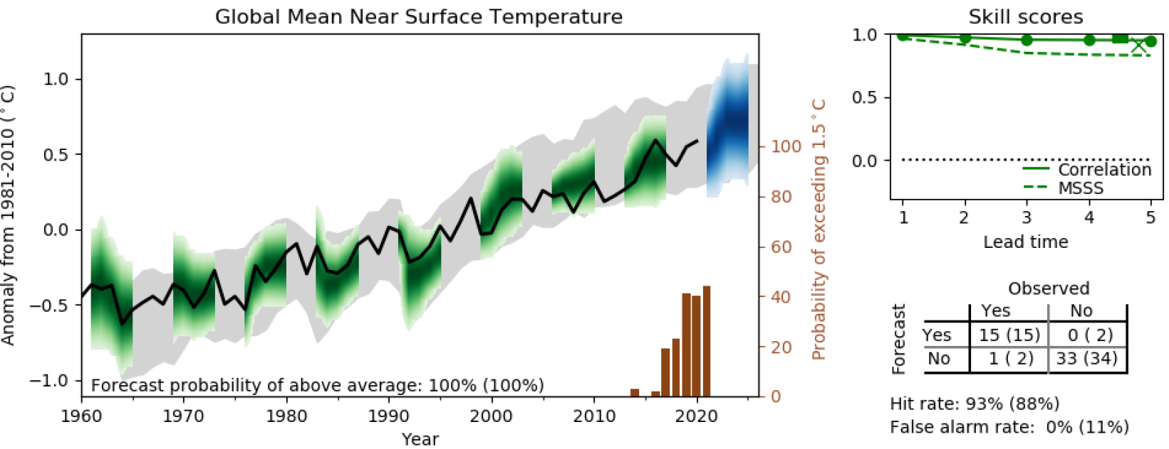
Figure 4.12: Multi-annual predictions of annual global mean near surface temperature relative to 1981–2010. Annual mean observations in black, forecast in blue, hindcasts in green and uninitialized simulations in grey. The shading indicates the 90% confidence range. The probability for above average in the five-year mean of the forecast is given at the bottom the main panel (in brackets the probability for above average in the first year). The inset in the main panel, referring to the right axis, is the probability of global temperature exceeding 1.5 °C above pre-industrial levels for at least one year during the five years starting in the indicated year (Smith et al. 2018). Observed temperatures are an average of three observational data sets (Hansen et al., 2010, updated; Karl et al., 2015, updated; Morice et al., 2021, updated), they are near surface (1.5 m) over land and surface temperatures over the ocean. Model temperatures are near surface throughout (WMO, 2021; Hermanson et al., 2022). Correlation and Mean Squared Skill Score (MSSS) for annual means in the forecast are shown in the upper right panel. A contingency table for the probabilistic skill is shown in the lower right.
With additional effort, it may be possible in the future to produce annual to decadal forecasts operationally on sub-regional scales, through the RCOFs. Such a capability would give Parties potentially further downscaled information for medium range planning. A few case studies of the use of decadal predictions in specific sectoral context (https://climate.copernicus.eu/sectoral-applications-decadal-predictions) have shown how decision-relevant information can be extracted from these simulations.

State of adaptation efforts: climate services
The WMO tracks climate services capacities of Member states based on data provided by countries documenting the degree to which a set of functional capacities spanning the hydro-meteorological systems and services value chain have been implemented. Such functional capacities can be either basic, essential, full or advanced. By assessing a country’s capacity across the full value chain, WMO is able to assess how many Members are able to provide services at the Basic, Essential, Full and Advanced levels. Currently, 70% of Members for which data are available are able to provide services on at least an essential level. It is essential that further support be provided to Parties to enable more countries, especially LDCs and SIDS, to operate the systems and provide the services that underpin effective climate action.
The Global Framework for Climate Services (GFCS) was established by the international community at the World Climate Conference-3 in 2009. The GFCS seeks to accelerate and coordinate the implementation of technically and scientifically sound measures to improve climate-related outcomes through the development and incorporation of science-based climate information into planning, policy and practice.
As a framework with broad participation and reach, GFCS enables the development and application of climate services to assist decision-making at all levels in support of addressing climate-related risks. The GFCS has five components:
- Observations and Monitoring
- Climate Services Information System
- Research, modeling and Prediction
- User Interface Platform
- Capacity Development.
The GFCS focuses on developing and delivering services in five priority areas identified as high priorities for adaptation in Parties’ Nationally Determined Contributions (NDCs) to the Paris Agreement:
- Agriculture and Food Security
- Disaster Risk Reduction
- Energy
- Health
- Water.
The GFCS is guided by a 10-volume Implementation Plan developed by hundreds of experts from the World Meteorological Organization (WMO) and participating institutions, approved through inter-governmental processes. Organizations contributing to GFCS governance and implementation include the World Meteorological Organization (WMO), the European Centre for Medium-Range Weather Forecasts (ECMWF), the World Bank, the Norwegian Refugee Council, the United Nations Development Programme (UNDP), the United Nations Food and Agriculture Organization (FAO), the World Food Programme (WFP), the World Health Organization (WHO), the International Federation of Red Cross and Red Crescent Societies (IFRC), the European Commission, the United Nations Environment Programme (UNEP), the United Nations Office for Project Support (UNOPS), the United Nations Education, Science and Culture Organization (UNESCO), the United Nations International Strategy for Disaster Reduction (UNISDR), the United Nations Institute for Training and Research (UNITAR), the Global Water Partnership, EUMETSAT, and others (see gfcs.wmo.int/partnership).
At country level, GFCS implementation is guided by National Frameworks for Climate Services (NFCS). An NFCS is a multi-stakeholder stakeholder interface platform that enables the development and delivery of climate services at country level. NFCSs focus on improving co-production, tailoring, delivery and use of science-based climate predictions and services, focused on the five GFCS priority areas. NFCSs support the Paris Agreement by helping Parties prepare, maintain and communicate their NDCs. NFCSs support the preparation and implementation of National Adaptation Plans (NAPs), by providing climate services that help assess climate vulnerabilities, improve the understanding of climate and its impacts, identify adaptation options, and provide operational products that support decision-making in climate-sensitive sectors. NFCSs also provide a mechanism for the systematic monitoring and documentation of socio-economic benefits associated with the services provided.
The GFCS is now nearing the end of its initial 10-year implementation phase. Drawing on this decade of implementation, and based on the analyses on the State of Climate Services for agriculture and food security, water and EWS, recommendations for improving climate services for adaptation include investing it:
- Systematic observation – The systematic observations that underpin climate services needed to support priority areas identified in Parties’ NDCs remain inadequate
- Systems integration – Operational exchange of data and products between the national, regional and global levels is essential for improving service delivery for country-level adaptation. Fit for purpose-financing is needed to enable data and products to flow from countries to advanced data processing and forecasting centers and vice versa.
- Co-development of decision-support products and services – Increased interaction with stakeholders in climate sensitive sectors is needed to co-design, develop and deliver the tailored products and services that support improved user decisions leading to improved adaptation outcomes.
- Access to services – Data consistently show that “last mile” service delivery is insufficient to ensure widespread access to climate services, particularly in developing countries.
- Climate science basis – Climate action and associated investments should be based on the best available science. Methods and tools now available for this purpose should be upscaled on a widespread basis to promote adaptation effectiveness.
- Capacity data – Data on Party adaptive capacities in the area of climate services is incomplete and the data that are available need to be quality assured as a basis for certification of climate services capacities.
- Overall investment levels and associated data – Adaptation finance for climate services remains inadequate, especially for meeting needs in LDCs and SIDS. More detailed data on financial allocations for hydro-met systems and services is needed to enable tracking of financing in relation to assessed gaps and needs.
- Documentation of socio-economic and environmental benefits of adaptation action – Although case studies suggest high returns on investments in climate services for adaptation, more systematic documentation of the benefits of adaptation actions and the resulting improvements in adaptation outcomes is needed in order to ensure that the measures being financed are cost-effective and that progress towards the global adaptation goal is being achieved.
To address these needs, a country-driven, bottom-up approach to the next phase of implementation will build on the foundation from the first phase which, as noted previously, has assisted 70% of countries for which data are available to provide climate services for adaptation at an essential, full or advanced level. The next phase of implementation will continue to focus on country-level support. Foundational elements for the next phase include identification of national adaptation priorities based on Parties NAPs and NDCs, identification of effective actions based on scientific evidence of past, present and projected future climate conditions, technical advisory services to ensure that investments in hydro-met systems and services are designed and implemented to international standards, quality management processes to certify specific services and capacity improvements, and continuous reporting to the international community on status, gaps and needs in the State of Climate Services reports.

Assessing overall progress made in achieving the global goal on adaptation
The status of systematic observations and associated hydro-meteorological systems and services provide metrics relevant for assessing overall progress made in achieving the global goal on adaptation. These range from metrics based on the status of the systematic observations themselves, the use thereof, overall capacities to deliver related adaptation services, documented improvements in adaptation outcomes achieved from science-based adaptation action, and systematic observation of hydro-meteorological events and impacts.

Using observations to monitor implementation of adaptation
GCOS is considering how observations can be used to monitor the implementation of adaptation. Some existing ECV products could be used to extract information on the socio-temporal development of adaptation (observations of adaptation). Relevant ECV products would be those that, for example, show shifts in Land Cover and Land Use reflecting shifts in agricultural patterns in response to climate drivers, shifts in settlements away from coasts in response to sea-level rise, shifting patterns of prescribed burning in response to climate change.
It is also possible that, for certain sectors, enhanced or new products would provide more direct observations of human adaptation to climate change. For example, while remote sensing (“land cover”), at the appropriate resolution, can track green cover in cities – a potential adaptation response to raising urban heat. Observations of temperature could provide a measure of the success of this adaptation measure.
It is clear that with current capabilities in relation to its ECVs and ECV products, the global climate observing system could provide indicators for adaptation that could be used in the global stocktake. With modest enhancement of products or new products, these could be used at national level to add value to National Adaptation Plans, through assessment of climate hazards and vulnerabilities, assisting in identification of adaptation options and implementation, and in management, monitoring and evaluation of adaptation actions.
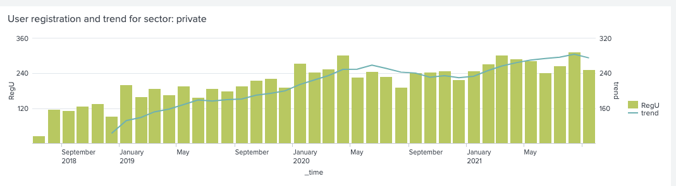
Figure 4.13: The user registrations on Copernicus Climate Data Store from users self-identifying as belonging to the private sector.

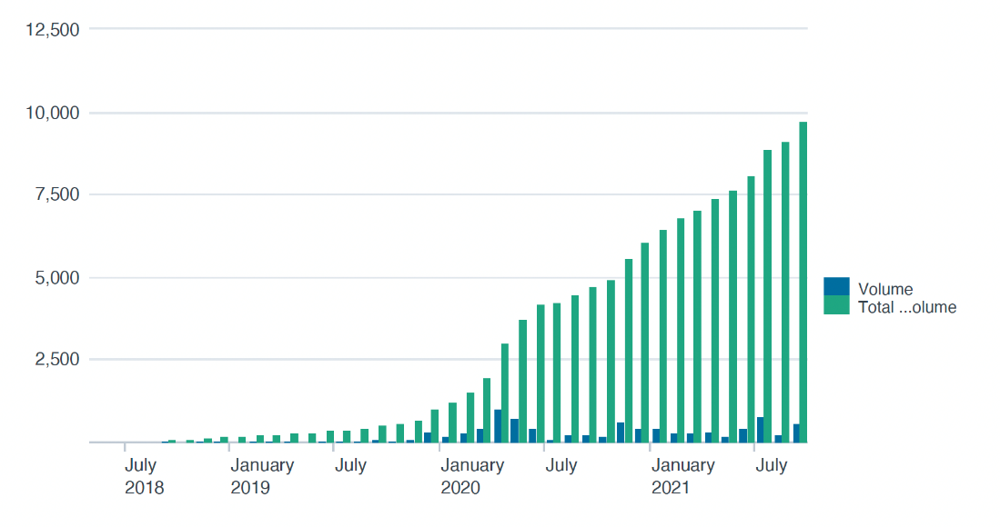
Figure 4.13: Evolution of the volume of satellite ECV data downloaded from the Copernicus Climate Data Store by users self-identifying as belonging to the private sector

Climate services-related adaptive capacity
WMO tracks Member country climate services capacities, including how many Members are able to provide services at the Basic, Essential, Full and Advanced levels. Currently, 70% of Members for which data are available are able to provide services on at least an essential level. WMO technical regulations state that Members should ensure that their organizations responsible for the provision of meteorological, hydrological, climatological or other environmental services establish and implement a properly organized Quality Management System (QMS), comprising procedures, processes and resources needed to provide for the quality management of the information and services to be delivered to users. WMO QMS procedures are currently being applied to quality assure Member climate services capacity data as a basis for assessing, and eventually certifying, Member climate services capacity levels. The capacity levels, so certified, constitute metrics that can be used for assessing global adaptation goal progress.

Improved adaptation outcomes from actions based on systematic observations and associated services
Another metric of the effectiveness of adaptation action can be obtained through systematic observation of the socio-economic benefits of results achieved based on decisions informed by hydro-meteorological systems and services. Systematic observation of such benefits is currently one of the weakest links in the hydro-meteorological systems and services value chain, and yet it is essential not only for documenting the effectiveness of adaptation action but also for evaluating the cost-effectiveness of adaptation investments. Authoritative guidance on documenting costs and benefits is provided by the World Bank, USAID, WMO handbook on valuing weather and climate.

Systematic observations of hazardous events and impacts
Data on hazardous hydro-meteorological events and associated impacts, if systematically collected by Parties, provides an indicator of progress towards the achievement of the Global Goal on Adaptation (GGA). Such data provide scientific evidence that can be used to determine the extent to which:
- Hydrometeorological events are becoming more frequent or severe
- Impacts are increasing or decreasing as a result of adaptation (or non-adaptation) to climatic trends and extremes, once the characteristics of the hydrometeorological events through which such changes are manifested are accounted for.
In other words, such data provide a means of assessing the degree to which impacts are a function of insufficient adaptation – that is, increasing exposure and vulnerability in the absence of adequate adaptation – as well as the degree to which impacts are a function of the changing nature of the events themselves. As such, authoritative data obtained as described below can provide a globally standardized indicator of the adequacy of adaptation efforts.
To support its Member countries in this undertaking, the World Meteorological Organization (WMO) has taken steps towards standardizing weather, water, climate, and other related environmental hazard information, and has implemented a methodology for assigning unique identifiers to such events for use in cataloging them and linking them to data on associated impacts, This methodology, for cataloging Hazardous Events, was endorsed in 2019 by the eighteenth session of the World Meteorological Congress (Cg-18).

Cataloging Hazardous Events (CHE)
Societies, ecosystems and economies are generally adapted to average climate conditions and are resilient to small deviations from the average. Problems emerge when climate change and variability result in conditions outside the normal ranges of historical climate. Events outside these normal ranges are considered hazardous hydrometeorological events. They include such things as heatwaves, droughts, floods, storms, coastal inundation, and various types of severe weather.
Systematic and standardized cataloging of such events requires identifying each event uniquely, while at the same time being able to group together events which are hydro-meteorologically related. This is done through the assignment of a Universally Unique IDentifier (UUID) (figure 4.14). The UUID is an ISO-standard random number, generated and assigned by a relevant national, regional or global WMO meteorological authority. In addition to the UUID, key attributes contained in a data record for each event include information that defines the event, such as event start and end times, spatial extent, and event type. Other attributes provide context such as description, local identifier (e.g. local or regional names of storms), and links to other events (e.g. heavy rain to tropical cyclone) which enables the clustering of events (e.g. events linked to other events) into larger scale (synoptic) phenomena. Additional information about each event can be stored in a separate database, also associated with the UUID, for storing relevant hydro-meteorological parameters (wind speeds, precipitation amounts, values of hydro-meteorological indexes, etc.).
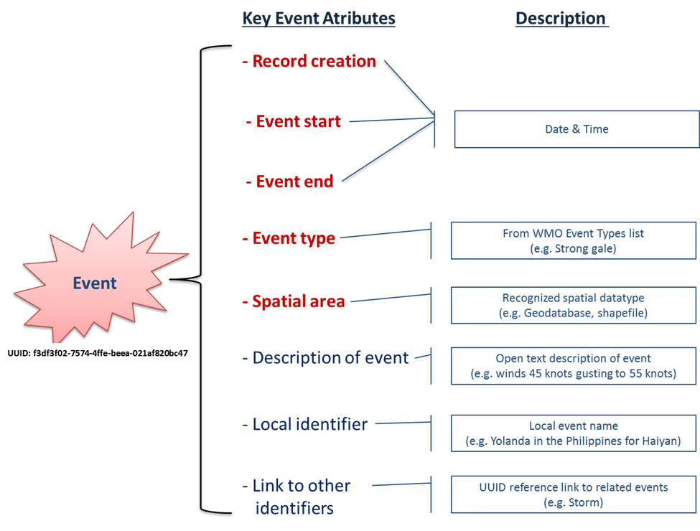

Figure 4.14: Event record containing UUID and key event attributes (attributes in red are mandatory entries)
Event types (drought, flood, heatwave, etc.) are determined by consulting a standardized WMO typology, compiled from authoritative WMO references and resource materials and adopted by the World Meteorological Congress. The typology will be a standard living list that can be amended by countries and regions through the WMO governance mechanisms. The event typology will also be referenced to by the WMO Information System, to allow consistent access to the most updated version.

Cataloging associated impacts
In addition to its benefits for documentation of changing hazardous event behavior, an important feature of CHE implementation is that country authorities responsible for assessing and cataloging information on impacts can use the same UUID to link data on impacts to the hydrometeorological event with which the impacts are associated. This capability makes it possible to accurately attribute impacts to specific types of hydrometeorological phenomena on a case by case basis.
Information on impacts associated with hydro-meteorological events to date is already available. The global reference dataset for such impacts is currently the International Disasters Database (EM-DAT) maintained by the Center for Research on the Epidemiology of Disasters (CRED) (www.emdat.be). Increasingly, national governments are now putting in place the relevant institutional mandates and procedures needed to systematically document impacts as a function of government. Data on impacts on national and sub-national scales for approximately 90 countries are available through the DesInventar disaster information management system (United Nations DesInventar Open Source Initiative - Official Website).
Moreover, a comprehensive methodology for standardized impact assessment has been developed by United Nations Economic Commission for Latin America and the Caribbean (ECLAC) (Handbook for estimating the socio-economic and environmental effects of disasters | Publication | Economic Commission for Latin America and the Caribbean (cepal.org)). This methodology has been applied to assess impacts associated with hundreds of hydrometeorological events globally, dating to the 1970s. This methodology provides a global standard for impact assessment. Examples of its application for high-impacts events are available from Post Disaster Needs Assessments | GFDRR and the methodology is also in widespread application on national levels.

Applications towards the development of a GGA indicator
Further adoption of these standards and practices – for cataloging hazardous events and for assessing and documenting associated impacts -- would provide transparent and authoritative data on impacts for documenting the efficacy of adaptation efforts. WMO and the United Nations Office for Disaster Risk Reduction are partnering on providing joint support to Parties. These efforts include:
- Capacitation and coordination of relevant national, regional and global centers for the preparation and maintenance of event catalogs, including the assignment of UUIDS;
- Capacitation and coordination of relevant national authorities for UUIDs for linking events and associated loss and damage;
- Capacitation of, and coordination with, stakeholders for accessing and using the event catalogs and associated data as an input to comprehensive risk management approaches including, inter alia, risk assessments, design of risk management measures including risk transfer (insurance) schemes, and underpinning research, and
- Further methodological refinement.
Such support to Parties could be further enhanced by recognition of standardized documentation of impacts associated with hazardous hydrometeorological events, which would represent progress towards defining indicators to track the future GGA.

Summary and Conclusions on the Role of Systematic Observations and Services supporting Adaptation
Systematic observations are vital for successful adaptation. They underpin the identification, planning, implementation and monitoring of adaptation measures. They are the first step in a chain linking observations through data exchange, global models supporting local models, warnings and planning and finally successful decision making.
To understand and predict climate requires observations of the oceans, cryosphere, hydrosphere biosphere in addition to the atmosphere.
Despite many recent improvements there remain areas where the system should be improved:
- Spatial coverage of ground-based observations is incomplete in parts of Africa, South America, Southeast Asia and the polar areas. Ocean observations need to be improved in coastal waters, the polar regions and in the deep oceans which are crucial for long-term prediction of the climate.
- Many terrestrial and oceans observations do not have assured long-term funding. The ability to produce and maintain long-term records is at risk. Many small developing countries do not have the resources to maintain systematic observations.
- While most observational data is well archived and accessible there remain some issues. Some data centers do not have the long-term commitment to support they need. In some areas access to hydrological data is restricted.
- Further improvements in the global observing system will allow the observations to provide even more support for adaptation and improve the adaptation outcomes.
- Access to early warning services, an adaptation measure of proven effectiveness, is highly uneven globally, with the greatest needs for improvement being in LDCs and Africa. Particular attention is needed on improving communication of warnings and preparedness for response.
- Furthermore, data on high-risk hydro-meteorological events and associated impacts, if systematically collected by Parties, provide an effective indicator of progress towards the achievement of the Global Goal on Adaptation (GGA).
- Across all regions, monitoring and evaluation of societal outcomes and benefits of science-based climate services for adaptation action stand out as one of the weakest areas in the climate services value chain.
- Exchange of observations and data is a critical component of operational hydro-meteorological systems and services that underpin adaptation decision-making. Lack of data sharing is resulting in suboptimal availability and use of climate information and services.
- While investments have increased substantially over the past decade, both more and better investments are needed. Better investments include investments that
- support the national-regional-global integrated hydrometeorological system on which all countries depend in a more holistic, less piecemeal, manner, and
- address the past, present, and projected future climate contributing factors to adaptation outcomes based on sound climate science information.

Means of Implementation - Systematic Earth Observations to support climate finance allocation, technology and capacity development for climate action
As we have seen in Chapters 2 and 3, an underpinning approach to the use of Systematic Observations in support of the Global Stocktake is value chain-based. For both mitigation and adaptation the effectiveness of this approach has been stressed and its implementation described. The value chain approach provides an effective means to analyze the information flow through each of its links from observations, to products, to applications/services, to decision-making. But importantly it also provides a basis for analyzing stakeholder involvement at each step of the value chain and to understand and confirm their respective roles in supporting the sustained production of products and service for decision making, and GST relevant policy uptake. Moveover it provides a means to ensure traceability throughout the value chain so as to highlight specific observation system components that are critical to sustain - thus prioritize climate finance and resource allocation.

Systematic Observations and associated climate science information to improve Parties’ access to Climate Finance
Guiding Questions:
11. What are the barriers and challenges, including finance, technology development and transfer and capacity-building gaps, faced by developing countries (para 36(f))?
12. What is the state of progress on provision of means of implementation and support and mobilization and provision of support, including the information referred to in Article 9, paragraphs 4 and 6, Article 10, paragraph 6, Article 11, paragraph 3, and Article 13, in particular paragraphs 9 and 10, of the Paris Agreement (§36(d))?

Climate science basis for climate action
Recognizing the contribution of science-based decision making in responding to climate change, the Green Climate Fund (GCF) and World Meteorological Organization (WMO) have partnered to provide the global community with access to new climate information, tools, and guidance to develop the scientific basis for climate action decisions. These resources and products respond to a growing demand from stakeholders of the GCF and the WMO and others to have access to such tools and information platforms to guide the development of climate actions, particularly for adaptation and resilience projects. The aim of providing these products is to help countries identify and select the most effective climate actions to overcome the challenges of climate change. In doing so, the guidance can contribute to country-level decision-making and the mobilization of climate finance.
The methodology in this guidance provides access to data, state of the art model outputs, tools and examples. These include a web-based Climate Information Platform (CIP) (www.climateinformation.org) that provides interactive maps and graphs summarizing key climate change indicators at the local level. These indicators are derived from state-of-the-art climate models combined with procedures drawn from global and regional climate model intercomparison projects. The CIP also provides access to Climpact (climpact-sci.org) – a statistical tool that calculates context-specific climate indicators and high-impact event indicators from daily temperature and precipitation data, and for identifying trends and variability at the local level. A guide on developing the climate science basis for climate action describes how to use these data and tools, and how to access expert assistance if needed. Additional data, tools and methods, and examples of their use in different sectoral and geographic contexts, are provided in two supplementary Annexes.
The voluntary use of this guidance and associated resources is expected to build country-level institutional capacities to strengthen developing countries’ climate services capabilities. The use of climate data and information supports countries in decision-making, for identifying and implementing climate actions or for any other goals on their development agenda. The GCF and WMO will regularly update these products based on feedback from countries, partners, project developers, and other key stakeholders.
A climate science-based approach strengthens the country's capacity for climate analysis and delivery of climate services through institutions such as National Meteorological and Hydrological Services (NMHSs) – as well as strengthens the capacity to identify and select climate action priorities. Monitoring the past, present, and projected future status of climate enriches countries’ abilities to track climate conditions in their local contexts. This provides evidence for country-level contributions to the Paris Agreement GST, including the preparation of national communications and future reports under the Paris Agreement transparency framework. A climate science basis also contributes to formulating and implementing other climate-related national policies, including the climate-sensitive objectives of the United Nations Sustainable Development Goals (SDGs) and the Sendai Framework for Disaster Risk Reduction.
Adoption of climate science as an essential element of the framework for climate action facilitates aggregation of scientific findings concerning national and local conditions into WMO and IPCC global processes. This can enrich national, regional, and global data sets and assessments. Such data are a crucial input for climate research, on which the IPCC process, as well as forecast systems for managing climate variability and change, depend. As better data and information are made available through globally aggregated data sets and models, they can enhance local decision-making processes; and as local data and processes improve they can feed back into global initiatives, thereby generating a virtuous cycle of both local and global benefits for decision making.

Climate science for climate finance
Climate science is relevant to climate finance in at least three ways: a) it supports the selection of transformative climate actions; b) it promotes effective implementation of climate actions, and: c) it facilitates countries’ access to finance.
a) Selecting Transformative Climate Actions
Climate science provides a basis for identifying and selecting investments necessary for adapting to a changing climate situation. Climate science is an essential aspect that ensures that the proposed intervention will generate climate-adaptive benefits for vulnerable populations, communities, and sectors.
Since climate finance seeks to support climate actions that address climate variability and change at local, national or transnational levels, results obtained through climate actions are strengthened when investments draw upon scientific evidence concerning climate risks and opportunities that need to be understood, identified, assessed, and addressed.
A climate science basis also ensures that funding dedicated to supporting climate action addresses climate impacts as opposed to other non-climate related development needs or priorities. It is expected that climate actions will likely enhance countries’ development agendas that can and should be supported, but as a co-benefit of climate finance. This leverages climate finance in a targeted way that uses climate science to select actions that will indeed address countries’ climate change issues.
Furthermore, a climate science basis contributes to selecting and designing actions that address climate variability and change, and in a manner envisaged to lead to transformational impacts. A scientific basis provides the foundation on which actions can be selected. These actions can be more transformative when science demonstrates the need for investment and can show where impacts will be greatest. This information can equip project planners and designers to think more innovatively and address future climate impacts in a more transformative way.
Using climate science to identify how climate variability and change contribute to climate impacts and selecting effective actions based on that knowledge, can also prevent actors from selecting actions that may inadvertently lead to maladaptation. Avoiding maladaptation requires paying attention to multiple climatic and non-climatic contributing factors and to future impacts of proposed interventions to ensure that their selection and implementation do not somehow erode sustainable development.
b) Promoting Effective Implementation
Context-specific climate information can generate more effective results at the local level, increasing the effectiveness of climate actions. By clearly establishing relationships between climatic and non-climatic contributing factors and their impacts, and between climate actions and their outcomes, the use of climate information in the planning and design of projects results in more effective implementation. It also increases the likelihood of actions achieving their intended results.
By building and improving on national, regional, and global data sets, observations and analyses, climate science provides a more comprehensive understanding of what is happening locally in terms of climate trends, variability and change, informing appropriate response actions. Evidence about climate drivers and impacts at a high resolution allows decision-makers to size, plan, and design solutions that respond more effectively to local circumstances and needs. This should ultimately lead to a smoother implementation of the selected actions.
c) Facilitating Access to Finance
Climate science enables public and private actors, including development financing institutions, governments, and private sector investors (such as financiers and project developers) to take an evidence-based approach to addressing risks arising from climate variability and change. An evidence-based approach: a) provides greater certainty that an intervention is more likely to address impacts in any given area of focus; b) accommodates for better upfront planning and design of investments; and c) mitigates potential risks. This makes science-based investments more attractive to climate financiers. The increased certainty, as well as opportunities for better planning and risk mitigation, in turn, facilitates countries’ access to climate finance.

Results achieved from support to Parties
To date, in their development phase, the tools and methods for developing the climate science basis for climate action were successfully applied by Parties to inform further development of adaptation investments, some with mitigation benefits, in fisheries and marine ecology; forestry; water resource management; coastal zone management; energy; coastal erosion, marine submersion and urban flooding; disaster risk reduction, agriculture and health. The tools and methods were used to support the full development of an adaptation investment funded by the GCF in 2021, and have also been applied by Parties in the development of half a dozen National Adaptation Plans (NAPs).
The following are example use cases as a result of support to Parties.
Use Case 5.1: Climate Science Basis for Investments to Protect Forest Cover in Saint Lucia

The case of Saint Lucia exemplifies the role played by national policies and consultations among key national and sectoral focal points in identifying the specific sectoral impacts to address, and corresponding desired outcomes. Preserving and protecting forest cover in the face of climate variability and change is identified as a priority in the Third National Communication on Climate Change in Saint Lucia.

Moreover, a 2009 Forest Inventory estimated that Saint Lucia’s forests store approximately 5.5 million tons of carbon. Due to the rapid development presently occurring in Saint Lucia, the health and sustainability of its forests will play a pivotal role in storing carbon and preventing it from entering the atmosphere.

Through a stakeholder consultation process, forests, development of a wildfire policy was identified as an area of focus. This included the design of management measures for addressing present and future fire-related incidents. A climate science basis for this specific area of focus can be developed using climate indicators relevant to the forestry sector and fire behavior (see Table 1 in Step 2). Key measures identified through the climate science basis analyses to protect forests and preserve and/or enhance their benefits under current and expected climate conditions include:

- Implementation of wildfire policy through the use of data on location, availability of resources, weather predictions, topography, air quality and predictions on fire behavior for present and future fire incidents;
- Increase tree cover outside of forest-protected areas through the use of climate-vegetation models and satellite datasets;
- Forest protection through the use of downscaled data from climate scenarios and their combination with water, crop, forestry and economy models.

Use Case 5.2: Climate Science Basis for Investments in Reduction of Climate-related Risks in Cabo Verde

In Cabo Verde, Climpact was used to generate indices relevant to the priorities identified in the national policy documents. The country focal points agreed to develop the climate science basis for the disaster risk reduction sector. As recognized by several national strategies, such as the National Strategy for Disaster Risk Reduction (DRR) in Cabo Verde, the small island developing state has experienced a significant escalation in the number of disasters linked to the occurrence of extreme weather events such as increased precipitation. The National Institute of Meteorology and Geology (INMC) provided national and sectoral decision-makers with observed time series data from 13 automatic weather stations installed across the country that were subsequently processed by Climpact experts to generate precipitation indices. Through calculation and analysis of these indices, decision-makers observed an increase in the frequency of above-average annual precipitation values after 2008, and that higher precipitation years were regularly followed by periods of low precipitation and drought.

Through further historical analysis of the indices, national, regional and global experts noted that these wet-drought cycles have been occurring since 1980. The same pattern was found in several islands of the archipelago. These results facilitated the identification options to address risks and opportunities associated with increased precipitation values, such as the establishment of a national Early Warning System.

Meanwhile, climate projections generated from the CIP helped decision-makers in the DRR sector to better understand potential future changes in precipitation, a major source of climate risk for the country, and specifically an increased frequency and severity of extreme precipitation events. Climate indicators generated using the CIP projected an overall 4% increase in the total annual precipitation expected in the archipelago during the 2011-2040 period under an RCP 8.5 scenario. These results, in addition to the historical trends of increased precipitation values detected in Climpact indices, pointed to a possible increase in flood periods, and in the annual values of water discharge and runoff.

This information was jointly assessed by a working group composed of DRR and climate experts who analyzed the upward trend in the total quantity of rainfall during the rainy season. On the basis of the history of hydro-meteorological hazards in Cabo Verde and the island’s conditions of exposure and vulnerability, DRR national experts inferred that increased occurrence of extreme rain events in short periods of time may lead to floods of greater intensity, and potentially to an increase in associated damage and losses, in specific locations of Cabo Verde. This information was used to target DRR interventions in high-risk areas.

Measures identified based on the analysis include:
- Development of vulnerability maps and identification of risk scenarios for hazardous areas where natural disasters typically occur;
- Definition of criteria and rules for warning and alert dissemination;
- Creation of a common database/platform for sharing information and data for all users and stakeholders;
- Development of contingency and action plans for specific climate impacts;
- Empowerment of communities and individuals to respond appropriately in a timely manner to extreme events;
- Implementation of civil structures to minimize the impact of disasters;
- Enhancement of coordination mechanisms and integration of the efforts of the various public and private entities.

Use Case 5.3: Climate Science Basis for Adaptation Investments in the Health Sector in Cambodia

In Cambodia, climate indices generated using Climpact helped to establish thresholds and probabilities of occurrence for specific health-related hazards, such as heatwaves. The analysis of historical trends of exceedance of these temperature thresholds identified a significant upward trend in temperatures above 29°C for the period 1981 to 2010. Further projected into the future, this showed a potential to dramatically increase vector-borne disease transmission (e.g. malaria and dengue). The information provided by climate indices was interpreted in synergy with non-climatic considerations that could exacerbate or override the effects of climate on vector-borne diseases, such as urbanization and migration.

Some of the adaptation options for addressing the health impacts of climate change identified through the climate science basis analysis are listed below:

- Vulnerability assessment of the national health system structure and health facilities to disruption by extreme events, and long-term climate trends;
- Investments in the national health system infrastructure to strengthen the resilience of information and communication systems, health facilities and professional staff to extreme events and long-term climatic changes;
- Training on climate-sensitive disease prevention and control;
- Mainstreaming of climate change and health risks into public health programmes, in-service training and curricula;
- Awareness campaigns on climate change-related impacts on water, sanitation and food hygiene;
- Establishment of a national committee for health and disaster preparedness, management and response;
- Development of a Health Early Warning Systems for priority climate-sensitive diseases;
- Promotion of inter-sectoral and international collaboration on health adaptation options;
- Enhancement of disaster preparedness and response at the community level.

Use Case 5.4: Climate Science Basis for Adaptation Investments in the Agriculture Sector in the Democratic Republic of Congo

In the climate science basis for the agricultural sector in the Democratic Republic of Congo, national experts showed how increasing variability in seasonal rainfall, augmented frequency and magnitude of droughts, and occurrence of weather extremes represent a physical hazard for the ecosystem and the natural resource base of communities. However, the propensity of communities and individuals to be negatively affected by climate variability and change was recognized to be exacerbated by non-climatic contributing factors such as population growth, degradation and overuse of natural resources, and difficulties in accessing health or education facilities. These additional non-climatic contributing factors were then considered for the identification of climate responses, as well as for ensuring cultural, environmental, and socioeconomic acceptability of the proposed actions.

Based on the observed climate trends and simulated projections, a number of adaptation measures were recommended, whose identification combined a biophysical assessment with socio-economic data to identify vulnerable groups of people and areas. As diversification of livelihoods increases resilience to climate change, measures such as ecosystem restoration and soil conservation were identified to contribute to enhanced resilience of the agriculture sector as a whole in addition to crop and livestock management:

- Use adapted varieties (early and drought-resistant);
- Promoting alternative crops;
- Developing livestock farming;
- Adopting agroforestry systems;
- Building reservoirs and retention basins;
- Promoting integrated crop protection;
- Using short-cycle varieties, maize, rice and beans;
- Strengthening soil conservation practices;
- Comprehensive crop protection.

Use Case 5.5: UK Space Agency, UNOSAT and the Commonwealth Secretariat supporting improved access to climate finance in Pacific SIDS: CommonSensing approach

“The CommonSensing approach stems from the realization that for EO solutions to work, providers of EO data need to go to countries and learn about the specific context in order to adopt the best approach. Common challenges we face are scattered information, high cost of EO tools, high-resolution imagery not readily available, and the limited capacity in terms of public expertise”

The IPP project CommonSensing is funded by the UK Space Agency to enhance the resilience of small island states to climate change. CommonSensing, led by UNOSAT, provides an insight on how space technology and EO data can support countries in special situations in making evidence-based decisions for sustainable, climate-resilient and inclusive development. SIDS are on the frontline of the devastating impacts of climate change. With nearly a third of the population living on land less than 5m above sea level, they are vulnerable to the threat of rising sea levels, degrading coastlines, communities and livelihoods. Extreme weather events also often significantly affect the economic and social development of these low-lying island countries.

To address climate challenges, SIDS have the growing need of climate finance to accelerate the implementation of their national plans for adaptation and mitigation. Quality and unbiased satellite data can help improve access to global climate funds by providing sufficient evidence, justification and climate rationale for proposed interventions. Scaled-up international development cooperation remains critical to enhance climate resilience and capacity for disaster risk management in SIDS.

The Commonwealth Secretariat is assisting the Pacific SIDS, namely Fiji, Solomon Islands and Vanuatu to develop and institutionalize capacity to produce bankable climate finance proposals with the use of geospatial-based CommonSensing tools and data.

Earth observation-related initiatives with private climate finance
To date, discussions of the Earth Observations (EO) and climate finance communities have often been held in silos. However, there is a clear need to create links and stronger engagement and cooperation opportunities between these two communities, and relevant stakeholders.
EO, notably satellite observations, present new ways to evaluate our economic, social and environmental systems and are available to everyone who has the capacity and capability to use it. The derived EO information is also supplementary and complementary to national statistics and other information sources. It is essential to make EO data and knowledge accessible, usable and understandable by non-technical stakeholders, such as decision makers, climate policy advisors, and private sector companies, insurers and asset managers. It strongly supports the E in ESG (Environmental, Social, and Governance), and relates to ongoing initiatives such as the Task Force on Climate-related Financial Disclosures (TCFD) and Principles for Responsible Investment (PRI).
In order to further the collaboration between the Systematic Observation and climate finance communities, GEO organized a Climate Policy and Finance Workshop from 21 to 23 September 2021. The workshop raised awareness of how Earth observations can strengthen the evidence base for public and private investment decisions on climate action. This was supported by an overview of ongoing initiatives by development banks, financial firms and insurance companies making use of Earth observations data and information for analysis and decision making.
Selected examples of ongoing collaborations are collected in the GEO Climate Policy and Finance Workshop Outcomes Report (GEO 2021) and presented below.

Use Case 5.6: World Bank - ESA collaboration: EO for climate risk finance

“We cannot have the EO community work in silos, we need to make sure they understand our language, our clients’ language”

The World Bank Crisis and Disaster Risk Finance team at the Finance, Competitiveness and Innovation Global Practice (FCI) leverages innovative analytics to produce a comprehensive assessment of financial risks for emerging markets and developing economies. This includes leveraging optical and radar satellite data to develop new insights into complex risks, such as those faced by the financial sector in developing countries in the context of climate change.
Such climate physical risk assessment supports decision-makers with new understanding of future climate risks and their potential impact on the resilience of populations, financial markets and entire sectors of their economies. Since 2019, the joint partnership between the World Bank/FCI and the European Space Research Institute (ESRIN) of the European Space Agency (ESA) has developed innovative analytics for new, more reliable risk information to a broader range of climate and crisis risks.
Examples of concrete solutions were presented, including the Next Generation Drought Index project in Senegal, which makes use of Copernicus soil moisture data to improve current estimates of drought affected populations. The financial mapping of exposures in Tunisia also benefited from the processing of EO data to produce a comprehensive database of commune-level assets for the entire country.

Use Case 5.7: Satellite Applications Catapult: Asset-level insights for private climate finance

“Both asset-level and dynamic data collected give commercial institutions more granular information to advise their investment decisions and assess their operations”

EO has an inherent value proposition for financial institutions and can play an important role in addressing climate and sustainability data issues. Geospatial data, when combined asset-level data on location and ownership of physical assets, can offer insights on climate and environmental risks, opportunities and impacts from the physical asset level onwards. Which investors can be aggregated at the company-, portfolio- or country-level to support numerous use cases such as valuation, risk management, reporting or investor engagement.

A key enabler for EO data to support private climate finance is access to accurate and trusted global datasets of physical assets in every major sector of the global economy. We need to know where assets are, their characteristics, and who owns them. In a manner that is analogous to the Human Genome Project, it is now possible to sequence or decode the real economy from space using EO, geospatial and AI techniques, to create universally trusted, transparent and verifiable asset-level datasets covering every major sector of the global economy. The Spatial Finance Initiative’s GeoAsset Project has started to do this for the cement and steel industries and is looking for partners to expand into other sectors

Use Case 5.8: UNEP FI: Mobilizing the financial sector to confront climate risk

“Many of the climate finance issues are interdisciplinary, therefore we need to have this all-hands-on-deck approach, across science, the financial sector, business and policy, to see how we develop, repurpose and leverage different tools”

UNEP FI has run TCFD pilots since 2017 and has helped dozens of financial institutions to implement the TCFD’s recommendations. The initiative was developed after the TCFD, to understand market instrument’s role in managing climate risk. The focus of UNEP FI’s programmes is threefold:
• Climate scenarios
• Data and methodology
• Reporting and governance

UNEP FI has recently released several reports that provide actionable guidance on climate risk topics for practitioners to advance industry good practices

Use Case 5.9: Rabobank - ACORN: Unlocking the voluntary carbon market with remote sensing

“The project establishes the concept of carbon removal units, which involves high-quality satellite imagery to ensure validation of data. The carbon removal units can thus be validated by external partners, and sold internationally on voluntary carbon markets to companies”

Acorn (Agroforestry CRUs for the Organic Restoration of Nature) unlocks the international voluntary carbon market for smallholder farmers in developing countries. Acorn’s mission is to combat climate change, land degradation and food insecurity while improving the livelihoods of smallholder farmers. Its solution balances competing land use demands in a way that benefits both human well-being and the environment.
Acorn enables the sale of ex post, nature-based carbon removal units (CRUs) to corporations. The carbon sequestration behind these units is managed and made transparent through remote sensing technology and scalable certification according to the Acorn Framework and Methodology. As such, Acorn is a game-changer in the currently opaque, yet growing voluntary carbon market. First results of carbon removal units are being generated in Uganda, Tanzania and Ivory Coast. The project goal is to create impact for and reach over 15 million smallholder farmers.

Use Case 5.10: The Global Resilience Index Initiative: A public-private collaboration to build a common language of risk

“While metrics related to assessing organizations’ decarbonization strategies are increasingly well defined and progress towards net zero and alignment with the Paris Agreement, the physical risk assessment is actually not yet as well represented. This particularly limits the ability of organizations, regulators and the wider stakeholder community to continue to assess the potential benefits that can be made from increased investment in resilience, across all communities and sectors including humanitarian, infrastructure, green finance and international development”

The Global Resilience Index Initiative is a multi-partner task force which will provide a globally consistent model for the assessment of resilience across all sectors and geographies. It will be a curated, open-source resource offering high-level metrics across the built environment, infrastructure, agriculture and societal exposures with many potential applications in aggregated risk management worldwide. This collaborative body aims to solve the data emergency faced by leaders globally, and in turn, support them in their efforts to overcome the climate crisis. By making quality data more accessible and easily available, institutions and decision makers will be able to quantify the value of building resilience and the economic risk that may arise from a lack of action. This innovative initiative draws upon the experience of cross-sector modeling through collaboration with governments, academia, insurance and engineering.

The Global Resilience Index Initiative was officially launched at COP26 in November 2021, with further development and operational applications foreseen by the summer of 2022. The launch of the full open repository and indices is expected to take place at COP27 in November 2022

Technology Development and Transfer
Guiding questions:
11. What are the barriers and challenges, including finance, technology development and transfer and capacity-building gaps, faced by developing countries (para 36(f))?
13. What is the overall progress made towards achieving the long-term vision on the importance of fully realizing technology development and transfer in order to improve resilience to climate change and to reduce greenhouse gas emissions referred in Article 10.1? What is the state of cooperative action on technology development and transfer (Article 10.2)?
The EO system, which enables the observation and monitoring of human, terrestrial, oceanic, and atmospheric changes, combines several disciplines and calls for new data analytics and the generation of new models (Guo et al. 2015), especially when referring to Big EO Data. EO, and in particular satellite data, provide benchmark measurements on variables which contribute to the accuracy of climate models and projections that inform policy decisions.
Big Data refers to a collection of very large and complex datasets, both structured and unstructured, which are difficult to process using traditional data software applications or management tools (Provost and Fawcett 2013).
While EO has the potential to overcome existing data constraints and lead both to a better understanding of the changes taking place at different levels and to a better monitoring of the effectiveness of the measures implemented (WMO 2018), several limitations exist. These range from human capacity to technical and political barriers that may prevent the application of EO and their efficient use for climate policy and climate action.
Michetti et al (2021) have provided an overview of EO-related barriers. Among the technical barriers, there is, first and foremost, an issue of capacity and a lack of the necessary expertise to handle the data. While this concern goes beyond EO and relates to Big Data in general, it does prevent the application and use of EO for climate science and policy. In the UNFCCC context, specific barriers to integrating science in adaptation planning and implementation have been identified in some countries. These barriers include the capacity of national, subnational, and sector experts to work effectively with climate data and climate change scenarios in adaptation planning and decision-making; the availability and accessibility of cli- mate data and climate change scenarios to underpin effective adaptation planning and implementation; and the capacity to undertake comprehensive risk and vulner- ability assessments covering all key systems at the national, subnational, and sectoral level (UNFCCC-Adaptation Committee 2020).
Specifically for Big EO Data, large repositories for data storage and high- performing computers with fast networks, with an ability to build and develop applications, are inherent limitations (Schnase et al. 2016). The extent to which the information can be transformed into valuable knowledge depends on the capacity to analyze, manage, and interpret the large datasets and extract usable knowledge (EC 2017; Schnase et al. 2016). Increasing data volumes present several challenges in relation to the higher complexity of preprocessing and processing data, the need to use new models and advanced data harmonization techniques or data analytics, and the issue of uncertainty propagation (BDVA 2017). However, the increased availability of analysis-ready data (ARD), namely, preprocessed, ready-to-use data made available by data providers often on cloud services, coupled with the development of open-source solutions such as the Open Data Cube technology for the analysis of temporally rich EO data and other gridded data collections, will make it easier to work with Big EO Data.
A second set of technical issues prevent the effective utilization of EO for high- resolution adaptation based on satellite information. This information is often not appropriate for local-level decision-making either because its spatial resolution is too coarse or because it cannot be effectively downscaled due to a lack of in situ stations and long-term series of data that complement space-based EO data and information, a factor which is particularly relevant in developing countries (WMO 2018).
In addition to technical barriers, there are also barriers of a political nature. These include open-access issues, IT security of data and developed algorithms, and the associated costs (Sudmanns et al. 2019), as well as restrictions due to intellectual property and privacy issues (EC 2017). Indeed, open, accessible, and free data can foster both the transparency and the usefulness of retrieved information from EO, on top of enabling the advancement of climate services, EWS, and climate models that require the use of observation data unrestricted by administrative boundaries (WMO 2018).
Additional policy and governance obstacles relate to the release of sensitive data on strategic issues (e.g., sea level rise data and possible impacts on specific private buildings, hazards, etc.); complex government framework and differences in data accessibility across the world; the absence of a long-term vision on EO and a space policy to foster the harmonization of standards; and nonsystemic involvement of industry representatives and the existence of only a limited collaboration between different countries (EC 2017). In the case of space information (especially in the case of the “new” rather than traditional space), the development of hybrid data procurement schemes which – in addition to governmental or public organizations – are increasingly seeing the participation of private actors is creating a disruptive trend where space is being transformed into a commodity. While the presence of private companies able to make big investments closes the existing capacity gap and brings benefits in terms of technological progress, concerns might arise if innovations were to be turned into proprietary solutions (Denis et al. 2017).
The development of key cooperation initiatives and technological progress are already helping to address some of these obstacles. However, most of them still need to be tackled in the years to come to unlock or enhance the use of EO and transform the information gathered into valuable knowledge.

Frontier technologies for Earth observations in support of climate decision making
The use of cloud services for Earth observation data is an important way of extracting information from satellite imagery big data. Cloud services minimize the efforts to download, store, and manage large datasets. In principle, they allow users to focus on the production of information and analysis, rather than focusing on the management of data.
Since 2019 the GEO Secretariat has been working with global technology providers to lower the barriers for access to state-of-the-art cloud services, through dedicated programmes providing licenses, grants, technical and financial support to the GEO community, following a competitive call for proposals. By eliminating the cost of owning computational infrastructure and operating data centers, cloud services lower the barriers to accessing and analyzing EO data. This activity has been focused on least developed, and low- and middle-income countries, particularly to support the implementation of the Paris Agreement, the Sendai Framework for Disaster Risk Reduction, the United Nations Sustainable Development Goals (SDGs), and related activities in the GEO work programme. Going forward new activities will also include the New Urban Agenda and sustainable urbanization.
As of January 2022, there are more than 60 cloud credits projects with Amazon Web Services, Google Earth Engine and Microsoft Planetary Computer. Once they have ended, the goal is to bring some of the outputs and outcomes into the GEO work programme for continuity.
- GEO-Amazon Web Services (AWS) Cloud Credits Programme: The programme is a joint collaboration between the Amazon Sustainability Data Initiative (ASDI), AWS Open Data Program and GEO to enable developing countries to harness the potential of Earth observations for sustainable development including climate action. Data sharing in a public cloud computing environment enables users to analyze vast amounts of data in minutes, regardless of where they are and how much local storage or computing capacity they have available. As part of this collaboration, AWS is providing 1.5 million USD worth of cloud services to almost 20 projects in developing countries ranging from Costa Rica to Rwanda to Nepal to help them host, process, and analyze open Earth observation data to develop applications that will enable better decisions by government agencies and research institutions that support environmental and development goals.
- GEO-Google Earth Engine License Programme: GEO and Google Earth Engine (GEE) announced 32 projects from 22 countries that will be awarded 3 million USD towards production licenses and 1 million USD in technical support from EO Data Science to tackle some of the world’s greatest challenges using open Earth data. The GEO-GEE Programme is also supporting projects with the United Nations Environment Programme (UNEP) and the United Nations Economic and Social Commission for Western Asia (UNESCWA) to use GEE to support climate change and disaster monitoring activities over the next two years. Additional information can be found here: Newsroom (eodatascience.com)
- The GEO-Microsoft Planetary Computer Programme: Microsoft’s “Artificial Intelligence (AI) for Earth” has as its vision the creation of a “Planetary Computer” that will harness the power of data, ingenuity, and technology to tackle environmental issues. The GEO community was invited to take advantage of centralized data and analytical tools of the Planetary Computer for local analyses and decision making. Contributions of local observations to global data repositories will help create and refine computational tools, to ensure that the tools developed are both locally useful for decision makers taking conservation action, while also engineered for global-scale relevance. The GEO-Microsoft collaboration included several calls: 1) for GEO BON: 1 million USD, namely 500K USD in Azure cloud credits and 500K USD in funding over a 1-year period for 5 projects on biodiversity; 2) 1 million USD, namely 500K USD Azure credits and 500K USD in funding for 8 projects linked to the GEO work programme; 3) 500K USD Azure credits and 500K USD in funding for an additional 8 projects linked to the GEO work programme.
A number of the projects are moving along rapidly with impressive results, demonstrating that it is feasible for least developed countries to successfully leverage big EO data and cloud computing platforms for application development. These projects are incredibly appreciative of the opportunity afforded by the GEO cloud credits programmes and while at different levels of maturity, many project participants have also learned a lot about cloud services.
The “zero download model” (i.e. no EO data or analytical software downloaded locally) has been successfully demonstrated, lowering barriers to accessing and analyzing EO data:
- Since data are shared in a public cloud computing environment, researchers no longer have to worry about downloading or copying data before getting to work; and
- Data users can analyze massive amounts of data in minutes, regardless of where they are in the world or how much local storage space or computing capacity they can access.
Multiple benefits of the open knowledge approach have also been demonstrated:
- Having an open, common set of data to work from brings consistency to results;
- Risk of erroneous or “stale” data reduced due to increased scrutiny;
- Cross-collaboration is encouraged and serves as a reality check on many levels; and
- Open access to data and computing environments enables broader uptake (especially for least developed countries).
An example of a cloud credits project supporting climate change research is presented below.
Use Case 5.11 HiRISE: using Google Earth Engine to investigate the role of ice shelf instability on sea level rise

Antarctica’s ice sheet is melting so rapidly that now over 200 billion tonnes of ice is pouring into the ocean annually, causing sea levels to increase by a half-millimeter every year.
Scientists and communities across the globe hold concerns for the future and are asking questions around how the ice shelves will evolve in our changing climate, i.e. “How much smaller will they get?” and “How fast will they shrink?”.

This uncertainty is mainly due to the limited understanding of the process that determines the instability of ice shelves. To reduce this uncertainty, the Ice Shelf Monitoring project by research consortium, HiRISE, has been focusing on ice shelves in Antarctica and mapping them out accurately using field measurements, satellite data and models.
The project is one of the recently announced Group on Earth Observations (GEO) - Google Earth Engine (GEE) Program winners that were granted funding to tackle environmental and social challenges using open Earth data.

With this project, we want to build a GEE platform to analyze and demonstrate the use of satellite data over Antarctic ice shelves. This will allow insight into the surface, subsurface and basal conditions of the ice shelves, which are major sources of uncertainty in determining future sea level projections.
We will focus on using GEE for processing the following satellite imagery sources: Sentinel-1/2/3; Landsat; MODIS; Cryosat; Icesat-2; REMA.

The outcome of our project will be easily accessible satellite and model products on current Antarctic ice shelf status. These will be available for use by the broader community.
This developed GEE platform will complement the HiRISE consortium, which was recently funded by the Dutch Research Council (NWO) and consists of TUDelft, IMAU, KNMI, NIOZ and ULB.

GEE enables us to scale up the methodologies used to access large scale satellite archives across Antarctica and provide a platform (app) to quickly browse and download insightful data sets.
Making these data available can help make more accurate estimations of how the stability of ice shelves is set to change in the coming centuries - and the possible impact this will have on communities and our environment.
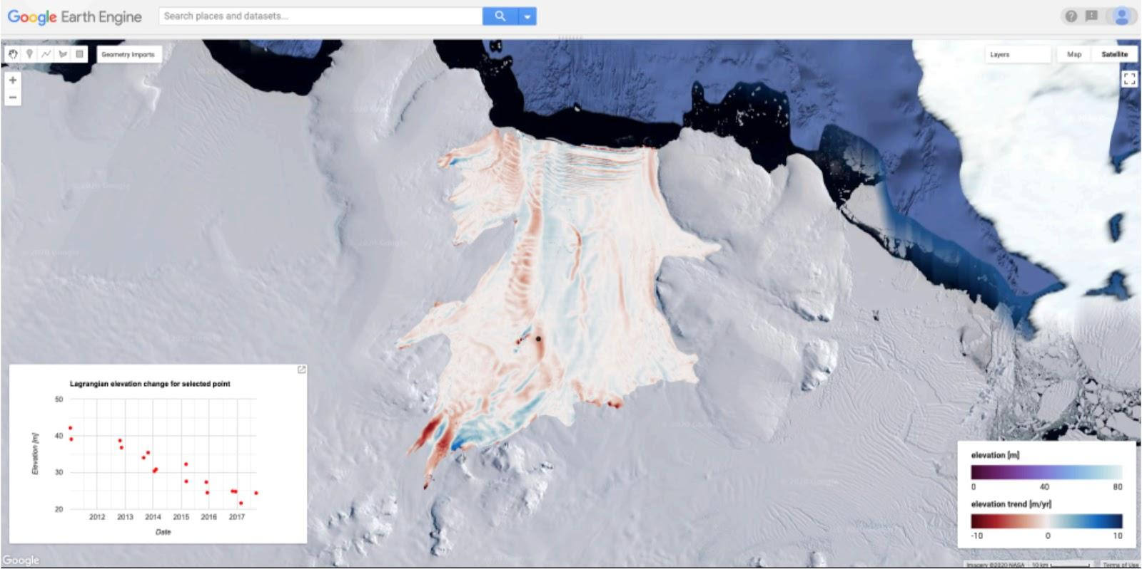
The support available within the GEO-GEE program will help us to improve the processing chain, data accessibility, visibility, and increase the available processing capability of our project.
We hope this project will enable scientific breakthroughs by allowing insights on a larger scale (Antarctic-wide) and create societal impact by bringing polar satellite data closer to the scientific community and wider public.

Use Case 5.12: LUP4LDN: Using Google Earth Engine for Land Use Planning for Land Degradation Neutrality

In 2020, the Group on Earth Observations Land Degradation Neutrality (GEO-LDN) initiative, together with the United Nations Convention to Combat Desertification (UNCCD) launched an international technology innovation competition to design EO-derived tools and products that could support transparent and well-informed land-use decisions and the local to national level across the globe.
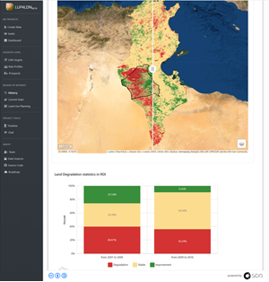
The tools that were developed contribute to climate change mitigation and adaptation and can be used to monitor and track progress towards the achievement of SDG Indicator 15.3.1 on “the proportion of land which is degraded over total land area”. Addressing desertification, land degradation and drought is a cost-effective solution to reduce and sequester carbon and to restore biodiversity and as such it clearly contributes to the goals stated in the Paris Agreement.
In March 2021, Land Use Planning for Land Degradation Neutrality (LUP4LDN), a tool developed by SCIO, was awarded financial and technical support valued at 100K USD for the transformation of the prototype into an operational and scalable tool, and a 2-year license for free access to use Google Earth Engine (GEE) as part of their solution.
The LUP4LDN application supports the achievement of land degradation neutrality by facilitating land use planning and sustainable land management. The application supports land use planners, policy makers and other end users in the identification of areas where it is most crucial to focus, providing visual representation and comparative analyses of impacts of land degradation gains and losses and trade-offs towards achieving land degradation neutrality.

Capacity Building
Guiding Questions:
11. What are the barriers and challenges, including finance, technology development and transfer and capacity-building gaps, faced by developing countries (§36(f))?
14. To what extent has progress been made on enhancing the capacity of developing country Parties to implement the Paris Agreement (Article 11.3)?

Using Earth Observations to support and enhance adaptation in developing countries
As noted above there are still gaps in systematic observations, systems and services for climate action: almost all the ECVs are consistently deficient over certain regions, most notably parts of Africa, South America, Southeast Asia, the Southern Ocean, and ice-covered regions, a situation that has not improved since the 2015 GCOS Status Report (GCOS-195).
The three GCOS Regional Workshops in Fiji, Uganda and Belize have looked at why some regions have problems in making sufficient observations. These issues include:
- For small nations (e.g. SIDS and PSIDS) the costs of observations may far exceed the resources available nationally amounting to a substantial fraction of the Gross Domestic Product (GDP).
- Lack of planning for foreseeable expenses (e.g. maintenance, equipment replacement, consumables).
- Lack of trained staff and poor staff retention.
- Poor understanding of the national benefits of observations: their contribution to disaster preparedness, adaptation planning and other climate services.
- Furthermore, in remote and inaccessible areas, there are technical difficulties in the maintenance of operational observations.

International Earth observation data policies supporting local adaptation
A number of activities at the international level aim to support countries, especially developing countries in obtaining and using observational data and/or derived products such as forecasts.
Strengthening systematic observation capacities
To address persistent gaps in the observing system, in particular in countries without sufficient resources to maintain and observation sites and networks, the Eighteenth World Meteorological Congress in 2019 adopted the concept for a Global Basic Observing Network (GBON), which, if fully implemented, will provide essential observations for global Numerical Weather Prediction (NWP) and reanalyses, providing data on several ECVs and filling in gaps in the observing system coverage. WMO is currently working to establish a Systematic Observations Financing Facility (SOFF), created as a Multi Partner Trust Fund jointly established by WMO, UNDP and UNEP, that will provide financial and technical support for the implementation and operation of GBON to those Members who would not otherwise be able to implement this network. Transforming the GBON and SOFF from concepts to an operational reality requires the efforts and support of all Parties.
The GCOS Cooperation Mechanism (GCM) was established to identify and make the most effective use of resources available for improving climate observing systems in developing countries, particularly to enable them to collect, exchange, and utilize data on a continuing basis in pursuance of the UNFCCC. In recent years, several countries have provided funds and participated on the Donor Board. While the impact of the GCM at a station or national level can be significant, in recent years, the funding available to the GCM only allows a handful of countries to be assisted. As the SOFF, if funded to the level envisaged on a sustained basis, only addresses a few ECVs, the GCM could support observations of the remaining ECV, proving sufficient funds were available.
Data Policies
How data is made available to users is determined by the data policy. WMO has been working towards adopting a new data policy, suitable for addressing climate change, that allows free and open access to all data. Increasingly data centers and data stores are open to all.
Good Practices for Observations
For observation to be useful they must be consistent globally whoever performs the observations. GCOS has established a set of requirements for all the ECV and these will be updated in the 2022 GCOS Implementation Plan. WMO has regulations and guidance on equipment and how to make observations that ensure a consistent approach is adopted globally.

Supporting local data processing, forecast, early warnings and advisories
One aspect of responding to climate change are early warning systems (EWS, Figure 5.1) which are seen as the adaptation priority by Parties. Data provided by 138 WMO Members, (including 74% of LDCs and 41% of SIDS), presented in the 2020 report on the State of Climate Services: Risk information and early warning systems^{[5]}, show that just 40% of countries have multi-hazard early warning systems, and one third of people in the 73 countries that provided information are not covered by early warnings. However, there are also communication issues around supplying warnings to the public.
Again, here observations are vital. More local networks of observations may be needed at a higher spatial resolution than the global networks, to allow truly local forecasts and projections. The resolution needed will depend on the variable: precipitation is much more spatially variable than temperature. Any support to such networks should ensure a sustainable future for the observations beyond the end of the project.

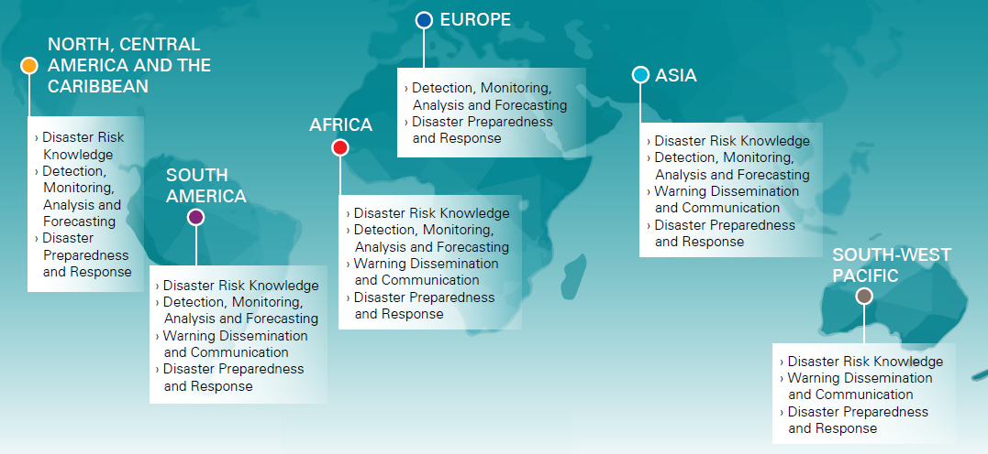
Figure 5.1: Needs across the EWS value chain by region, as indicated in NDCs and NAPs. Source: Nationally Determined Contributions (NDCs), WMO 2020
In addition to the SOFF and GCM discussed above, there are projects that, in part, aim to improve networks and observations. However, many of these projects only spend a relatively small proportion on observations and the long-term sustainability beyond the end of the project is difficult.

Use Case 5.13: Capacity building for Climate Risk and Early Warning Systems

The Climate Risk and Early Warning Systems (CREWS) initiative saves lives, assets and livelihoods through increased access to early weather warnings and risk information for people in Least Developed Countries (LDCs) and Small Island Developing States (SIDS) – the world’s most vulnerable countries. The CREWS Trust Fund has invested over US$ 40 million in projects in 44 LDCs and SIDS – and has mobilized an additional US$ 270 million from public funds of other development partners. Australia, France, Germany, Luxembourg, the Netherlands, Switzerland and the United Kingdom contribute to the pooled CREWS Trust Fund and provide oversight to CREWS operations through the CREWS Steering Committee. Canada supports CREWS objectives through additional funds to WMO for related CREWS activities.

Use Case 5.14: GEO-CRADLE: Scaling up the nextSENSE Pilot Application

GEO-CRADLE is the Group on Earth Observations (GEO) Initiative for capacity building in the Middle East, North Africa and the Balkans. It aims to sustain the outputs of the H2020 GEO-CRADLE project by scaling up their reach in terms of geographic coverage and operational maturity.
The nextSENSE pilot developed by GEO-CRADLE fosters the use of EO data focusing on solar energy potential to develop services aimed to support the efficient exploitation of the sun as an energy source. After the initial success of this application in North Africa and Europe, it has been applied to southern Asia in 2021, modifying the EO data sources and atmospheric conditions to adapt to local conditions.
The application provides useful solar energy production data to key electricity handling institutions and solar plants, allowing the monitoring and forecasting of solar energy production. By doing so, the application will boost regional production of renewable energy and the creation of a renewable energy market in the region, ultimately contributing to climate change mitigation. The nextSENSE pilot relies upon Copernicus data and core services, innovative modelling and real-time solar energy calculating systems in order to deliver reliable and high-resolution solar Atlases and broader climatology studies.

Capacity Building to Encourage the Use of the Top-Down Atmospheric Budgets
The primary objective of these pilot inventories is to start a conversation between the atmospheric greenhouse gas measurement and modeling communities and the national inventory agencies, the UNFCCC, and other relevant stakeholders (IG3IS, GCOS, IPCC) to establish the utility and best practices for the use of top-down atmospheric inventories in future Global Stocktakes. In particular, these products will help to define the best ground-based, airborne, and space-based products for building top-down inventories and the best practices for combining top-down and bottom-up inventory techniques and products. We also anticipate that they will foster the development and delivery of capacity building curricula to build a larger user community for the much more advanced top-down inventory products delivered for the 2028 GST and beyond.
To support these objectives, this effort includes the development of capacity building materials that:
- Provide a transparent description of the top-down atmospheric inventories, including their inputs, analysis methods, principal products and their uncertainties.
- Proposes methods to combine the information contained in these top-down atmospheric products with bottom-up inventory products to:
  - Assess the accuracy and completeness of the emissions reports on regional, national and local scales;
  - Facilitate the development of inventories, particularly for the non-fossil fuel sectors;
  - Identify opportunities for improving GHG inventories (e.g. KCA) to support future GSTs; and
  - Solicits input from stakeholders (UNFCCC, IPCC) and users in the national inventory community to develop more complete and relevant top-down GHG products to support future GSTs.

Use Case 5.15: Database of public and private GHG satellite missions targeting UNFCCC delegations
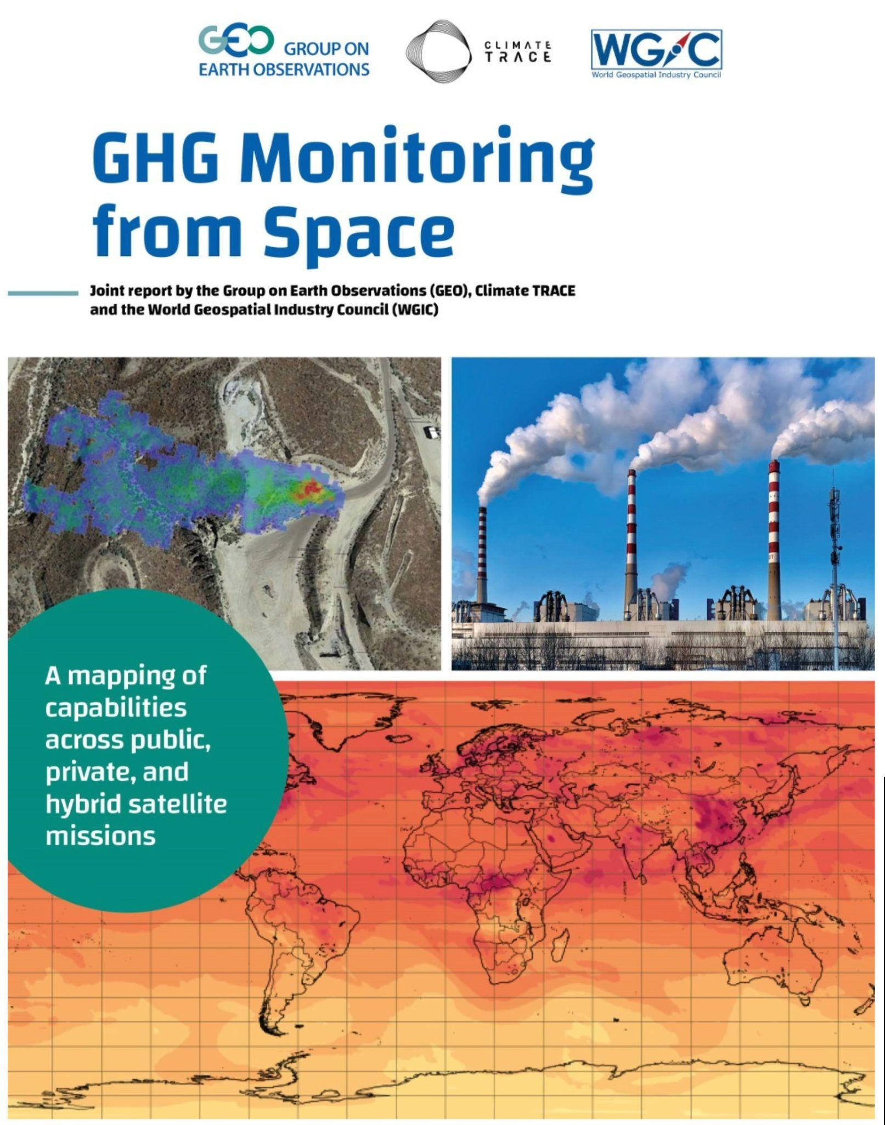
The report “GHG Monitoring from Space: A mapping of capabilities across public, private and hybrid satellite missions” was jointly launched by the Group on Earth Observations (GEO), Climate Trace, and the World Geospatial Industry Council (WGIC) at COP26 in 2021.
This report specifically targets policy makers in the UNFCCC context, and is ultimately aimed to raise awareness among decision makers of the existing and emerging capabilities to track GHGs in the lead up to the first Global Stocktake of the Paris Agreement in 2023.

The EO tools, products and services to improve the accuracy of GHG reporting are increasingly provided by both public and private sector entities, offering a variety of services ranging from data inventories, to maps, to strategic guidance. However, policy makers are not always aware of, or able to access or fully utilize the existing EO capabilities. It will be critical to support awareness raising, accessibility, and capacity development to enable scientifically-sound decision making.
Notably, it is crucial for policy makers to gain a full overview of existing and upcoming capabilities to improve GHG reporting and strengthen climate mitigation policy at all levels, with data from public and private satellite missions.

To respond to these challenges, this report represents the first joint and systematic effort by public and private sector entities to map existing and prospective GHG monitoring capabilities from space. It provides a clear and comprehensive overview of current and future satellite missions and instruments that collect relevant data of GHG emissions in support of the NDC revision and BTR development, as well as the overall GST process, in a way that is accessible by policy makers.

The report contains a database of 33 relevant satellite missions and instruments both in orbit and in planning, funded by public, private and not-for-profit entities. These missions have a potential to contribute to National GHG Inventories and the GST, focusing on the three major gases listed under the Paris Agreement for reporting purposes by Parties: carbon dioxide (CO2), methane (CH4), and nitrous oxide (N2O). Of these 33 identified missions, most are driven by public entities (21, of which 13 in orbit and operational). In addition, there are 7 commercial missions (of which 1 in orbit and operational, and 1 in its final trial period before being fully operational in orbit) and 5 hybrid missions (all in development) with proposed launch dates until the 2040s.

The database features specific information on the country or region where the mission is based, the contributing or coordinating organizations, the mission name and the related instrument, the mission status (in orbit, in development, end of mission), the mission goal and application, GHG data monitored directly (CO2, CH4, N2O), potential policy-relevant application (pointsource, national, and global level), and data access.

Key policy-relevant messages can be drawn from the analysis of the identified satellite missions:
- Satellite observations reduce uncertainty in GHG emission monitoring by providing data across a range of spatial, temporal and spectral resolutions or scales.
- Government space agencies have the capability to collect national and global baseline data for all relevant GHGs in a sustained manner with measurement availability ranging into the 2040s.
- Private sector companies are speedily entering the market and bringing additional point-source emissions monitoring capabilities for specific GHGs.
- Hybrid models are increasingly emerging and leveraging respective strengths. Based on these findings, we call for continued cooperation between public and private sector entities to fully maximize complementary capacities and synergies to support policy makers in the race to net zero emissions going forward.
- Collaboration, innovation and financing are key levers for GHG monitoring from space.
- Open data, open science and open knowledge are essential to drive on-the-ground solutions.
- New opportunities are arising for analyzing secondary remote sensing measurements with frontier IT technologies which call for transparency and capacity development.

Collaborative Interface with National GHG Inventory teams and experts in the AFOLU sector
National reporting on the AFOLU sector supports mitigation and adaptation activities and contributes to the NDCs. This is expected to facilitate technology transfer and capacity building within the countries and will lead to further refinements of the national requirements. The coordination framework being developed by space agencies for AFOLU efforts includes a strong component of engagement with national GHG inventory teams and experts. This collaborative interface will help to: i) determine needs and requirements regarding the potential use of space-based data and derived products for specific IPCC variables, following IPCC guidance and principles; ii) test and improve existing datasets to develop harmonized “best available” products; iii) address some of the outstanding issues that hinder the use of products by national teams; and iv) provide examples of the practical implementation of the 2019 Refinement to the 2006 IPCC Guidelines. This activity is led by SilvaCarbon (2021) and is leveraged by their partner network and well-established relationship with Government institutions responsible for reporting to the UNFCCC. Results from the first year of the CEOS AFOLU team included an overview of the use of LULC maps derived from satellite data in domestic GHG inventories and other reporting to the UNFCCC, a few first examples of the successful uptake of biomass maps derived from EO data (or the practical implementation of the 2019 IPCC Refinement), and the preparation of regional workshops.

In these workshops, national technical teams present their current methods and their NFIs; invited independent experts introduce and discuss the IPCC guidance and requirements; and remote sensing experts and scientists from CEOS agencies show their different mapping data and methods. The dialogue begins in the workshop and continues at national scales, in working clusters facilitated by SilvaCarbon and including a champion in the national team and a champion in the CEOS group for each country cluster of selected scientists and national teams to explore nationally appropriate opportunities for the use of space-based data and maps (biomass is a first case). At least one member with GHG inventory experience is included in the cluster (e.g., from the UNFCCC roster). The ultimate objectives are: i) to invite countries to share their NFI data and expertise to test the maps and contribute to harmonization of global independent maps and estimates that directly contribute to the GST; and ii) to explore opportunities under different national circumstances and different needs to enhance the uptake of satellite data and derived products by national teams in national reporting to the UNFCCC (indirect contribution to the GST).

Summary and Conclusions on the Role of Systematic Observations supporting Means of Implementation
Earth observations (EO) are being increasingly used to strengthen the evidence base for the climate rationale in funding proposals submitted to the Green Climate Fund (GCF), thus improving developing countries’ access to public finance for mitigation and adaptation projects. Many examples of ongoing support to Parties in accessing climate finance by the Systematic Observation community can be found.
Furthermore, private climate finance - including financial firms, insurance/reinsurance companies and businesses - are also employing EO tools to enhance climate risk assessments on their own assets, which creates more transparency and ultimately drives private sector investments in climate resilience globally. This is a relatively new and growing area of interest for the Systematic Observation community.
The products and initiatives presented above are a testament of the major progress which has been made in the adoption of EO data and derived products in support of evidence-based decision making. While EO has the potential to overcome existing data constraints and lead both to a better understanding of the changes taking place at different levels and to a better monitoring of the effectiveness of the measures implemented, several limitations exist. These range from human capacity to technical and political barriers that may prevent the application of EO and their efficient use for climate policy and climate action.
The Systematic Observation community has been working with global technology providers to lower the barriers for access to state-of-the-art cloud services, through dedicated cloud computing programmes providing licenses, grants, technical and financial support to developing countries
Apart from this kind of technical support, financial support is needed to ensure the advancement of developing countries' Earth observation data systems and applications. For surface-based observations, the Systematic Observations Financing Facility (SOFF) seeks to provide technical and financial assistance to countries to generate and exchange basic observational data.
Several capacity building initiatives are in place both for adaptation and mitigation, including support for local data processing, forecast, climate risk, early warnings and advisories; capacity building to encourage the use of space-based data for national GHG reporting; as well as collaborations with National GHG Inventory teams and experts in the AFOLU sector.
In developing capacities, it is critical to better target and design solutions which can be adapted to different contexts, which would only be possible through increased collaboration and coordination among the different Systematic Observation actors. The technical supplements to the NAP Guidance which we will see in Chapter 5 are a good illustration of this. In fact, improved cooperation will help identifying users’ needs in relation to the Paris Agreement and making sure that these are addressed by relevant products and that observational gaps relating to in situ data, of which the integration is still lagging behind, are properly addressed.

Cross-cutting issues - Systematic Earth Observations to support reporting and best practices across thematic areas, including Loss and Damage

Evidence and methodologies towards assessing and addressing implementation and support needs, particularly in developing countries
Guiding question:
15. What evidence and methodologies exist for taking stock of the implementation of the Paris Agreement to assess the collective progress towards achieving its purpose and long-term goals, including under Article 2.1(a–c), in the thematic areas of mitigation, adaptation and means of implementation and support, including on efforts to address the social and economic consequences and impacts of response measures and efforts to enhance understanding, action and support, on a cooperative and facilitative basis, related to averting, minimizing and addressing loss and damage associated with the adverse effects of climate change (para 6(b))?

Methodologies to support NAPs
The value of climate science for decision-making depends on the use of the best available data for characterizing the climate system and dealing with uncertainties. Reliable, high resolution and timely climate information is, therefore, a crucial input for decisions intended to promote adaptation to climate change and minimize impacts associated with climate-related hazards.
WMO and GCF have jointly developed a methodology, which was submitted as a Supplement to the NAPs Technical Guideline at COP26, showing that past, present, and projected future climate information is necessary in order to understand how the climate affects a region or sector. The conclusions drawn from implementing the methodology can support the identification of science-based climate actions and the design of climate services that respond to the local context, address potential vulnerabilities, and promote resilience to future climatic conditions.
This provides evidence for country-level contributions to the Paris Agreement GST, including the preparation of national communications and future reports under the Paris Agreement transparency framework. A climate science basis also contributes to formulating and implementing other climate-related national policies, including the climate-sensitive objectives of the United Nations Sustainable Development Goals (SDGs) and the Sendai Framework for Disaster Risk Reduction.
Climate and climate change-related risks to sustainable development are evident in the relationship between the state of the climate indicators described in the previous section of this synthesis report and the SDGs (Figure 6.1).
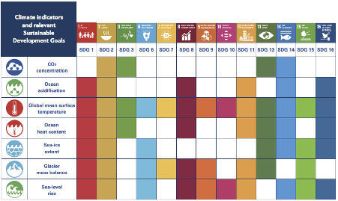
Figure 6.1: State of the climate indicators whose variability, extremes and trends pose risks to achievement of Sustainable Development Goals
The Group on Earth Observations Global Agriculture Monitoring (GEOGLAM) is developing supplementary technical guidance for NAPs to integrate Earth observations and remote sensing into adaptation planning in the agricultural sector, which also responds to SDG 2 “Zero hunger”.

Support to NDCs and MRV systems
Countries are building their institutional arrangements and national Measurement, Reporting and Verification (MRV) systems to respond to the Enhanced Transparency Framework requirements, including its connections to the regular updates of their NDCs every five years. The early consideration and integration of operational technologies and data sets from the Systematic Observation community in such arrangements and systems will be critical to enhance their capabilities and the robustness of their MRV systems.

The Cross-cutting nature of AFOLU observations responding to the evolving needs for MVS
The AFOLU sector in particular, as highlighted in both chapters 2 and 3 of this synthesis report, will increasingly become relevant in both mitigation and adaptation, and be key area for synergies between the two (including through Nature Based Solutions). Specifically, the use of AFOLU sector Systematic Observations will become increasingly important in the next 15-20 years. Assuming that the proposed legislative efforts are implemented as planned, the envisaged Systematic Observation contributions to Monitoring and Verification Support (MVS) capacities should put more emphasis on monitoring biological emissions (e.g. from agriculture) and critical carbon sinks (across the AFOLU sectors), since they will be able to discern fossil GHG emission plumes that will be reduced and eventually disappear over the next 15-25 years (depending on the region). This will have implications both for the monitoring of the contributions of these sectors in the mitigation context as well as the use of Systematic Observations in monitoring the impact of ongoing climate change to these sectors in an adaptation context. Consistency and interoperability between these different contributions from the Systematic Observation community will be critical.

Enhanced understanding, action and support for averting, minimizing and addressing loss and damage through Systematic Earth Observations
Guiding Question:
21. What efforts have been made to enhance understanding, action and support, on a cooperative and facilitative basis, related to averting, minimizing and addressing loss and damage associated with the adverse effects of climate change and what progress has been made (paras 6(b) and 36(e))?

Monitoring slow onset events
Climate-related slow-onset events are very dangerous but their full impact potential can take decades to manifest. The UNFCCC Cancun Agreements (Decision 1/CP.16) identify eight slow-onset events: desertification, glacial retreat and related impacts, land and forest degradation, loss of biodiversity, ocean acidification, salinisation, increasing temperatures and sea level rise.
A 2012 UNFCCC technical paper stated that “there are synergistic interactions between rapid-onset and slow-onset events that increase the risk of loss and damage” highlighting the importance of addressing both in order to build climate resilience. The paper also states that slow-onset events were already impacting developing countries negatively.
Most types of slow-onset events identified in the Cancun Agreement have important implications for development. All of them can be monitored using EO. Given their slow evolution, monitoring slow onset events and building long-term time series showing the otherwise very subtle changes can be an impactful tool for decision making.
Often, these events are interconnected. For example, recent reports suggest that the rate at which land ice is melting is increasing faster than expected because the Arctic is experiencing disproportionate warming compared to the rest of the globe (AMAP, 2017). This will inevitably contribute to an increase in sea level rise and affect vulnerable island and coastal communities. Long before the sea inundates that land, it can cause a number of issues from erosion and salt-water intrusion (which threatens potable water and arable land) to high tides that lead to frequent flooding.
On the other hand, climate change can also impact natural habitats that plants and animals depend upon. Shifts in climatic conditions can lead to habitat changes (including the complete loss of a habitat) and potentially go beyond the migrational capabilities of species. This can alter competitive relationships in an ecosystem, threaten whole species and severely degrade habitat quality.
The European Space Agency (ESA)-funded Earth Observation for Sustainable Development (EO4SD) initiative addresses the issue of Climate Resilience, including the topic of loss and damage.

Monitoring extreme events, notably hydro-meteorological hazard events
As opposed to slow-onset events, extreme weather and climate-related events have very obvious and dramatic sudden impacts. Extreme events include hazards such as heatwaves, extreme rainfall, tropical cyclones, droughts, floods, and wildfires. EO can improve climate projections and risk assessments over time. These changes in risk scenarios are also crucial for the management of slow onset disasters.
Systematically collected data on loss and damage associated with hydro-meteorological events provides key evidence for designing adaptation measures and for assessing the effectiveness of adaptation efforts. Systematic collection of data on such events, and associated loss and damage, provides Parties with information that can be used for a wide range of applications, including risk assessments, land use planning, infrastructure design and construction standards, and design and implementation of early warning systems (EWS).
As illustrated in the Adaptation chapter of this report (see section 3.6.2), EWS are extremely important for climate resilience as they may enhance adaptive capacity and mitigate climate-related risks and vulnerabilities in the context of early detection and surveillance processes. EWS directly depends on observations and may require short or longer time series (WMO 2018); examples include floods, storms, and drought warnings or alerts on climate-related morbidity.
Globally, data for the past 50 years analyzed in the WMO Atlas of Mortality and Economic Losses from Weather, Climate and Water Extremes (1970–2019) show that, while loss of life has been decreasing, damage and economic losses associated with hydro-meteorological events is increasing, as is the number of events with which significant losses and damages are associated (Figure 6.2). During the 50-year period, US$ 202 million dollars in damage occurred on average every day. Economic losses due to weather, climate and water extremes have increased sevenfold from the 1970s to the 2010s. The reported losses from 2010–2019 (US$ 383 per day on average over the decade) were seven times the amount reported from 1970–1979 (US$ 49 million). Storms were the most prevalent contributor to damage, resulting in the largest economic losses around the globe. It is the sole hazard for which the attributed portion is continually increasing.
Two different economic classification methodologies – from the United Nations and the World Bank – both reveal that the majority of reported deaths from weather, climate and water extremes occurred in developing countries, while countries with developed economies incurred the majority of economic losses. According to the United Nations country classification, 91% of recorded deaths occurred in developing economies while 59% of economic losses were recorded in developed economies. According to the World Bank country classification, 82% of deaths have occurred in low and lower-middle-income countries and most (88%) of the economic losses have occurred in upper-middle- and high-income countries.
A downturn in observed disaster frequency over 2010-2019 from the previous decade (see Figure 6.2) is cause for cautious optimism, but more time will be needed in order to establish whether this is a trend or simply a temporary dip in loss and damage event frequency. The reduction in loss of life is attributable to the success of risk management measures, with risk information and early warning systems having been identified as particularly effective risk management measures (Natural Hazards Unnatural Disasters, World Bank, 2010).
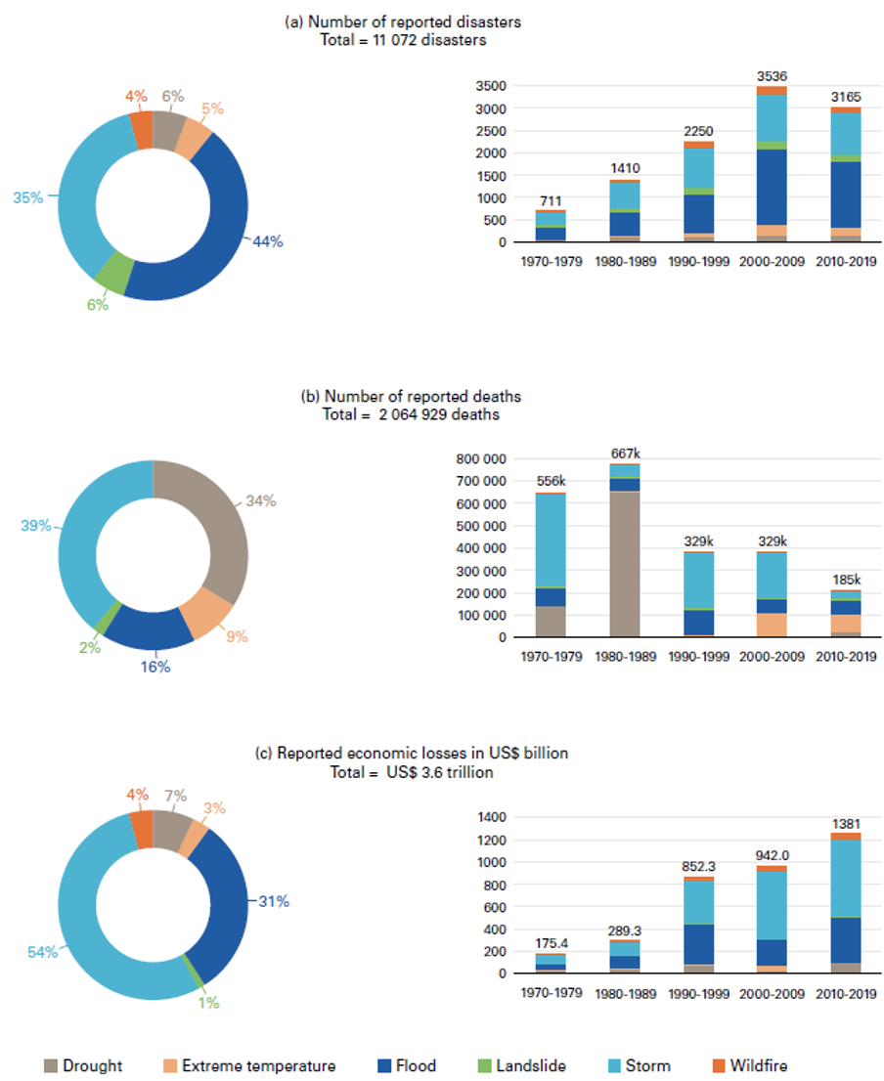
Figure 6.2: Distribution of (a) number of disasters, (b) number of deaths and (c) economic losses by hazard type by decade globally (Atlas of Mortality, WMO, 2021)
At the country level, systematic observation of hydro-meteorological events and associated losses and damages can guide identification, design and implementation of effective measures for reducing adverse impacts. Collected over time, historical data on events and impacts is an important evidence base for risk identification. Once such risks are identified they can be addressed through risk reduction and risk financing measures.
Satellite sensors are useful tools in index insurance design and validation but they are not always accurate. Ultimately using multiple datasets in conjunction with ground observations can bolster certainty that a weather event was significant enough to cause a payout.
The examples below show how Earth observations are increasingly being used by insurers and reinsurers, as well as governments to support risk transfer mechanisms in developing countries.
Use Case 6.1: SAGABI Project: Pilot public asset insurance - Climate Finance Mechanism within cities in Ghana supported by GIZ, HKV, Allianz Re
“To develop an insurance product, it is essential that the risk can actually be quantified. For our project, EO data was used to develop a forecasting flood risk model, validated with ground truth data and calibrated against a past catastrophic flood event. The results from this model were used to create a tailor-made, affordable and adequate insurance cover for the city of Accra”

Risk transfer mechanisms like insurance are an important part of a holistic risk management concept. For rare, very heavy national catastrophic events, major financial impact will not be avoided, even when risk prevention and adaptation measures have been properly implemented. Insurance solutions become essential to enable fast recovery and sustainable financing.
However, affordable and adequate insurance is not possible without the assessment and quantification of the underlying risk. The lack of proper risk quantification is one of the reasons for the insurance protection gap in many regions of the global South, for instance in Accra.
In a public-private partnership, GIZ, Allianz Re and HKV Consulting have pioneered a holistic risk management concept for three different municipalities in Accra, the capital of Ghana, that integrates an innovative and Earth observation data-driven insurance solution. As a cornerstone, HKV developed a flood risk model of Accra, which was later used by Allianz to develop pilot insurance products in a scarce environment.

Use Case 6.2: Index-based flood insurance developed by IWMI

Thousands of farmers in India and Bangladesh have been compensated for flood damage to their crops, thanks to innovative satellite-based insurance developed by International Water Management Institute (IWMI) scientists. Between 2017 and 2020, farmers from 7000 households in Bihar, India, and Gaibandha, Kurigram and Sirajganj districts in Bangladesh, shared a total payout of 150,000 USD.
IWMI is bringing its Index Based Flood Insurance (IBFI) product to thousands more farmers through private sector partnerships. In India, its work with WRMS will help to insure 25,000 farmers against floods and other risks, and in Bangladesh, a partnership with Green Delta Insurance Company is making the insurance available to 100,000 farmers.
At the heart of IWMI’s flood insurance product is a hydrological model, which helps to predict where runoff will travel and collect in the event of severe rainfall. The model identifies areas most at risk from flooding; essentially, a flood-risk ‘index’. Initially, observed rainfall and discharge data were used to build the model. This provided a good degree of accuracy but meant that development was limited to areas where there were high levels of observed data, such as from weather stations. Fortunately, the availability of high-resolution satellite data from the European Space Agency ESA Sentinel 1 satellite helped to overcome this challenge.
In the most recent insurance pilot in Bangladesh in 2019, IWMI researchers used satellite maps from the NASA MODIS mission, looking at 250m by 250m plots of land, to map inundation on a daily basis between 2001 and 2018. This highlighted historic patterns and showed where flooding might happen in the future. The researchers validated the model using data from the Bangladesh Water Development Board (BWDB) and European Space Agency (ESA) Sentinel-1 satellite data. Insurance experts then designed payout conditions around anticipated timings and levels of flooding, potential crop damage, wages and other socioeconomic factors.

Use Case 6.3: GEOGLAM: Earth observations applied to Early warning systems and Disaster Risk Financing in the agriculture sector - Uganda case study
A case study is presented to illustrate the power of Earth observations, notably satellite data and information, to support an early warning system triggering a financing facility in the context of a drought-related failure in the agriculture sector, which would have caused huge losses. The case study is based on the work of the Group on Earth Observations Global Agriculture Monitoring (GEOGLAM) with the Ugandan government.
Vulnerable households in Uganda face considerable climatic risks, primarily related to drought. Uganda’s predominantly rural population mostly consists of smallholder farmers who are subject to several production constraints and have limited capacity to cope with recurrent climatic shocks. The Karamoja region is particularly vulnerable to food insecurity due to poor, sporadic rainfall, is highly exposed to droughts, with more than 80% of households heavily relying on low-productivity and rainfed subsistence crops.
The Disaster Risk Financing (DRF) project under the Third Northern Uganda Social Action Fund (NUSAF III) provides additional support to households in the Karamoja region immediately following crop failure triggered by an agricultural drought event. Support takes the form of a temporary expansion of Labor-Intensive Public Works activities to offset the loss of food production. This additional support in times of crisis is intended to safeguard development gains made under the broader NUSAF project which would otherwise be lost. DRF has provided increased resilience, while reducing the costs of response through proactive action. Key to the process is early, pro-active response to emerging food security events based on timely, regular monitoring information.
To ensure that additional resources are released as quickly as possible following the onset of a drought event, DRF funds are triggered automatically using objective, pre-agreed and quantitative indicators. Satellite-based remotely sensed data can be used to achieve these goals, and is considered far more reliable than rainfall data, with no gaps in geographic or time coverage, and very small delay times in obtaining data. The Normalized Difference Vegetation (NDVI) Anomaly index was identified and confirmed by the DRF committee, as the most appropriate remote sensing indicator to measure the status of pasture and assess grazing resources available to livestock in Karamoja.
The NDVI Anomaly data used for risk modeling and triggering DRF mechanism is derived from the Global Agriculture Monitoring (GLAM) East Africa Portal (http://pekko.geog.umd.edu/glam/east-africa/zoom2.php), which is a portal for MODIS satellite time series. The NDVI Anomaly index a 16-day intervals basis during the rainfall season (JJAS) in Karamoja. If in any of the months during this period the index falls below the threshold, the DRF mechanism is triggered. These data are complemented by on-ground assessment as well as data collection by extension agents in the region using the OpenDataKit for pre-season, in-season and post season crop monitoring.
Developing the DRF led to Uganda’s interest in the Crop Monitor system which is now published as part of the Uganda National Integrated Early Warning Bulletin (U-NIEWS) published since 2016. The report includes a GEOGLAM crop monitor report and pasture and vegetation assessment based on the GLAM system- http://www.necoc-opm.go.ug/UNIEWS/
In disaster response early warning is the key, particularly for relatively slow-moving disasters like drought. Proactively assessing risk saves money and keeps food on the table for Ugandan families. Following on from the 2016 DRF experience, by May 2017, satellite data showed drought conditions would cause widespread crop failure in Uganda. By August, the GEOGLAM Crop Monitor for Early Warning – an international report using satellite data to monitor crop conditions – confirmed poor production. The Ugandan government provided disaster relief aid to 31,386 households – about 150,000 people – and saved USD 2.6 million in the process. In early 2018, they paid USD 2.6 million to 23,388 households, strengthening food security for many who would have otherwise had to wait until the next season’s harvest or food aid from the government. According to Martin Owor, Commissioner Office of the Prime Minister “In the past we always reacted to crop failure, spending billions of shillings to provide food aid in the region. 2017 was the first time we acted proactively because we had clear evidence from satellite data very early in the season”.
The simplicity of the DRF framework and access to the GLAM system made it possible to run locally increasing not only the credibility of the analysis but ownership, significantly accelerating the data to decision continuum. Further, having multiple stakeholders review, vet and verify the results ensures the information is authoritative and trusted.
GEOGLAM provides an excellent example of how to work with end users to co-create a trusted space-enabled decision support service. Based on the success of the crop monitoring, EO-based monitoring is now an operational part of the Ugandan National Early Warning Bulletin.
GEOGLAM is now building on their co-development experience to develop supplemental technical guidance for the NAP process within the UNFCCC. As well as knowledge packages available through the GEO Knowledge Hub, to provide technical resources to use knowledge and apply to systems.

Good practices, experience and potential opportunities to enhance climate action through the application of Earth observations
Guiding question:
18. What are good practices, experience and potential opportunities to enhance climate action, including international cooperation, on mitigation and adaptation and to increase support under Article 13.5 of the Paris Agreement (para36(g)? Which of these can be transferable or replicated by others? How effective was sharing good practices and experiences on climate action and support, including on enhancing the implementation of adaptation action (Article 7.14(b))?
The following examples represent use cases showing how systematic observations and associated systems and services can be used to achieve successful adaptation outcomes in the areas prioritized in Parties’ NDCs.
They are highly transferable and replicable, provided that the operational hydro-meteorological systems and services that underpin them are adequately supported, both technically and financially.
Use Case 6.4: Earth observations applied to Disaster Risk Reduction in Europe
In this case study atmospheric ECVs from observations and reanalyses have been used to generate a pan-European interactive catalog of past extreme precipitation events. (https://climate.copernicus.eu/sectoral-specific-challenges/disaster-risk-reduction/pluvial-flood-risk-assessment-urban-areas). This allows the user to identify past events and rank them in terms of affected area, magnitude, and severity (empirical damage and loss records from public repositories). The same data provided the inputs to production of maps of pluvial flooding hazard, risk and damages (based on a high-resolution hourly precipitation dataset) for a pool of 20 European cities.
The prototype product has been designed for city planners, civil servants, civil protection, administrators, insurers to make simpler for them to:
• identify the areas historically more impacted by heavy precipitation events and to have access to detailed information about the severity and probability of occurrence of heavy precipitation in recent decades;
• fast and reliably detect the urban areas potentially interested by pluvial flooding;
• understand how unsustainable land-use (soil sealing) and improper urban planning contribute to increased vulnerability, and to support investigating incentives, which insurers and public authorities may use to foster individual and collective risk reduction efforts.
The use of reanalysis for assessing wind storm damage over Europe
Jointly with flooding one of the climate hazards the insurance industry is most worried about is European wind storms. In this case study a combination of reanalysis data and in situ wind observations has been used to generate a catalog of wind storms for the European sector which goes back to 1979. For each storm the track of the center of minimum pressure and the location of maximum wind has been stored. These were calculated automatically running over the whole archive of historical data. For each storm and estimation of the maximum wind gust recorded at each location was also stored. These maps, which are known as storm footprints, have then been used in combination with socio-economic data and the location of buildings, to estimate the damages induced by each storm at each location. Whilst much more complex catastrophe models have been used to this purpose by the insurance industry, the case study illustrates an end-to-end transformation of climate information in sector relevant data in an open, traceable and transparent way. More information on this case study can be found here: https://wisc.climate.copernicus.eu/wisc/#/help/products

Use Case 6.5: GEO Blue Planet: Eutrophication indicators and tools

The SDGs include a goal (SDG 14: Life Below Water) to conserve and sustainably use the oceans, seas and marine resources for sustainable development. SDG 14 Target 14.1 "by 2025, prevent and significantly reduce marine pollution of all kinds (...)" provides a deadline for progress on reducing marine litter which is informed by SDG indicator 14.1.1a, “Index of Coastal Eutrophication”.
Many UN member countries do not have in water data available to report yearly on eutrophication along their coasts. In order to provide indicators that could be reported on a yearly basis on a global scale, the Group on Earth Observation (GEO) Blue Planet initiative worked with UNEP and space agencies to develop satellite-based indicators for eutrophication.
GEO Blue Planet is now planning to work with member countries to co-develop visualizations and tools to increase the utility of the indicators and to further develop more in depth regional and national indicators.
GEO Blue Planet is aiming to use this as a model for engaging with UNFCCC, including for mitigation and adaptation efforts and the Global Stocktake. EO can inform NAPs on issues related to coastal erosion, saltwater intrusion, changes in species distributions, ocean acidification, storm surge risk and other coastal issues. As well as support the mapping of Blue Carbon ecosystems to set NDC targets.

Use Case 6.6: GEO Blue Planet - Dynamic Coast: mapping the intertidal zone across the UK and Ireland to inform coastal adaptation

The international concern over increases in coastal erosion is focused on the risk to coastal assets, but there is also increased recognition of the impact on intertidal ecosystem services that may accompany increased erosion. Accurate time series mapping of the intertidal zone is key to understanding the risks posed by erosion yet, due to high cost and logistical complexities, it remains a difficult environment to regularly survey and map at national scales.
Coast X-Ray is an approach to map the intertidal zone by measuring water occurrence frequencies using tidally calibrated satellite imagery (Sentinel-2), processed within Google Earth Engine. Using the UK and the Republic of Ireland as a test case, the resulting output compares favorably with the outputs from high-resolution digital elevation models. Due to the increasing societal importance of the impact of climate change and rising sea level on the coast, it is imperative that the intertidal zone is mapped regularly and accurately. Methods such as Coast X-Ray offer a rapid and cost-effective complementary approach to support traditional aerial or ground surveying to the longstanding logistical complexities and economic costs associated with national mapping of such a dynamic environment.
Knowing where the coastline is and how it is changing is crucial for coastal adaptation planning and implementation. Earth observation provides a cost-efficient way to answer these fundamental questions.

Use Case 6.7: Digital Earth Africa: A platform to support climate action in Africa

The Group on Earth Observations (GEO) Digital Earth Africa initiative (DE Africa) provides reliable, operational EO data to deliver decision-ready products and services to address social, environmental and economic changes in Africa. Analysis-ready Landsat, Sentinel-1 and Sentinel-2, including historic datasets, are hosted on Amazon Web Services (AWS) in Cape Town. Further, DE Africa provides free access to cloud computing platform (Sandbox), open source Jupyter notebooks and algorithms, and online training, which makes it an ideal platform to deliver projects in support of climate action in Africa. DE Africa reduces the EO data processing effort by 80% compared to traditional approach, which makes analysis ready data several times faster to implement programmes.
The platform is operational and offers cost-effective solutions for countries interested in setting up national inventory systems for biennial reporting, mitigation and adaptation projects as part of their Nationally Determined Contributions (NDCs) under the Paris Agreement. DE Africa 2020 Annual Report provides a detailed list of achievements to date. The 2021 Annual Work Plan provides current activities. DE Africa’s work programme is delivered by six regional implementing partners coordinated by the Programme Management Office based in Pretoria, South Africa. Together, DE Africa partners reach more than 40 countries in Africa and have the required capability and capacity to support projects to assist countries to rapidly deploy national systems. This is a good time for new investors and collaborators to take advantage of the existing investment and infrastructure to build additional tools and services.

The following example presents a global early warning system for wildfire monitoring.
Use Case 6.8: GWIS: Earth observations applied to Early warning systems for fire monitoring – Australia case study
The Global Wildfire Information System (GWIS) is a joint initiative of the Group on Earth Observations (GEO) and Copernicus work programmes. Using advanced methods on data processing for wildfire detection and monitoring, numerical weather prediction models, and remote sensing, GWIS enables enhanced wildfire prevention, preparedness and effectiveness in wildfire management. GWIS provides the first global database of wildfire events for a continuous time frame (between 2001-2019) enabling the analysis of wildfire regimes worldwide and providing the basis for the assessment of potential effects of climate change.
Over the 2019-2020 summer, bushfires heavily impacted various regions in Australia and caused widespread harm to people and animals and damage to the economy. Multiple states of emergency were declared across New South Wales, Victoria, and the Australian Capital Territory. During the most critical phase between December 2019 and January 2020, the European Commission established contact with the Australian government to offer support in terms of physical means and analysis of the situation, drawing on the GWIS data.
At the global level, GWIS is set to be a unique resource supporting developing countries that may not have access to national-level information on wildfires. Unfortunately, those being most affected by disasters more often include middle and low-income and developing countries according to the UN Development Programme (2018). This global open data portal is providing necessary information to those countries that need it most.

The case study below explores how the Food and Agriculture Organization of the UN (FAO) and the Mongolia Red Cross are working through critical early warning messages to protect livestock farmers from experiencing the adverse impacts of dzuds , which are becoming more severe and frequent than in the past due to climate change.
Use Case 6.9: Protecting Mongolian herding families through early warnings and anticipatory action
CHALLENGE
Raising livestock remains the most important livelihood in Mongolia and is the sole source of income for 35% of households. For Mongolians and their livestock, very hot summers and dry, very cold winters have been part of life for centuries. But climate change has made what is known as a dzud (a term used to describe severe weather conditions in Mongolia) more severe and more frequent. During recent dzuds many herding households have lost all their livestock or could not afford extra fodder, of which there is little available anyway. Consequently, they are often threatened with destitution in the space of a single season.
APPROACH
Ahead of the 2018 dzud, two critical warnings were issued to support Mongolian farmers. The Government of Mongolia sounded a first alarm in November, through its Information and Research Institute of Meteorology, Hydrology and Environment (IRIMHE). The Institute shares a dzud risk map annually, and for the 2018 season it showed half the country already covered by snow. This product is the first of its kind in Mongolia and has become the key service for triggering anticipatory humanitarian action. The second warning was a joint FAO-WFP Crop and Food Security Assessment pointed towards abnormal dry conditions which resulted in below-average availability of fodder. The warning combined 11 indicators in total, including snow-cover days, weather patterns and agricultural vulnerability to show 30% of the country as being at high risk – and another 30% at medium risk – of a severe dzud. Overlaying the monitoring and forecasting together with social and economic information helped closely pinpoint the most vulnerable families to target for anticipatory actions. These EWSs were used once again in 2020 by FAO and the Mongolian Red Cross.
OUTCOMES
FAO and the Government acted quickly based on these warnings to support 1,008 vulnerable herders and their families living on the urban fringes of Ulaanbaatar. Anticipatory actions included destocking of livestock, with households receiving money for the carcasses of a goat and a sheep in December 2017 to cover their immediate needs. Families told FAO interviewers that this helped them to buy extra food supplies at the best time, before prices spiked as the dzud began to bite. Shortly after, FAO distributed 340 tonnes of concentrated feed and 17 tonnes of nutritional supplement to rural herders swiftly followed at the start of 2018, the lean season. FAO distributed the livestock meat from destocking to vulnerable urban households living in poor areas on the edges of Ulaanbaatar. This saved the households a precious US$ 32 over a period of more than two months when finances were especially stretched. Families said they were able to divert the money they saved to buying essentials, such as food, medicine and school supplies. Meanwhile, FAO distributed 340 tonnes of concentrated feed and 17 tonnes of nutritional supplement to rural herders swiftly followed at the start of 2018, the lean season. The Mongolian Red Cross also provided 2 500 herder families with cash transfers and emergency livestock kits. A recent study showed that by providing early assistance before winter conditions reached their most extreme, the Red Cross intervention effectively reduced livestock mortality by up to 50% and increased offspring survival for some species, thereby helping to secure future livelihoods.
PARTNERS
FAO-WFP Crop and Food Security Assessment, Government of Mongolia and Information and Research Institute of Meteorology, Hydrology and Environment (IRIMHE), Mongolia Red Cross, Nagoya University of Japan and the Red Cross Red Crescent Climate Centre.

The following case study discusses how a multi-faceted approach to early warnings and early action based on enhancement of seasonal forecasting capability is well preparing Bangladesh, a high-density population and highly exposed country, for the impact of flooding.
Use Case 6.10: Early warnings and anticipatory actions are preparing Bangladesh for the impact of flooding
CHALLENGE
Bangladesh has a population of more than 165 million inhabitants, with a population density of 1 100 individuals per square kilometer – the highest in the world. Density rates in coastal areas number 1 000 individuals per square kilometer, and flood plains constitute 80% of the country’s total area. The country has a long history of natural hazards, of which floods and cyclones are predominantly responsible for the vast majority of the 520 000 deaths recorded over the last 40 years. The Risk-informed Early Action partnership (REAP) was formed in 2019, and it aims to make a billion people around the world safer from disasters by 2025, by bringing the humanitarian, development and climate communities together to take practical solutions for early action to scale. Bangladesh is a great example to do so at large scale. The International Federation of Red Cross and Red Crescent Societies (IFRC), the UK Met Office and the World Food Programme (WFP) have been leading efforts to strengthen early warning systems and scale up early action, supporting the government.
APPROACH
As early as 1965, the government initiated early warning systems for residents living along coastal zones and the results are tangible. Cyclone Sidr, which struck in November 2007, was similar to its two major predecessors (Bhola in 1970 and Gorky in 1991), and it devastated a similar area of the country. However, the estimated casualty figure of 4 234 deaths from Sidr reflected a 100-fold improvement following 37 years 44 of effort through the Cyclone Preparedness Programme, established in 1970 following Cyclone Bhola. Currently, information on hazardous events is provided by the Bangladesh Meteorological Department (BMD) to zonal offices and sub-district offices. The sub-district offices pass this information to unions (at the village level) through high-frequency radios. Volunteers then spread out and issue cyclone warnings throughout villages. In recent years, the UK Aid’s Asia Regional Resilience to a Changing Climate (ARRCC) project has commenced activities to facilitate the enhancement of the forecasting capability of BMD across all timescales to deliver weather and climate information, and services. These include technical support to help build capacity of BMD for IBF, seasonal forecasting and the development of national climate projections; development of sub-regional early warning services for crop-threatening wheat diseases; and the development of new sea-level rise assessments.
OUTCOMES
The Forecast-based financing (FbF) approach, implemented by WFP and the Bangladesh Red Crescent Society (BRCS), has created many benefits for flood-affected households. According to a survey carried out by WFP in August 2019, the average asset loss in FbF target areas has dropped from US$ 78 to US$ 57 after being affected by floods. The FbF approach has been activated four times ahead of floods, in 2017, 2019, and recently in 2020, scaling up the number of beneficiary population from 5 000 vulnerable households in 2017 to more than 300 000 vulnerable people ahead of the recent floods in 2020, and supporting them with a range of early actions based on their needs, for example unconditional cash transfers to very poor households, agricultural inputs to farmers and hygiene and health kits to vulnerable girls and women.
PARTNERS
Bangladesh Meteorological Department, REAP partners (including the UK Met Office, World Food Programme, the Bangladesh Red Crescent Society, the Food and Agriculture Organization of the United Nations and the United Nations Population Fund), the Global Flood Awareness System, the Flood Forecasting and Warning Centre and the Red Cross Red Crescent Climate Centre, German Red Cross.

The next case study describes how observation and monitoring help to produce reliable and actionable information for water management ahead of Hurricanes. The Group on Earth Observations (GEO) Global Water Sustainability (GEOGloWS) Streamflow Forecast service provides a worldwide application of the global runoff forecasts from ECMWF that transforms runoff into river discharge forecasts for every river in the world.
Use Case 6.11: Reliable and actionable information for water management ahead of Hurricanes Eta and Iota in Honduras
CHALLENGE
The Valley of Sula is prone to flooding, mainly during the rainy season and during storms such as Hurricanes Eta and Iota, as it drains more than 22 000 km². The only major river control structure in the upper basin is the El Cajón Dam, officially known as Central Hidroeléctrica Francisco Morazán, which controls 39% of the water contribution to the valley. The Honduran state power company, Empresa Nacional de Energía Eléctrica (ENEE), manages this massive hydroelectric dam and is responsible for the generation, distribution, and commercialization of electricity in the country. With the arrival of the Eta and Iota storms in 2020, the El Cajón Dam reached maximum storage capacity. As of October 30, 2020, when inflow to the reservoir averaged 450 m3 / sec, the reservoir level was 272.60 m above sea level. With Eta’s arrival, the water elevation increased by 13.35 m, surpassing the 285 m maximum reservoir level.
APPROACH
With Iota approaching, ENEE accessed available sources of information to ensure the population’s safety in the valley and minimize economic losses for the country. Although ENEE had access to forecasted precipitation from the Central America Flash Flood Guidance (CAFFG) system for Central America, the maximum forecast provided (24 hours) was not enough information to estimate the amount of runoff that Iota was to bring 13 days later. Partners at AmeriGEO, the regional community of the Group on Earth Observations (GEO) for the Americas, informed ENEE about the available 15-day discharge forecast from the GEOGLoWS-ECMWF Streamflow Forecast service provided directly from the web. ENEE used the discharge forecast to manage the reservoir levels before Iota’s arrival. With the priority being to make room and recover reservoir storage capacity, ENEE used the GEOGloWS Streamflow Forecast to define a series of low water releases between the storms, while following the discharge protocols, requiring not to exceed the maximum of 1000 m3/sec discharge. A total of 185.95 million m3 were released before Iota’s arrival, creating enough storage in the reservoir for the runoff Iota brought from the upper basin.
OUTCOMES
The use of the GEOGLoWS-ECMWF Streamflow Forecast service avoided severe socio-economic losses in the Sula Valley. Without the controlled water releases prior to Iota, power generation would have been stopped when the level reached 290.20 m above sea level; the reservoir level would have reached 295 m above sea level, and 93.87 million m3 would have been released through the free spillway of the dam, leading to a greater disaster. Power outage and flooding would have affected the agricultural and industrial productivity of the valley that generates about 65% of national GDP, representing over 50% of the country’s exports. Direct and indirect impacts to the roughly two million people (30% of the national population) residing in rural and urban areas within the valley would have been incalculable. Comparing the economic losses for Hurricane Mitch in 1998 (US$ 3 793.6 million), and Hurricane Eta and Iota in 2020 (US$ 2 171 million), losses were reduced by 40% in 2020. Some of this reduction was due to the implementation of DRR measures and differences in the nature of the hazards. However, considering that El Cajón Dam is the only structure in place capable of controlling the massive amount of runoff to the Sula Valley, the benefits of the use of the GEOGloWS-ECMWF information in ENEE’s reservoir management during Hurricanes Eta and Iota were considerable.
PARTNERS
GEO, GEOGloWS Initiative, AmeriGEO, and ENEE-Honduras.

The following use case shows how capacity development in the use of observations increased crop production in West Africa by building rural farmers’ knowledge and access to information during the growing seasons. Roving seminars focused on how to better generate and integrate climate services and information at local level.
Use Case 6.12: Providing training and seminars to improve decision-making at the local level in West Africa
CHALLENGE
Farmers in West African countries needed to build capacity across several areas including improving skills in weather and climate risk management and the use of weather and climate information and services to improve rural agricultural production, and preparation against the weather threats emerging from climate change.
APPROACH
CAPACITY DEVELOPMENT: One to two-day Roving Seminars on Weather, Climate and Farmers were conducted with the aim of sensitizing farmers to weather and climate information and how best to apply that information to their operational farm management. The objective was to provide farmers with increased information for dealing with weather and climate impacts on agricultural production on their farms and to increase the interaction between local farming communities and local staff of NMHSs. Farmer feedback was also crucial in enabling NMHS staff to provide better services for the agricultural community. The seminars focused on five main areas: climate variability and climate change, specific climate risks to agriculture in each region, agro meteorology products and tools, agronomic research for adaptation to climate change, and farmer perception of weather and climate information provision and feedback. Under this capacity development activity, 18 400 people from 4 500 villages have been trained through 428 Roving Seminars in 17 different countries. Among participants, 11 042 were farmers and 1 457 extension and other services’ agents. Among farmers, 1 464 were women (13%). An average of 46 people participated in each seminar, representing 17 villages.
USER INTERFACE PLATFORM: Significant effort was devoted to obtaining farmer feedback fostering participation and building capacity among agricultural extension agents, establishing routes for information flow between stakeholders and developing methods for rapid processing of data and their conversion into appropriate and useful advice.
OBSERVATION AND MONITORING: 8 125 plastic rain gauges have been distributed, an average of 18 per seminar. Seminars provided training on rainfall observation techniques, data collection and transmission and rain gauge installation.
OUTCOMES
Project outcomes include:
(a) Better strategic choices by farmers on seed varieties;
(b) Better decisions on appropriate planting date to avoid losses;
(c) Better choices regarding favorable periods for fieldwork resulting in better alignment of crop development cycles with the rhythm of the rains;
(d) 35% increase in crops yields reported in project evaluations for four countries;
(e) USD 45/ha savings achieved by not weeding.
PARTNERS
World Meteorological Organization.
TIMELINE
2012–2015.

The case study below explains how climate services served as a starting point for shaping a climate change adaptation strategy in an ongoing project to increase agricultural productivity and improve water efficiency in a major agricultural region in China through an approach that leveraged different components of the GFCS.
Use Case 6.13: Mainstreaming Climate Change Adaptation in Irrigated Agriculture in China
CHALLENGE
Grain production in an important agricultural region in China was in decline due to increased water scarcity. Large scale irrigation projects had been started but because of climate change this region was especially vulnerable and adjustments needed to be made in the ongoing irrigation project.
APPROACH
CLIMATE SERVICES INFORMATION SYSTEM: Focus centered on identifying and prioritizing adaptation options. The project assessed climate change projections for the region, identifying regional vulnerabilities that could be exacerbated because of climate change, and identifying different actions to help reduce vulnerability in the region.
USER INTERFACE PLATFORM: The largest component of the work sought to demonstrate, implement, and integrate adaptation measures among stakeholder groups. Significant effort and resources were put into applying the solutions found in the assessments.
CAPACITY DEVELOPMENT: Emphasis was placed on mainstreaming adaptation into the national Comprehensive Agriculture Development program and strengthening institutional capacity. This centered on research and development of adaptation policies, building institutional capacity on climate change adaptation, monitoring and evaluation, and project management.
OUTCOMES
Average per capita income among farmers rose by USD 326 per year, and high-value crop production rose from 3.2 million tons to 4.2 million tons per year (S. Dobardzic, et al. 2016).
PARTNERS
The Global Environment Facility’s Special Climate Change Fund (SCCF), Government of China, World Bank and other partners.
TIMELINE
2008–2012.

The next case study explores how climate services contribute to offer an innovative risk protection mechanism for farming communities in the Dry Corridor of Central facing recurrent droughts and increasing irregular rainfall.
Use Case 6.14: Climate services for anticipatory community contingency funds in the Dry Corridor of Central America
CHALLENGE
The climatic conditions of Nicaragua, Honduras, El Salvador and a large part of Guatemala, an area known as Central America’s Dry Corridor, are characterized by recurrent droughts and increasing irregular rainfall. Rural livelihoods are affected by significant harvest losses every three out of five production cycles and rural families are often left without enough food. In the area, around 62% of farming families rely on the production of staple grains but harvests rarely cover their nutritional requirements.
APPROACH
FAO, with the support of the Belgian cooperation, implemented an innovative risk protection and financial transferal mechanism, called Community Contingency Funds (CCFs), to provide farm insurance to those families who cannot access the conventional financial system. A producers’ association directly manages the resources and provides assistance to its members in emergency situations, such as in the case of sudden extreme climate events (e.g., droughts, hurricanes and floods). Several activities can be funded through CCFs, once approved by the board of directors, which include coverage of household expenses during emergencies, purchase of supplies for the next agricultural season in the case of crop losses, and the provision of financial means for productive and commercial activities. Interest rates of interest paid by association members vary between 3-5%, while also non-members can apply for CCFs during emergencies at higher rates.
OUTCOMES
In Guatemala, CCFs are activated through the Early Warning System known as Sitio Centinela (sentinel site) by the association’s board of directors. Once an assessment is carried out on the availability and access to food and on the management of risk, a decision is taken to declare a state of emergency and the CCF is activated. In Honduras, the responsibility to declare an emergency resides with national-level Permanent Commission for Contingencies (COPECO) once the data provided by the Food Crisis Early Warning System (SATCA) and reported to the Municipal Emergency Committee (CODEM) are evaluated. Access to CCFs has equipped the associations in both countries with rain gauges and thermometers to register monthly rainfall in millimetres and average temperatures. CCFs have the potential to support rural families with access to low-interest finance to meet nutritional needs compromised by the impacts of climate-related hazards.
PARTNERS
FAO, Belgian Development Cooperation, Gobierno de Guatemala, Gobierno de Republica de Honduras.

The following use case discusses how the hydrology office of the Costa Rican Energy Institute has been using climate information to define the country’s long-term needs for hydropower Costa Rica climate services for hydropower.
Use Case 6:15: Costa Rica climate services for hydropower generation expansion plan
CHALLENGE
Costa Rica has a long history of hydropower supply based on the country’s rich water resource and the proven capacity to exploit it economically and with environmental responsibility. The country’s electricity generation in recent years has been almost 100% renewable. In countries with a predominant dependence on hydroelectric systems, such as Costa Rica (66% of present capacity) it is necessary to count on reliable information regarding the occurrence of dry events, with associated probabilities, and the variability of other renewable sources (solar and wind). In these systems, critical situations are usually associated with water shortages in dry seasons. Dependence on energy systems based on renewable resources, particularly hydropower, makes countries such as Costa Rica, extremely vulnerable to climate variability and change. To quantify the future availability of renewable energy sources is a complex problem because the past behavior of the physical variables cannot be relied on in order to forecast possible future energy generation. Globally, by modeling future hydropower over seasonal cycles, a 40% reduction of hydropower generation due to climate variability has been estimated.
APPROACH
The hydrology office of the Costa Rican Energy Institute (ICE) was asked to contribute to the Generation Expansion Plan (PEG) to define the optimal investments necessary to satisfy the country’s electricity demand. A 55-year record of monthly flow was used to represent the hydrology, corresponding to the historical record for the period 1965-2019. The PEG assumes that the effects of climate change that may occur in the next two decades are within the climate variability already contained in the system modeling for hydroelectric plants, which provide most of the country’s generation. Climate information also reveals that wind energy is a good complement to hydroelectric energy throughout the year, especially during the dry season. El Niño cycles (dry years) are associated to stronger wind patterns, which favour high wind power generation. During La Niña cycles (very rainy years), winds are weaker but there is more hydroelectric generation. This complementarity is also present in the annual horizon because the wind pattern in Costa Rica is stronger during the driest months than in rainy season.
OUTCOMES
The PEG is defined as the reference framework for the medium and long-term planning purposes. This frame of reference informs the main actors of the electricity sector about the electricity development strategies that the country is analyzing, the possibilities of the different technological options and the resource needs in the future. As climate change impacts are better quantified, successive revisions of the PEG will consider the inclusion of these effects into their analysis, the scope of which should encompass wind and solar in addition to hydrologic resources. Costa Rica’s energy generation system, composed mostly of variable renewable sources, requires backups to guarantee security in meeting the demand. These backups are provided in a more economical and efficient way by the hydropower plants with reservoirs and regulation capacity. The scenarios evaluated show that for the period 2020 to 2035 the country will require an increased capacity ranging from 450 to 1255 MW. The cost has been estimated between US$ 390 and US$ 668 million. This considers the inclusion of projects based on different sources, predominantly solar, then wind, hydro and geothermal.
PARTNERS
ICE, JICA and Interamerican Development Bank.

The case study below shows how Australia’s refined and improved system alerts authorities when severe heat is likely to trigger excess mortality, helping to control the mortality rate associated with the heat waves.
Use Case 6.16: Effective heat alert systems save lives in Southeast Australia
CHALLENGE
Record heat waves in southeast Australia in January 2009 and January 2014 led to an increase in mortality and morbidity, well in excess of the rates expected for the time of year. Both heat waves recorded daily maximum temperatures well in excess of 40 °C over three and four-day periods respectively, and minimum temperatures above 25 °C. Drought and heat waves substantially increased the risk of wildfires. The likelihood of the weather conditions that led to wildfires has increased by at least 30% since 1900, as a result of anthropogenic climate change (van Oldenborgh, G.J. et al. 2020).
APPROACH
During the January 2009 heatwave, a prototype heatwave alert system was only in testing phase, based on research identifying a threshold temperature above which excess mortality occurred in Melbourne, Australia. By the time of the January 2014 heat wave, the heat alert system had been considerably refined, based on further scientific work and interactions between climate scientists and public health authorities. The heat alert system relies on predicted daily temperatures routinely provided by the Bureau of Meteorology. When the temperature at any time in the next seven days is predicted to exceed the threshold identified as triggering excess mortality, a heat wave alert is issued to local government authorities, emergency services, the health and aged care sectors, government departments and agencies, and major metropolitan service providers.
OUTCOMES
In the days immediately after the 2009 heat wave, deaths increased by 60% relative to the weeks before the heat wave. The excess mortality associated with the 2014 heat wave (167 deaths) was substantially lower than in 2009 (374 deaths), even though the 2014 heat wave lasted longer. After the 2014 heat wave, deaths increased by 25% relative to the mortality in the two weeks before. The only substantial difference between the two heat wave events was the better developed, implemented and communicated heatwave alert system in 2014. This suggests that the heat wave alert in 2014 saved many lives. Media briefings also alert the general community to the heat wave alert, and to actions that could be taken to minimize health risks associated with high temperatures. The recently increased quality of the temperature forecasts issued by the Bureau of Meteorology in Australia means that these forecasts provide credible warning of heat waves. The increased forecast quality, and the introduction of heat wave alert systems, have come at an important time, as record heat waves become more frequent and more severe.
PARTNERS
Monash University, Bureau of Meteorology of Australia, WMO and World Health Organization Climate and Health Office.

The following case study describes how climate information improves water resources management in the Sahel and Sahara, helping to boost food security in arid and semi-arid zones in the Sahel.
Use Case 6.17: Climate information for improved water resources management in the Sahel
CHALLENGE
Drought and desertification are a real problem for communities across the Sahel and Sahara. Lack of rain can lead to a very low survival rate of seedlings, the destruction of the cereal crop and disappearance of livestock.
APPROACH
The Great Green Wall Initiative (GGWI) has been conceived as a model to help in the fight against drought and desertification, ensure ecosystem restoration and the development of arid and semi-arid zones in the Sahel. By 2030, the Great Green Wall aims to sequester 250 million tons of carbon, restore 100 million hectares of currently degraded land, and create 10 million jobs. Twenty countries across the region are now involved in the initiative, supported by a broad set of international partners. The GGWI of the Sahara is contributing to tackling climate change impacts, including drought, through:
• Energy transition: Boosting local community access to renewable energy for basic household needs as well as communal and production needs;
• Infrastructure, cities and local action: Contributions to low-emission rural infrastructure at scale (irrigation, energy, market access);
• Resilience and adaptation: Building climate risk into a sustainable production of high value drylands products to connect local producers to international markets; and
• Youth and citizen mobilization: A GGW public awareness campaign has been launched to create a global movement targeting global citizens behind a rousing call to ‘grow a new world wonder’.
Through the use of climate information, the GGWI is supporting thousands of communities to access food security through land and water restoration and providing training to farmers to access climate resilient technologies.
OUTCOMES
Climate information has played a significant role in improving the management of water resources and making the agriculture sector in the Sahel more resilient. In certain countries, such as Senegal, the establishment of a warning system to cope with climate uncertainties helps to provide advice to farmers on sustainable agricultural practices. For example, innovative practices, such as reviving the roots of plants and trees and digging half-moon pits on the ground to store water and hold moisture more efficiently to enable the percolation of water to the roots, have become more common.
Since the launch of the GGWI in 2007, key results include:
• Ethiopia: 15 million hectares of degraded land restored; land tenure security improved;
• Senegal: 25 000 hectares of degraded land restored; 11.4 million trees planted;
• Nigeria: 5 million hectares of degraded land restored, and 20 000 jobs created;
• Burkina Faso: 3 million hectares of land have been rehabilitated through local practices by community; and
• Niger: 5 million hectares of land restored, delivering 500,000 tons of grain per year enough to feed 2.5 million people.
PARTNERS
African Union, FAO, GEF, IUCN, The World Bank, CILSS, EU, Royal Botanic Gardens Kew, Sahara and Sahel Observatory, and the UN.

The succeeding case study demonstrates how the systematic integration and sharing of data for tracking desert locust swarms is operationalizing a new product that monitors soil moisture for locust breeding, helping to develop EWS to protect African nations from upsurge in desert locust and saving millions of dollars’ worth of cereal across 10 countries.
Use Case 6.18: EWS protects African nations from upsurge in desert locust
CHALLENGE
After Cyclone Pawan made landfall in early December 2019, flooding in the Horn of Africa created highly favorable breeding conditions for the desert locust. The region is facing the worst desert locust crisis in over 25 years, and the most serious in 70 years for Kenya. Desert locust swarms are also moving across India, Pakistan and the Islamic Republic of Iran. The situation remains alarming, particularly in Ethiopia, Kenya and Somalia and is under control for now in Sudan, Eritrea, Egypt, Saudi Arabia and Oman. In January 2020, FAO scaled up its activities and launched a formal appeal to contain the locust upsurge.
APPROACH
Control and surveillance operations were led by national governments, with FAO providing support in the form of pesticides, bio-pesticides, equipment, aircraft and training. FAO’s Desert Locust Information Service (DLIS) issued 10 warnings on the situation and inform the governments of the affected countries. This input was integrated into FAO’s desert locust global EWS. Once alerted to the situation, the governments of the affected countries mobilized staff and resources to kick-start the control operation and engaged with FAO to design, implement and monitor technically sound and to-scale operations. The United States National Oceanic and Atmospheric Administration (NOAA), in collaboration with FAO, has customized its HYSPLIT dispersion model so that it can be used for tracking desert locust swarms forward and backward in time. The model results are incorporated into FAO’s advice and forecasts which are then provided to affected countries for improved preparedness and response. FAO has also rapidly expanded its original eLocust3 digital tool, a rugged handheld tablet that sends data from the field via satellite, to new versions for smartphones, a GPS satellite communicator and a web form. FAO’s DLIS uses satellite imagery to monitor rainfall and green vegetation in locust breeding areas and is putting into operation a new product that monitors soil moisture for locust breeding. In collaborating with Airbus, FAO is using remote sensing technology to estimate damage caused by the outbreak.
OUTCOMES
Thanks to FAO support, 400,000 hectares have been protected across 10 countries thus far. Based on preliminary analyses and projections of areas controlled, and the likely damage caused if not protected, 720,000 tons of cereal were saved or secured across Djibouti, Eritrea, Ethiopia, Kenya, Somalia, South Sudan, Sudan, Uganda, the United Republic of Tanzania and Yemen, worth around US$ 220 million. This is enough to feed almost five million people for one year. Through damage averted to rangeland and livestock tropical units, an additional 350,000 pastoral households have been spared from livelihood loss and distress.
PARTNERS
FAO, the US National Oceanic and Atmospheric Administration and Airbus.

The case study below showcases how severe weather warnings can deliver benefits of up to US$ 50 million a year by protecting fishermen and small boat passengers in the Lake Victoria Basin region, generating socio-economic and environmental benefits in terms of avoided losses of assets and human lives.
Use Case 6.19: An EWS protecting those living and working in the Lake Victoria Basin, East Africa
CHALLENGE
The Lake Victoria Basin (LVB) is the “lifeblood” of East Africa, supporting 25% of the population, and especially those in the agriculture and fishing industries. Between 3,000 and 5,000 deaths occur each year in the LVB as a result of navigation accidents due to strong winds and high waves.
APPROACH
The WMO Severe Weather Forecasting Programme in Eastern Africa (SWFP-Eastern Africa) began as a demonstration project back in 2010, designed to protect people across seven countries: Burundi, Ethiopia, Kenya, Rwanda, South Sudan, Tanzania and Uganda. The SWFP is implemented through a ‘cascading forecasting process’. It uses numerical weather prediction (NWP) contributions from the World Meteorological Centres in Exeter, Reading and Washington to support the Regional Specialized Meteorological Centres (RSMCs) in Nairobi and Dar es Salaam. Due to this operational support from WMO global and regional centers, today the seven countries are able to issue forecasts and warnings at national and local levels, across the LVB region. Five out of the seven countries are also involved in the HIGHWAY project, set up in 2017 to strengthen the process by providing the latest NWP tools, nowcasting products and a nearcast system which can help NMHSs to issue timely alerts and warnings to fishers and local communities. The HIGHWAY project has also contributed to the enhancement of observation systems used across the LVB. More, and higher quality, observational meteorological data improves NWPs at the regional scale, and increases detection and monitoring capabilities with respect to severe weather.
OUTCOMES
A key indicator of the results of the above measures is the value of avoided losses due to the use of climate or weather information. The primary benefits of the interventions on the lake are the reduction in deaths from drowning, for fishermen and small-scale passenger transport, as well as the loss of boats and subsequent loss of livelihoods. A pilot study showed that around 73% of the sampled population used the supplied weather information. As a result, 46% of the beneficiaries – estimated at around 400 000 people – saved more than US$ 1 000, and 2.56% saved more than US$ 10 000 from loss of property.
PARTNERS
WMO, UK Met Office (UKMO), University Corporation for Atmospheric Research (UCAR), Kenya Meteorological Department (KMD), Rwanda Meteorological Agency (Meteo Rwanda), Tanzania Meteorological Authority (TMA), Uganda National Meteorological Authority (UNMA), ActionAid Uganda, Lake Victoria Basin Commission (LVBC) and East African Community (EAC).

Enhancing adaptation action by indigenous peoples and local communities in climate action through Earth observations
Guiding Questions:
6. What is the state of adaptation efforts, support, experience and priorities, including the information referred to in Article 7, paragraphs 2, 10, 11 and 14, of the Paris Agreement, and the reports referred to in Article 13, paragraph 8, of the Paris Agreement (§36(c)), taking into account the best available science, traditional knowledge, knowledge of indigenous peoples, and local knowledge systems?
23. What climate actions have been undertaken by non-Party stakeholders and UNFCCC observer organization and what has been their impact? (§37(i)) Which ones have worked and what obstacles or barriers have been encountered? (§36(g))?
Indigenous Peoples have a long history of technological innovation and are experts in using in situ data to enhance their traditional knowledge. To combat climate change and its adverse impacts, all stakeholders are needed on board, including Indigenous Peoples, who are custodians of invaluable knowledge about the sustainable use of land and natural resources.
Earth observation data (EO) and tools, when co-developed with and for Indigenous peoples, can promote a "people-centered" and Indigenous knowledge-driven approach to climate action. Indigenous Peoples and local communities are essential partners in the global effort to support climate action, conserve biodiversity and put an end to ramping environmental degradation. Indigenous Peoples' identities, cultures, traditional knowledge and ways of life are inextricably linked to nature.

The GEO Indigenous Alliance
The Group on Earth Observations (GEO) Indigenous Alliance has identified key barriers and challenges faced by Indigenous communities in accessing key EO data, ranging from lack of electricity and internet access to lack of technical training. To overcome these challenges, the GEO Indigenous Alliance is building strong collaborations and partnerships with a variety of stakeholders from the private sector, civil society, and academia. Continued collaboration will ensure that cutting-edge datasets and technologies are accessible and usable by Indigenous communities on the frontlines of climate change to address their priorities.
The GEO Indigenous Alliance plays a key role in advancing the integration of Indigenous knowledge with EO data and tools, and actively advocates for the implementation of CARE with FAIR principles to enable Indigenous peoples to participate equally in the creation, application, and management of EO data and tools. Through the "Indigenous Hackathon'' methodology, which has proven successful in mobilizing Indigenous communities and the collective intelligence of the crowd to co-create culturally relevant and cost-effective ICT tools, the GEO Indigenous Alliance promotes Indigenous-led innovation so that Indigenous communities can play a proactive role in the climate crisis.
In December 2020, the GEO Indigenous Alliance hosted the inaugural GEO Indigenous Summit 2020 event, which brought together Indigenous Peoples from around the world to share Indigenous-led innovations in Earth observation data, science, and technology, and discuss issues of Indigenous data sovereignty and data management in support of Indigenous communities. This summit gave Indigenous communities the opportunity to share their challenges and innovations with the GEO community. Open discussions at the end of each main session included questions about the need to protect Indigenous knowledge and develop meaningful partnerships with non-Indigenous communities.
Selected examples were collected in the Indigenous Summit report (GEO Indigenous Alliance 2021) and presented below, further illustrating how the Earth observation community is supporting Indigenous peoples and local communities in addressing the impacts of climate change with new technologies coupled with traditional knowledge.
In November 2021, GEO Indigenous Alliance representatives participated in COP27 and engaged with the Local Communities and Indigenous Peoples Platform.

Use Case 6.20: Norway’s International Climate and Forest Initiative (NICFI)
Norway has been supporting efforts to reduce tropical deforestation with an annual budget of up to USD 300 million since 2008 through Norway's International Climate and Forest Initiative (NICFI). A significant portion of this funding goes towards securing land rights for Indigenous Peoples and local communities, as well as supporting their participation in global climate and biodiversity talks. Satellite imagery is a great source of information because it covers large areas and provides information that is consistent over time. Access to such data will help level the playing field for Indigenous Peoples and local communities, and Norway is working to ensure that such data is accessible to all.
High-resolution satellite imagery can be used to detect illegal logging, map and monitor forest areas, and document land rights. But access to such data has been limited, these images have been too expensive to allow widespread use and they have been hampered by restrictive licenses, and they have been complicated to use. Norway is removing these bottlenecks by making this data available to all, free of charge.

In 2020 NICFI awarded KSAT and its partners Planet and Airbus with a multi-year contract to provide an unprecedented volume of satellite data free of charge for anyone wishing to use it to help reduce and reverse tropical forest loss. The data is available for use by any commercial and non-profit organizations as long as the purpose is in line with the initiative’s goals and not for financial gain.

Use Case 6.21: SE4Amazonian
Indigenous communities in the Amazon face high levels of poverty and are usually left behind national action plans such as electrification. In line with SDG 7, the project SE4Amazonian aims to facilitate access to renewable energies for Indigenous communities in the Ecuadorian Amazon. As detailed information on location, dispersed nature and the size of communities - but also socioeconomic information, e.g. on the use of energy sources - is often incorrect or simply missing, innovative data approaches including the use of Earth observation information and participatory mapping are needed.

With the direct involvement of technicians from eight Indigenous nationalities, classified remote sensing images were validated and further geospatial information on livelihood characteristics from 775 households out of 58 communities was derived. Based on this information, rural electrification plans were developed for the participating communities. The approach represents a cost- and time-efficient way to aid Indigenous and remote communities.

Use Case 6.22: Wildfire Monitoring in Madagascar

Wildfires continue to present a major risk in many countries. It is estimated that nearly 400 million hectares of natural areas are burnt every year, causing loss of life, tremendous environmental and economic damage, and contributing to the increase of carbon emissions worldwide. The Madagascar Fire Report App brings together existing EO information sources at regional and national level to provide a comprehensive view and evaluation of fire patterns and effects at a global level. The Madagascar Fire Report App is a ready to use mobile web application that allows park rangers in Madagascar to easily report information about a recent wildfire. The mobile web app provides a very simple and mobile friendly interface, allowing the park ranger to carry out their work in the field. Input parameters are provided as sliders with pictograms for easy understanding and inputting that also allows non-english speakers to use the interface. Active fire hotspots (last 24hrs, 48hrs and 72hrs) from the NASA’s Fire Information for Resource Management System (FIRMS) can be visualized on the map as well Web Mapping Services (WMS) from GEO providers within the GEO Discovery Access Broker (GEO DAB) e.g. the Copernicus Atmosphere Monitoring Service (CAMS) Radiation Data over Africa "JADE". In total the Madagascar Fire Report App can harvest 25.225.230 national and global WMS.

Use Case 6.23: Scaling up EO for community-based forest management under ESA's EO4SD Forest Management initiative

The Earth Observation for Sustainable Development (EO4SD) Forest Management project, financed by the European Space Agency (ESA), will demonstrate the benefit and utility of EO-based information in the field of Forest Management, including for community-based forest management and community REDD+. Activities will be implemented in specific countries in Latin America, Asia Pacific and Africa and will be linked to the programs and projects of international finance institutions – the World Bank and Asian Development Bank. Skills transfer via capacity development will enable stakeholders to both use and produce relevant EO products. The EO4SD Forest Management cluster is seeking information from stakeholders on their requirements, experiences, and challenges to the adoption of EO for community-based forest management.

Use Case 6.24: Citizen Science with the CoCoRaHS (Community Collaborative Rain, Hail and Snow) Network
CoCoRaHS (Community Collaborative Rain, Hail and Snow) Network is a non-profit community-based network of volunteers that measure and map precipitation nationally using low-cost measurement tools such as rain gauges, hail pads and home-built snowboards. Understanding and quantifying changes in precipitation are a key component to understanding climate change impacts. CoCoRaHS stresses not just data collection, but education and training of the greater public. As it has expanded its network recently to Alaska, building trust, providing learning opportunities and serving local Indigenous Alaskan communities is of utmost importance.

Use Case 6.25: NASA’s EO4IM: Online Training in Earth Observations for Indigenous Peoples Land Management

Indigenous Peoples lack equitable access to technologies that can aid in their continuing role as effective land stewards in the face of increasing pressures to their territories and erosion of their rights. The NASA-funded Applied Remote Sensing Training Program (ARSET) and Conservation International (CI) collaborated to build capacity in the utilization of remote sensing assets to strengthen Indigenous Peoples’ technical capacities in the use of Earth observations and enhance their sustainable land management practices.
The Earth Observations for Indigenous-led Land Management (EO4IM) NASA-funded project, led by CI, created customized training modules which were freely disseminated by ARSET in English and Spanish. Lectures, case studies, and demonstrations illustrated how Earth observations provide information for forest monitoring, mapping, and addressing ecosystem threats.

Use Case 6.26: OpenTEK: recognizing traditional ecological and Indigenous knowledge in international climate policy

OpenTEK is a free and open source platform to securely document and share traditional ecological knowledge (TEK). Specifically, OpenTEK focuses on knowledge related to the use and management of (agro)biodiversity and the impacts of climate change. OpenTEK is the result of the Local Indicators of Climate Change Impacts research team at the Universitat Autònoma de Barcelona. In 2021, OpenTEK will be modified following a series of workshops led by the Indigenous Climate Change Impacts Observation Network (ICCION), a policy programme of the same institution, which will aim to integrate the diversity of Indigenous perspectives and knowledge systems into international climate policy research. OpenTEK will serve as a central tool to making this network and process a success. The platform is designed as a progressive web-app (PWA) allowing users both to visualize existing geo-localized data and to collect new data from any device while in the field.

Summary and Conclusions on the Role of Systematic Observations for Cross-cutting issues
Earth observations (EO) are being used to support national reporting and planning by Parties with regard to NAPs, NDCs, as well as contributions to Monitoring and Verification Support for GHG Emissions and in the AFOLU sector. The early consideration and integration of operational technologies and data sets from the Systematic Observation community in national and international transparency arrangements and systems will be critical to enhance their capabilities and the robustness of their Measurement, Reporting and Verification (MRV) systems.
Furthermore EO can help enhance understanding and action to avoid and address losses and damages. All types of slow-onset events (desertification, glacial retreat and related impacts, land and forest degradation, loss of biodiversity, ocean acidification, salinisation, increasing temperatures and sea level rise) can be monitored using EO. When monitoring extreme events (extreme rainfall, tropical cyclones, droughts, floods, heatwaves and wildfires), EO can improve climate projections and risk assessments over time.
The systematic collection of EO has enabled better understanding of weather-related disasters and loss and damage over the past 50 years. At the country level, systematic observation of hydro-meteorological events and associated losses and damages can guide identification, design and implementation of effective measures for reducing adverse impacts. Once such risks are identified they can be addressed through risk reduction and risk financing measures. Insurance and reinsurance companies are directly exposed to climate change challenges, while uninsured assets are increasingly exposed to climate change risk. EO data analytics are increasingly being used to support the design of risk transfer mechanisms in developing countries.
A number of examples represent use cases showing how EO and associated systems and services can be used to achieve successful adaptation outcomes in the areas prioritized in Parties’ NDCs. They are highly transferable and replicable, provided that the operational hydro-meteorological systems and services that underpin them are adequately supported, both technically and financially.
The Earth observation community is supporting Indigenous peoples and local communities in addressing the impacts of climate change with new technologies coupled with traditional knowledge. EO data and tools, when co-developed with and for Indigenous peoples, can promote a "people-centered" and Indigenous knowledge-driven approach to climate action notably climate adaptation. Identified key barriers and challenges faced by Indigenous communities in accessing key EO data range from lack of electricity and internet access to lack of technical training. To overcome these challenges, the GEO Indigenous Alliance is building strong collaborations and partnerships with a variety of stakeholders from the private sector, civil society, and academia, and facilitating participation of Indigenous representatives in the UNFCCC process.

Summary of Contributions of Systematic Observations and Path Forward
EO is the foundation for action in the Paris Agreement.
Mitigation:
- To mitigate the adverse impacts of climate change while encouraging sustainable development, Parties to the Paris Agreement are pursuing efforts to limit global temperature increases, foster reduced GHG emissions and climate resilient development and to align finance flows to meet these objectives.
- To track progress toward these objectives, the Paris Agreement has established an enhanced transparency framework, requiring Parties to submit BTRs, NDCs and NAPs and to participate in GSTs, recognizing that Parties can only manage what they can measure.
- Systematic observations of the Earth can make substantial contributions to these efforts.
o Ground-based, airborne and space-based measurements of atmospheric CO2 and CH4 are being analyzed with atmospheric inverse methods to estimate greenhouse gas CO2 and CH4 emissions and removals from human activities and the natural biosphere and ocean.
§ Pilot budgets of CO2 and CH4 removals at national levels are presented here
o High-resolution, space-based observations of AFOLU are being compiled and harmonized to support national inventory development activities and to identify climate threats and adaptation opportunities.
o Global observations of temperatures and other critical climate variables are also being made to track progress toward the primary goals of the Paris Agreement.
o While substantial progress is being made in all three of these areas, these are scientific activities, rather than operational efforts with sustained funding.
AFOLU (Maria)
- Systematic observations, consistent time series and robust data, are essential to understand better and assess the role of the AFOLU sector in compensating the unavoidable emissions by 2050. Mainstreaming systematic observation products in the national MRV systems, for both estimating emissions and removals and assessing impacts of climate change will be critical to enhance ambition at national level for the AFOLU sector in a more realistic and effective way.
Adaptation (from Maxx):
- Investments in systematic observation-based systems and services are currently piecemeal, with international financing coming largely in the form of ad hoc projects. This financing model is ill-suited for strengthening such systems, which are operationalized through a holistic global institutional architecture comprising National Meteorological and Hydrological Services, regional and global centers. More suitable financing arrangements should be found for systematically reinforcing this global system, with an emphasis on enhancing the global operational exchange of observations, data and products, and strengthening developing country capacity in poorly served regions where vulnerabilities are highest.
- Climate science information based on systematic observations, historical data and climate change projections is essential for the design and implementation of effective adaptation actions. Developing countries need technical and financial support to ensure that investments, plans and policies incorporate such information, and that those investments plans and policies address the needs for further strengthening the climate science information base and the systematic observations on which that information depends, as well as the operational hydro-meterological systems and services needed to support the actions identified. Furthermore, data on high-risk hydro-meteorological events and associated impacts, if systematically collected by Parties, provide an effective indicator of progress towards the achievement of the Global Goal on Adaptation (GGA).

Means of Implementation (Sara):
- EO are being increasingly used to strengthen the evidence base for the climate rationale in funding proposals submitted to the Green Climate Fund (GCF), thus improving developing countries’ access to public finance for mitigation and adaptation projects. Many examples of ongoing support to Parties in accessing climate finance by the Systematic Observation community can be found. Furthermore, private climate finance - including financial firms, insurance/reinsurance companies and businesses - are also employing EO tools to enhance climate risk assessments on their own assets, which creates more transparency and ultimately drives private sector investments in climate resilience globally. This is a relatively new and growing area of interest for the Systematic Observation community.
- The Systematic Observation community has been working with global technology providers to lower the barriers for access to state-of-the-art cloud services, through dedicated cloud computing programmes providing licenses, grants, technical and financial support to developing countries. Apart from this kind of technical support, financial support is needed to ensure the advancement of developing countries' Earth observation data systems and applications. For surface-based observations, the Systematic Observations Financing Facility (SOFF) seeks to provide technical and financial assistance to countries to generate and exchange basic observational data.
- The fact that developing countries, LDCs and SIDS have limited access to Earth observation data impacts their ability to benefit from their use for climate change policy and has partially contributed to the creation of a capacity gap in the use of EO data across countries. Therefore, it is important that all the key actors work to build skills and develop capacity to use EO globally, by promoting free and open access to user-friendly products and co-designing tailored and scalable solutions and climate services. These solutions should be responsive to the needs of specific users for climate change mitigation, adaptation, and stocktaking methods. Several capacity building initiatives are in place both for adaptation and mitigation, including support for local data processing, forecast, climate risk, early warnings and advisories; capacity building to encourage the use of space-based data for national GHG reporting; as well as collaborations with National GHG Inventory teams and experts in the AFOLU sector.

Cross-cutting issues (Sara):
- EO are being used to support national reporting and planning by Parties with regard to NAPs, NDCs, as well as contributions to Monitoring and Verification Support (MVS) for GHG Emissions and in the AFOLU sector. The early consideration and integration of operational technologies and data sets from the Systematic Observation community in national and international transparency arrangements and systems will be critical to enhance their capabilities and the robustness of their Measurement, Reporting and Verification (MRV) systems.

- EO can help enhance understanding and action to avoid and address losses and damages. All types of slow-onset events can be monitored using EO. When monitoring extreme events, EO can improve climate projections and risk assessments over time. At the country level, systematic observation of hydro-meteorological events and associated losses and damages can guide identification, design and implementation of effective measures for reducing adverse impacts. EO data analytics are increasingly being used to support the design of risk transfer mechanisms in developing countries.

- A number of examples represent use cases showing how EO and associated systems and services can be used to achieve successful adaptation outcomes in the areas prioritized in Parties’ NDCs. They are highly transferable and replicable, provided that the operational hydro-meteorological systems and services that underpin them are adequately supported, both technically and financially.

- The Earth observation community is supporting Indigenous peoples and local communities in addressing the impacts of climate change with new technologies coupled with traditional knowledge. EO data and tools, when co-developed with and for Indigenous peoples, can promote a "people-centered" and Indigenous knowledge-driven approach to climate action notably climate adaptation.

References Cited

Baier, B., Sweeney, C., Wolter, S., Newberger, T. and Higgs, J. (2020). 2017-2018 Full-Column Greenhouse Gas Sampling Field Campaign Report. DOE/SC-ARM-19-014.
Bennedsen, M., Hillebrand, E., and Koopman, S. J. (2019). Trend analysis of the airborne fraction and sink rate of anthropogenically released CO₂, Biogeosciences, 16, 3651–3663, doi: 10.5194/bg-16-3651-2019
Benson, Abigail, Tylar Murray, Gabrielle Canonico, Enrique Montes, Frank Muller-Karger, Maria T. Kavanaugh, Joaquin Trinanes, and Lynn M. deWitt. 2021. Data Management and Interactive Visualizations for the Evolving Marine Biodiversity Observation Network. Special Issue on the Marine Biodiversity Observation Network: An Observing System for Life in the Sea. Oceanography. Vol 34, No. 2. https://doi.org/10.5670/oceanog.2021.220
BDVA (2017) Whitepaper Big Data in Earth observation. Big Data Value Association TF7-SG5: Earth observation and Geospatial. November 2017 © BDVA
Boschetti, L; Roy, DP; Giglio, L; Huang, HY; Zubkova, M; Humber, ML (2019). Global validation of the collection 6 MODIS burned area product. REMOTE SENSING OF ENVIRONMENT, 235, 111490. DOI: 10.1016/j.rse.2019.111490
Chevallier, F. (2021). Fluxes of carbon dioxide from managed ecosystems estimated by national inventories compared to atmospheric inverse modeling. Geophysical Research Letters, e2021GL093565. doi: 10.1029/2021GL093565
Cusworth, D. H., Duren, R. M., Thorpe, A. K., Pandey, S., Maasakkers, J. D., Aben, I., Jervis, D., Varon, D. J., Jacob, D. J., Randless, C. A. Gautam, R., Omara, M., Schade, G. W., Dennison, P. E., Frankenberg, C., Gordon, D., Lopinto, E., and Miller, C. E. (2020). Multisatellite Imaging of a Gas Well Blowout Enables Quantification of Total Methane Emissions. Geophysical Research Letters, 48, e2020GL090864, 48, doi:10.1029/2020GL090864, 2020.
David, K., J., Deng, A., Lauvaux, T., Miles, N. L., Richardson, S. J., Sarmiento, D. P., Gurney, K. R., Hardesty, R. M., Bonin, T. A., Brewer, W. A., Lamb, B. K., Shepson, P. B., Harvey, R. M., Cambaliza, M.l O., Sweeney, C., Turnbull, J. C., Whetstone, J., and Karion, A. (2017). The Indianapolis Flux Experiment (INFLUX): A test-bed for developing urban greenhouse gas emission measurements. Elem Sci Anth, 5: 21, DOI: 10.1525/elementa.188.
DeCola et al. (2019). An Integrated Global Greenhouse Gas Information System (IG3IS) Science Implementation Plan. GAW Report No. 245.
Deng, Z., Ciais, P., Tzompa-Sosa, Z. A., Saunois, M., Qiu, C., Tan, C., Sun, T., Ke, P., Cui, Y., Tanaka, K., Lin, X., Thompson, R. L., Tian, H., Yao, Y., Huang, Y., Lauerwald, R., Jain, A. K., Xu, X., Bastos, A., Sitch, S., Palmer, P. I., Lauvaux, T., d’Aspremont, A., Giron, C., Benoit, A., Poulter, B., Chang, J., Petrescu, A. M. R., Davis, S. J., Liu, Z., Grassi, G., Albergel, C., and Chevallier, F.: Comparing national greenhouse gas budgets reported in UNFCCC inventories against atmospheric inversions, Earth Syst. Sci. Data Discuss. [preprint], doi: 10.5194/essd-2021-235, in review, 2021.

Denis G, Claverie A, Pasco X, Darnis J-P, de Maupeou B, Lafaye M, Morel E (2017) Towards disruptions in Earth observation? New Earth Observation systems and markets evolution: possible scenarios and impacts. Acta Astronaut 137:415–433, ISSN 0094-5765
European Commission, Digital Transformation Monitor (2017) Big Data in Earth observation. https://ec.europa.eu/growth/tools-databases/dem/monitor/sites/default/files/DTM_Big%20Data%20in%20Earth%20Observation%20v1.pdf
Estes, Maurice, Clarissa Anderson, Ward Appeltans, Nic Bax, Nina Bednaršek, Gabrielle Canonico, Samy Djavidnia, Elva Escobar, Peer Fietzek, Marilaure Gregoire, Elliott Hazen, Maria Kavanaugh, Franck Lejzerowicz, Fabien Lombard, Patricia Miloslavich, Klas O. Möller, Jacquomo Monk, Enrique Montes, Hassan Moustahfid, Monica M.C. Muelbert, Frank Muller-Karger, Lindsey E. Peavey Reeves, Erin V. Satterthwaite, Jörn O. Schmidt, Ana M.M. Sequeira, Woody Turner, Lauren V. Weatherdon. 2021. Enhanced monitoring of life in the sea is a critical component of conservation management and sustainable economic growth. Marine Policy. Volume 132. https://doi.org/10.1016/j.marpol.2021.104699
Ferrier S., T.D. Harwood, C. Ware, A.J. Hoskins. 2020. A globally applicable indicator of the capacity of terrestrial ecosystems to retain biological diversity under climate change: The bioclimatic ecosystem resilience index. Ecological Indicators, 117, https://doi.org/10.1016/j.ecolind.2020.106554
Frey, M., Sha, M. K., Hase, F., Kiel, M., Blumenstock, T., Harig, R., Surawicz, G., Deutscher, N. M., Shiomi, K., Franklin, J. E., Bösch, H., Chen, J., Grutter, M., Ohyama, H., Sun, Y., Butz, A., Mengistu Tsidu, G., Ene, D., Wunch, D., Cao, Z., Garcia, O., Ramonet, M., Vogel, F. and Orphal, J. (2019). Building the COllaborative Carbon Column Observing Network (COCCON): long-term stability and ensemble performance of the EM27/SUN Fourier transform spectrometer. Atmospheric Measurement Technologies, 12, 1513–1530. doi:10.5194/amt-12-1513-2019
GEO 2021. GEO Climate Policy and Finance Workshop - Outcomes Report GEO Climate Policy and Finance Workshop_Outcomes Report.pdf (earthobservations.org)
GEO, ClimateTRACE, WGIC 2021. GHG Monitoring from Space: A mapping of capabilities across public, private, and hybrid satellite missions. GHG Monitoring from Space_report final_Nov2021.pdf (earthobservations.org)
GEO Indigenous Alliance 2021. GEO Indigenous Summit Report 2020. GEO Indigenous alliance (earthobservations.org)
GFOI 2020. Integration of remote-sensing and ground-based observations for estimation of emissions and removals of greenhouse gases in forests: Methods and Guidance from the Global Forest Observations Initiative. Edition 3.0. Rome, Italy, U.N. Food and Agriculture Organization, 2020, 286 p.
Guo H, Zhang L, Zhu L (2015) Earth observation big data for climate change research. Adv Clim Chang Res 6:108–117. https://www.scipedia.com/public/Guo_et_al_2015a
Hagen, S.C.; Delgado, G.; Ingraham, P.; Cooke, I.; Emery, R.; P. Fisk, J.; Melendy, L.; Olson, T.; Patti, S.; Rubin, N.; Ziniti, B.; Chen, H.; Salas, W.; Elias, P.; Gustafson, D. Mapping Conservation Management Practices and Outcomes in the Corn Belt Using the Operational Tillage Information System (OpTIS) and the Denitrification–Decomposition (DNDC) Model. Land 2020, 9, 408. https://doi.org/10.3390/land9110408
Hermanson, L., et al. 2022: WMO Global Annual to Decadal Climate Update: A prediction for 2021-2025, Bulletin of the American Meteorological Society (BAMS), in press.
IPCC 2006, 2006 IPCC Guidelines for National Greenhouse Gas Inventories, Prepared by the National Greenhouse Gas Inventories Programme, Eggleston H.S., Buendia L., Miwa K., Ngara T. and Tanabe K. (eds). Published: IGES, Japan.
IPCC 2014, In: Core Writing Team, Pachauri, R.K., Meyer, L.A. (Eds.), Climate Change 2014: Synthesis Report. Contribution of Working Groups I, II and III to the Fifth Assessment Report of the Intergovernmental Panel on Climate Change. Cambridge University Press, Cambridge, UK, and New York, USA.
IPCC 2014. Agriculture, Forestry and Other Land Use (AFOLU). Smith P., M. Bustamante, H. Ahammad, H. Clark, H. Dong, E.A. Elsiddig, H. Haberl, R. Harper, J. House, M. Jafari, O. Masera, C. Mbow, N.H. Ravindranath, C.W. Rice, C. Robledo Abad, A. Romanovskaya, F. Sperling, and F. Tubiello,. In: Climate Change 2014: Mitigation of Climate Change. Contribution of Working Group III to the Fifth Assessment Report of the Intergovernmental Panel on Climate Change [Edenhofer, O., R. Pichs-Madruga, Y. Sokona, E. Farahani, S. Kadner, K. Seyboth, A. Adler, I. Baum, S. Brunner, P. Eickemeier, B. Kriemann, J. Savolainen, S. Schlömer, C. von Stechow, T. Zwickel and J.C. Minx (eds.)]. Cambridge University Press, Cambridge, United Kingdom and New York, NY, USA
IPCC 2019, Climate Change and Land: an IPCC special report on climate change, desertification, land degradation, sustainable land management, food security, and greenhouse gas fluxes in terrestrial ecosystems [P.R. Shukla, J. Skea, E. Calvo Buendia, V. Masson-Delmotte, H.-O. Pörtner, D. C. Roberts, P. Zhai, R. Slade, S. Connors, R. van Diemen, M. Ferrat, E. Haughey, S. Luz, S. Neogi, M. Pathak, J. Petzold, J. Portugal Pereira, P. Vyas, E. Huntley, K. Kissick, M. Belkacemi, J. Malley, (eds.)]
IPCC 2019, 2019 Refinement to the 2006 IPCC Guidelines for National Greenhouse Gas Inventories, Calvo Buendia, E., Tanabe, K., Kranjc, A., Baasansuren, J., Fukuda, M., Ngarize S., Osako, A., Pyrozhenko, Y., Shermanau, P. and Federici, S. (eds). Published: IPCC, Switzerland.
IPCC AR6 WG1, 2022, Climate Change 2021: The Physical Science Basis. Working Group I contribution to the Sixth Assessment Report of the Intergovernmental Panel on Climate Change. [Masson-Delmotte, V., P. Zhai, A. Pirani, S. L. Connors, C. Péan, S. Berger, N. Caud, Y. Chen, L. Goldfarb, M. I. Gomis, M. Huang, K. Leitzell, E. Lonnoy, J.B.R. Matthews, T. K. Maycock, T. Waterfield, O. Yelekçi, R. Yu and B. Zhou (eds.)]. Cambridge University Press. In Press.
Karion, A., Sweeney, C., Tans, P. P. and Newberger, T. (2010). AirCore: An innovative atmospheric sampling system. Journal of Atmospheric and Oceanic Technology, 27, 1839–1853. doi:10.1175/2010JTECHA1448.1
Kavanaugh, M.T., T. Bell, D. Catlett, M.A. Cimino, S.C. Doney, W. Klajbor, M. Messié, E. Montes, F.E. Muller-Karger, D. Otis, J.A. Santora, I.D. Schroeder, J. Triñanes, and D.A. Siegel. 2021. Satellite remote sensing and the Marine Biodiversity Observation Network: Current science and future steps. Oceanography 34(2), doi: 10.5670/oceanog.2021.215
Key, R. M., Kozyr, A., Sabine, C. L., Lee, K., Wanninkhof, R., Bullister, J. L., Feely, R. A., Millero, F. J., Mordy, C. and Peng, T. H. (2004). A global ocean carbon climatology: Results from Global Data Analysis Project (GLODAP). Global Biogeochemical Cycles, 18(4), GB4031. doi:10.1029/2004GB002247
Lasko, K., Vadrevu, K.P., Tran, V.T., Ellicott, E., Thanh T N Nguyen, T.T.N., Hung Q Bui, H.Q., and Justice, C (2017). Environ. Res. Lett. 12 085006. https://doi.org/10.1088/1748-9326/aa751d
Laufkötter, C., Vogt, M., Gruber, N., Aumont, O., Bopp, L., Doney, S.C., Dunne, J.P., Hauck, J., John, J.G., Lima, I.D., Seferian, R. and Völker, C. (2016). Projected decreases in future marine export production: the role of the carbon flux through the upper ocean ecosystem. Biogeosciences, 13, 4023–4047. doi:10.5194/bg-13-4023-2016
Michetti M., Cogo E., Venturini S. (2021) Monitoring Adaptation Using Earth Observations in View of the “Global Stocktake”. In: Leal Filho W., Luetz J., Ayal D. (eds) Handbook of Climate Change Management. Springer, Cham. doi: 10.1007/978-3-030-22759-3_153-1
Miloslavich, Patricia; Bax, Nic; Simmons, Samantha; Klein, Eduardo; Appeltans, Ward; Aburto-Oropeza, Octavio; Anderson-García, Melissa; Batten, Sonia; Benedetti-Cecchi, Lisandro; Checkley, Dave; Chiba, Sanae; Duffy, Emmett; Dunn, Daniel; Fischer, Albert; Gunn, John; Kudela, Raphael; Marsac, Francis; Muller-Karger, Frank; Obura, David; and Shin, Yunne-Jai. 2018. Essential Ocean Variables for sustained observations of marine biodiversity and ecosystems. Global Change Biology. Volume 24, Issue 6. Pages 2416-2433. http://dx.doi.org/10.1111/gcb.14108.
Mori, Akira S., Laura E. Dee, Andrew Gonzalez, Haruka Ohashi, Jane Cowles, Alexandra J. Wright, Michel Loreau, Yann Hautier, Tim Newbold, Peter B. Reich, Tetsuya Matsui, Wataru Takeuchi, Kei-ichi Okada, Rupert Seidl & Forest Isbell. 2021. Biodiversity–productivity relationships are key to nature-based climate solutions. Nature Climate Change. 11, 543–550. https://doi.org/10.1038/s41558-021-01062-1
Muller-Karger, Frank E., Erin Hestir, Christiana Ade, Kevin Turpie, Dar Roberts, David Siegel, Robert J. Miller, David Humm, Noam Izenberg, Mary Keller, Frank Morgan, Robert Frouin, Arnold G. Dekker, Royal Gardner, James Goodman, Blake Schaeffer, Bryan Franz, Nima Pahlevan, Antonio G. Mannino, Javier A. Concha, Steven G. Ackleson, Kyle Cavanaugh, Anastasia Romanou, Maria Tzortziou, Emmanuel Boss, Ryan Pavlick, Anthony Freeman, Cecile S. Rousseaux, John Dunne, Matthew C. Long, Eduardo Klein, Galen A. McKinley, Joachim Goes, Ricardo Letelier, Maria Kavanaugh, Mitchell Roffer, Astrid Bracher, Kevin R. Arrigo, Heidi Dierssen, Xiaodong Zhang, Frank W. Davis, Ben Best, Robert Guralnick, John Moisan, Heidi M. Sosik, Raphael Kudela, Colleen B. Mouw, Andrew Barnard, Sherry Palacios, Collin Roesler, Evangelia G. Drakou, Ward Appeltans, Walter Jetz. 2018. Satellite Sensor Requirements for Monitoring Essential Biodiversity Variables of Coastal Ecosystems. Ecological Applications. Ecological Society of America. DOI: 10.1002/eap.1682.
Peiro, H., Crowell, S., Schuh, A., Baker, D. F., O’Dell, C., Jacobson, A. R., Chevallier, F., Liu, J., Eldering, A., Crisp, D., Deng, F., Weir, B., Basu, S., Johnson, M. S., Philip, S., and Baker, I. (Submitted to Atmos. Chem. Phys. 2021).
Provost F, Fawcett T (2013) Data science for business. O’Reilly Media, Sebastopol. https://www.researchgate.net/publication/256438799_Data_Science_for_Business.
Schnase J et al (2016) Big Data challenges in climate science: improving the next-generation cyberinfrastructure. IEEE Geosci Remote Sens Mag 4(3):10–22, ISSN 2473-2397; e-ISSN 2168-6831
​​Sundquist ET, Broecker WSVolk T, Hoffert MI (1985) in Geophys Monogr Ser, The carbon cycle and atmospheric CO2: Natural variations Archean to present, eds Sundquist ET, Broecker WS (American Geophysical Union, Washington, DC), Vol. 32, pp 99–111.
UNFCCC - Adaptation Committee (2020) Data for adaptation at different spatial and temporal scales. Technical paper by the Adaptation Committee. ISBN no. 978-92-9219-191-7. https://unfccc.int/documents/267555
United Nations Human Settlements Programme. (2011). Cities and climate change: Global report on human settlements, 2011. London, UK: Earthscan.
van der Werf, G. R., Randerson, J. T., Giglio, L., Collatz, G. J., Mu, M., Kasibhatla, P. S., Morton, D. C., DeFries, R. S., Jin, Y., and van Leeuwen, T. T.: Global fire emissions and the contribution of deforestation, savanna, forest, agricultural, and peat fires (1997–2009), Atmos. Chem. Phys., 10, 11707–11735, https://doi.org/10.5194/acp-10-11707-2010, 2010.
Winkler, K., Fuchs, R., Rounsevell, M. and Herold, M. (2021). Global land use changes are four times greater than previously estimated, Nature Communications, 12, 2501. doi: 10.1038/s41467-021-22702-2
WMO 2014. Implementation Plan of the Global Framework for Climate Services (GFCS).
WMO 2016. Climate Services for Supporting Climate Change Adaptation - Supplement to the Technical Guidelines for The National Adaptation Plan Process (WMO-No. 1170).
WMO 2016. Regional Climate Outlook Forums.
WMO (2018) Systematic observations and the Paris agreement – Report of the Task Team on the Paris agreement. GCOS – No. 222. https://library.wmo.int/index.php?lvl1⁄4notice_display&id1⁄420689
WMO 2019. 2019 State of Climate Services: Agriculture and Food Security.
WMO 2019. State of the Climate in Africa 2019 (WMO- No. 1253).
WMO 2020. State of the Climate in Africa 2020 (WMO-No. 1275).
WMO 2020. State of the Climate in Latin America and the Caribbean 2020 (WMO-No. 1272).
WMO 2020. State of the Climate in South-West Pacific 2020 (WMO-No. 1276).
WMO 2020. State of the Climate in Asia 2020 (WMO-No. 1273).
WMO 2020. State of Climate Services: Risk information and early warning systems.
WMO 2021. Developing the Climate Science Basis for Climate Action, WMO and Green Climate Fund (GCF) Secretariats.
WMO 2021. United in Science 2021: A multi-organization high-level compilation of the latest climate science information.
WMO 2021. 2021 State of Climate Services (WMO-No. 1278).
WMO 2021. WMO Atlas of Mortality and Economic Losses from Weather, Climate and Water Extremes (1970–2019) (WMO-No. 1267).
Wunch, D., Toon, G. C., Blavier, J.-F. L., Washenfelder, R. A., Notholt, J., Connor, B. J., Griffith, D. W., Sherlock, V., and Wennberg, P. O. (2011). The total carbon column observing network, Philos. T. R. Soc. A, 369, 2087–2112, doi:10.1098/rsta.2010.0240.

see: https://www.ipcc.ch/assessment-report/ar6/
https://unfccc.int/topics/science/workstreams/RSO/overview
https://unfccc.int/sites/default/files/resource/Non-paper%20on%20Preparing%20for%20GST1_0.pdf
https://doi.org/10.1175/BAMS-D-13-00047.1
https://gcos.wmo.int/en/gcos-status-report-2021
https://cds.climate.copernicus.eu/cdsapp#!/dataset/insitu-observations-surface-marine?tab=overview
https://cds.climate.copernicus.eu/cdsapp#!/dataset/insitu-observations-surface-land?tab=overview
https://cds.climate.copernicus.eu/cdsapp#!/dataset/insitu-observations-gruan-reference-network?tab=overview
https://climate.copernicus.eu/new-portal-allows-sharing-historical-weather-observations-climate-research
https://library.wmo.int/index.php?lvl=notice_display&id=3030#.YhJpEujMI2x
https://ceos.org/gst/ghg.html
https://di.unfccc.int/time_series
GEO-TREES.pdf (earthobservations.org)
United in Science 2021: A multi-organization high-level compilation of the latest climate science information (WMO, 2021).
2019 State of Climate Services: Agriculture and Food Security (WMO, 2019).
WMO Atlas of Mortality and Economic Losses from Weather, Climate and Water Extremes (1970–2019) (WMO-No. 1267).
GEO Climate Policy and Finance Workshop_Outcomes Report.pdf (earthobservations.org)
GEO Climate Policy and Finance Workshop_Outcomes Report.pdf (earthobservations.org)
https://climate.copernicus.eu/operational-windstorm-service-insurance-sector
https://climate.copernicus.eu/european-storm-surges
https://cds.climate.copernicus.eu/cdsapp#!/software/app-c3s-global-temperature-trend-monitor?tab=app https://climate.copernicus.eu/surface-air-temperature-september-2021
https://climate.copernicus.eu/precipitation-relative-humidity-and-soil-moisture-january-2022
WMO 2021 State of Climate Services: Water
The data, provided by WMO Members, cover 600 hydrology-related capacities and functions, of which 32, that align with the components of the value chain through which climate services are delivered for water, are summarized in this report.
https://cds.climate.copernicus.eu/cdsapp#!/dataset/sis-biodiversity-era5-global?tab=form
https://cds.climate.copernicus.eu/cdsapp#!/dataset/sis-extreme-indices-cmip6?tab=overview
State of Climate in 2021: Extreme events and major impacts | World Meteorological Organization (wmo.int)
https://climate.copernicus.eu/ESOTC#:~:text=The%20European%20State%20of%20the,behalf%20of%20the%20European%20Commission
State of the Climate in Africa 2019 (WMO- No. 1253).
State of the Climate in Africa 2020 (WMO-No. 1275).
State of the Climate in Latin America and the Caribbean 2020 (WMO-No. 1272).
State of the Climate in South-West Pacific 2020 (WMO-No. 1276).
State of the Climate in Asia 2020 (WMO-No. 1273).
2020 State of Climate Services: Risk Information and Early Warning Systems (WMO- No. 1252).
2020 State of Climate Services: Risk Information and Early Warning Systems (WMO- No. 1252).
2021 State of Climate Services (WMO-No. 1278).
2021 State of Climate Services (WMO-No. 1278).
https://public.wmo.int/en/our-mandate/climate/regional-climate-outlook-products.
Regional Climate Outlook Forums (WMO 2016).
Implementation Plan of the Global Framework for Climate Services (GFCS) (WMO, 2014).
Climate Services for Supporting Climate Change Adaptation - Supplement to the Technical Guidelines for The National Adaptation Plan Process (WMO-No. 1170).
Valuing Weather and Climate: Economic Assessment of Meteorological and Hydrological Services (wmo.int)
WMO 2021, Developing the Climate Science Basis for Climate Action.
Annex II. Country Case Studies - Developing the Climate Science Basis for Climate Action (WMO 2021).
Annex II. Country Case Studies - Developing the Climate Science Basis for Climate Action (WMO 2021).
Annex II. Country Case Studies - Developing the Climate Science Basis for Climate Action (WMO 2021).
Annex II. Country Case Studies - Developing the Climate Science Basis for Climate Action (WMO 2021).
GEO Climate Policy and Finance Workshop_Outcomes Report.pdf (earthobservations.org); GEO Indigenous alliance (earthobservations.org)
GEO Climate Policy and Finance Workshop_Outcomes Report.pdf (earthobservations.org)
GEO Climate Policy and Finance Workshop_Outcomes Report.pdf (earthobservations.org)
GEO Climate Policy and Finance Workshop_Outcomes Report.pdf (earthobservations.org)
GEO Climate Policy and Finance Workshop_Outcomes Report.pdf (earthobservations.org)
GEO Climate Policy and Finance Workshop_Outcomes Report.pdf (earthobservations.org)
GEO-GEE project: Ice Shelf Monitoring in Antarctica (eodatascience.com)
Launch of the joint report “GHG Monitoring from Space: A mapping of capabilities across public, private and hybrid satellite missions” (earthobservations.org)
Slow onset events | UNFCCC
Monitoring of Climate Change Impacts: slow-onset events | climate resilience (gmv.com)
Monitoring of Climate Change Impacts: extreme events | climate resilience (gmv.com)
GEO Climate Policy and Finance Workshop_Outcomes Report.pdf (earthobservations.org)
Economics of Index-based Flood Insurance (IBFI): scenario analysis and stakeholder perspectives from South Asia. :: IWMI (cgiar.org)
GEO Climate Policy and Finance Workshop_Outcomes Report.pdf (earthobservations.org)
GEO Climate Policy and Finance Workshop_Outcomes Report.pdf (earthobservations.org)
GEO Climate Policy and Finance Workshop_Outcomes Report.pdf (earthobservations.org)
State of Climate Services: Risk information and early warning systems (WMO, 2020).
State of Climate Services: Risk information and early warning systems (WMO, 2020).
2021 State of Climate Services (WMO-No. 1278).
2019 State of Climate Services: Agriculture and Food Security (WMO, 2019).
2019 State of Climate Services: Agriculture and Food Security (WMO, 2019).
State of Climate Services: Risk information and early warning systems (WMO, 2020).
2021 State of Climate Services (WMO-No. 1278).
State of Climate Services: Risk information and early warning systems (WMO, 2020).
2021 State of Climate Services (WMO-No. 1278).
State of Climate Services: Risk information and early warning systems (WMO, 2020).
State of Climate Services: Risk information and early warning systems (WMO, 2020).
GEO Indigenous alliance (earthobservations.org)
GEO Indigenous alliance (earthobservations.org)
GEO Indigenous alliance (earthobservations.org)
GEO Indigenous alliance (earthobservations.org)
GEO Indigenous alliance (earthobservations.org)
GEO Indigenous alliance (earthobservations.org)
GEO Indigenous alliance (earthobservations.org)

