Aerosol systematic variability – observations and simulations

Abstract
Systematic variability
Only NOAA sites

1. Introduction

Paragraph about forcing and models and aerosols…

Most global climate models are chemical transport models, meaning their primary inputs (and outputs?) relate to aerosol composition. Thus, many measurement/model evaluations have focused on aerosol composition (e.g., organics (Tsigaridis et al., 2014), sulfate and/or black carbon (e.g., Eckhardt et al., 2015; Koch et al., 2009), and/or dust (e.g., Chin et al., 2009). However, because ultimately the direct climate effects of aerosol particles are caused by their optical properties, it is also useful to compare how well models can simulate observations of aerosol optical properties. Previous efforts related to aerosol optical property evaluation have primarily focused on aerosol optical depth (AOD, e.g., Ginoux et al., 2006).

Many previous model/measurement comparisons have focused on the individual aerosol properties related to the amount of aerosol (i.e., mass concentrations or column loading), in terms of either annual values or values as a function of season (or month). However, another approach is to explore how well models reproduce the observed co-variance of aerosol properties. Comparing simulated and observed systematic variability may provide more holistic information about how well the model is simulating aerosol processing, sources, transport, etc. than what is learned from individual component comparisons. For example, Eckhardt et al. (2015) show co-variance plots of sulfate and black carbon from both measurements and models to evaluate how models treat mixing relative to the measurements (their figure 13). In addition to looking at the co-variance of properties related to aerosol amount, it may also be useful to evaluate derived optical properties that are less dependent (though not completely independent (Delene and Ogren, 2002; Andrews et al., 2017) on aerosol amount such as the scattering and absorption Angstrom exponents (SAE and AAE, respectively) and single scattering albedo (SSA). Such relationships may provide useful constraints on acceptable parameter space for modelling efforts. It’s also possible that systematic variability may be used to evaluate the effectiveness of different aerosol parameterizations/descriptions in models – e.g., number of size bins (pers. comm., N. Schutgens, 2018).

Here, we investigate how well models simulate the observed co-variance amongst three common aerosol optical properties: SSA, SAE and AAE that do not depend on aerosol amount. This analysis is done within the context of the AeroCom project (website), the goal of which is to improve representation and simulation of aerosol properties in global climate models and, by doing so, improve predictions of the aerosol-related climate effects (REFERENCE, Kinne 200x?).

2. Methods

2.2 Description of AeroCom models used (grid size, temporal res, variables, etc)
Model output was requested from the AeroCom community of aerosol modelers for the INSITU experiment. The specific output requested was surface simulated aerosol optical properties (extinction and absorption) at 440, 550 and 880 nm at dry (RH = 0%) conditions (see link to AeroCom page for full description of model output request). Table 1 provides a list of the models which provided output either for this Phase III AeroCom data call.

Table 1. Description of models used in analysis
Model name  Gridbox size  Output Year | Citation(s) | MET | Mixing | Something  Else  Chemistry?  BCabs(λ)
TM5  3.0° x 2.0°  2010 | Van Noije et al., 2014 | Offline (ERA-Interim) | Internal mixing within modes
GEOS-Chem  2.4° x 2.0°  2010 | Bey et al. (2001) | offline chemistry-transport model  (GEOS-5) | External mixing
CAM5  2.4° x 1.9°  2010 | Liu et al. (2012)  Ghan et al. (2012) | horizontal winds nudged towards ERA-Interim reanalysis | Internal mixing by volume
ECHAM6-SALSA  1.8° x 1.9°  2010 | Bergman et al. 2012.  Laakso et al., 2016 | Nudged towards ERA-Interim reanalysis data | Internal mixing by volume
GEOS5-Globase  1.25° x 1°  2010 | Chin et al., 2002, 2014  Colarco et al. 2010 | runs in “re-play” mode; MERRA met analysis | External mixing
GEOS5-MERRAero  0.6° x 0.5°  2010 | Buchard et al 2015, 2016 | Driven by meteorology from the MERRA-1 reanalysis | External mixing
Oslo CAM5 | (need to check wavelengths provided for them)
OsloCTM

2.2 Description of in-situ aerosol optical property data
The data used in this study consists of surface in-situ aerosol light scattering coefficients and aerosol light absorption coefficients measured at 21 sites in the NOAA Federated Aerosol Network (NFAN, Andrews et al., 2017). The network data includes both long term GAW monitoring sites and some shorter term deployments funded by the US Department of Energy (DOE) as part of their mobile facility program between 2005 and 2015). The measurements at all sites are typically made following GAW protocols (WMO/GAW, 2016) meaning the measurements are made at low humidity (usually RH<40%, assumed to be low enough RH that water does not contribute significantly to the aerosol properties). Figure 1 is a map of the surface in-situ sites used in this study. Table S1 in supplemental materials provides more information about the surface sites and their instruments.

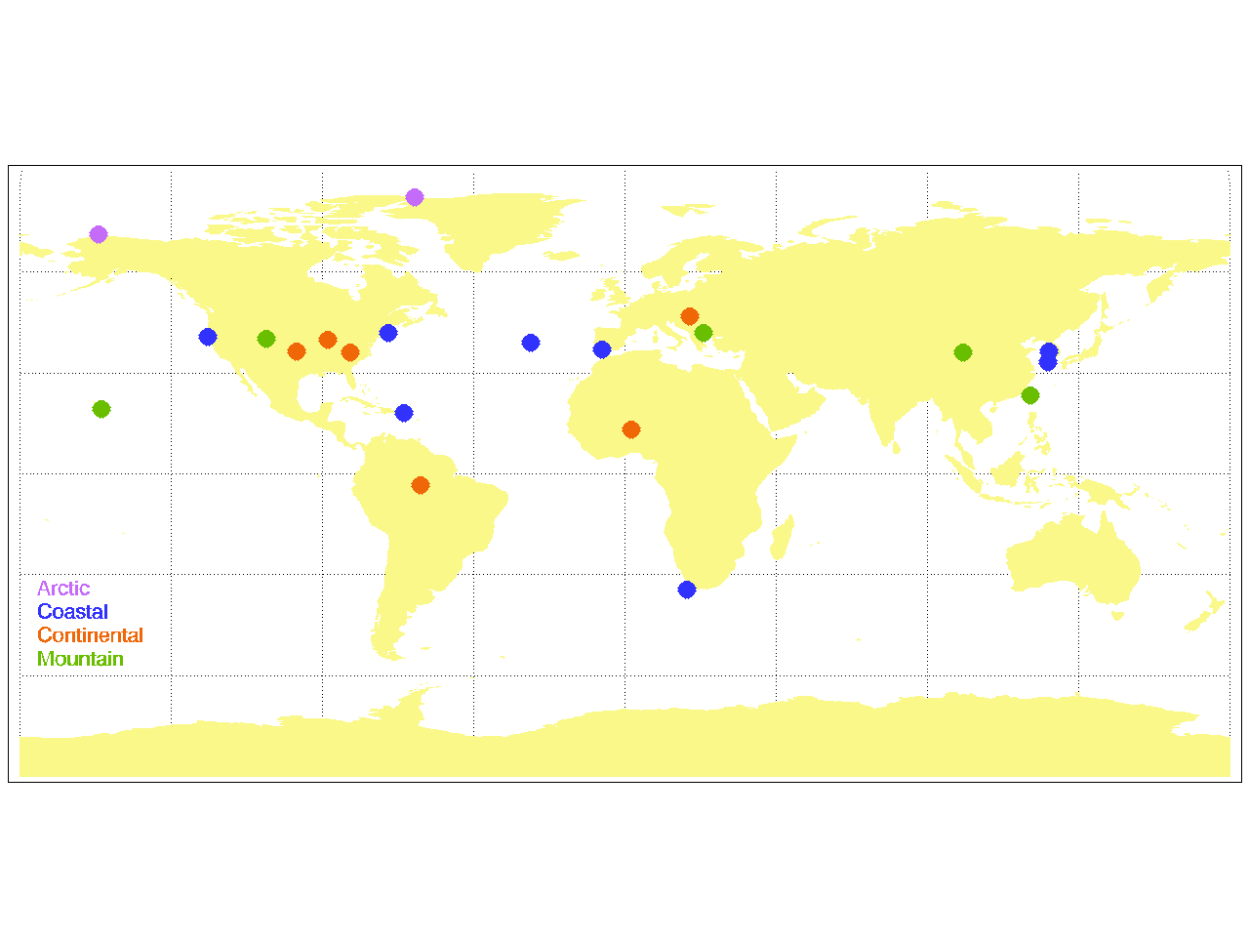
Figure 1. Map of in-situ sites, colored by site type. don’t separate into different types of sites?

The Level 2, hourly-averaged QA/QC’d data were downloaded from EBAS (add website, citation) and DOE/ARM (add website, citation) and underwent further review and interaction with the data providers as previous efforts involving multi-site analyses have shown external data review to be extremely helpful (e.g., Asmi et al., 2013; Collaud Coen et al 2013; Andrews et al., 2011).

The light scattering measurements at all sites were made by an integrating nephelometer (TSI model#3563). The TSI nephelometer is a spectral instrument (450, 550 and 700 nm) allowing the calculation of wavelength dependence of scattering. The TSI nephelometer data have been corrected for known instrument non-idealities (truncation, light source) using the Anderson and Ogren (1998) method.

The light absorption measurements were made using one of two spectral, filter-based instruments: the three-wavelength Particle Soot Absorption Photometer (PSAP, Radiance Research; wavelengths: 467, 530 and 660 nm) and/or the three-wavelength Continuous Light Absorption Photometer (CLAP, NOAA’s extended sampling time version of the PSAP; wavelengths: 467, 528 and 652 nm; Ogren et al., 2017). The PSAP and CLAP are corrected for scattering artifacts and other instrument non-idealities (e.g., Bond et al., 1999, Ogren et al., 2010). In order to keep the absorption data self-consistent (i.e., same correction scheme) aethalometer data were not used in this study.

These in-situ surface sites measure continuously – there are no downtimes because of lack of sun or cloudy conditions as one would have for remote sensing instruments. This minimizes the need for temporal matching (Schutgens reference). There can however be gaps due to instrument failures, although these are relatively rare. We only compare the annual data points if the in-situ data represents at least XX% of the year.

2.3 Calculated aerosol parameters
From the model values of aerosol absorption and extinction and measured values of aerosol absorption and scattering additional non-dimensional parameters can be calculated. First, for the model data, aerosol scattering is calculated by subtracting absorption from extinction so that the same aerosol variables (spectral absorption and spectral scattering) are available for both models and measurements. Then three non-dimensional parameters are calculated for both model and measurement data: the scattering Angstrom exponent (scattering AE (SAE)), the absorption Angstrom exponent (absorption AE (AAE)) and the single scattering albedo (SSA):

(1) xAE = log(σ₁/σ₂)/log(λ₂/ λ₁)
and
(2) SSA = σ_{sp,i}/(σ_{sp,i} + σ_{ap,i})

where x in equation 1 represents S or A for scattering or absorption, respectively. σ is the aerosol light scattering (subscript ‘sp’) or absorption (subscript ‘ap’) at wavelength i (λ_{i}). The in-situ scattering and absorption data are adjusted via Angstrom exponent interpolation to match the model output wavelengths of 440 and 550 nm; the SAE and AAE presented here are for the 440/550 nm wavelength pair.

SAE is a proxy for aerosol particle size. Larger SAE values (SAE ≥ 2) indicate that there is more scattering contribution from sub-micrometer particles while smaller SAE values (SAE<1.5) indicate larger particles (>1 μm) have a greater contribution to the observed light scattering (reference). AAE has been used as an indicator of particle composition/type (references) although it is also a function of aerosol size (REF). The SSA is another indicator of aerosol composition, providing information on the contribution of aerosol absorption to aerosol extinction. Values of SSA close to unity represent a primarily scattering aerosol (little to no absorption) while decreasing values of SSA indicate relatively more absorption is contributing to extinction. The single scattering albedo of black carbon is approximately 0.3 (reference).

2.4 Merging of model and measurement
In order to compare measurements with models, the simulated values from the model gridpoint closest to each site was chosen to compare with the measurements (same as Eckhardt et al., 2015). The models used in this analysis employ a wide range of spatial gridding (see Table 1), meaning the subgrid model variability is likely a limitation of this analysis. Wang et al. (2018) suggest that for absorbing aerosol, GAW sites (which encompasses the NFAN sites used in this analysis) should typically provide quite representative data over across a large range of spatial scales.

The in-situ data may consist of ~1 year to more than 15 years of data, while the models have provided output for only 1 year (either 2008 or 2010, see Table X). Based on evaluation of the available multi-year in-situ datasets, the discrepancies between the models and measurements tend to be larger than the observed year-to-year variability for the sites where we have multi-year data sets. This may not be true for all sites, but for simplicity (and due to the available model output) we’ve chosen to ignore this potential source of error in the model/measurement comparisons. Figure SX in supplemental materials provides a timeline for all of the sites in one figure and Table SX gives the dates the various sites operated.

3. Results
    - SAE vs SSA
Figure 2 shows the relationship between single scattering albedo and scattering Angstrom exponent for the measurements (Fig. 2a) and for the 8 models (Figs 2b-i). The data points in Figure 2 are color-coded by a simple descriptor of site ‘type’, e.g., (Arctic, coastal (clean and polluted coastal sites both have this designation), continental and mountain (which are just high elevation sites)). There are some clear similarities amongst the observations and model output. First, there is a general trend of increasing SAE (increasing amounts of smaller particles) with decreasing SSA (larger contribution from more absorbing aerosol). Second, both the observations and models show that Arctic and coastal sites tend to have whiter, larger particles (higher SSA, lower SAE) while continental sites are the opposite. The mountain sites tend to cluster with the continental sites which is consistent with those sites being influenced by continental aerosol. The differences amongst the observations and models are primarily discrepancies in the SSA with many of the models simulating a significantly wider range of SSA than is reported by the observations. Less obviously, the simulated SAE suggests larger particles (lower SAE) than derived from the measurements of spectral aerosol scattering.

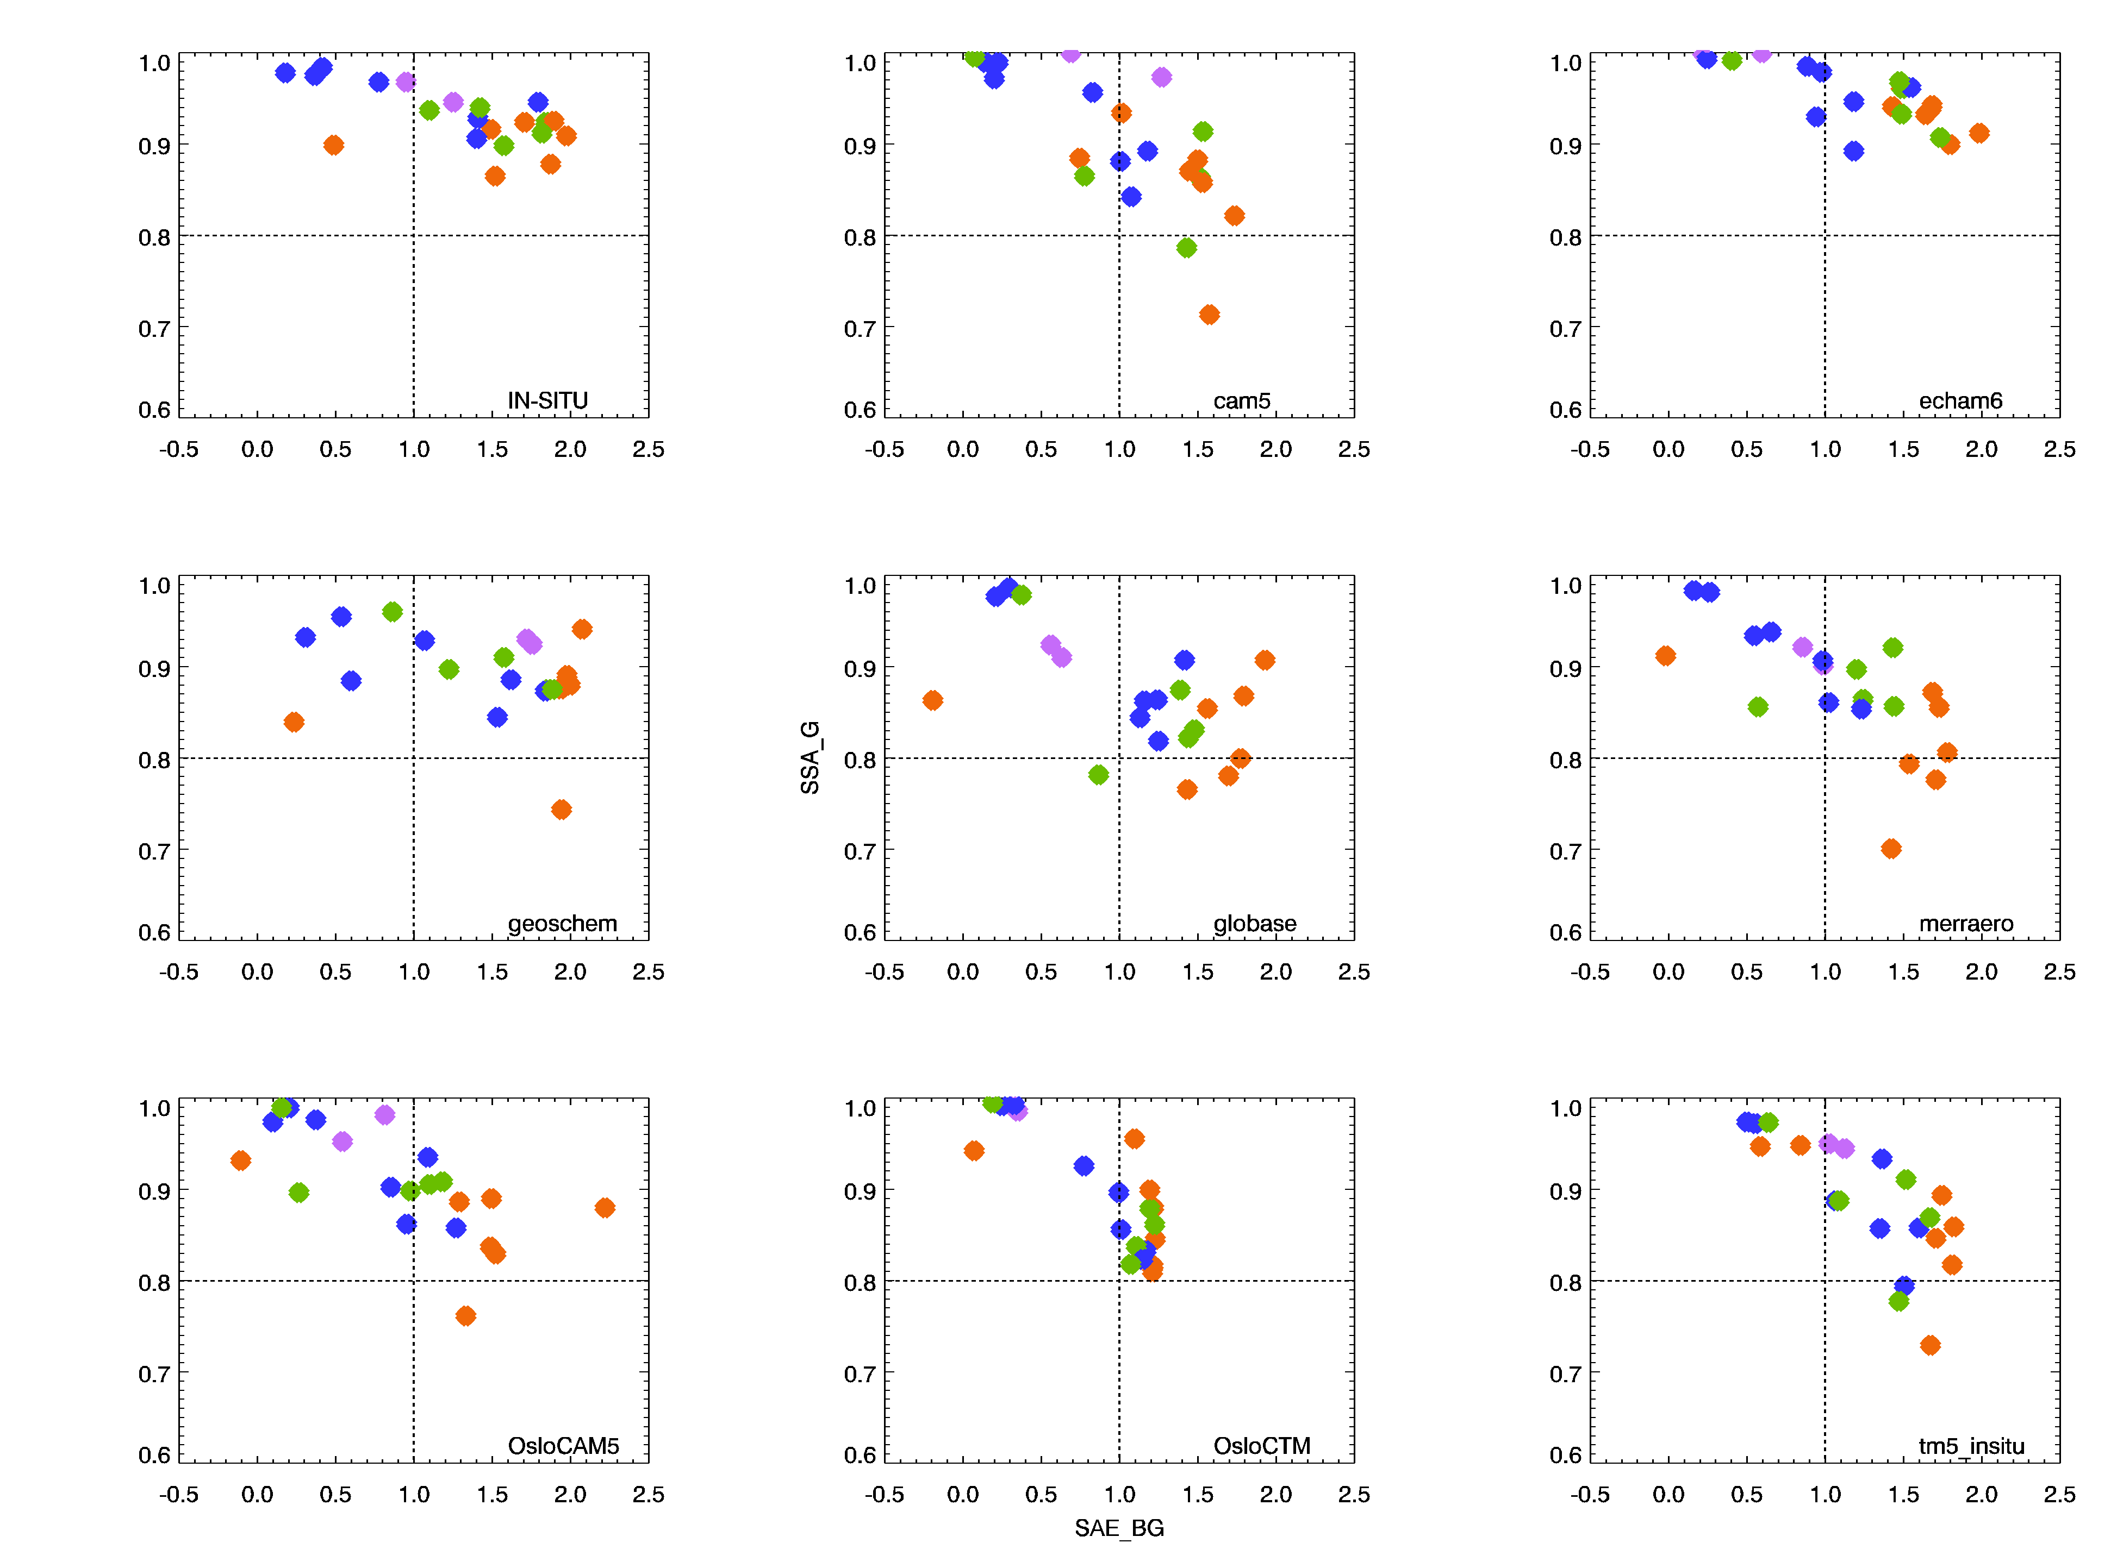
Figure 2 Annual median values of single scattering albedo (at 550 nm) versus scattering Angstrom exponent (440/550 nm wavelength pair). Blue = coastal sites, purple = polar sites, green = mountain sites, orange = continental sites. In-situ measurement data is plot in upper left, remaining plots are for the various models. Need to put letter labels on plots! fix y-axis label so on geoschem plot. Spell out variables for axis labels

    - AAE vs SAE
Figure 3 is similar to Figure 2 but shows the relationship between the scattering Angstrom exponent and the absorption Angstrom exponent. This figure shows that, in addition to there being discrepancies between the observations and models, there are also significant differences amongst the model simulations. Some of the models reproduce the relatively flat AAE with SSA obtained from the measurements, although they do not capture the observed variability. Some of the models simulate a tendency of AAE to decrease as SAE increases, while one model simulates the opposite trend. Compare/mention with lauren’s paper (Schmeisser et al., 2017)
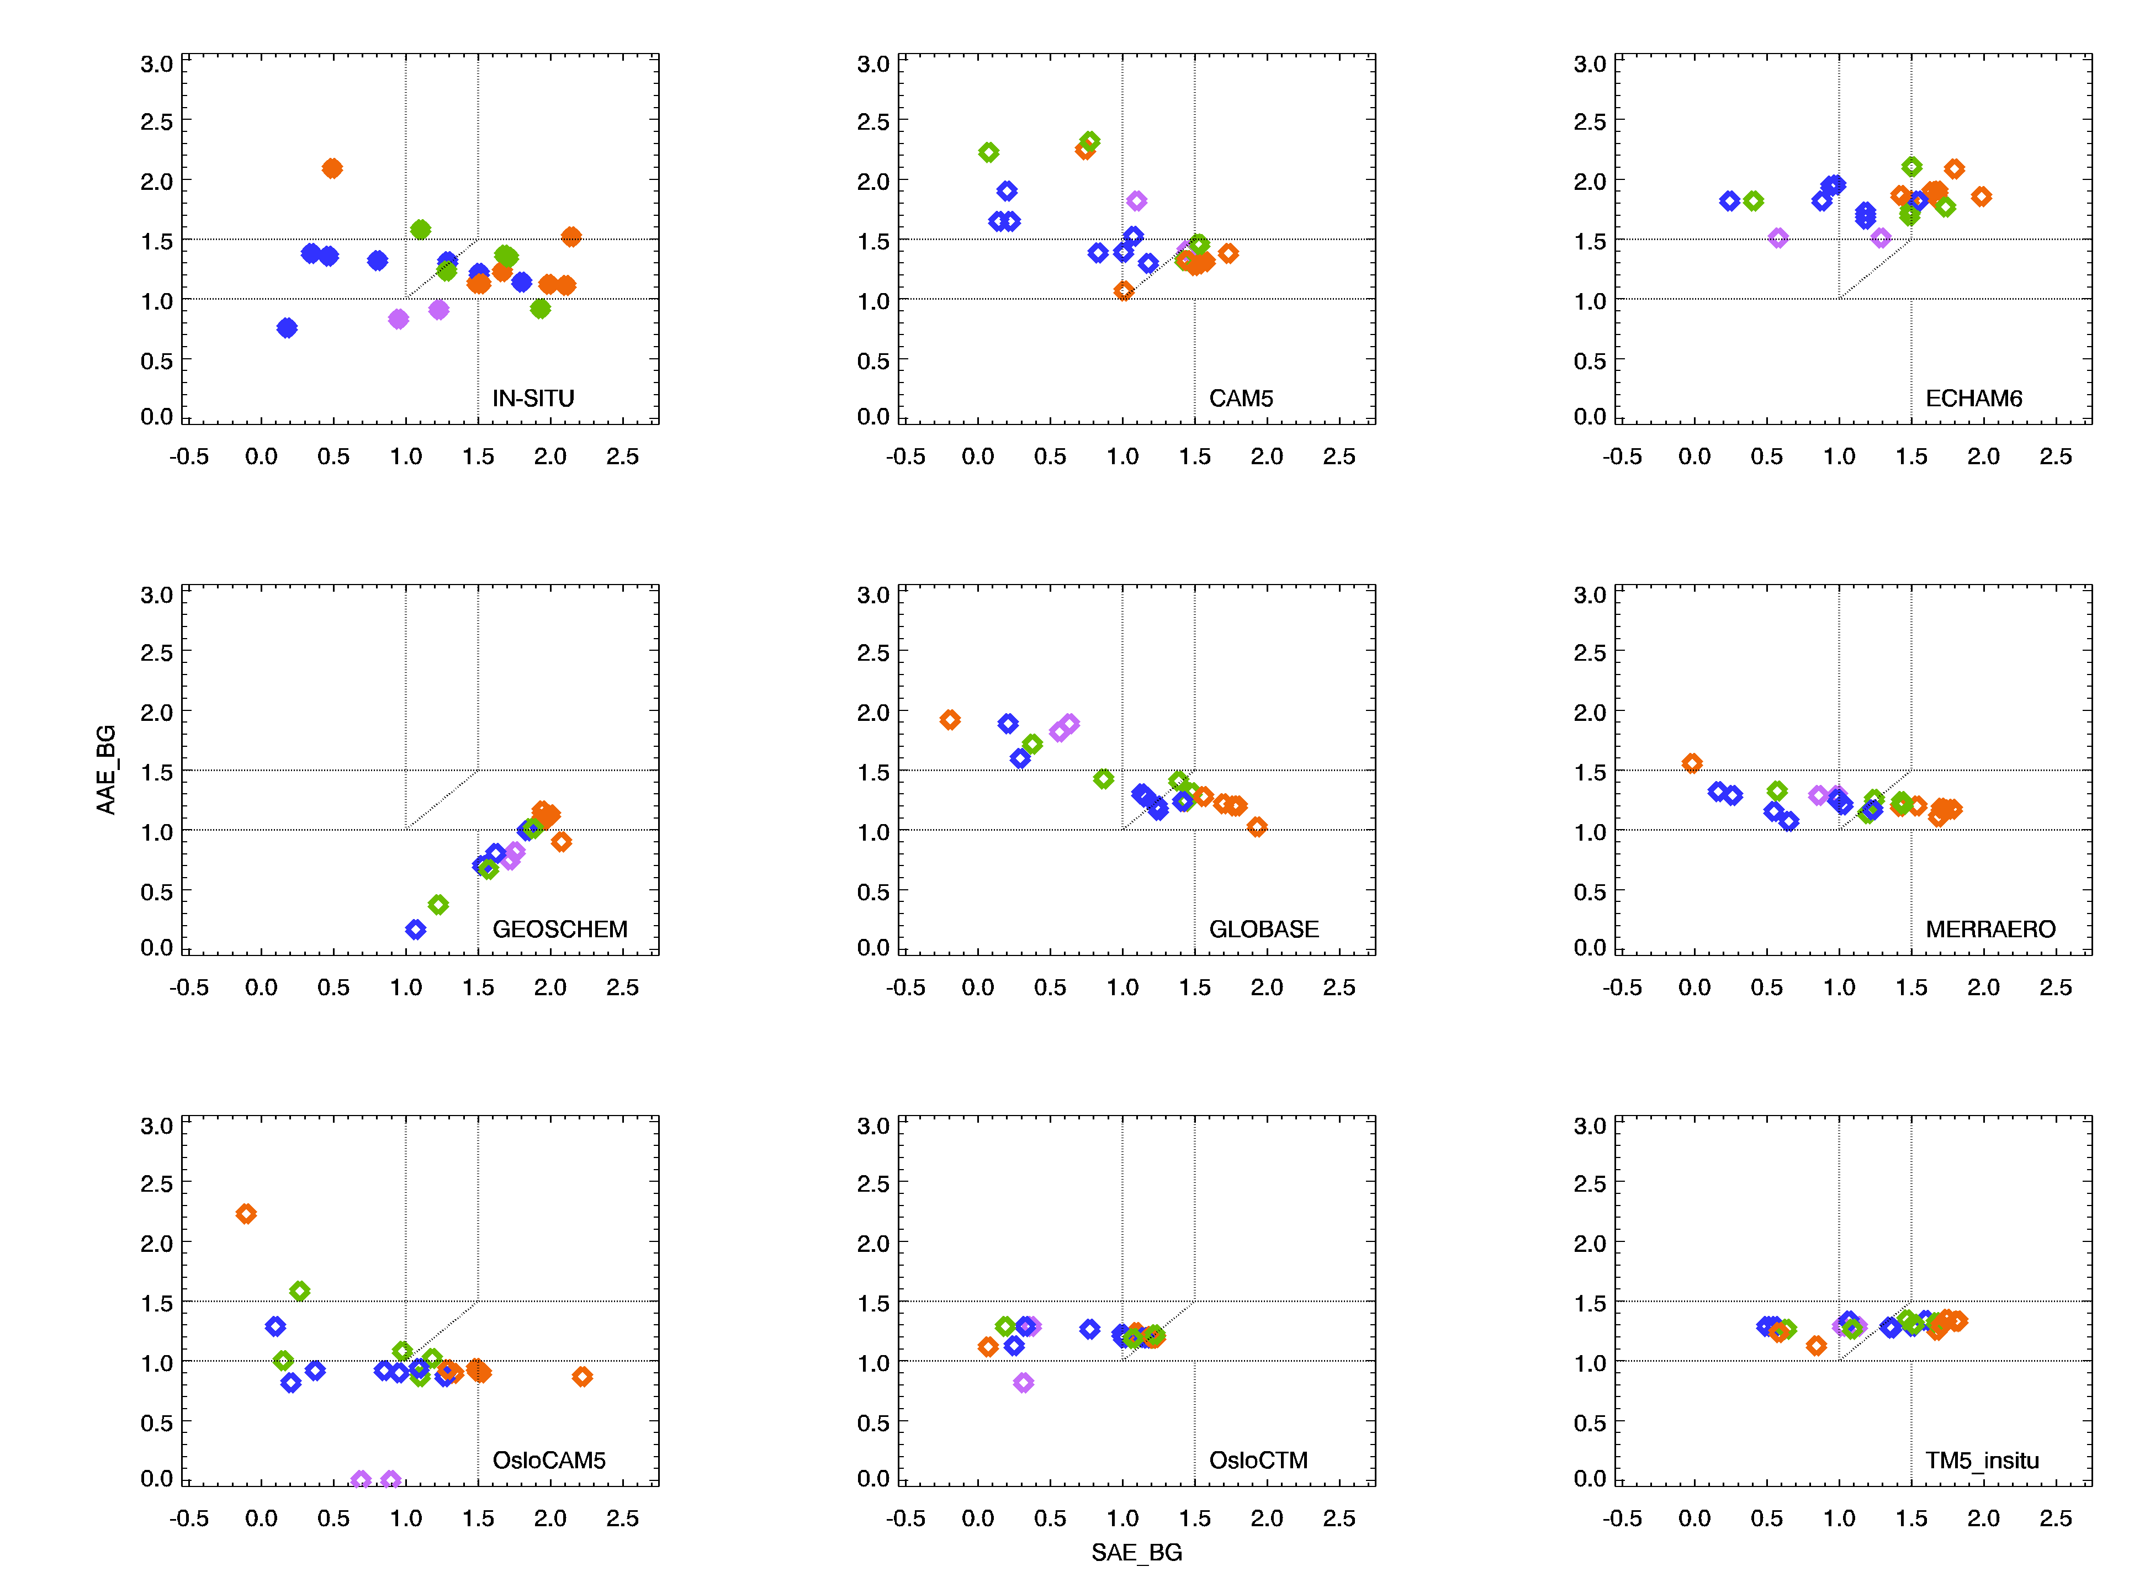
Figure 3 Annual median values of absorption Angstrom exponent vs scattering Angstrom exponent (440/550nm wavelength pair for both variables). Dashed lines on plot correspond to different composition categories defined by XXX

    - AAE vs SSA
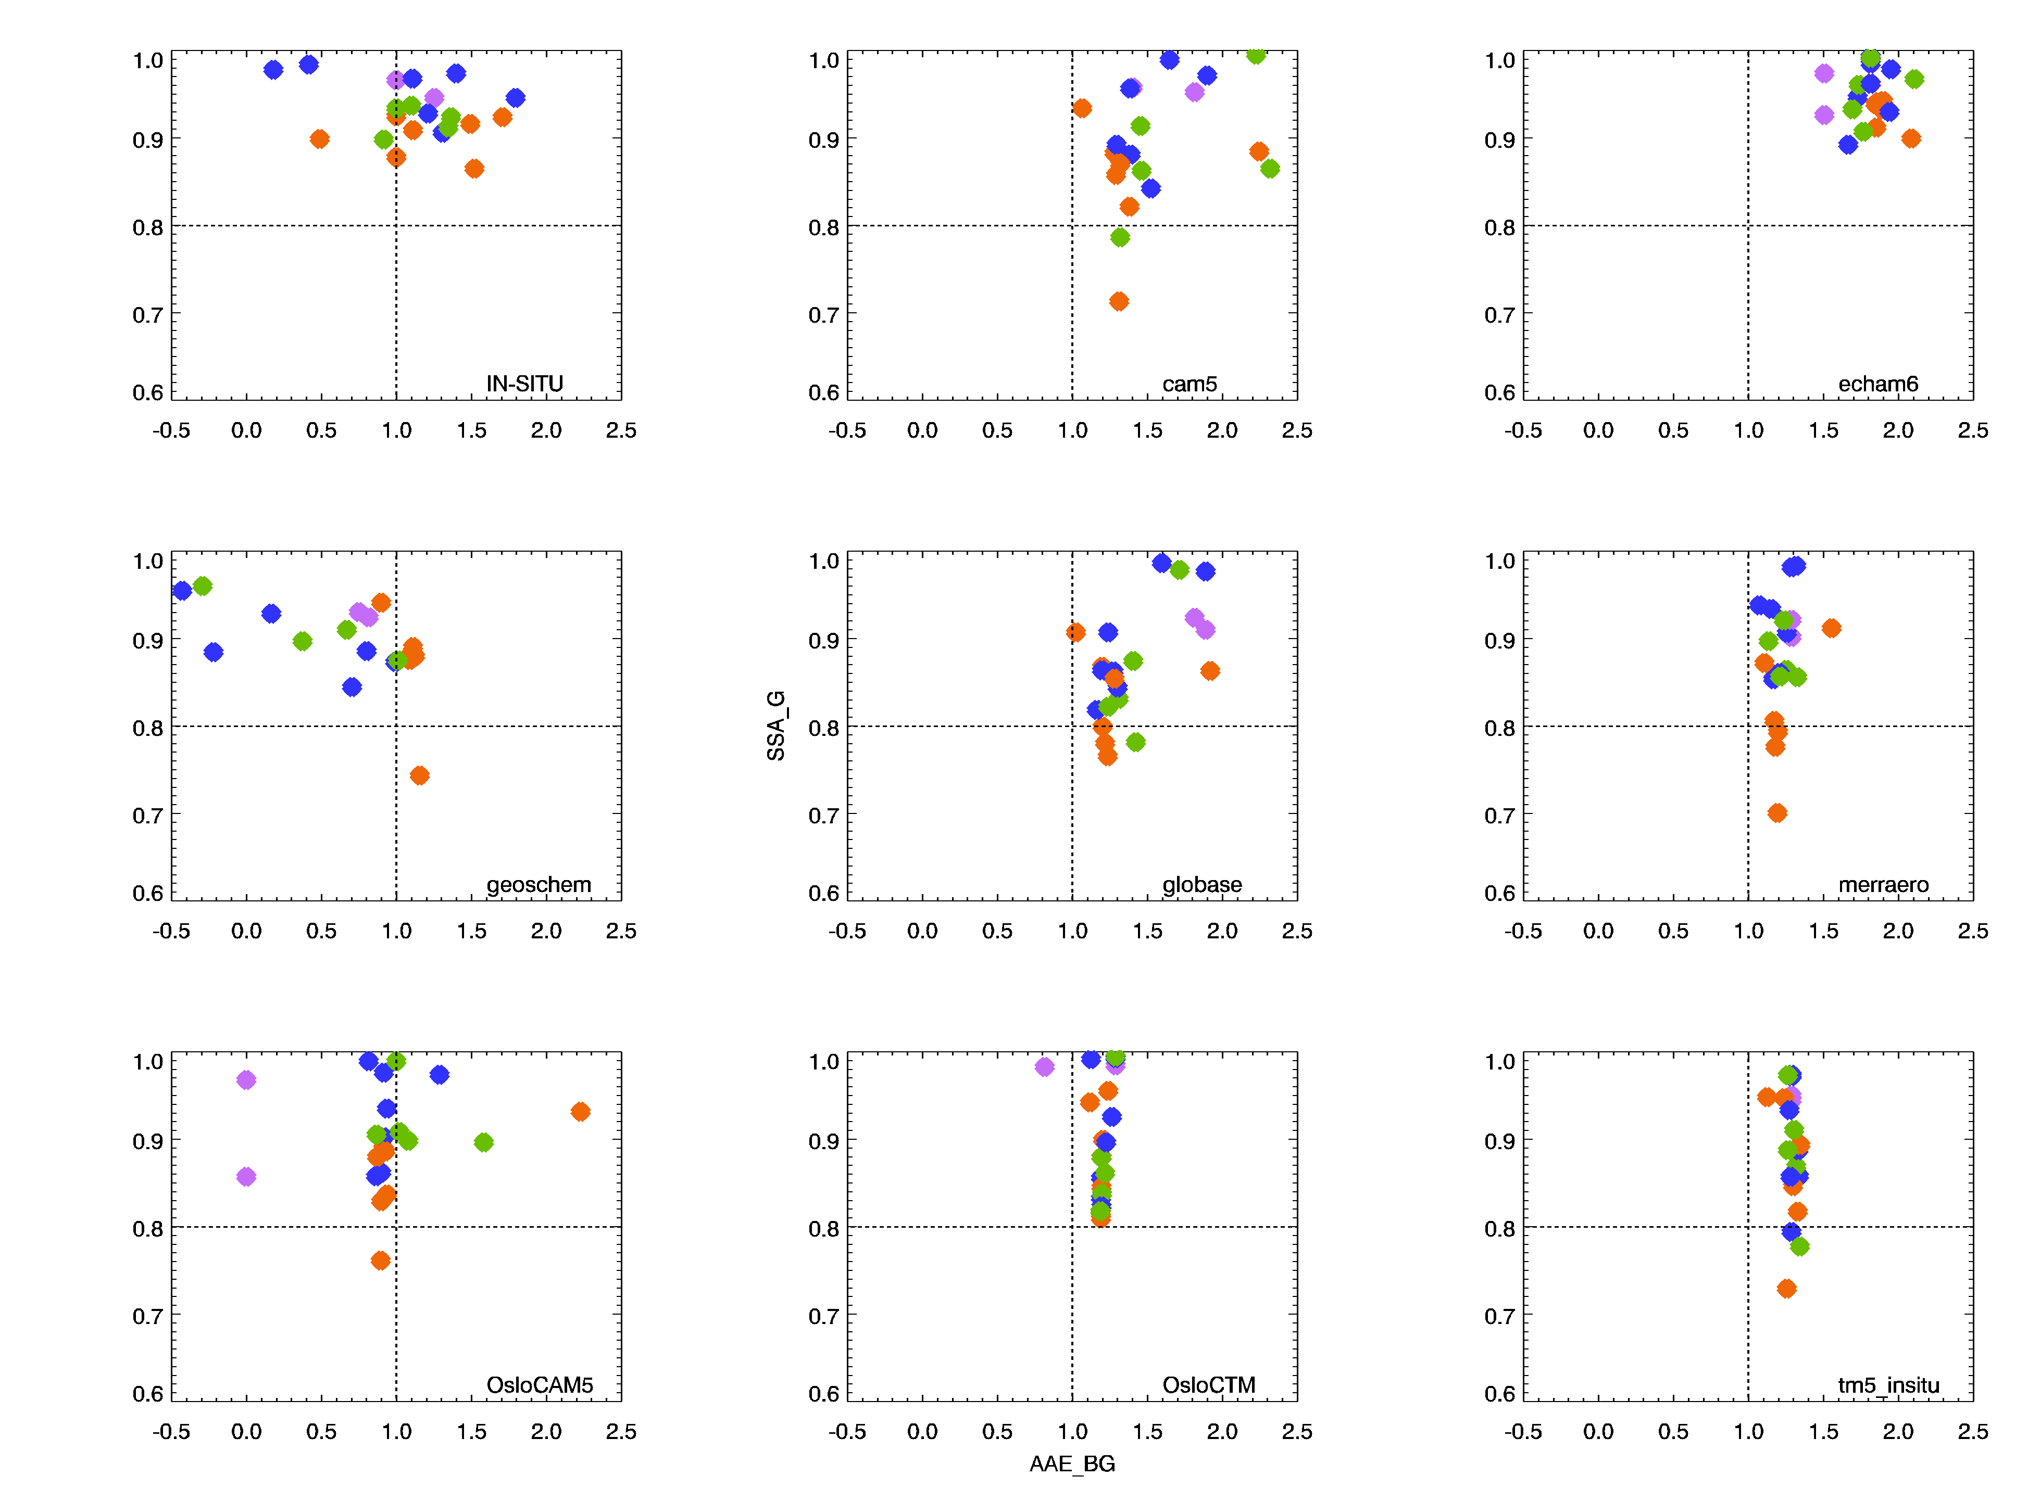
Figure 4 Annual median values of absorption Angstrom exponent vs single scattering albedo (440/550 nm wavelength pair for AAE, 550 nm for SSA)

    - XY plots of SSA, SAE (and AAE?) is this needed?? Or save for climatology paper?
Figure 5 shows model vs measurement scatter plots of the three parameters (SSA, SAE and AAE)
Perhaps this figure should be before the sys var figures if included here.

4. Discussion
- What is dry – is observation SSA > model SSA because of water associated with the not completely dry observational data?
- Is observation SAE < model SAE because of measurement size cut (typically <10um, but at a few sites <1um?)
- How do models deal with spectral dependence of absorption?
- Connor’s poster suggested significant differences between virkkula and bond correction (virkkula AAE>bond AAE)

5. Conclusions

6. References

Anderson, T. L., Ogren, J.A., “Determining aerosol radiative properties using the TSI 3563 integrating nephelometer,” Aerosol Sci. Technol., 29, 57– 59, 1998.
Andrews, E., Ogren, J.A., Kinne, S., Samset, B., "Comparison of AOD, AAOD and column single scattering albedo from AERONET retrievals and in situ profiling measurements," Atmos. Chem. Phys., 17, 6041-6072, 2017.
Andrews, E., Ogren, J.A., Bonasoni, P., Marinoni, A., Cuevas, E., Rodriguez, S., Sun, J.Y., Jaffe, D.A., Fischer, E.V., Baltensperger, U., Weingartner, E., Collaud Coen, M., Sharma, S., Macdonald, A.M., Leaitch, W.R., Lin, N.-H., Laj, P., Arsov, T., Kalapov, I., Jefferson, A., Sheridan, P.J., “Climatology of aerosol radiative properties in the free troposphere”, Atmospheric Research, 102, 365-393, 2011.
Andrews et al., "Climatology of aerosol radiative properties in the free troposphere", Atmospheric Research, 102, 365-393, 2011.
Asmi, A., Collaud Coen, M., Ogren, J.A., Andrews, E., Sheridan, P., Jefferson, A., Weingartner, E., Baltensperger, U., Bukowiecki, N., Lihavainen, H., Kivekäs, N., Asmi, E., Aalto, P.P., Kulmala, M., Wiedensohler, A., Birmili, W., Hamed, A., O'Dowd, C., Jennings, S.G., Weller, R., Flentje, H., Mari Fjaeraa, A., Fiebig, M., Lund Myhre, C., Hallar, A.G., and Laj,P., “Aerosol decadal trends – Part 2: In-situ aerosol particle number concentrations at GAW and ACTRIS stations,” Atmos. Chem. Phys., 13, 895-916, 2013.
Bond, T. C., Anderson, T. L., and Campbell, D.: Calibration and intercomparison of filter-based measurements of visible light absorption by aerosols, Aerosol Sci. Technol., 30, 582–600, doi:10.1080/027868299304435, 1999.
Collaud-Coen, M., Andrews, E., Asmi, A., Baltensperger, U., Bukowiecki, N., Day, D., Fiebig, M., Fjaeraa, A.M., Flentje, H., Hyvärinen, A., Jefferson, A., Jennings, S.G., Kouvarakis, G., Lihavainen, H., Lund Myhre, C., Malm, W.C., Mihapopoulos, N., Molenar, J.V., O'Dowd, C., Ogren, J.A., Schichtel, B.A., Sheridan, P., Virkkula, A., Weingartner, E., Weller, R., and Laj, P.,” Aerosol decadal trends – Part 1: In-situ optical measurements at GAW and IMPROVE stations,” Atmos. Chem. Phys., 13, 869-894, 2013.
Breider, T. J., et al. "Annual distributions and sources of Arctic aerosol components, aerosol optical depth, and aerosol absorption." Journal of Geophysical Research: Atmospheres 119.7 (2014): 4107-4124. {Model measurement comparisons of aerosols and ozone in the Arctic}
Delene, D. J. and Ogren, J. A., “Variability of aerosol optical properties at four North American surface monitoring sites,” J. Atmos. Sci., 59, 1135–1150, 2002.
Eckhardt, S., et al., “Current model capabilities for simulating black carbon and sulfate concentrations in the Arctic atmosphere: a multi-model evaluation using a comprehensive measurement data set,” Atmos. Chem. Phys., 15, 9413–9433, 2015.
Ginoux, P., Horowitz, L. W., Ramaswamy, V., Geogdzhayev, I. V., Holben, B. N., Stenchikov, G., Tie, X., “Evaluation of aerosol distribution and optical depth in the Geophysical Fluid Dynamics Laboratory coupled model CM2.1 for present climate,” J. Geophys. Res., 111, doi:10.1029/2005JD006707, 2006.
WMO/GAW protocols reference

Glantz, Paul, et al. "Remote sensing of aerosols in the Arctic for an evaluation of global climate model simulations." Journal of Geophysical Research: Atmospheres 119.13 (2014): 8169-8188.{comparison between NorESM model and measurements at Zeppelin}

Huneeus et al., 2011 (dust);

IPCC, 2013: Climate Change 2013: The Physical Science Basis. Contribution of Working Group I to the Fifth Assessment Report of the Intergovernmental Panel on Climate Change, [Stocker, T.F., D. Qin, G.-K. Plattner, M. Tignor, S.K. Allen, J. Boschung, A. Nauels, Y. Xia, V. Bex and P.M. Midgley (eds.)]. Cambridge University Press, Cambridge, United Kingdom and New York, NY, USA, 1535 pp, doi:10.1017/CBO9781107415324.

Jiao et al., 2014 (arctic bc);
Kim et al., 2014
Kinne, S., et al., “An AeroCom initial assessment – optical properties in aerosol component modules of global models,” Atmos. Chem. Phys., 6, 1-20, 2006.
Koch, D., et al “Evaluation of black carbon estimations in global aerosol models,” Atmos. Chem. Phys., 9, 9001–9026, 2009. {highly cited paper about difficulty modeling BC in arctic (among other places), covered in Wang 2014}

Koffi et al., 2012

Lacagnina et al., 2015;
Mann et al., “Intercomparison and evaluation of global aerosol microphysical properties among AeroCom models of a range of complexity,” Atmos. Chem. Phys., 14, 4679–4713, 2014.
Myhre, G. et al., “Radiative forcing of the direct aerosol effect from AeroCom Phase II simulations,” Atmos. Chem. Phys., 13, 1853–1877, 2013.
Ogren, J. A., “Comment on “Calibration and Intercomparison of Filter-Based Measurements of Visible Light Absorption by Aerosols”, Aerosol Sci. Technol., 44, 589–591, doi:10.1080/02786826.2010.482111, 2010.
Ogren, J.A., Wendell, J., Andrews, E., and Sheridan, P., 2017: Continuous light absorption photometer for long-term studies, Atmos. Meas. Tech., 10, 4805-4818, https://doi.org/10.5194/amt-10-4805-201.

Pandolfi, M., Cusack, M., Alastuey, A., Querol, X., “Variability of aerosol optical properties in the Western Mediterranean Basin,” Atmos. Chem. Phys., 11, 8189–8203, 2011.
Petzold maap paper?
Samset et al., 2014 (BC);
Schutgens et al., 2016 comparing spatial/temporal consistent data sets
Schmeisser ACP 2017 paper about systematic variability
Sheridan et al. ACP 2012 AAO paper
Sheridan, P.J., Delene, D.J., and Ogren, J.A., “Four years of continuous surface aerosol measurements from the Department of Energy’s Atmospheric Radiation Measurement Program Southern Great Plains Cloud and Radiation Testbed site,” J. Geophys. Res., 106, 20735-20747, 2001.
Sherman, J.P., Sheridan, P.J., Ogren, J.A., Andrews, E., Hageman, D.C., Schmeisser, L., Jefferson, A., Sharma, A., “A multi-year study of lower tropospheric aerosol variability and systematic relationships from four North American regions,” Atmos. Chem. Phys., 15, 12487-12517, 2015.
Shindell, D. T., et al. "A multi-model assessment of pollution transport to the Arctic." Atmospheric Chemistry and Physics 8.17 (2008): 5353-5372.{Sensitivity of aerosol and gas concentrations in Arctic to changes in emissions using multiple models}
Tsigaridis, K. et al. “The AeroCom evaluation and intercomparison of organic aerosol in global models,” Atmos. Chem. Phys., 14, 10845–10895, 2014.
Virkkula PSAP papers (original and correction)
Wang, R., Andrews, E., Balkanski, Y., Boucher, Olivier, O., Myhre, G., Samset, B.H., Schulz, M., Schuster, G.L., Valari, M., Tao, S., ‘Spatial representativeness error in the ground-level observation networks for black carbon radiation absorption”, Geophys. Res. Lett., https://doi.org/10.1002/2017GL076817, 2018.
WMO/GAW, WMO/GAW Aerosol measurement procedures, guidelines and recoommendations, Report No 227, 2nd edition ed., World Meteorological Organization, Geneva, Switzerland, 2016.

Model papers in table 1 – need to sort and complete references
Bergman, T., Kerminen, V.-M., Korhonen, H., Lehtinen, K. J., Makkonen, R., Arola, A., Mielonen, T., Romakkaniemi, S., Kulmala, M., and Kokkola, H.: Evaluation of the sectional aerosol microphysics module SALSA implementation in ECHAM5-HAM aerosol-climate model, Geosci. Model Dev., 5, 845-868, doi:10.5194/gmd-5-845-2012, 2012.
Bey, I., D. J. Jacob, R. M. Yantosca, J. A. Logan, B. Field, A. M. Fiore, Q. Li, H. Liu, L. J. Mickley, and M. Schultz, Global modeling of tropospheric chemistry with assimilated meteorology: Model description and evaluation, J. Geophys. Res., 106, 23,073-23,096, 2001.
Buchard, V., and Coauthors, 2015: Using the OMI aerosol index and absorption aerosol optical depth to evaluate the NASA MERRA Aerosol Reanalysis. Atmospheric Chemistry and Physics, 15 (10), 5743–5760, doi:10.5194/acp-15-5743-2015.
Buchard, V., and Coauthors, 2016a: Evaluation of the surface PM2.5 in Version 1 of the NASA MERRA Aerosol Reanalysis over the United States. Atmospheric Environment, 125, 100–111, doi:10.1016/j.atmosenv.2015.11.004.
Chin, M., P. Ginoux, S. Kinne, O. Torres, B. N. Holben, B. N. Duncan, et al., Tropospheric aerosol optical thickness from the GOCART model and comparisons with satellite and sun photometer measurements, J. Atmos. Sci., 59, 461–483, 2002.
Chin, M., T. Diehl, Q. Tian, J. M. Prospero, R. A. Kahn, A. Remer, H. Yu, A. M. Sayer, H. Bian, et al., Multi-decadal variations of atmospheric aerosols from 1980 to 2009: sources and regional trends, Atmos. Chem. Phys., 14, 3657-3690, doi:10.5194/acp-14-3657-2014, 2014.
Chin, M., T. Diehl, O. Dubovik, T. F. Eck, B. N. Holben, A. Sinyuk, and D. G. Streets, Light absorption by pollution, dust and biomass burning aerosols: A global model study and evaluation with AERONET data, Ann. Geophys., 27, 3439-3464, 2009.
Colarco, P. R., A. da Silva, M. Chin, T. Diehl: Online simulations of global aerosol distributions in the NASA GEOS-4 model and comparisons to satellite and ground-based aerosol optical depth, J. Geophys. Res., 115, D14207, doi:10.1029/2009JD012820, 2010.
S. J. Ghan, X. Liu, R. C. Easter, R. Zaveri, P. J. Rasch, J.-H. Yoon, and B. Eaton, 2012: Toward a Minimal Representation of Aerosols in Climate Models: Comparative Decomposition of Aerosol Direct, Semidirect, and Indirect Radiative Forcing. J. Climate, 25, 6461–6476, doi: 10.1175/JCLI-D-11-00650.1.
Laakso, A., Kokkola, H., Partanen, A.-I., Niemeier, U., Timmreck, C., Lehtinen, K. E. J., Hakkarainen, H., and Korhonen, H.: Radiative and climate impacts of a large volcanic eruption during stratospheric sulfur geoengineering, Atmos. Chem. Phys., 16, 305-323, doi:10.5194/acp-16-305-2016, 2016.
Liu, X., Easter, R. C., Ghan, S. J., Zaveri, R., Rasch, P., Shi, X., Lamarque, J.-F., Gettelman, A., Morrison, H., Vitt, F., Conley, A., Park, S., Neale, R., Hannay, C., Ekman, A. M. L., Hess, P., Mahowald, N., Collins, W., Iacono, M. J., Bretherton, C. S., Flanner, M. G., and Mitchell, D.: Toward a minimal representation of aerosols in climate models: description and evaluation in the Community Atmosphere Model CAM5, Geosci. Model Dev., 5, 709-739, doi:10.5194/gmd-5-709-2012, 2012.
Myhre, G., et al. (2013), Radiative forcing of the direct aerosol effect from AeroCom Phase II simulations, Atmos. Chem. Phys., 13(4), 1853-1877
Skeie, R. B., et al. (2011), Anthropogenic radiative forcing time series from pre-industrial times until 2010, Atmos. Chem. Phys., 11(22), 11827-11857.
Takemura, T., T. Nozawa, S. Emori, T. Y. Nakajima, and T. Nakajima, 2005: Simulation of climate response to aerosol direct and indirect effects with aerosol transport-radiation model. J. Geophys. Res., 110, D02202, doi:10.1029/2004JD005029.
Van Noije et al., Simulation of tropospheric chemistry and aerosols with the climate model EC-Earth, Geosci. Model Dev., 2014

Appendix - Supplementary Materials
Table S1. List of sites used in this study
Station ID  Station name  ‘Type’ | Country  Lat Long Elev (m asl) | Instruments (dates)
ALT  Alert  ‘Polar’ | Canada  82.45 N, 62.52 W, 210 | TSI neph  PSAP-3w  CLAP-3w
AMY  Anmyeon-do  ‘coastal’ | South Korea  36.54 N, 126.33 E, 46 | TSI neph  PSAP-3w  CLAP-3w
APP  Appalachian State  ‘continental’ | USA  36.21 N, 81.69 W, 1100 | TSI neph  PSAP-3w  CLAP-3w
ARN  El Arenosillo  ‘coastal’ | Spain  37.10 N, 6.73 W, 41 | TSI neph  CLAP-3w
BEO  BEO-Moussala  ‘mountain’ | Bulgaria  42.18 N, 23.59 E, 2925 | TSI neph  CLAP-3w
BND  Bondville  ‘continental’ | USA  40.05 N, 88.37 W, 230 | TSI neph  PSAP-3w  CLAP-3w
BRW  Barrow  ‘polar’ | USA  71.32 N, 156.61 W, 11 | TSI neph  PSAP-3w  CLAP-3w
CPR  Cape San Juan  ‘coastal’ | USA (Puerto Rico)  18.38 N, 65.62 W, 17 | TSI neph  PSAP-3w  CLAP-3w
CPT  Cape Point  ‘coastal’ | South Africa  34.35 S, 18.49 E, 230 | TSI neph  PSAP-3w  CLAP-3w
GSN  Gosan  ‘coastal’ | South Korea  33.28 N, 126.17 E, 72 | TSI neph  PSAP-3w  CLAP-3w
GRW  Graciosa  ‘coastal’ | Portugal (Azores)  39.08 N, 28.03 W, 15 | TSI neph (4/2009 – 12/2010)  PSAP-3w  CLAP-3w
KPS  K-puszta  ‘continental’ | Hungary  46.97 N, 19.58 E, 125 | TSI neph  PSAP-3w  CLAP-3w
LLN  Mt. Lulin  ‘mountain’ | Taiwan  23.47 N, 120.87 E, 2862 | TSI neph  PSAP-3w  CLAP-3w
MAN  Manacapuro  ‘continental’ | Brazil  3.21 S, 60.59 W, 50 | TSI neph (12/2013 – 12/2015)  PSAP-3w  CLAP-3w
MLO  Mauna Loa  ‘mountain’ | USA  19.53 N, 155.58 W, 3397 | TSI neph  PSAP-3w  CLAP-3w
NIM  Niamey  ‘continental’ | Niger  13.47 N, 2.17 E, 205 | TSI neph (12/2005 – 12/2006)  PSAP-3w
PVC  Cape Cod  ‘coastal’ | USA  42.07 N, 70.20 W, 1 | TSI neph (7/2012 – 6/2013)  PSAP-3w  CLAP-3w
SGP  Southern Great Plains  ‘continental’ | USA  36.60 N, 97.50 W, 315 | TSI neph  PSAP-3w  CLAP-3w
SPL  Storm Peak  ‘mountain’ | USA  40.46 N, 106.74 W, 3220 | TSI neph  PSAP-3w  CLAP-3w
THD  Trinidad Head  ‘coastal’ | USA  41.05 N, 124.15 W, 107 | TSI neph  PSAP-3w  CLAP-3w
WLG  Mt Waliguan  ‘mountain’ | China  36.28 N, 100.90 E, 3810 | TSI neph  PSAP-3w

