REQUIRED CONSTITUENT PARTS OF A PROPOSAL
(in order of assembly)
Proposal Cover Page
"Development and Assessment of Airborne Methods for Megacity Carbon Emission Flux Measurements"

Proposal Summary (abstract)

We propose airborne measurement campaigns in Indianapolis and Los Angeles designed to test and refine a simple mass balance approach to quantify CO₂ and CH₄ emissions from urban environments. These experiments focus on the joint deployment of the ALAR and CARVE platforms in each city to exploit their unique measurement capabilities and understand the benefits of different measurement and sampling strategies. The ALAR platform is able to measure CO₂ and CH₄ fluxes directly within the urban dome, while the CARVE platform delivers column CO₂, CH₄ and CO measurements that provide important constraints on mass flow within, into and out of the urban dome.
The first campaign will consist of six flight days (~24 flight hours) over a 10-day period in Indianapolis in Fall 2012. This campaign leverages the extensive ground and airborne measurements infrastructure already deployed by the NIST-sponsored INFLUX experiment. This campaign will also take advantage of the comparatively simple nature of the Indianapolis measurement problem. The urban area has well defined rectangular boundaries ~30 km on a side. It is isolated within a large agricultural region having relatively flat topography and no nearby interference from other anthropogenic sources, making it appear like a mesoscale point source with a downwind plume. The timing of the campaign minimizes the influence of biological sources and sinks. We also exploit the planned addition of a TCCON (Total Column Carbon Observing Network) ground-based solar-viewing Fourier transform spectrometer to the INFLUX experiment by NASA in summer 2012 and will use this as ground truth for the CARVE airborne column measurements.
A second campaign of six flight days (~24 flight hours) over a 10-day period in Los Angeles in Spring 2013 is also planned. The Los Angeles experiment will leverage existing NASA ground-based remote sensing assets – the TCCON FTS at Caltech and the CLARS spectrometer on Mt. Wilson – as well as expanded surface in situ sampling sites planned for summer 2012 installation under NIST and California Air Resources Board sponsorship. The scale and complexities of the Los Angeles megacity present a significant measurement challenge and it is unclear whether the simple mass balance methodologies and measurement strategies developed for Indianapolis will translate to the Los Angeles environment. The Los Angeles urban domain is an irregularly shaped conglomerate of municipalities ~100 km in size and ringed by coastal mountain ranges. Daily meteorology is dominated by offshore coastal airflow early in the day, and the formation of a well-mixed urban dome in the middle of the day. Anthropogenic CO₂ emissions are dominated by transportation, and there is large uncertainty regarding the size and source of anthropogenic CH₄ emissions. The timing of the Los Angeles campaign minimizes the impact of biological activity and time series measurements from within the basin suggest the high probability of at least one episode of surface CO₂ concentrations >500 ppm during the 10-day campaign.
We will test the hypothesis that when combined with suitable ground measurements aircraft measurements are unique in their ability to provide the necessary constraints for taking a simple mass balance approach to top-down flux estimate of CO₂ and CH₄This work benefits NASA’s ACOS, OCO-2, OCO-3 and ASCENDS missions by investigating solutions for validating space-based measurements of column CO₂ enhancements in urban domains. It also complements the CMS flux project by providing detailed, high spatial and temporal resolution sub-grid scale fluxes that can be used to validate the regional/urban fluxes calculated from global inversions of sparse satellite and sub-orbital data.

Table of Contents

Development and Assessment of Airborne Methods for
Megacity Carbon Emission Flux Measurements

A. Technical Proposal .......................................................................................................... A-1
A.1 Introduction ................................................................................................................ A-X etc
A.2 Objectives and expected significance of the proposed Research ............................... 1-1
A.3 Research Flight Platforms ....................................................................................... 1-2
A.4 Experimental Plan …………………………………………………….................... 1-8
A.5 Connections to GOSAT, OCO-2, and other satellite retrieval data sets ………..... A-X
A.6. Plan of Work, with Timeline……………............................................................ A-X
A.7 Project Management .................................................................................................. 1-15

B. References and Citations..............................................................................................B1 - BXX

C. Biographical Sketches ............................................................................................................ 3-1

D. Current and Pending Support ............................................................................................... 4-14

E. Statement of Commitment and Letters of Support ................................................................ 5-9

F. Budget Narrative ................................................................................................................ 6-9.

A. Technical Proposal
A.1. Introduction
The development of public policies for management of climate change through management
of the sources (and sinks) of greenhouse gases requires a reliable accounting of the current global distribution of sources and sinks. The key components of the Earth’s greenhouse effect are CO₂ and CH₄, because CO₂ is the current main driver of change (Lacis et al., 2010), and/or both CO₂ and CH₄ are components of the Earth system with reservoir feedstocks (e.g. soil and plant carbon, permafrost, methane hydrates; Cox et al., 2000, McGuire et al., 2009, Serreze and Barry, 2011) that can represent positive climate system feedbacks. There is a pressing need to better quantify GHG sources and sinks, in light of the record increase in emission rates for CO₂ (Peters et al., 2012), and the very long (thousands of years) environmental lifetime for CO₂ (Eby et al., 2009; Archer et al., 2009). There is thus a great need for development of methods that provide accurate fluxes for these species. On small scales (~ 1 km) the eddy covariance method has proven very effective (e.g., Goulden et al., 1996; Dragoni et al., 2011). There is also an urgent need for flux measurements on scales from urban (~10 km) to regional, state and national scales (100 – 1000 km) to support policy development and treaty verification (Sarmiento et al., 2010). Additionally, there is a pressing technical need for flux measurements on scales that are directly comparable to those of individual satellite-based soundings (Morino et al., 2011; Butz et al., 2011).
While space-based column CO₂ and CH₄ measurements have been compared favorably with surface-based measurements for isolated validation sites (e.g. TCCON; Morino et al., 2011; Butz et al., 2011; Wunch et al., 2011), the derivation of surface fluxes is much more challenging. Kort et al. (2012) used GOSAT measurements to detect CO₂ enhancements of 3.5 ± 1.5 ppm over Los Angeles, consistent with the daily increases observed by Wunch et al. (2009); however, there is no proven method for evaluating space-based measurements of enhanced CO₂ distribution in and around urban domes with in-situ measurements. The development of such methods is required to enable OCO-2, OCO-3 and ASCENDS to achieve their mission objectives.
Over the last decade the state-of-the-art approach for flux estimation has relied heavily on boundary layer measurements and the inferred flux based on inverse estimates which use high resolution transport to infer air mass mixing and advection over the region of interest. These studies have been applied to studies like the Mid-Continent Intensive where a ring of towers provides the in-situ measurements and other models provide background concentrations (e.g. Lauvaux, 2012). Because these inverse methods are heavily influenced by inferred background values of the tracer of interest and prior fluxes used as a first guess in the inversion, it is difficult to verify how sensitive the methods are to the data as opposed to the transport, priors and background concentration estimates.
Recent advances in the precision and stability used for greenhouse gas and isotope ratio measurements (Zare et al., 2009; Chen et al., 2010) using both in-situ instruments and Fourier transform spectrometers (ref) have open the door to experimental methods are based on simple mass balance calculations which do not depend on priors, complex numerical transport models or background values because, in principle, the latter two are measured and the former is not needed. In its simplest form the mass balance approach needs four pieces of information - boundary layer height, wind weed, change in concentration due flux and width of plume. Most studies that have employed mass balance techniques assume a steady state where all of these factors remain constant over the time that it takes a plume to pass over the study area. In addition there is the assumption that the vertical mixing is either instantaneous (i.e. the PBL has no vertical or horizontal tracer gradients) or that the horizontal boundaries defining the fluxes region are definitive.
Because most studies (e.g. Turnbull et al.; Mays et al.; Ryerson et al. 2002 and Trainer et al. ??) that have made flux estimates from aircraft using mass balance techniques have only had one aircraft, they have had to assume that the steady state conditions have been met. In addition they often assume that trace gas concentrations both upwind and downwind of the flux region are well mixed because many of these studies only fly at one altitude to determine the upwind and downwind concentrations. Despite all these assumptions, the mass balance approach is appealing because it does not rely on prior assumptions about background concentrations, land to air fluxes or transport which is often confounded not only by biases in horizontal transport but inaccurate boundary layer heights which can have disastrous consequences to flux estimates.
In the proposal we will take advantage of two recently funded ground networks that are measuring CO₂ and CH₄ in Indianapolis and Los Angeles (LA) to test the mass balance assumptions and uncertainties. We hypothesize that aircraft measurements provide a robust approach to measuring urban emissions using simple mass balance approaches.

As a result of testing this hypothesis we will:
1. Quantitatively define the uncertainties and quantitative skill in urban scale greenhouse gas flux measurements, for a medium-sized city and for a “megacity”.

2. Assess and define approaches, necessary meteorological and chemical measurements and
density, and the sensitivity of measurement uncertainty to the measurement density/quality.

This proposed effort complements the DISCOVER-AQ investigation and could provide valuable
lessons for the planned D-AQ campaigns in Houston in 2013, and another large urban environment in 2014. Our proposed work takes critical steps towards establishing methodologies for validating ACOS, OCO-2, OCO-3 and ASCENDS measurements of CO₂ in and around urban areas. While NASA and other agencies worldwide are gearing up for systematic use of satellite measurements to inform policy and treaties with respect to greenhouse gas management, there is currently a dearth of properly evaluated and optimized approaches for providing the data required to validate space-based measurements of enhanced CO₂ in urban domes.

A.2. Objectives and expected significance of the proposed research
In order clearly understand all the uncertainties associated with the mass balance approach we will leverage the NIST-sponsored Indianapolis Flux Experiment (INFLUX; http://influx.psu.edu/) and LA Megacity Experiment which provide a robust infrastructure to test and verify mass-balance estimates of urban CO₂ and CH₄ fluxes. Indianapolis was chosen as a city because it has meteorology that can be reliably simulated (i.e. flat terrain) and is reasonably well isolated from other urban environments. It has also been a test case for development of a highly spatially and temporally resolved emission flux model for CO₂ (Gurney et al., 2009) based on bottom-up inventories. To date INLFUX supports a network of 6 towers (with 11 total planned by Fall of 2012) equipped with Picarro CRDS instruments, sonic anemometers, and flask sampling equipment for conditional determination of isotope ratios of CO₂ and CH₄, halocarbons and hydrocarbons, as well as aircraft-based measurements, similar to those described in Mays et al. (2009). Further instrumentation which includes and high resolution doppler lidar (HRDL) and an FTS ground site which will be following TCCON protocol is scheduled to coincide with the proposed campaign. INFLUX represents an opportunity for leveraging resources and capabilities, in preparation for larger scale “Megacity” urban scale carbon monitoring system (CMS) efforts (CMS Scoping Study Workshop Report, 2010) which is expected to have as many as eight new towers (list other resources) distributed around the LA Basin.
Another key NASA resource that will be leveraged for this experiment is the Carbon in Arctic Reservoirs Vulnerability Experiment (CARVE; Miller 2012 IEEE paper) aircraft that is one of the first Earth Ventures (EV-1) investigations. CARVE, which aims to improve understanding of carbon cycle processes in the Arctic, uses a NASA C-23 Sherpa aircraft and carries an innovative airborne remote sensing payload, including a nadir-viewing Fourier transform spectrometer to record total column measurements of CO₂, CH₄ and CO that are doubly sensitive to the portion of the atmosphere below the plane’s flight altitude. The payload also includes a Picarro instrument to simultaneously record precise continuous in-situ CO₂, CO, and CH₄ measurements and programmable flask packages (PFPs) for absolute calibration of the in-situ CO₂, CH₄ and CO measurements as well as point detection of more than 50 other trace gases and isotope ratios. Using the CARVE aircraft and payload to augment the existing INFLUX experimental design by conducting rapid “rastering” of the urban outflow (see Figure xx) for flux measurements represents an unprecedented opportunity to leverage NASA assets as a critical contribution to an ongoing pilot project for the monitoring of urban CO₂ emissions, a stated goal of NASA’s Carbon Monitoring System (CMS Scoping Study Workshop Report, 2010).
By combining the resources carried on the CARVE aircraft and those resources available from the INFLUX and LA studies we hope to be able carefully evaluate all of the uncertainties associated with this mass balance approach. For starters, the INFLUX network that will provide a valuable picture through continuous measurements of CO2 and CH4 mixing ratios, winds and boundary layer height which will form the basis for evaluating the steady-state assumption. Knowledge of how long a boundary layer has lasted over a given part of the city will provide very important constraint on the observed enhancements of both CO2 and CH4 emerging from urban emissions. The addition of a second plane provides a further constraint on the steady state assumption with contemporaneous measurements of background and or air mass following (Lagrangian) observations while the downwind plume is being interrogated. In the case of the CARVE and ALAR planes there are two additional assets that can be leveraged to further quantify errors. In the case of the CARVE aircraft there is the ability to measure changes due to fluxes throughout the atmospheric column with the FTS. This provides a very important constraint on our assumption that the boundary layer is well mixed. The wind measurements on ALAR provide a measure of the spatial consistency of the winds throughout the flux area.
While it is clear that the simple mass balance picture that depicts air entering a box on one side and emerging from the other side does not hold in LA it is possible to leverage the total column measurements that will be provided by CARVE aircraft based FTS measurement to map out the column integrated CO2 and CH4 as the LA Basin fills. Coincident flights with ALAR will provide low cost analysis of winds below the boundary layer and a better understanding of the three dimensional structure of these trace gases as they build up in the LA Basin.

As a result of these two campaigns we will be able:

1. Develop new approaches for determination of urban-scale greenhouse gas emissions flux measurements, that utilize and evaluate remote sensing data (aircraft and satellite), that can be used for assessment of the adequacy of existing approaches for carbon management policy development.

2. Test our hypothesis that aircraft measurements provide a robust approach to measuring urban emissions using simple mass balance approaches and characterize and quantify the uncertainties in mass balance approach.

3. Evaluate the cost and feasibility for scaling up efforts to include multiple cities or larger scale megacity environments, as a function of the size, landscape and available resources.

These questions will be pursued in two two-week intensive measurement campaigns, in Indianapolis in October of 2012, and in L.A. in March of 2013, that very effectively leverage existing community resources, with substantial costs savings. For both campaigns, we will rely on two uniquely instrumented aircraft, the ALAR and Carbon in Arctic Reservoirs Vulnerability Experiment (CARVE) aircraft. We focus on Indianapolis, in part as an ideal urban environment, that is isolated from other major metropolitan areas and associated emissions for ~200km in each direction, with a flat topography, enabling more accurate transport modeling and data treatment, for the mass balance approach. The well-defined boundary allows plume sampling to be optimized in such a way that the plume will be detectable while at the same time local sources will not confound the urban plume signal. Indianapolis is the 12th largest city in the United States and thus is a significant city in terms of scale. It also has a fuel mix that is reasonably representative of midwestern cities. It has a ~600MW coal-fired powerplant within the city limits, which is helpful from a signal-checking point of view, and for quantitative comparisons. It is close to the ALAR aircraft home, which presents large savings in costs, and provides experimental and logistics efficiency. It has reasonably simple meteorology in the sense that it is flat and has distinct seasonality.

A.3 Research Flight Platforms
In this project, we plan to utilize two well-tested research platforms for carbon-cycle research - ALAR and CARVE. These are described in detail below.

1. ALAR aircraft
This effort relies on use of two instrumented aircraft, that will fly complementary components of each day’s flight plan. The Purdue University investigators will operate the
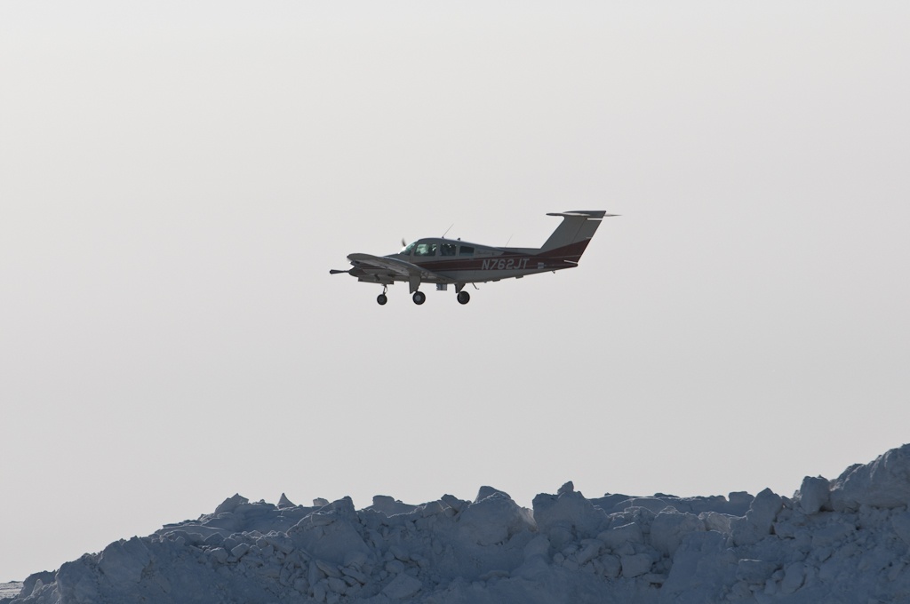
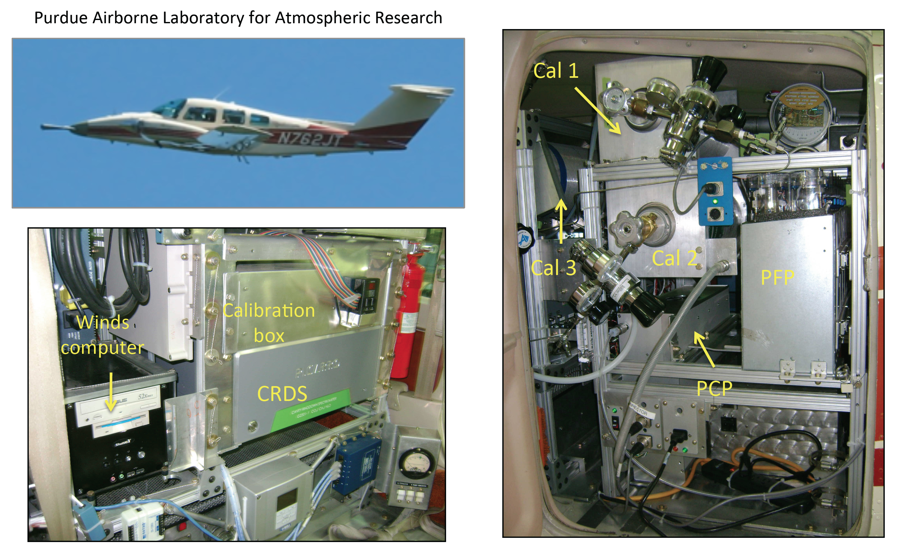
Airborne Laboratory for Atmospheric Research (ALAR; http://www.chem.purdue.edu/shepson/ alar.html). ALAR is a 4-seat twin engine (2 x Lycoming180HP) Beechcraft Duchess, with an instrument payload of ~500lbs, and ~1kW of available power, which was outfitted in 2002 specifically for studies of atmosphere-surface interactions studies (see photo of ALAR in flight during the recent NASA-led BROMEX (http://seaice.apl.washington.edu/AirChemistry/) campaign in Barrow, AK, in Figure 1). ALAR has been used extensively for studies of air quality and greenhouse gas fluxes (Martins et al., 2009; Mays et al., 2009; Lauvaux et al., 2012). A part of the focus for ALAR has been development of the capability to conduct eddy covariance flux measurements for greenhouse gases and VOCs. Thus ALAR has a thoroughly tested and documented “Best Air Turbulence” (BAT) probe to enable high frequency and reliable 3D wind measurements (Garman et al., 2006, 2008). This capability is very important to this project, and represents a capability that is a complement to the CARVE aircraft. The twin engine configuration allows for the use of the BAT probe on the nose of the aircraft, to enable reliable determination of the 3D wind vector, at 50Hz, when used in combination with a high precision INS/GPS system (Novatel Black Diamond System). This capability is a critical component of the data acquisition to enable calculation of emission fluxes, to help define the wind field, and to define the boundary layer height from the turbulence profile, as described below. Two instrument racks that contain the INS/GPS, the power supply/conditioner, a power inverter, a ruggedized PC, and the Picarro instrument and flask sampling packages sit in place of the rear seat (see Figure 2). There are two RAM air inlets on the nose cone that bring sample air rapidly (at 0.1s residence time, using a 60cfm DC blower) through a 1" diameter PFA-Teflon sample line to the instrument rack. The system is designed so that the residence time in the sample air line is short enough to allow for flux measurements via that line. The BAT probe has been
Figure 1. ALAR in flight in Alaska’s North Slope.
Figure 2.
described at: http://www.noaa.inel.gov/capabilities/bat/ and the uncertainties in our measurements of the vertical windspeed, w, have been thoroughly evaluated as described in Garman et al. (2006; 2008). We estimate an uncertainty in w of ~6 cm/s. This results in part from the very good accuracy and precision of the Novatel Black Diamond GPS/INS system and the fact that the BAT probe has been windtunnel tested and calibrated. We have also recently conducted a calibration of the horizontal winds, and the propagated uncertainties are ±2º in heading and ±0.2m/s in wind speed. This very low-cost aircraft platform (low cost in part because PI Shepson is the ALAR pilot, and thus pilot costs are minimized, and in part due to low fuel burn rates and low maintenance costs) has been proven to be very flexible in operation, having led a range of science missions, including studies of CO₂ and CH₄ fluxes into the biosphere (Martins et al., 2009; Lauvaux et al., 2012) and from urban environments (Mays et al., 2009), for studies of HONO production on canopy surfaces and in the atmosphere (Zhang et al., 2009), and for studies of cloud water processing of atmospheric nitrogen (Hill et al., 2007) and studies of cloud water bacteria (Kourtev et al., 2011). It was also recently used for column BrO measurements through the boundary layer and free troposphere during BROMEX, and is being used for CO₂ flux measurements as part of the NASA EV-1 AirMOSS project.
The ALAR aircraft measurements will have three significant components: 1) 3D wind measurements; 2) in situ measurements of CO₂, CH₄ and H₂O and 3) flask package measurements for CO₂, CO, CH₄, SF₆, H₂, N₂O, halocarbons, and ¹⁴C of CO₂. ALAR also has a 2B O₃ instrument that measures at 0.5Hz. ALAR has now been used extensively for INFLUX, and the Picarro instrument exhibits in-flight precision and accuracy of better than 0.1% for both CO₂ and CH₄. The accuracy is afforded from application of routine (every ~30 min.) in-flight calibrations, that produce three-point calibration curves for each flight. Figure 3, below, shows calibration curves overlaid from multiple INFLUX flights, showing the remarkable calibration stability. The three cylinders, purchased from NOAA ESRL, are chosen to just bracket the full range of likely observational concentrations.
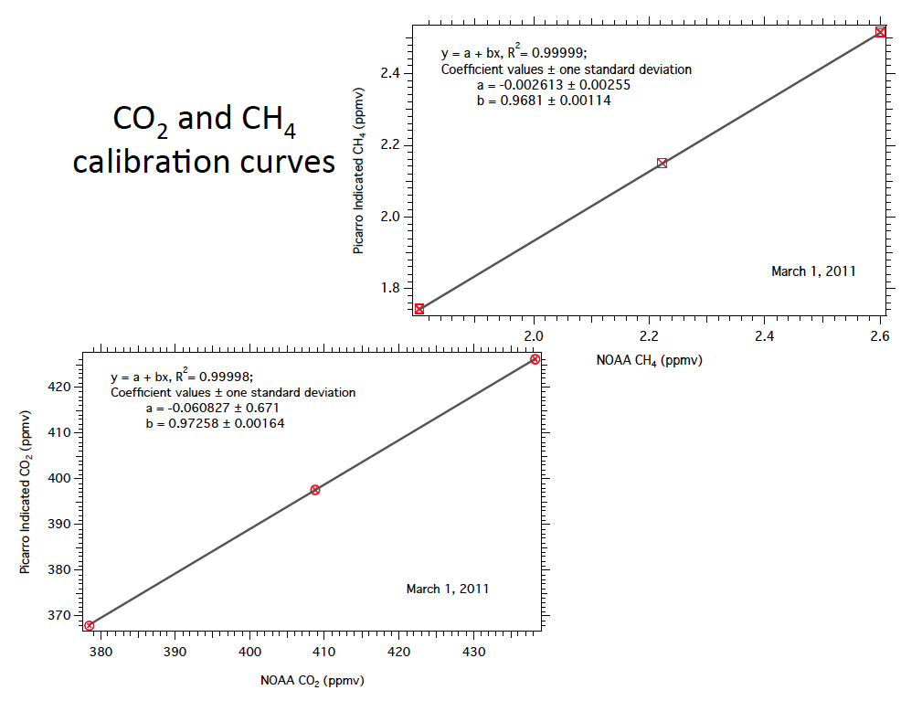
The NOAA 12-flask package is an automated sampling device that flushes and fills a 0.7 L
Figure 3.
flask to 40 psia in 15-30 seconds. These flasks can be programmed to either be filled
in parallel pairs or as single flasks. By sampling two flasks at once, it is possible to not only validate the CO₂ and CH₄ measurements but also to collect sample for a concurrent ¹⁴CO₂ measurement. Additionally, we will be measuring CO, SF₆, H₂, N₂O, and and broad suite of hydro- and halocarbons from these same flasks to identify possible correlates to ¹⁴CO₂ (Miller, 2012)
[last sentence was redundant with above]

2. CARVE aircraft
The Carbon in Arctic Reservoirs Vulnerability Experiment (CARVE) is a NASA Earth Ventures (EV-1) investigation designed to directly test hypotheses attributing the mobilization of vulnerable Arctic carbon reservoirs to climate warming and quantify feedbacks between carbon fluxes and carbon cycle-climate processes in the Arctic. The CARVE payload includes a Fourier transform spectrometer (FTS) designed to measure total column CO₂, CH₄ and CO from near infrared spectral radiances and an In-Situ Gas Analyzer Suite (ISGAS) for continuous CO₂, CH₄ and CO measurements and whole air sampling at discrete locations. Key requirements of the CARVE investigation are to detect small spatial gradients in CO₂ and CH₄ concentrations and to characterize CO₂/CH₄/CO emission factors from natural and anthropogenic combustion sources. These same attributes make the CARVE payload ideally suited for characterizing urban CO₂ and CH₄ emissions.
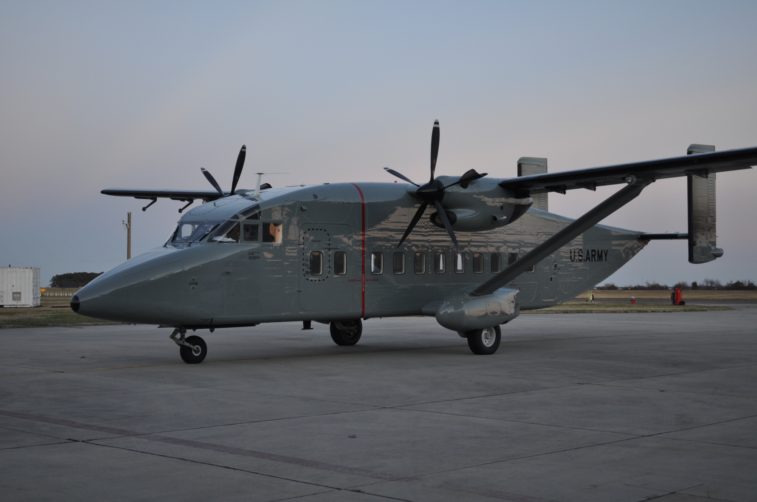
Figure 4. The CARVE C-23B Sherpa on the runway at Wallops Flight Facility.

The CARVE aircraft is a NASA C-23B Sherpa (Fig. 4) acquired in 2011 from the U.S. Army. The key C-23B characteristics and performance specifications are given in Table 1. The endurance and range of the C-23B are twice the capability required for the proposed flights and provide robust margins against flight plan modifications that may be required in real time due to air traffic control direction, atmospheric variability, etc. Typical cruise speed is comparable to that of the ALAR aircraft, ensuring minimal differences in the inlet sampling from the two platforms. The altitude range and rate of climb exceed the requirements of the proposed flight plans.
TABLE 1. CARVE C-23B Characteristics
Characteristic | C-23B Spec. | Units
Length | 58 | Feet
Wing Span | 75 | Feet
Height | 17 | Feet
Cabin Volume | 1151 | Cubic Feet
Payload Capacity | 7000 | Pounds
Endurance | 7.5 | hours
Range | 1200 | Naut miles
Cruise Speed | 190 | Knots
Stall Speed (VS0) | 85 | Knots
Engines | 2
Power plant | PT6A-65AR | Model
Thrust per engine | 1400 | SHP
Propellers Blades | 5
Rate of Climb | 2,100 | Feet/min
Stock Fuel capacity | 672 | Gallons
Flight Crew | 2 | Pilots
Electrical Power | 6,000 | Watts

The C-23B provides more than adequate payload capacity, power, and cabin space for the payload and science crew. Figure 5 shows the instrument and rack locations as well as the actual installation.

Fourier Transform Spectrometer (FTS)
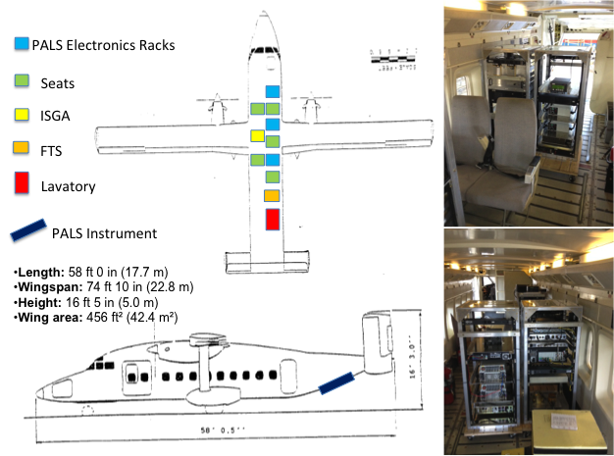
The CARVE FTS acquires high-resolution near-infrared spectra of solar radiance reflected from the Earth’s surface below the aircraft, from which column abundances of CO₂, CH₄, and CO are retrieved using algorithms of the type developed for OCO (refs). The FTS telescope has a 10 degree field of view, which will yield data with ~100m x ~100m spatial resolution at a 1 Hz readout rate under nominal flying conditions.

Figure 5. Organization of the CARVE instruments and support racks and their installation in the C-23B.

The column abundances retrieved from the CARVE FTS provide a unique airborne capability for urban flux measurements. By flying orthogonally to the outflow direction, the column measurements create a curtain that captures all mass flowing through it and provides accurate boundary conditions for emissions outflow. The mass flux through that curtain will be determined with reliance on the wind field data provided by the ALAR aircraft. Vertical profiling of the column measurements will be accomplished by retracing flight paths at different altitudes. Additionally, the airborne FTS measurements provide a direct link to the column measurements made from space by the GOSAT, MOPITT and OCO-2 satellite instruments and flights of the CARVE FTS can be used to test strategies for space-based sampling of urban emissions.
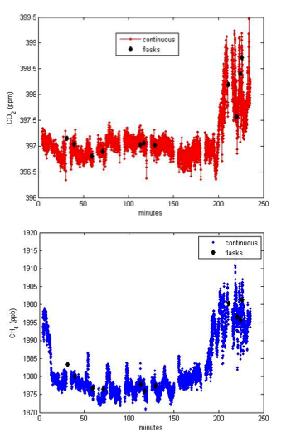
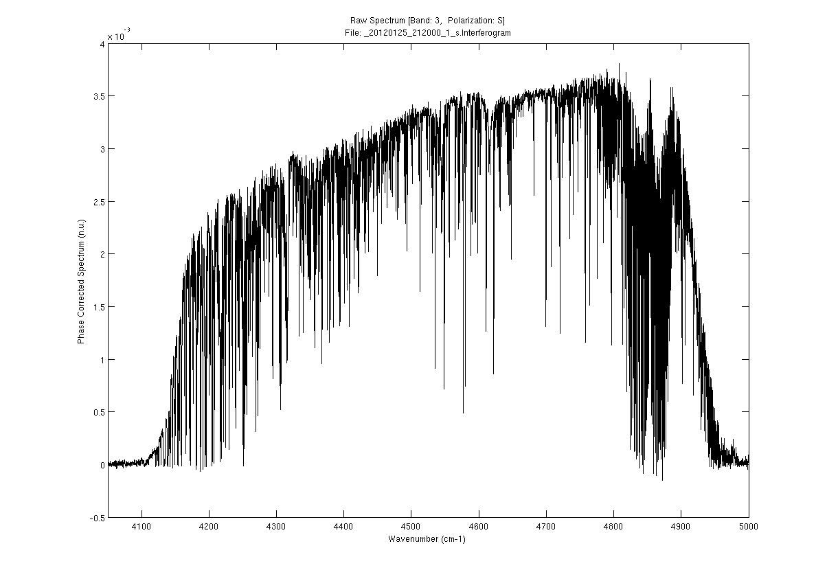
The CARVE FTS is a slightly modified version of the flight-proven Tsukuba FTS built by ABB Bomem for the Japanese Aerospace Exploration Agency (JAXA) as the airborne precursor for the Greenhouse gases Observing SATellite (GOSAT) (ref?). The heart of the CARVE FTS is Bomem’s Generic Flight Interferometer (GFI) which was the basis for a series of airborne and spaceborne remote-sensing FTS including: Paris, Tokyo, the Atmospheric Chemistry Experiment (ACE) FTS on SciSat (ref?) and the Crosstrack Infrared Souder (CrIS) FTS for the Joint Polar Satellite System (JPSS).

Figure 7. In situ CO₂ (top) and CH₄ (bottom) measurements recorded by CARVE on 3/29/11. PFP data are shown as black dots in each panel. The abrupt increases near 200 minutes are from an agricultural fire sighted ~5 miles away.

Figure 6. Spectrum of reflected sunlight recorded with the CARVE FTS on 1/24/12 verifying the instrument performance. The SNR and spectral line shape are excellent.

The FTS was delivered in January 2012. Performance was verified by recording spectra of sunlight reflected from a spectralon panel positioned below entrance aperture (see Fig. 6). Retrievals of X_{CO2} retrievals yielded a spectrum-to-spectrum reproducibility of 1.6 ppm for different 30 second blocks of 1 Hz measurements, consistent with the instrument design. The reproducibility was 6 ppb for X_{CH4} and 4 ppb for X_{CO}.

In Situ Gas Analyzer System
The CARVE in-situ gas analyzer system includes instrumentation very similar to the ALAR payload: a Picarro G1401 analyzer for continuous in-situ measurements of CO₂, CH₄ and CO, and up to three 12-flask Programmable Flask Packages (PFPs) to acquire whole air samples. The ISGAS is fed from two separate inlets, one leading to each of the ISGA components. The inlets are aft facing, installed before the engines to avoid intake of any exhaust fumes. Synflex tubing is used to avoid contamination of the inlet air and minimize changes in concentrations due to desorption from the tubing walls. The inlet was constructed based on the flight-proven design used by the NOAA Aircraft Program.
Continuous measurements from the Picarro analyzer are calibrated against on-board standard gas samples once every 30 minutes by an automated system. Allan variance analyses of the Picarro signals against calibrated gas samples demonstrated excellent performance. Measured precisions (1) for 2.5-second integration times are 0.012 ppm for CO₂, 0.12 ppb for CH₄ and 2.3 ppb for CO. In-situ measurements recorded during the CARVE 2011 engineering test flights showed excellent agreement between the continuous in-situ measurements and the absolute calibration measurements from the PFPs. Figure 7 shows CO₂ and CH₄ data recorded as the plane approached a small (~ 1 ha) burning of residual crops from the previous season. The CARVE instruments picked up clear signatures of the fire at a distance of ~5 miles at a flight altitude of 3000 feet. The absolute calibration of the Picarro data yielded a mean bias of 0.01 ppm and a precision of ±0.16 ppm for CO₂ and a mean bias of 0.6 ppb and a precision of ±2.0 ppb for CH₄.
This outstanding performance provides CARVE with high sensitivity to rapid changes in atmospheric concentrations of these gases. Simultaneous CO₂ and CO continuous in-situ measurements, combined with a knowledge of the background CO₂ and CO concentrations and the local CO₂/CO emission factor, provide another unique capability: the ability to quantify the fraction of CO₂ from fossil fuel combustion (FFCO2) continuously via evaluation of the CO₂(excess)/CO(excess) ratio (Newman et al., 2012).

PFPS

The NOAA 12-flask package is an automated sampling device that flushes and fills a 0.7 L
flask to 40 psia in 15-30 seconds. These flasks can be programmed to either be filled
in parallel pairs or as single flasks. By sampling two flasks at once, it is possible to not only validate the CO₂ and CH₄ measurements but also to collect sample for a concurrent ¹⁴CO₂ measurement. Additionally, we will be measuring CO, SF₆, H₂, N₂O, and and broad suite of hydro- and halocarbons from these same flasks to identify possible correlates to ¹⁴CO₂ (Miller, 2012). Most importantly, as demonstrated in Turnbull (Sac), it is possible to create pseudo-continuous ¹⁴CO₂ (CO₂-fossil fuel) traces by “calibrating” the Picarro continuous CO measurements to regularly spaced measurements of the ¹⁴CO₂:CO ratio from the flask air samples. In the Sacramento urban study, the combination of continuous CO and flask ¹⁴CO₂ allowed for a direct determination of fossil-fuel CO₂ emissions. This methodology will be applied here (at least in Indy) by having CARVE sample the downwind segments (Figure 11).

[Colm, do you have a good version of Jocelyn’s figure?]

A.4. Experimental Plan
A.4.a. Indianapolis flights
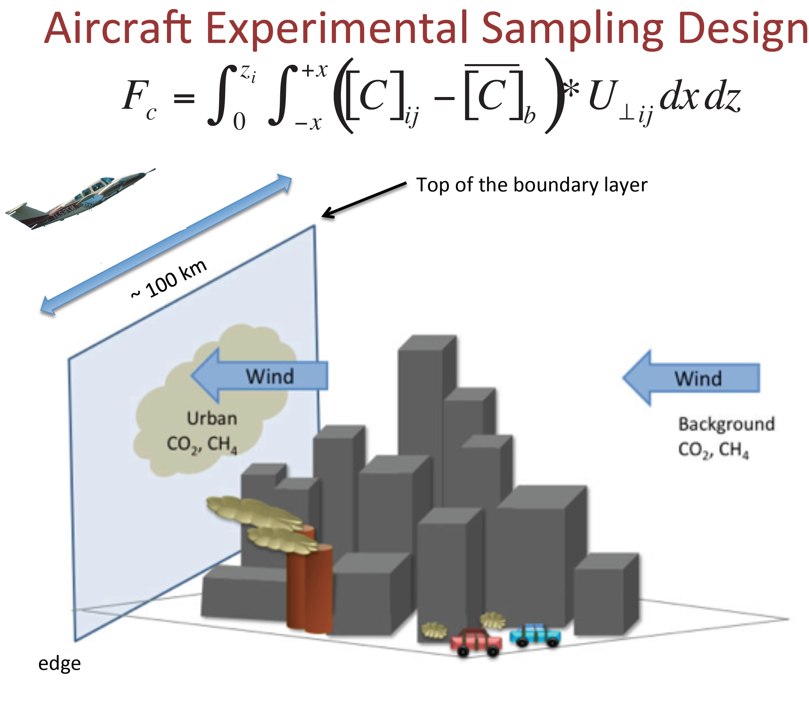
The principal objectives of this effort are to develop and evaluate the limits and capabilities of the mass-balance approach for determination of the integrated CO₂ and CH₄ flux from an urban area-wide environment. This is currently being done as part of INFLUX for Indianapolis, using ALAR. Here we are proposing complementary incremental flights of ALAR, and the CARVE aircraft flights, to enable us to probe the attainable minimum uncertainty, and define the components of the experiment and sampling approach that determine the overall uncertainty. The ALAR INFLUX experiment involves sampling the outflow air, perpendicular to the city. This works well for Indianapolis, as the plumes tends to flow out in a predictable and constant manner (on the experiment time frame), that can be readily compared to the upwind background (unlike the case for Los Angeles). We then smooth the data to produce a complete data field downwind, including the urban plume components, subtract the background, and multiple by the perpendicular wind component and integrate over all downwind frame components to obtain a total flux. The experiment is described in cartoon form in Figure 8, with the integration as described in the figure. An example of the nature of the data and the magnitude of the signal is shown in Figure 9, taken from Mays et al., 2009. Figure 10 shows how useful the BAT probe can be in defining the top of the boundary layer, in this case, from the variance of the vertical wind speed (shown in pink in Figure 10.). We have now done many experiments for Indianapolis, in part aiming at assessment of the components of the calculated flux that contribute the most to the uncertainty. From that analysis, we have found that the most important uncertainties derive from the determination (and constancy) of the boundary layer height, the determination of the background concentrations, and the interpolation technique. Each of these contributes approximately equally, at about 20% each. The interpolation technique relates to the problem of sampling statistics for the ALAR in-situ sampling approach, in that there are typically 4-5 transects, and so the downwind plume is always under-sampled. However, as with all uncertainties, they are poorly defined. The use of the CARVE aircraft applied to the relatively simple Indianapolis case will afford a unique opportunity to determine what is possible with the mass balance approach, and to minimize these uncertainties. This is the case because:
Figure 8.
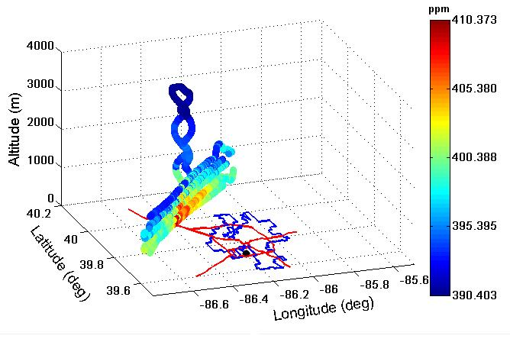
1. We will have dramatically improved boundary layer characterization. This relates to the fact that two LIDAR systems will be in place by October 2012 in Indianapolis, and because the ALAR aircraft can spend more of its measurement time characterizing the boundary layer while the CARVE aircraft is rastering the full downwind plume.
WD
Figure 9. Example CO₂ data
for Indianapolis.
2. The interpolation issue will largely disappear, as the entire column will be sampled by the CARVE FTS instrument. This then presents us with a unique opportunity to conduct experiments during which simultaneous mass balance fluxes from ALAR with its sampling limitations are compared to the results from CARVE, to better assess the impact of limited sampling statistics.
3. With use of these two aircraft, for most experiments, the ALAR aircraft can sample the upwind background concentrations (while defining the boundary layer height and wind field), while the CARVE aircraft can sample the complete downwind plume.
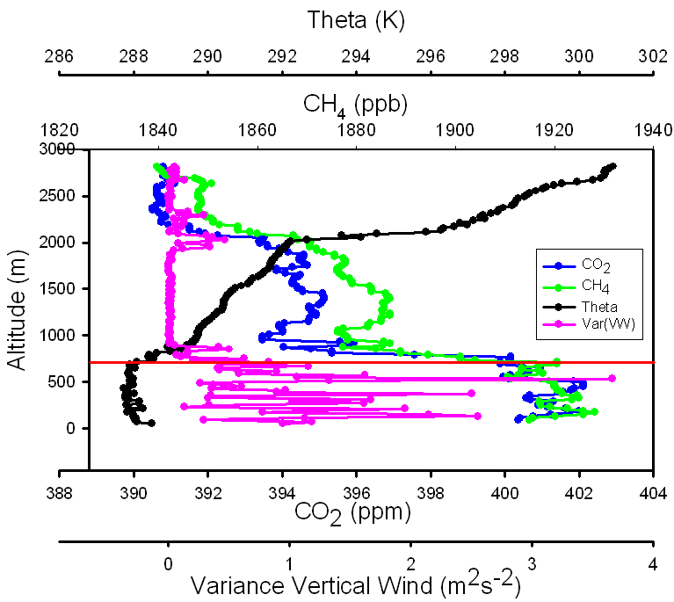
For the existing ALAR approach in Indianapolis, we have been able to apportion some emissions to know emitters, e.g. the Harding St. Power Plant. For that point source, we can compare our determine individual source measured flux with that reported to EPA; the mean difference between the ALAR power plant measured flux and that reported is 13%, for the three determinations we have conducted to date. This bodes well for what can be done with the more optimized approaches we propose here. This will be assessed for this experiment for the optimized two-aircraft approach. For ALAR by itself, the background data are obtained by flying perpendicular to the plume with legs that extend beyond the boundaries of the city. However, that approach can miss “background” sources that are directly upwind of the city. So, for some experiments, we will obtain upwind data with ALAR, and then fly the two airplanes in tandem, to assess the undersampling impact, and to enable assessment of the impact of both methods of acquiring background concentrations.
Figure 10. Vertical Profile Data.
In Figure 11, we show a sample flight plan for a mass balance experiment in Indianapolis, for this proposed effort. We show a sample case in which the wind direction is from the northwest. The CARVE aircraft would then sample the urban plume flying perpendicular. ALAR would sample the background CO₂ and CH₄ upwind of the city, and also conduct vertical profiles to define the boundary layer height upwind, and within the city. We propose that 4 of the 6 flights be conducted in this manner, covering different wind directions, and 2 of the 6 with both ALAR and CARVE flying the longer width downwind transects together. With both aircraft flying downwind, we can extend the widths of the transects to enable acquisition of background data from the “wings”, while also covering the plume well with both aircraft. The CARVE aircraft will also enable assessment of temporal variability in the flux, over the time period (up to 3 hours) over which ALAR normally samples the downwind plume. This approach enables us to conduct an optimized flux measurement, assess overall and component uncertainties, and to fully leverage the INFLUX assets.
Figure 11. Example Flight Plan
for Indianapolis.

A.4.b. Los Angeles Flights
For a variety of reasons, including their importance in terms of global impact, the magnitude of the signal for satellite measurement assessment, and the magnitude of the signal for surface-based measurements, there is a need to apply available measurement techniques to megacities, like LA. However, this is a challenge for a variety of reasons, including the fact that a substantial fraction of mega-cities world-wide are coastal, with complex regional topography and associated meteorology. In many ways, this makes Los Angeles a representative case. And, there is a significant degree of local knowledge and capabilities, available infrastructure, and a half-century of research dedicated to understanding the relationships between emissions, meteorology, and air quality. We thus believe that, for the U.S. and the CMS community, the LA basin is a sensible first-cut mega-city for application of the methods described here.
Figure 12. Example Idealized LAB Flight Plan.
Figure 8. LAB representative flight plans.
The LA Basin (LAB) also represents very significant measurement challenges. Unlike Indianapolis, the LAB is not a “flow-through” environment. In the summer, air flows into the basin in the daytime from the ocean, and out from the basin to the ocean at night. In the winter, flow tends to often flow along the coast, with spring as a transitional period. For the daytime sea breeze case, air tends to flow into the LAB and be trapped by the surrounding mountains. It is thus not a simple matter to conduct a downwind experiment as for INFLUX. However, the LAB will tend to accumulate emissions through the daytime period, and then it flows out into the air above the Pacific Ocean at night. We thus envision two viable approaches, shown in simplified form in Figure 12. In the first approach, shown in yellow in the Figure, we conduct a mass balance experiment by measuring the outflow concentrations in the evening, flying perpendicular to the outflow direction. Given the wind vector obtained from ALAR, and the integrated net mass outflows, obtained from both CARVE and ALAR downwind transects, and given the accumulation time period, the total LAB flux can be obtained. This approach relies on early morning measurements of the initial concentrations throughout the LAB. It is important to note that flying in the LAB is also a challenge with respect to operations within and around Class B airspace for LAX. For the evening outflow measurements, this is not an issue, and the top of LAX airspace is 10,000 ft. this does, however, pose a challenge for the ALAR aircraft for the morning measurements in the basin, and for the “basin-filling” experiment discussed below. However, for VFR flights in the LAB, a proven approach is to fly “suggested VFR flyways”, which are created to provide routings that are alternatives to flight within Class B with approach control clearances; following the published altitudes and flyways keeps the aircraft clear of airspace that requires a clearance. However, our experience is that it is prudent and useful to meet with ATC personnel (in this case, those at L.A. ARTCC) to discuss the experiment and flight plans, and receive guidance for the optimum means to fly the flight plans and while complying with airspace restrictions. This often involves daily discussions with approach control, and receiving a VFR flight following squawk code upon VFR flight plan activation. Thus, the sample flight plans (both sets) shown in Figure 12 are idealized/conceptual.
The other approach, shown in white in Figure 12, is referred to as the “basin filling approach”. In this approach, the rate of change of net concentrations of CO₂ and CH₄ are measured, e.g. initial and final, by sampling the full LAB in the early morning and late afternoon, and calculating the LAB-integrated net change in mass of these species throughout the basin. This approach will require a 3D smoothing of the data using a 3D kriging (or other) approach, and measuring the rate of change relative to a smoothed 3D initial concentration field. We will also need to conduct measurements at the top of the boundary layer, and near the basin edges at mountain tops, to quantify the degree of “spilling” into the free troposphere and/or out of the basin. The data coverage will be optimized using the two aircraft simultaneously.
For both approaches, we will compare with the inventories available from (CARB?) and from Vulcan.

A.5. Connections to GOSAT, OCO-2, and other satellite retrieval data sets

This project directly supports and connects to ACOS, OCO-2, OCO-3, ASCENDS. In spite of the incoming flood of satellite retrievals of land cover/land use information and column concentrations of greenhouse gases, we have poor knowledge of the spatial and temporal distribution of CO₂ and CH₄ concentrations in urban domes. NASA and the carbon cycle science community has no proven method for validating space-based retrievals of X_{CO2}. This effort aims to help relieve that pressure, and take us significantly further down the path to defensible solutions, with known limits of uncertainty. This project provides critical reference data for characterizing CO₂ concentrations in urban environments with high spatial resolution., along with development and evaluation of urban area-wide emissions flux approaches.
The flights of the CARVE FTS are especially important and will provide the first detailed characterization of the spatial and temporal dependence of column CO₂.
We will thus test the following hypothesis:

Since urban CO₂ domes are stable and well mixed near mid-day and column measurements have large influence footprints, a single column measurement may be representative of the entire urban dome.

We can use the CARVE FTS measurements to test the uniformity of the urban dome and the null hypothesis that single column measurements are insufficient and that multiple measurements are needed. We will in this case provide important guidance and information regarding the necessary spatial scales over which column measurements should be conducted.

Chip? Expand?
Connections to NASA CMS Flux pilot – high resolution data for sub-grid scale characterization of fluxes inferred from global inversions of satellite data – how well do the global inversions represent urban environments?

We will also assess the interplay, complementarity and/or redundancy in information content for application of multiple methods, i.e. mass balance, ¹⁴CO₂, inverse modeling, emission ratio methods, and Lagrangian approaches. We have separate and well-defined objectives for INFLUX and LA. INFLUX is more mature, better-instrumented by October of 2012, but LA is the near-term Megacity objective, and we can and will take the lessons of INFLUX to LA. We will also develop substantial experience in development of sampling approaches in study regions with complex meteorology, that can drastically influence the most viable sampling approaches.

A.6. Plan of Work, with Timeline
We are proposing to conduct 6 flights of ~four hours each for Indianapolis, and the equivalent of that for LA. These experiments will take place over a two week period in the Fall of 2012 for Indianapolis, and in the spring of 2013 for LA. The timeline for these two sets of experiments is shown in Figure 13, below. The campaign schedule avoids conflict with CARVE Alaska flights while leveraging integration and transit costs.

A.7 Project Management
There are three co-PIs on this proposal, Paul Shepson, Purdue University, Charles Miller, JPL, and Colm Sweeney, CIRES. Their responsibilities are outlined below. Paul, show a figure?
Paul Shepson - project lead, ALAR flights, flight planning and coordination of CARVE and ALAR flight plans; ALAR data analysis, manuscript preparation and reporting.
Figure 13.

Charles Miller - co-PI will be responsible for the CARVE flights and flight planning, data analysis from the CARVE instruments, and coordination of the LAB flights and flight planning with ground-based observations. Dr Miller is the CARVE PI and will ensure that the scheduling and use of the CARVE platform in this project will not jeopardize the CARVE Baseline Investigation requirements.

Colm Sweeney - co-PI, Will provide logistical support during each campaign and be responsible for analysis of in-situ data on collected on the CARVE aircraft as well as help in flight planning. Sweeney has extensive experience planning, analyzing and executing campaigns to measure CO2, CO and CH4 in urban and rural areas.

We will also be collaborating with Steve Wofsy, Harvard University, who will….?
A letter of support from Prof. Wofsy is attached.

This project leverages a number of assets, such as PBL height characterization via LIDAR, from the NIST-sponsored INFLUX project. We thus provide a letter of commitment from James Whetstone, the INFLUX Project Manager, in Appendix X. There are multiple strengths of this proposal; among them are that all infrastructure components are in place, including the existing INFLUX campaign, which we are leveraging. All instrumentation to be used in this experiment already exists in both aircraft and is all field tested.

Ken Davis – Science Lead of INFLUX – commit access to INFLUX data, previous measurements, modeling, met fields, etc.

Riley Duren – JPL – Measurements and modeling of CO₂ and CH₄ emissions from the Los Angeles Megacity/Megacity Carbon Project

Paul Wennberg, Debra Wunch – Caltech FTS for column CO₂, CH₄, CO, etc. ground truth

Stan Sander – JPL – CLARS observations of LA

Chip can you specify? Are these people part of the budget or are they in-kind collaborators. Do we need letters from them?

A.7.1. Data Management Plan
Our data management plan will be built upon the experience gained from the recent field campaigns from the Tropospheric Chemistry Program (e.g., INTEX-A, INTEX-B, and
ARCTAS) and EV-1 (CARVE, AirMOSS). Data submission will be conducted in two phases: field data and final data. The field data will be submitted shortly after completion of each flight (or calendar day for ground measurements), i.e. within 24–48 hours. During previous NASA airborne studies, field data successfully served three main goals: monitoring the progress in attaining science objectives, providing a quick check of instrument performance, and planning later flights. The final validated data will be delivered at the end of the project. The project duration is sufficiently short that delivery of preliminary or intermediate data is not warranted.
During the project, data will be stored by the project team. The final data will be submitted to the Carbon Dioxide Information and Analysis Center (CDIAC, http://cdiac.ornl.gov/) at Oak Ridge National Laboratory for archive and public distribution. CDIAC hosts other data that researchers will find critical in analyzing the results including records of atmospheric CO₂, CH₄ and other radiatively active gases and emissions of carbon dioxide from fossil fuel combustion. All data, data products, metadata, etc. will adhere to NASA’s Earth Science Data Policy. Data from ALAR and CARVE will be archived in a consistent georeferenced data format, in a convenient merged format, with appropriate metadata.

No more than 15 pages to here, from page 4 (to page 18)

B. References and Citations

Butz, A., et al. (2011), Toward accurate CO₂ and CH₄ observations from GOSAT, Geophys.
Res. Lett., 38, L14812, doi:10.1029/2011GL047888.

Chen, H. et al., High-accuracy continuous airborne measurements of greenhouse gases
(CO(2) and CH(4)) using the cavity ring-down spectroscopy (CRDS) technique,
Atmos. Meas. Techniques, 3, 375-386, 2010.

Cox, P. M., Betts, R. A., Jones, C. D., Spall, S. A., and Totterdell, I. J.: Acceleration of global
warming due to carbon-cycle feedbacks in a coupled climate model, Nature, 408, 184–187, 2000.

Dragoni, D., H. P. Schmid, C. A. Wayson, C. S. B. Grimmond, and J. C. Randolph, Evidence of
increased net ecosystem productivity associated with a longer vegetated season in a deciduous forest in south-central Indiana, USA, Global Change Biol., 17, 886-897, 2011.

Eby, M., K. Zickfeld, A. Montenegro, D. Archer, K. J. Meissner, and A. J. Weaver, Lifetime of Anthropogenic Climate Change: Millennial Time Scales of Potential CO₂ and Surface Temperature Perturbations, J. Climate, 22, 2501-2511, 2009.

Garman, K. E., K.A. Hill, P. Wyss, M. Carlsen, J.R. Zimmerman, B.H. Stirm, T.Q. Carney, R. Santini, and P.B. Shepson, An Airborne and Wind Tunnel Evaluation of a Wind Turbulence Measurement System for Aircraft-based Flux Measurements, J. Ocean and Atmos. Technol., 23, 1696-1708, 2006.

Gurney, K. R., D. L. Mendoza, Y. Y. Zhou, C. C. Miller, S. Geethakumar, S. D. Du Can,
High Resolution Fossil Fuel Combustion CO(2) Emission Fluxes for the United States, Environ. Sci. Technol., 43, 5535-5541, 2009.

Hill, K. A., P. B. Shepson, E. S. Galbavy, C. Anastasio, P. S. Kourtev, A. Konopka, and B. H. Stirm (2007), Processing of atmospheric nitrogen by clouds above a forest environment, J. Geophys. Res., 112, D11301, doi:10.1029/2006JD008002.

Hsu, Y. K., T. VanCuren, S. Park, C. Jacober, J. Herner, M. Fitzgibbon, D. R. Blake, and D. D. Parrish, Methane emissions inventory verification in southern California, Atmos. Environ., 44, 1-7, 2010.

Kort, E. A., C. Frankenberg, C.E. Miller Space-based Observations of Megacity Carbon Dioxide, submitted to Geophysical Review Letters, 2012.

Kourtev, P. S., Kimberly A. Hill, Paul B. Shepson, and Allan Konopka, Atmospheric cloud water contains a diverse bacterial community, Atmos. Environ, 45, (2011), 5399-5405.

Lacis, A. A., G. A. Schmidt, D. Rind, R. A. Ruedy, Atmospheric CO₂: Principal Control Knob
Governing Earth’s Temperature, Science, 330, 356-359, 2010.

Lauvaux, T., A. E. Schuh, M. Uliasz, S. Richardson, N. Miles, L. I. Diaz, D. Martins, P. B. Shepson, and K. J. Davis, Constraining the CO₂ budget of the Corn Belt: Exploring Uncertainties from the Assumptions in a Mesoscale Inverse System, Atmos. Chem. Phys., 12, 337–354, 2012.

Martins, D. K., Sweeney, C., Stirm B. H., and Shepson P. B., Regional surface flux of CO₂ inferred from changes in the advected CO₂ column density, Agric. Forest Meteorol. (2009), doi:10.1016/j.agrformet.2009.05.005.

Mays, K., P. B. Shepson, B. Stirm, A. Karion, C. Sweeney, K. Gurney, Aircraft-Based Measurements of the Carbon Footprint of Indianapolis, Environ. Sci. Technol., 43, 7816–7823, 2009.

McGuire A. D., L. G. Anderson, T. R. Christensen et al. Sensitivity of the carbon cycle in the
Arctic to climate change, Ecol. Monographs, 79, 523-555, 2009.

Miller, C. E. and S. J. Dinardo, CARVE: The Carbon in Arctic ReservoirsVulnerability
Experiment, IEEE, 978-1-4577-0557-1/12, 2012.

Morino, I., et al., Preliminary validation of column-averaged volume mixing ratios of
carbon dioxide and methane retrieved from GOSAT short-wavelength infrared spectra,
Atmos. Meas. Tech., 4, 1061–1076, 2011.

Newman, S., S. Jeong, M. L. Fischer, X. Xu, C. L. Haman, B. Lefer, S. Alvarez, B.
Rappenglueck, E. A. Kort, A. E. Andrews, J. Peischl, K. R. Gurney, C. E. Miller, and Y. L. Yung, Diurnal tracking of anthropogenic CO₂ emissions in the Los Angeles basin megacity during spring, 2010, Atmos. Chem. Phys. Discuss., 12, 5771–5801, 2012.

Peters, G. P., G. Marland, C. Le Quéré, T. Boden, J. G. Canadell and M. R. Raupach, Rapid
growth in CO₂ emissions after the 2008–2009 global financial crisis, Nature Climate Change, 2, 2-4, 2012.

Sarmiento, J. L., M. Gloor, N. Gruber, C. Beaulieu, A. R. Jacobsen, S. E. M. Fletcher, S. Pacala,
and K. Rodgers, Trends and regional distributions of land and ocean
carbon sinks, Biogeosciences, 7, 2351-2367, 2010.

Serreze, M. C. and R. G. Barry, Processes and impacts of Arctic amplification: A research synthesis, Global and Planetary Change, 77, 85–96, 2011.

Turnbull, J. C., A. Karion, M. L. Fischer, I. Faloona, T. Guilderson,
S. J. Lehman, B. R. Miller, J. B. Miller, S. Montzka, T. Sherwood, S. Saripalli, C. Sweeney, and P. P. Tans, Measurement of fossil fuel derived carbon dioxide and other anthropogenic tracegases above Sacramento, California in Spring 2009, Atmos. Chem. Phys., 11, 705-721, 2011.

U. S. Environmental Protection Agency, Inventory of U.S. Greenhouse Gas Emissions and Sinks: 1990 – 2010, EPA 430-R-12-001, 2012.

Wunch, D., P. O. Wennberg, G. C. Toon, G. Keppel-Aleks, and Y. G. Yavin (2009), Emissions of greenhouse gases from a North American megacity, Geophys. Res. Lett., 36, L15810,
doi:10.1029/2009GL039825.

Zare, R. N., D. S. Kuramoto, C. Haase, N. M. R. Saad, High-precision optical measurements of
(13)C/(12)C isotope ratios in organic compounds at natural abundance, Proc. Nat. Acad.
Sci., 106,10928-10932, 2009.

Zhang, N., X. Zhou, P. B. Shepson, H. Gao, M. Alaghmand, and B. Stirm (2009), Aircraft measurement of HONO vertical profiles over a forested region, Geophys. Res. Lett., 36, L15820, doi:10.1029/ 2009GL038999.

Zhou, Y. Y., K. R. Gurney, Spatial relationships of sector-specific fossil fuel CO₂ emissions in the United States, Global Biogeochem. Cycles, 25, Article Number: GB3002
DOI: 10.1029/2010GB003822 Published: JUL 7 2011.

C. Biographical Sketches.
BIOGRAPHICAL SKETCH
Paul Bradford Shepson 560 Oval Drive
Purdue University Phone: (765) 494-5207
West Lafayette, IN 47907 Email: pshepson@purdue.edu
Proposal Role: Principal Investigator; ALAR flights; flight planning;

Professional Preparation
1. Undergraduate: S.U.N.Y. College at Cortland, NY, B.S. Chemistry, 1978.
2. Graduate: Pennsylvania State University, State College, PA, Ph.D. Analytical/Atmospheric
Chemistry, 1982.

Appointments
2008 - Head, Department of Chemistry, Purdue University
2006 - 2008 Director, Purdue Climate Change Research Center
2004 - Founding and Interim Director, Purdue Climate Change Research Center
2003 - Head, Analytical Chemistry Division, Dept. of Chemistry, Purdue U.
1994 - Professor, Departments of Chemistry and Earth and Atmospheric Sciences, Purdue University
2000 Visiting Scientist, Pacific Northwest National Labs
1994 - 2006 Adjunct Professor, Department of Chemistry, York University
1991- 1994 Associate Professor (with tenure), York University, North York, Ontario.
1988- 1993 Acting Director, Centre for Atmospheric Chemistry (CAC), York University
1987- 1991 Assistant Professor, Department of Chemistry, York University, Toronto, Ontario.
1982- 1987 Research Chemist, Northrop Services, Inc. (on-site U.S. EPA Contract Research), Research Triangle Park, N.C.
1982 Research Chemist, Mobil Research and Development Corp., Paulsboro, N.J.

Relevant Prior Research and Management Experience
Shepson is currently Head of the Department of Chemistry at Purdue University, which has 50 faculty, 330 graduate students, 400 undergraduates, and a large technical staff (~80), with an annual research effort of $20M/yr, and a Departmental budget of $11M/yr. Prior to that he created and Directed the Purdue Climate Change Research Center, a large multi-disciplinary research center at Purdue (http://www.purdue.edu/discoverypark/climate/). At York University in Toronto he Directed the Center for Atmospheric Chemistry for 5 years. Professor Shepson has led numerous large scale field campaigns and directed international scientific projects, including the Ocean-Atmosphere-Sea Ice-Snowpack (OASIS) Program (http://www.oasishome.net/) which has a large IPY effort, and co-led the Air-Ice-Chemical-Interactions (AICI) IGAC project. He recently flew ALAR for 80 research hours in/around Alaska’s North Slope, as part of the NASA BROMEX campaign. Working with Mary Anne Carroll and Steve Bertman, he helped organize and direct the Program for Research on Oxidants: PHotochemistry, Emissions and Transport (PROPHET) program that has operated at the University of Michigan Biological Station since 1997. He created the INFLUX project, in collaboration with Colm Sweeney (NOAA), Kevin Gurney (ASU) and Ken Davis (PSU). Since 2002 he has led and been the chief pilot for the Purdue Airborne Laboratory for Atmospheric Research (ALAR; http://www.chem. purdue.edu/shepson/alar.html)., currently acting as pilot for two NASA projects - AirMOSS and BROMEX. He also has ~25 years experience in atmospheric chemistry modeling. Prof. Shepson has mentored 49 graduate students and 17 postdoctoral researchers in his laboratories.

National and International Responsibilities/Activities:
1988 - 1994 Member and Secretary (1988-1990), Canadian Institute for Research in Atmospheric Chemistry (CIRAC) Scientific Steering Committee
1991 - 2005 Associate Editor, Atmosphere-Ocean
1997 - 2001 Associate Editor, Journal of Geophysical Research – Atmospheres
1997 - Associate Director, Program for Research on Oxidants: Photochemistry, Emissions and Transport (PROPHET)
1999 - 2004 Scientific Steering Committee, NSF Ocean Atmosphere Ice Interactions Panel
2003 - External Advisory Panels, NSF-OPP; ACD-NCAR; NSF-GEO (2008-2010)
2001 Visiting Professor, Institute for Ion Physics, University of Innsbruck, Austria
2004 - 2008 Founding Director of the Purdue Climate Change Research Center
2006 - 2011 Co-coordinator (with Eric Wolff) of the Air-Ice Chemical Interactions (AICI) program
2002 - Development of the Ocean-Atmosphere-Sea Ice-Snowpack (OASIS) Program
Professor Shepson is a Private Pilot with Instrument, Commercial, and Multi-Engine ratings (~1500hrs).

Selected Recent Publications
Edwards, G. D., D. K. Martins, T. K. Starn, K. A. Pratt, and P. B. Shepson, A disjunct eddy accumulation system for the measurement of BVOC fluxes: Lab characterizations and Field deployment, Atmos. Meas. Tech. Discuss., 5, 2703–2746, 2012.
Costa, A. W., G. Michalski, B. Alexander, and P. B. Shepson, Analysis of Atmospheric Inputs of Nitrate to a Temperate Forest Ecosystem from Δ¹⁷O Isotope Ratio Measurements, Geophys. Res. Lett., 38, L15805, doi:10.1029/2011GL047539, 2011.
Lauvaux, T., A. E. Schuh, M. Uliasz, S. Richardson, N. Miles, L. I. Diaz, D. Martins, P. B. Shepson, and K. J. Davis, Constraining the CO₂ budget of the Corn Belt: Exploring Uncertainties from the Assumptions in a Mesoscale Inverse System, Atmos. Chem. Phys., 12, 337–354, 2012.
Zhou, X., N. Zhang, M. TerAvest, J. Hou, D. Tang, S. Bertman, M. Alaghmand, P. B. Shepson, M. A. Carroll, S. Griffith, P. Stevens, Nitric Acid Photolysis on the Forest Canopy Surface as a Tropospheric Nitrous Acid Source, DOI: 10.1038, Nature Geosciences, 4, 440-443, 2011.
Slade, J. H., T. M. VanReken, G. R. Mwaniki, S. Bertman, B. Stirm, and P. B. Shepson (2010), Aerosol production from the surface of the Great Lakes, Geophys. Res. Lett., 37, L18807, doi:10.1029/2010GL043852.
Mays, K., P. Shepson, B. Stirm, A. Karion, C. Sweeney, K. Gurney, Aircraft-Based Measurements of the Carbon Footprint of Indianapolis, Environ. Sci. Technol., 43, 7816–7823, 2009.
Zhang, N., X. Zhou, P. B. Shepson, H. Gao, M. Alaghmand, and B. Stirm (2009), Aircraft measurement of HONO vertical profiles over a forested region, Geophys. Res. Lett., 36, L15820, doi:10.1029/ 2009GL038999.
Martins, D. K., Sweeney, C., Stirm B. H., and Shepson P. B., Regional surface flux of CO₂ inferred from changes in the advected CO₂ column density, Agric. Forest Meteorol. (2009), doi:10.1016/j.agrformet.2009.05.005.
Nghiem, S. V., I. G. Rigor, A. Richter, J. P. Burrows, P. B. Shepson, J. Bottenheim, D. G. Barber, A. Steffen, J. Latonas, F. Wang, G. Stern, P. Clemente-Colón, S. Martin, D. K. Hall, P. Tackett, G. Neumann, and M. Asplin, Field and satellite observations of the formation and distribution of Arctic atmospheric bromine above a rejuvenated sea ice cover, in press, J. Geophys. Res. 117, D00S05, doi:10.1029/2011JD016268, 2012.

Hill, K. A., P. B. Shepson, E. S. Galbavy, C. Anastasio, P. S. Kourtev, A. Konopka, and B. H. Stirm (2007), Processing of atmospheric nitrogen by clouds above a forest environment, J. Geophys. Res., 112, D11301, doi:10.1029/2006JD008002.
Garman, K. E., P. Wyss, M. Carlsen, J. R. Zimmerman, B. H. Stirm, T. Q. Carney, R. Santini, and P. B. Shepson, The contribution of variability of lift-induced upwash to the uncertainty in vertical winds determined from an aircraft platform, Boundary Layer Meteor., 126, 461-476, 2008.
Garman, K. E., K.A. Hill, P. Wyss, M. Carlsen, J.R. Zimmerman, B.H. Stirm, T.Q. Carney, R. Santini, and P.B. Shepson, An Airborne and Wind Tunnel Evaluation of a Wind Turbulence Measurement System for Aircraft-based Flux Measurements, J. Ocean and Atmos. Technol., 23, 1696-1708, 2006.
~160 publications in the field of atmospheric chemistry

CHARLES E. MILLER
Jet Propulsion Laboratory, California Institute of Technology
4800 Oak Grove Drive, Pasadena CA 91109-8099 USA
Tel: +1 818 393 6294 Email: charles.e.miller@jpl.nasa.gov

Education
Ph.D., Physical Chemistry, University of California, Berkeley (1991)
B.S., Chemistry and History, Duke University, cum laude and departmental prize in Chemistry (1986)

Areas of Expertise
Atmospheric Chemistry and Photochemistry, Molecular Spectroscopy, Carbon Cycle Science

Professional Experience
Jet Propulsion Laboratory (2003 – present)
Principal Investigator, Carbon in Arctic Reservoirs Vulnerability Experiment (2010 – present)
Deputy Principal Investigator, Orbiting Carbon Observatory (2001–2009)
Principal Scientist (2010 – present)
Project Scientist (2005 – present)
Assistant Professor, Department of Chemistry, Haverford College (1997–2003)
National Research Council Resident Research Associate, NASA Jet Propulsion Laboratory (1994–1997)
Welch Postdoctoral Fellow, Rice University (1991-1994)

Relevant Current Projects
NASA Earth Systems Science Pathfinder (ESSP)/Ventures (EV-1): Carbon in Arctic Reservoirs Vulnerability Experiment (CARVE), Principal Investigator
NASA: The Orbiting Carbon Observatory (OCO-2) Mission, Science Team member
JPL DRDF: Creating a High-resolution Greenhouse Gas Emissions Inventory for the LA Megacity, Co-I
GOSAT Research Announcement: Validation of GOSAT Data Using OCO Methods and Algorithms, Co-I
DOE Atmospheric Radiation & Monitoring Program: OCO FTS Validation Intensive Operation Period, PI

Relevant Professional Activities
WMO CO₂ Experts Science Advisory Group (2009 – )
US Carbon Cycle Science Steering Group (2008 – )
Contributing author US Carbon Cycle Science Plan 2010-2020 (2008 – 2011)
Department of Energy Climate Change Science Program Review Panel (2007, 2010)
Expert Reviewer, Intergovernmental Panel on Climate Change (IPCC) 4th Assessment Review (2005-6)
Contributing Author: North America Carbon Program Plan (2002)

Relevant Publications (more than 110 total)
Space-based Observations of Megacity Carbon Dioxide, E.A. Kort, C. Frankenberg, C.E. Miller, submitted to Science
Carbon in the City, R. Duren and C. E. Miller, submitted to Nature Climate Change
Diurnal tracking of anthropogenic CO₂ emissions in the Los Angeles Megacity during spring 2010, S Newman, S. Jeong, M.L. Fischer, X. Xu, C.L. Haman, B. Lefer, S. Alvarez, B. Rappengleuck, E.A. Kort, A.E. Andrews, J. Peischi, K.R. Gurney, C.E. Miller, Y.L. Yung, Atmos. Chem. Phys. Discuss., 12, 5771-5801, 2012. doi:10.5194/acpd-12-5771-2012
Towards Robust, Global Greenhouse Gas Monitoring, R.M. Duren, C.E. Miller, Greenhouse Gas Measurement & Management 1, 80-84 (2011). DOI:10.1080/20430779.2011.579356
Precision requirements for space-based X_{CO2} data. C.E. Miller, et al., J. Geophys. Res.112, D10314, (2007). doi:10.1029/2006JD007659

Colm Sweeney
325 Broadway
Boulder, Colorado 80304
Colm.Sweeney@noaa.gov
Tel: (303) 497-4771

Education
Ph.D. 2000 Columbia University, New York, NY
(October) Chemical Oceanography. “Biogeochemical Regimes and meso-scale variability in the Ross Sea, Antarctica”.
M. S. 1996 Columbia University, New York, NY
Geology. “Carbon Cycles in Biosphere II Ocean”.
B. A. 1988 Bowdoin College, Brunswick, ME
Chemistry. Also extensive study in biochemistry and physics.

Work Experience
2005 – Present NOAA/CMDL, Boulder, CO
Cooperative Institute for Research in Earth Sciences, Research Scientist III.
2002 – 2005 Princeton University, Princeton, NJ
Research Staff Member.
2002 – Present Lamont-Doherty Earth Observatory of Columbia University, Palisades, NY
Adjunct Assistant Research Scientist.
2000 – 2002 Lamont-Doherty Earth Observatory of Columbia University, Palisades, NY
Post Doctoral Researcher. Development of time series for measurements of surface water CO₂ nutrients in the Drake Passage.

Research Interests
- Constraining the North American Carbon budget through vertical profiles of CO₂ and other trace gases
- Arctic Methane emissions
- The role of the Southern Ocean in the future Global Carbon Budget
- Air-sea gas exchange

Recent selected publications

Petron, G., G. Frost, B. R. Miller, A. I. Hirsch, S. A. Montzka, A. Karion, M. Trainer, C. Sweeney, A. E. Andrews, L. Miller, J. Kofler, A. Bar-Ilan, E. J. Dlugokencky, L. Patrick, C. T. Moore, T. B. Ryerson, C. Siso, W. Kolodzey, P. M. Lang, T. Conway, P. Novelli, K. Masarie, B. Hall, D. Guenther, D. Kitzis, J. Miller, D. Welsh, D. Wolfe, W. Neff and P. Tans (2012), Hydrocarbon emissions characterization in the Colorado Front Range: A pilot study. J. Geophys. Res.-Atmos. 117 doi: D0430410.1029/2011jd016360
Turnbull, J. C., A. Karion, M. L. Fischer, I. Faloona, T. Guilderson, S. J. Lehman, B. R. Miller, J. B. Miller, S. Montzka, T. Sherwood, S. Saripalli, C. Sweeney and P. P. Tans (2011), Assessment of fossil fuel carbon dioxide and other anthropogenic trace gas emissions from airborne measurements over Sacramento, California in spring 2009. 11(2), 705-721 doi: 10.5194/acp-11-705-2011
Karion, A., C. Sweeney, P. Tans and T. Newberger (2010). "AirCore: An Innovative Atmospheric Sampling System." Journal of Atmospheric and Oceanic Technology 27(11): 1839-1853 DOI: 10.1175/2010jtecha1448.1
Crevoisier, C., C. Sweeney, M. Gloor, J. L. Sarmiento and P. P. Tans (2010). Regional US carbon sinks from three-dimensional atmospheric CO2 sampling. Proceedings of the National Academy of Sciences of the United States of America 107(43): 18348-18353 DOI: 10.1073/pnas.0900062107

D. Current and Pending Support
E. Statements of Commitment and Letters of Support

F. Budget Narrative
The work commitment in terms of %of FY for each of the significant investigators, and other personnel is listed in the table below. Detailed descriptions of the budgetfor each year are in subsequent pages.
Name | Organization | Role | Work Commitment, Yr. 1 | Work Commitment, Yr. 2
Paul B. Shepson | Purdue University | PI | 15 | 15
Colm Sweeney | CIRES | Co-I/ Institutional PI
Charles E. Miller | Jet Propoulsion Laboratory | Co-I/ Institutional PI

Shown below are the totals (to the nearest 0.1K) per year for each organization, and the overall totals.
Yearly budget Table
(thousands of $U.S.) | Year 1 | Year 2 | Total
Purdue University |  |  | 264.3
CIRES |  |  | 124.3
JPL |  |  | 272.2
Total: |  |  | 660.8
Detailed Budget Justification, Year 1, Purdue University
Personnel
This effort involves aircraft flights over Indianapolis and Los Angeles, CA., using the Purdue ALAR aircraft. The Chief ALAR pilot is the project PI, Paul B. Shepson. This minimizes the costs to NASA, and enables efficient flight and science planning by the PI. We are requesting one month in the Fall of 2012 and one in the spring of 2013 for the PI project management. The bulk of the analysis of data from ALAR will be done by postdoctoral researcher Maria Cambaliza, who has considerable experience working on INFLUX. We request 5 months of her time for the Indianapolis Experiments, and 5 months for the LA flights. The aircraft is maintained, and instruments are installed by our A&P mechanic, Brian Stirm, who has been working on ALAR since the inception of this research platform in 2002. We request 2 months support for Mr. Stirm for the Indianapolis experiments and two months for the L.A. experiments.
Supplies and Expenses
A. Indianapolis Flights
$6,000 fuel, maintenance supplies
$2,000 aircraft insurance
$2,000 expendible supplies - valves, fittings, calibration gases, pumps, tools
B. L.A. Flights
$6,000 for fuel and maintenance supplies in LA.
$3,750 transit costs to/from LA
10 days hangar costs in LA, $2,000
$2,000 aircraft insurance
$2,000 expendible supplies - valves, fittings, calibration gases, pumps, tools

Travel
A. Indianapolis Flights
There are no travels costs for the Indianapolis flights
B. L.A. Flights
14 days per diem for two people
13 nights of hotel costs for two people, calculated at $125/night.

JPL Budget Narrative!

CIRES Budget Narrative!
Budget Justification
Personal – Sweeney and Miller are both Co –PIs on the Carbon in Arctic Reservoirs Vulnerability Experiment (CARVE) and oversee flask measurements of 55 trace gases which include CO₂, CH₄ and CO as well as C-14 isotopes of CO2 in addition to many halocarbons and hydrocarbons as well as in-situ measurements of CO₂, CH₄ and CO on the NASA C-23B Sherpa that will be deployed at Indianapolis, IN and Los Angeles, CA. Sweeney will provide onsite data analysis of in-situ instrumentation to aid in flight planning and Miller will provide oversight and analysis of flask measurements. Because most of the measurements are done at University of Colorado and there is no need for NOAA resources to do the analysis of the data (including computers) all work will performed at University of Colorado and not at the NOAA/ESRL facility.
Sample analysis – Carbon -14 isotope analysis will performed by Scott Lehman at the Institute of Arctic and Alpine Research (INSTAAR) at $250 per sample. Flask sample analysis of greenhouse gases, hydrocarbons and halocarbons will be performed by NOAA/ESRL at the discounted price of $25 per sample.
Travel – will cover Sweeney’s travel Indianapolis, IN and Los Angeles, CA for field campaigns which will require 10 days accommodations ($282/day) rental car and airfare at each site.

Descoping Options

G. Facilities and Equipment
Purdue University
The key equipment from Purdue is a Beechcraft Duchess light twin-engine aircraft, the “Airborne Laboratory for Atmospheric Research’ (ALAR) dedicated to atmospheric research within the Shepson Group (http://www.chem.purdue.edu/shepson/alar.html). ALAR was designed for flux measurements, with capabilities for flux measurements of sensible heat, latent heat, CO₂, CH₄, and VOCs. ALAR is outfitted with a flux-capable Picarro Cavity Ringdown instrument for H₂O, CH₄ and CO₂ measurements. It also has a flask package and compressor for simultaneous whole air sampling, including for isotope measurements of the greenhouse gases. There is a three-cylinder calibration system, that operates under the control of the Mission Scientist. Air is sampled through a PFA inlet manifold, with a manifold residence time of 0.1s. The ALAR aircraft is a key asset that will be available for this project. Winds are measured using a nose-mounted turbulence probe, in association with a Novatel Black Diamond GPS/INS data system. Winds are determined in real time via this data at 50Hz, using an on-board computer. 3D wind measurements have been extensively calibrated and verified (Garman et al., 2006; 2008). The 3D turbulence data will be used in this project for analysis of the wind fields, for trajectory modeling, and mass balance flux measurements. The aircraft work is supported by the Purdue Aviation Technology program; information can be obtained at: http://www.tech.purdue.edu/at/

CIRES
1.1 Flask Package Analysis
The 12-pack is sent back to NOAA/ESRL in Boulder, CO, for analysis of as many as 55 trace gases. The gases fall into four broad categories including: greenhouse gases, carbon isotopes, halocarbons and hydrocarbons.
1.1.1 Greenhouse Gases
The greenhouse gases are measured by the Measurement of Atmospheric Gases that Influence Climate Change (MAGICC) system on one of two nearly-identical automated analytical systems. The MAGICC systems consist of custom-made gas inlet systems, gas-specific analyzers, and system-control software. The gas inlet systems use a series of stream selection valves to select a specific flask or standard reference gas mixture. Before opening a flask the flask manifold and sample inlet line are evacuated to 40 Pa to ensure that there is no residual gas in the manifold when the flask valve is open. Once the flask valve is open, about 450 ml of sample gas pass through a cold trap maintained at ~-80°C for drying and into one of five trace-gas analyzers. The first 100 ml of each flask sample going into the MAGICC systems is used to flush the sample line and manifold after the evacuation. The second ~50ml of sample flows into a gas chromatograph (GC), which uses an electron capture detector to measure N₂O and SF₆ with a repeatability of 0.4 ppb and 0.03 ppt respectively [Dlugokencky et al., in preparation, 2012]. The third ~50 ml of sample is diverted to a second GC, where pulsed-discharge He ionization isolates H₂ before detection, providing a precision of ±0.4 ppb for H₂ [Novelli et al. 2009]. Two instruments are currently used to measure CO, however individual flasks are not measured on both. CO is also determined by either resonance fluorescence at ~150 nm with a precision of ±0.4 ppb, or by UV absorption spectroscopy with precision ~ 1 ppb [Novelli et al. 1998]. Long-term comparison of the two systems show the GC and fluorescence measurements agree within ~ 1 ppb. A fourth ~50 ml aliquot of sample is diverted to a GC analyzer for flame-ionization detection of CH₄ with a precision of ±1.2 ppb (Dlugokencky et al. 1994). Finally, a non-dispersive infrared analyzer measures the last 100 ml of sample with a precision of ±0.03 ppm (Conway et al. 1994). The precision of each instrument is determined from 1 standard deviation of ~20 aliquots of natural air measured from a cylinder, except for N₂O, which is determined as 1 standard deviation of the mean absolute difference of pairs of samples collected simultaneously in network flasks. Assessed the same way as the other species, instrument precision for N₂O is ~0.2 ppb but because there does seem to be a decrease in the reproducibility between flasks, this is reported reproducibility. All measurements are reported as dry air mole fractions relative to internally consistent standard scales maintained at NOAA. We use the following abbreviations for measured mole fractions: ppm = µmol mol⁻¹, ppb = nmol mol⁻¹, and ppt = pmol mol⁻¹.
1.1.2 Halocarbons and hydrocarbons
More than 50 halocarbons, hydrocarbons and sulfur containing trace gases have also been measured at many of the aircraft sites. Although this study will not directly discuss the results of these measurements these measurements are in integral part of the data quality control. The gases are measured using a GC/mass spectrometric technique and requires ~200ml aliquots from each flask. Each sample is pre-concentrated with a cryogenic trap near liquid nitrogen temperatures. Analytes desorbed at ~110°C are then separated by temperature-programmed GC column (combination 25m x 0.25mm DB5 and 30m x 0.25mm Gaspro), followed by detection with mass spectrometry to monitor compound-specific ion mass to charge ratios (ref?). Flask sample responses are calibrated versus whole air working reference gases which, in turn, are calibrated with respect to gravimetric primary standards (NOAA scales: CFC-11 on NOAA-1992, CFC-12 on NOAA-2001, HFC-134a on NOAA-1995, benzene on NOAA-2006 and all other hydrocarbons (besides methane) on NOAA-2008. Absolute uncertainties for analyses reported here are <5%.
1.1.3 Isotopes
A subset of 12-pack flasks is also analyzed for isotopes of CO₂ at the University of Colorado INSTAAR Stable Isotope Lab. An automated analysis system allows a ~450 cm³ sample to be analyzed for ¹³C/¹²C ratio of CO₂ (±0.02‰) and ¹⁸O/¹⁶O ratio of CO₂ (±0.04‰) [Vaughn et al., 2004??]. As with the MAGICC system, the manifold of each 12-pack is evacuated before the flask valve is opened. The whole air sample flows at 40 cm³/min through one cold trap (-90 °C) to dry samples and a second cold trap (−196 °C) to extract CO₂ from whole air sample. The extracted CO₂ is then released into a dual inlet isotope ratio mass spectrometer (Isoprime, Elementar, Middlewich, U.K.) and compared against a “working” reference, which is extracted from whole air collected at Niwot Ridge, CO. Working references have been linked to the VPDB-CO2 scale by comparison with CO₂ evolved from carbonate primary standards [Coplen 1995]. Up to 4 of the programmable flask packages can be automatically analyzed for isotopes in a 24-hour period on the instrument.
A smaller subset of samples is measured for ¹⁴C/¹²C ratio of CO₂ [e.g. Miller et al. 2012]. The high precision measurements, also denoted as D14CO₂, are made through a combination of effort at the University of Colorado INSTAAR Laboratory for AMS Radiocarbon Preparation and Research (NSRL) and the accelerator mass spectrometer at University of California at Irvine. The process begins by: (a) extracting the CO₂ from whole air, using a cryogenic extraction system [Turnbull et al. 2009]; (b) reducing the CO₂ to elemental graphite over Fe catalyst with Mg(ClO₄)₂ to remove water; and (c) making the 14C measurement with a high-count accelerator mass spectrometer (AMS) (Turnbull et al. 2009).

JPL?

